Loan

Loan Details
To create a new loan use the menu Financial management > Loan > Personal Loan.
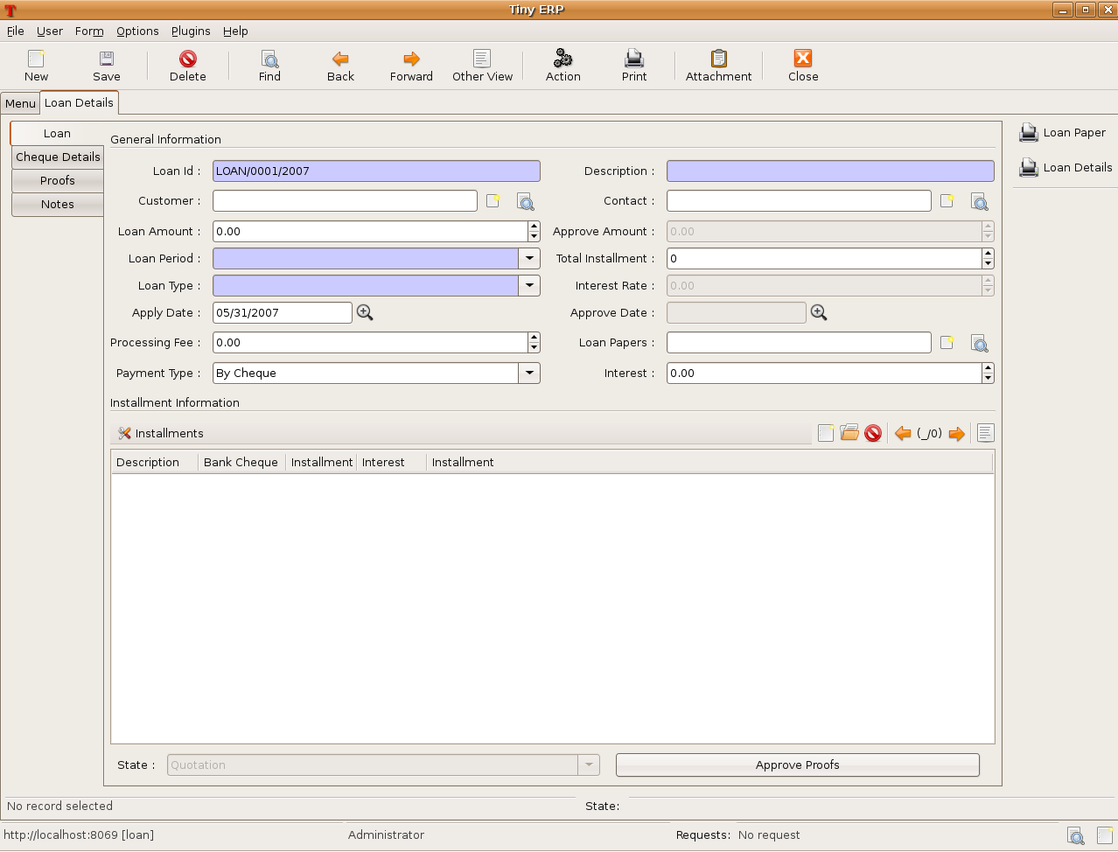
The First Tab contains information regarding loan.
Loan Id : The Loan number in the first field is automatically generated by the sequence of Loan.
Description : Description about loan.
Customer : Name of Customer. When you enter the customer, the other required fields are filled automatically.
Loan Amount : Amount of loan applied.
Approve Amount : Amount of loan to be approved. It is the amount of difference between Loan amount and Processing Fee if any.
Loan Period : Period of loan. When you select Loan Period , Total Installment field will fill automatically.

Apply Date: Date of loan applied.

Approve Date: Date of loan approve. It will fill automatically after final approval.

Processing Fee: Processing charge if any.

Payment type: type of payment. i.e. by cheque, by cash etc.

Interest: Rate of Interest. It will filled automatically after approval of finance.

Loan Papers: Documents require for granting loan.

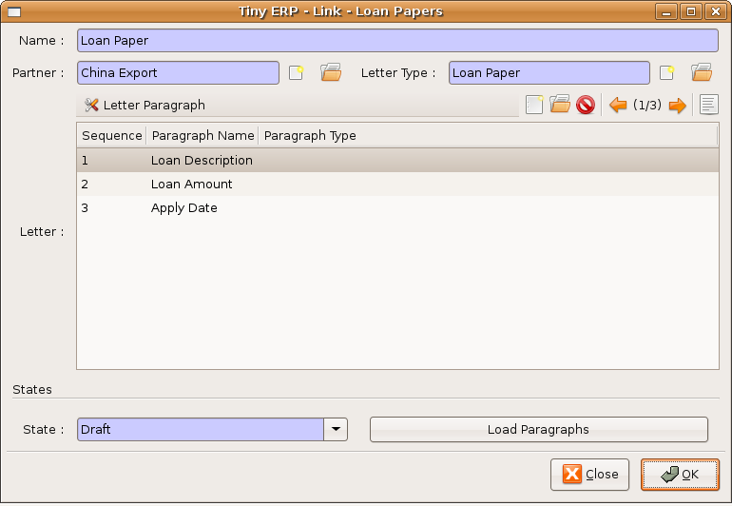

Loan Type : Type of loan. i.e. Home Loan etc.
For Loan type first of all u have to enter the enteries in Interest List. For that use Financial Management > Configuration > Loan > Interest > Interest List.
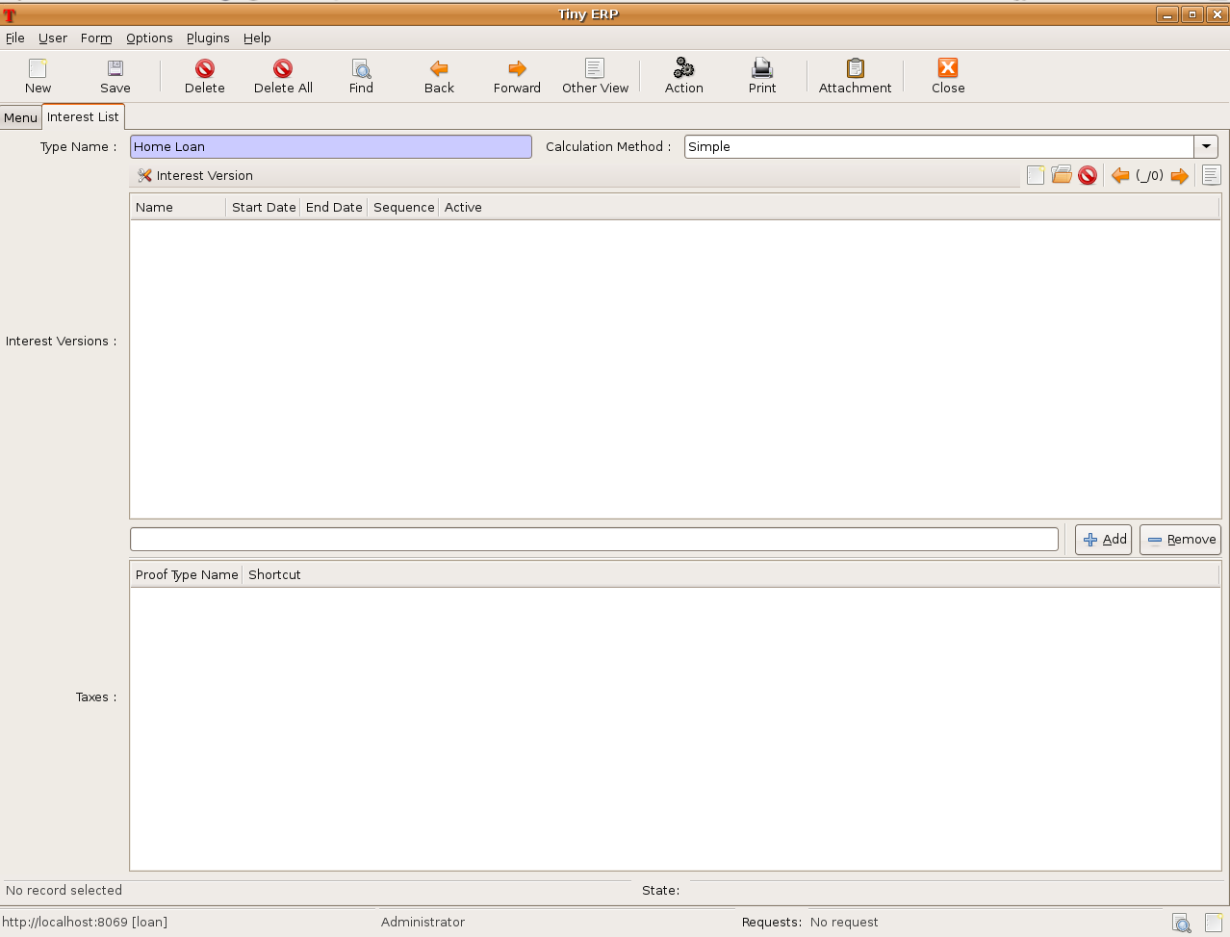
Type Name : Type of Loan.
Calculation Method : Interest calculation method. i.e. simple or compound.
Interest Version : It contails all the details regarding Interest Rate.
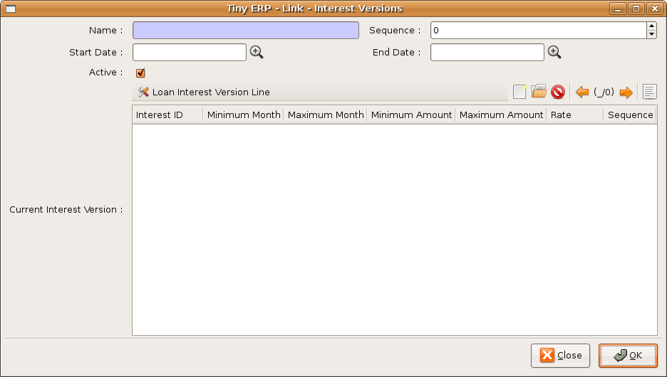
The Second Tab of Loan Details contains information regarding cheque details.
The Third Tab of Loan Details contains information regarding all the proof details.
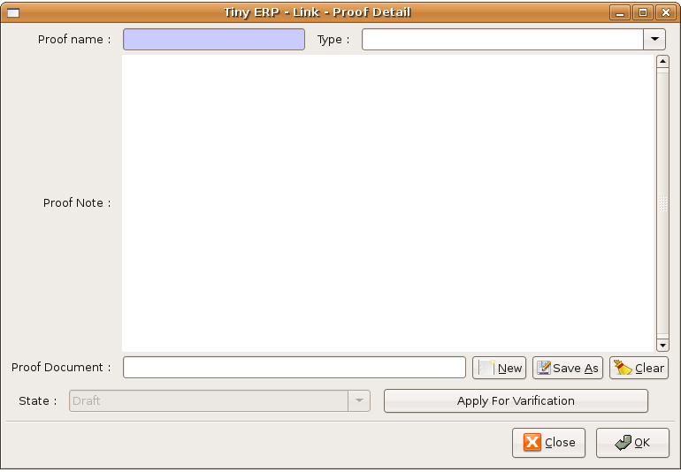

Here only the required filed is Proof Name.
For field Type first of all u have to enter the enteries in Proof Type. For that use Financial Management > Configuration > Loan > Proof Type.

The Fourth Tab of Loan Details contains Notes, Remarks if any.

Reports
Several reports are available thanks to the 'Print' icon The list of available reports for Loan Details are:

- Loan Paper : prints the details of document.
- Loan Details : prints the details regarding loan.

Cheque Details

For cheque details use the menu Financial management > Loan > Cheque.

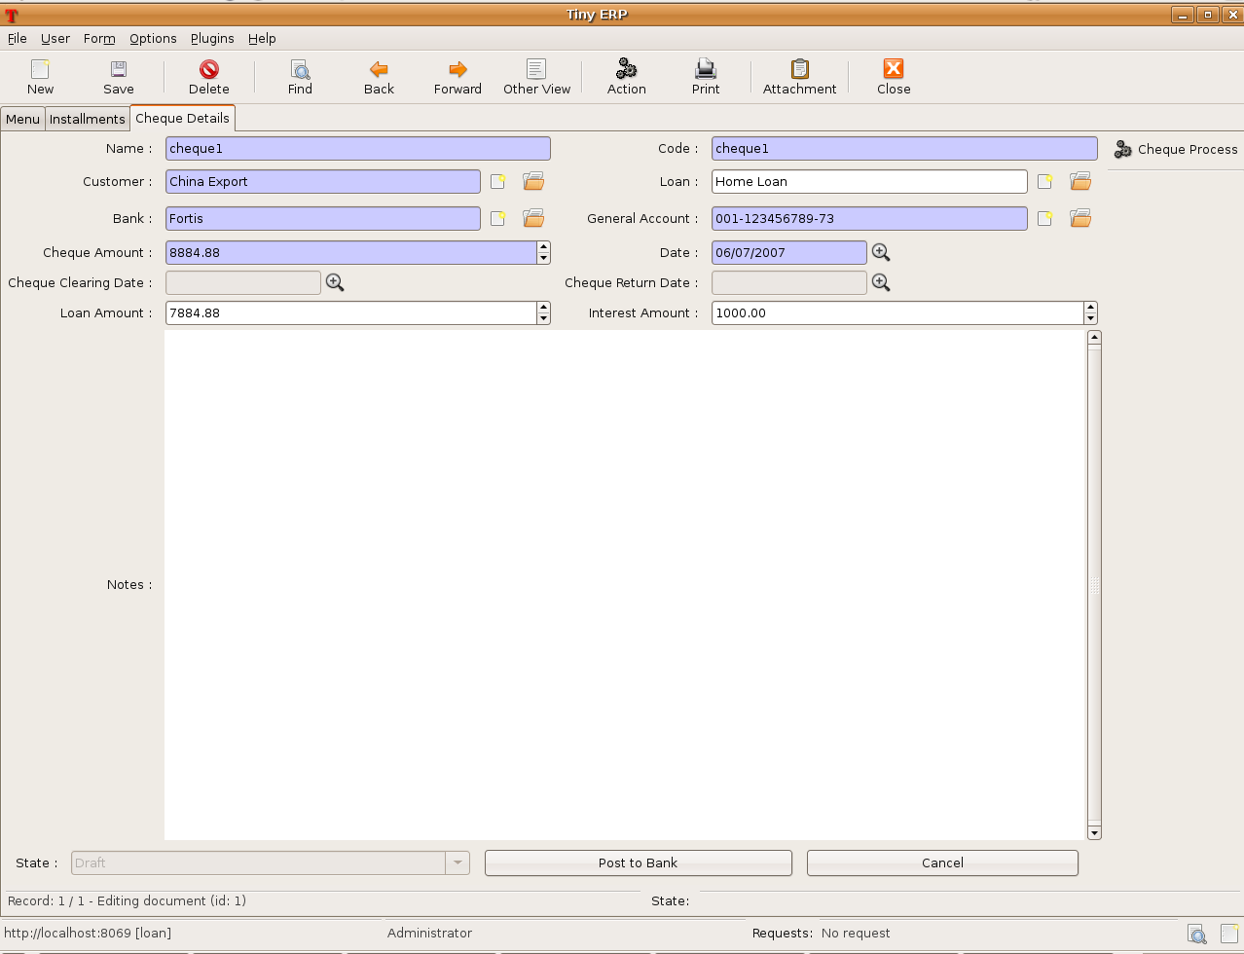

Name : Cheque name.

Code : Cheque code.

Customer : When u enter the Name of customer, the other fields Loan, Bank Name and Bank account are filled automatically.

Cheque Amount : Amount of cheque (Installment amount + Interest amount).

Cheque clearing date : Date of cheque cleared. It will filled automatically at the time of cheque clear.

Cheque return date : Date of cheque returned if any. It will filled automatically at the time of cheque
return.

Loan amount : Amount of Installment.

Interest amount : Amount of Interest.

Actions on Cheque Details
To execute actions on cheque details, make a research and select a group of cheque list (list
mode) and click on the 'Action' icon. Tiny ERP gives the list of the available actions:
• Cheque process: This action will change the state of all draft cheque list to the state posted.

Installment Details
For installment details use the menu Financial management > Loan > Installment.
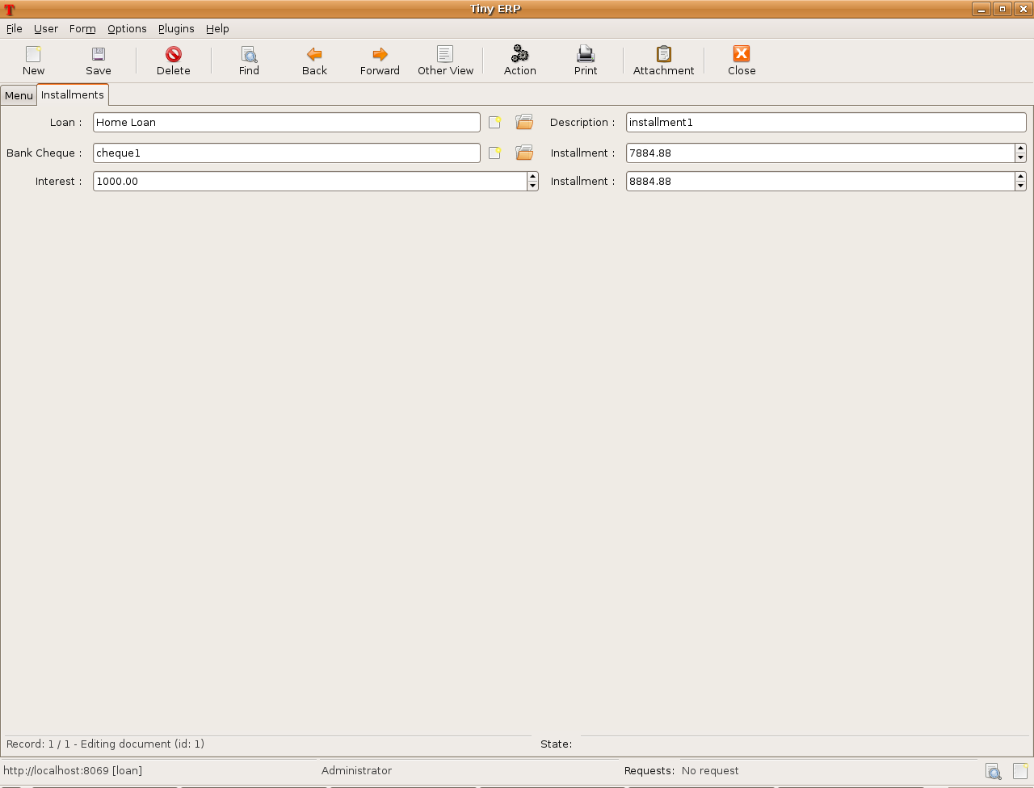
Loan : Type of Loan.
Description : Any description for an Installment.
Bank Cheque : Cheque Name.
Installment : Installment amount.
Interest : Interest amount.
Installment : Total installment amount (Installment + Interest).

