OpenERP OUTLOOK PLUG-IN USER GUIDE

- Overview of OpenERP Outlook Plug-in
- Configuration of OpenERP in outlook
- Synchronize Contact Detail
  - Creating Contact.
  - Link to existing Contact
- Archive Mail to OpenERP Objects.
  - Create new Document.
  - Open existing Document.

Creating New Resources from email.
Using WebServer with Open Partner and Open Document.

- Overview of OpenERP Outlook Plug-in

Outlook plug-in facilities user to search the record for the specific document and also allows archiving mail to multiple documents at once. PlugIn also manages the document list, where new document can be added and old one can be removed.
Add In also allows Creating New Resources like to Lead toProject Issue, to Applicants from email.

Synchronize Contact Detail like Creating Contact, Searching, Viewing and Editing Contact Details based on the sender of the email. Plug IN can also be configured to connect to the required server and also allows selecting the list of databases already installed.

- Configuration of OpenERP in outlook
- From Menu Bar, Open OpenERP -> Configuration. Following dialog box will appear:
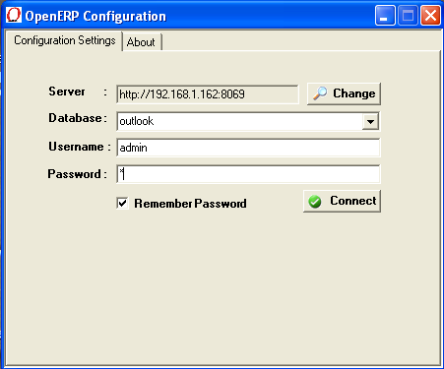

- In “Configuration” tab, default values for the server path, port, database name, username and password will be set for the localhost.

- The Remember password option will help you to remember the password when you want to use it next time with same database.

- To change the port and server you want to connect to click on button “Change”. Following dialog will appear:

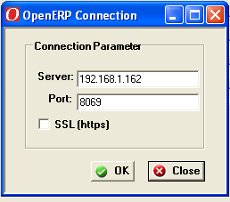

Click on “Ok” to connect to specified server at specified port which will bring you back to previous dialog box with list of databases on that server. Select the database you want to connect to and give proper username and password.

- Click on “Test Connection” to check
  - Whether specified server is running on given port,
  - Whether there exist any database on that server,
  - If yes, whether the username and password you have entered is correct or not.
  - On successful connection following Message box
will appear:
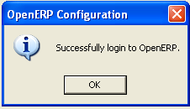

And on server console the follwing message will be dislplayed.

- In “About” tab, information about the plug-in is given
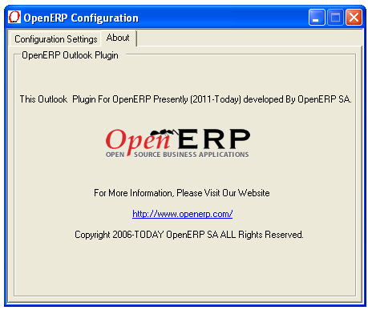

- Synchronize Contact Detail:

A) If the email address is already in saved in the specifiec database then it will opne that contact in the web browser.

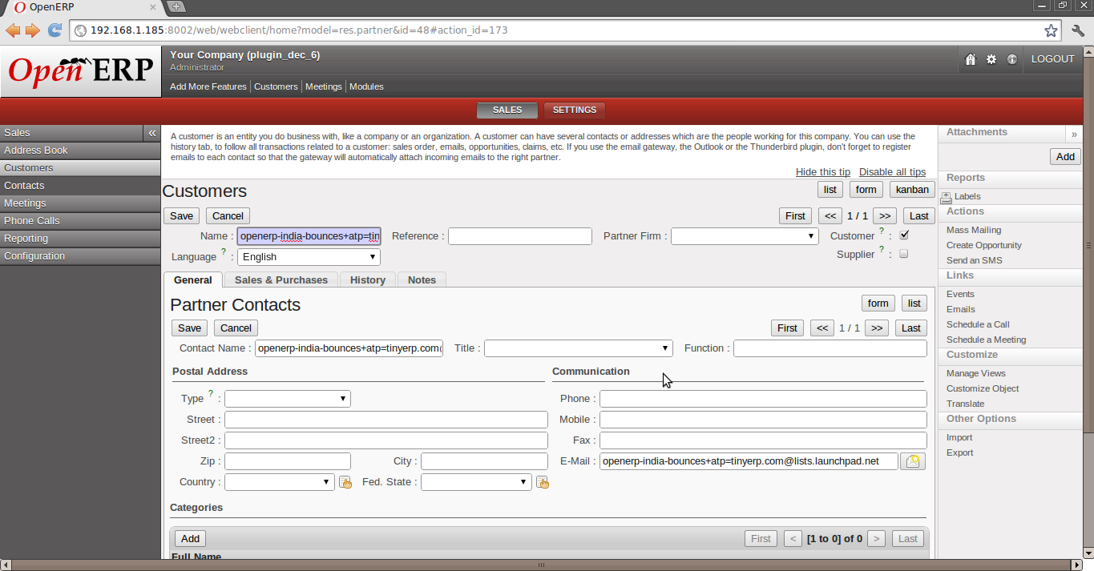

B) Otherwise it will give two options.
1) Create a new contact with the partner name same as the contact name.

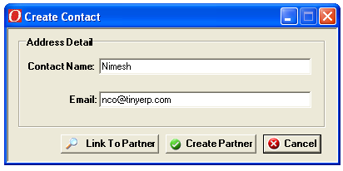

Here by clicking on the Crate partner button one can create new partner same as the contact name.
Otherwise click on cancel to close the form.

Then it will opens the contact form in the web-browser.

2) Link to an existing partner.

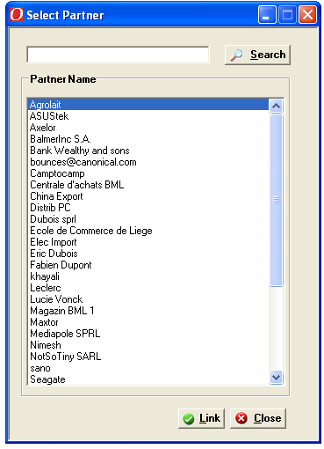

One can link the partner with the existing one by selecting the partner and click on link button.

There is also a serching facility to search the partners by its name.

After linking the partner it will opens it in the web-browser

- Archive Mail to OpenERP Objects.

  - From toolbar, clicking on “OpenERP -> Documention”, following dialog box will appear:

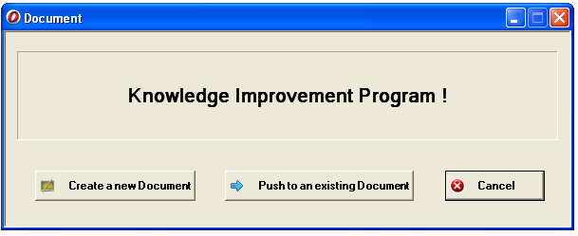

In this dialog box, It will take the subject name as you have selected the mail.
From here one can (If document is not created.):
    - Create a New Document.
    - Push to an existing document.
    - Exit.
- Create a New Document :
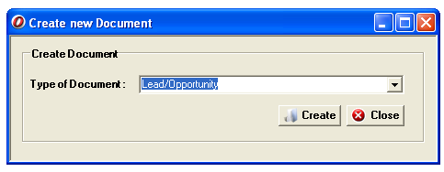
If click on the create new document then it will opens a new dialog box to create the new doucment.

In the combo box ther is a lost of objects. By selecting the object one can create a new document to push the data.

When you create a document it will opens it in the web-browser.

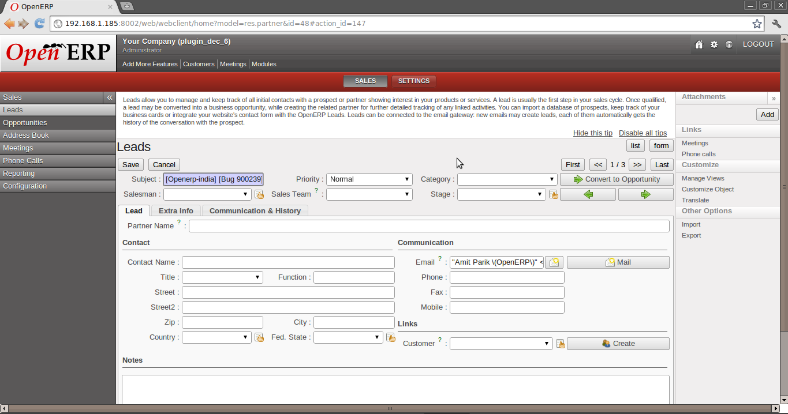

Click on close to close the window.

    - Push to Extisting Document

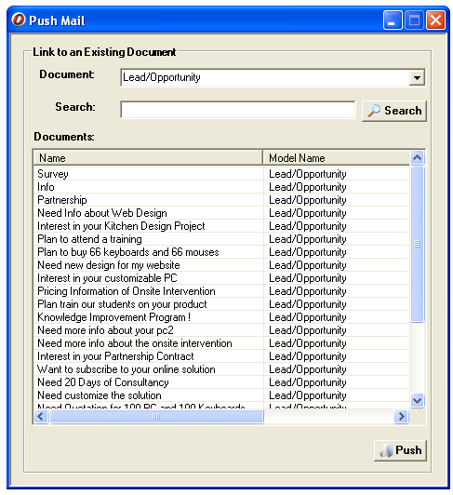

Form the Document dropdown one can select object to see the list the items of the that object.

One can search the specfic item by typing the name and click on the search object.

To push :- select the items from the list to push and click on the push button.

Once it pushed its opens the document in the web-browser.
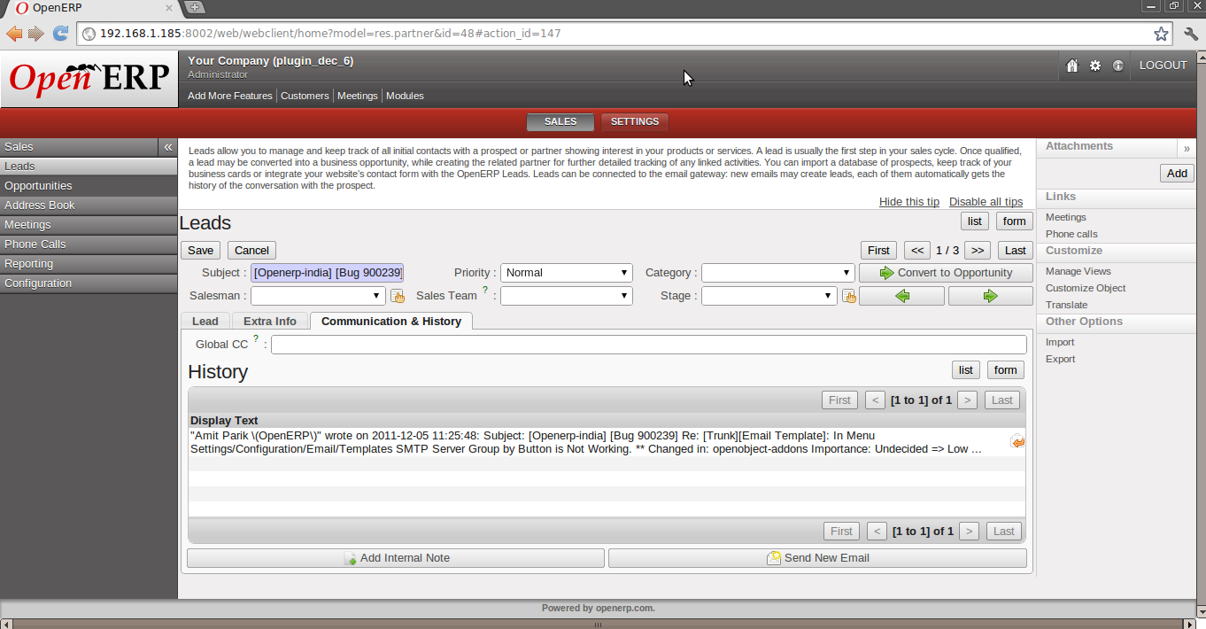

Details of attechemnt are ..
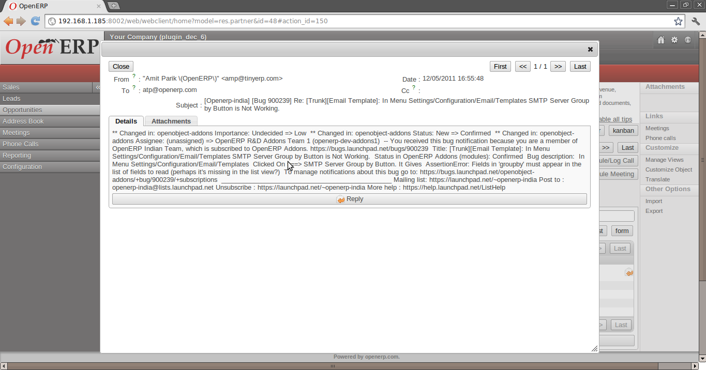

If the document is already created(For the existing document) then it will opens the dialog box:

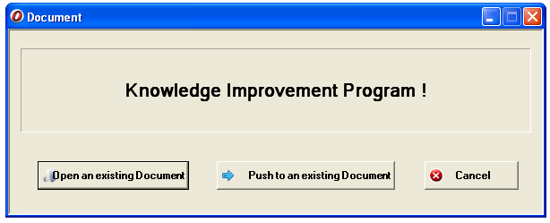

If you click on Open an existing Document button then it will open the document in the web-browser.

Conclusion:

The plug-in can be very useful to manage attachments and allow user to work with OpenERP from Outlook. It simplifies the work and also save time of the archiving mail details. Contact detail of the user can also modified or new contact can be created without switching application.

Enjoy Archiving the Outlook Email and Managing Contact with OpenERP.

