Case 1: Export ignores a „0,00 €“ invoice created by deduction of a 100% down-payment:

The issue is related to a invoiced sale order (down-payment-invoice: AR/2023/03/0001)
and a final invoice („Nullrechnung“ AR/2023/03/0002) by using the down-payment.
This final invoice was ignored in the export.

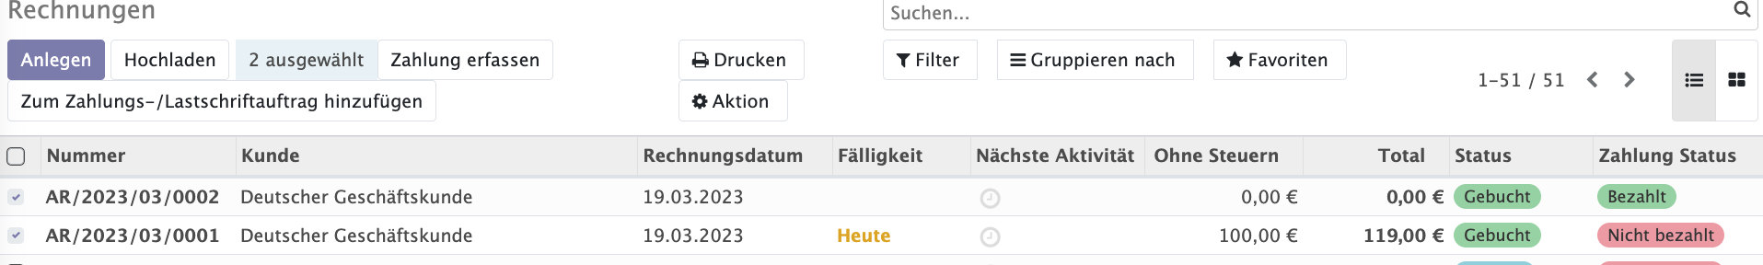
…

created by:

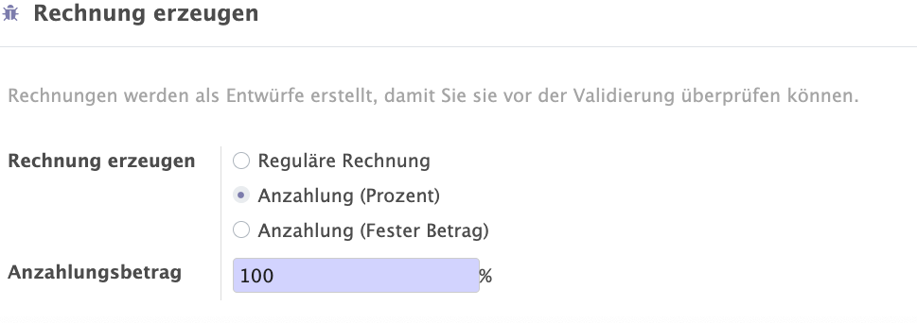
...

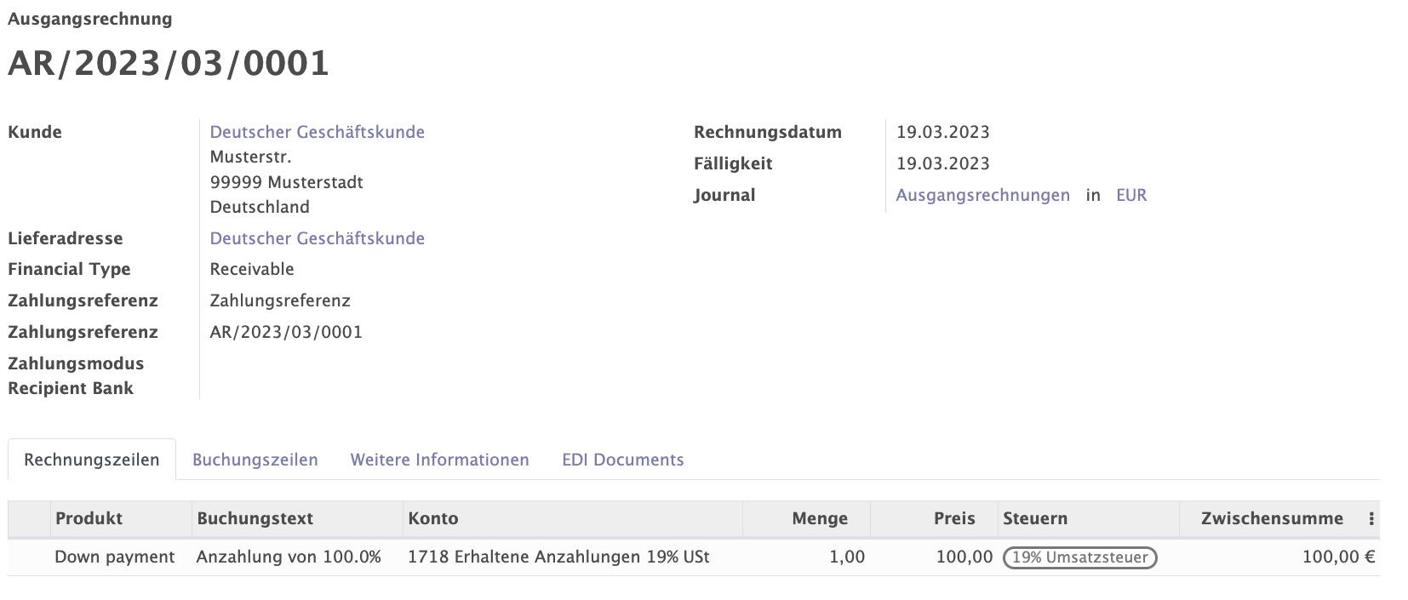
…
with this account move...

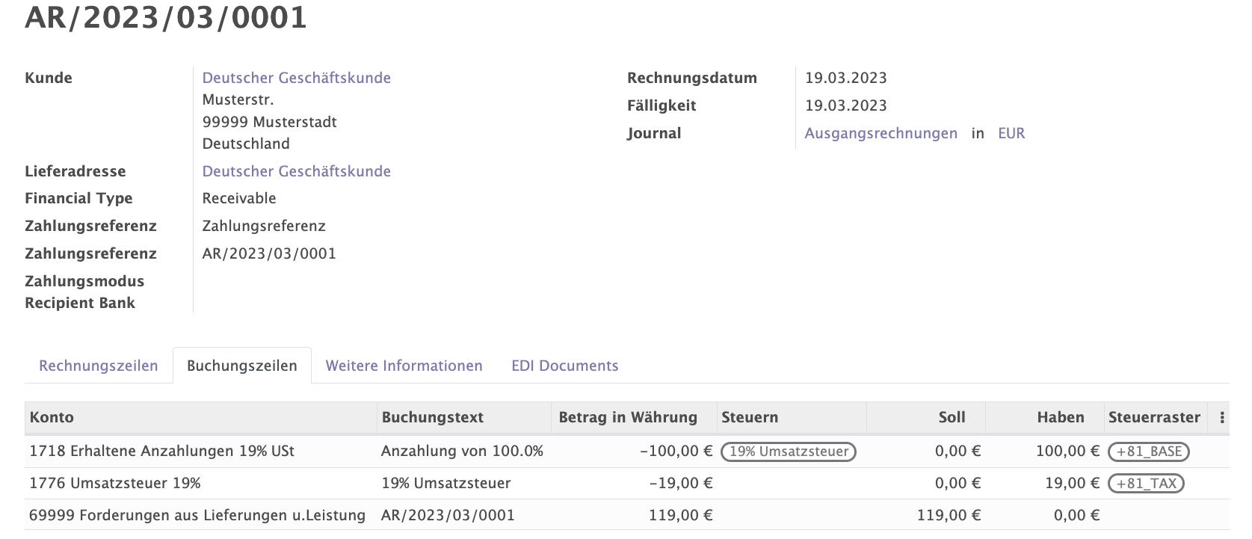
…

then we created the final invoice by …

…
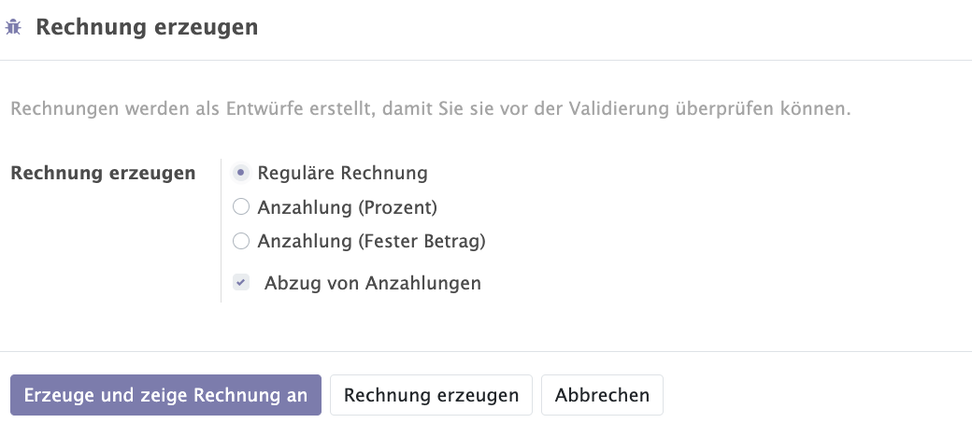
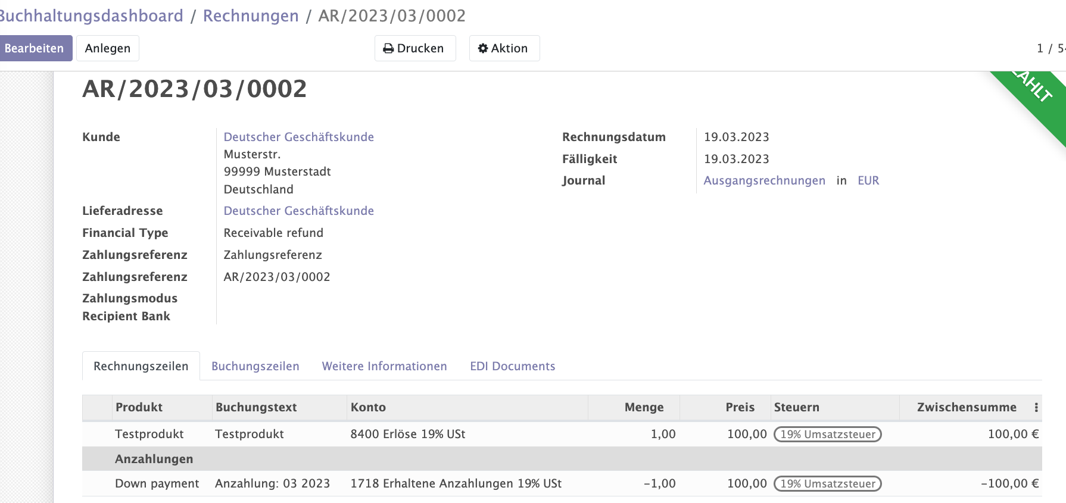
…
..

with this account move..

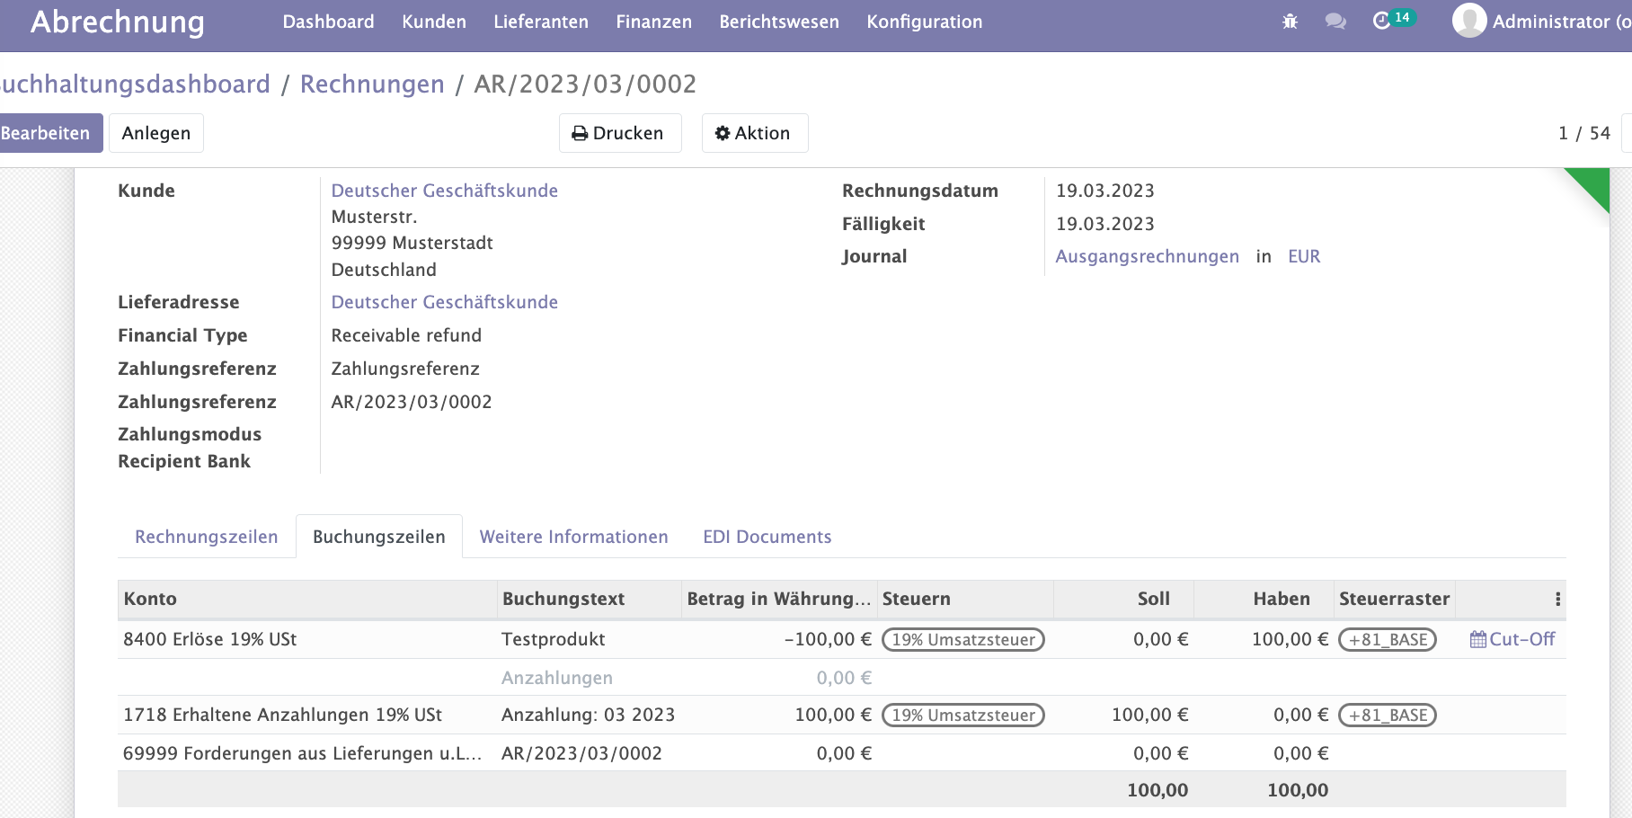
…

This first case above doesn't lead to an exception, it simply ignores to put the invoice into the export. This ignorance would be correct for „real“ Nullrechnungen, f.e. because a product has qty=0 and price=0,00 €. However for the case of 100% down-payment deduction we would require the account moves.

Case 2: Odoo Datev Export XML exception with partial „Down Payment“ deduction (f.e. 80% down payment). This export caused the error:
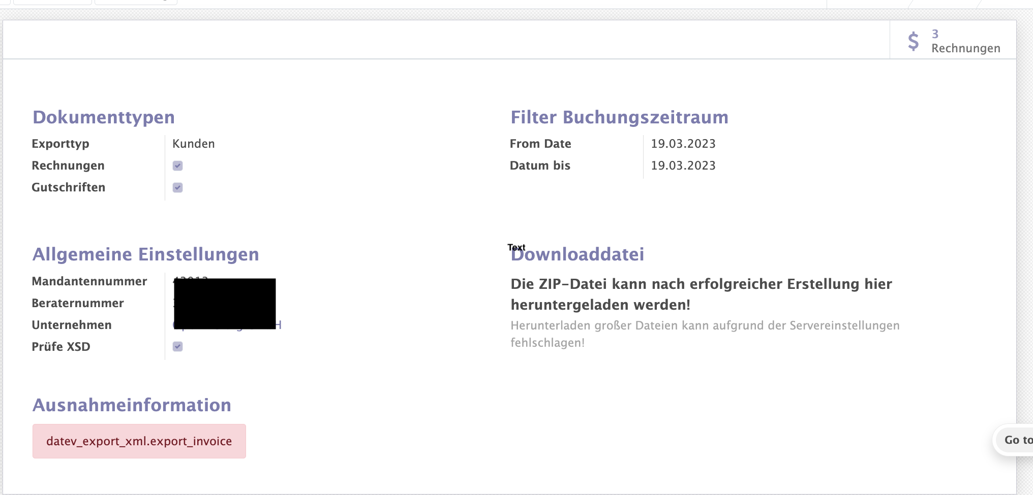
…

A 80% down-payment's final invoice caused a DATEV Export XML exception.
The following down-payment invoice itself could be exported correctly.

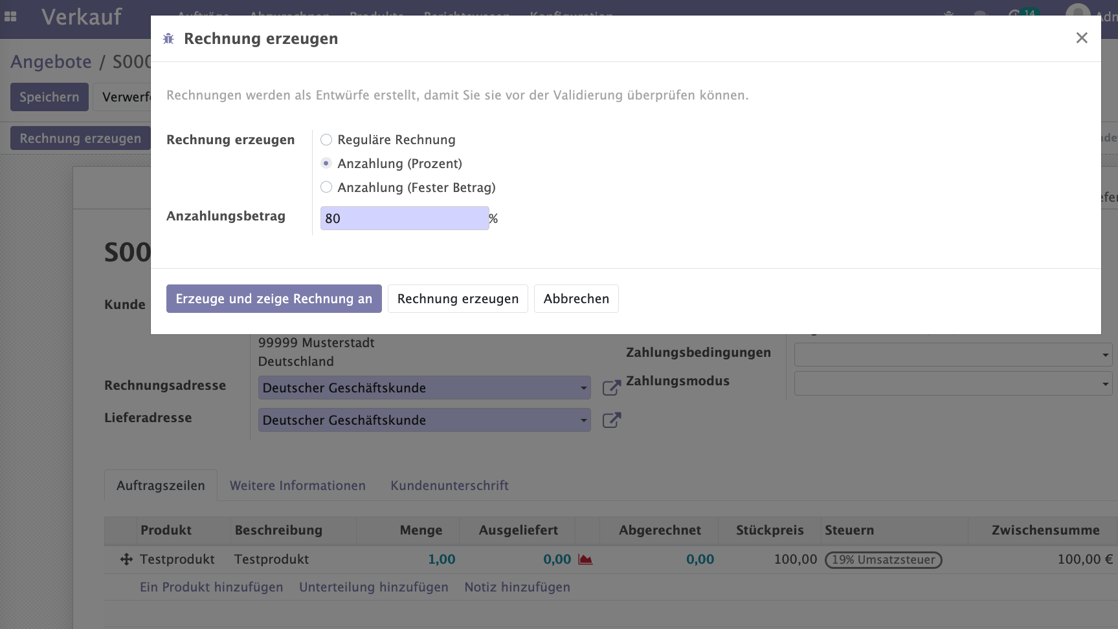
…

…
The corresponding final invoice caused the following exception in the export:

Ausnahmeinformation
datev_export_xml.export_invoice

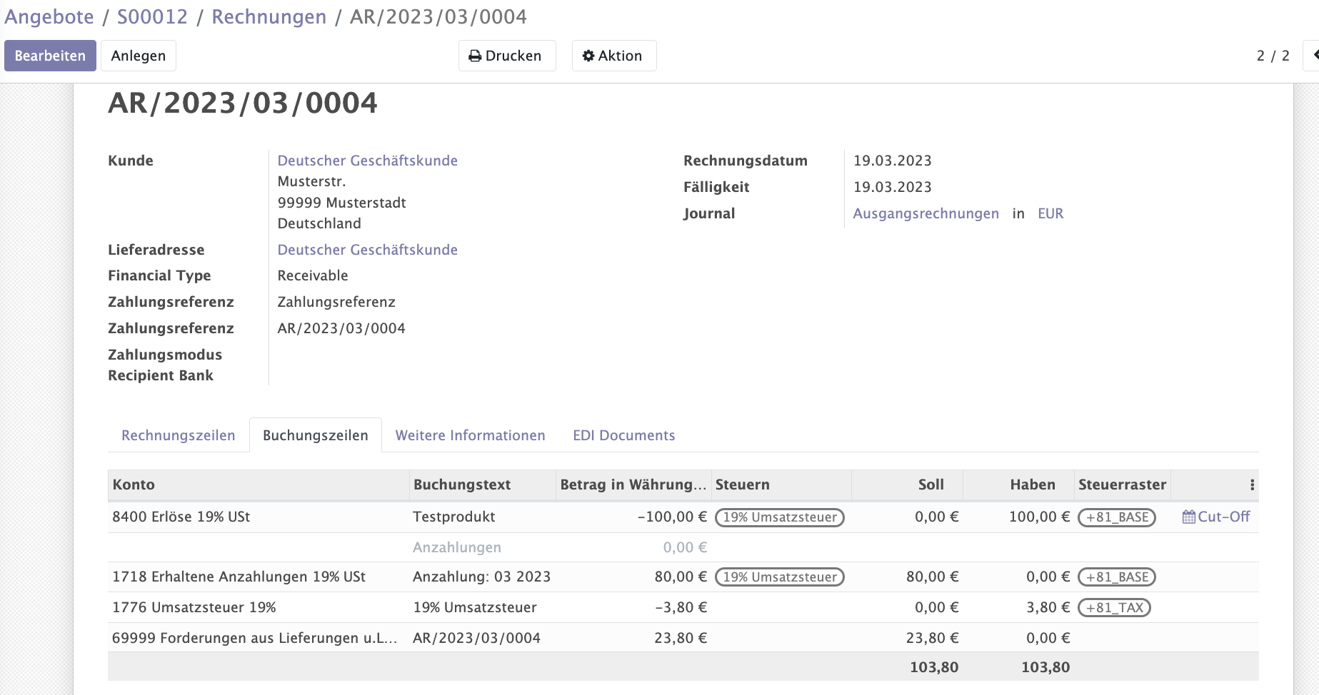
..

Nevertheless it is also an issue in Odoo EE export at least with the „Nullrechung“, i am not 100% sure if they can handle a 80% down-payment. In the Odoo EE export the counterpart account (AR) is missing, which could be solved at least by hand in the .csv Export file.

https://github.com/odoo/odoo/issues/115432

