|  |
| --- |
| **INTEGRATION PROCESS WEBSERVICES**    31-07-2013 |

SHIPPING FLOW

Step 1











Step 2

**--------------------------------------------------------------------------------------------------------------------------**

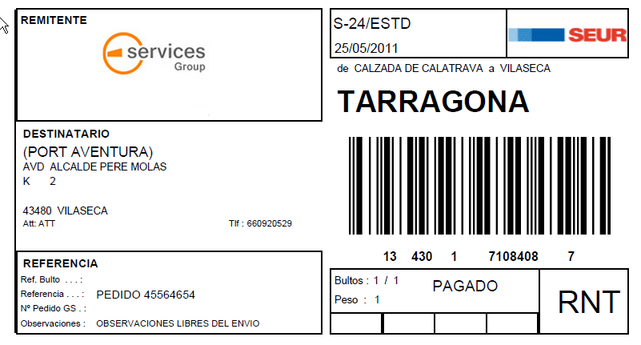

**SEUR labels printing and shipment integration service**

A number of methods can be used in the SEUR labels printing service.

### Technical specification of the web service

### <http://cit.seur.com/CIT-war/services/ImprimirECBWebService?wsdl>

### Input/output parameters

The call under the **impresionIntegracionPDFConECBWS** method is made with the following input/output parameters:

* Input parameters:
  + imp:in0: User, Mandatory
  + imp:in1: Password, Mandatory
  + imp:in2: Data to be printed in XML format. Attached are the xsd of the format of data based on the type of label. Mandatory
  + imp:in3: File name. Mandatory
  + imp:in4: Tax identification number (NIF) of the Integrated Client. If this value is not known, the integration code can be used. It can be fixed. Mandatory
  + imp:in5: Franchise code. Customer’s code would be ‘28. It can be fixed. Mandatory
  + imp:in6: Account code: If this value is not known, -1 should be used. It can be fixed. Mandatory
  + imp:in7: System called by the service: optional. If not used, this value should be left blank (“”). It can be fixed. Mandatory
* Output parameters:
  + Result of the operation: The “OK” string, if the data has been processed correctly,
    - 14-digit number corresponding to the barcode of the label and string in code64(pdf) with the label, or any of the error messages listed in the table below (placed in <ECB>)
    - or any of the error messages listed in the table below (placed in <traza>)
  + or any of the errors in the table below, with:

|  |  |
| --- | --- |
| **Error** | **Description** |
| ERROR – INCORRECT USER/PASSWORD | Log-in error: invalid user and/or password |
| VALIDATION ERROR | Error that occurs when the data sent to the web service for printing does not comply with any of the validation rules |
| ERROR – COULD NOT OBTAIN THE PLATFORM | Error that occurs when the data does not make it possible to obtain a valid platform |
| ERROR – COULD NOT OBTAIN THE TRANSPORT LINE | Error that occurs when the data does not make it possible to obtain a valid transport line |
| ERROR | Error |

**---------------------------------------------------------**

**imp:in5: Data to be printed in XML format. If the following fields do not have the expected format, the KO string in the web service response will be ‘VALIDATION ERROR’.**

**If postal code and location (<poblacion_consignatario> and <codPostal_consignatario>) of the consignee are not validated we can work with this algorithm**



**or simply response with a non-valid label, that will be reprinted at SEUR’s facilities.**

Fields Description XML:

<ci> is the **customer integration code**

<nif> is the customer **Tax Identification Code**

<ccc>> is the customer **Seur’s Code**

Values for <servicio>

|  |  |  |
| --- | --- | --- |
| **CODE** | **NAME** | **SHORT NAME** |
| 001 | SEUR - 24 | S-24 |
| 003 | SEUR - 10 | S-10 |
| 005 | MISMO DIA | S-MD |
| 007 | COURIER | COUR |
| 009 | SEUR 13:30 | S-13 |
| 013 | SEUR - 72 | S-72 |
| 015 | S-48 | S-48 |
| 017 | MARITIMO | *MAR |
| 019 | NETEXPRESS | NTEX |
| 077 | CLASSIC | CLSC |
| 083 | SEUR 8:30 | S830 |

Values for <producto>

|  |  |  |
| --- | --- | --- |
| **CODE** | **NAME** | **SHORT NAME** |
| 002 | ESTANDARD (STANDARD) | ESTD (STD) |
| 004 | MULTIPACK | MPAC |
| 006 | MULTI BOX | MBOX |
| 018 | FRIO (COLD) | FRIO (COLD) |
| 052 | MULTI DOC | MDOC |
| 054 | DOCUMENTS | DOCS |
| 070 | INTERNATIONAL T | INTE |
| 072 | INTERNATIONAL A | INAE |
| 076 | CLASSIC | CLAS |
| 002 | ESTANDARD (STANDARD) | ESTD (STD) |
| 004 | MULTIPACK | MPAC |

Normally, servicio=1, product=2

<total_bultos> is for the total number of packages that make up the delivery.

<total_kilos> is the total weight of delivery.

The values of this field are whole numbers (without decimals).

<pesoBulto> is the total weight of a parcel, with 2 decimals (ie 5,35 kilos)

<observaciones> is an open text for comments from the delivery notes. No longer than 150 positions.

< referencia_expedicion > and <referencia_bulto> are Customer’s identifiers for shipments and parcels. Shipment reference (referencia_expedicion) cannot be informed twice a day. They must no be longer than 45 positions.

<clavePortes> is the label type check for cold stores

|  |  |
| --- | --- |
| “F” | Invoice (F= Factura)  Transport charges paid (Portes Pagados) |
| “D” | Due (D=Debido) |

<clavePod></clavePod> is the type of proof of delivery used.

|  |  |  |
| --- | --- | --- |
| “ “ | Without CDE | Without Comprobante de entrega (Proof of delivery). |
| “S” | Seur | Return of SEUR delivery note signed. |
| “I” | Immediate | Return of signed sender documents |

<claveReembolso> states who pays the refund payment.

This field is obligatory if we fill out the field “valor del reembolso” (repayment value under valorReembolso. It must be defined like 12,26 ).

|  |  |  |
| --- | --- | --- |
| “F” | Factura (Invoice) | The sender pays refund costs. |
| “D” | Debido (Owed) | The addressee pays the refund costs. |
| “ ” | No refund | There is no refund to be made. |

Consignee detalis:

<nombre_consignatario> is the name of the Consignee. No longer than 40 positions.

<direccion_consignatario>is the name of the Consignee’s address. No longer than 70 positions.

This field should only contain the name of the street, motorway, avenue, square etc., without type and number. In the case where the consignee wishes to collect the goods from the SEUR destination agency, this field should contain only the following text: TO BE COLLECTED”. Any other additional information (for example: the name of the consignee) can be inputted into the comments field.

<tipoVia_consignatario> is the type of route. No longer than 3 positions.

Most normal values are AUT - AUTOVIA ; AVD – AVENIDA, CL – CALLE, CRT – CARRETERA, CTO - CENTRO COMERCIAL, EDF – EDIFICIO, ENS – ENSANCHE, GTA – GLORIETA¸ GRV - GRAN VIA, PSO – PASEO, PZA – PLAZA, POL - POLIGONO INDUSTRIAL, RAM – RAMBLA; RDA - RONDA ; ROT – ROTONDA, TRV – TRAVESIA, URB - URBANIZACION

<tNumVia_consignatario> is the type of number of the route. Normally takes N. – Número, but sometimes BL - Bloque ; IN - Indefinido ; KM - Kilómetro ; LT - Lote ; NV - Nave . No longer than 2 positions.

<numVia_consignatario> is the number of the Street.

<escalera_consignatario>, <piso_consignatario>, <puerta_consignatario> are the MAIN DOOR/FLOOR/DOOR for the Consignee.

<poblacion_consignatario> and <codPostal_consignatario> must be validated in web service infoPoblacionesCortoStr or with the next master data.



<email_consignatario>, <telefono_consignatario> and <atencion_de> are the mail, tel and contact person for the consignee.

**Label Sample in PDF**



**Sample Call**



**SEUR manifest printing service**

### Technical specification of the service

http://cit.seur.com/CIT-war/services/DetalleBultoPDFWebService?wsdl

### Input/output parameters

The call under the **generacionPDFDetalleNoFecha** method is made with the following input/output parameters:

* Input parameters:
  + imp:in0: Tax identification number (NIF) of the Integrated Client. If this value is not known, the integration code can be used. It can be fixed. Mandatory
  + imp:in1: Franchise code. Customer’s code would be ‘28. It can be fixed. Mandatory
  + imp:in2: User, Mandatory
  + imp:in3: Password, Mandatory
* Output parameters:
  + Result of the operation: a decode base64 string with all the outstanding shipments to be picked up by SEUR

|  |  |
| --- | --- |
| **Method** | **Manifest Creation and printing** |
| URL (production environment) | http://cit.seur.com/CIT-war/services/DetalleBultoPDFWebService |
| SOAP Call |  |