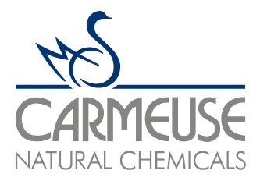 |  | Carmeuse Lime & Stone  Pleasant Gap Operations  965 East College Avenue  Pleasant Gap, PA 16823

PRODUCT INFORMATION
Product Description: |  | HiCal QL 3/4” X 1/8” Water Grade
Product Code: |  | 17800
Production Facility: |  | Pleasant Gap
Packaging: |  | Bulk
Typical Properties: Chemical |  |  | Average (%)
 | Carbon Dioxide (CO₂)  Sulfur (S)  AvLime Index  Calcium Oxide (CaO)  Magnesium Oxide (MgO)  Silica (SiO₂)  Alumina (Al₂O₃)  Ferric Oxide (Fe₂O₃)  LOI |  | 0.96  0.05  92.9  95.3  1.2  1.4  0.5  0.2  1.4
Typical Properties: Physical |  |  | Average (%)
 | ASTM Reactivity  - Temp. Rise in 30 seconds (°C)  - Temperature Rise in 3 min (°C)  - Temp. Rise T_{total} (°C)  - Total Active Slaking Time (min)  Loose Bulk Density (#/ft³) |  | 26  50  51  5  52-78
The information contained in this product information sheet is, to the best of our knowledge, true and accurate, but any typical values given are subject to occasional variations based on variations in the raw material inputs and processing operations. Each user is advised to evaluate the product (specific compositions, physical properties and performance characteristics) independently for suitability in the intended use.

