Orange County Community Health Assessment and Improvement Plan
2025-2030

Our shared vision and health promotion strategic plan to address the most pressing health issues of Orange County residents

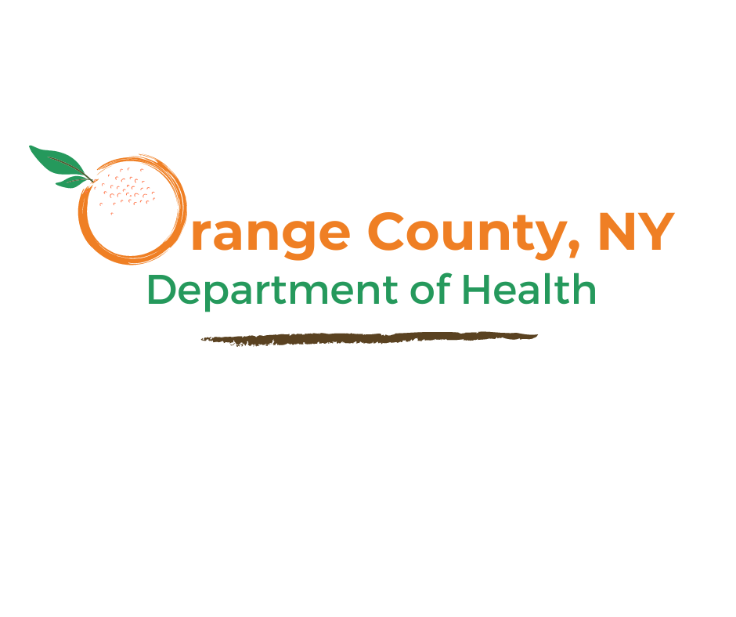

What is a Community Health Assessment and Community Health Improvement Plan?
The Community Health Assessment (CHA) describes the overall health of the community by presenting information on health status, factors that influence health, and community needs and assets. As a foundational public health service, the CHA allows the Orange County Department of Health (OCDOH) to assess and monitor health and to identify specific populations that may be at an increased risk of poor health outcomes. Through systematic, comprehensive data analysis, the CHA identifies key health priorities as outlined by the New York State Department of Health’s (NYSDOH) Prevention Agenda. The Community Health Improvement Plan (CHIP) is a long-term, system-wide effort to improve resident health by addressing these identified public health priorities. Creating both the CHA and CHIP is a collaborative process. The OCDOH, key partners, area hospitals, and diverse stakeholders work together to coordinate efforts, establish priorities, and combine resources to guide health promotion strategies.

What Does the CHA/CHIP Process Look Like?
The OCDOH utilizes the Mobilizing for Action through Planning and Partnerships (MAPP) 2.0 framework developed by the National Association for County and City Health Officials. MAPP is a community-driven strategic planning process that streamlines the prioritization of health issues, the identification of resources, and the advancement of health equity. As part of the assessment phase, the OCDOH collaborated with the other six Mid-Hudson (M-H) Region LHDs and area hospitals to conduct the M-H Region CHA during the spring and summer of 2025. The regional findings were shared with the OC community in the fall of 2025. Based on partner input, additional sub-county level analysis was conducted that same winter, leading to the completion of the OC CHA in January 2026. To assess the most pressing health needs of local residents, the assessment drew upon extensive data review and analysis from over 30 secondary and 7 primary data sources.
Following the MAPP 2.0 framework, health priorities were identified through a rigorous process of data triangulation. This method synthesized findings from three essential assessments:
- Community Status Assessment: Analyzed quantitative health outcomes and social determinants of health to identify existing inequities. This included a review of demographics, morbidity, mortality, and health behaviors.
- Community Context Assessment: Captured qualitative insights and lived experiences to understand the human impact of social systems. This included a review of the Forces of Change Assessment, the Community Asset Survey, focus groups with underrepresented community members, key informant interviews, the Resident Priority Selection Survey, the Provider Survey, and the OC Community Health Survey. These assessments were completed across the county and included feedback from over 2,200 local residents.
- Community Partner Assessment: Evaluated the collective capacity of our public health network to address these identified disparities. These assessments occurred during the Orange County Health Summit and collaborative meetings with over 140 partners in 2025.
The OCDOH established a CHIP Steering Committee composed of 22 external stakeholders representing area hospitals, community-based organizations, business owners, schools, colleges, federally qualified health centers, and the community. Meeting from January through June 2026, the committee reviewed the assessments to collectively select priority areas and evidence-based strategies. Together, they developed the plan’s goals, responsible partners, implementation timelines, evaluation measures, and both short and long-term objectives. The OCDOH extends its sincere gratitude to the OC CHIP Steering Committee members listed below for their invaluable guidance, input, and ongoing partnership.
Name | Organization
Karina Bajana  Cynthia Barton  Brandon Bogert  Kate Dabroski  Joanni Gallagher  Caitlin Higgins  MaryAlice Kovatch  Dina Leduc  Erin Lynch  Moira Mencher  Krista Miller  Aimee Monastero  Amie Pinckney  Liana Rivers  Maureen Roche  Lourdes Santacruz  Thomas Scaglione  Jhack Sepulveda  Sharlyn Serwatien  Logan Tierney  Liz Walsh  Sherry Wyckoff | Orange-Ulster BOCES  Montefiore St. Luke's Cornwall Hospital  Orange County Department of Mental Health  Montefiore St. Luke's Cornwall Hospital  Alcohol and Drug Awareness Council of Orange County  Mental Health Association of Orange County  Alcohol and Drug Awareness Council of Orange County  Mount Saint Mary College (MSMC)  Alzheimer's Association  Garnet Health  Sun River Health  Garnet Health  Orange County Department of Mental Health  Wellness Inspiring Spiritual Health  Garnet Health  Westchester Medical Center Health Network  Westchester Medical Center Health Network  SUNY Orange  Westchester Medical Center Health Network  Montefiore St. Luke's Cornwall Hospital  Westchester Medical Center Health Network  Sun River Health

What were the major health issues identified?
Premature death (death before age 65) in Orange County (OC) is the second worst in the Mid-Hudson (M-H) Region and exceeds the overall New York State (NYS) rate. Heart disease and cancer are the leading causes of both overall death, and premature death (death before age 75) by a large margin. These health gaps widen significantly along racial and ethnic lines, with OC having the second highest percentage difference in premature deaths between Black non-Hispanic people and White non-Hispanic people, in the M-H Region. Obesity is a primary driver of these leading causes of death, heavily contributing to the development of diabetes, stroke, and hypertension, all of which accelerate premature death. Currently, OC’s percentage of overweight or obese adults is the highest in the M-H Region at 75%.
Over the past ten years, obesity rates have continually grown, mirroring subsequent increases in cardiovascular disease, prediabetes, and hypertension. Notably, OC’s age-adjusted all-cancer mortality rate is the highest in the M-H Region at 151 per 100,000 residents, which is 1.1 times higher than the NYS average rate based on the latest available data. Within these preventable causes of death, stark disparities exist among racial and ethnic minorities. These disparities are evident across multiple indicators including premature deaths, food insecurity, infant mortality, asthma hospitalizations, as well as hospitalizations and mortality due to heart disease, breast cancer mortality, colorectal cancer mortality, and premature births.
Many of these health outcomes are driven by the social determinants of health, conditions where systems and policies determine the environments in which people live. Given the deep connection between physical and mental health, public health interventions must address both areas together. In 2024, 36% of OC adults aged 18 and older reported experiencing moderate or serious psychological distress. Notably, this figure rises to 47% among adults with an annual income below $25,000 underscoring the impact of poverty on resident well-being. Substance use also remains a critical challenge: between 2019 and 2022, OC ranked fourth in the M-H region for opioid-involved overdose deaths, surpassing the NYS rate excluding New York City. However, significant strides have been made in addressing substance use in OC, achieving a 45.5% reduction in overdose deaths from 2021 to 2024, according to available local data.
Other health and socioeconomic areas where OC falls behind NYS or has worsened since the last assessment include:
- Food insecurity
- Severely cost burdened households
- Cardiovascular disease hospitalization rate
- Adults with prediabetes
- Asthma hospitalization rate among adults
- Emergency department visits for asthma in children 17 years and younger
- Stroke hospitalization rate
- Cancer mortality, including all-cancer, female breast cancer, lung and bronchus, prostate, and colorectal cancer
- Childhood immunization rates, among children 24–35 months of age
- Percentage of births, with late or no prenatal care
- Percentage of women age 50–74 years receiving breast cancer screening, based on recent guidelines
- Early syphilis case rate
To identify common themes across various data collection methods, a crosswalk table was developed to track the top three health priorities from each assessment and survey. This tool enabled OC to synthesize multiple data points and visually identify where community concerns, provider perspectives, and secondary data intersect.
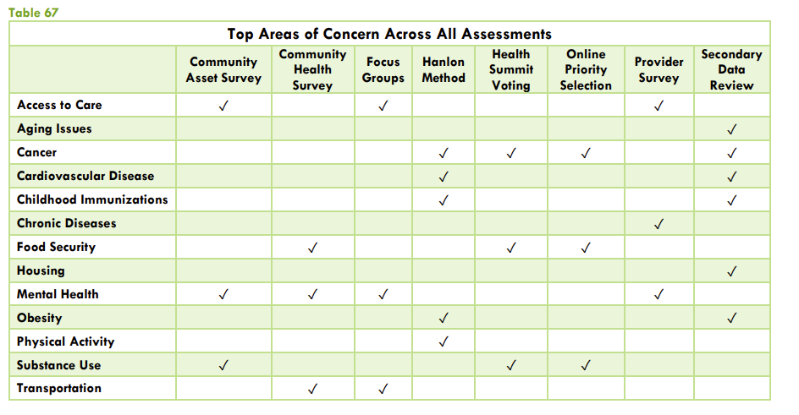
This process directly informed the selection of the final three priority areas, ensuring the choices made were grounded in both empirical data and community-voiced needs.

wHAT PRIORITY AREAS WERE CHOSEN?
The figure below depicts the evolution of the prioritization process. It began with a comprehensive review of all data topics, progressed to the identification of major health concerns across the eight assessment sources, and concluded with selection of the final CHIP priority areas. This visual ensures transparency in how OC moved from raw data to community-validated priorities.
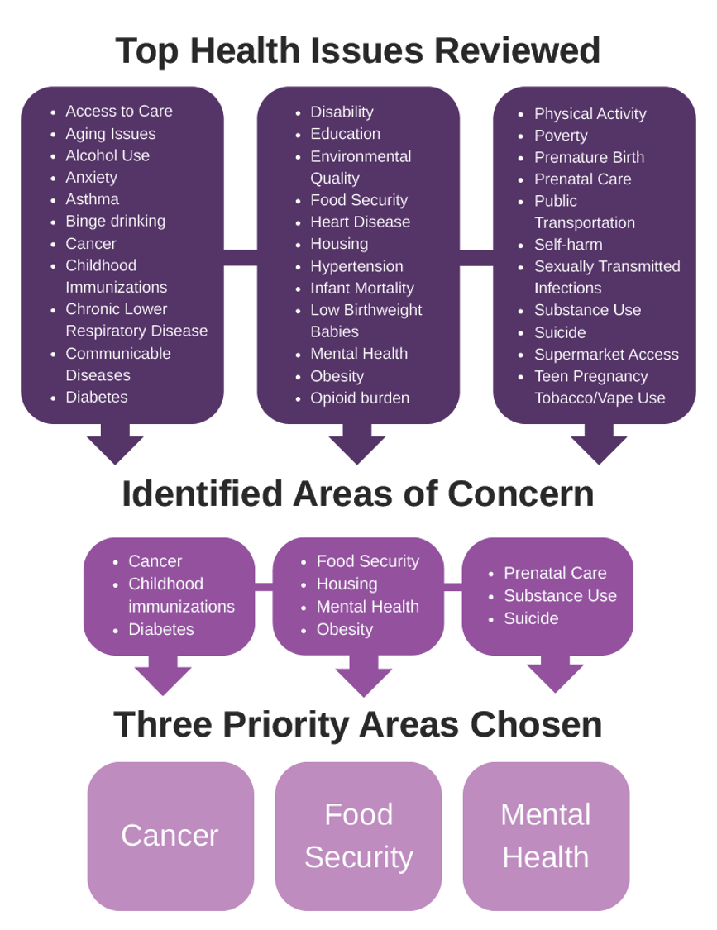

The final priorities selected from the NYSDOH Prevention Agenda 2025-2030 include:
Domain 1: Economic Stability
Priority: Nutrition Security
SMARTIE Objective: Increase food security in households with an annual total income of less than $25,000
Domain 2: Social and Community Context
Priority: Anxiety and Stress
SMARTIE Objective: Decrease the percentage of adults with an annual income of less than $25,000 experiencing frequent mental distress
Domain 4: Health Care Access and Quality
Priority: Preventive Services for Chronic Disease Prevention and Control
SMART Objective: Increase the percentage of adults age 45 to 75 years who are up to date on their colorectal cancer screening based on the most recent guidelines
The full OC CHIP action plan can be found on page 8.
As seen above, OC faces numerous health challenges; however, not all could be selected for CHIP implementation. These needs were not excluded due to lack of importance, but for a variety of other factors. OCDOH focused its plan on areas where it can have the greatest direct impact. Some upstream structural issues such as housing, poverty, and transportation fall largely outside OCDOH’s authority and are better addressed through other systems and sectors. Similarly, substance use, suicide prevention, and maternal and infant health are already the focus of strong, dedicated efforts led by the OC Department of Mental Health and/or existing community coalitions, both of which OCDOH actively partners with. Taking on these areas separately, would risk duplicating work that is already ongoing. Additionally, there are resource and capacity constraints including a reduced public health workforce. Most importantly, OCDOH took a collaborative approach to identifying the three chosen priorities through the resident priority selection surveys, partner voting during the OC Health Summit, and health and human services provider survey. Outcomes of these assessments held the most weight when determining which priorities were selected.

HOW IS PROGRESS AND IMPROVEMENT BEING TRACKED?
Each priority area has a corresponding workgroup led by the OCDOH that will use existing partnerships to actively recruit additional community partners and residents to participate. These workgroups meet monthly or quarterly depending on the priority area. Progress from these workgroups will be shared during a priority-specific Mini-Summit Series meeting, which will be held annually, and presented at the OC Health Summit, being held biennially starting in 2027. The CHIP Steering Committee will oversee the work of all three priority area workgroups and will switch to quarterly meetings in the fall of 2026 to review progress, make modifications as necessary, and ensure that each strategy is executed.
OCDOH is in the process of creating an OC CHIP Dashboard to track data collected quarterly by the workgroup leaders for each priority area. Both short-term process indicators and long-term outcome indicators will be collected through primary data analysis, qualitative data from workgroup and community members, and through review of secondary data sources. Data collected will guide any mid-course corrections needed.
The new CHIP dashboard will be accessible to the public here: https://www.orangecountygov.com/2361/Dashboard-Portal
The full Mid-Hudson Region and Orange County CHAs, Executive Summary, and CHIP can be found here: https://www.orangecountygov.com/2325/Reports-Assessments.

