Appendix

MongoDB Database ERD

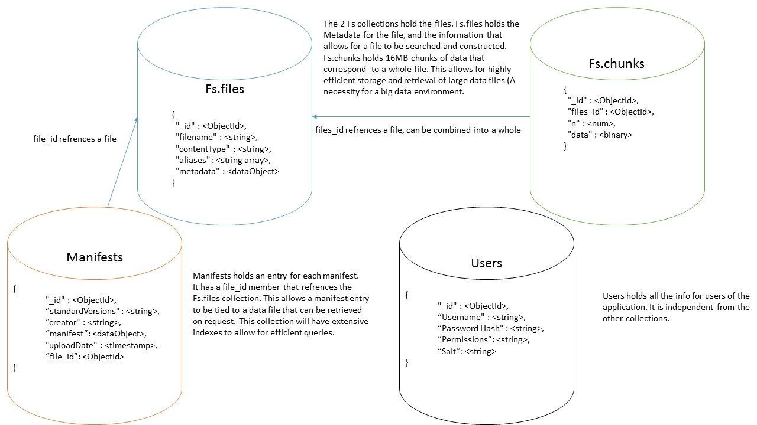

Upload New Manifest

From this page, a Data Scientist can upload a new manifest and scripts, set a title for the manifest and description.

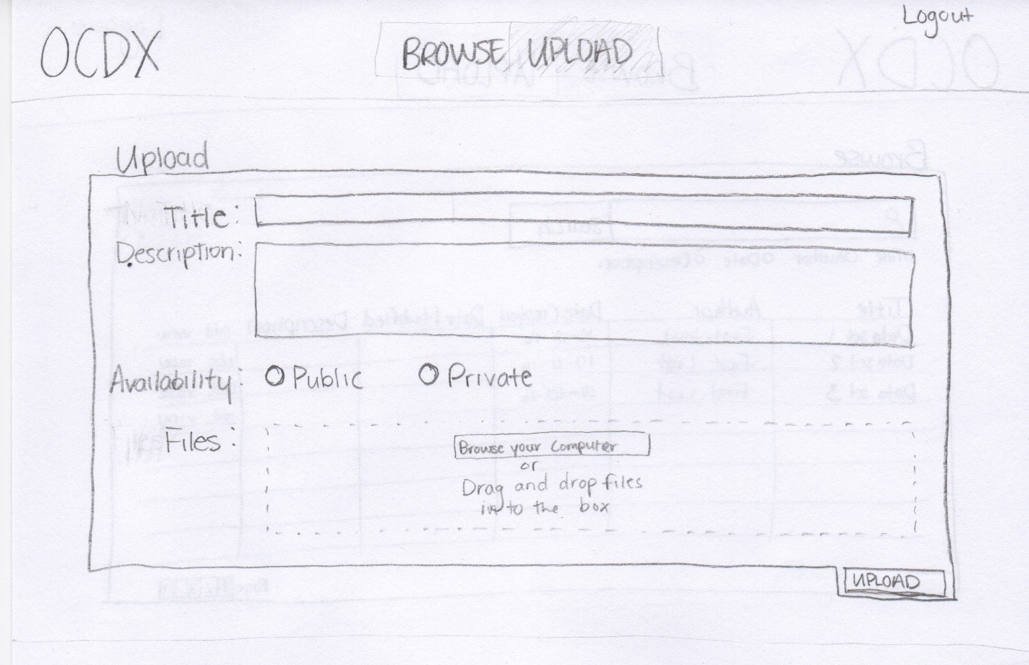

Browse Uploaded Manifests

A Data Scientist can search and browse uploaded manifests.

Data Scientists can organize the search results by Title, Author, Date or Description.

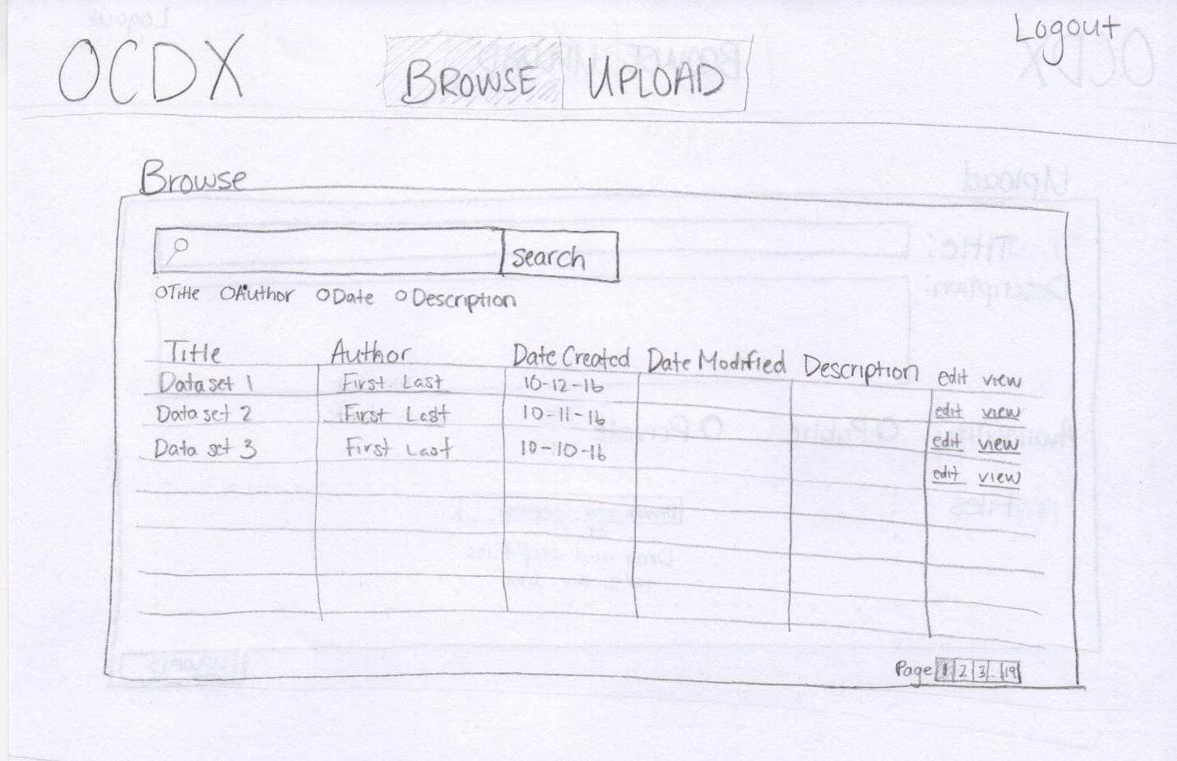

Manifest Description

This page provides the full information for a given manifest.

A data scientist can view the important information about a manifest including the Title, Author(s), and description.

A data scientist can contribute to a manifest if they have permission to do so.

A data scientist can download uploaded files from a given manifest.

