**User Manual**

**1. Accessing the website:**

To access OCDX the user needs to enter the URL below.

<http://ec2-35-161-12-137.us-west-2.compute.amazonaws.com/>

This takes the user to our home page where a variety of options are found.

**2 Logging in:**

The user may click “Login” from anywhere on the website.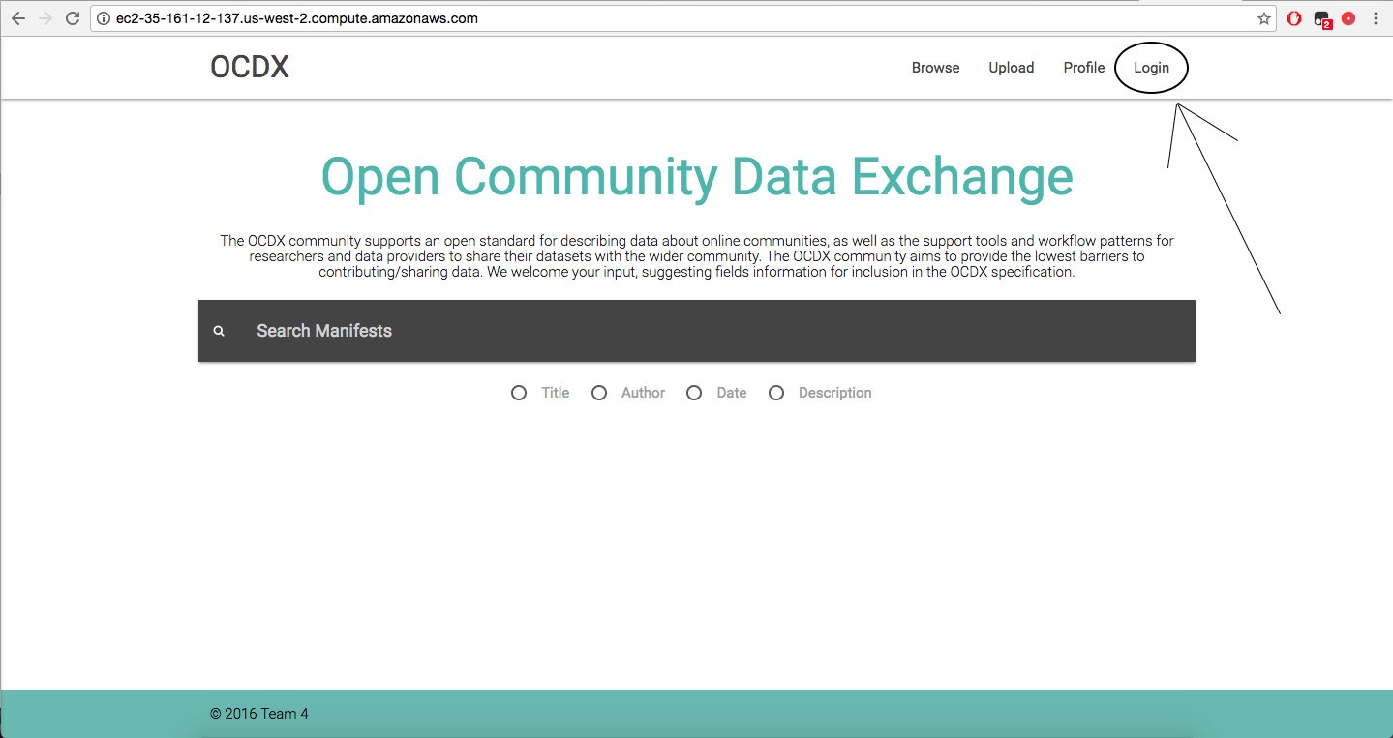

**User Documentation**

**Version 1**

**3. Login Through Google:**

The user must have a google account to login to our website. Logging in gives the user permission to upload any manifest and edit files where they have permission.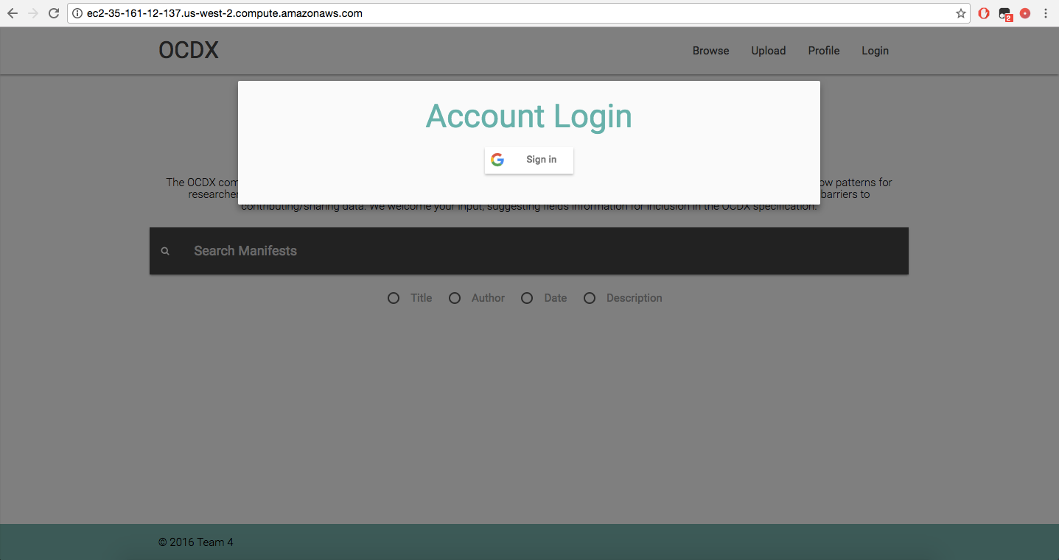

**4. Viewing Users Profile**

Once the user is logged in they will be able to click on the “Profile” tab and view contact information as well as Manifests uploaded by the user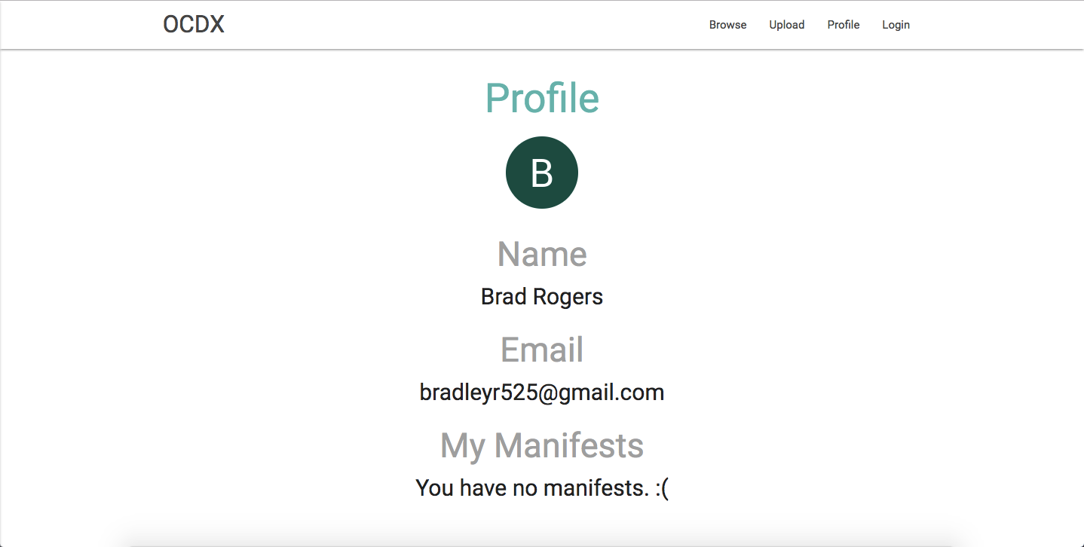

**5. Uploading a Manifest**

As long as the user is logged in they will be able to click on the upload tab from anywhere on the website and begin the process of uploading a Manifest.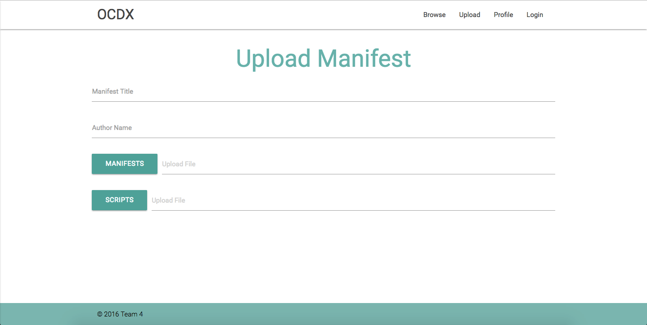

**6. Browsing/Searching**

By clicking on the browse tab the user has the ability to search through uploaded manifests. By default the most recently created Manifests will be show. However, the user will be able to search through all fields of a Manifest or they may search by one of the specific fields shown below (title, author, ………). Once a specific Manifest is found through the browse page, the user has the option to view or edit that Manifest.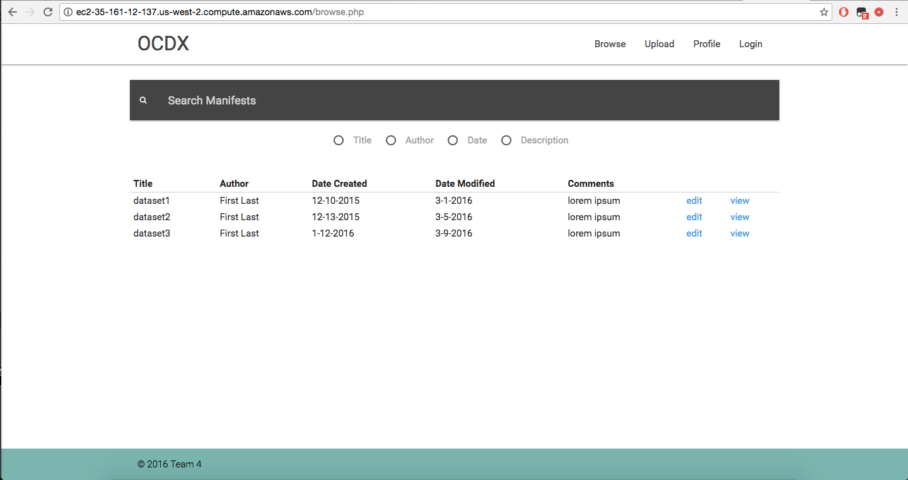

**7. Viewing Manifests**

The view page opens a specific Manifest which will be in readonly. From there the user may download any files within the Manifest or edit the Manifest entirely if they have permission.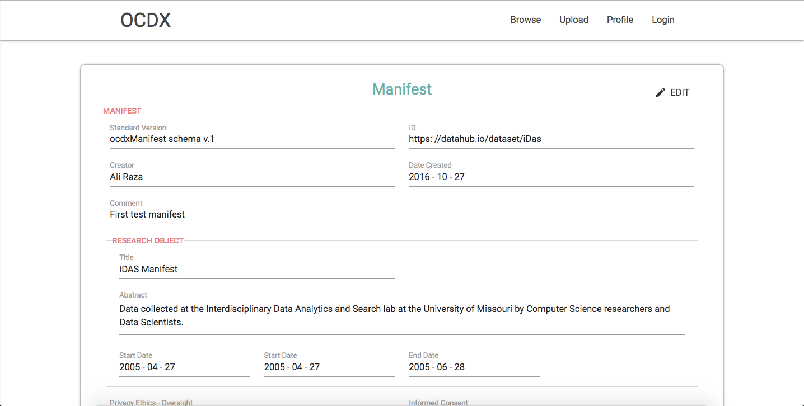

**8. Editing Manifests**

If the user clicks on the edit button in the top right corner of the Manifest all of the fields will become editable at which point the user may cancel the changes or save them.