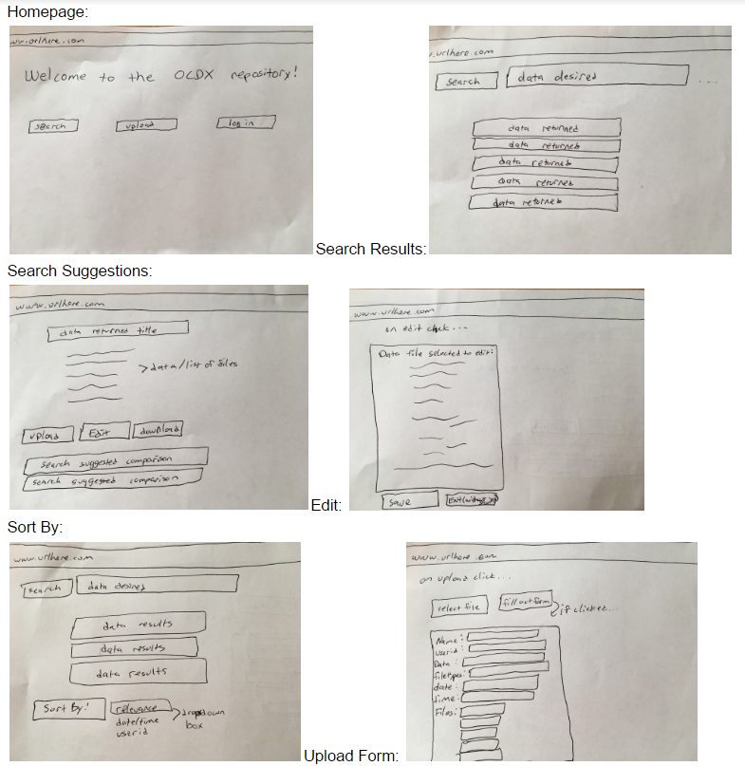

Search: When a user clicks Search, they will be able to type in the text field. The results will be loaded onto the page giving the user options from there. At the bottom of the search results, there will be suggestions as well as sorting options allowing the user to view the data presented in a different way.

Upload: When a user clicks Upload, they will be prompted to fill out a user form documenting the information about the upload they are about to perform. After the form is filled out, their files will be uploaded.

Edit: If a user chooses, they have the ability to edit the file directly within the application and save it which will save the current version on the web app.

Login: The login button will send the user to a login screen where they can type in their credentials and proceed to interact with the application.

Download: The download button will allow the user to download the selected file(s) and save them locally to their desktop.