Software Name: Data Exchange Platform

Authors: Kurt Bognar, Zach Bryant, Luke Jehle, Yi Hou, Hanyu Liang, Kyle Whitney

Version: 2

Date: OCT 31, 2016

Contents:

3 Users and activities

4 Data

5 System vs User Requirements and

6 Functional vs Non-Functional

7-9 Screen designs

10 ERD

11 Glossary

12 Change Log

13 Sprint Documentation

1. The system will have the following users:
   1. Researchers - users who actually submit data to the service and do data science.
   2. Independent Users - users who simply view the stuff on the sight and post comments but don’t actually research
   3. Admin
2. The system will have the following activities for each user:
   1. Researchers can:
      1. Report other researchers, pages or users to the admin via a button.
      2. Do CRUD operations on information and profiles they own
      3. Comment on other people's profiles
      4. Login to the site
      5. Request changes to be made on others reasearch
   2. Independent Users
      1. Report other researchers, pages or users to the admin via a button.
      2. Do RD operations on information and profiles they own
      3. Comment on other people's profiles
      4. Login to the site
   3. Admin
      1. Ban users who post inappropriate content
      2. Do CRUD operations on information and profiles they own
      3. Login to the site
      4. Grant permissions to users who have become researchers and admin permissions to researchers
      5. Accept changes that have been requested on profiles
      6. Comment/delete comments on other people's profiles
3. Data (all elements require ID and timestamp)
   1. Create
      1. JSON, page\_ID
   2. Read
      1. page\_ID, time\_on\_page
   3. Update
      1. page\_ID, updated\_JSON, archived\_JSON
   4. Delete
      1. page\_ID,
   5. Accept changes
      1. Acceptor\_ID, changer\_ID, content
   6. Delete comments
      1. Report\_id
   7. Permissions
      1. Id\_type
   8. Banning
      1. Report\_id
   9. Change
      1. Requestor\_id, page\_id, content, admin\_assigned, researcher\_assigned
   10. Login
       1. User\_id, password, salt, attempts?
   11. Comment
       1. Content, page\_id
   12. Report
       1. Reporter\_id, reportee\_id, reason, page\_id, comment\_id, admin\_assigned
4. Use Cases (optional)
5. System vs User Requirements
   1. User
      1. I will be able to upload a file of any size and any type.
      2. There will be less than 3 secs of navigation between pages including search.
      3. Searching will be based on variety of fields.
      4. Collaboration and feedback will be built into the system.
   2. Sys Reqs
      1. The system will run on a Linux server
      2. The system will have >10gb of memory (~1TB)
      3. The system will require the user to be connected to internet
      4. The system will have a PostgreSQL database
      5. The system must allow multiple users to access the system at once.
      6. The system will be accessible via any browser
6. Functional vs Non-Functional
   1. The functionality of the system will allow the user to
      1. Comment on various data profiles
      2. be notified of various activities
      3. CRUD
      4. Search
      5. Up/download files <= 10gb and all types of files
      6. Login/out and sign up
      7. Report users/pages
      8. Ban other users if they are an admin
      9. Propose changes to data profiles
      10. Delete comments if they’re an admin
   2. Non-functional requirements of the system are
      1. Timing: navigation < 3 secs
      2. Size: growing
      3. Reliability/robustness: backed-up, redundant, 99% up
      4. Portability: windows, linux, macos, not cellphones/tablets

Primary Author: Kurt Bognar

Secondary Authors: Kyle Whitney, Zach Bryant, Yi Hou, Luke Jehle, Hanyu Liang

**Login/Registration Page**

Author: Luke Jehle Reviewer: Yi

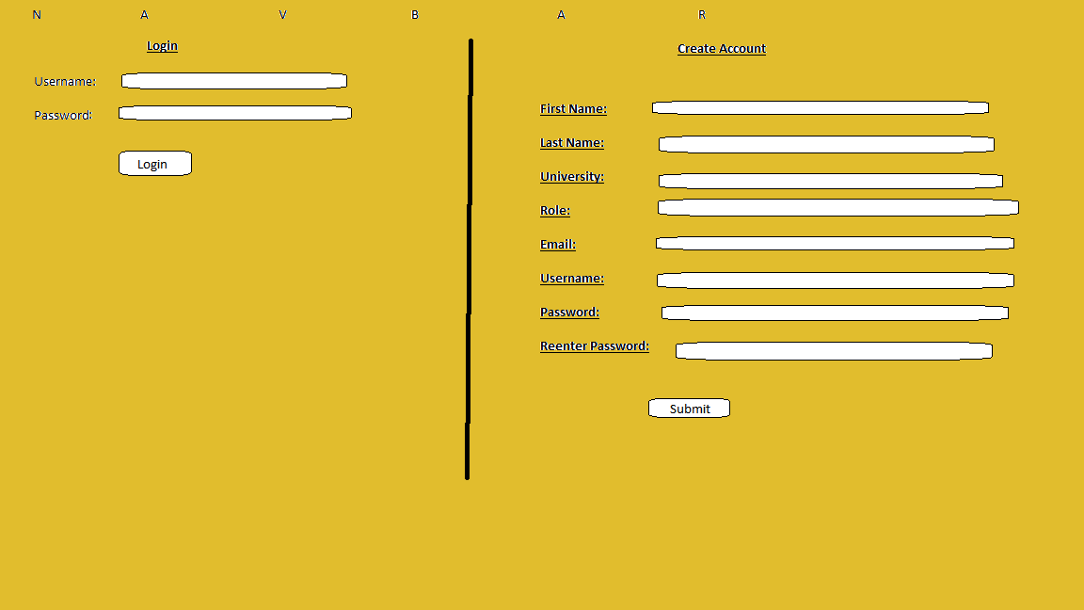

**Upload File Page**

Author: Kyle Whitney Reviewer: Zach Bryant

Upload Screen.png

**Nav Bar**

Author: Zach Bryant Reviewer: Kyle Whitney

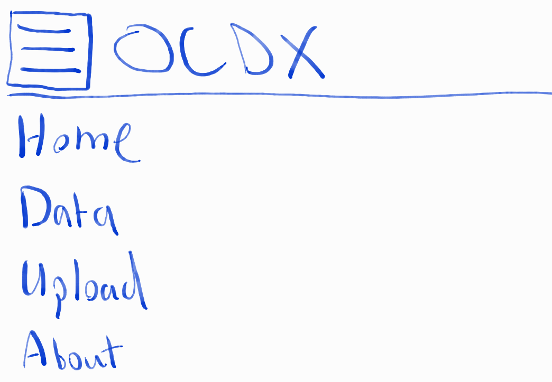

**Profile Page**

Author: Zach Bryant Reviewer:HanyuLiang

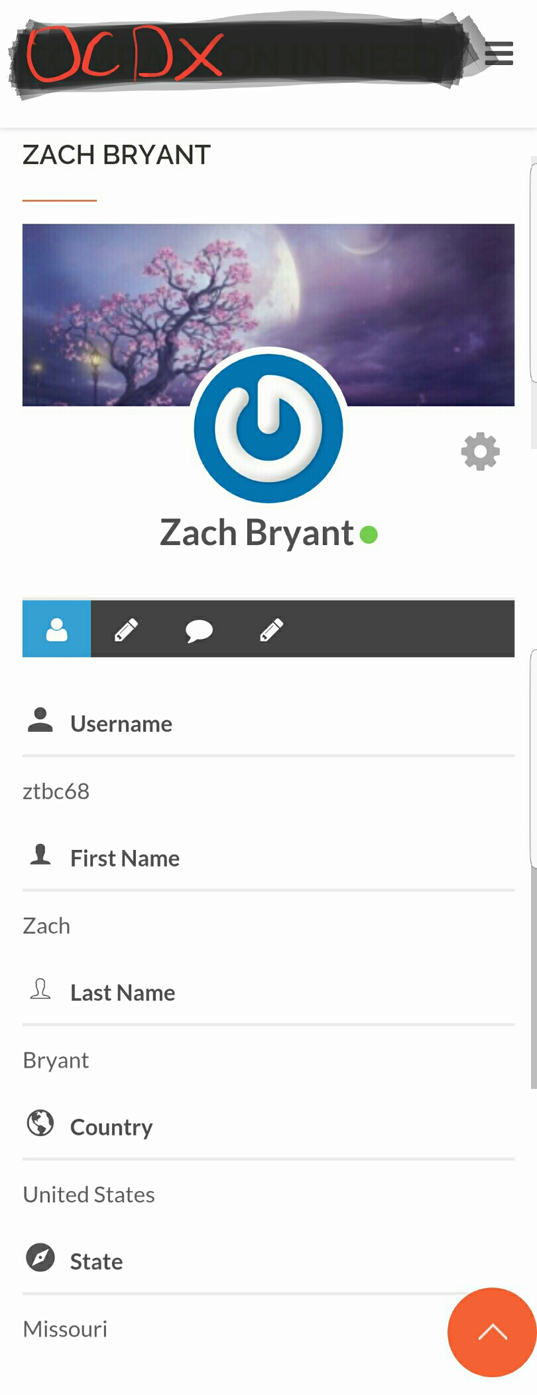

**Banned User Page**

Author: Kyle Whitney Reviewer: Luke Jehle

Banned Screen.png

**Search Page**

Primary author:Hanyu Liang reviewer:Kurt Bognar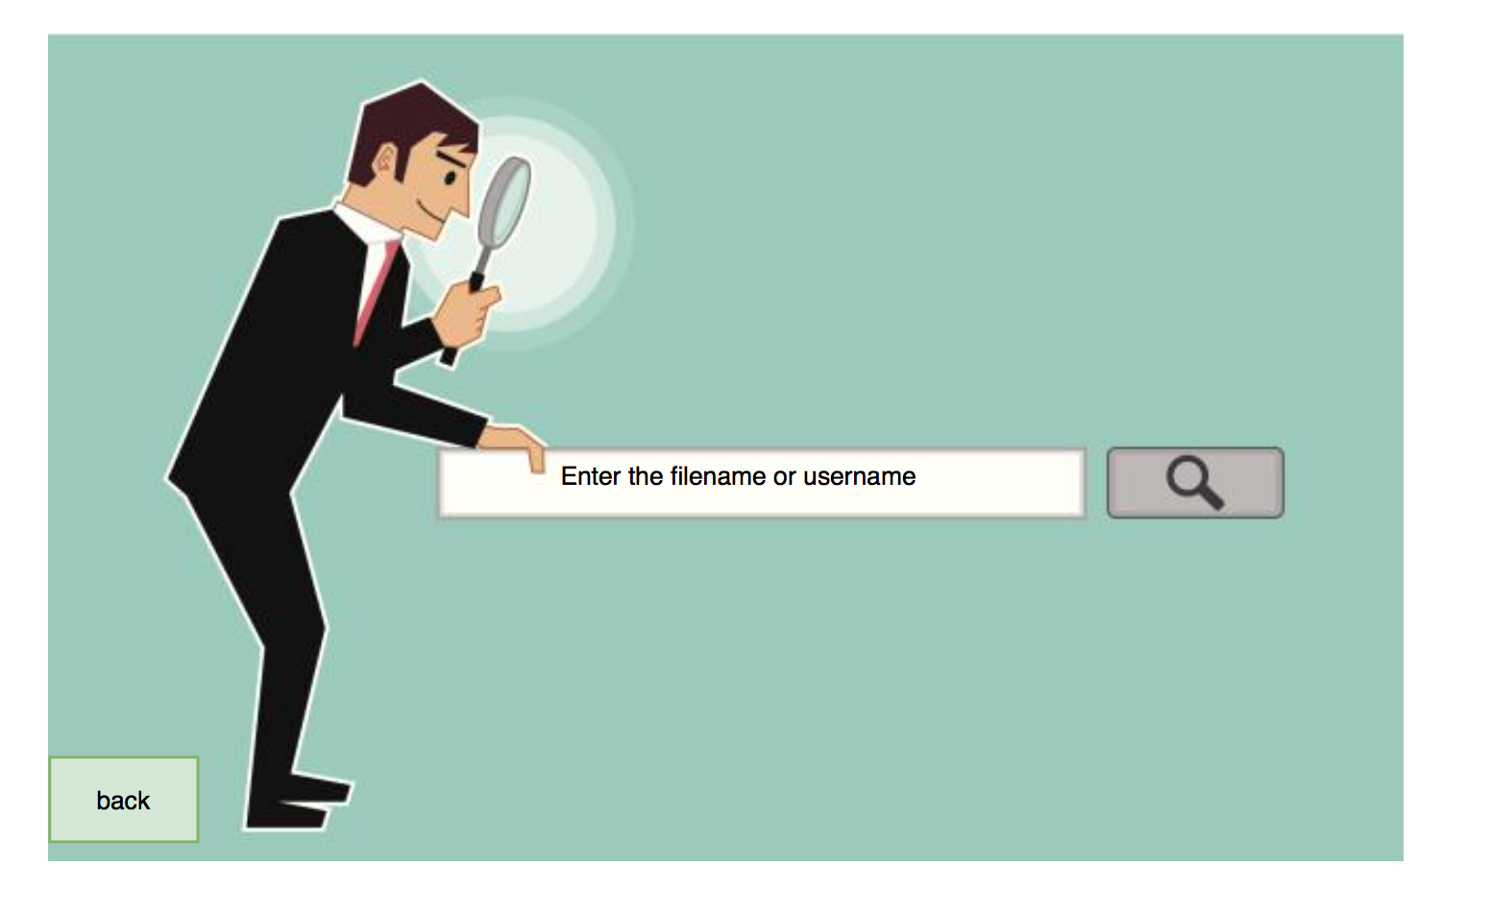

**Search Return Page**

Primary author:Hanyu Liang reviewer:Kurt Bognar

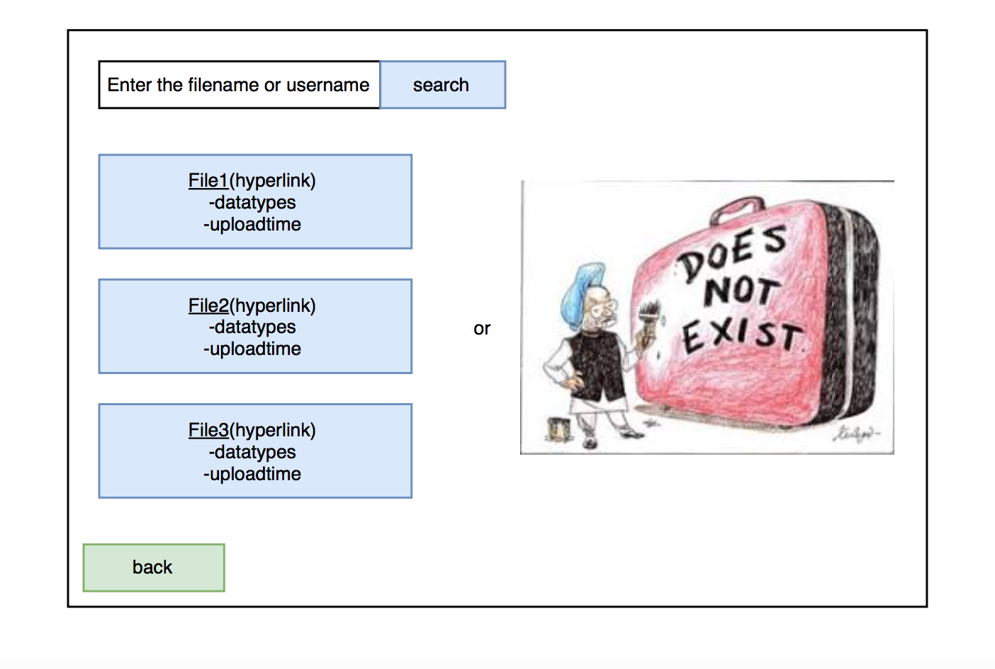

**ERD**

Authors: Kurt Bognar, Yi Hou  
Checked by: Luke Jehle

Kurt_ERD_V2.png

Glossary:

Change Log:

V1 completed: OCT 18, 2016

V2

* Kurt
  + updated and finalized ERD
  + DB written in PostgreSQL and implemented on server
  + Reqs document updated
  + Sprint 1 documentation added
  + wiki, changelog, glossary added
* Yi
  + Made up some seed data
  + Sprint 1 document updated: regression testing
* Luke
  + Created a main menu mockup
  + Brainstormed what clicks on each page would do
  + Brainstormed unit testing scenarios
* Liang
  + write the information architecture
* Zach
  + created user profile and nav bar mockups
  + Updated Sprint 1 document: regression testing/validation vs verification
  + Installed apache on server and made Hello World page
  + Organized git: created docs folder and moved relative items
  + Updated wiki and organized git
* Kyle
  + Created a Class Diagram
  + Created the User Acceptance Test scenarios
  + Created Integration testing outline

Sprint Doc 1 <https://docs.google.com/document/d/1KK3FSdSTFl66txpVCzHYahYq0coZhd3w3LDdNDPN3lo/edit?usp=sharing>