About search: In the blank , enter the filename or username that you what to search. And then click the search button(the glass). If you don’t want to search anything, you can click back button and it will go to main page. After clicking the button, it will go to search2 page. In the search2 page, the page will shows all file or username about you want to search if the filename or username is exist. Otherwise, the page will show the photo in the right that means you failed search something. If you want to search again, you can enter the filename or username in the text blank. And then click search and it will go to search2 again. If not, you can click back and then the search will end and back to the main page.

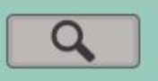



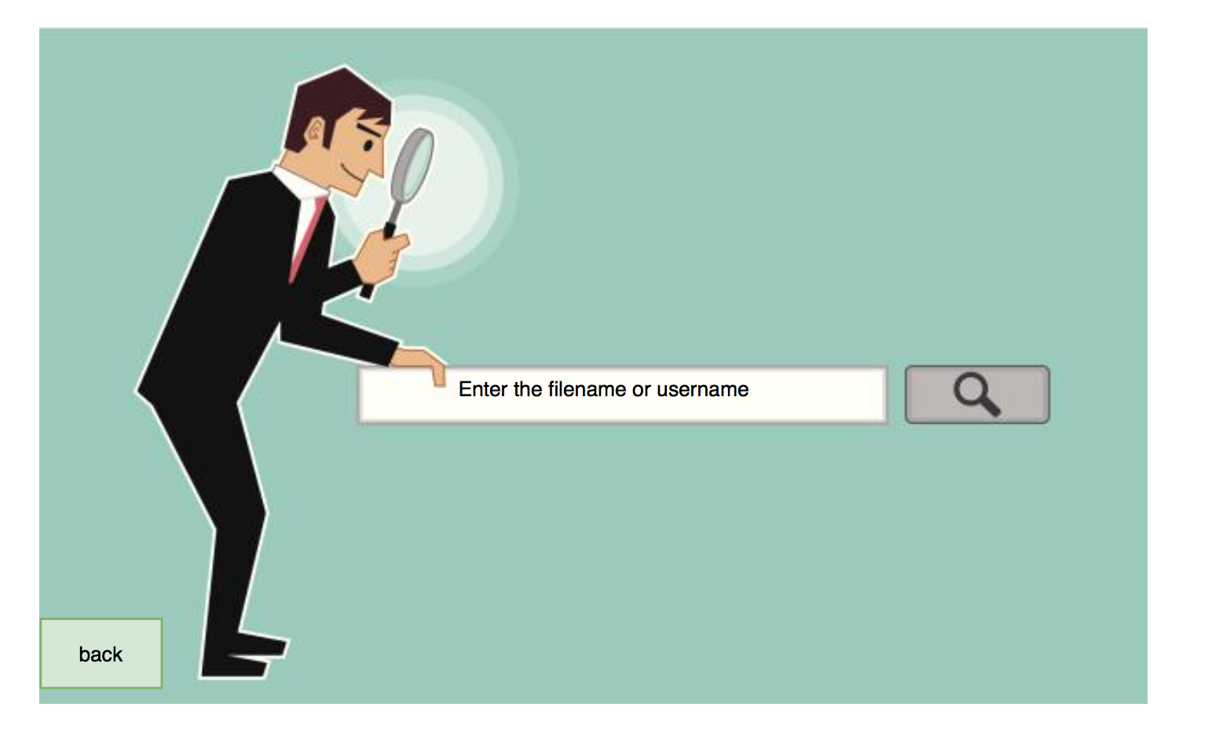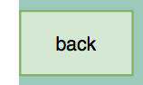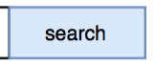

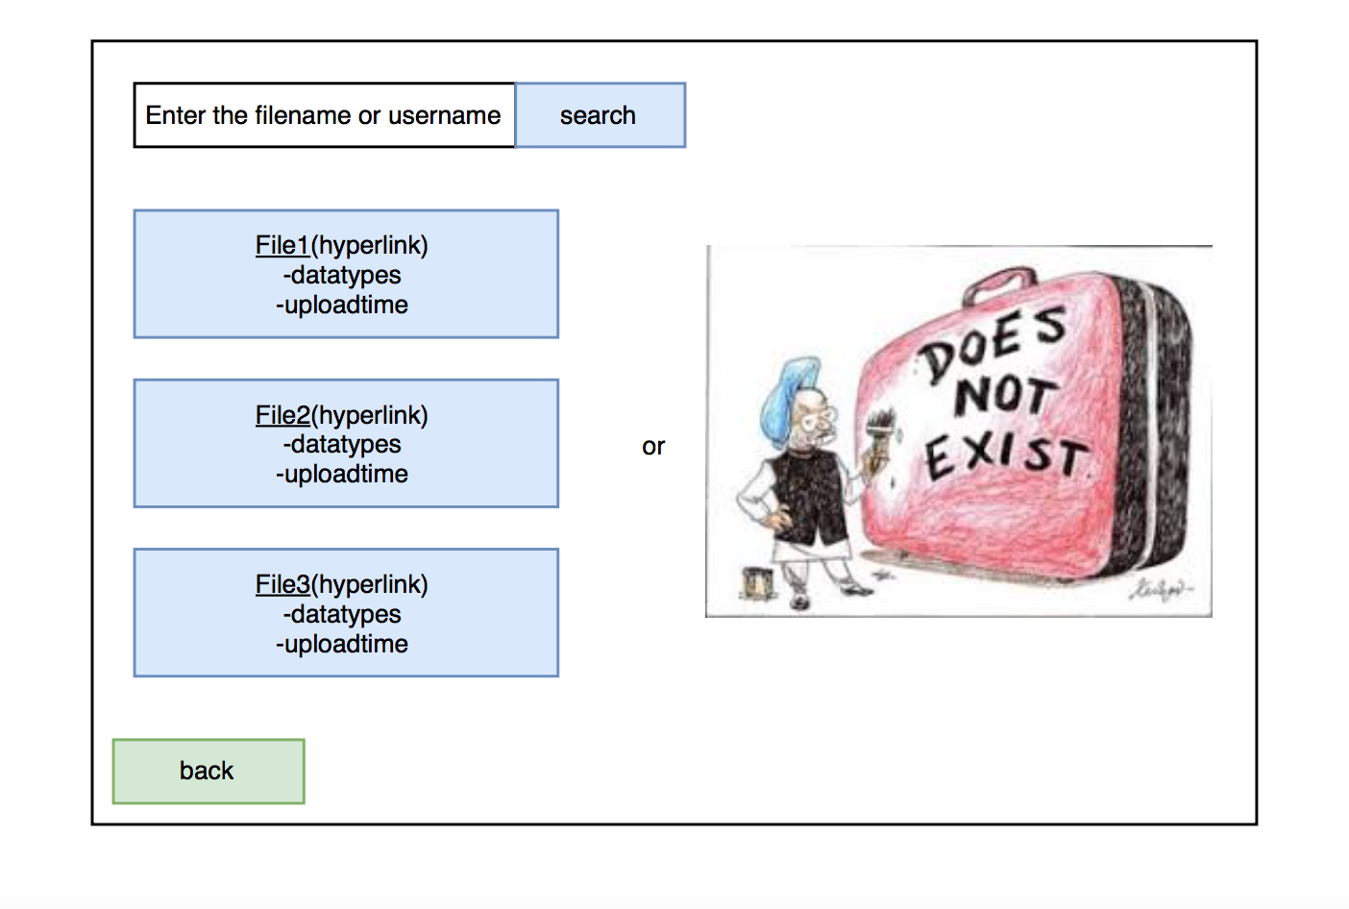

about file profile: The file profile shows information about the file.when you click the person button,It shows the personal information of files’ owner. when you click the pencil button, it shows report page.you can give a reason and report this file if you hate this file. The third button, the cloud button, is comment button. when you click this button, it will go to comment page. In the comment page, you can look all comments about this file and write yourself comments about this file. When click top-right button, it will go to Nav Bar page.



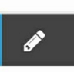

person button

cloud button

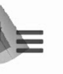

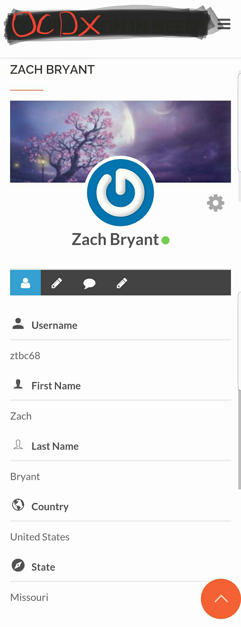

About Nav Bar: in the Nav Bar, it has four button:Home, Data, Upload and About.

when you click these button, the page will go to other page ,Home page,Data page, Upload page and file profile page.



home button

data button



upload button

about button

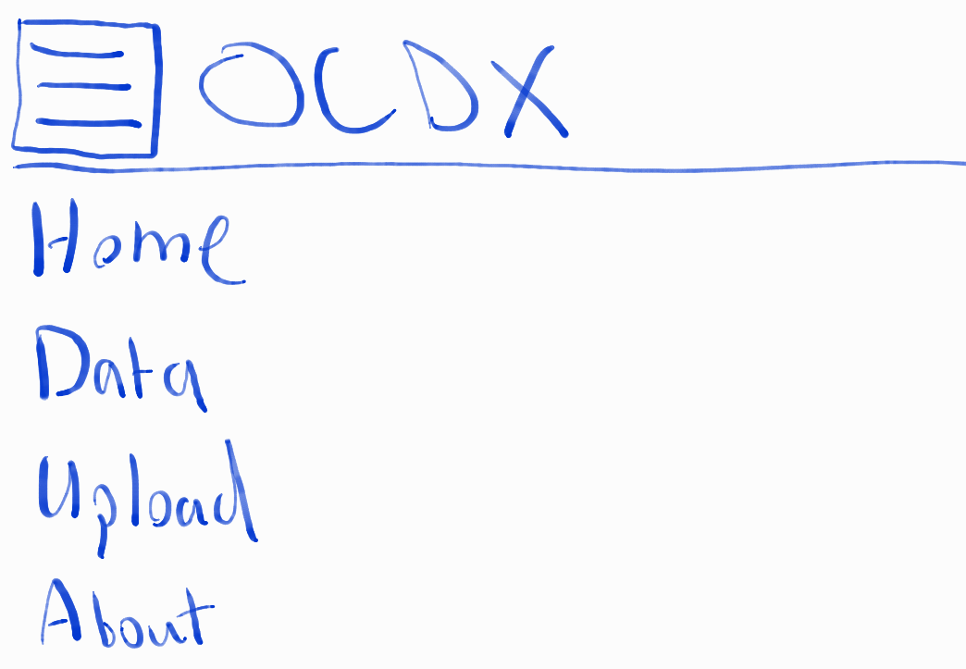

**How Clicking Will Work**

**Login Page**

After username and password have been entered click login - user will be directed Home Page

* If no username and password is given, error message will be received on click that the user needs an appropriate username and password.
* If incorrect username or password, error message will be received the username and password they entered are incorrect

When creating account, when all information has been entered and submit is clicked, the user will be sent to the login screen again, a success message will pop up saying the user has been registered.

* If not enough info has been entered, error will pop up telling the user more info needs to be provided
* If user has already been registered with information provided by the user, error will pop up saying user has already been registered using that information.

**Upload File**

* Clicking select file allows the user to browse their local file directory to select a file.
* Clicking upload will upload the file to the database. If no file is selected, or file exceeds the max file size, error message will pop up.

**User Profile**

Click the edit pencil - Allows user to edit username, first name, last name, country and state.

Click the picture - allows user to edit profile picture

**Navbar**

Click home - Takes user back to the home page

Click Data - Takes user to library page - this is where users can search and view others research

Click Upload - Takes user to upload data page

Click About - Takes user to the about page where user can find out more about the mission and what happens in this library

**Data page**

Click Search - clicking search will allow user to search under the keywords entered in the bar. If nothing is entered, the page will refresh.

Click file - Pulls up the file that allows the user to then download the file.