user documentation

Content:

Description------------------------------------------------------------------------------------------------- 1

Navigation bar--------------------------------------------------------------------------------------------- 1

Post page--------------------------------------------------------------------------------------------------- 2

Login_in page--------------------------------------------------------------------------------------------- 2

Register page---------------------------------------------------------------------------------------------- 3

Description:

a metadata specification (instantiated as an OCDX manifest) and infrastructure for storing, describing, analyzing, and sharing datasets for making sense of online human interactions. This work will enable scientists and citizens to answer fundamental questions about our society as it exists on the Internet.

Navigation bar:



1.Choose the page you want to go in here through clicking appropriate button.

“OCDX Engine” -> post page.

“Login”-> login-in page.

“Register”-> sign-up page.

2.Dierct enter the information that you want to search into search space,and click search button. It will go to search page and show information that you want to search in the search page.

post page:



we will post information that we want to tell to persons in this page.

Login_in page:

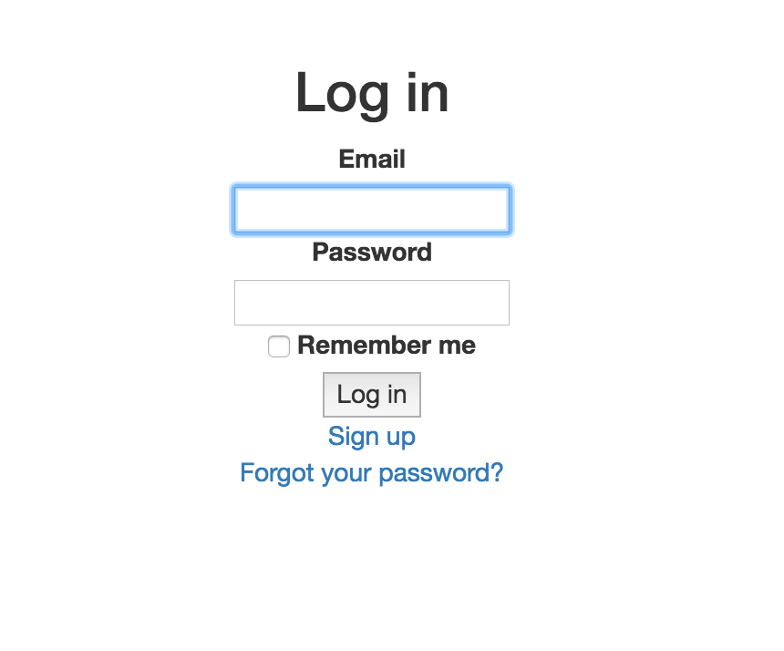

1.Enter your personal email and password, check it correct. And click login in button.

(if you are lazy and do not want to enter the e-mail and password again,click “Remember me”)

2.If you forget password, click “forgot your password?” . the password will automatically sent to your e-mail.

3. If you do not register before, click ”sign up” . You will go to register page and can create your account in the register page.

Register page:

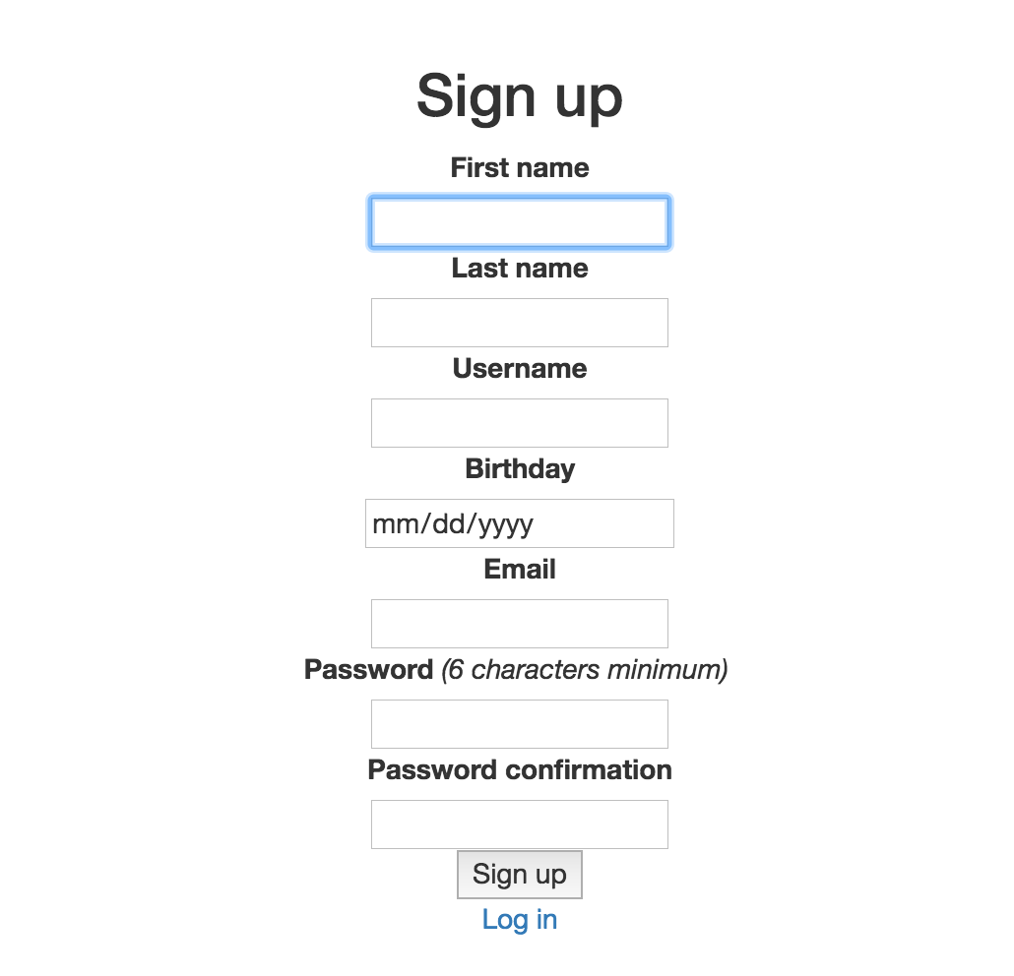

Create your account in this page.

1.enter your First name and Last name.

2.enter your username(This is the your name that let others look in this system.)

ps: hope the username is not same as others,so create a unique username.

3.enter your birthday.

4.enter your e-mail: this is your account when you login in.

5.enter your password:at least 6 characters.

6.enter your password again: must be same as password you first enter.

7.check the information you enter. If think is correct, click “sign up” button.

8.when finish your register and want to enter this system as soon as possible,click “login in” button and go to login-in page.