## MetaDrop

**Andrea McGovern, Teddy Ivanov, Olivia Apperson, Soya Ouk, Xinyi Li**

**Version 4**

**11/16/16**

**Table of Contents**

Project Overview 3

Markdown (Wiki) Link 3

Test Cases 3

Requirements Analysis 4

Software Design

Class List 7

Table List 8

ERD 9

Database Creation/Queries 10

Screen Designs 11

Updated User Interface (Link to site) 16

Glossary 20

Change Log 21

Sprint 2 22

# Project Overview

As a team we are going to build an online infrastructure for computational social scientists, social scientist, and citizens that will facilitate and centralize our understanding of online human interaction. We will create a database that will allow metadata specification to store, share, describe, and analyze data sets. This will help solve the problem of not being able to easily access the metadata, and now scientist and citizens can easily access it via the internet.

Markdown (Wiki):

<https://github.com/TeddyIvanov/SoftwareEngineering-Group3/blob/master/README.md>

Test Cases:

[https://github.com/TeddyIvanov/SoftwareEngineering-Group3/blob/master/Testing--Documentation](https://github.com/TeddyIvanov/SoftwareEngineering-Group3/blob/master/Testing--Documentation%20(1).pdf)

[%20(1).pdf](https://github.com/TeddyIvanov/SoftwareEngineering-Group3/blob/master/Testing--Documentation%20(1).pdf)

# Requirements Analysis

**Actors** (Created by: Teddy Ivanov, Reviewed by: Andrea McGovern)**:** Researcher/User:

❏ Computational Social Scientist

❏ Social Scientist

❏ Citizens Admin:

❏ System Administrator

**Activities** (Created by: Andrea McGovern, Reviewed by: Olivia Apperson ):

❏ Logging in and out of the system

❏ Uploading metadata files to be stored in the database

❏ Ability to search and filter through libraries of files

❏ Ability to download files for use

❏ Be able to edit metadata files

**Use Cases** (Created by: Olivia Apperson, Reviewed by: Xinyi Li)**:**

❏ A Computational Social Scientist, Social Scientist, and Citizens have the ability to...

❏ Log in and out of the system

❏ Upload a metadata file

❏ Edit a metadata file

❏ Delete a metadata file

❏ Search through metadata files

❏ Download a file

❏ A System Admin has the ability to…

❏ Log in and out of the system

❏ Delete uploaded files/edits

❏ Search through files

❏ Edit metadata files

❏ Add users to the system

**User Requirements** (Created by: Soya Ouk, Reviewed by: Xinyi Li)**:**

❏ The System Administrator, Computational Social Scientist, Social Scientist as well as the Citizens should have login credentials.

❏ The System Administrator and Researchers should each have their own correct permissions.

❏ The Researchers must submit the correct and compatible file type.

❏ Admin can upload files, edit files, delete files, browse for files, version control, and add new users to the system.

❏ Regular users can upload files, edit files, delete files, and browse through the files.

**System Requirements** (Created by: Olivia Apperson, Reviewed by: Teddy Ivanov)**:**

❏ Database

❏ Used to store information on metadata files and user's credentials.

❏ Webpage

❏ User interface that visualizes the database of metadata and allow user to see what abilities they are performing.

❏ Internet Access

❏ Access to the internet will allow the users to visit the webpage, also allow updates to the database.

❏ Computer

❏ Platform in which the webpage can be accessed. Also can be used to make changes to the database for admins.

**Functional Requirements** (Created by: Xinyi Li, Reviewed by: Soya Ouk)**:**

❏ Be able to login and logout

❏ Be able to upload files

❏ Be able to search in a search bar for JSON files

❏ Be able to edit files in the browser

❏ The system should not crash when a user tries to upload a file or edits a file

❏ If a file is not of the correct types, it should not be uploaded

❏ If a user does not have the correct credentials or user roles then they should not be able to do those tasks

❏ Be able to remove files

❏ Be able to fix changes

**Non-Functional Requirements** (Created by: Teddy Ivanov, Reviewed by: Soya Ouk)**:**

❏ This project is a semester project for the software engineering CS 4320 class, so it must be finished by the end of the semester

❏ The size of the database has to be large enough to hold JSON files (10 Gigabytes of files)

❏ Be able to handle uploading and downloading in real time (less than one second to upload/download)

❏ Easy to use User Interface that works on Firefox and Chrome

❏ Upload JSON files and script files (only acceptable file types)

❏ File extension checking to make sure it of the correct type (i.e. .JSON)

❏ Correct username of at least 8 characters and password with at least 8 characters

❏ If a file is larger than 250MB, then it should not be uploaded

# Class List

Classes: (Created by Xinyi Li, Reviewed by Teddy Ivanov)

❏ Researcher/User

❏ attributes: name:String, password:String, IsAdmin:Boolean,

❏ methods: login(), logout(), uploadFile(), downloadFile(), deleteFile(), editFile()

❏ Admin

❏ attributes: name: String, IsAdmin:Boolean,

❏ methods: addUser(), uploadFile(), login(), logout(), downloadFile(), deleteFile(), revertEdit(), editFile(), updateDatabase()

❏ MetaDataFile

❏ attributes: title:String, author:String, date:DateTime

❏ methods: display(), delete(), edit(), upload()

# Table List

Created by: Olivia Apperson, Reviewed by: Soya Ouk

❏ Table for Files (type, data, name, author, etc.)

❏ Users (name, username, password, etc.)

❏ MetaData (comment, checksum, title, etc.)

❏ Relationship table between Files and Users

# ERD

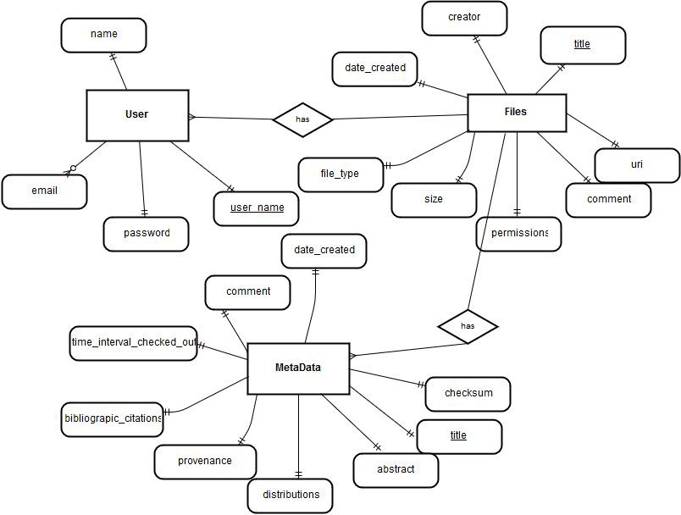

# Database Creation/Queries

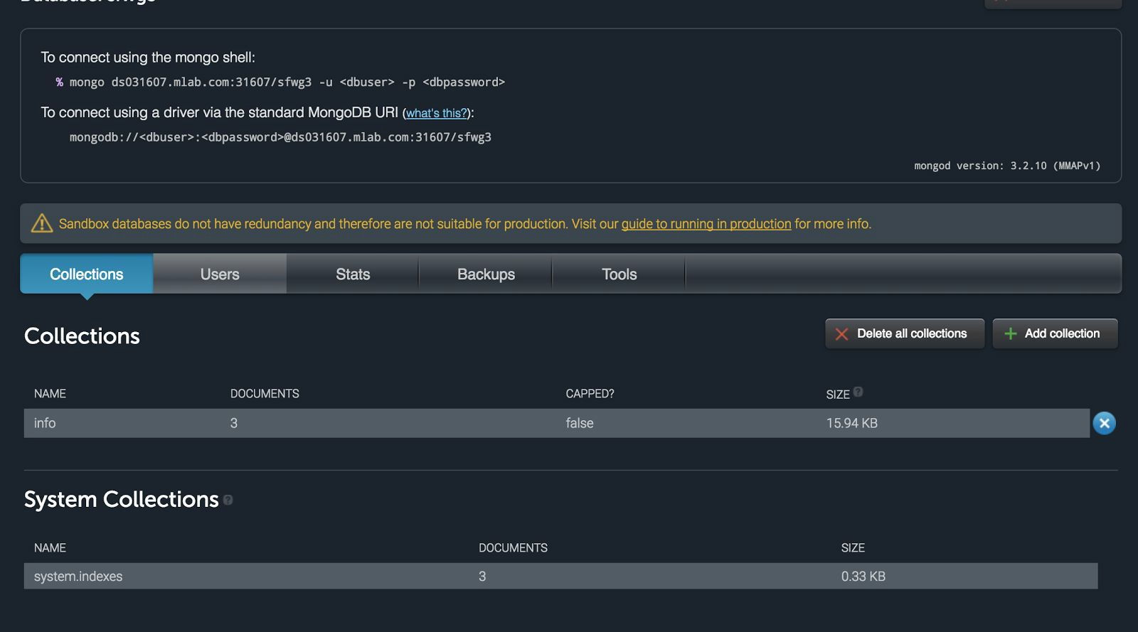

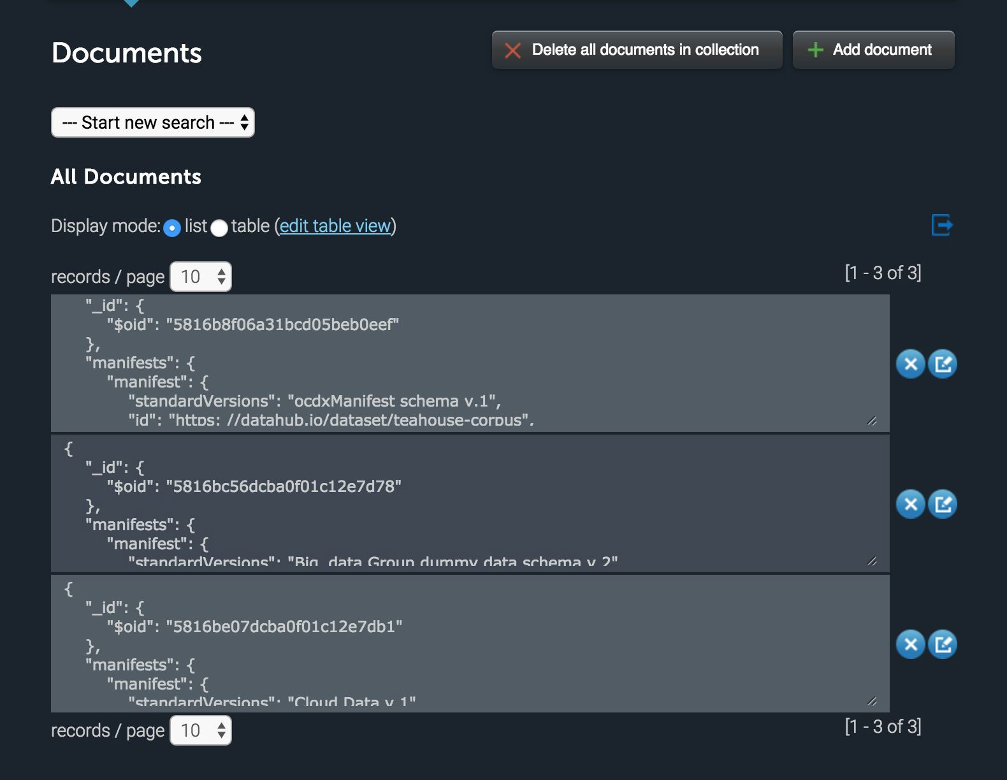

# Screen Designs

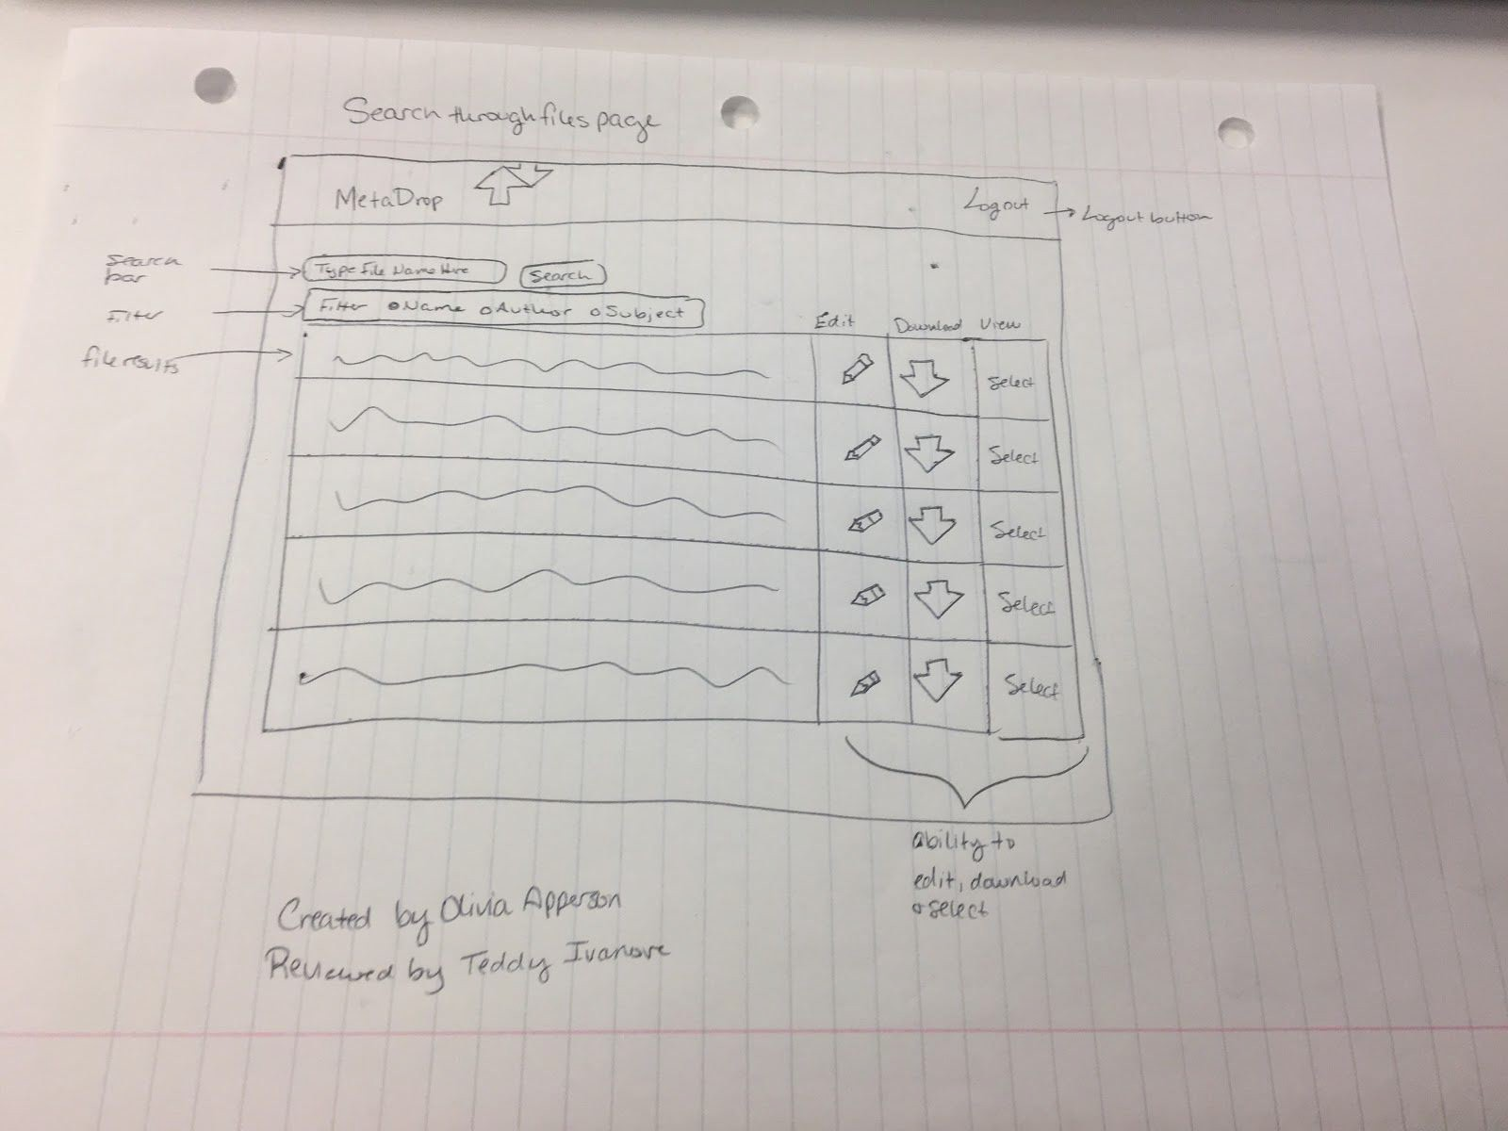

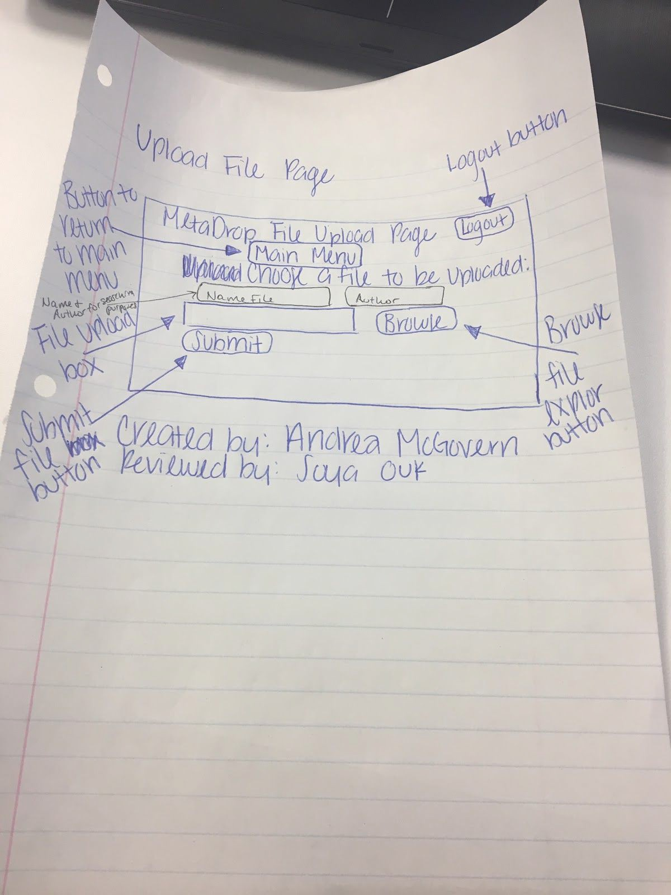

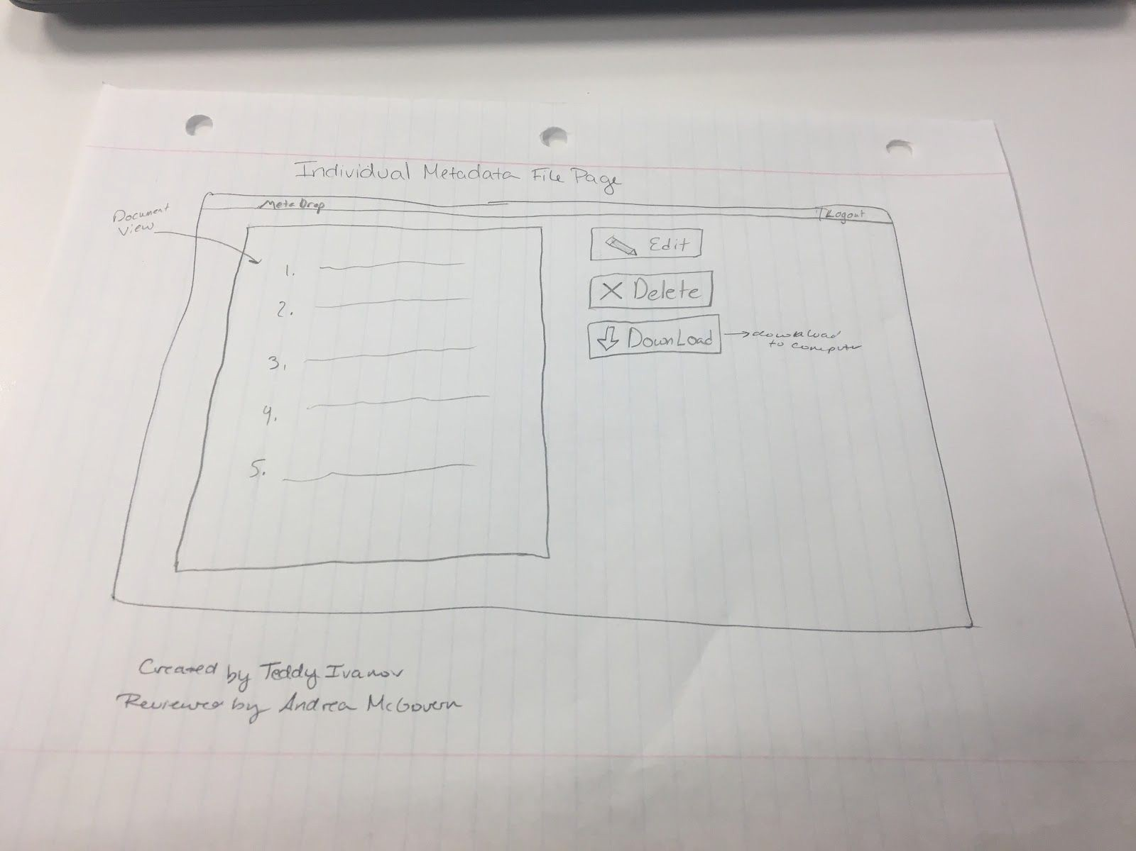

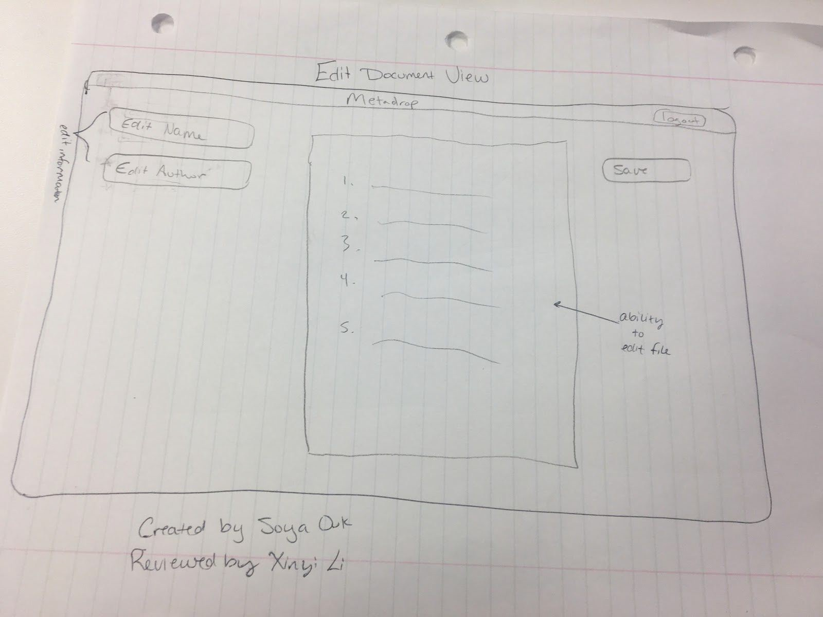

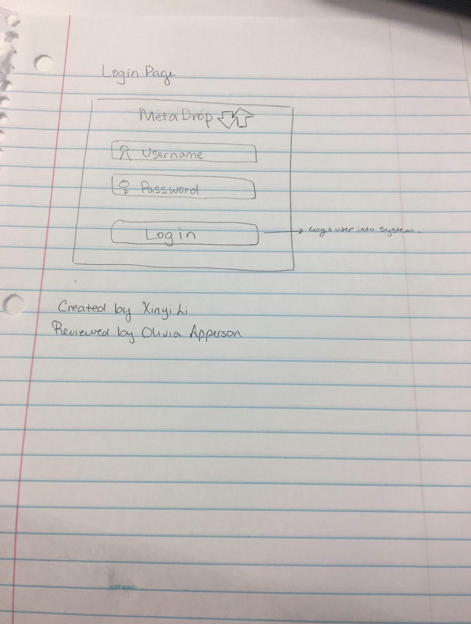

**Updated User Interface**

**Website:** [**http://ec2-35-160-238-84.us-west-2.compute.amazonaws.com/final_project/index.html**](http://ec2-35-160-238-84.us-west-2.compute.amazonaws.com/final_project/index.html)

**Login Page | Register Page**

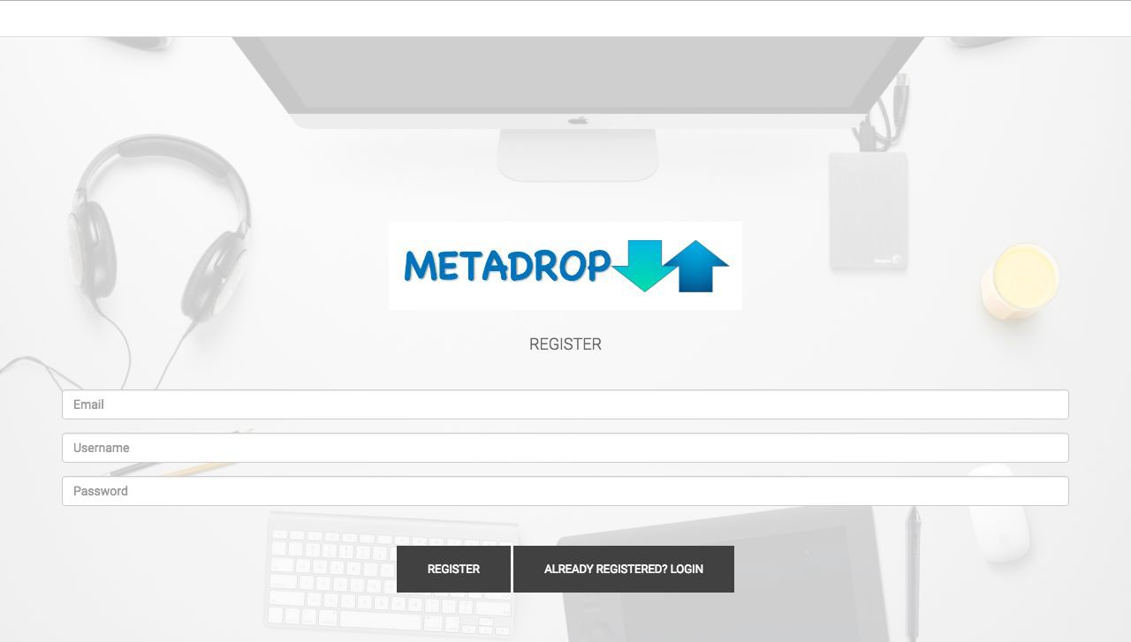

**Modify JSON page**

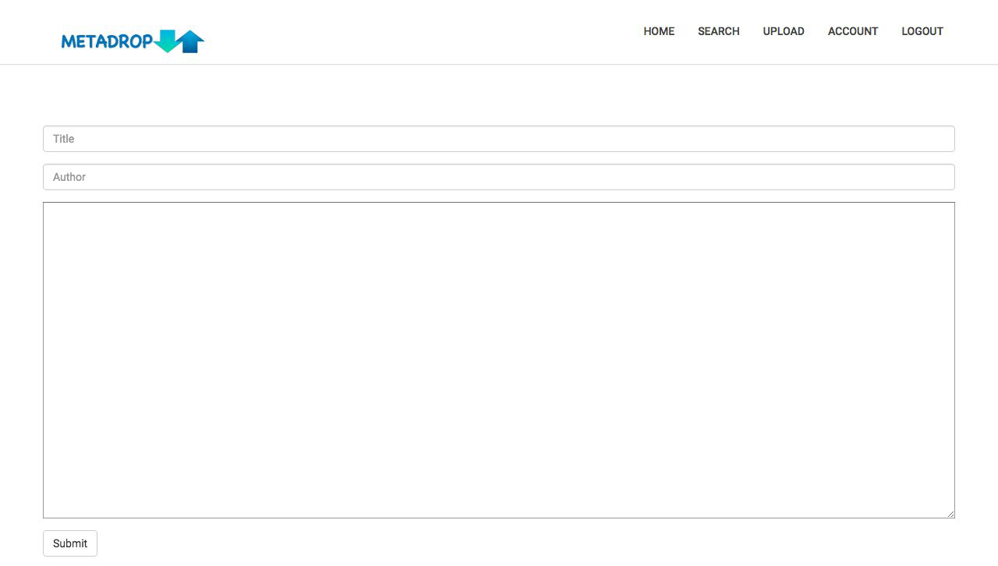

**User Account Page**

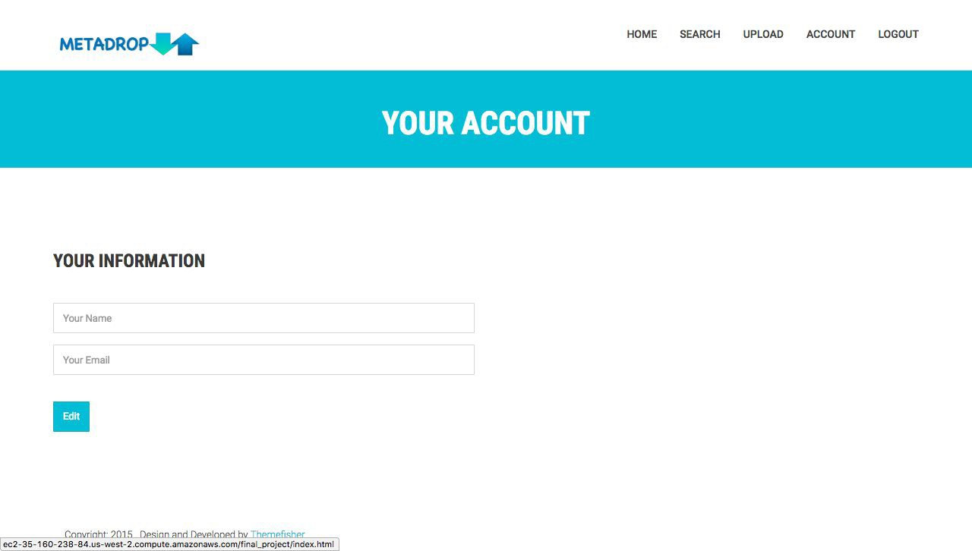

**Upload File Page**

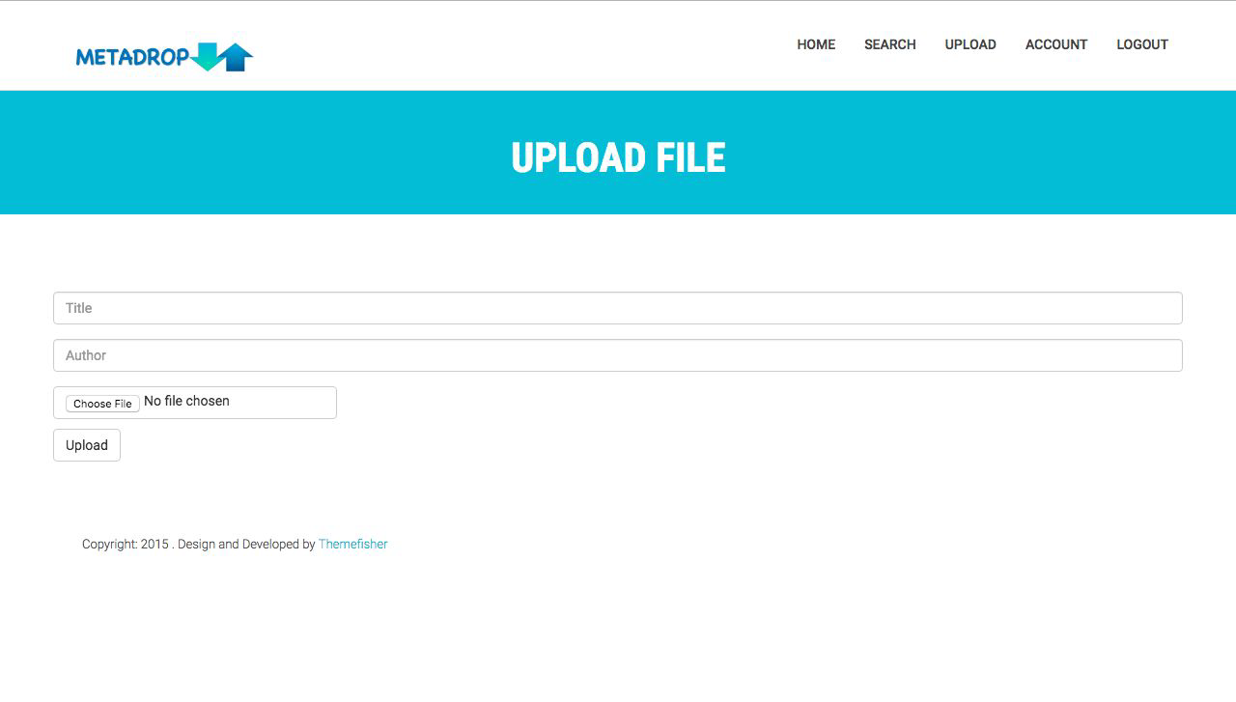

**Search for JSON Files Page**

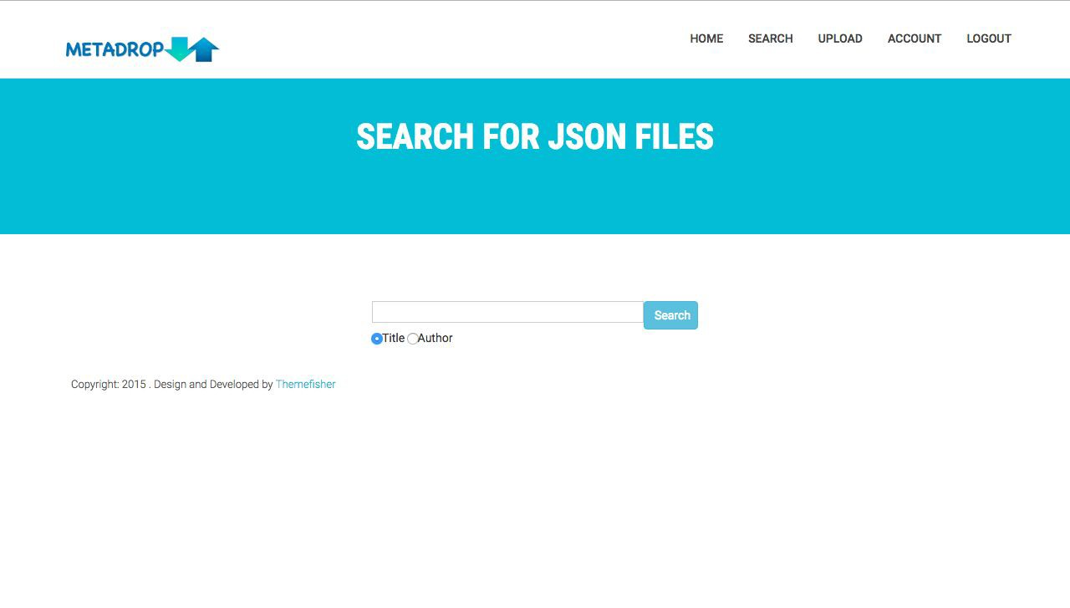

**Home Page**



# Glossary

Created by: Soya Ouk, Reviewed by: Olivia Apperson

**Computer Platform**: A system that consists of a hardware device and an operating system that an application, program or process runs upon.

**Computational social science:** refers to the academic sub-disciplines concerned with computational approaches to the [social sciences](https://en.wikipedia.org/wiki/Social_Science).

**Functional Requirements:** Details of services the software must provide.

**JSON:** A language easy to write and edit by humans and easy to read and parse by machines.

**Metadata:** a set of data that describes and gives information about other data.

**Non-Functional Requirements:** Constraints on the functionalities of the software.

**OCDX:** Open Community Data EXchange, is a metadata specification and robust infrastructure for long term sustainability.

**OCDX Manifest:** a bill of materials for datasets.

**System Requirements:** Pre-requisites that often define the operating environment.

**User Requirements:** Facts and assumptions about the expected outcome of the software implementation; What the software will enable a user to do or not do.

# Change Log

Created by: Olivia Apperson, Reviewed by: Andrea McGovern

## Version 1

* Project Overview created
* Requirements Analysis created
* Class/Function List created
* Table List created
* Screen Designed Created
* Change Log Created
* Glossary Created

## Version 2 (Revised for more points)

* Glossary Updated
* NonFunctional Requirements Updated
* Functional Requirements Updated
* User Requirements Updated

## Version 3 (Sprint 1)

* Screen Designs Added
* Website URL added
* Updated ERD added
* MarkDown (Wiki) link added
* Database and Storage information added

# Sprint 2

# General

* Sprint Documentation: <https://github.com/TeddyIvanov/SoftwareEngineering-Group3/blob/xlv4c_Sprint3/Final%20Project%E2%80%94Metadrop-SPRINT-2.pdf>
* Lead: Olivia Apperson Co: Xinyi Li
* Students worked to provide accurate and thorough documentation for Sprint 2.

# Database

Leads: Teddy Ivanov and Andrea McGovern

* We worked together to create insert, delete, and update commands into the database and use in php scripts. These can be found in the DML folder above.
* We met on Monday from 4-6, Wednesday from 4-6:30, and Thursday from 4-8.
* We had to start over from scratch, and create a new ubuntu instance on AWS becasue php 7 wasnt compatible with Mongodb. It is also easier to debug on a linux server rather than a Mocrosoft one.
* We met with Jeremy during his office hours to set up the new service. He helped us download php 5, mongodb driver, and filezilla.
* We then continued working on our own to download Apache and figured out how to access the root folder with the correct permissions to host all of our files on the instance. Firebase allows you to store JSON files as well, but instead of using php we chose JavaScript. It allows to easily be able to ensure that a user is logged in cross site.
* We met again on Friday from 2 - 8, and decided to change from a MongoDB to a Firebase database, becasuse we thought it would be easier to handle the login. Firebase

is a NoSQL Json database that allows us to host our web app and helps maintain state across the domain.

* Separate Directory found here
* Website can be found here with UI: website

# User Interface

1. Stub-calls for all interactive elements:
   * Stub Calls
   * Lead: Soya Ouk Co: Olivia Apperson
   * Stub Call Categories:
     + Registration
     + Files
2. Begin UI Elements: Website can be found here with UI:
   * <http://ec2-35-163-197-29.us-west-2.compute.amazonaws.com/index.html>
   * Lead: Olivia Apperson Co: Soya Ouk
   * Pages Include:

* Login
* Register
* Edit File
* Search File
* Upload File
* Landing Page
  + Pages were updated to accommodate PHP and connection to the database
  + Register page was deleted and consolidated with Login page

# Other

1. Management of users/roles (User Accounts)

* Lead: Xinyi Li Co: Teddy Ivanov
* Researcher/User:
  + Logging in and out of the system
  + Uploading metadata files to be stored in the database
  + Search metadata files through key words
  + Download own files for use
  + Edit own metadata files
  + Delete own metadata files
* Administrators:
  + Logging in and out of the system
  + Edit metadata files by all users
  + Delete metadata files by all users
  + Search files through key words
  + Add/delete users to the system

# Testing and Documentation

Sprint 1: <https://github.com/TeddyIvanov/SoftwareEngineering-Group3/blob/master/RequirementsAnalysis_sprint1.docx.pdf>

Sprint 2: <https://github.com/TeddyIvanov/SoftwareEngineering-Group3/blob/master/Final%20Project—Metadrop-SPRINT-2.pdf>

# Unfinished Tasks

* + Further additions to the database will be needed but current status is on par with Sprint 2
  + Further modifications and additions to the UI will be needed but current status is on par with Sprint 2

# Log

* + Updated Webpages
  + Switched to Ubuntu server
  + Updated Test Cases
  + Updated Documentation
  + Added user/admin roles
  + Added stub-calls

## Revisions from Sprint 1

# General

* + Link to Github root included in submission:
    - https://github.com/TeddyIvanov/SoftwareEngineering-Group3
  + Test cases now included below under testing section

## Database/UI

* + ERD revised and included below

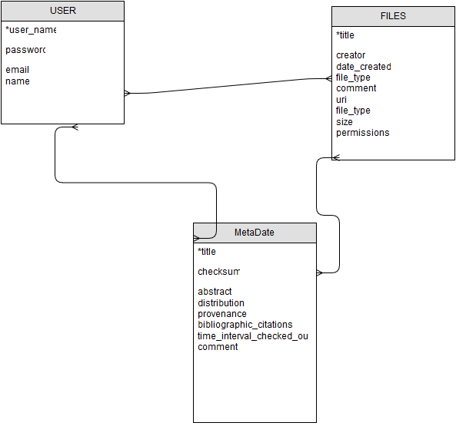

* + Information architecture (flow) is included below

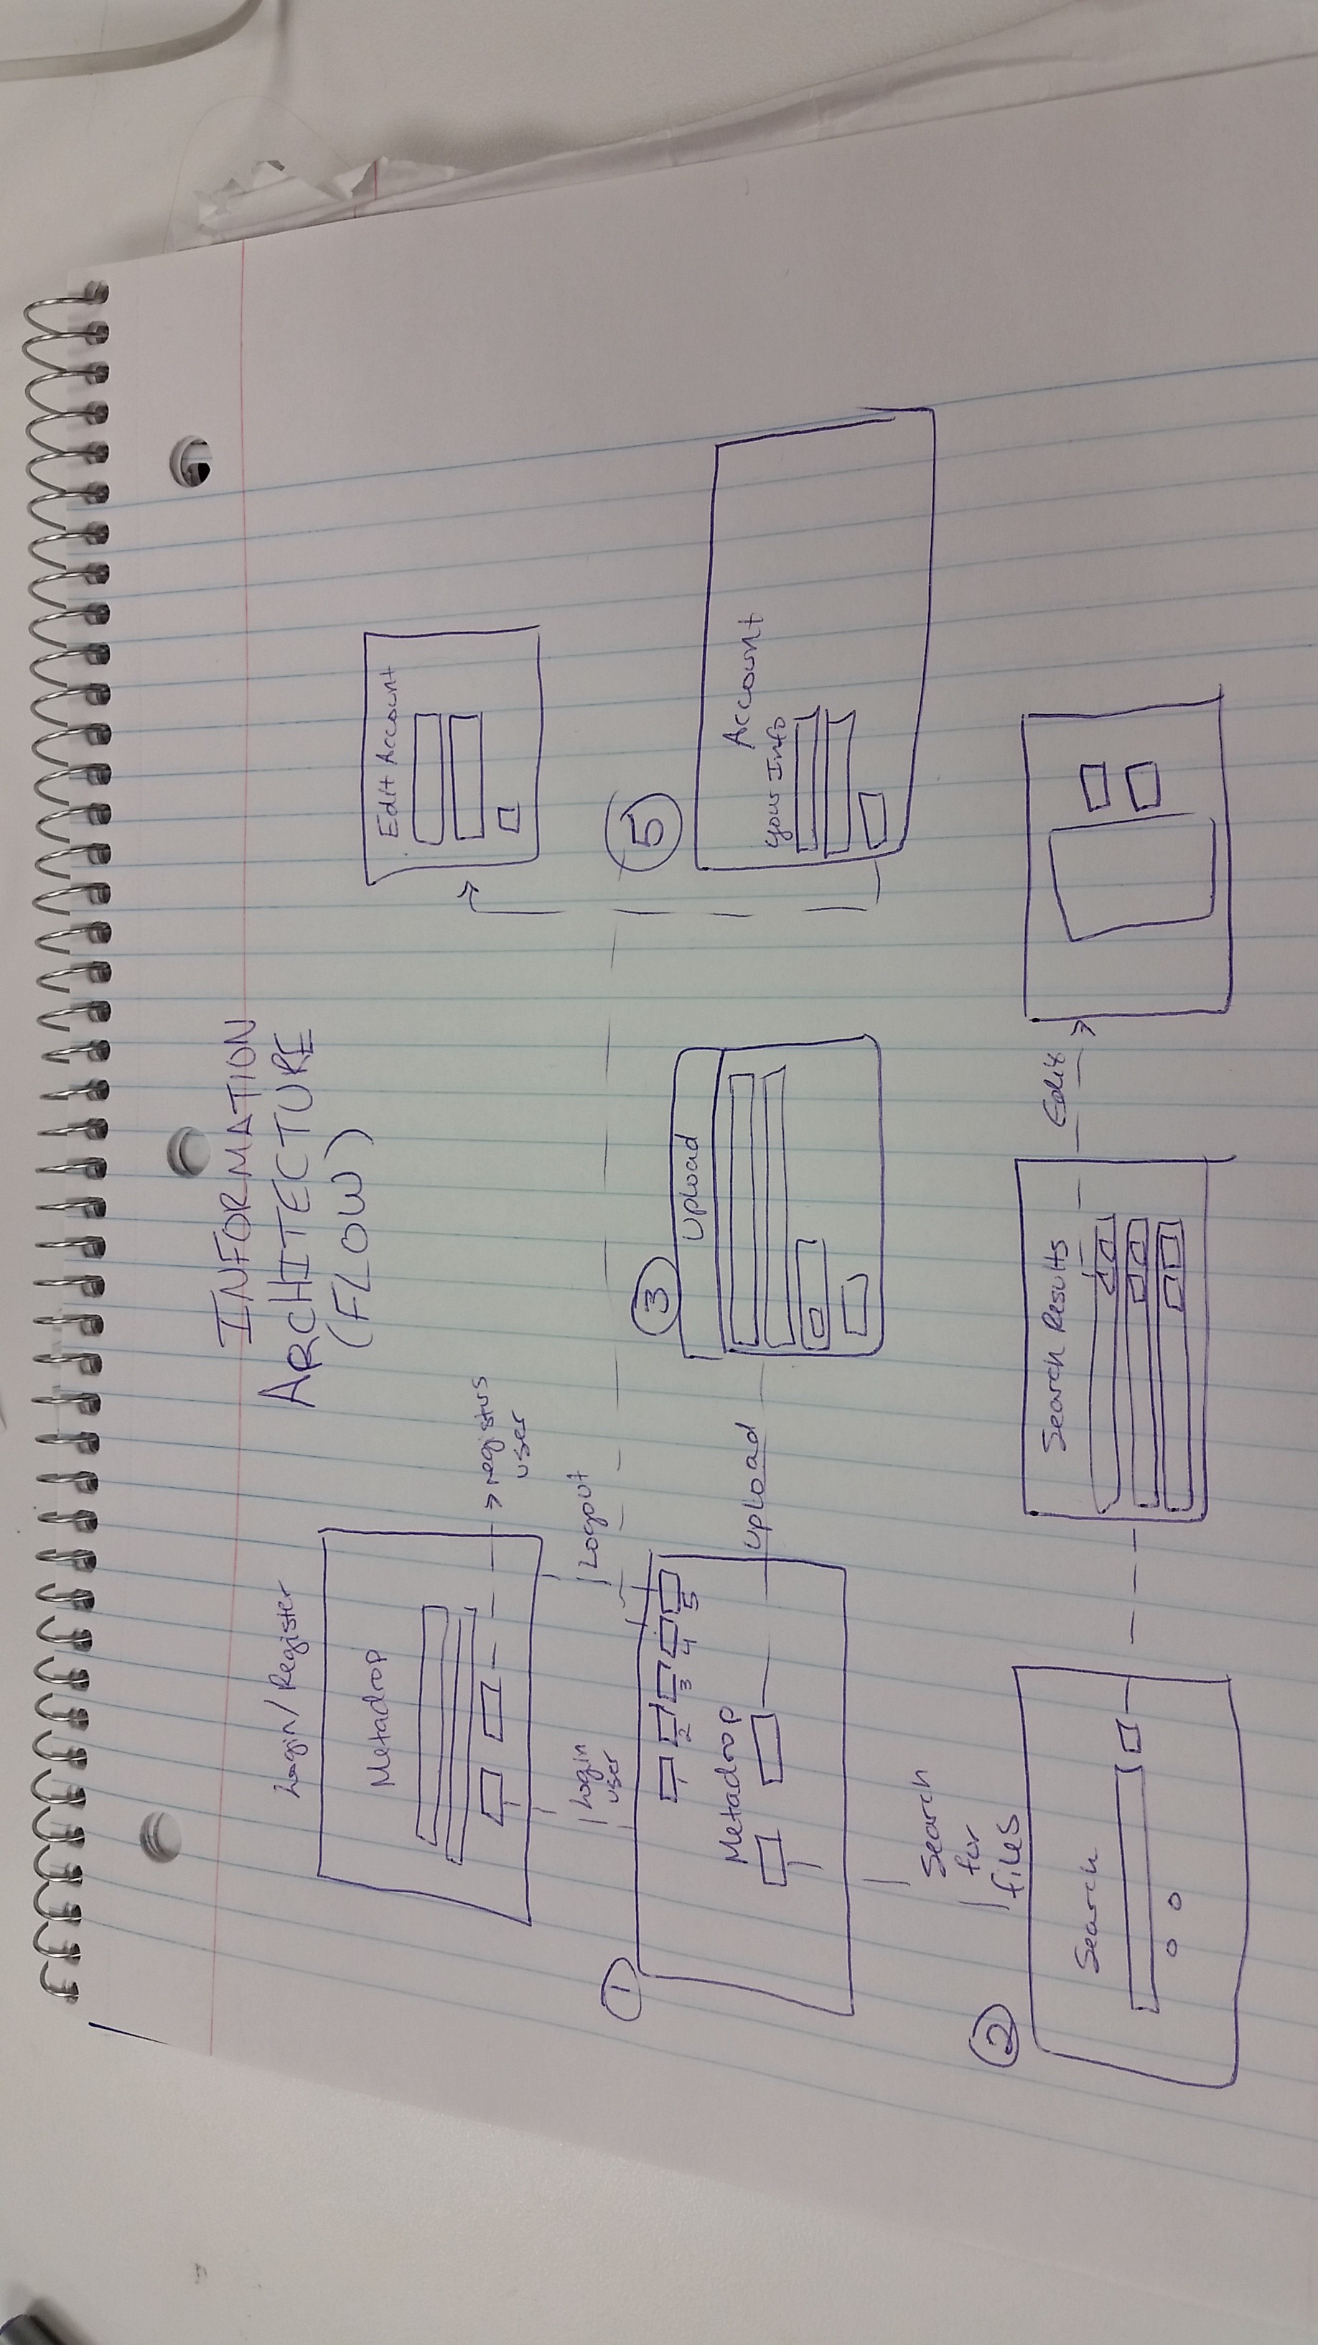

# Testing

* + Github links with pawprints now available
  + Revised Test cases included below:
    - https://github.com/TeddyIvanov/SoftwareEngineering- Group3/blob/master/testing_sprint2.pdf

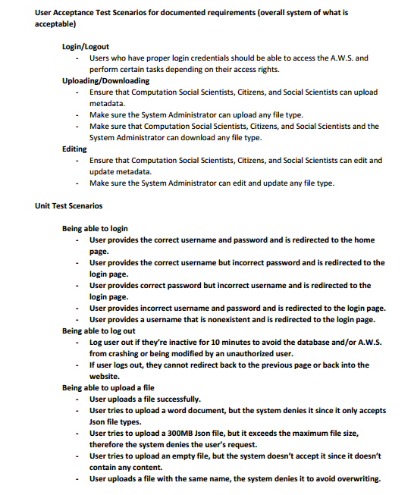

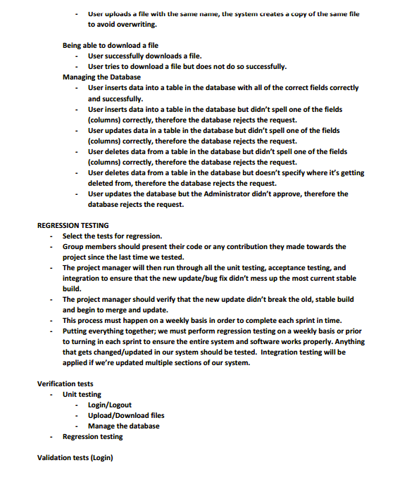

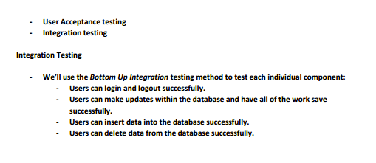

# Sprint 3

# General

Sprint documentation can be found [here](https://github.com/TeddyIvanov/SoftwareEngineering-Group3/blob/master/MetaDrop%20Sprint%203.docx) and within this Sprint 3 Markdown

# Deploy to Group Account???

# User Interface

* Pages were updated to correctly connect to database and to check if links were still in working condition
* The following pages were added/edited for additional features:
  + Account.html --Changed fields of user information and correctly linked Edit button
  + EditAccount.html --Added this page to allow user to edit personal information
  + Modify.html --Added a comments section for more user input

# Temporal Logic of UI

Doc: <https://github.com/TeddyIvanov/SoftwareEngineering-Group3/blob/oamr6_Sprint3/Temporal%20Logic%20of%20UI.docx>

**\*Full Tutorial of Website can be found in the user manual, located here. The following is the flow and navigation of pages**

**Login/Register Page:**

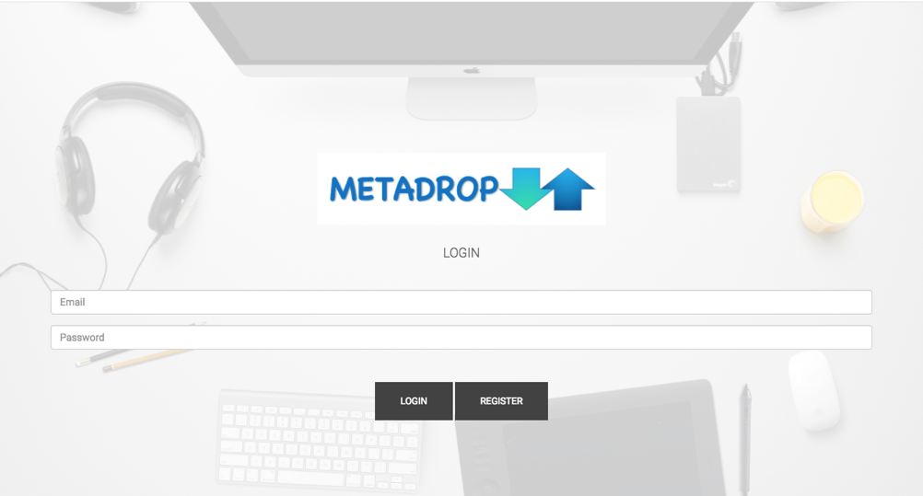

**Landing Page**

**Login/Register Page: Prompted to log in**



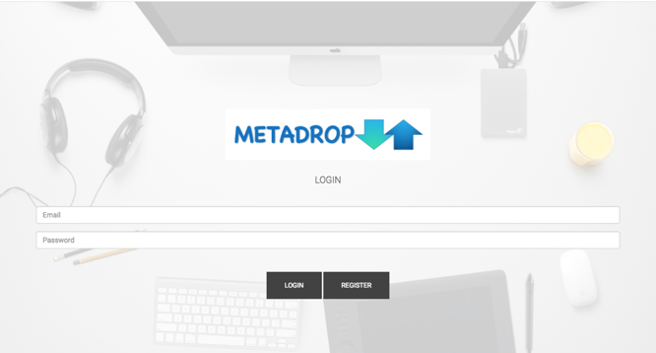

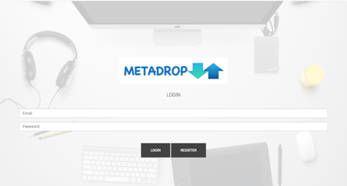

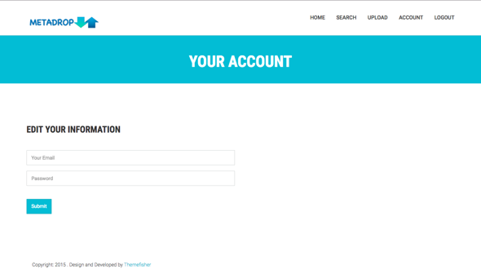

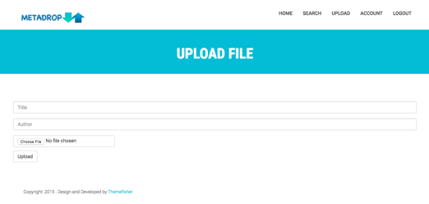

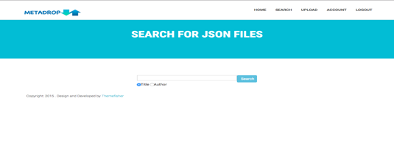

**Landing Page**



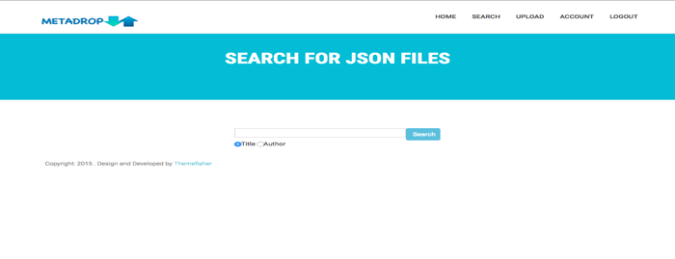









**Search for Files Page**

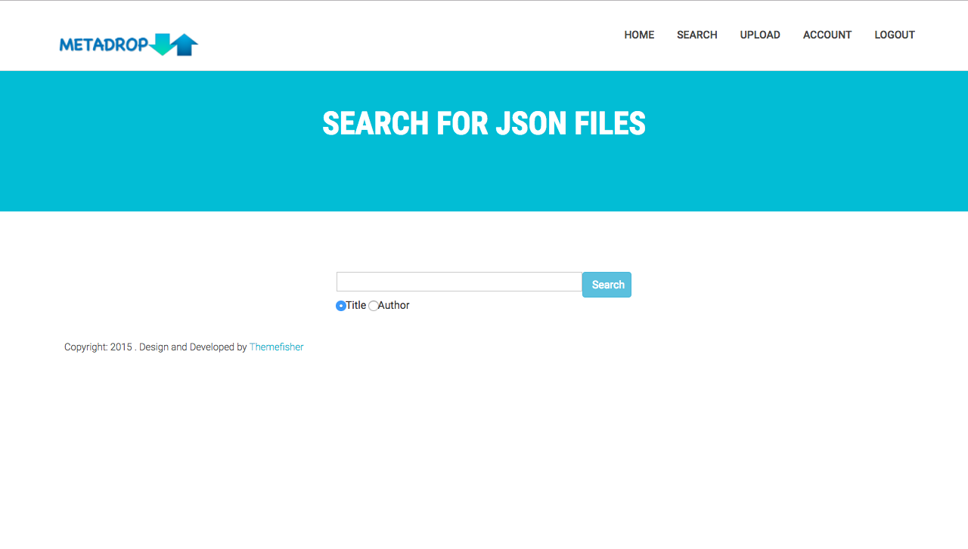

**Search Results**

**Search Results Page (To be created)**







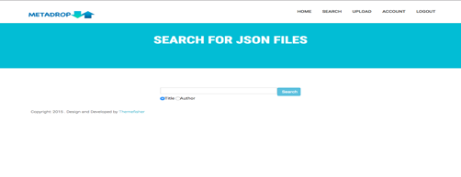



**View/Edit Page**

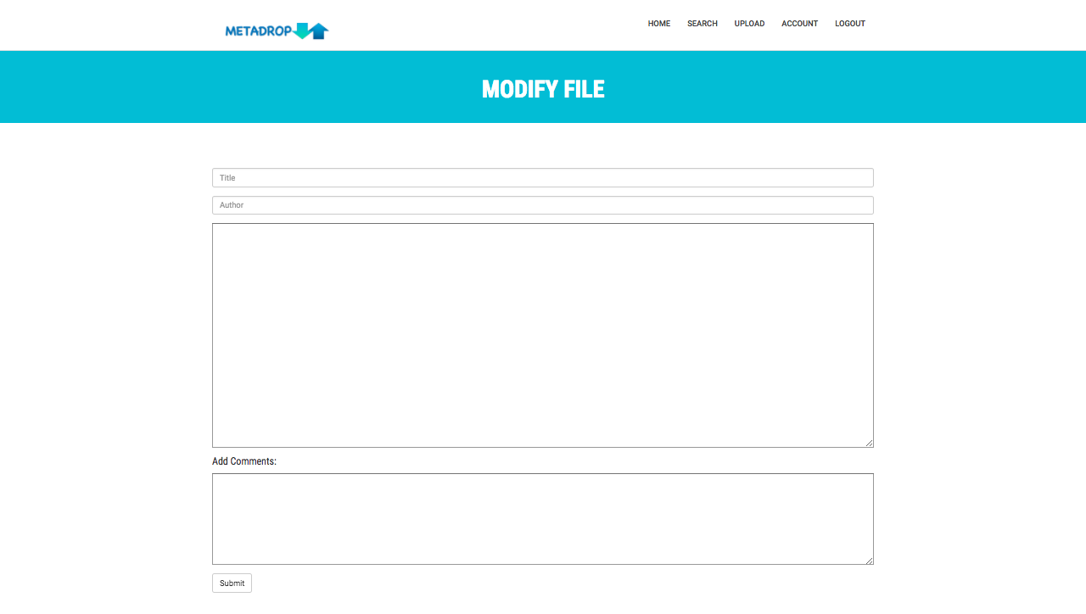

**<- Search results page**





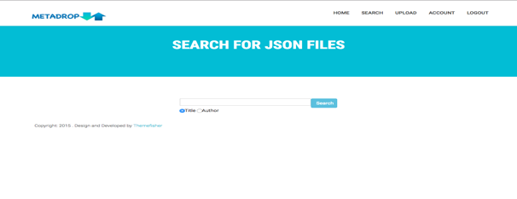



**Upload a File**

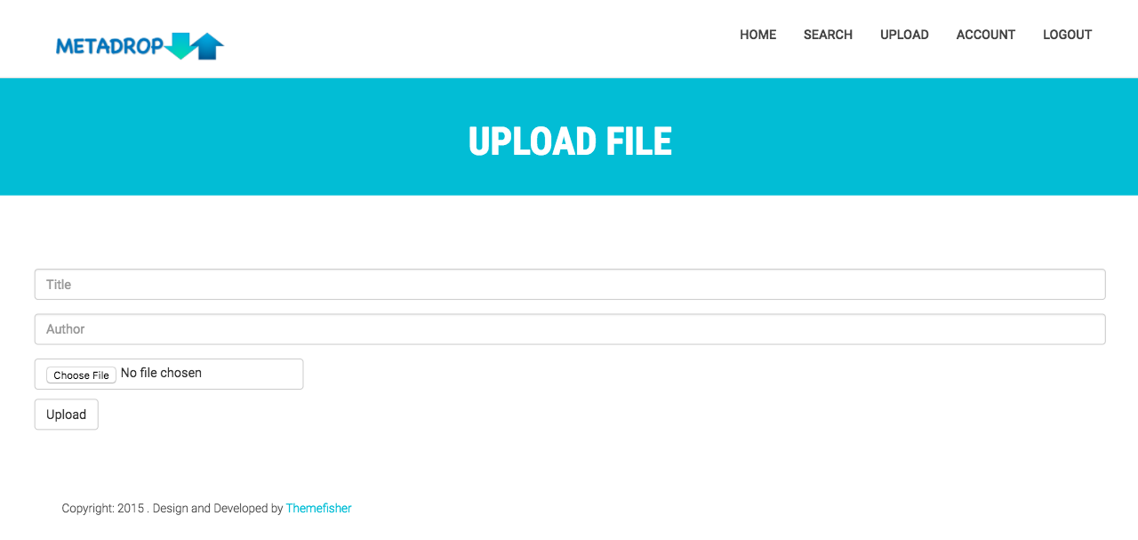

**Success Message**









**Account**

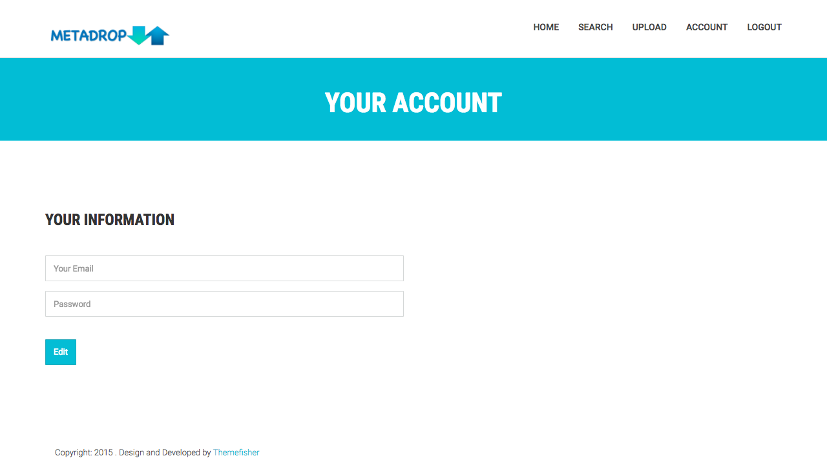











**Edit Account**

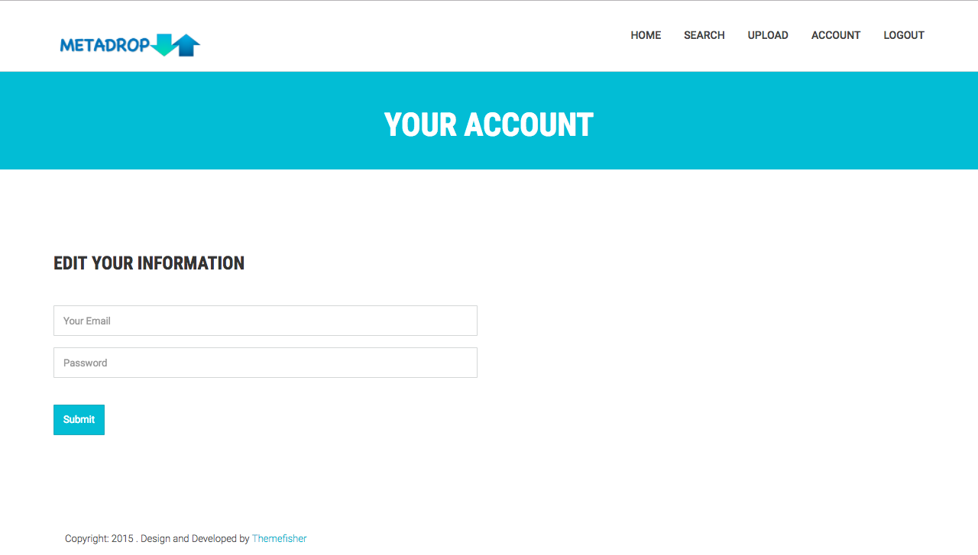

# Data Visualizations??

# Testing

* Description of user tests
* Edge cases

# User Documentation

User Documentation was structured and started. The following sections were added:

* Introduction (Olivia Apperson)
* Software and Applications needed (Andrea McGovern)
* Deployment (Andrea McGovern and Teddy Ivanov)
* End User Manual (Olivia Apperson)

# Improvements to Sprint 2

8 points were lost in Sprint Documentation

* Sprint 2 added to Requirements and Design Documentation
* Broken links, including Stub Calls and DML, fixed
* Link to Commits added

2 points lost for Testing

* User Acceptance testing not included in Regression testing
* Verification/Validation revised