|  |
| --- |
| **Disk Scheduling Algorithms (5.4.3)**  [FCFS (FIFO)](http://cs.uttyler.edu/Faculty/Rainwater/COSC3355/Animations/diskschedulingfcfs.htm)  [SSTF](http://cs.uttyler.edu/Faculty/Rainwater/COSC3355/Animations/diskschedulingsstf.htm) (Shortest Seek Time First)  SCAN(Scan Algorithm Disk Scheduling)  Elevator(Up/Down) |

|  |  |
| --- | --- |
| Q1 | A disk queue with requests for I/O blocks on cylinders in orders: 10, 22, 20, 2, 40, 6, 38. Assume that the disk head is initially at cylinder 9. How many cylinder do total head movement using **SSF (Shortest Seek First)** algorithms? |
| a. | 47 |
| b. | 69 |
| c. | 45 |
| d. | None of the others |

|  |  |
| --- | --- |
| Q2 | A disk queue with requests for I/O blocks on cylinders in orders: 10, 22, 20, 2, 40, 6, 38. Assume that the disk head is initially at cylinder 38. Which the ordering cylinder in progress do using a slight modification of **elevator algorithms**? |
| a. | 38 38 40 2 6 10 20 22 |
| b. | 38 40 2 6 10 20 22 38 |
| c. | 38 38 22 20 10 6 2 40 |
| d. | 38 38 40 22 20 10 6 2 |

Q.3 Suppose that a disk drive has 5000 cylinders, numbered 0 to 4999. The drive is currently serving a request at cylinder 143, and the previous request was at cylinder 125. The queue of pending requests, in FIFO order, is 86, 1470, 913, 1774, 948, 1509, 1022, 1750, 130

Starting from the current head position, what is the total distance (in cylinders) that the disk arm moves to satisfy all the pending requests, for each of the following disk-scheduling algorithms?

1. FCFS

The following shows the order of requests processed by the FCFS:

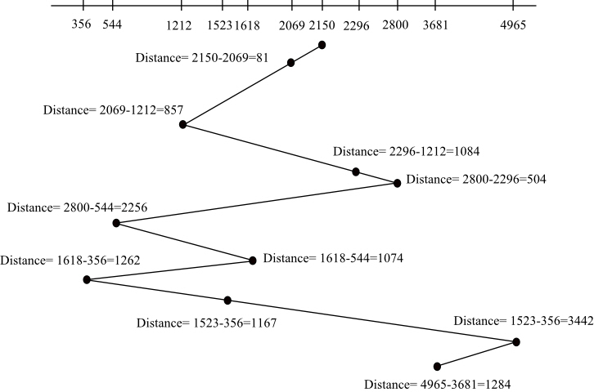

The total distance =81+857+1084+504+2256+1074+1262+1167+3442+1284=13011

1. SSTF

Total distance=(2150-2069)+ (2296-2069)+( 2296-2800) +(3681-2800)+ (4965-3681)+( 4965-1618)+( 1618-1523)+( 1523-1212)+( 1212-544)+( 544-356)

=81+227+504+881+1284+3347+95+311+668+188 =7586

The distance = 146 + 504 +881+1284+34(4999-4965)+2930(4999-2069) +451+95+311+668 +188 =7492