Six satellite damage products, one earthquake: what responders could and could not have trusted
Z. Arno, L. Milano · OCHA Centre for Humanitarian Data (draft v3.0, internal)
2026-08-10

Abstract
After the M7.5 earthquake that struck coastal Venezuela on 24 June 2026, at least eight organisations released satellite-derived building-damage products. We evaluated the six that published an analysed extent, scoring them not against a single expert reference but against three with complementary blind spots: expert damage points from Copernicus EMS, crowd review of AI-flagged locations, and 415 field reports. This lets the references check each other, and the expert reference did not pass: it captured 94% of field-reported destroyed buildings but only 49% of those reported as significantly damaged. Every precision measured against it is therefore a floor: Microsoft’s rises from 0.08 to roughly 0.24 once crowd-confirmed damage is counted.
At building level, every product performed poorly. As delivered, precision ranged from 0.01 to 0.08 (recall 0.31–0.69); even in the ~61 km² core region where all six products and the expert reference overlap, their best case, it reached only 0.05–0.09. None separated itself from a deliberately simple benchmark that uses no satellite imagery at all: a model built on coastline distance, building density and shaking intensity, fitted with hindsight to this event’s own damage map. That benchmark matched or beat three of the six there, and four of the six across their full delivered footprints. At neighbourhood scale the products are usable: they ranked sectors by damage burden reliably. The same hindsight benchmark ranked those sectors about as well, so the products’ contribution at this scale was availability: they delivered during the response a ranking that geography could reproduce only after the fact.
The rest of their value lies in their disagreement. How many products must agree before a building is flagged works as a dial a responder can set, from flagging every building any product marked (97% of known damage, but 26 visits per damaged building found) to flagging only unanimous buildings (93% of flags correct, 18% of the damage). Counting agreement between methodologically independent products roughly doubles the accuracy of any single product and requires no weights, no training data and no reference, which makes it the only method we tested that is both effective and computable during a response; a statistically fitted combination scores 18% higher, but fitting it requires the damage map responders are still waiting for.
These findings come from one event and should be read as a case study and a reusable evaluation method, not as general laws.

Introduction
In the first days after a major earthquake, responders need to know where the damage is and how bad it is, before ground access is possible. Satellite-derived damage products fill this window, and their supply has grown quickly. The 2026 Venezuela earthquake drew products from a variety of organisations: the EU’s rapid-mapping service (Copernicus EMS), a technology company (Microsoft AI for Good), universities (Oregon State University, working with NASA; the University of Houston), an NGO (IMPACT Initiatives), UN bodies (the UNEP/OCHA Joint Environment Unit; the World Food Programme, working with the LIST and CERN research institutes), and volunteer AI platforms (HOT fAIr, DISHA). These products disagree with each other, sometimes dramatically. A coordinator receiving several of them in the same week has no established way to decide which to trust, for what purpose, and at what spatial scale.
We evaluated the six products that published an analysed extent, scoring them against three references rather than one: expert damage points (Copernicus EMS), a crowd review of AI-flagged locations (MapSwipe), and reports from field teams on the ground (ChatMap). Their blind spots differ (the crowd saw only flagged places, so it can refute false alarms but never reveal a miss; the field reports are the reverse), so each reference is used only for the question it can answer, and the three check each other. That checking mattered: the expert reference turned out to miss half of the lesser damage the field teams reported, so precision measured against it alone is a floor, not an estimate.
The paper is organised around three questions a coordinator would actually ask. Can a responder act on a single flagged building? Do the products at least rank neighbourhoods well enough to triage? And what is the sensible way to use them in the next event? Each results section answers one piece, states how the answer was measured in a few sentences, and points to the Appendix for the full method. Everything here comes from one event in one coastal, dense-urban geography: the method transfers, and the specific numbers should be treated as hypotheses until they are replicated.

The event, the products, and the references
An M7.5 earthquake, preceded about 40 seconds earlier by an M7.2, struck near Yumare on the Venezuelan coast at 22:05 UTC on 24 June 2026. Severe damage was concentrated along the La Guaira coastal strip, in western Caracas, and in several inland towns. Copernicus EMS rapid mapping was activated the same night (EMSR884).
We evaluate the six products that published a defined or defensible analysed extent, the area the product actually examined (Table 1): without one, “no flag” cannot be distinguished from “never looked”, so neither misses nor false alarms can be counted fairly. Two further AI products (HOT fAIr and DISHA) published no extent and appear in the availability inventory only.
Table 1: Products evaluated. *Flag counts are as mapped onto the shared building-footprint base used throughout this paper; totals differ from providers’ native counts because of footprint-base differences. OSU figures refer to its v0 delivery, the version available during the response; a revised v1 arrived after the study window with minimal score differences where the two overlap (Appendix postscript).
Product | Provider | Sensing basis | Analysed buildings | Damage flags*
Microsoft AI4G | Microsoft | very-high-res optical + AI classifier | 72,162 (own footprints) | 8,410
IMPACT v2 | IMPACT Initiatives | Sentinel-1 radar coherence change | swath (~372 km²) | 22,954
OSU | Oregon State Univ. / NASA | Sentinel-1 radar coherence change | swath (~471 km²) | 31,259
UH QuakeDamage | Univ. of Houston | very-high-res optical (Vantor imagery, author-confirmed) + AI classifier grading every footprint | 447,263 incl. intact | ~91k dmg/destroyed
LIST | WFP / LIST / CERN | AI change detection on before/after radar imagery (provider-stated) | 163,225 | 15,904 in core region
UNEP debris | UNEP/OCHA JEU | radar-derived debris mass per footprint | no extent (stated assumption) | 96,046

The sensing bases fail in different ways, which matters when the products are combined: radar coherence methods are structurally resistant to the vegetation-change false alarms that can fool optical and radar-brightness methods (the Appendix’s sensing primer explains why, with an agricultural control comparison from this event). Analysed extents span three orders of magnitude, from Microsoft’s single coastal strip (210 km²) to LIST’s two full Sentinel scenes (~224,000 km²); the like-for-like comparisons live in the ~61 km² core region where all published extents and the reference overlap (Figure 1). Delivery timing is part of the picture, though this paper does not yet analyse it: Figure 2 reconstructs availability from our own ingest dates (an upper bound; provider release dates are still being confirmed). The whole set arrived within about eight days of the mainshock, and several products were sequences rather than single artefacts, so the version a responder acted on depended on when they looked.
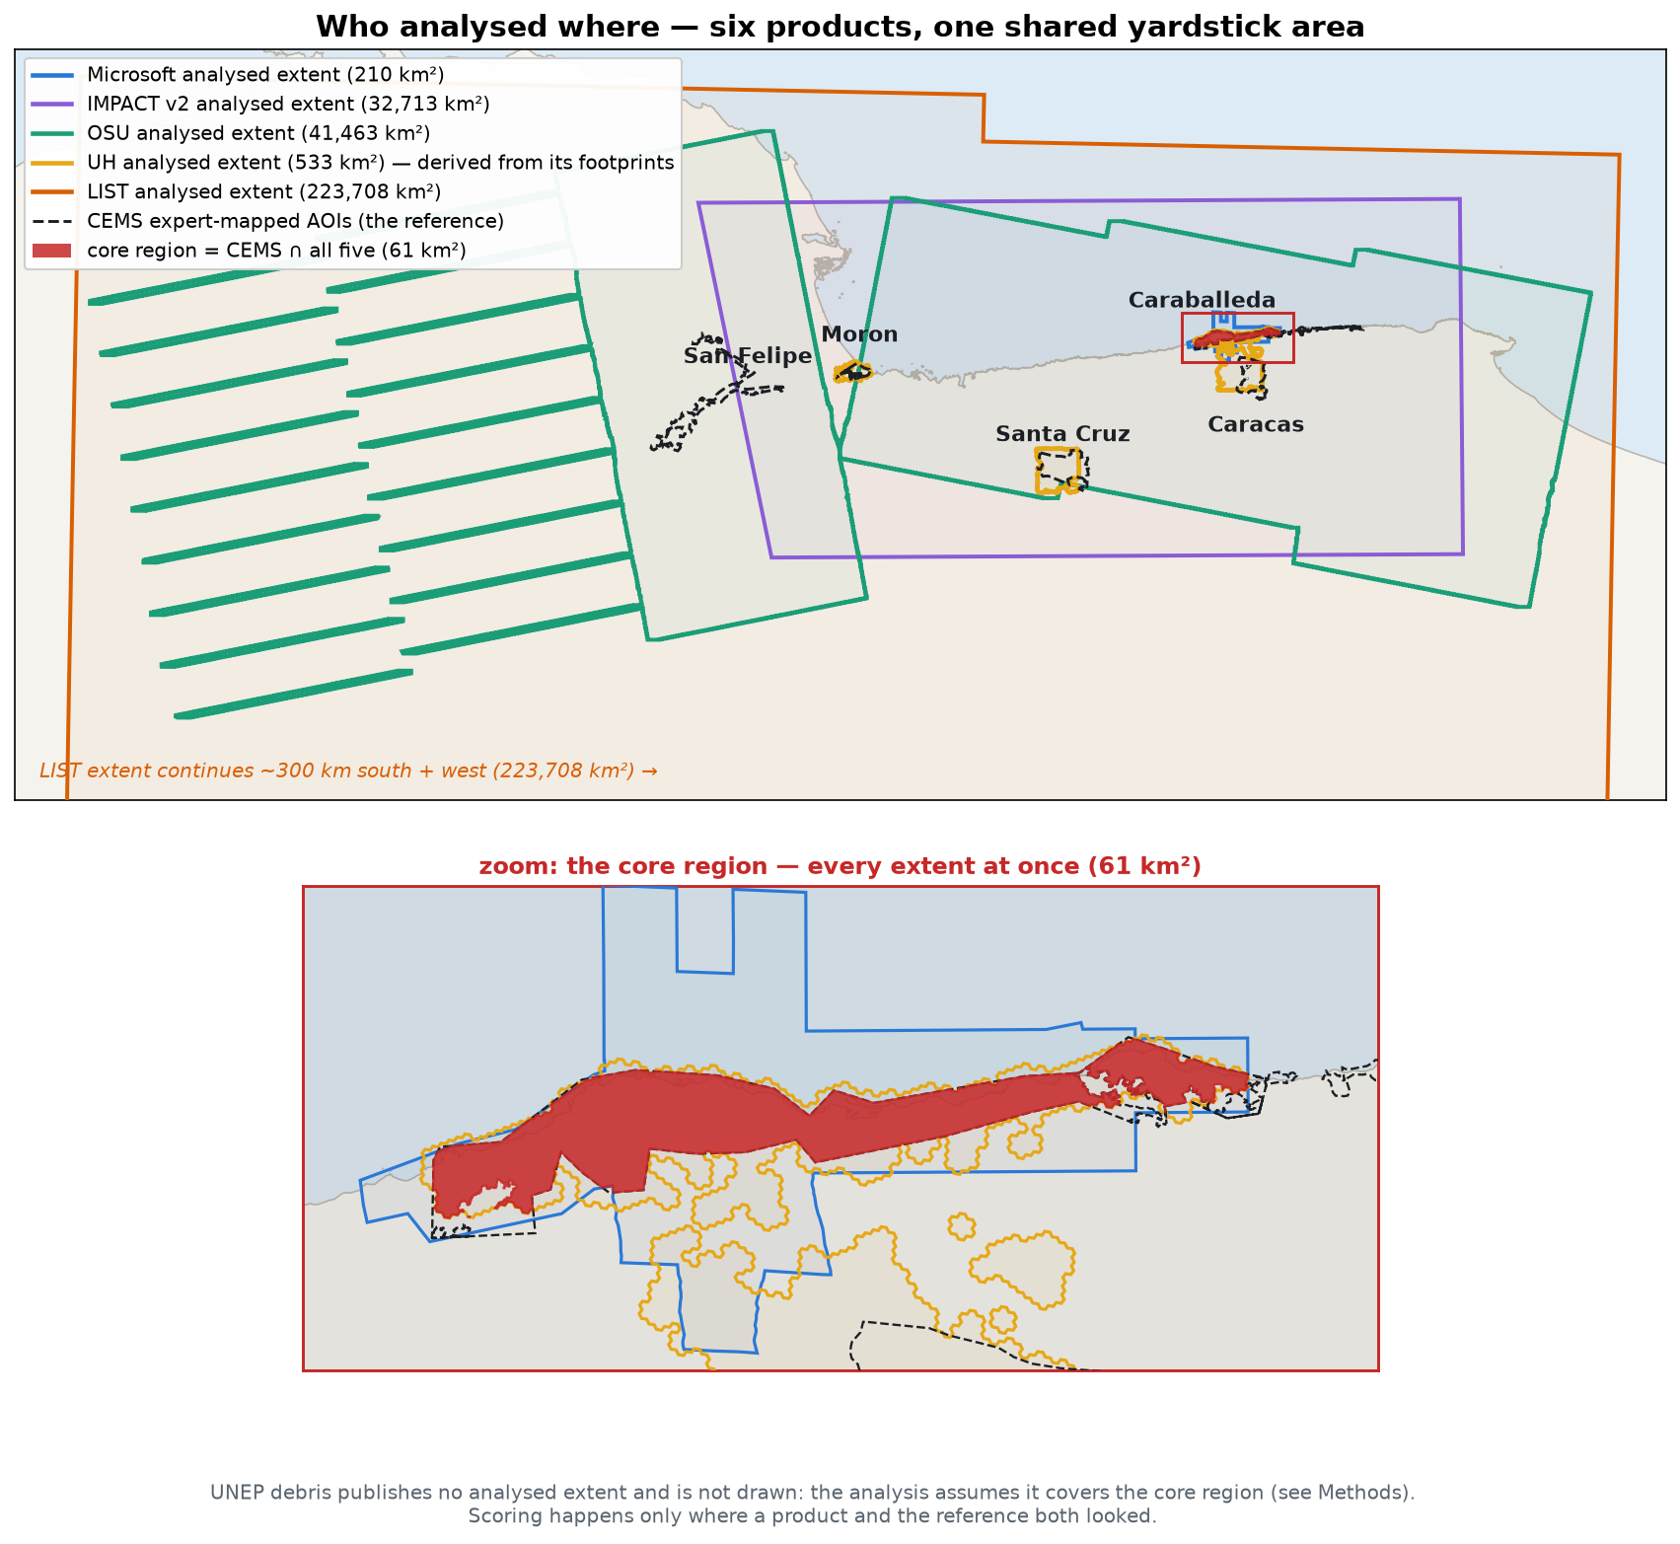
Figure 1: Who analysed where. Each product’s analysed extent, the five expert-mapped CEMS AOIs (dashed black), and, in red with the zoom frame below, the ~61 km² core region where the head-to-head, ensemble and fusion analyses live. UH publishes no extent (its polygon is derived from its own classified footprints); UNEP publishes none at all and is scored under a stated coverage assumption.

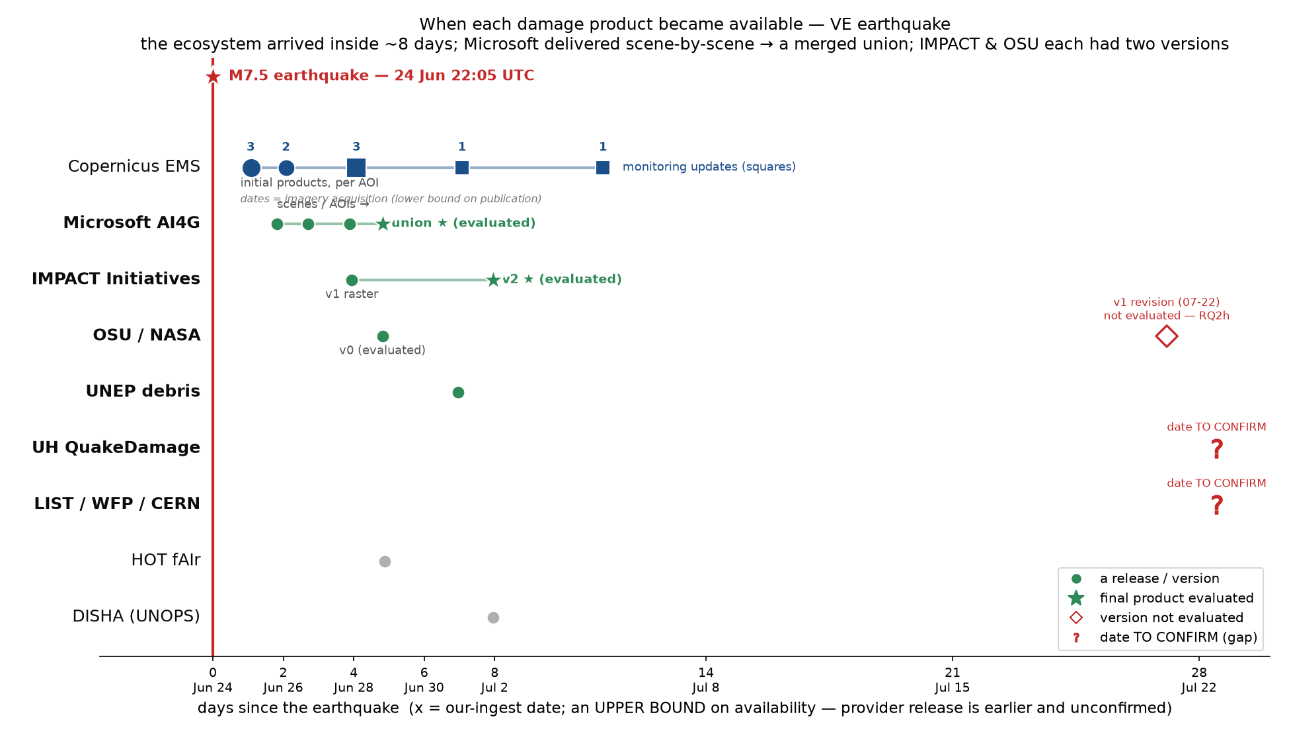
Figure 2: Product availability, measured from the M7.5 mainshock: preliminary, pending provider confirmation. Circles mark a release or version; a filled star marks the final product actually evaluated. Positions are our-integration dates (an upper bound on availability), so true release is earlier. Red markers are dates still to confirm.
The three references, and what each can see. Copernicus EMS provides trained-analyst damage points and is the primary reference: every headline precision and recall is computed against it, under one matching rule (a building counts as damaged if a CEMS point lies within 10 m; the Appendix gives the reasoning and sensitivity). Three other distances appear in this paper, each doing exactly one job: 20 m absorbs phone-GPS error when matching against field reports; a separate 20 m re-run of the label itself is the Appendix’s sensitivity check; and 30 m is the line-of-sight scale a wasted trip is judged at, shown alongside 10 and 20 m in Table 3. MapSwipe is a crowd campaign in which more than 400 volunteers reviewed ~50 m cells at locations AI products had flagged: it can refute false alarms but can never reveal a miss, so it is used to adjudicate disputed flags, never as ground truth. ChatMap is 415 building-level damage reports from field teams, positives-only with no survey frame: it can reveal misses but says nothing about false alarms (Figure 3). Because their blind spots do not overlap, the three can be turned on each other, which is how the expert reference’s own bias was measured (Section 5). One rule governs every number in this paper: against an incomplete reference, measured precision is a floor and measured recall is a ceiling.
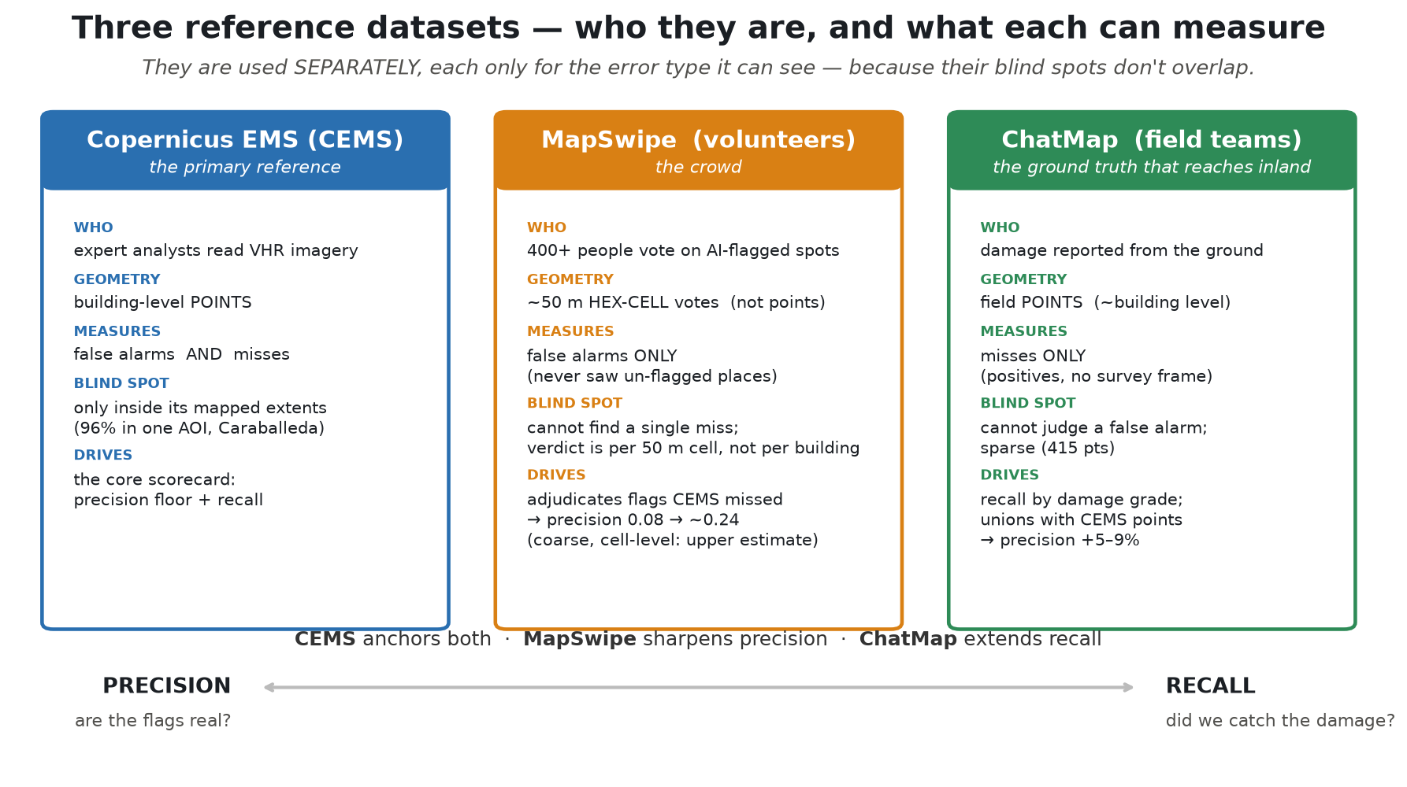
Figure 3: The three reference datasets at a glance. Two are HOT-run and easily confused: MapSwipe is remote volunteers voting on ~50 m cells, used to adjudicate false alarms; ChatMap is field teams reporting building-level points from the ground, used to reveal misses.

Building-level precision does not support acting on single flags
Result. Scored per building, every product performed poorly. Across everything the expert reference mapped, as the products were actually delivered, precision ran from 0.009 (UH) to 0.081 (Microsoft). Even in the core region, where all six products and the reference overlap and every product scores best, precision reached only 0.045–0.093 against recall of 0.31–0.69: ten to twenty misses for every hit, in the products’ best case (Figure 4). The products do find damage; what they also produce is an enormous number of flags with nothing recorded underneath them.
How it was measured. A flag counts as a hit if an expert damage point lies within 10 m of the building, a radius chosen from the urban fabric (median neighbour spacing is 9.7 m). Results are quoted in the core region unless labelled as-delivered, because outside the damage zone the reference is too thin to interpret failure cleanly; the as-delivered numbers are the operationally honest ones. Matching details, the radius sensitivity, and the two reporting regions are in the Appendix (matching details; radius sensitivity; Table 4).
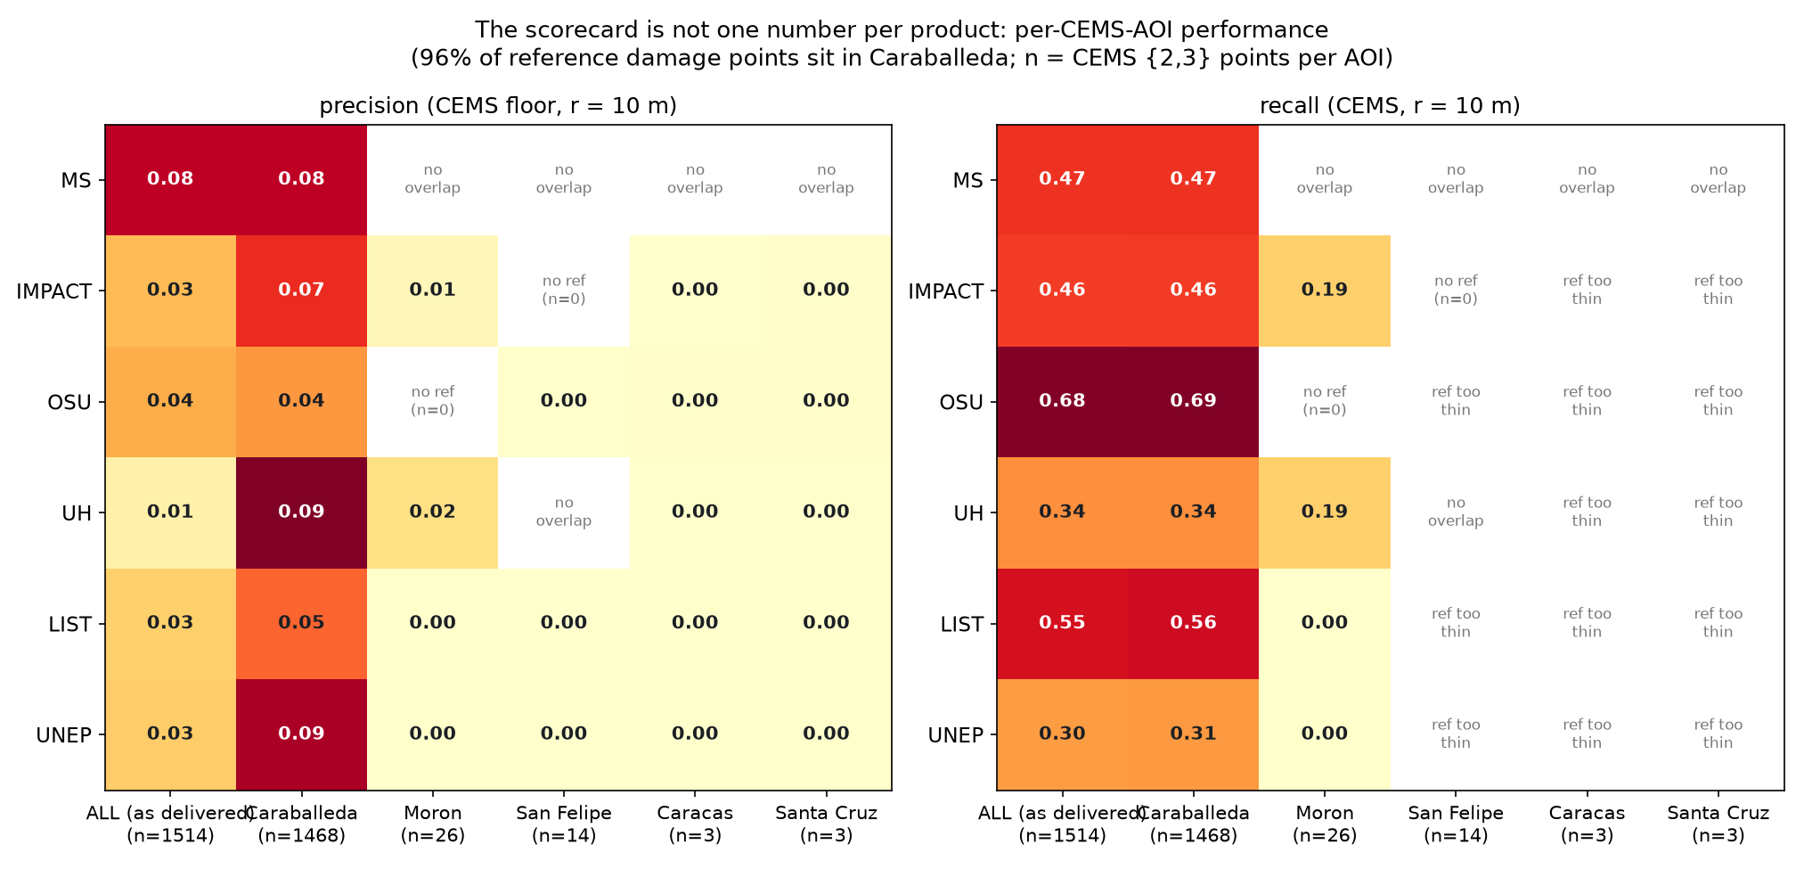
Figure 4: Region: each CEMS AOI separately, plus the pooled as-delivered total. Per-AOI scorecard. Left: precision floor per product per CEMS AOI; right: recall where the reference is thick enough to support it. 96% of all CEMS damage points are in the first column. Outside Caraballeda, measured precision is 0.00–0.02 despite flag shares up to 27.5%: a floor against a nearly-empty reference, in which product over-flagging and reference incompleteness cannot be separated.

A hindsight geography model matches the products
Result. A model given only three context variables (distance to the coast, local building density, and USGS ShakeMap shaking intensity) and no satellite data at all sits inside the product range in every comparison we ran (Table 2, Figure 5). At the single best operating point in the core region it reaches F1 0.128 against 0.148 for the strongest product; on their full delivered footprints it matches or beats four of six on both precision and recall at their own list sizes.
Table 2: Every single-product-versus-geography comparison in this paper, in one place. No individual product separates itself in any frame; combining products is what pulls clear (Section 7).
comparison | region | metric | outcome
Area ranking (Figure 7) | as delivered | rank correlation ρ | geography ranks better for 5 of 6 (OSU the exception)
Area ranking (Figure 7) | core | rank correlation ρ | single geography score 0.65; products split 3–3 around it
Building lists at matched size | as delivered | precision and recall | 4 of 6 matched or beaten; Microsoft and OSU stay ahead
Building lists at best cut | core | F1 | null 0.128 sits inside the product range; matches or beats 3 of 6

How it was measured, and how to read it. The model is fitted with hindsight to this event’s own damage labels and validated on spatial blocks it never trained on, so it is a null, not an operational alternative: its inputs were available on day zero, its fitted coefficients were not. A product that beats it has demonstrated information beyond coarse spatial structure; a product that loses to it has placed flags no better than a retrospective geography prior. The construction, the fairness safeguards, and why average precision is quoted only for continuous scores are in the Appendix (construction; fairness). Block-bootstrap intervals put numbers on the takeaway: none of the six products separates above the null (every product-minus-null F1 interval reaches below zero, and OSU’s sits entirely below), while flat voting (+0.158, interval 0.081 to 0.227) and weighted fusion (+0.214, interval 0.162 to 0.256) clear it decisively (intervals).
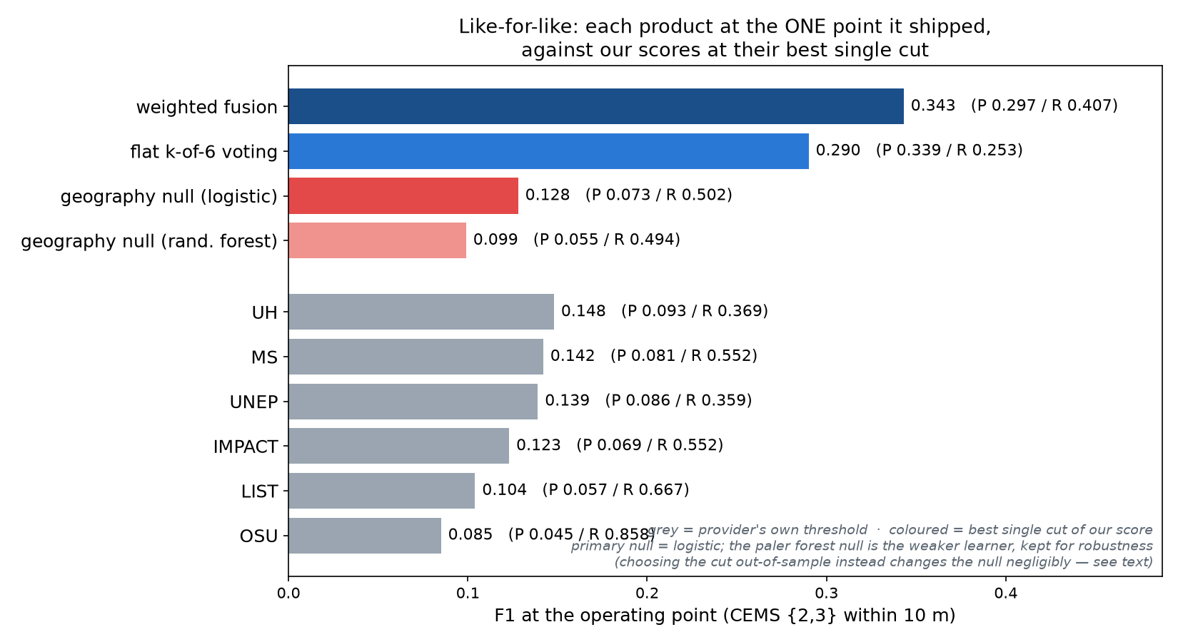
Figure 5: Lens: core region (61 km²). Every predictor at one operating point, F1 side by side. Grey bars are the six products exactly as shipped; coloured bars are our constructions at their best single cut. The geography null (0.128) lands inside the product range, while flat voting (0.290) and weighted fusion (0.343) reach more than twice the best single product, which is where the products’ real value shows (Section 7).

The expert reference is a floor, so every precision is an interval
Result. Checked against the field reports, Copernicus EMS captured 94% of destroyed buildings but only 49% of those significantly damaged (Figure 6): the expert map is thorough about destruction and patchy about everything short of it, and the products inherit the same slope. Crediting the flags that crowd reviewers confirmed as damaged lifts Microsoft’s precision from 0.08 to roughly 0.24, a factor of three that reflects the reference, not the product. Some damage escaped everything: about 11% of field-reported damage points, mostly in inland hill communities, had no flag from any product within 20 m despite lying inside analysed extents. Taken together, though, the products’ combined recall is genuinely high: at least one of the six flagged within 20 m of 96% of field points in the core region.
How it was measured. The three references were turned on each other: field points grade the expert reference’s completeness by damage class; crowd verdicts re-judge the flags the expert reference calls false; and every precision is then reported as an interval from the expert-measured floor to the crowd-adjusted value. An independent re-vote of the crowd campaign at three times the depth confirmed the adjustment’s stability (13.2% versus 11.5% of flags confirmed). The adjudication mechanics, their granularity caveats, and the re-vote are in the Appendix (adjudication mechanics; the crowd re-vote).
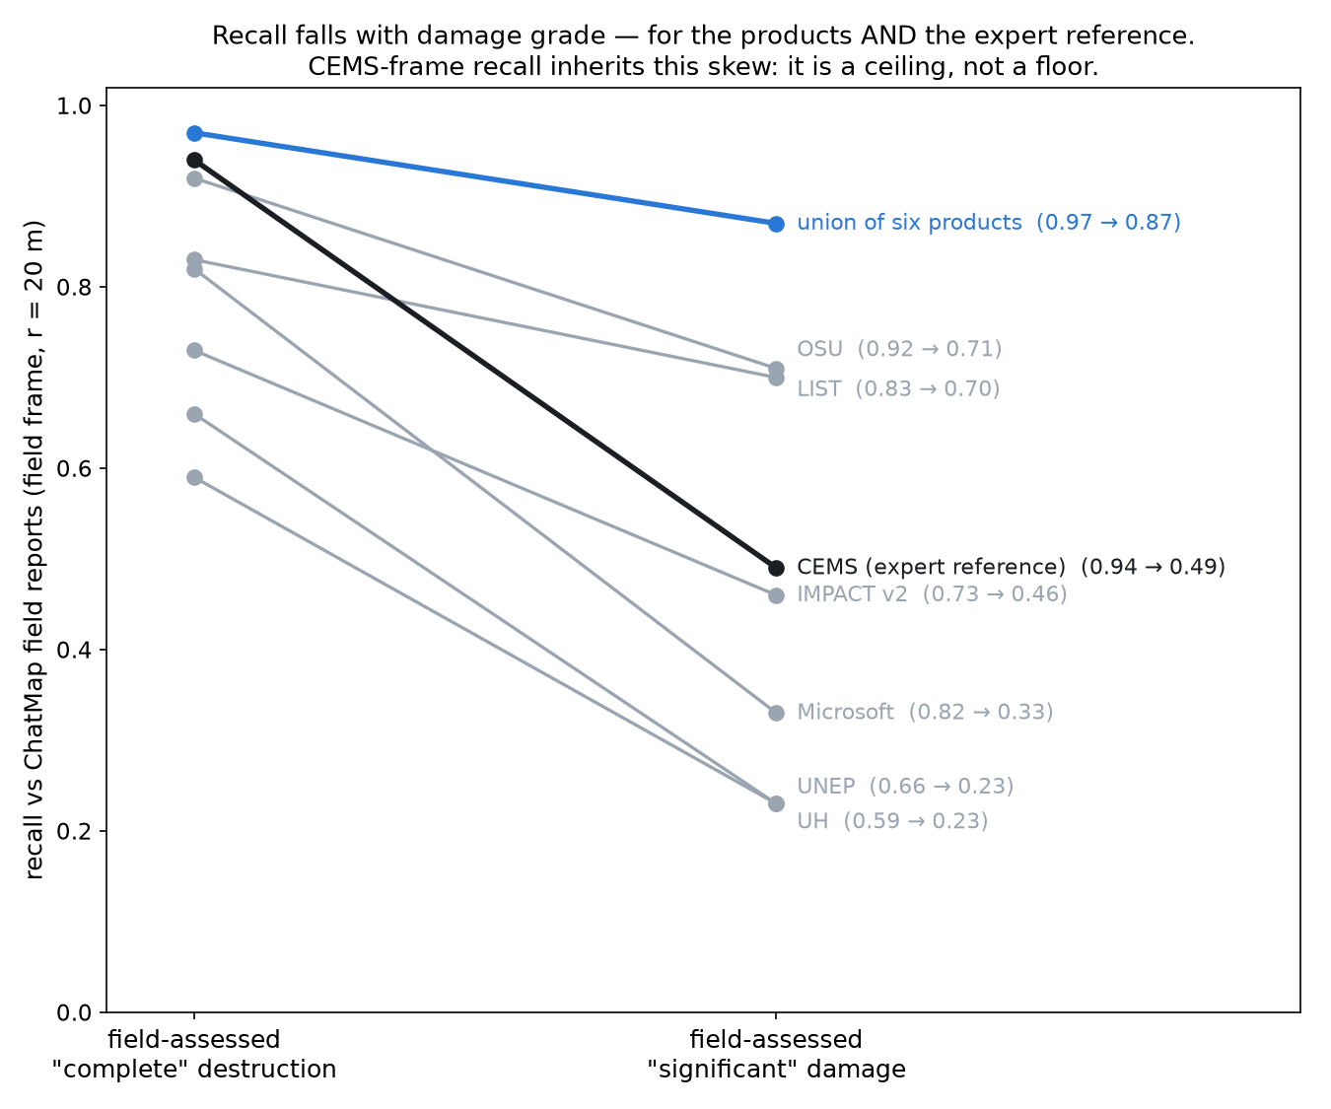
Figure 6: Region: within the CEMS-analysed extents; reference: field reports (20 m GPS tolerance). Recall by damage grade. Each line is one dataset’s recall against field-reported damage, at “complete” destruction versus “significant” damage. Every line slopes down: the products and the expert reference alike find lighter damage far less often, which is why measured recall is a ceiling and measured precision a floor.

Area ranking works, and geography ranks about as well
Result. Ask which neighbourhoods to go to first, rather than which buildings, and the picture improves a lot: at the ~5 km² sector scale the best products correctly identify 80–85% of the twenty worst-hit cells, with rank correlations around 0.54–0.59. This is the scale at which the products are genuinely usable. It is not, however, a scale at which they demonstrate information beyond geography, and we tested that under both of the paper’s lenses (Figure 7). As delivered, across everything each product shipped, the hindsight geography model out-ranks five of the six. Read that carefully, because 96% of the reference sits in one damage zone, so the as-delivered task is largely “find the damage zone”, which coast-plus-density solves almost by definition. In the core region, where every product and the model score the identical cells and the model therefore has a single score (0.65), the six split three–three: LIST (0.74), IMPACT (0.72) and OSU (0.70) rank above it, Microsoft (0.61), UNEP (0.58) and UH (0.48) below. So the products do carry real information about where within a damage zone to go first; what they do not add is knowledge of which zone, the part geography already encodes.
How it was measured. Flags and reference points are aggregated to hexagonal grid cells and each product’s ordering of cells is compared with the expert ordering by rank correlation, with the geography model’s expected damage count ranked the same way. In the as-delivered test each comparison runs on the cells of that product’s own footprint, so the model is re-scored per row; in the core-region test all six products and the model are scored on the identical shared cells, so the model has one value. The cell lattices, full tables, and a priority map are in the Appendix (method; tables).
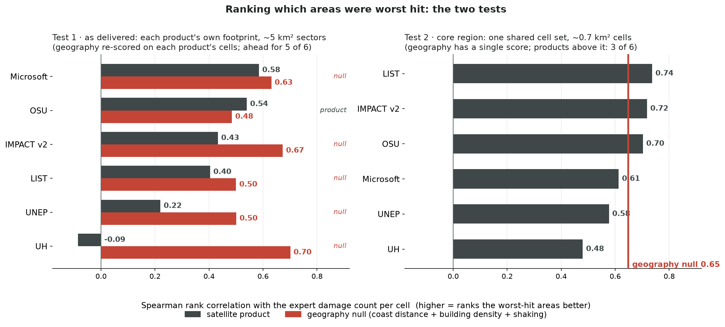
Figure 7: Lenses: test 1 as delivered (each product’s own footprint cells, so the model is re-scored per row); test 2 the core region (one shared cell set, so the model has a single score). Both ranking tests: how well each product orders cells by damage (grey) against the geography model on the same cells (red). As delivered the model ranks better for five of six; in the core region the six split three–three around its single score of 0.65.

Agreement between independent products is the operating point
Result. The products fail in different places, so the number of them agreeing on a building is informative, and it behaves as a dial with a known price at every setting (Table 3): from “any product” (97% of known damage at the 30 m line-of-sight scale, at a price of 26.4 field visits per damage point reached) to “all six” (crowd-adjusted precision 0.93, 18% of the damage); 4-of-6 costs 3.4 visits per find, unanimity 0.8. Counting agreement roughly doubles the accuracy of the best single product (F1 0.290 against 0.148) and requires no weights, no training data and no reference, so it is computable the hour the second product lands. A statistically fitted fusion of the same inputs scores 18% higher (0.343), but its weights come from the damage map a responder is still waiting for: like the geography null, it explains the event afterwards and cannot run during one.
Table 3: Building-level performance of the six products and the six agreement rules in the core region, at matching radii of 10, 20, and 30 m. At 10 m, product cells also show the as-delivered value in parentheses; agreement rules are defined on the shared footprint base and exist only in the core region. Crowd-adjusted precision re-judges the expert-unmatched flags against the crowd verdicts (10 m). Visits/find is field visits per damage point reached at the 30 m line-of-sight scale (flags ÷ R₃₀ × 1,467 reference points); as a ratio of counts it falls below 1 where damage is dense enough that one stop puts several recorded points within sight. Shading ranks values within each column (darker = higher; for visits/find, fewer). The geography and fusion models are compared at their operating points in Figure 5 and the Appendix. 95% block-bootstrap confidence intervals for these values are tabulated in the Appendix.
 | flags | 10 m |  |  |  | 20 m |  |  | 30 m
 | flags | P | R | F1 | P (crowd-adj) | P | R | F1 | P | R | F1 | visits/find
Products
Microsoft | 9,138 | 0.081 (0.081) | 0.474 (0.474) | 0.139 | 0.242 | 0.138 | 0.622 | 0.226 | 0.184 | 0.708 | 0.292 | 8.8
IMPACT v2 | 10,788 | 0.069 (0.032) | 0.462 (0.457) | 0.120 | 0.256 | 0.133 | 0.627 | 0.219 | 0.205 | 0.712 | 0.318 | 10.3
OSU | 25,882 | 0.045 (0.036) | 0.688 (0.681) | 0.084 | 0.230 | 0.087 | 0.860 | 0.159 | 0.137 | 0.913 | 0.239 | 19.3
UH | 5,362 | 0.093 (0.009) | 0.337 (0.336) | 0.146 | 0.418 | 0.148 | 0.437 | 0.221 | 0.197 | 0.506 | 0.284 | 7.2
LIST | 15,904 | 0.057 (0.026) | 0.564 (0.548) | 0.103 | 0.242 | 0.111 | 0.766 | 0.194 | 0.172 | 0.861 | 0.286 | 12.6
UNEP | 5,605 | 0.086 (0.027) | 0.313 (0.305) | 0.135 | 0.253 | 0.143 | 0.451 | 0.217 | 0.188 | 0.562 | 0.281 | 6.8
Voting rules (k of 6 agree)
1-of-6 | 37,644 | 0.034 | 0.768 | 0.066 | 0.208 | 0.069 | 0.934 | 0.128 | 0.109 | 0.973 | 0.195 | 26.4
2-of-6 | 21,060 | 0.056 | 0.710 | 0.104 | 0.240 | 0.108 | 0.895 | 0.193 | 0.167 | 0.943 | 0.284 | 15.2
3-of-6 | 9,409 | 0.101 | 0.605 | 0.173 | 0.283 | 0.184 | 0.787 | 0.298 | 0.267 | 0.856 | 0.407 | 7.5
4-of-6 | 3,347 | 0.187 | 0.419 | 0.259 | 0.383 | 0.311 | 0.579 | 0.405 | 0.405 | 0.665 | 0.504 | 3.4
5-of-6 | 1,005 | 0.339 | 0.232 | 0.276 | 0.560 | 0.503 | 0.329 | 0.398 | 0.600 | 0.410 | 0.487 | 1.7
6-of-6 | 214 | 0.640 | 0.093 | 0.163 | 0.932 | 0.850 | 0.147 | 0.251 | 0.967 | 0.184 | 0.309 | 0.8

The active ingredient is independence of method, not diversity of sensors. The strongest two-product rule in the study pairs Microsoft with UH, the weakest product we measured: both are optical, and they even share an imagery vendor, but they share no model, and their failure zones sit at opposite ends of the study area, so each covers for the other (Figure 8). The pair that shares its entire method, the two Sentinel-1 coherence products, is the weakest of all fifteen pairings. What products share (sensor, platform, model) is knowable without labels on day one, so the transferable rule is: count agreement between independent methods.
Three qualifications keep this honest. Flat voting means trusting every product equally, and that UH’s full vote helped could only be established with a reference in hand. Single products cannot be tuned out of their ceiling: same-sensor agreement, confidence-score sweeps, and within-product corroboration all plateau well below the cross-product rules (Appendix). And choosing the agreement threshold buys a workload, not a hit rate: flag counts are observable on day one, the precision they deliver is not. What this section implies for practice is collected in the Recommendations.
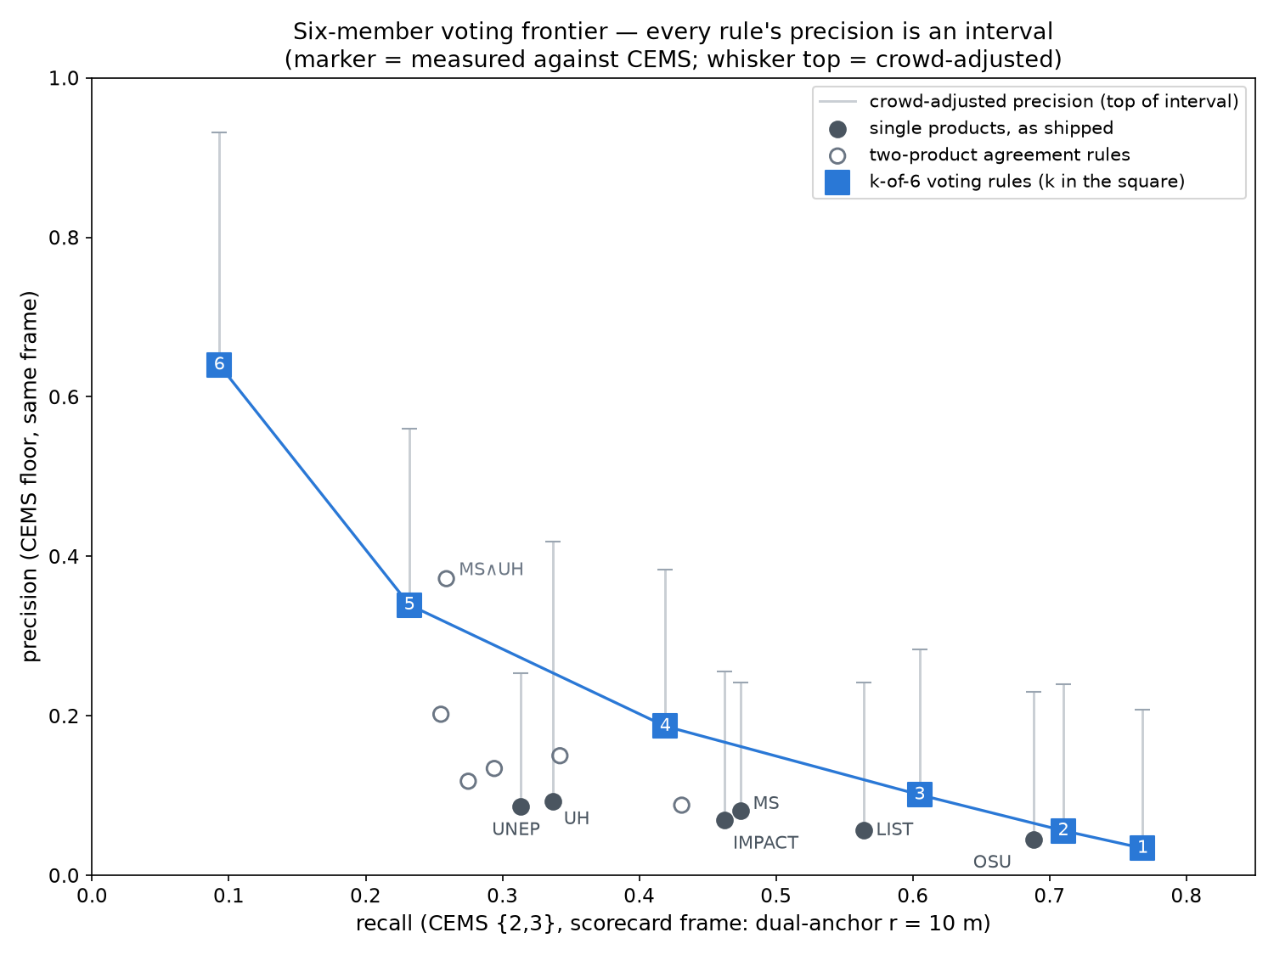
Figure 8: Lens: core region (61 km²). The fifteen two-product rules. Pairing across independent methods lifts precision; the pair sharing its entire method is the weakest of all.

One failure could be traced; five could not be examined
Result. Microsoft’s largest failure is a western strip where crowd reviewers judged 71% of its flags undamaged. Its published per-building metadata places that strip under a single satellite scene, processed alone (Figure 9); east of the boundary, where scenes overlap, the same product’s precision is four times higher (0.205 against 0.052). A vendor-level cross-check runs in the same direction: UH, whose authors confirm it ran exclusively on imagery from the same vendor, flags only 3% of that strip where Microsoft flags 32%. The failure is established to travel with the scene; whether the cause was the image itself or the model’s handling of it cannot be separated with current data. Microsoft’s own public report corroborates the mechanism from the producer’s side: it names the Catia La Mar overlap as its single largest source of inter-scene disagreement, with the Vantor 25 June scene flagging ~2,600 buildings as damaged that the Planet 26 June scene calls intact, resolved in overlap zones by preferring the later Planet read. The strip in question is where no second scene was available to overrule the first. Microsoft was the only product publishing metadata at this granularity, which is why its failure is the only one that could be examined this way.
How it was measured. The crowd campaign’s verdicts were aggregated over the strip and compared with the product’s per-building scene counts and dates; an independent second crowd campaign over the same cells later reproduced the confirmation side of the verdict. Details, including what the re-vote could and could not re-test, are in the Appendix (the case study in full; the crowd re-vote).
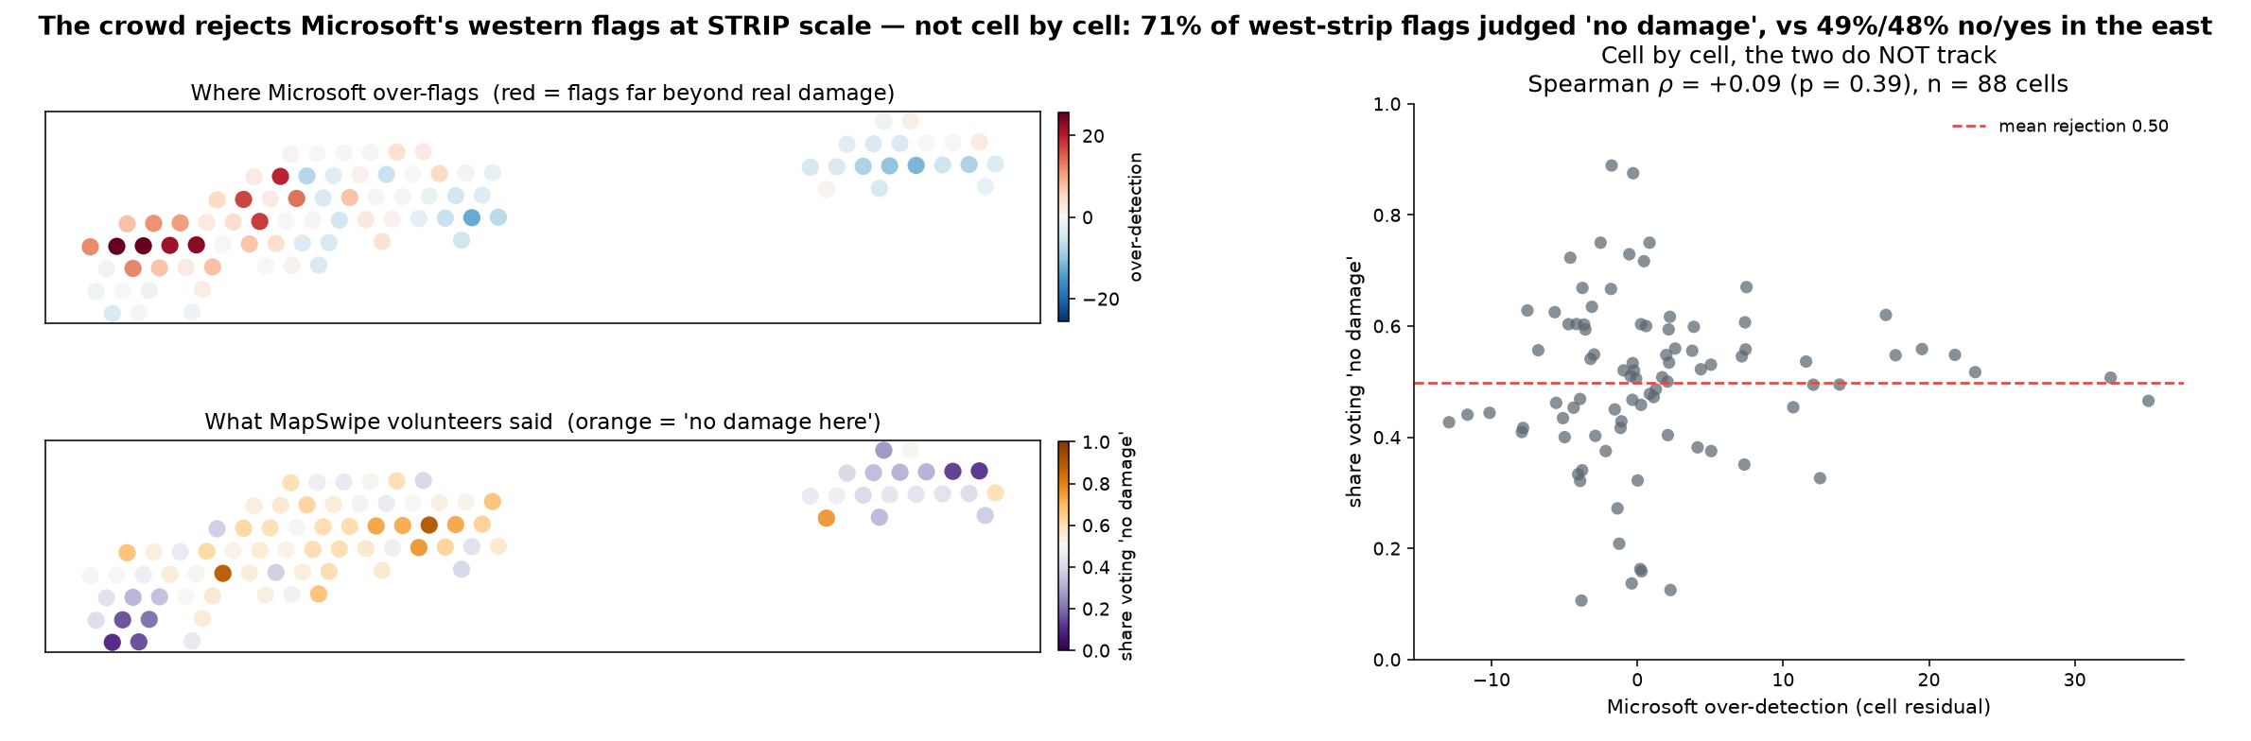
Figure 9: Region: the western half of Microsoft’s delivered strip (Catia La Mar). The western strip. Top left: where Microsoft flags far more than the expert map records. Bottom left: where crowd volunteers said nothing is there. Right: cell by cell the two do not track; the agreement is at the scale of the strip, which sat under a single satellite scene.

Summary and discussion
The three questions from the Introduction now have answers. Can a responder act on a single flagged building? No: precision is 0.04–0.09 even in the best-mapped area, every number measured against an incomplete reference is a floor, and no single product can be tuned out of that ceiling. Do the products rank neighbourhoods well enough to triage? Yes, and this is their genuinely usable scale; but a hindsight geography model ranks about as well, so treat the ranking as useful rather than as evidence the product saw something the map did not. What is the sensible way to use them? Count agreement between independent methods. It is the only method we tested that is both effective (roughly double any single product) and available during a response, and its price at every setting is knowable in advance as a workload.
Two further results close tempting shortcuts. First, a product’s reliability cannot be judged from its own flags: across fifteen product-and-area combinations, nothing in the flags’ rate, clustering, or cross-product agreement predicted measured reliability (every correlation statistically indistinguishable from zero). False alarms cluster the way real damage clusters, so the map alone cannot tell a devastated neighbourhood from a fooled model; judging reliability where no reference exists requires field reports, a crowd, or a model trained on previous events. Second, and more encouraging: where a reference does exist, failures can be mapped, not just measured. Across 78–86% of each product’s territory the errors scatter randomly, the harmless kind of wrong, and the trouble concentrates in a few identifiable pockets, which suggests discounting each product’s vote inside its known bad pockets as a next step for fusion.
The strongest way to harden every claim here is replication, and a specific candidate exists: the 2025 Myanmar earthquake has a comparable multi-product, crowd-validated landscape. The method transfers as-is; whether the single-product ceiling, the monotone ordering of the voting rules, and the grade gradient hold there is exactly what one event cannot establish.

Recommendations
The results imply changes in practice for three audiences. We collect them here, once.
 For responders
Do not spend time choosing a product; spend it counting agreement between products. On this event no single product was meaningfully better than a model of coastline distance and building density, but the number of products agreeing on a building roughly doubled the accuracy of any of them alone. Unlike a fitted model, counting requires no weights, no training data and no reference, so it can be done the hour the second product arrives. Weight the count toward independent methods: products that share a sensing method fail together and their agreement carried the least information in our tests, while products with nothing in common but the event cover for each other’s failure zones. Then set the threshold from your own capacity (Table 3 gives the flag counts and visit costs at each level), remembering that you are choosing a workload, not a guaranteed hit rate. Used at sector scale, any major product ranks where to go first: trust that ranking, not the building counts, while noting that coarse geography ranks about as well. Nothing in the current ecosystem sees lighter damage reliably, so plan shelter assessments accordingly.

For providers
Publish an analysed extent; without one, a product cannot be evaluated or safely used. Publish per-building acquisition metadata (scene count and dates); those fields are what allowed this paper to trace a failure to a single satellite scene. Surface corroboration to users as a confidence tier rather than leaving it in an archive column. Validate where the product is deployed, not where validation data happens to exist; the failing scene here was the unvalidated one. Check new products against a geography-only baseline, which every single product in this event merely tied. And accept feedback during the activation: a crowd campaign rejected 71% of one zone’s flags within days, and no channel existed to carry that signal back while reprocessing could still help.

For evaluators and coordinators
A single expert reference understates precision most where damage is lighter. Publish measured precision as a lower bound, or better, adjudicate the disputed flags against a second reference and publish the interval. Note that unanimous product agreement without expert corroboration turned out to be mostly real damage, so consensus doubles as a detector of reference gaps and a field-validation queue. Finally, coverage is an ecosystem property: the inland communities missed by every product were inside analysed extents, and nobody knew that nobody was seeing them. A shared, live picture of who is looking where costs providers nothing and closes the one gap here that no amount of fusion can.

Limitations
One event, one geography, and mostly one neighbourhood. This is a single earthquake in a coastal, dense-urban setting, and the core comparison region is only ~61 km². More restrictive still, 96% of the CEMS reference sits in a single AOI (Caraballeda), so every pooled number is effectively that AOI’s number. In the four low-damage AOIs, measured precision (0.00–0.02) cannot distinguish product over-flagging from reference incompleteness (Figure 4). The specific rule orderings and magnitudes are hypotheses elsewhere.
The crowd and field references have limits of their own. The crowd campaign was seeded from two AI products’ flags, so it scrutinises products unevenly and can never see any product’s misses; its volunteers are not damage-assessment experts, and their verdicts are per ~50 m cell, not per building. The field reports are undated, positives-only, skewed toward destruction, and come with no defined collection area, so the inland-gap estimate is a lower bound.
What we know about the products themselves is uneven. The independence-versus-shared-method contrast rests on a single same-method pair. UH’s exclusively-Vantor optical basis is author-confirmed; LIST’s radar basis remains provider-stated rather than documented, and input-imagery details and release dates for both await provider confirmation. OSU’s revised v1, delivered after the study window, is used by the operational dashboard but enters this paper only in the version comparison (Appendix postscript): scored on the common extent the differences are minimal (precision 0.036 against 0.034, recall 0.68 against 0.64) even though more than half the flag list turned over, so the response-time v0 is scored throughout.
Voting inherits the shared footprint base. Two products can fail to co-flag a building for alignment reasons rather than genuine disagreement, so the recall of the strict-agreement rules is understated.
The geography null enjoys hindsight the products never had. It is fitted to this event’s reference labels; although it is scored strictly on held-out buildings (including under buffered validation: excluding training buildings within 300 or 500 m of any test building moves its F1 by at most 0.002, Appendix), it carries an event-specific calibration no responder possessed. It is an upper bound on geography-only skill, and the claim it supports is about information content, not about what was operationally in hand. A model fitted on previous earthquakes, which is what a responder would really have, would score somewhere below this bound and remains untested.
Pending work. Population-weighted prioritisation is in progress and absent from this draft. The timeliness axis is preliminary: Figure 2 reconstructs availability only, and the decision-relevant interaction of accuracy with arrival date awaits confirmed provider-release dates.

Appendix
The main text states each result with a summary of how it was measured; this appendix carries the full machinery, inherited from the long-form draft (manuscript_v2), which it supersedes.

Matching products to references, in full
The product and reference use different geometries (CEMS drops points on damaged buildings, while each product flags its own footprints on its own building base), so there is no shared list of instances on which to build a single confusion matrix. We therefore score by proximity, the standard approach for detection-style evaluation: precision anchors on the product (of its flagged buildings, how many have a CEMS damage point within radius r?), and recall anchors on the reference (of the CEMS damage points, how many have a product flag within r?). Each metric carries its own denominator. Because the two metrics are precision and recall, neither uses the undamaged background (true negatives), which we could not enumerate anyway, since CEMS never labels the undamaged stock.
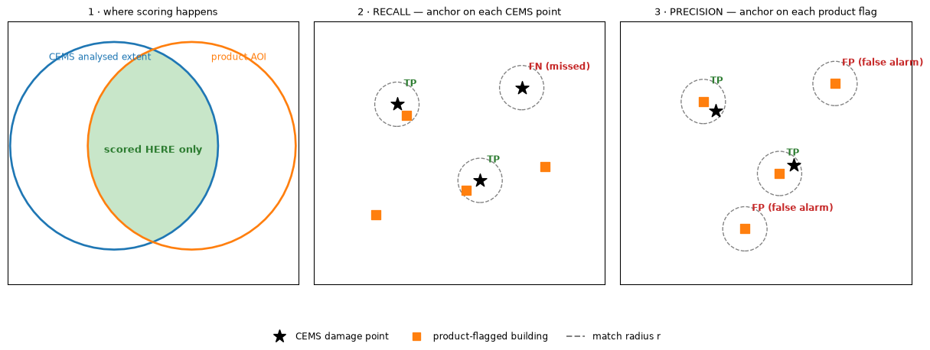
Dual-anchored matching. Left: a product is scored only where it AND the reference both looked. Middle: recall anchors on the reference; each CEMS damage point asks whether a product flag lies within radius r. Right: precision anchors on the product; each flagged building asks whether a CEMS point lies within r. Each metric brings its own denominator.
A product is only accountable where both it and the reference actually looked, so all scoring is restricted to the intersection of analysed extents; Figure 1 maps every extent this paper scores against, and the core region they share. UNEP debris publishes no extent. Based on its density across the study region, we make the explicit assumption that it fully covers the ~61 km² core comparison region, the same logic used for its stand-alone evaluation in fully enclosed administrative units.
An analysed extent says where a product looked, not whether it could see: cloud can hide individual buildings inside a declared extent. A robustness check against the one product that publishes per-building visibility found the effect negligible in this event (details in the Appendix), so all products are scored without visibility corrections; the check is impossible for the five that publish no such field.
The matching radius comes from the urban fabric rather than from convenience. The median distance between neighbouring building centroids in the core region is 9.7 m, and 93% of buildings have a neighbour within 20 m. We therefore use r = 10 m as the largest radius at which “did the product flag this building” is still a meaningful question. Larger radii answer a different and equally legitimate question, namely whether the flag put a responder within sight of real damage. We use named scales for those: 30 m (line of sight), 60 m (same block), 100 m (right area).
One matching rule, two labelled exceptions. Every CEMS-based precision and recall in this paper uses the 10 m radius, so all of them are directly comparable. Two labelled exceptions appear later, each because it answers a different question: the coverage and visits-per-find columns of the voting table use 30 m, the line-of-sight scale (“would a responder sent here see the damage”), and recall against the ChatMap ground reports uses 20 m, absorbing phone-GPS error in field-collected points. Both are restated where they are used. (That field-matching 20 m is unrelated to the 20 m label radius of the Appendix sensitivity re-run, which is an alternative definition of the target itself.)
Separately from the matching radius, results are reported in one of two regions, and numbers are comparable only within one:
Table 4: The two reporting lenses. Sections and captions state which they use. The core region gives every predictor an identical cell set (one geography score); as-delivered is per-product by design, so the geography model is re-scored on each product’s own footprint there.
reporting region | what it is | used for
Core region | the ~61 km² intersection of the CEMS extents with all five extent-publishing products (Figure 1): one shared cell set | voting, the pairwise rules, fusion, and the best-F1 geography comparison
As delivered | each product’s full delivered footprint, wherever CEMS mapped: a different region per product | the as-delivered scorecard and geography benchmark; ranking test 1

One point about what the radius is: it is not a tolerance applied to the products, but the definition of the target every predictor is scored against:
A building counts as damaged if a CEMS damage point lies within r metres of it.
Widening it changes the truth being chased, not the leniency of the scoring: at 20 m the identical CEMS points label 2,733 core-region buildings damaged; at 10 m, 1,350. The product-versus-geography comparison is mildly radius-dependent as a result, so the every product and voting rule is re-scored at 20 m and 30 m (Table 3), the models are refit at both in the Appendix (“Performance versus matching radius”), and no conclusion changes.
Two implementation details complete the picture. The fusion analysis, which needs a label for every building rather than only the flagged ones, matches buildings to CEMS points by centroid, while the headline scorecard matches on each product’s native geometry; at the same radius the two implementations agree to within 0.005 in precision for every product (Table 7, Appendix), so that choice is immaterial. The radius is the one choice that moves numbers. Microsoft’s precision is 0.080 at 10 m and 0.138 at 20 m: the same product, the same flags, the same reference, two definitions of what counts as a hit.

Area ranking and error structure: method
For questions about where damage is concentrated, we aggregate per-building flags to hexagonal grid cells at two sizes, roughly 0.74 km² and 5.2 km² (the larger approximates a triage sector), and compare each product’s ranking of cells against the ranking implied by CEMS, using rank correlation and top-k overlap.
Whether a ranking survives noisy per-building labels depends on how the noise is arranged in space, so we test that directly. A regression suited to counts (Poisson) predicts each cell’s flag count from its CEMS damage count, with the cell’s building stock built in as the baseline so that “more flags because more buildings” cannot register as bias. What remains (flagging above or below what the real damage explains) is then tested in two ways: for whether it bunches together on the map rather than scattering (Moran’s I, a standard score for exactly this, with its significance judged by reshuffling the values across the same cells many times, which controls for the shape of the built-up area itself), and for correlation with variables that would corrupt a ranking, namely building density, distance to the coast, and modelled shaking intensity.
Two further tests use the same cell lattice. The first asks whether a product’s reliability in an area can be predicted from its flag pattern alone (its flag rate, how tightly its flags cluster, how much it agrees with the other products), by correlating those signals with measured reliability across every product-and-area combination. The second classifies each product’s territory cell by cell, using local versions of the same clustering score, into places where its errors scatter at random and places where they pile up.

Combining products, and adjudicating disagreements: method
For per-building questions, each product’s flags are projected onto the shared Overture footprint base and combined by voting. A building passes the “k-of-6” rule when at least k of the six products flag it. Throughout the paper, k-of-6 names a rule, never a score. Voting rules are scored exactly as single products are.
Because CEMS itself has gaps, precision measured against CEMS is a lower bound. A reference gap can turn a correct flag into an apparent false positive, but never the reverse, so the true precision lies at or above the measured value. We estimate how far above by adjudication: for every flagged building with no CEMS point within 10 m, we look up the MapSwipe majority verdict for its cell and count the share that volunteers judged damaged. “Crowd-adjusted precision” adds those confirmed flags back to the numerator. Each precision estimate in this paper is therefore an interval, from the CEMS-measured lower bound to the crowd-adjusted value. One caveat sets the character of the upper end: MapSwipe verdicts are per ~50 m cell, not per building (Figure 3), so a crowd-confirmed flag means “damage somewhere in this cell,” not “this building.” The crowd-adjusted value is therefore an upper estimate of building-level precision, and the truth lies between it and the CEMS floor. The stability of that crowd verdict was itself re-tested: an independent second crowd re-voted the same cells at three times the depth after this paper’s freeze and confirmed 11.5% of the same flags where the first crowd confirmed 13.2%, so the upper estimates here sit slightly high; the mechanism and the full re-test are in the Appendix (Figure 12). A second, independent check uses ChatMap instead: because its field points are building-level, they can be unioned directly with the CEMS points, which raises measured precision by a smaller, sharper 5–9% (the field data is sparse, 415 points, but geometrically exact).
Recall has no such correction, and its bias runs the other way. Adjudication re-judges flags; it cannot add the damage CEMS never recorded to recall’s denominator: the crowd saw only AI-flagged places, and the field reports are positives-only with no survey frame, so the full denominator is unknowable. Because the reference over-represents destruction, which is the damage class every product detects best, recall measured against it is flattered rather than understated. The rule of thumb for this whole paper: against an incomplete reference, measured precision is a floor and measured recall is a ceiling. The grade-stratified field-frame measurements in Section 5 quantify how much the recall ceiling gives back.

The geography null model and weighted fusion, in full
Two of this paper’s constructions are models rather than products, and both are built the same way. The geography null model exists to calibrate what the accuracy numbers mean: it asks how much of the damage pattern could be recovered from coarse spatial structure and shaking alone, so that a product’s score can be read against something other than zero. It uses three context variables computed per building, all available within hours of any earthquake: distance to the coastline, local building density, and the shaking intensity estimated by the USGS ShakeMap. From these it predicts which buildings carry CEMS-recorded damage. It is validated by spatial blocking: the map is cut into ~5 km² zones and the model is always scored on zones it was not trained on, because neighbouring buildings resemble each other in both their features and their damage, and an ordinary random split would leak that resemblance into an inflated score (Figure 10).
A null is only meaningful if it is the strongest honest account of “just geography”; a weak one would flatter the products by construction. We therefore fit it two ways: a logistic regression (a standard statistical model that weighs the three variables) and a random forest (a more flexible model built from many decision trees, able to capture interactions between the variables). Whichever scores higher in a given analysis is the one reported, and both are disclosed. Which of the two wins genuinely differs across the paper’s analysis layers; the full comparison and the reasons are in the Appendix (Table 8). Nothing about the fusion results depends on that choice.
We call it a null model rather than a baseline, and deliberately avoid naming it after day zero, because the distinction is easy to blur and consequential. Its three inputs are genuinely available on day zero; its fitted coefficients are not. Estimating them requires the very damage labels a responder is waiting for, so the model cannot be run on the day it names. It is not an alternative anyone could have deployed. What it provides instead is a reference level (the standard role of a null model, like a majority-class or stratified-random comparator), and because we allow it to be fitted with hindsight, it is a generous null. The two directions therefore read differently. A product that beats it has demonstrated real information beyond spatial structure, and the inference is strong precisely because the null was given every advantage. A product that loses to it has flags placed no better than an obvious retrospective geography prior, which is a serious finding about that product. It is not, however, a claim that geography was an available substitute.
How much event information the null actually uses differs by analysis layer: in the core region the shaking estimate barely varies and the model runs on static geography alone, while across the delivered footprints shaking carries a quarter to a third of its weight. The as-delivered comparison is consequently the better founded of the two, and the core-region comparison should be read strictly as a null (the Appendix carries the detail).
The model’s output is not a flag list but a continuous risk score per building. Every cutoff on the score is a different flag list, so the model traces a whole curve of precision–recall trade-offs, while a product, whose provider already fixed the threshold, is a single point in that plane; the two are compared point-against-curve. Average precision, the area under that curve, is reported only for continuous scores; a shipped product is compared at its operating point instead (the Appendix shows why a one-list “average precision” would mislead).
The weighted fusion is the same construction with the six products’ flags and confidence fields added to the three context variables: the geography null is exactly this model with the product inputs removed. Both are refit for each analysis they appear in, always under the same blocked validation. One caution: the learned weights are calibrated to this single event and should not be assumed to transfer.
Two questions of fairness follow from putting a fitted model beside an unfitted product, and both have short answers. Are they scored on the same data? Yes: the validation folds partition the buildings, every building is scored by a model that never saw it, so models and products face identical building sets with identical denominators (the threshold-selection mechanics are in the Appendix). Is the model advantaged by hindsight? Yes, deliberately: it is fitted to this event’s reference labels, so it is an upper bound on geography-only skill for this event, and the claim it supports is about information content (the products add little beyond what three context variables carry), never the operational claim that responders held such a model on day zero. The Limitations return to this.
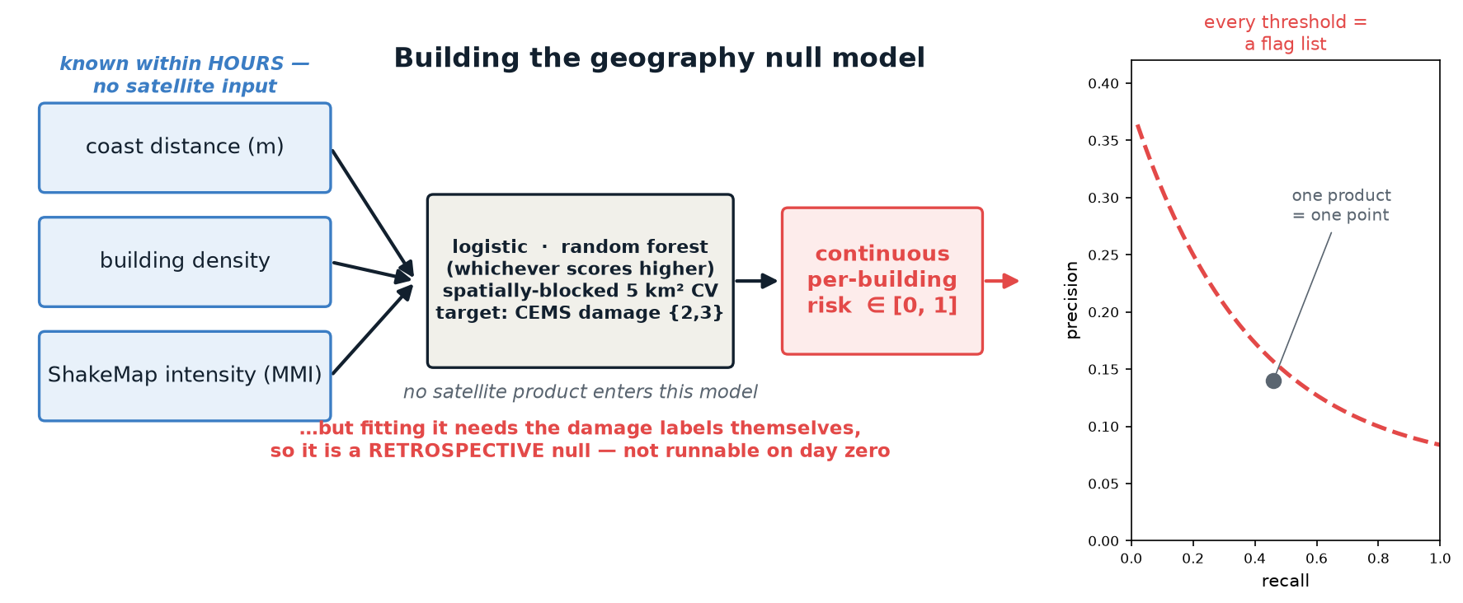
Figure 10: How the geography null model is built. Three context variables known within hours of the earthquake (coast distance, building density, and ShakeMap intensity) feed one spatially-blocked model whose target is CEMS damage; both learners are fitted and the stronger one is reported (the logistic here, the forest across the larger delivered footprints of Section 5). Its output is a continuous per-building risk, so every threshold on it is a different flag list and the score traces an entire precision–recall curve, against which a single product is one already-thresholded point. No satellite product enters this model. Note what the diagram cannot show: fitting it requires the damage labels themselves, which is why it is a retrospective null rather than something available on the day its inputs are.

Area-ranking detail: tables and error structure
Because area ranking is the products’ strongest result, it deserves the same null test as the building-level numbers (the first of this paper’s three product-versus-geography comparisons; Table 2 collects all three). We summed the geography model’s predicted per-building risk (each building’s risk always taken from a model fit that had never seen its neighbourhood) over exactly the cells used above, giving an expected damage count per cell that needs no threshold, and correlated those with the CEMS count the same way:
Table 5: How well each ranking matches the expert damage count per cell (rank correlation, Spearman’s ρ): each product against the geography model, on identical cells within that product’s shared region. The two scales are hexagonal grid cells of roughly 5 km² (“res 7”) and 0.7 km² (“res 8”). Only OSU exceeds the geography model, at either scale.
scale | product | ρ product | ρ geography null | difference
~5 km² (res 7) | Microsoft | 0.585 | 0.631 | -0.046
~5 km² (res 7) | OSU | 0.540 | 0.485 | +0.055
~5 km² (res 7) | IMPACT v2 | 0.433 | 0.673 | -0.240
~5 km² (res 7) | LIST | 0.404 | 0.500 | -0.096
~5 km² (res 7) | UNEP | 0.220 | 0.501 | -0.281
~5 km² (res 7) | UH | -0.085 | 0.701 | -0.786
~0.7 km² (res 8) | OSU | 0.505 | 0.478 | +0.027
~0.7 km² (res 8) | Microsoft | 0.466 | 0.568 | -0.102
~0.7 km² (res 8) | IMPACT v2 | 0.292 | 0.594 | -0.303
~0.7 km² (res 8) | LIST | 0.276 | 0.445 | -0.169
~0.7 km² (res 8) | UNEP | 0.068 | 0.451 | -0.383
~0.7 km² (res 8) | UH | -0.114 | 0.580 | -0.694

The result is uncomfortable but clear: geography alone ranks these areas better than the products do, beating five of the six at the sector scale and five of six again at the finer scale. The margins are not marginal (IMPACT 0.673 against 0.433, UNEP 0.501 against 0.220), and UH’s rank correlation is negative (−0.085), meaning its sector ordering is slightly worse than no information at all. Only OSU is ahead of the null, and only narrowly (0.540 against 0.485).
That comparison spans all five mapped areas, however, and 96% of the reference damage sits in one of them. Much of what it rewards is therefore the coarse discrimination of Caraballeda from four quiet AOIs, a task coastline distance and building density solve almost by definition. The sharper question is whether the products can out-rank geography within the damage zone, and there the picture is different. Restricting every region to Caraballeda and re-running at ~0.7 km² cells, the six split evenly (Table 6): LIST, OSU and IMPACT beat the null; Microsoft, UNEP and UH fall below it; and at ~0.1 km² the same three–three split holds. So the products do carry real information about where within a damaged area to go first: what they do not add is knowledge of which area that is, which is the part geography already encodes. The headline five-of-six should be read as a statement about the coarse task, not as evidence that the products are uninformative at every scale.
Table 6: The same test restricted to the Caraballeda AOI, ~0.7 km² cells. Within the damage zone the six split evenly against the null, and the same three-three split holds at ~0.1 km².
product | ρ product | ρ geography null | difference
LIST | 0.668 | 0.543 | +0.125
IMPACT v2 | 0.548 | 0.456 | +0.092
OSU | 0.642 | 0.562 | +0.080
UNEP | 0.451 | 0.524 | -0.074
Microsoft | 0.466 | 0.568 | -0.102
UH | 0.389 | 0.597 | -0.208

The interpretation carries the caveat already stated: the null is hindsight-fitted (Section 4), so this says the damage pattern was largely recoverable from geography after the fact, not that a responder had this ranking on day one. What it does rule out is the reading that area ranking demonstrates the products are extracting damage information the geography does not already contain. At this scale they are reproducing a spatial pattern, competently, that was largely predictable from the map.
The error-structure test explains why ranking survives. The residual over-flagging is strongly clustered in space (Moran’s I 0.45–0.60, p = 0.001 for each of the three products this test covers: Microsoft, IMPACT, and OSU, the members whose extents overlap CEMS broadly enough for the cell-level regression; extending it to the newer members is open work), so the errors are not random noise. But once building stock is controlled, the clustering follows the earthquake itself: residuals rise toward the coast and with modelled shaking, and show no association with building density. The specific worry that flags merely reproduce the building map finds no support once building stock is controlled. In short, the products over-call most where damage is genuinely worst. That error structure preserves area rankings. The dangerous alternative, errors that track urban form, is what the test rules out.
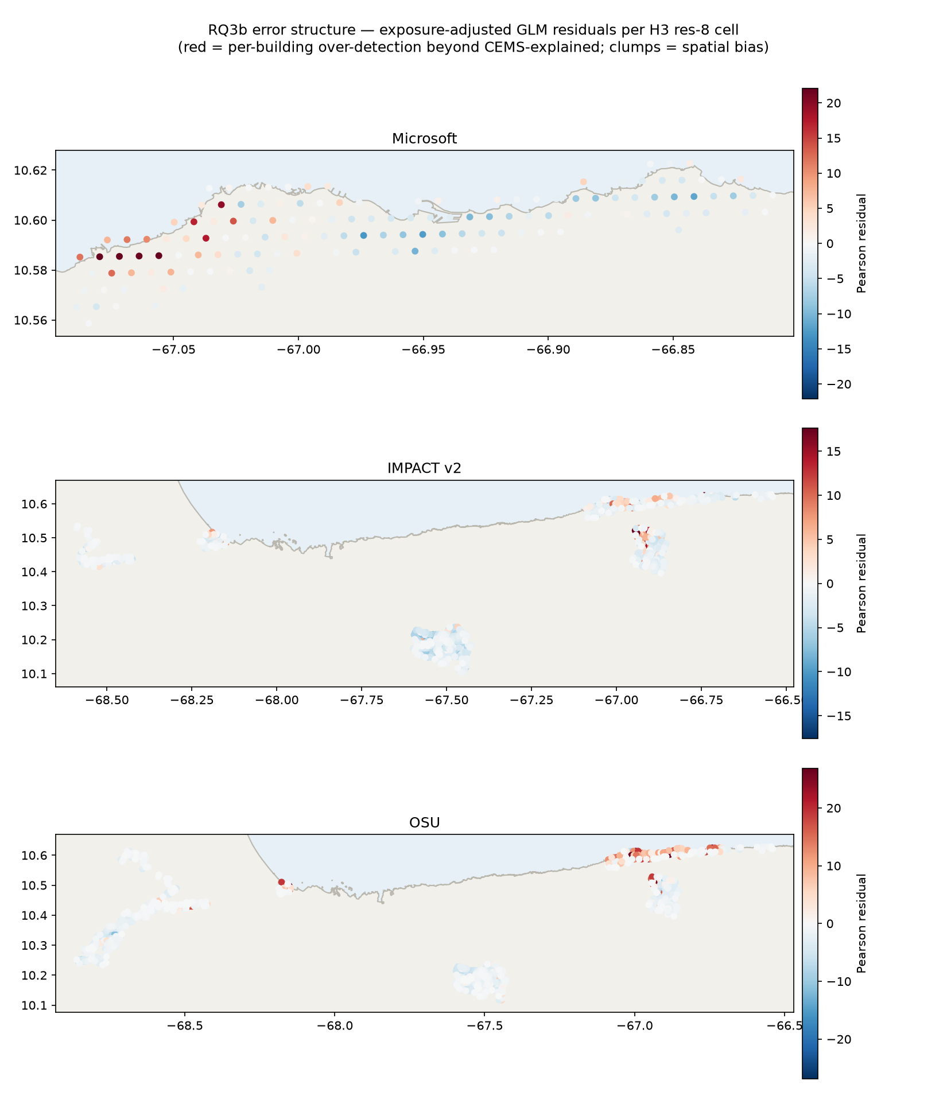
Where each product over-flags once its building stock is accounted for (red = more flags than the recorded damage explains), for the three products the error-structure test covers. Each panel autoscales to its own analysed region, which is why they look so different: Microsoft analysed a single ~30 km coastal strip, so its few hundred grid cells appear as individual dots, while IMPACT and OSU are Sentinel-1 swaths spanning roughly 200 km, whose thousands of cells merge visually. IMPACT and OSU residuals follow the coastal severity gradient. Microsoft’s error is a single hard cluster at the west end of its region.
The same cell lattice yields two results that the Discussion takes up. First, nothing in a product’s own flag pattern predicts how reliable it is: across the fifteen product-and-area combinations, no correlation between the pattern signals (flag rate, clustering, agreement with other products) and measured reliability was statistically distinguishable from zero. Second, mapping each product’s errors cell by cell, 78–86% of each product’s territory shows errors scattered at random (noise rather than bias), with the failures concentrated in a few identifiable pockets; Microsoft’s western strip, taken up in Section 8, is the largest.
One product does not fit this benign pattern. Microsoft’s residual error is not a gradient but a single dense cluster in the western coastal strip, and no covariate explains it. At this point in the analysis we cannot say what the cluster is: real over-detection and a local gap in the reference would look identical. Section Section 8 resolves the question with the other two references.
That ambiguity applies to every number in this section, not just the anomaly. Everything above assumes CEMS is complete within its extents. The next section tests that assumption.

The scorecard in both frames, in full
The pooled scorecard is one place’s scorecard. That cautionary tale generalizes, and it bounds every headline number in this paper. CEMS activated five separate AOIs, but 96% of its damage points sit in one of them: Caraballeda (1,468 points, against 26 in Morón, 14 in San Felipe, and 3 each in Caracas and Santa Cruz). Splitting the scorecard by AOI (Figure 4) shows two things. First, the pooled numbers are Caraballeda’s numbers: the per-AOI Caraballeda row reproduces the headline scorecard almost exactly. Second, outside Caraballeda every product keeps flagging at scale (IMPACT marks 9,445 buildings in the Caracas AOI, UH marks 32,145, 27.5% of the stock, in Santa Cruz) while measured precision collapses to 0.00–0.02 everywhere. We state plainly what those zeros can and cannot mean. They are floors against a reference that recorded almost nothing in those AOIs, so two explanations are confounded: the products hallucinating where damage is sparse (the same low-damage-zone mechanism as the UH agricultural case and the Microsoft west strip), and CEMS under-recording damage in AOIs it mapped thinly. The crowd cannot arbitrate here: the MapSwipe campaign concentrated on the coastal strip, and at most 12% of these out-of-Caraballeda flags fall on voted cells. Recall is measurable only in Morón (26 points), where the best product finds 19% of it. What survives the ambiguity is the conditional: every performance claim in this paper describes dense-damage coastal terrain, and in the four low-damage AOIs the products’ flags are almost entirely uncorroborated by any reference we have.
Pooling all five AOIs gives the as-delivered scorecard: the product as a responder received it, junk zones included. As-delivered precision: Microsoft 0.081, OSU 0.036, IMPACT 0.032, UNEP 0.027, LIST 0.026, UH 0.009. Two things stand out. UH’s number is ten times worse than its best-case 0.093, because most of its flags sit in the low-damage AOIs (32,145 in Santa Cruz alone). And Microsoft’s number is unchanged, not because its model behaves differently, but because it only published flags for the coastal strip it had analysed carefully. Restraint in coverage is itself a product property: shipping fewer, better-scoped zones protected Microsoft’s as-delivered precision, while shipping everywhere destroyed UH’s.
Two mechanisms make the as-delivered numbers what they are, and both are worth stating because they answer the obvious objection: shouldn’t precision be destroyed outside the one dense zone? The first is arithmetic. Because the four low-damage AOIs record almost no damage, precision there is essentially zero, and the pooled figure is a flag-weighted average, so a product’s as-delivered precision falls by almost exactly the share of its flags that land outside Caraballeda: Microsoft 0% of flags and 0% lost, OSU 17% and 16%, IMPACT and LIST 52% and 52%, UNEP 68% and 68%, UH 90% and 90% (every product lands on the diagonal precision lost = share of flags in the dead zones; plotted in Figure 11, in the Appendix). Precision is not resisting the false alarms; it collapses in direct proportion to where each product chose to flag. The second mechanism means even this understates the problem: the as-delivered frame can only score flags that fall inside a CEMS extent, and most products flag far beyond one. Of each product’s total flags, the share landing outside every CEMS extent (where no reference can score them at all) is 4% for Microsoft but 43% for OSU, 71% for IMPACT, 76% for UNEP, and 79% for LIST. Since damage was concentrated on the coast, the bulk of those unscoreable flags are almost certainly false positives. So every precision figure in this paper, as-delivered included, is measured on each product’s most favourable, reference-covered subset; the true precision across a product’s full output is very likely lower, and unmeasurably so.
The as-delivered frame also re-runs this paper’s harshest benchmark (the second of the three product-versus-geography comparisons of Table 2). We trained the geography null model (coast distance, building density, and ShakeMap intensity, constructed as described in Section 4) on each product’s full delivered footprint under the same spatially blocked validation, then had it flag exactly as many buildings as that product shipped, taking its highest-risk buildings first. Compared this way, list against list at each product’s own delivered size, four of the six products are matched or beaten by the geography model on both precision and recall (pairs below read precision / recall): IMPACT 0.032 / 0.55 against the model’s 0.040 / 0.68; UH 0.009 / 0.37 against 0.022 / 0.92; LIST 0.026 / 0.65 against 0.032 / 0.78; and UNEP 0.027 / 0.35 against 0.045 / 0.57. At UH’s own list size the geography rule reaches 92% of the reference damage at more than twice UH’s precision. Only two products stay ahead of geography alone: Microsoft (0.081 / 0.55 against 0.053 / 0.36), which shipped only its carefully analysed strip, and OSU (0.036 / 0.85 against 0.032 / 0.77), which flagged so widely it bought recall the null could not match at that list length. This result is unchanged by the matching radius: repeated at 20 m it is the same four products, in the same direction (Appendix). One caveat cuts across all of this: outside Caraballeda the reference is thin, and the penalty for flagging there falls on the products, which did flag, not on the baseline, which did not. To whatever extent CEMS under-recorded those areas, part of the gap would close. But a responder in the first week had exactly the same information deficit, which is the point of the as-delivered frame.

The single-product ceiling: three experiments
Could a better single product fix per-building precision? Three independent experiments in this event say no. The limit behaves like a property of the sensing method rather than of any particular product. We refer to it as the modality ceiling: a precision level that single-method tuning does not rise above. (Note that this is the opposite kind of bound from the reference-driven lower bounds of Section 5: those mean the truth is higher than measured; the ceiling means single-product performance stops improving.)
- Same-sensor agreement barely helps. Requiring both Sentinel-1 coherence products (IMPACT and OSU) to agree raises precision only to 0.088, barely above the single products. Products that share sensor physics share false positives, so voting cannot remove them.
- Product confidence scores add nothing. Sweeping Microsoft’s continuous damage-fraction score (within its own analysed region, where its baseline numbers run higher than in the core region) trades recall 0.66→0.10 for precision 0.10→0.19. The shipped binary flag already sits near the best F1 on that curve. There is no hidden headroom in the confidence field.
- Agreement within one product plateaus too. Microsoft flags corroborated by a second satellite scene are 2.5 times more precise than single-scene flags (0.245 versus 0.097). That is a real gain and worth publishing. But it remains well below the strongest two-product rule (0.372), and in the low-damage zone where two scenes overlap, even flags confirmed by both scenes were rejected by 72% of crowd reviews. Agreement inside one model inherits that model’s calibration failures.

The west-strip case study, in full
The scorecard left the Microsoft west-strip anomaly unexplained. It can now be resolved completely, and the resolution is the paper’s best argument for metadata transparency.
The crowd settles what the cluster is. In the western strip, volunteers judged 71% of Microsoft-flagged locations “no damage”, against a roughly even split in the damage-dense east. Independent people looking at post-event imagery saw nothing at most of the places the cluster flags. The cluster is real over-detection, not a gap in the reference.
The product’s own metadata explains where it came from. Every building in the strip has num_observations = 1: the zone was covered by exactly one satellite scene. The platform behind the product (HASTE; Robinson, Ortiz et al. 2026) trains a fresh model for each scene and uses agreement between overlapping scenes as its only internal check. The west never got that check. Cloud is ruled out as an alternative explanation: the west is the most cloud-free zone in the product, and the visibility check in Methods moved nothing. Splitting the product at the scene boundary shows what the headline number was hiding. The single-scene west flags 28.7% of its buildings, with precision 0.05 and F1 0.10. The multi-scene east flags 7.6%, with precision 0.21 and F1 0.30, the best single-product zone we measured anywhere in this study. The same product contains both.
A head-to-head test of the two overlapping scenes pins down the mechanism. Scored independently on the ~24,700 buildings both scenes covered, the “better” scene’s advantage turns out to be restraint, not accuracy: it flags 4.9% of buildings against the other’s 27.8%, but its flags are crowd-confirmed at a lower rate (7% versus 14%). Microsoft’s merge rule, which resolved conflicts in favour of that scene, was directionally right (68% of the overruled flags were crowd-rejected) but silently discarded roughly 845 flags on buildings the crowd judged damaged. And buildings flagged by both scenes were still 72% crowd-rejected in this low-damage zone. The failure unit is the calibration of each per-scene model, not the satellite, the provider, or the product as a whole.
A cross-product control seals that attribution. UH’s authors confirm their analysis ran exclusively on Vantor imagery (the same commercial source as the failing scene) and over the same strip UH shows the opposite pattern: it flags 3.4% of buildings in the west at precision 0.138 (its best zone anywhere), against Microsoft’s 32.4% at 0.033. Same imagery vendor, different model, no cluster; the failure travelled with the per-scene calibration, not the pixels. (UH’s acquisition dates are unconfirmed, so this is vendor-level rather than scene-level evidence.)
Three things about this case study generalize. First, a single product-level metric averaged over a 4× internal quality split, and the split was only detectable because per-building provenance was published. Second, the provider’s own validation missed the failure: the failing scene was exactly the one absent from their labeled validation set, and the platform’s previous external evaluation (Turkey) showed the opposite bias, conservative under-flagging. Per-scene behaviour in a new event was not predictable from the track record. Third, the diagnosis was available during the response: the crowd campaign that rejected 71% of the strip’s flags finished within days of the flags being published, but no channel existed to carry that signal to the provider. For the five products that publish no per-building provenance, we can show that they fail but never why.

A version postscript: what a product revision changes
One provider revised its product after the study window: OSU delivered a v1 on 22 July (confidence tiers, ~8% expanded coverage, 69,431 flags versus v0’s 58,870). The paper scores v0 throughout, because v0 is what responders had during the response; the operational dashboard has moved to v1. Since both versions key to the same building base, they can be scored identically on the common extent against the same 1,488 CEMS points (this comparison spans OSU’s full extent, so its precision runs lower than the core-region scorecard figure). The result: precision 0.036 (v0) versus 0.034 (v1), recall 0.68 versus 0.64, minimal accuracy change, while more than half the flag list turned over (v1 dropped 30,565 of v0’s 57,066 flags and added 42,723 new ones). A revision that relabels half the buildings without moving precision or recall is itself evidence for this paper’s central reading: at the individual-building level these products are noise-dominated, and version-to-version stability deserves a place beside accuracy in how such products are judged. The area-level signal, by contrast, is robust to exactly this kind of churn.

Radar and optical: why they fail differently
Optical products (Microsoft, UH) classify what damage looks like from above. Radar coherence products (IMPACT, OSU) measure something else: whether the fine-scale arrangement of radar reflectors inside each pixel stayed stable between satellite passes. An intact building is a stable reflector and keeps high coherence; a collapse rearranges the reflectors and coherence drops. Vegetation never holds coherence in the first place, so coherence methods are largely immune to the farmland and vegetation changes that produce false alarms in optical and amplitude-based methods. LIST also runs on radar, but not on coherence: per the provider it is a deep-learning change-detection model (a ResNet) applied to before-and-after radar images (no methodology document accompanied the delivery), so we do not assume it shares that protection. UNEP’s debris mass is likewise radar-derived.
The contrast is measurable in this event. Santa Cruz serves as a control case: the expert reference analysed it and found almost no damage, and much of it is agricultural. There the two coherence products flagged 1.2% and 0.9% of buildings, while the optical UH product flagged 27.5% (Section 5).

Performance versus matching radius
All CEMS-based results in this paper use a 10 m matching radius, and every model is fitted and evaluated at that radius. Because the radius defines the target itself, the whole analysis is re-run at 20 m (doubling the positive class: 2,733 labelled buildings against 1,350) and at 30 m (the line-of-sight scale).
Table 3 in the main text carries every product and voting rule at all three radii in the paper’s primary machinery; the models’ radius behaviour is summarised below.
Three patterns to read from it. Every number rises with the radius, because a flag one or two buildings away from recorded damage starts to count as a hit. The geography null gains fastest: a wider radius smears each expert point into a blob of neighbouring buildings, making the target area-shaped, which is exactly the shape a smooth spatial predictor captures well; refit at 30 m the null’s F1 climbs 0.128/0.206/0.282 and matches or beats five of the six products. And combination stays ahead at every radius (voting at its best cut 0.290/0.342/0.364, fusion 0.343/0.386/0.427), so the paper’s conclusions do not depend on the radius choice; the tight 10 m label is simply the most demanding reading, and the one where a building-level claim means a building. The wider radius raises all absolute values, because a flag one building away from a recorded damage point starts to count as a hit. It also flatters the geography null specifically, for a reason worth understanding: a wide radius smears each reference point into a blob of neighbouring buildings, making the target area-shaped, which is exactly the shape a smooth spatial predictor captures well. The tighter 10 m label concentrates the positives onto individual buildings, where per-building discrimination is required, and there the case for combining products strengthens, from 1.8× to 2.3× the best single product. Reporting at 10 m is therefore both the more consistent choice and the more demanding one.
A second implementation check belongs beside this one. The headline scorecard matches flags to CEMS points on each product’s native geometry, while the fusion analysis matches by building centroid; a reader could reasonably worry that this difference alone shifts the numbers. It does not: at the same 10 m radius the two implementations agree to within 0.005 for every product:
Table 7: Precision at r = 10 m under the two matching implementations. Centroid versus native-geometry matching is worth at most 0.005; with the radius held fixed the two are effectively the same measurement.
product | scorecard (native geometry) | fusion analysis (centroid) | difference
UH | 0.090 | 0.093 | +0.003
UNEP | 0.090 | 0.086 | −0.004
Microsoft | 0.080 | 0.081 | +0.001
IMPACT | 0.070 | 0.069 | −0.001
LIST | 0.060 | 0.057 | −0.003
OSU | 0.040 | 0.045 | +0.005

The per-building visibility (cloud) check. Only Microsoft publishes a per-building visibility field. Scored against it, the effect is negligible in this event: 3.6% of buildings are mostly obscured, precision is unchanged under any visibility filter, and exactly one missed reference point falls on an obscured building. The model abstains under cloud rather than flagging into it.

Was the model-versus-product comparison fair?
This section carries the machinery behind Section 4’s fairness claims, for the reader who wants to check them.
Which learner represents geography best. Every feature set is fitted with both a class-balanced logistic regression and a random forest (400 trees, minimum leaf 20), and the stronger one is reported:
Table 8: Average precision by learner and feature set, under spatially blocked validation. Where products are involved the learner is irrelevant; for the geography null it is not, and which learner wins depends on the analysis layer.
feature set | random forest | logistic
all inputs (weighted fusion) | 0.283 | 0.284
context only, core region | 0.045 | 0.060
context only, full delivered footprints | stronger for 5 of 6 | stronger for MS only
products only | 0.258 | 0.271

Wherever products enter, the two learners are indistinguishable, so no fusion result depends on the choice. The null is a different matter, and the two analysis layers disagree about which model represents geography better. In the compact core region the logistic wins (0.060 against 0.045): shaking is near-constant there and the remaining relationship is smooth, so the forest mostly fits block-specific structure that does not generalise. Across the full delivered footprints the ranking reverses for five of six products, because those regions span real variation in shaking that interacts non-linearly with coast distance and density. The paper therefore uses the logistic null in the core region and the forest null in the as-delivered analysis: the report-the-stronger rule applied twice. One further reporting detail: the headline fusion number comes from the logistic regression, which scores identically to the forest (AP 0.28 either way), while the null and its products-only mirror are both fitted with the forest so that those two are directly comparable to each other.
How much event information the null uses, by analysis layer. Within the compact core region the ShakeMap estimate barely varies and its measured importance is exactly 0.000: there the null runs on coastline distance and building density alone, and its skill is a hindsight description of where damage happened to fall. Across the full delivered footprints, shaking varies for real and carries 0.25–0.31 of the model’s weight, so the null genuinely uses event information there. Microsoft is the exception that proves the mechanism: it shipped only the coastal strip, and over that near-identical ground the shaking term again drops to zero.
Buffered validation. Spatial blocking leaves block edges: a training building just across a block boundary resembles its test-side neighbours, which could flatter a smooth model. Checked directly by re-running the validation with training buildings excluded within 300 m and then 500 m of any test building: the null’s F1 moves 0.128 to 0.126 at both buffers (AP 0.060 to 0.059/0.058) and the fusion’s F1 0.343 to 0.345/0.340, so no conclusion rests on the unbuffered design. The building-density feature is computed over all buildings including test rows; it uses only pre-event footprint locations, never labels, so it carries no label information across folds.
Coefficients and thresholds are protected separately. The model’s coefficients are estimated strictly out-of-fold: each building’s score comes from a model that never saw its block. The decision threshold (the cut that turns the continuous risk into a flag list) is a second, separate choice that blocked validation does nothing to protect, so where a single operating point is reported the cut is selected inside the training folds and applied blind to the held-out data. The difference this makes here is nil (F1 0.129 with the cut chosen out-of-sample against 0.128 chosen in hindsight), but that is a fact about this sample size (a single scalar estimated from hundreds of thousands of buildings is pinned down closely either way), not a general licence: on a small reference the same shortcut could flatter a model materially.
Why a single product’s average precision is degenerate. Average precision is a recall-weighted sum over the steps of a precision–recall curve, and a binary flag list has only two steps: the flagged set itself, and the trivial “flag everything” endpoint. It therefore evaluates to
$${AP}_{\text{binary}}=P⋅R+(1−R)⋅π$$
where $π$ is the prevalence of damage. The second term is free credit that any predictor whatsoever collects for the flag-everything endpoint. Because $π$ (0.023 here) is far below every product’s precision, the term drags each product’s AP down toward prevalence, hardest for the products with the lowest recall. The effect is to compress genuinely different products into a narrow band (0.042–0.055 across our six, whose precisions actually range from 0.045 to 0.093), sitting right where a mediocre continuous score also lands (the forest null’s AP is 0.045). Two products can share an AP because one has high precision and low recall while the other has the reverse; the number conceals exactly the trade-off an operational reader cares about. This is why the paper reports AP only among the continuous scores and places the products as points, never as AP bars beside them.
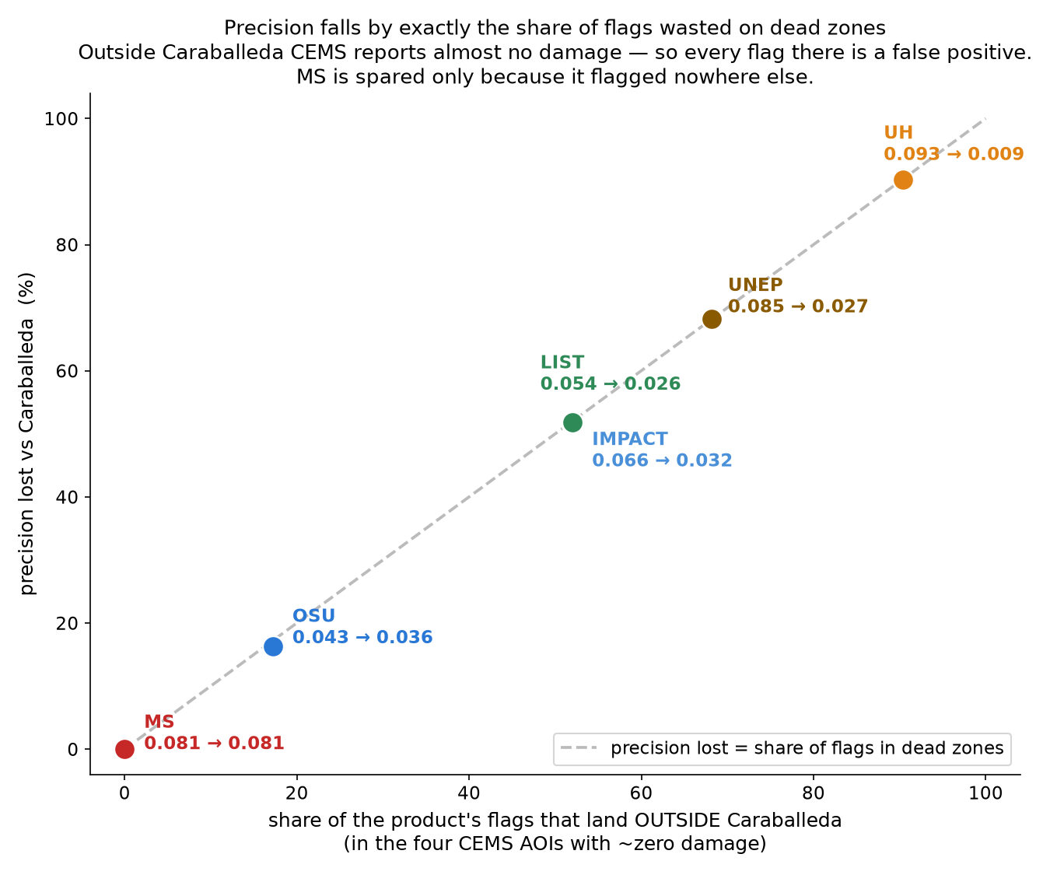
Figure 11: Why as-delivered precision falls the way it does. Each product’s as-delivered precision (y) is plotted against the share of its flags that land outside Caraballeda (x), where the reference records essentially no damage. Every product lies on the diagonal (precision lost equals the share of flags in the dead zones), so the as-delivered precision is governed almost entirely by where a product chose to flag, not by any resistance to false alarms. Microsoft is spared only because it flagged nowhere else. This is the arithmetic behind the first mechanism in Section 5.

Confidence intervals for the headline numbers
Every interval below is a 95% spatial block bootstrap: H3 cells (res-8 in the core region, 133 blocks; res-7 as-delivered) are resampled with replacement 2,000 times and each statistic is recomputed from the frozen match indicators as a ratio of cell-weighted sums. The same cell draw is shared by every predictor, so differences between predictors are paired. The models are scored from their frozen out-of-fold scores at their frozen operating cuts; nothing is refitted inside the loop, so the intervals measure sampling noise around the reported numbers, not a re-run of the threshold search. Because whole neighbourhoods are resampled, the intervals are wide: one damage cluster entering or leaving the sample moves a product’s precision by more than its decimals suggest, which is worth remembering when reading any two products as “different”.
Table 9: Core region, 95% block-bootstrap intervals. P/R/F1 at 10 m, crowd-adjusted precision (10 m), F1 at 30 m, and visits per find (30 m). The 20 m radius and the as-delivered lens are in the frozen artefact (RQ9).
 | 10 m |  |  |  | 30 m
 | P | R | F1 | P (crowd-adj) | F1 | visits/find
Microsoft | 0.081 (0.049–0.123) | 0.474 (0.374–0.564) | 0.139 (0.087–0.197) | 0.242 (0.198–0.299) | 0.292 (0.193–0.397) | 8.8 (5.9–14.3)
IMPACT v2 | 0.069 (0.044–0.095) | 0.462 (0.387–0.526) | 0.120 (0.080–0.160) | 0.256 (0.202–0.339) | 0.318 (0.228–0.398) | 10.3 (7.6–15.7)
OSU | 0.045 (0.030–0.061) | 0.688 (0.637–0.734) | 0.084 (0.057–0.112) | 0.230 (0.190–0.284) | 0.239 (0.173–0.306) | 19.3 (14.1–29.2)
UH | 0.093 (0.053–0.146) | 0.337 (0.263–0.418) | 0.146 (0.089–0.207) | 0.418 (0.324–0.510) | 0.284 (0.185–0.384) | 7.2 (4.6–12.2)
LIST | 0.057 (0.039–0.075) | 0.564 (0.504–0.614) | 0.103 (0.072–0.132) | 0.242 (0.200–0.296) | 0.286 (0.212–0.356) | 12.6 (9.4–18.6)
UNEP | 0.086 (0.047–0.139) | 0.313 (0.235–0.395) | 0.135 (0.079–0.200) | 0.253 (0.202–0.319) | 0.281 (0.179–0.393) | 6.8 (4.4–11.8)
1-of-6 | 0.034 (0.023–0.048) | 0.768 (0.713–0.816) | 0.066 (0.044–0.090) | 0.208 (0.177–0.249) | 0.195 (0.138–0.254) | 26.4 (19.1–40.6)
2-of-6 | 0.056 (0.038–0.075) | 0.710 (0.657–0.753) | 0.104 (0.072–0.137) | 0.240 (0.201–0.291) | 0.284 (0.209–0.356) | 15.2 (11.3–22.5)
3-of-6 | 0.101 (0.069–0.135) | 0.605 (0.534–0.663) | 0.173 (0.124–0.222) | 0.283 (0.228–0.360) | 0.407 (0.310–0.493) | 7.5 (5.6–10.7)
4-of-6 | 0.187 (0.123–0.257) | 0.419 (0.335–0.499) | 0.259 (0.184–0.326) | 0.383 (0.296–0.506) | 0.504 (0.376–0.603) | 3.4 (2.5–4.9)
5-of-6 | 0.339 (0.230–0.445) | 0.232 (0.154–0.308) | 0.276 (0.195–0.343) | 0.560 (0.404–0.726) | 0.487 (0.354–0.593) | 1.7 (1.2–2.3)
6-of-6 | 0.640 (0.569–0.732) | 0.093 (0.052–0.137) | 0.163 (0.097–0.227) | 0.932 (0.862–0.987) | 0.309 (0.192–0.417) | 0.8 (0.6–1.0)

Table 10: Model frame (building labels, core region), 95% block-bootstrap intervals: F1 at each predictor’s frozen operating point and its paired difference from the logistic geography null. A difference interval that excludes zero separates from the null; only the combination rules do so upward.
 | F1 at operating point | F1 − null
Microsoft | 0.142 (0.092–0.201) | +0.014 (-0.028–+0.061)
IMPACT v2 | 0.123 (0.082–0.163) | -0.006 (-0.042–+0.032)
OSU | 0.085 (0.058–0.116) | -0.043 (-0.076–-0.012)
UH | 0.148 (0.094–0.219) | +0.021 (-0.032–+0.081)
LIST | 0.104 (0.073–0.137) | -0.024 (-0.057–+0.008)
UNEP | 0.139 (0.083–0.207) | +0.010 (-0.037–+0.066)
geography null (logistic) | 0.128 (0.091–0.168) | —
flat k-of-6 voting | 0.290 (0.199–0.360) | +0.158 (+0.081–+0.227)
weighted fusion | 0.343 (0.268–0.398) | +0.214 (+0.162–+0.256)

In the as-delivered lens the product intervals widen further (UH’s precision 0.009 runs 0.003 to 0.018); the full set is in the RQ9 artefact. Two claims elsewhere in the paper lean on these intervals. The 6-of-6 rule’s sub-1 visits per find survives: its interval tops out at 0.96. And the null-versus-product story sharpens to: no product demonstrably adds information beyond geography at its shipped operating point, one (OSU) demonstrably falls short of it, and both combination rules demonstrably clear it.

How the crowd adjustment works, and what happened when the crowd voted again
Every crowd-adjusted precision in this paper comes from one simple rule, and Figure 12 shows it acting on a real street in Catia La Mar. A flagged building with an expert damage point within 10 m counts as a hit outright; the crowd plays no part in that. Every other flag sits inside one of the ~50 m cells that MapSwipe volunteers voted on, and the rule is: if most volunteers who saw that cell said yes, damaged, the flag is counted as confirmed damage and improves the adjusted precision; if they said no or not sure, it stays a false alarm. Flags in cells the volunteers never saw are assumed to contain damage at the same rate as the flags the volunteers did see.
In August 2026, after this paper’s numbers were frozen, the campaign over this strip was run a second time: 728 new volunteers re-judged exactly the same 3,482 cells, and each cell now received about sixteen votes instead of six. Same buildings, different people, a much harder look. Two caveats keep this from being a perfect replication. The answer buttons changed: round 2 offered no “no damage” option, so a volunteer who saw nothing wrong had to press “not sure”, which means round 1’s headline finding for this strip (71% of cells actively judged undamaged) simply cannot be re-measured. And the two rounds showed volunteers different, though similarly dated, satellite images.
What can be compared across the rounds is how much damage the crowd confirmed, and that held up. Of Microsoft’s 7,661 flags in this strip with no expert match, the first crowd confirmed 13.2%; the second, deeper-looking crowd confirmed 11.5%. Two independent juries agree that roughly one flag in eight has crowd-visible damage under it. If anything, the harder look confirmed slightly less, so the crowd-adjusted values in this paper should be read as sitting a little high, consistent with their stated role as upper estimates.
What did not hold up is which cells were confirmed: only about a quarter of the cells the first crowd confirmed were confirmed again by the second (the purple outlines in Figure 12). That sounds alarming until one asks how much two small juries should agree even if volunteers were perfectly consistent, and the answer is: not much. Six votes on a borderline cell is close to a coin toss, and once that known voting noise is accounted for, the two rounds’ underlying judgements agree well (correlation 0.63, versus 0.29 before the correction). Most of the apparent chaos is small vote counts, not fickle volunteers. The practical lesson is the one this paper already follows: a single cell’s verdict is too noisy to lean on, but sums over thousands of cells are steady, which is why crowd verdicts appear here only inside aggregate numbers, never as building-level ground truth.
Finally, the cost in numbers. Recomputing each product’s crowd-adjusted precision with the second round’s verdicts in place of the first moves it by at most 0.03 in either direction: Microsoft’s falls from 0.237 to 0.223, UNEP’s from 0.074 to 0.043 (nearly all of its crowd-reviewed flags sit in this one strip), and IMPACT’s and UH’s tick slightly upward. No product overtakes another.
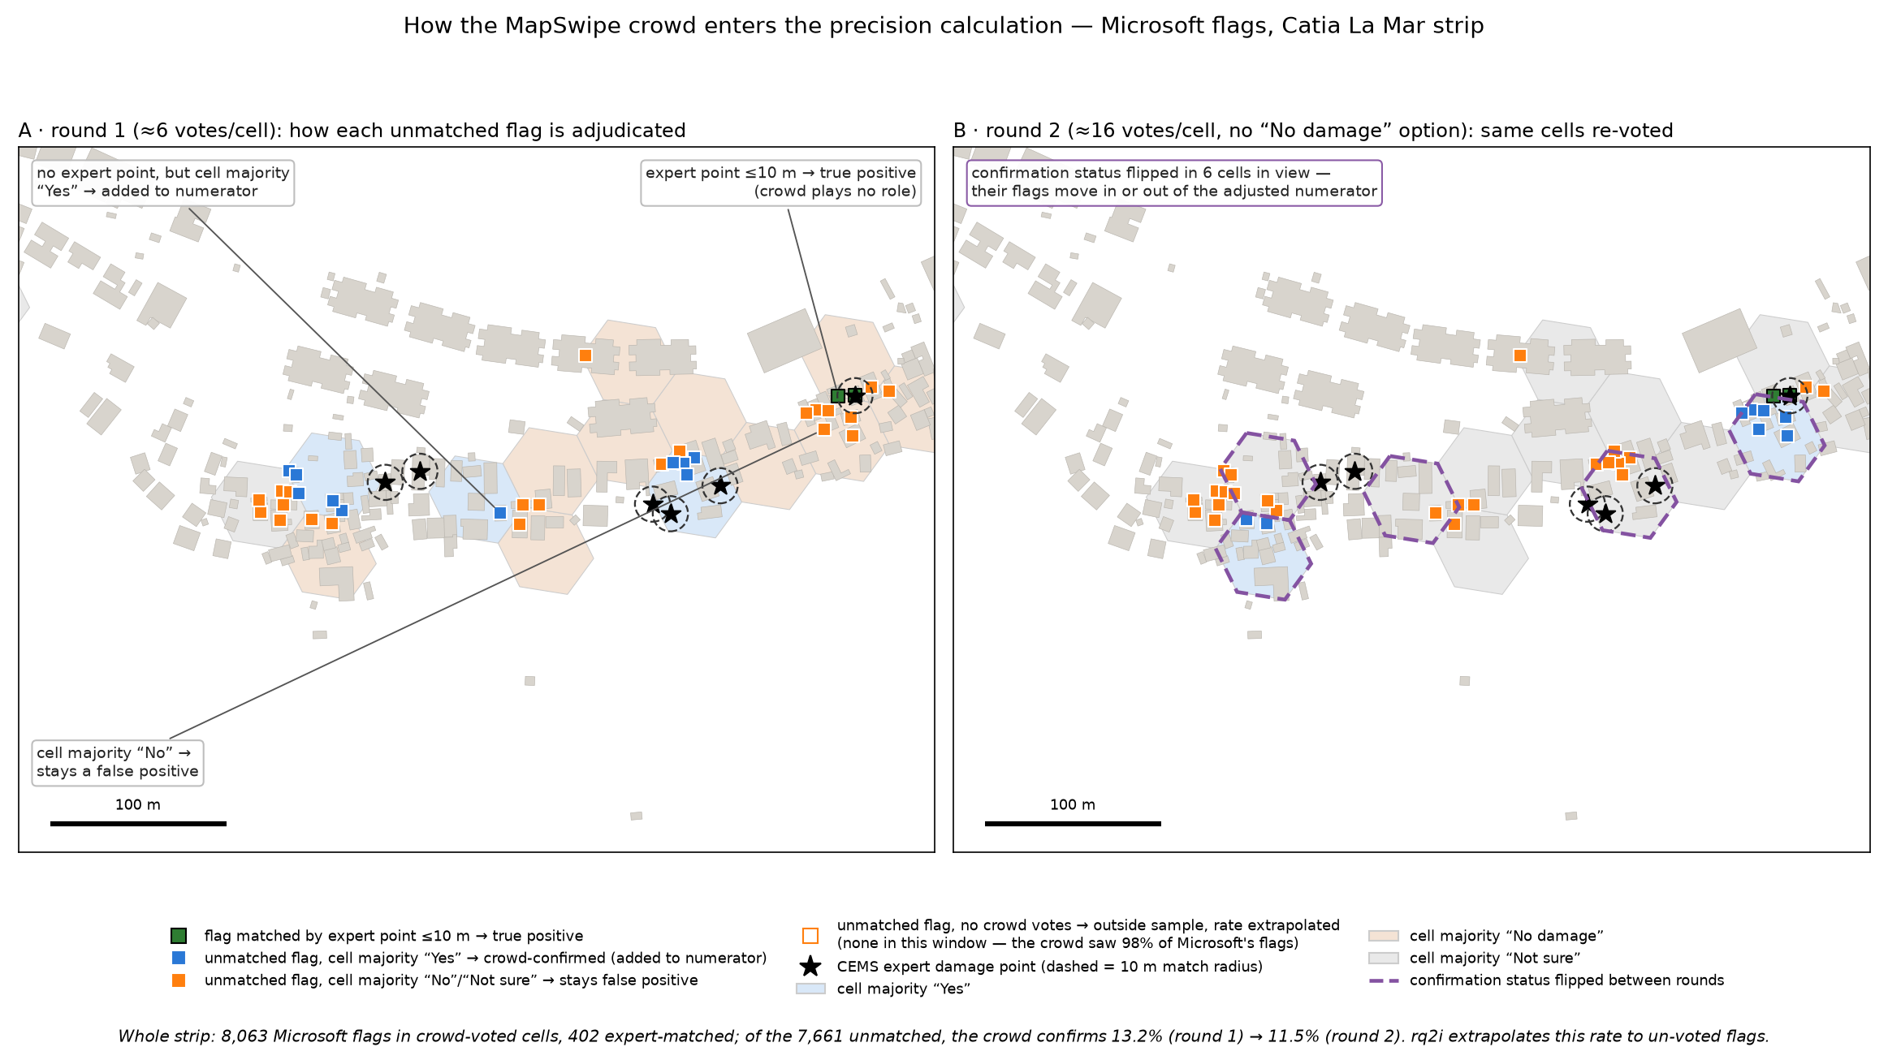
Figure 12: How the MapSwipe crowd enters the precision calculation, and what an independent re-vote changed. Both panels show the same Catia La Mar neighbourhood; hexagons are the ~50 m crowd task cells, tinted by majority verdict. A, round 1: a flag matched by an expert point within 10 m is a true positive (green); an unmatched flag in a cell the crowd judged damaged is counted as confirmed and improves the adjusted precision (blue); in a cell judged undamaged or uncertain it remains a false alarm (orange). B, round 2, re-voted the identical cells at ~16 votes each, with no “no damage” answer available (its “not sure” absorbs it): purple outlines mark cells whose verdict changed sides. Individual cells flip; the total the adjustment depends on barely moves (13.2% → 11.5% of the strip’s unmatched Microsoft flags confirmed).

Reproducibility note
All analyses run from immutable data snapshots, frozen on 2026-07-15 and stored as Parquet, GeoParquet, CSV, and GeoJSON files in the project’s Azure blob storage. Per-question scripts, running notes, and the full findings register, including every negative and superseded result, accompany this draft in the project repository.

