**Marine Heat Wave function**

**Rational**

Marine heatwaves (MHWs) have been shown to be increasing in frequency, strength, and duration with the warming of the global ocean (Oliver et al., 2018). These prolonged events of anomalously high ocean temperatures have substantial environmental and social economic impacts (Hobday et al., 2016; Oliver et al., 2018). These strong impacts, as well as the prospect of a high frequency of events, emphasizes the need to understand the dynamics of MHWs through increased observations and, importantly monitor in real time and attempt to predict the occurrences of these events. Hobday et al., 2016 have proposed a universal definition of MHWs, which allows for comparisons across various spatial and temporal scales. The standardized definition provides clear thresholds for operational systems allowing for increased confidence in real time monitoring and future predictions of MHWs. Along with the definition of MHWs, Hobday et al., 2016 have provided a python function to track marine heat waves (github.com/ecjoliver/marineHeatWaves). The function identifies MHW events and provides numerous diagnostics such as the intensity and duration of the events. The function requires single point/timeseries input data, which hinders the identification of the spatial scale of MHWs. The spatial extent of MHWs in real time and as forecasts provide stake holders and decision makers with crucial information for mitigations strategies. In order to easily identify the spatial extend of MHWs in real time and as forecasts a function was developed which focused on identifying the spatial extend of MHWs as part of the Ocean and Coastal Management System (OCIMS).

**Methods**

The universally accepted definition of MHWs suggested by Hobday et al. 2016 specified the conditions necessary to define anomalously warm events as MHWs. The conditions are set as follows:

* Ocean temperature must be greater than a spatially and temporally varying threshold. The threshold is defined by the 90th percentile of temperature values at the selected location for a climatological period. The percentile values should be calculated relative to 30-year climatology (Figure 1).
* Ocean temperature must exceed the percentile threshold for at least 5 consecutive days. If MHWs events (5 consecutive days above the defined percentile threshold) are separated by periods of 2 days or less of temperatures below the percentile threshold the MHW event is considered a single continuous event (Figure 1).

The threshold for determining MHWs must be calculated from climatologically grouped set of values for the selected location. This ensures that the threshold varies spatial and temporally in order to account for spatial and temporal variability across the ocean. A full description of the conditions needed to define MHWs as well as recommendations of best practices are available in Hobday et 2016.

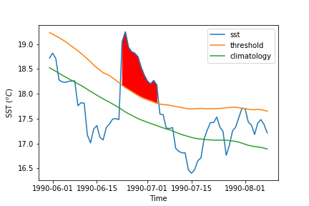

Figure 1: An example of the marine heat wave. The solid red fill highlights the period where sea surface temperature (SST) is above the threshold calculated for the selected region. The SST, threshold and climatology are represented by the solid blue, orange and green lines respectively.

**Comparison**

The marine heat wave detection code (github.com/ecjoliver/marineHeatWaves) provides a powerful tool for identifying MHWs and the associated diagnostics for single point or timeseries data; however, the function is resource intensive for large domains. The function will be referred as the pyMHW. The operationalization of the function requires the full domain of the South African exclusive economic zone (EEZ) in real time. Therefore, a less intensive function focused on covering the spatial domain of the EEZ was developed. The function will be referred to as the deff_MHW. The two functions were compared to confirm the deff_mhw function correctly identifies MHWs.

Both the pyMHW and deff_MHW function use a moving 31-day average when calculating the percentile threshold values and climatology (for data with a daily timescale). The pyMHW function has an additional option of a sliding window about day-of-year used for the pooling of values and calculation of climatology and threshold percentile, the default is 11 days. This option was set to zero as the 31-day moving already pools the percentile threshold and climatology values.

The focus of the comparisons was on the percentile threshold. Figure 2 shows the mean bias between the threshold calculated by the respective functions (py_MHW - deff_MHW). The mean bias for the entire southern African region was minimal with a range of ± 0.015°C. The small bias can be considered negligible as it is smaller than the typical accuracy of SST satellite products (O’Carroll et al. 2019).

**Figure 2:** The mean bias between the percentile thresholds calculated through the py_MHW and deff_MHW (py_MHW-deff_MHW). Both functions used SST AVHRR_OI (DOI: 10.5067/GHAAO-4BC02) from 01-01-1982 to 01-01-2019.

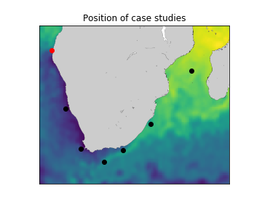The bias between the thresholds of each function was further analysed with case studies at selected locations. Comparing timeseries at the selected locations allows for a temporal comparison of the percentile threshold values. The locations were selected to cover a range of oceanographic provinces as well as oceanographic and biologically important areas (Figure 3). In addition, these areas are characterised by extreme dynamic oceanographic processes and, therefore, most likely to result in large differences in calculations using SST. Each of the case studies showed minimal differences (±0.015) between the calculated thresholds. For brevity, only the timeseries at the Angola Benguela front was shown (Figure 4). The Angola Benguela front was chosen as the differences in the percentile threshold were largest in the bias map (figure 2). The timeseries clearly highlight that although the differences are relatively large in the bias map (Figure 2) the differences between the percentile threshold were negligible over the timeseries (Figure 4).

**Figure 3:** The locations of the selected case studies. The Angola Benguela front is highlight by the red circle. The Lüderitz upwelling, Cape Peninsula upwelling, Agulhas Bank, Port Elizabeth regions, KZN Bight and Mozambique are denoted by the black circles respectively. 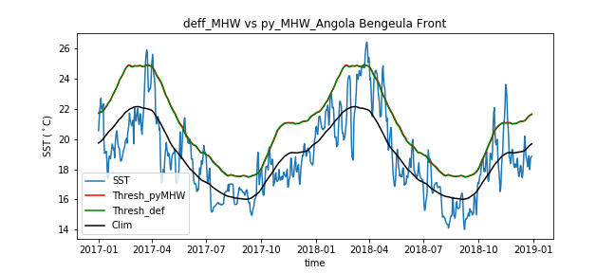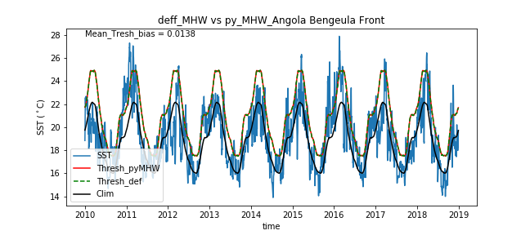

**Figure 3:** A timeseries of the SST, daily climatology (31 day moving average), percentile threshold calculated from the deff_MHW and py_MHW functions, respectively.

**Diagnostics**

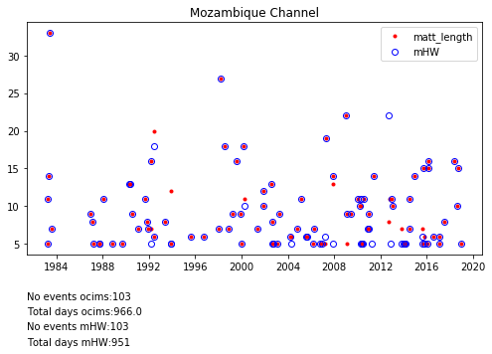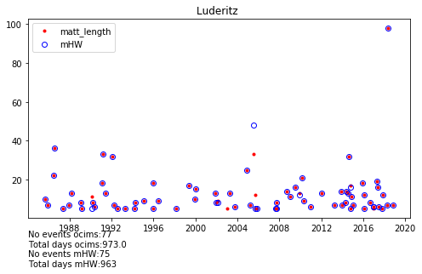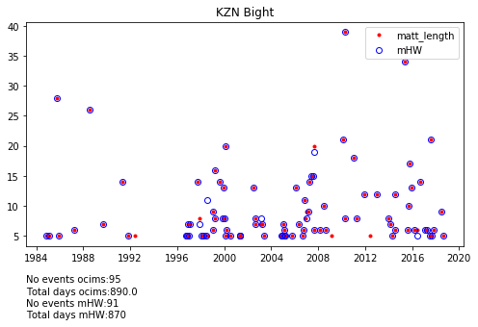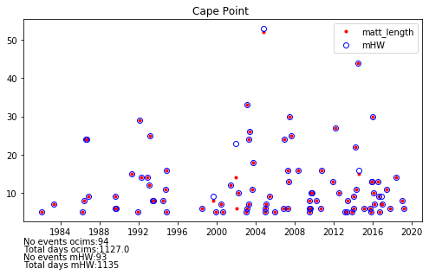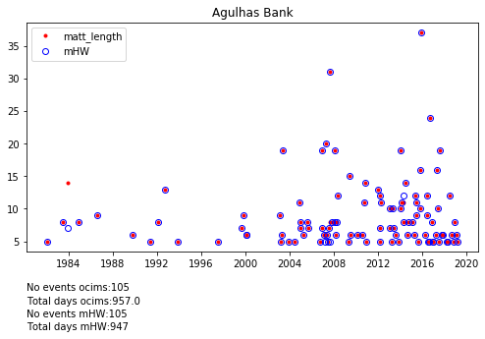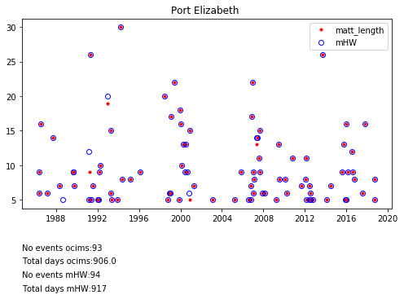

**Limitations**

As stated, a warm event is only classified as a MHW if the temperature is above the calculated threshold for 5 consecutive days. The prescribed time condition introduces limitations as real monitoring is inherently dependant on the availability SST data. Therefore, when monitoring MHW in real time, warm events which are above the prescribed threshold but do not fulfil the time condition may retrospectively be classified as a MHW. This limitation may result in the late identification of MHW events. To account for the latency in SST data, the function is adapted to identify marine heat spikes (MHS), which are classified as warm events above the prescribed threshold for >3 and <5 consecutive days. The MHS will help to identify regions which are likely to develop into MHWs.

**Conclusions**

The deff_MHW function showed a negligible difference between the calculated threshold and the threshold calculated by the py_MHW function both spatial and temporally. The accuracy of the deff_MHW function provides confidence that the function can be used in creating a MHW identification tool for the South Africa EEZ.

**References**

Hobday, A. J., Alexander, L. V., Perkins, S. E., Smale, D. A., Straub, S. C., Oliver, E. C. J., Benthuysen, J. A., Burrows, M. T., Donat, M. G., Feng, M., Holbrook, N. J., Moore, P. J., Scannell, H. A., Sen Gupta, A., & Wernberg, T. (2016). A hierarchical approach to defining marine heatwaves. *Progress in Oceanography*, *141*, 227–238. https://doi.org/10.1016/j.pocean.2015.12.014

Oliver, E. C. J., Donat, M. G., Burrows, M. T., Moore, P. J., Smale, D. A., Alexander, L. V., Benthuysen, J. A., Feng, M., Sen Gupta, A., Hobday, A. J., Holbrook, N. J., Perkins-Kirkpatrick, S. E., Scannell, H. A., Straub, S. C., & Wernberg, T. (2018). Longer and more frequent marine heatwaves over the past century. *Nature Communications*, *9*(1). https://doi.org/10.1038/s41467-018-03732-9