OCR4all –

An Open Source Tool Providing a Full OCR Workflow

Setup Guide

Version 2.0, May 2019

To be always up to date, especially with a view to new image releases and other innovations around OCR4all, please make sure to subscribe to our mailing list [OCR4all](https://lists.uni-wuerzburg.de/mailman/listinfo/ocr4all).

## Preparation

* You have to prepare the following folder structure:
  + *ocr4all*  (main folder)
    - *models* (folder for the neural network models)
    - *data* (folder for the documents you want to recognize)
      * *\*work title\** (folder that contains all data of a single, specific print/book)
        + *input* (folder for original, coloured/grayscaled book scans on page level)
* This structure can be created provisionally anywhere in your system. However, depending on your system (Linux, Windows, MacOS), you might have to move it later, see below.

## Choosing the right Docker version

* You will need the Community Edition (CE) of [Docker](https://www.docker.com/) for installation.
* **Recommendation:**
  + If you can: **Use Linux!**
  + Else, try to use a more recent Windows version that is compatible with *Docker for Windows*. The procedure for the *Docker Toolbox* version is more complicated and error-prone.
* For Linux: <https://docs.docker.com/install/> (choose your distribution on the left)
* For Windows:
  + There are two ways of using Docker on Windows: *Docker for Windows* and the *Docker Toolbox*.
  + *Docker for Windows*:
    - Available for Windows 10, 64 bit: Pro, Enterprise or Education (Build 14393 or later; check for your version, which can be found in your *System Information*)
    - <https://docs.docker.com/docker-for-windows/release-notes/> (If you do not want to register, do not chose “Download Docker for Windows” right away, but instead use “Download” under the “Stable Releases” section below)
  + *Docker Toolbox* for other (older) versions of Windows: <https://docs.docker.com/toolbox/toolbox_install_windows/>
* Mac: <https://docs.docker.com/docker-for-mac/>
  + Like with Windows, there is *Docker for Mac* und the *Docker Toolbox*: <https://docs.docker.com/docker-for-mac/docker-toolbox/>
  + However, these will not be covered in this guide.

**Following up, you will find three separate guides, each for a Linux system, *Docker for Windows* and for the *Docker Toolbox* (using Windows).**

**You can copy the different terminal commands without line breaks from the accompanying file *Aufrufe.txt.***

## Linux

#### Docker setup

* Follow the instructions under <https://docs.docker.com/install/> …

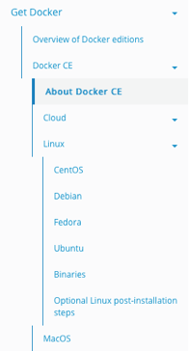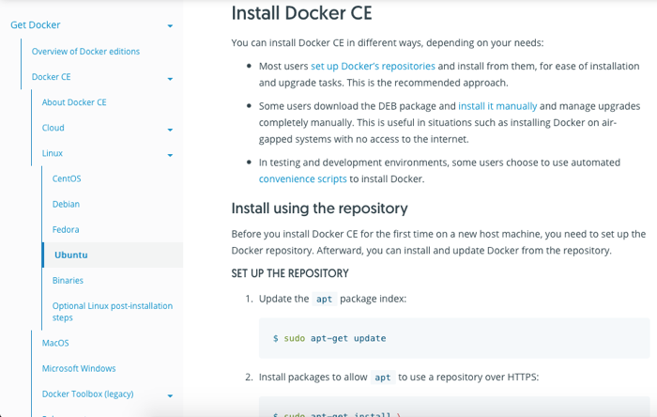

*Fig. 1: Choose Linux under Docker CE. Fig. 2: Choose your Linux version and follow the instructions*.

* … and appreciate that everything works without further adjustments!

#### OCR4all setup

* The OCR4all folder structure detailed above (“Preparation”) can be located anywhere you want.
* **Open a terminal inside the OCR4all folder** and load an OCR4all image by using the following command (this will take up a few minutes and requires a stable connection to the internet):

*docker pull ls6uniwue/ocr4all*

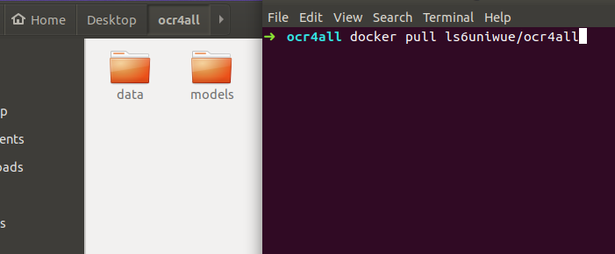

*Fig. 3: Load the OCR4all image via a terminal inside the OCR4all folder.*

* Create the OCR4all container using the following command:

*docker run -p 1476:8080 -p 5000:5000 -u `id -u root`:`id -g $USER` --name ocr4all \  
-v $PWD/data:/var/ocr4all/data \  
-v $PWD/models:/var/ocr4all/models/custom \  
-it ls6uniwue/ocr4all*

(Once again, this may take a while)

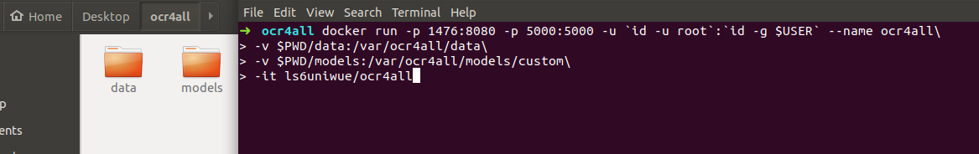

*Fig. 4: Create an OCR4all container.*

#### Browser access and further use

* OCR4all is optimized for Chrome/Chromium.
* Browser access: <http://localhost:1476/OCR4all_Web/>
* In the browser tool, check *Project Overview* -> *Project selection:* If you can find the two pre-loaded books called “Cirurgia” and “GNM”, the mapping (-v *$PWD/data:/…*) is working properly.

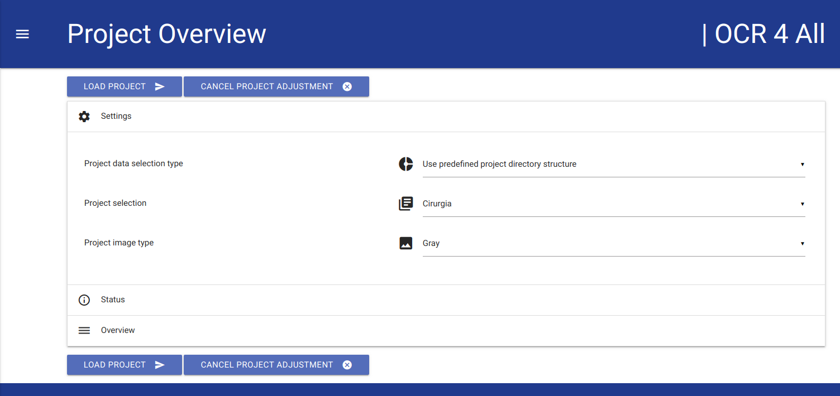

*Fig. 5: Project Overview – mapping is working.*

Otherwise, it´s likely that there was a typo in the “docker run” command, so you will have to create the container again. First, delete the container you just created:

Stop the process in the terminal using *CTRL+C*, then type: *docker rm ocr4all*

Check and correct your command (as with most terminals, you can sift through your previous commands using the arrow keys), especially the “-v *$PWD/data:/…*”-lines, then run it again.

* If everything is set up properly, you can (and should!) restart OCR4all in the future by using:

*docker start –ia ocr4all*

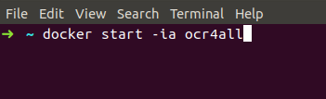

*Fig. 6: Command to (re-)start OCR4all.*

## Docker for Windows

#### Docker setup

* Follow the installation guide under <https://docs.docker.com/docker-for-windows/release-notes/>.

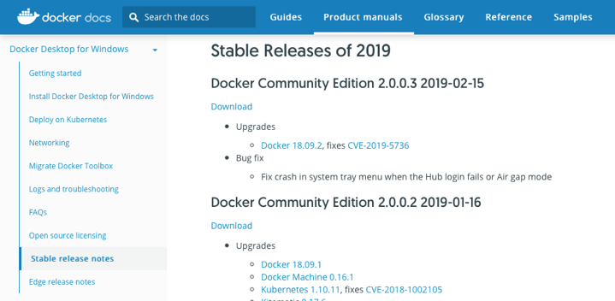

*Fig. 7: Download the latest Docker for Windows version from “Stable release notes”.*

Make sure to give all needed permissions, install all additional drivers etc.

* Start Docker.
* Adjust the Docker settings (Right-click on the Docker symbol in the hidden bottom-right toolbar, then chose *Settings*):
  + *Shared Drives*: Chosen drive (or partition).
    - You will need at least one. Our recommendation: Simply use “C:”.

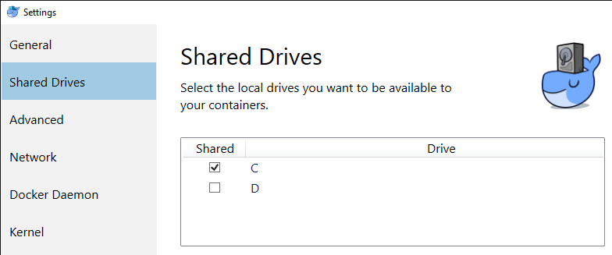

*Fig. 8: Shared drives.*

* + - Click *Apply*. (Attention: This requires a valid, non-empty Windows password. Changing or removing the password later results in a silent removal of your Docker privileges!).
  + *Advanced*: Adjust CPUs (max) and Memory (2GB+) if you want to.

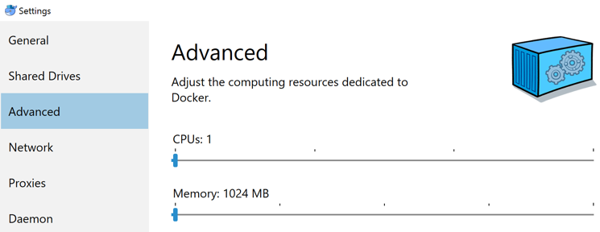

*Fig. 9: Adjust CPUs and Memory if you want.*

#### OCR4all setup

* Move the OCR4all folder structure detailed above (“Preparation”) to the shared drive (or partition). In the following example, we use “C:\Users\Public\ocr4all\...”. We recommend to use the same for the first setup.
* **Inside the OCR4all folder, open PowerShell** (Shift + right click inside OCR4all folder -> Open PowerShell window here) and load an OCR4all image using the following command (this will take up a few minutes and requires a stable connection to the internet):

*docker pull ls6uniwue/ocr4all*

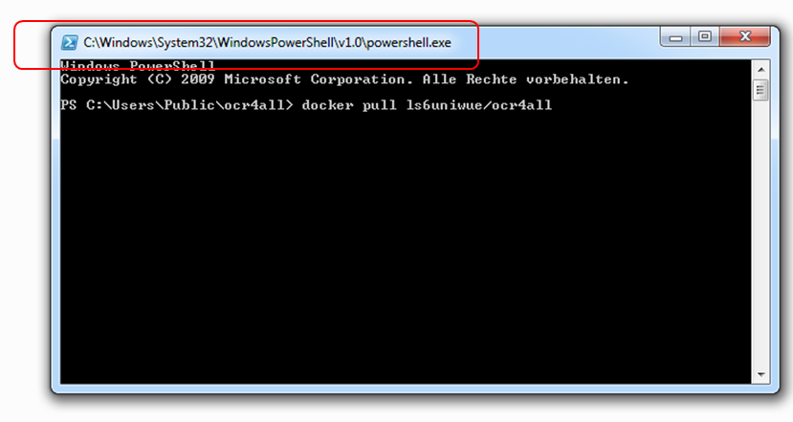

*Fig. 10: Load the OCR4all image via Windows PowerShell inside the OCR4all folder.*

* Create the OCR4all container using the following command (Note: this works only for the recommended setup, i.e. when the OCR4all folder is located in “C:\Users\Public\...”)

*docker run -p 1476:8080 -p 5000:5000 --name ocr4all*

*-v* ***C:\Users\Public\ocr4all\data****:/var/ocr4all/data*

*-v* ***C:\Users\Public\ocr4all\models****:/var/ocr4all/models/custom*

*-it ls6uniwue/ocr4all*

Alternatively, you will have to adjust the paths marked in bold print.

* Use absolute paths!
* Use auto completion!
* It is recommended to not use print working directory (PWD) in this case.

#### Browser access and further use

* OCR4all is optimized for Chrome/Chromium.
* Browser access: <http://localhost:1476/OCR4all_Web/>
* In the browser tool, check *Project Overview* -> *Project selection:* If you can find the two pre-loaded books called “Cirurgia” und “GNM”, the mapping (-v C:\Users\...) is working properly.



*Fig. 11: Project Overview – mapping is working.*

* Otherwise, there might be a typo in the “docker run” command, so you will have to create the container again. First, delete the container you just created:

Stop the process in PowerShell using *CTRL + C*, then type: *docker rm ocr4all*

Check and correct your command (as with most terminals, you can sift through your previous commands using the arrow keys), especially the two “-v C:\Users\...”-lines, then run it again.

* If everything is set up properly, you can (and should!) restart OCR4all in the future by using

*docker start –ia ocr4all*

## Docker Toolbox (for older Windows versions)

#### Docker setup

* Follow the installation guide at <https://docs.docker.com/toolbox/toolbox_install_windows/>.

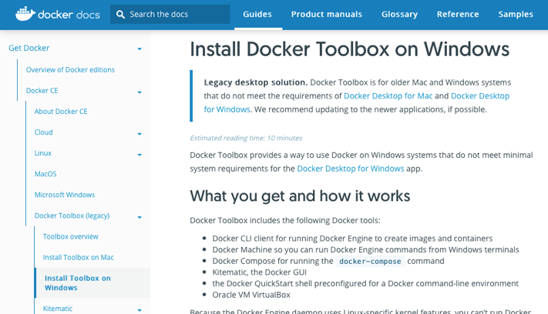

*Fig. 12: Choose “Install Toolbox on Windows” and follow the instructions*.

* Make sure to give all needed permissions, install all additional drivers etc.
* Start Docker Quickstart Terminal and wait for all processes to finish (Give the needed permissions; this needs a stable internet connection).

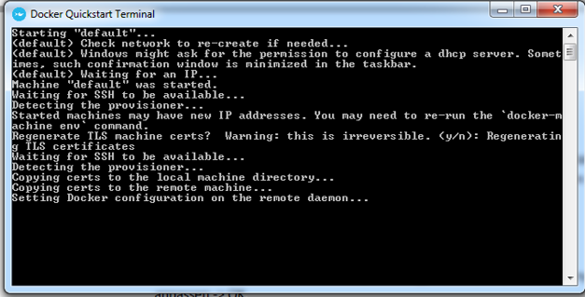

*Fig. 13: Wait for all processes to finish*.

* Close Docker Quickstart Terminal.
* Open Oracle VM Virtual Box.
  + Right click on *default* -> *Close* -> *Turn Off*.

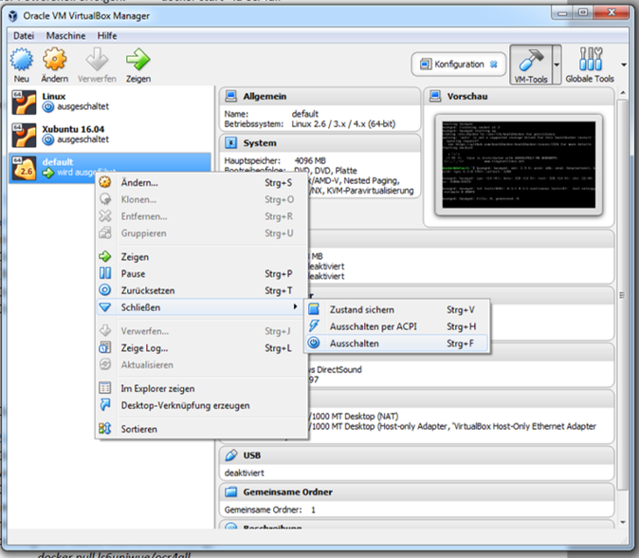

*Fig. 14: Turn off “default”*.

* + Click on *default* -> *Change* -> *System* -> Adjust CPUs (max) and Memory (2GB+) if you want to -> OK.

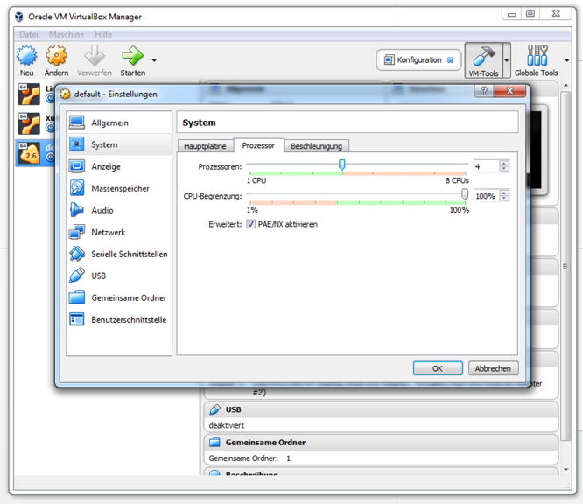

*Fig. 15: Adjust CPUs to maximum*.

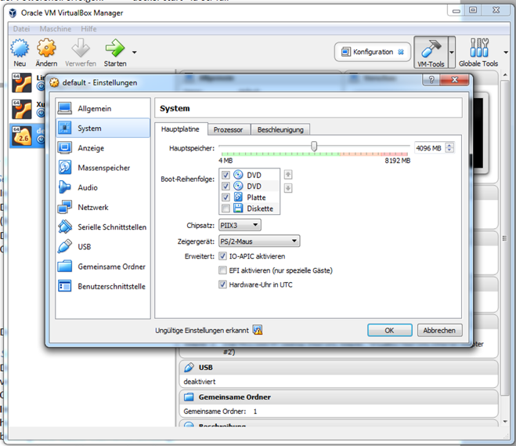

*Fig. 16: Adjust Memory to 2GB+*.

* + It is possible to share additional drives (partitions), however this is quite complicated and is not recommended or explained further at this point.
* Start Docker Quickstart Terminal again.

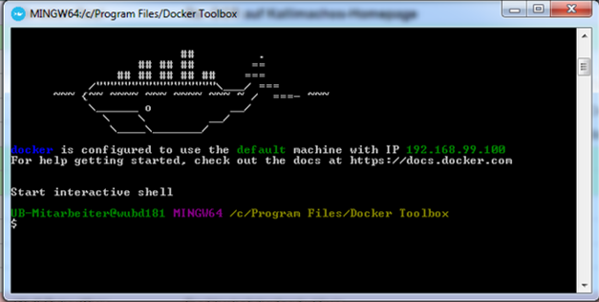

*Fig. 17: Start Docker Quickstart Terminal again*.

#### OCR4all setup

* Move the OCR4all folder structure detailed above (“Preparation”) directly into a folder inside C:\Users. In the following example, we use “C:\Users\Public\ocr4all\...”. We recommend to use the same for the first setup.
* **Inside the OCR4all folder, open PowerShell** (Shift + right click inside OCR4all folder -> Open PowerShell window here) and load an OCR4all image using the following command (this will take up a few minutes and requires a stable connection to the internet):

*docker pull ls6uniwue/ocr4all*

**

*Fig. 18: Load the OCR4all image via Windows PowerShell inside the OCR4all folder.*

* If necessary, open the **Docker Quickstart Terminal** again and create the OCR4all container using the following command (Note: this works only for the recommended setup, i.e. when the ocr4all folder is in C:\Users\Public\...)

*docker run -p 1476:8080 -p 5000:5000 --name ocr4all*

*-v* ***/c/Users/Public/ocr4all/data****:/var/ocr4all/data*

*-v* ***/c/Users/Public/ocr4all/models****:/var/ocr4all/models/custom*

*-it ls6uniwue/ocr4all*

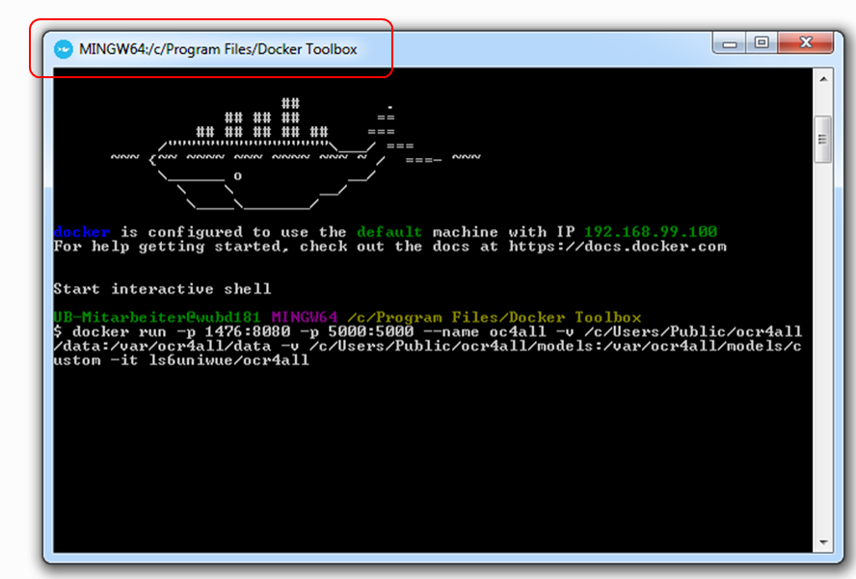

*Fig. 19: Create an OCR4all container.*

* + Alternatively, you will have to adjust the paths marked in bold print.
    - Use absolute paths!
    - Use auto completion!
    - It is recommended to not use print working directory (PWD) in this case.

#### Browser access and further use

* OCR4all is optimized for Chrome/Chromium.
* Browser access: <http://192.168.99.100:1476/OCR4all_Web/>
* In the browser tool, check *Project Overview* -> *Project selection:* If you can find the two pre-loaded books called “Cirurgia” und “GNM”, the mapping (-v …) is working properly.



*Fig. 20: Project Overview – mapping is working.*

Otherwise, it´s likely that there was a typo in the “docker run” command, so you will have to create the container again. First, delete the container you just created:

Stop the process in the Docker Quickstart Terminal using *CTRL + C*, then type:  
*docker rm ocr4all*

Check and correct your command (as with most terminals, you can sift through your previous commands using the arrow keys), especially the two “-v…”-lines, then run it again.

* If everything is set up properly, you can (and should!) restart OCR4all in the future by using

*docker start –ia ocr4all*

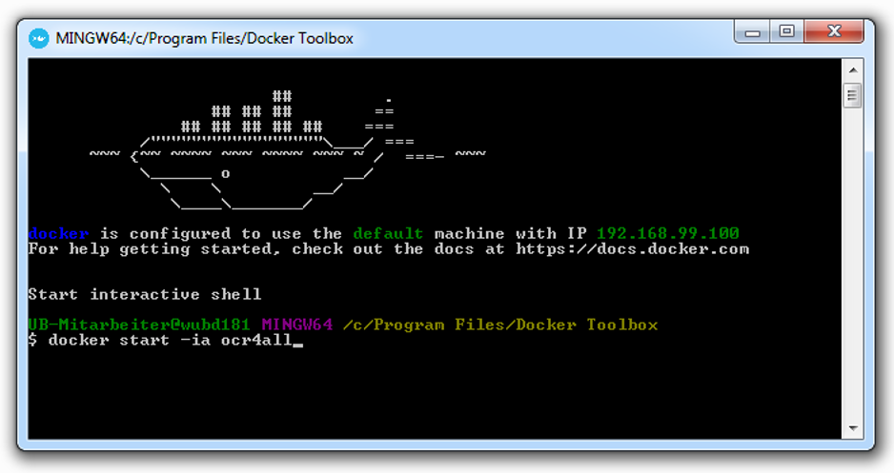

*Fig. 21: Command to (re-)start OCR4all.*