

Ocs Packager Usage Guide

Version 1.0

To use with OCS Inventory NG 1.0 or higher

OpenSource, Web enabled Inventory and Deployement System
http://ocsinventory.sourceforge.net
Table of Contents

1 Introduction. 4
2 Important notes 5
3 Manual. 6
3.1 Prerequisite 6
3.2 Usage 6
4 Publishing “ocspackage.exe” 9
4.1 Publishing on the communication server. 9
5 Deploying agent on a domain. 10
6 Other possible usages 12
7 Getting help in forums. 13

History and changes

Version | Date | Author | Comments
1.0 | 2006-11-18 | Emmanuel GUILLORY | Creation

Introduction.

Open Computer and Software Inventory NG Packager is an application designed to prepare automated installations for a very simple user action “Click” on windows. It also permit to do any scripted task with an alternate administrative account. This Packager is based on NSIS script and RemCom utilities open source projects.

OCS Inventory NG Packager is GPL software.
i.e. free to use & copy (see http://www.opensource.org).
OCS Inventory is also Open Source! This means if you want to modify the sources you can! However, if you want to update the source code to distribute it, you must provide your updates under GPL license terms.

Important notes

We would like to thanks Talha Tariq for Remcom program. Visit his project at http://sourceforge.net/projects/rce/ .

Manual.

Prerequisite

Using OCS Inventory Packager is the most fastest way to deploy and setup OCS Inventory NG Agent on stand alone or domain integrated computers. It is based on NSIS script and RemCom tools. It generates a file called ocspackage.exe based on your parameters witch allow a one click and/or a silent user install. Combined to the OcsLogon /install parameter will provide a very fast service deployment on the Windows operating systems.
We suppose here that you know the domain or local administrative account of your computers. You also know how to generate or obtain a certificate file. You are also familiar with most of Windows administrative tasks.

Usage

Download the Packager and the latest OcsAgentSetup.exe program from OCS Inventory Web Site.
Prepare your certificate.
Launch OcsPackager.exe and accept License agreement.

This windows appears.

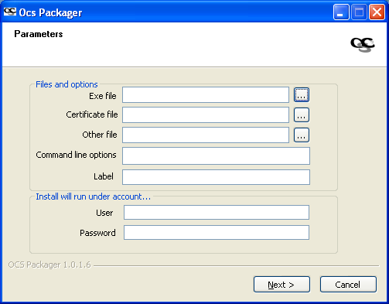

“Files and Options” group box:

  - On “Exe File” line, select your fresh downloaded OcsAgentSetup.exe program. This only line is mandatory.
  - On “Certificate file” line, select your cacert.pem file.
  - “Other fille” line permit an additional file witch will be coyed to your install folder.
  - On “Command line options” type all needed options for Ocs Agent setup program i.e.(/server:my_server /pnum:8081 /S). Do not forget /S option for a silent installation.
  - “Label” line will create a “label” file containing your fill in text. The first time OcsInventory.exe starts, a popup with this text appears. The entered value by the user is called the “TAG”.

“Install will run under account” group box:

  - On “User” line, fill the local admin account or a domain administrative account. “@” is used to separate the user from the domain name.
i.e. (administrator@my.domain.com)
  - Fill “Password” line with the greatest attention. There is no password validation.

You should have something like this:

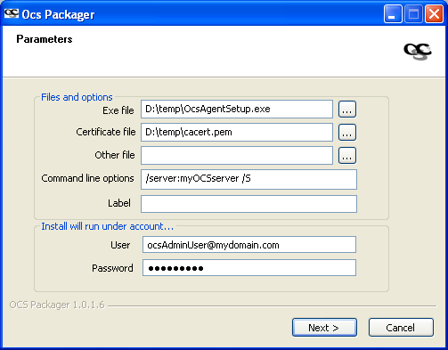

Click “Next” button.

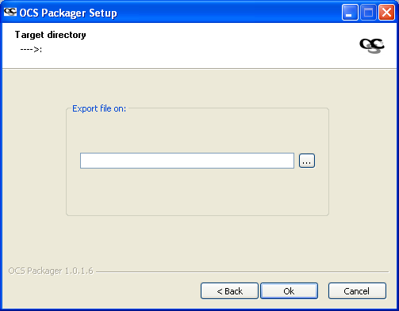
Select the destination folder and Click Ok.

At this point two brief windows appears. The first one to generate ocspackage.exe the other
to generate “ocsuninstall.exe” only to silent uninstall the Ocs Inventory Agent.

You can now test ocspackage.exe by launching it under a normal user account (no administrative privileges).
A brief Ocs Inventory banner may appear signifying the service setup.



Publishing “ocspackage.exe”

You must now upload ocspackage.exe to the communication server or publish it in an alternative web server if you use the Ocslogon.exe [/url:] option.

Publishing on the communication server.

Log on to the GUI (a least 4021) and select Agent icon:

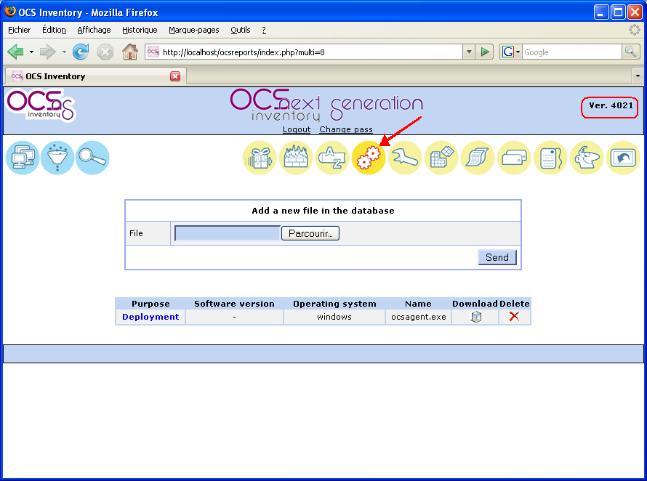
Then upload your “ocspackage.exe” file.

Deploying agent on a domain.

Ocspackage.exe is now ready to be automatically deployed through the last Ocslogon.exe login script a least rev 4.0.2.7

Launcher “OcsLogon.exe” will try to connect by default to the Communication server using a DNS name “ocsinventory-ng”, like if you open your favorite web browser and enter the URL http://ocsinventory-ng/ocsinventory.

To use a different URL, if you cannot add this DNS name, just rename “OcsLogon.exe” with the DNS name or IP address of the Communication server (for example “ocsinventory.domain.tld.exe” if you’ve created for your server a DNS record “ocsinventory.domain.tld” or “192.168.1.2.exe” if your server has 192.168.1.2 as IP address).

Launcher then will try to connect to the DNS name or IP address you’ve named it (http://ocsinventory.domain.tld/ocsinventory or http://192.168.1.2/ocsinventory).

NB: Always use last version of OcsLogon.exe. You can get it from last package OCSNG_WINDOWS_AGENT_XX.zip.

Create a new user GPO on an OU where you want OcsAgent to be deployed. In this one, go to Windows parameters – Script – Login script. Copy file “OcsLogon.exe” (or the renamed one) to the Logon folder of this GPO. Use the parameters field to specify the OcsLogon options.

You can also use a computer GPO by the same way.

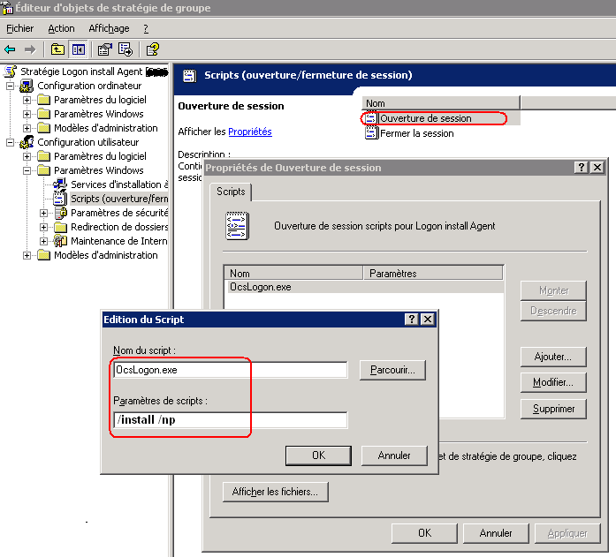

To setup ocspackage.exe OcsLogon has two new command line switches:

- /install
This option will produce ocspackage.exe download from communication server instead of ocsagent.exe. So Ocslogon test if service is already installed and exit if it is. If it is not ocspackage.exe is launched and service installed.

- /url:[http://myserver/emplacement/]
This option permit to download ocspackage.exe from another server. This option can be very useful on a multiple domains architecture with no Trust relationships or multiple separates administratives accounts. This way, severals differents ocspackage.exe binaries using correct domain administrative account can be used. Also OCS communication server is discharged from this task.

Notice that /deploy: option is compatible with Ocs service Agent.

Other possible usages

As you guess it is also possible to use ocspackager to do any other deployment or any administrative tasks Bypassing OCS Inevtory Deployment feature.

In example you've got some computers where you do not want to setup OcsAgent. These computers are not attached to your network but you'd like to deploy software without giving administrative account to a remote user.
In this case Ocspackager is very useful because you can package any setup program with its own options. You just have to know its silent option.

Administrative tasks can also be performed using a .vbs script. To do this, in “Exe file” field select the full path to your Cscript.exe file, in other file select your vbs file and in Command line option type “[yourBatch.vbs] /B ”
ocspackage.exe properties will always contains the packaged file name plus its version.

Getting help in forums.

If you are unable to diagnose yourself the problem, you can get help using OCS Inventory NG web site forums (http://ocsinventory.sourceforge.net/index.php?page=Forums).

If you do so, please provide us:

- Server operating system
- OCS Inventory NG server version and patch level
- Agent’s operating system
- OCS Inventory NG agent version
- Agent execution logs
  - Run “AGENT_INSTALL_FOLDER\ocsinventory.exe /NP /DEBUG /SERVER:you_server_address” under Windows. Log file is created on folder “AGENT_INSTALL_FOLDER” under name “your_computer_name.log”.
  - Run “ocsinv –debug > ocsinv.log” under Linux. Log file is “ocsinv.log”.
- Apache server error.log file, located for Windows under “SERVER_INSTALL_FOLDER\xampp\apache\logs\error.log” and for Linux under “/var/log/httpd/*error.log”.
- OCS Inventory NG Server log file, located for Windows under “SERVER_INSTALL_FOLDER\xampp\apache\logs\ocsinventory-NG.log” and for Linux under “/var/log/ocsinventory-NG/ocsinventory-NG.log” under Linux.

Thanks by advance.

