**LINKEDIN**

LinkedIn is a social networking service runs via the website and mobile apps. It is mainly launched with a purpose of connecting people professionally. It can be operated via both website and apps and available in 6 languages so that it’s easy to connect people worldwide easily.



A platform where people can connect with friends, companies, colleagues globally. People can look for jobs in any part of world and can apply and connect. It is used by almost every college student, companies and Employees working in any profession, working in any organization.

LinkedIn is one of those apps available in almost every phone which helps to show your skills with endorse and level of skill. So that company can check for your eligibility for the profile or not.

LinkedIn was first launched on May 5, 2003.In August 2004, LinkedIn reached 1 Million users and March 2006 was the first profitable month for LinkedIn. It’s revenue rate just got increasing year by year. Now it’s annual revenue run rate reached to $2 billion.

Further, LinkedIn reached to be a leading Social Media for Business-to-Business Marketing in 2020.

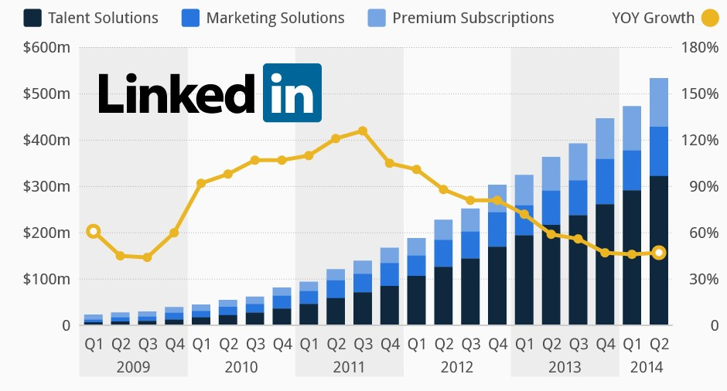

LinkedIn is the leading Social Media for Business-to-Business Marketing in 2020.

**LinkedIn Login/Signup**

* Users can signup to create a new account if new to join LinkedIn
* If users already have accounts, they can login by entering Email-id and Password

After logging in, You have to give your information including:- Name, Education details, Profile Picture, previous work profile if not fresher, skills and experience, Contact Information. This will decide your Profile Strength.

**Linked Pages:-**

These are the Favicons used to give link to jump on that page Placed in header file which is common to every page as Header.

1. **Home page** - Home page of LinkedIn where Post is shared and can look for jobs and status posted by others. So, that Students or Employees can search for the jobs available and can apply. Even companies can look for Employees who are eligible or not and can offer Jobs.

2 .**My Network** - Where information about your network. like- Invitations, Connections and people you may know are displayed.

3. **Jobs**–Page where option of filtering job profile and search and displays the job according to previous search and based on the profile. Where you can filter status, experience level or location of the job searching for. So, it searches and displays the jobs according to your filters.

4. **Messaging**–Contact page from where messages are share i.e. chatting page. Where You can send and receive messages from your friends, connection or companies

5.**Notification**–Notification page where notifications are displayed like -Any message received, also notify if someone viewed your profile.

6. **Me** –Where details of the user are displayed like Profile Picture and account is managed like settings.

7. **Work** - Information related to work is displayed. Where details of your working status. like-group, learning, post a job, Advertise –if something to advertise, slide share and salary.

There are 2 versions of LinkedIn i.e. Paid and Free.Free accounts doesn’t get some facilities like if someone viewed your profile, Notification will be provided but not allowed to revel identity of company or profile.

Skills are to be added so that company you have applied can see if you have the required skills and experience or not.You can connect as many people you can, and everyone can see your connections. You can have your profile picture and also you have option to see who is checking your profile.

A unique feature, your friends or connections can endorse your skills which means that your friends can support you by voting that what level of specific skill you have.

Now, something interesting!!!

You have seen website of LinkedIn, but ever thought how it looked earlier or when it was first released. so here some snapshots of LinkedIn from past.

**Snapshot of LinkedIn website of May 10, 2006**

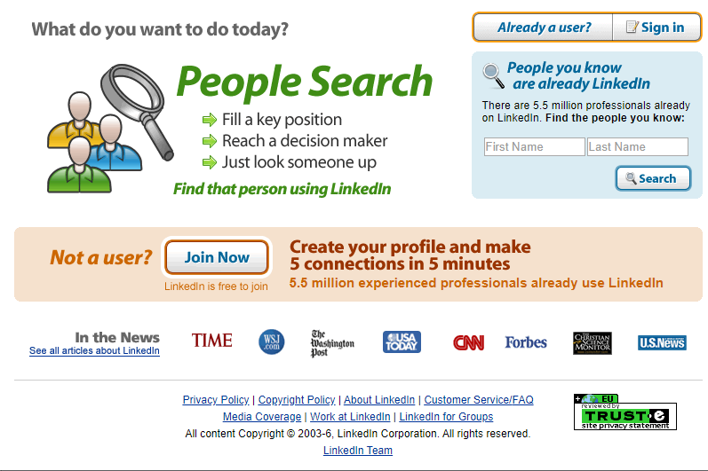

Snapshot of LinkedIn website of Feb 2, 2010

