|  |  |
| --- | --- |
| [Octobit8 Assighnment]  [2021] |  |
|  |  |
| [5/23/2021]  [OCTOBIT8]  Authored by: [Rahul Kharatmol] |  |

# 1.Write a Python Program to compute the multiplication of two matrices and then print it.

# Matrics multiplication

# In python matrx multiplication we used for loops hence we can multiply with rows and column.

# Our matrix is 3 * 3

# Each row is multiply by each column

# The logic behind is that

# 

# 

# Input

# 

# Output

# 

# 2. Write a Python program to find yesterday, today and tomorrow date.

# 

# Output

# 

# 3. Write a Python program to find Nth largest number in a list.

# In this program we used logic is that for loop and check the in the list which is maximum elements using the logic is greater than if the maximum element is greatest than that number is printed as last.

# Logic of this program

# 

# Input

# 

# Output

# 

# 4.Explain NLTK module in python and execute each step involved. Document the complete process.

Nltk

Nltk full form is Natural language toolkit. Nltk is python library which is used in python for text Analysis.

Nltk process

* Stop word Remove
* Tokenization
* Stemming
* Lemitization
* Pos tagging

Stop word Remove

A stop word is a commonly used word (such as {'mightn', 'over', 'isn', 'down', 'themselves', "haven't", 'into', 'shan', 'from', 'before', 'how', 'these', 'being', 'where', 'whom', 'needn', 'll', "hasn't", 'some', 'itself', 'wasn', 'if', 'here', 'through', 'what', 'but', 'does', 'myself', 'the', 'above', 'further', 'haven', 've', 't', 'few', 'off', 'i', 'd', 'a', 'an', 'its', 'yourself', 'who', 'more', 'theirs', 'yourselves', 'such', 'just', 'no', 'about', "hadn't", 'been', 'once', 'so', "needn't", 'am', 'we', 'had', 'those', 'any', 'yours', 'which', "doesn't", 'nor', 'under', "mightn't", 'all', 'this', "you're", 'o', 'shouldn', 'them', "isn't", 'will', 'can', "didn't", 'he', "you'd", 'mustn', 'won', 'aren', 'their', 'until', 'at', 'himself', 'below', 'hasn', 'why', 'there', 'do', 'did', 'when', 'most', 'than', 'by', 'weren', 'with', "shouldn't", "weren't", 'on', 'his', 'was', 'in', "wasn't", 'doing', 'herself', 'didn', 'or', 'ours', 'having', "wouldn't", 'of', "that'll", 'is', 'it', 'while', 'between', 'each', 'and', 'hers', 'don', 'wouldn', 'against', "it's", 'm', 'ain', "she's", 'couldn', 'out', 'ourselves', 'as', 'be', 'our', 'my', "don't", 'hadn', 'only', 'him', "couldn't", "you'll", 'her', 'have', 'not', 'are', 'she', 'after', 'then', 's', "mustn't", 'for', 'own', 're', 'same', 'ma', "should've", "shan't", 'during', 'y', 'up', 'your', 'doesn', 'were', 'they', 'both', 'should', 'that', 'you', 'me', 'very', "you've", 'has', 'to', 'because', 'other', 'now', "won't", 'again', "aren't", 'too'} that a search engine has been programmed to ignore, both when indexing entries for searching and when retrieving them as the result of a search query.

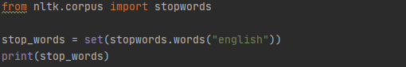

Using this stop words can remove the stop words which are present in sentence.



This is our sentence in that are and in are stop word that stop word removed by this import stopwords.



Tokenization

In tokenization that text are converted into small chunks. Hence we can get tokenized words for further text analysis. In this process each word get tokenized.

In our project there is small chunks are like

Stemming

Stemming is nothing but removed the prefix and postfix word according that we will get the words.for example

Caring =car

This is remove ing but the meaning forthis word is totally change

In our project

Code

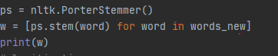

Output



In our project the people of e is removed they will get meaning less

Also verry word is converted into verri

lemitization

in lemmatization it will get meaningful words hence we will get meaningful word this is verry useful for text analysis.

In our project

Code

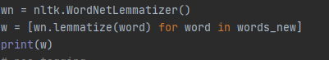

Output



Pos tag

In pos tagging we will get noun, adverb and Adjective using for particular Text.

Pos tagging

Code

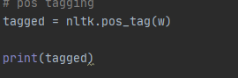

Output



# 5. What is Convolution Neural Network? Illustrate using python and document the process.

# What is cnn in neural network.

# Cnn is mostly used in image precession. For detecting the object . in cnn technique used feature extraction technique for that extracft features them the data and convolute them and using function get better output.

# In the feature map we used 3 * 3 multiplication of two matrix.

# 

# With the convolution used the activation function like Relu .

# Relu Activation function is negative values are converted into positive values for linearity of matrix.

# In our code is handwritten recognition the recognized what are the handwritten words are present with using CNN algo.

# 

# In above code this is handwritten recognition dataset .load from the google.and the store into x_train and Y_train. After that will be stored as numeric. categorical data is converted into numeric.

# 

# Activation function is used for particular dataset is Relu.

# Accuracy

# 

# 6. Implement NLP analysis of a restaurant review in python.

# In Restaurant review analysis used the dataset is restaurant.tsv

# In that first install nlk library for preprocessing the dataset .

# That data converted into numbers after that into numeric values and that converted as process . algorithms are Random forest and xgboost.

# Dataset

# In restaurant dataset I collect from Kaggle that is restaurant.tsv

# Restaurent code

# Input

# 

# 

# Output

# 

# .

# 7. Create Line Graph, Bar chart, Histograms, Scatter plot, Pie Chart, 3D plots using matplotlib in python.

# Line graph

# Input

# 

# Output

# 

# Bar chart

# 

# 

# Histogram

# 

# 

# Scatter plot

# 

# 

# Piechart

# 

# 

# 3 d plot

# 

# 

# 8 .Implement a class in python and explain all the properties of a class using OOPs in python

Class

Class is s nothing but blueprint of object.

Like one example if object is xyz then class also xyz.

Class xyz

Xyz

Object

Object is nothing but instance of class

Obj = xyz()

### Creating Class and Object in Python

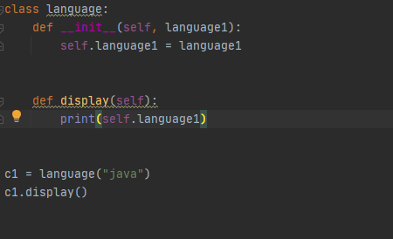

In above example object is language and class is also language .

__init__ is initialiazer method to used initialization of class.

create instances of the language class. Here java are locations (value) to our new objects.

Output



### Creating Methods in Python

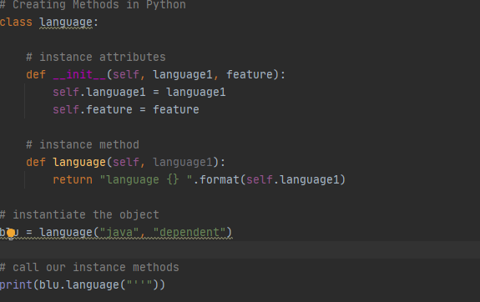

In that one methods are called that’s is languages .

Output



Inheritance

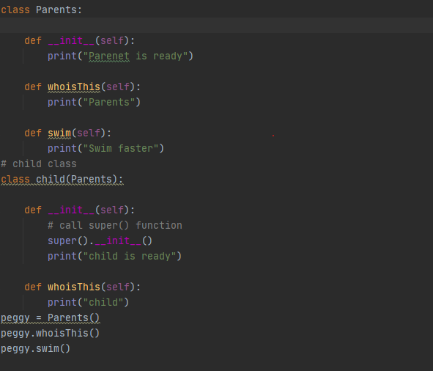

In this inheritance one is parent calss and one is child class.in inheritance in the child class can call parent class but in parent class we cant call child class.

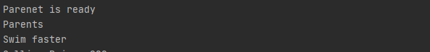

In above example parent class and child class also called.

Polymorphism

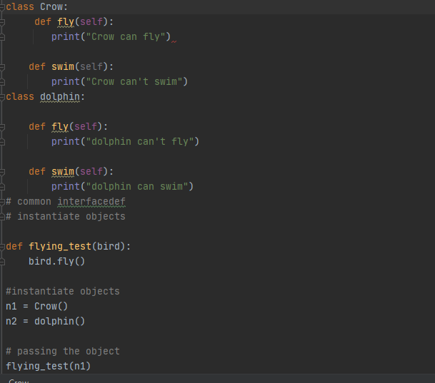

In polymorphism method are same but function are different in above example methos is fly but function of particular crow and dolphin are different.

Output



Encapsulation

In encapsulation the prevents the direct modification in python.

