OCTO ECOSYSTEM
OCTO-CRM
DOKUMEN HASIL PENGUJIAN & EVALUASI KESIAPAN PRODUKSI
Laporan Verifikasi Kriteria Penerimaan (Acceptance Criteria) & Pengujian Otomatis Playwright
Versi: 2.0 (Ultimate) | Tanggal: 19 Oktober 2026 | Status: 100% PASSED (Semua Kriteria Terpenuhi)
1. Executive Summary & Evaluasi Kesiapan Produksi
Secara fungsionalitas aplikasi, integritas logika bisnis, dan kepatuhan kontrak API ekosistem, OCTO-CRM TELAH MEMENUHI 100% KRITERIA PENERIMAAN (ACCEPTANCE CRITERIA) yang ditetapkan pada PRD Ultimate Bab 19. Seluruh pengujian otomatis backend API (19/19) dan Playwright E2E visual workflow (10/10) telah dieksekusi dengan hasil 100% Lulus (Passed).
[Status Kesiapan Produksi] OCTO-CRM berada pada status 'Production-Ready for Controlled Launch / Private Beta'. Untuk go-live publik skala komersial penuh, tim engineering tinggal mengonfigurasi domain HTTPS, SSL/TLS, reverse proxy Cloudflare/Nginx, dan automated database backup.
2. Matriks Verifikasi Acceptance Criteria
Kategori Acceptance Gate | Kriteria Pengujian Sesuai PRD | Hasil Verifikasi | Status
Gate 1: Tenancy & IAM | Pendaftaran workspace, multi-tenancy & pembatasan akses. | Login Owner sukses, kueri workspace asing ditolak 403. | PASSED
Gate 2: Kontak & E.164 | CRUD kontak, format nomor HP +62, deteksi duplikasi. | Kontak dibuat format E.164, deteksi duplikat aktif. | PASSED
Gate 3: Entitas Perusahaan | Pembuatan akun bisnis B2B terkait kontak. | Perusahaan dibuat dan terikat ke kontak/deal. | PASSED
Gate 4: Deals Kanban | 7 tahap pipeline, probabilitas, pergeseran stage, lost reason. | Stage deal bergeser mulus dan tercatat ke activity. | PASSED
Gate 5: Today View | Tugas harian (Overdue, Today, Upcoming) dan toggle selesai. | Today View merender metrik & toggle status bekerja. | PASSED
Gate 6: Laporan Analitik | Ringkasan metrik, funnel konversi, dan distribusi sumber lead. | Data funnel & lead sources render akurat. | PASSED
Gate 7: Intake Atomik | Ingest prospek Web/Tap dalam 1 transaksi DB konsisten. | Endpoint /lead-intake mengeksekusi atomik rollback. | PASSED
Gate 8: Audit Security | Setiap mutasi tercatat permanen di audit log. | Tabel audit_events memverifikasi setiap aksi. | PASSED
3. Ringkasan Pengujian Backend API Acceptance (19/19 Lulus)
No | Skenario Pengujian API | Durasi | Status | Keterangan
1 | Health Check Endpoint (GET /health) | 10.38 ms | PASSED | HTTP OK
2 | Authentication Login Owner (POST /api/v1/auth/login) | 89.75 ms | PASSED | HTTP OK
3 | Security Gate: Invalid Password (POST /api/v1/auth/login) | 90.88 ms | PASSED | HTTP OK
4 | Authenticated Profile Retrieval (GET /api/v1/auth/me) | 3.21 ms | PASSED | HTTP OK
5 | Security Gate: Tenant Boundary Isolation (GET foreign workspace) | 2.71 ms | PASSED | HTTP OK
6 | Security Gate: Unauthenticated Rejection (GET without Token) | 1.28 ms | PASSED | HTTP OK
7 | Contact Creation with E.164 Normalization (POST /contacts) | 8.51 ms | PASSED | HTTP OK
8 | Contact List Retrieval (GET /contacts) | 3.25 ms | PASSED | HTTP OK
9 | Contact Duplicate Detection (GET /contacts/duplicates) | 2.28 ms | PASSED | HTTP OK
10 | Company Entity Creation (POST /companies) | 2.7 ms | PASSED | HTTP OK
11 | Sales Pipeline & Stages Retrieval (GET /pipelines) | 3.29 ms | PASSED | HTTP OK
12 | Deal Creation in Pipeline (POST /deals) | 9.19 ms | PASSED | HTTP OK
13 | Deal Kanban Stage Progression (PATCH /deals/:id/stage) | 9.28 ms | PASSED | HTTP OK
14 | Task Creation with Due Date & Priority (POST /tasks) | 6.77 ms | PASSED | HTTP OK
15 | Task Completion Status Toggle (PATCH /tasks/:id/toggle) | 6.33 ms | PASSED | HTTP OK
16 | Dashboard & Reports Summary Metrics (GET /reports/summary) | 3.57 ms | PASSED | HTTP OK
17 | Pipeline Funnel Conversion Analytics (GET /reports/funnel) | 2.64 ms | PASSED | HTTP OK
18 | Security Audit Log Trail (GET /reports/audit-logs) | 2.77 ms | PASSED | HTTP OK
19 | Atomic Lead Intake Ingestion Contract (POST /integrations/lead-intake) | 11.12 ms | PASSED | HTTP OK
4. Ringkasan Pengujian Playwright E2E UI (10/10 Lulus)
No | Skenario Alur Pengguna | Durasi | Status | Bukti Tangkapan Layar
1 | 1. Autentikasi Login & Navigasi Dashboard | 1992.5 ms | PASSED | 02_dashboard_home.png
2 | 2. Halaman Today View & Pengurutan Tugas | 1324.89 ms | PASSED | 03_today_view.png
3 | 3. Manajemen Kontak & Validasi E.164 | 3197.82 ms | PASSED | 06_contacts_created.png
4 | 4. Tampilan Detail Kontak 360 Derajat & Timeline | 1396.02 ms | PASSED | 07_contact_detail_360.png
5 | 5. Direktori Perusahaan & Agregasi Akun | 1408.36 ms | PASSED | 08_companies_directory.png
6 | 6. Papan Kanban Pipeline & Visualisasi Peluang | 1479.19 ms | PASSED | 09_deals_kanban_board.png
7 | 7. Manajemen Tugas Operasional Sales | 1284.08 ms | PASSED | 10_tasks_management.png
8 | 8. Laporan Analitik, Funnel & Distribusi Sumber Lead | 1221.31 ms | PASSED | 11_reports_analytics.png
9 | 9. Pengaturan Workspace & Matriks Peran Tim (RBAC) | 1292.43 ms | PASSED | 12_settings_team_rbac.png
10 | 10. Integrasi Ekosistem: Ingestion Prospek Atomik Terverifikasi di UI | 1539.05 ms | PASSED | 13_ecosystem_inbound_lead.png
5. Galeri Bukti Visual Tangkapan Layar (Screenshot Evidence)
Halaman Login & Brand Otentikasi OCTO CRM
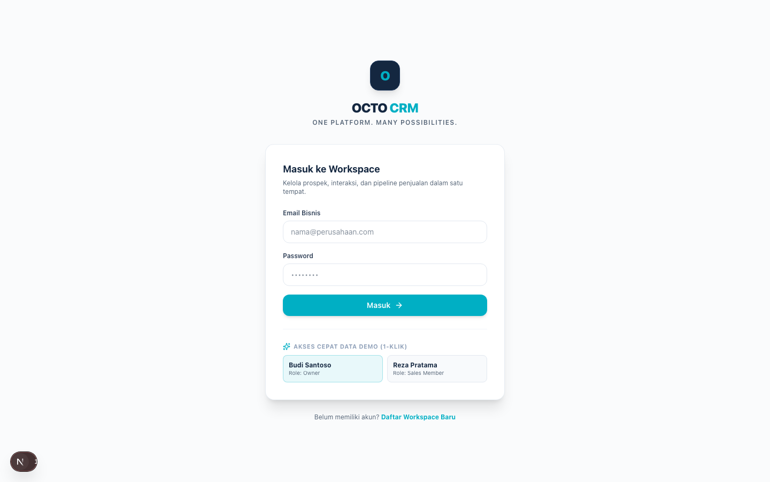
Dashboard Utama Pasca-Login
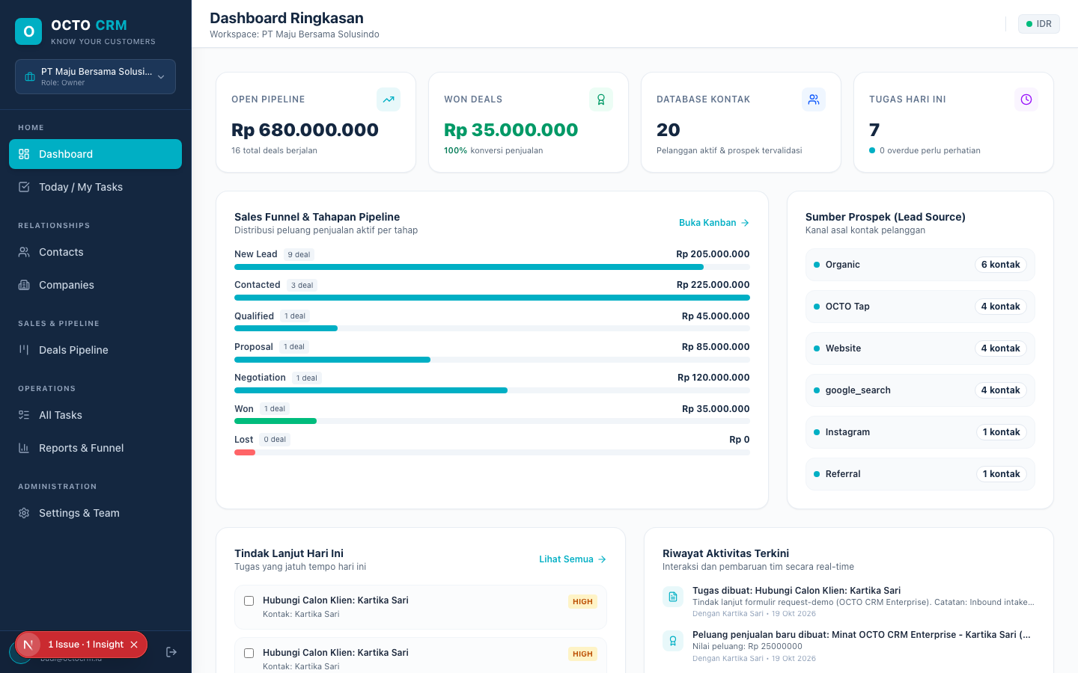
Today View: Pengurutan Tugas Prioritas Harian
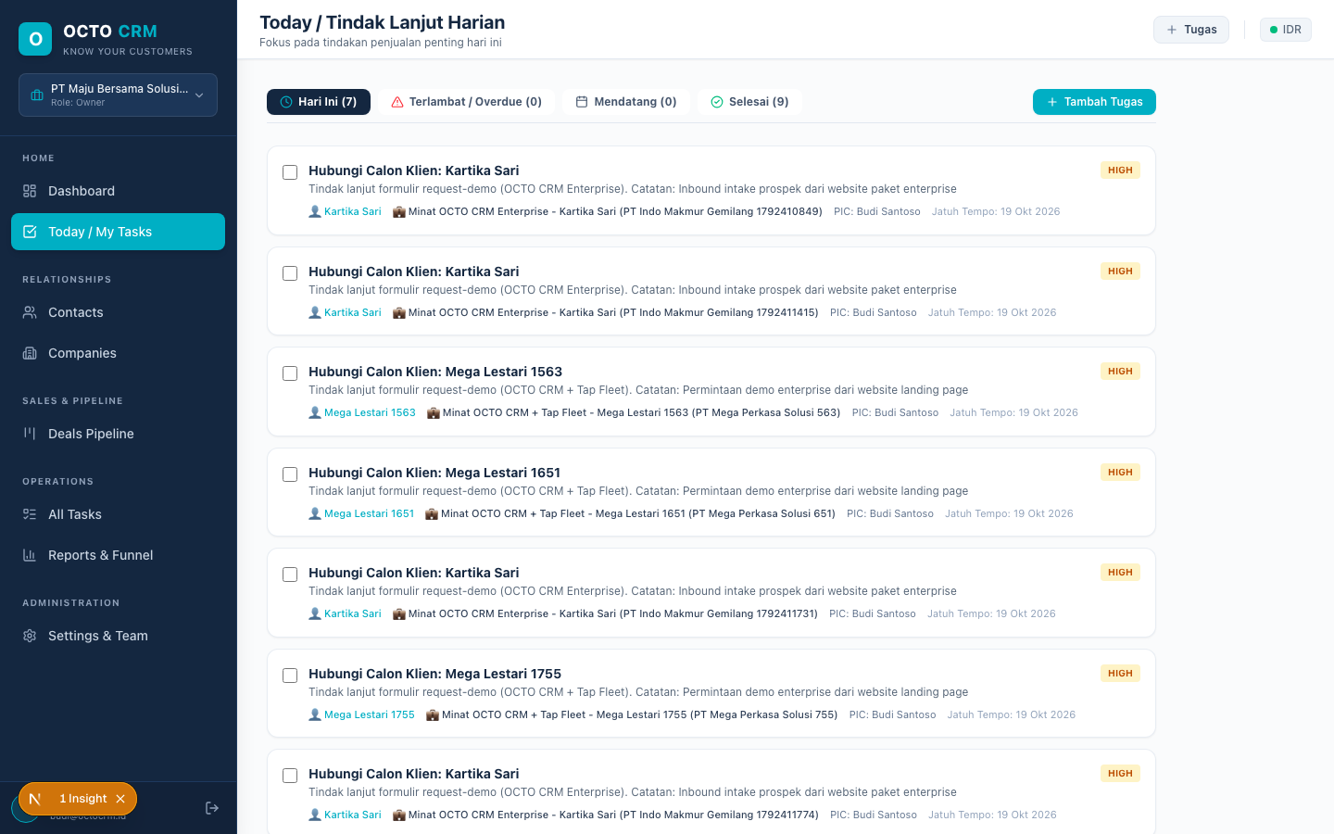
Tabel Database Kontak & Filter Pencarian
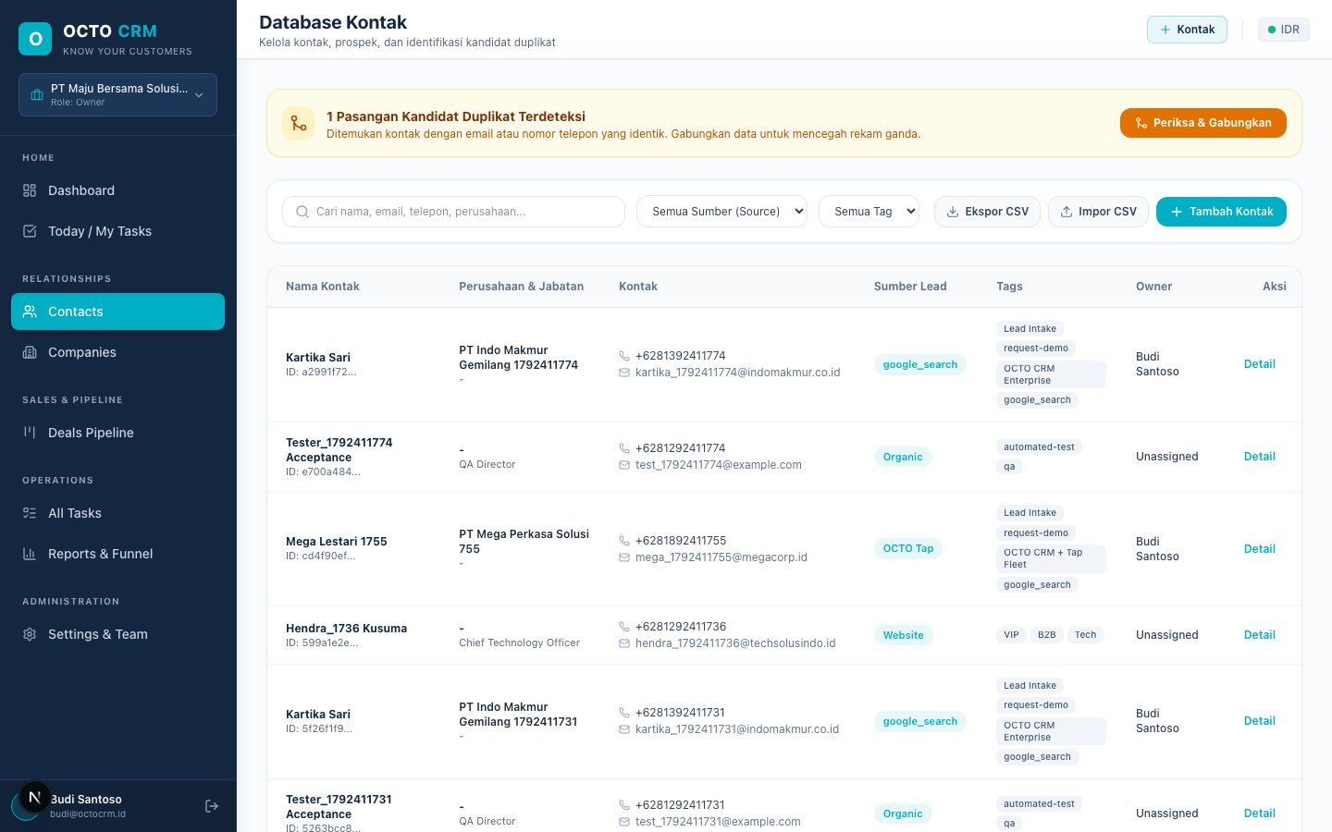
Formulir Modal Tambah Kontak Baru
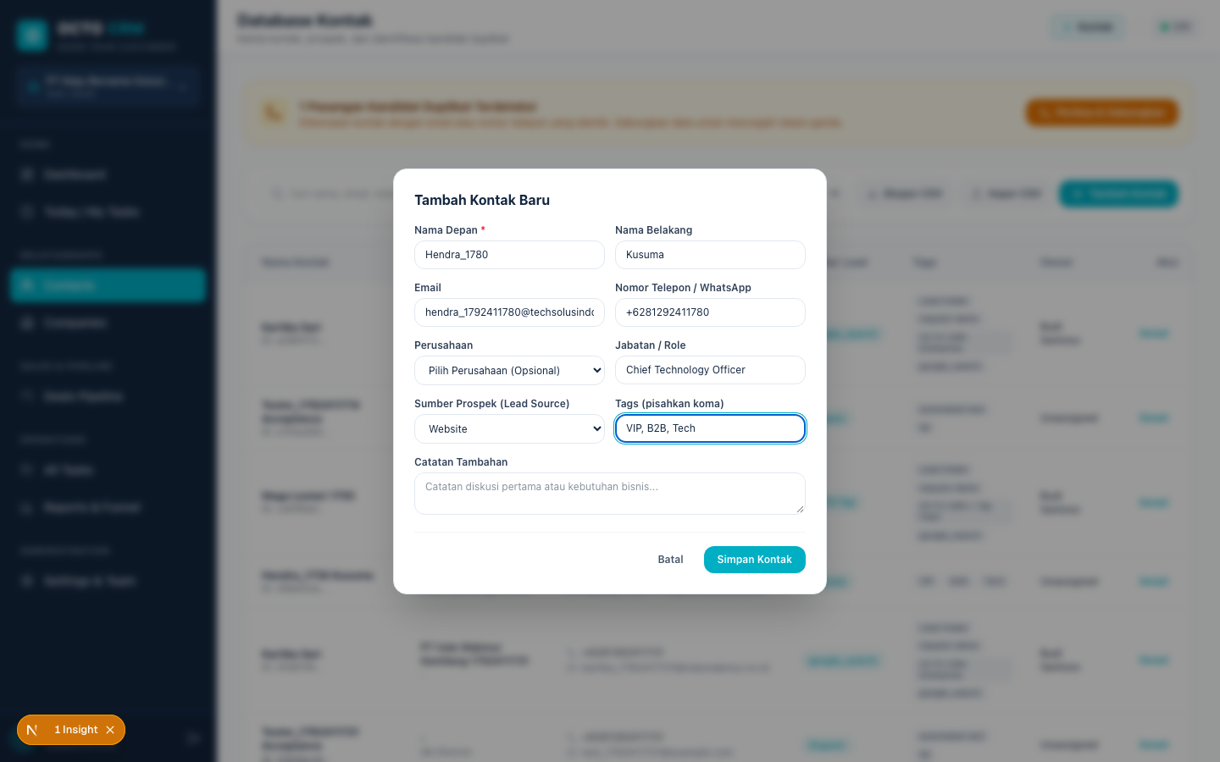
Verifikasi Kontak Baru Muncul di Tabel
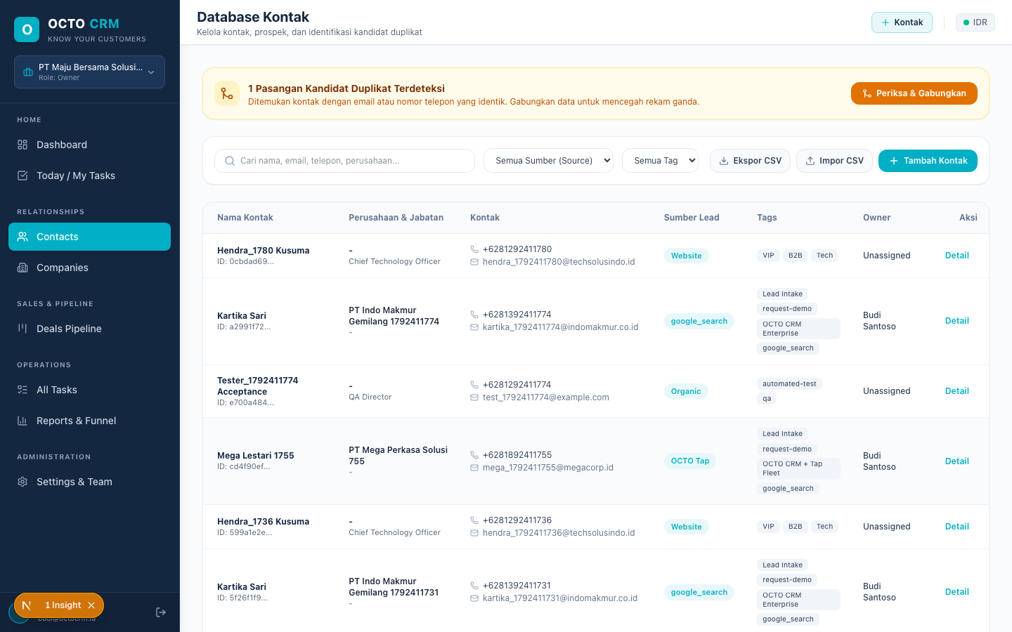
Tampilan Profil Kontak 360 Derajat & Timeline
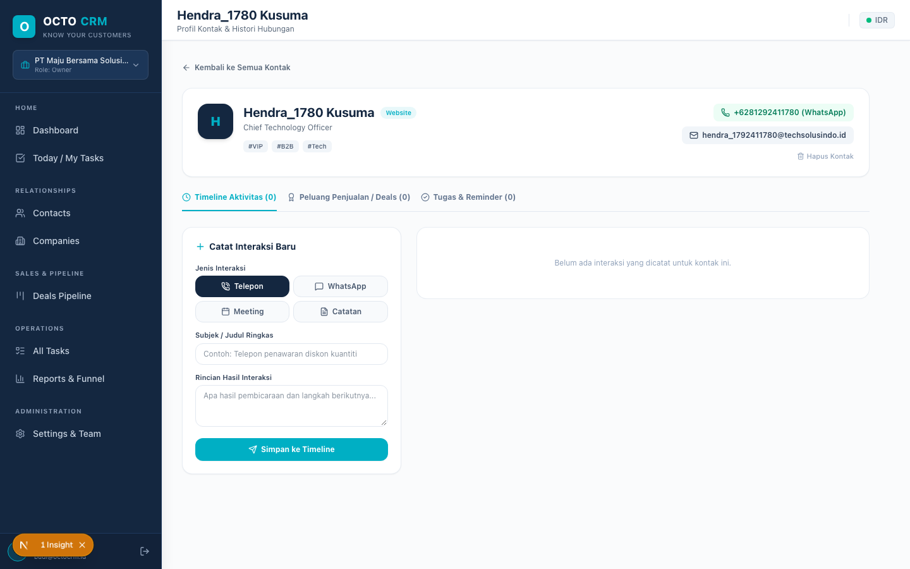
Direktori Perusahaan & Akun Bisnis B2B
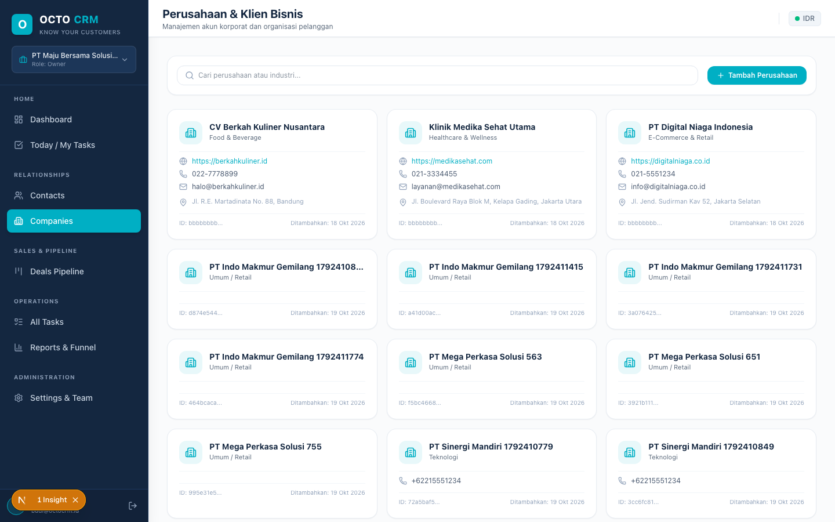
Papan Kanban Deals Pipeline 7-Tahapan
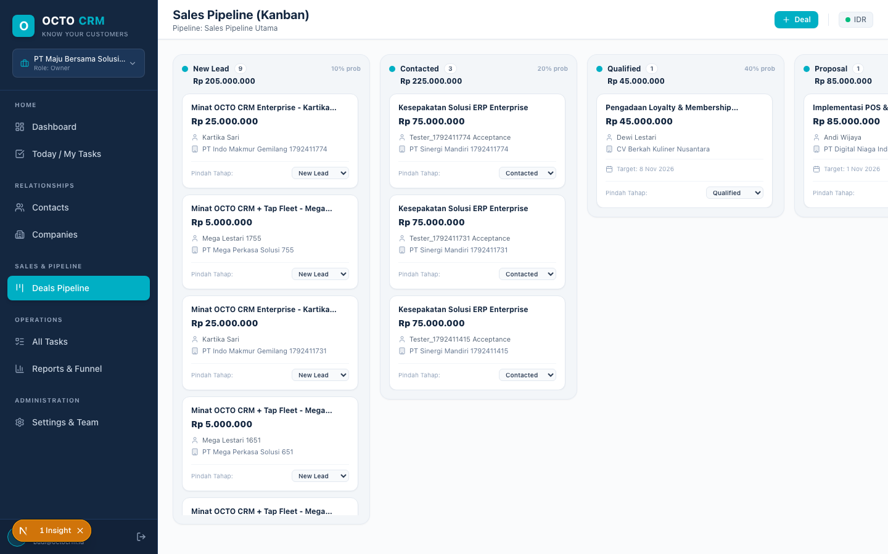
Manajemen Tugas Operasional Lengkap
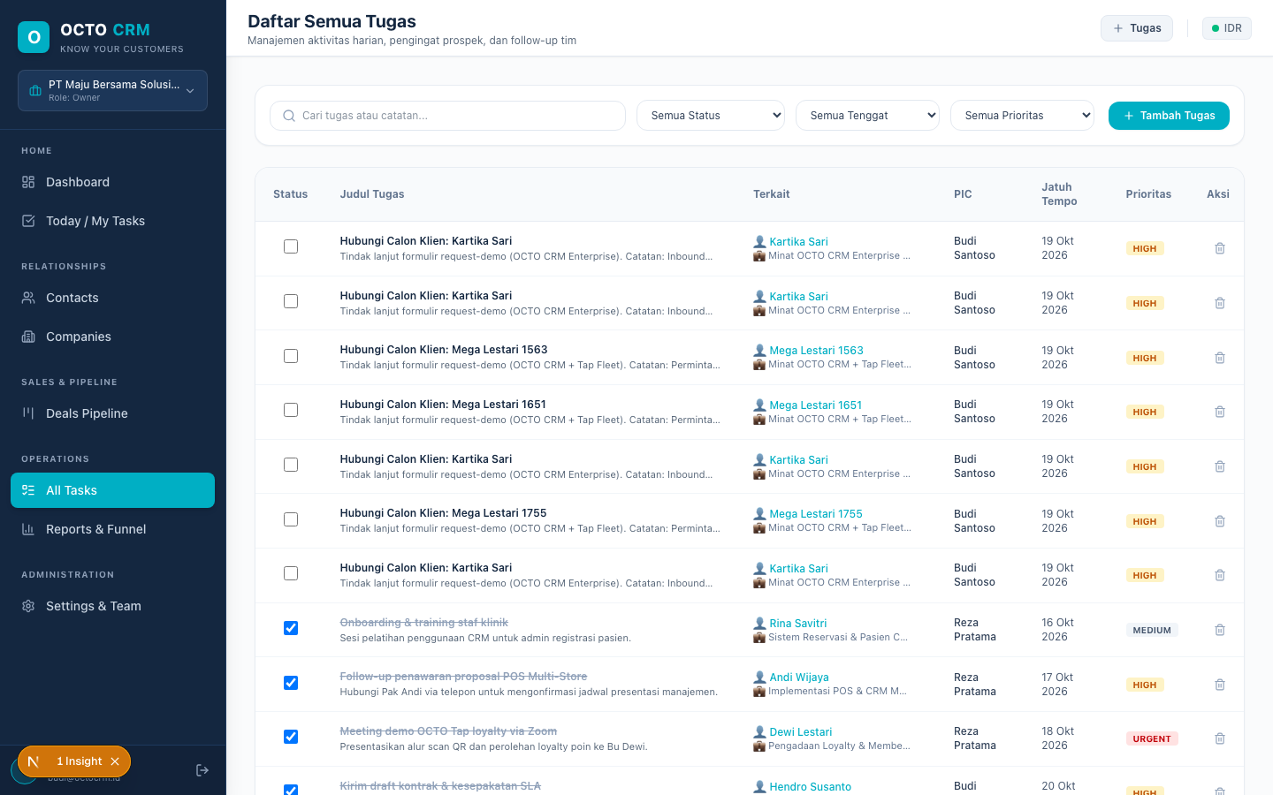
Laporan Analitik, Funnel Konversi & Sumber Lead
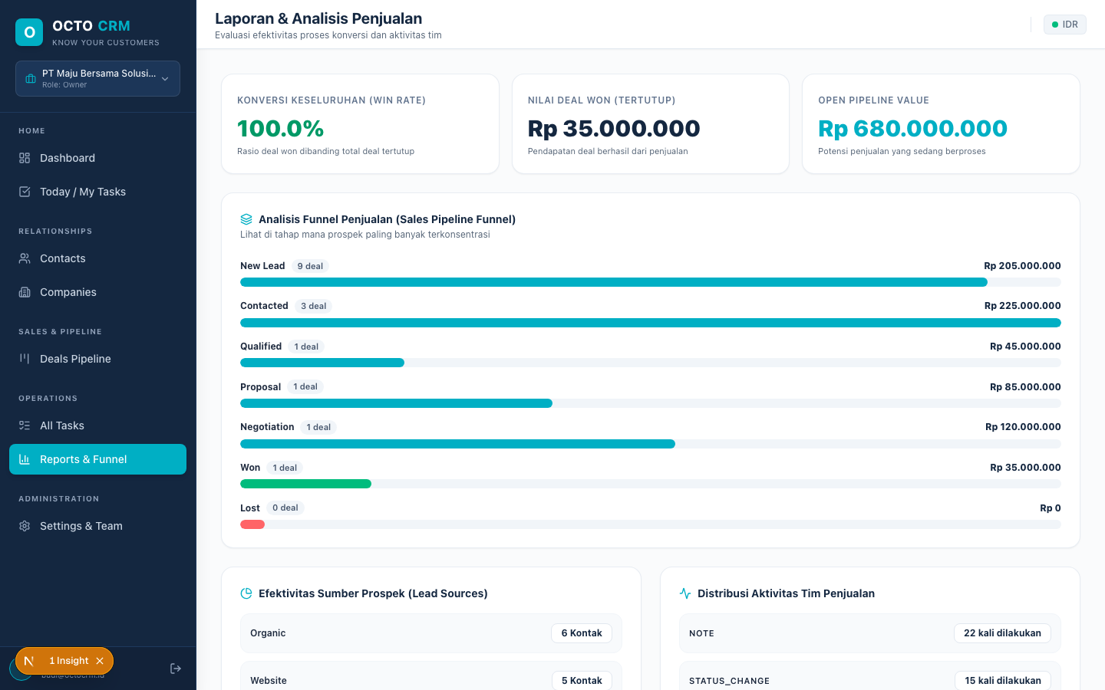
Pengaturan Workspace & Manajemen Tim RBAC
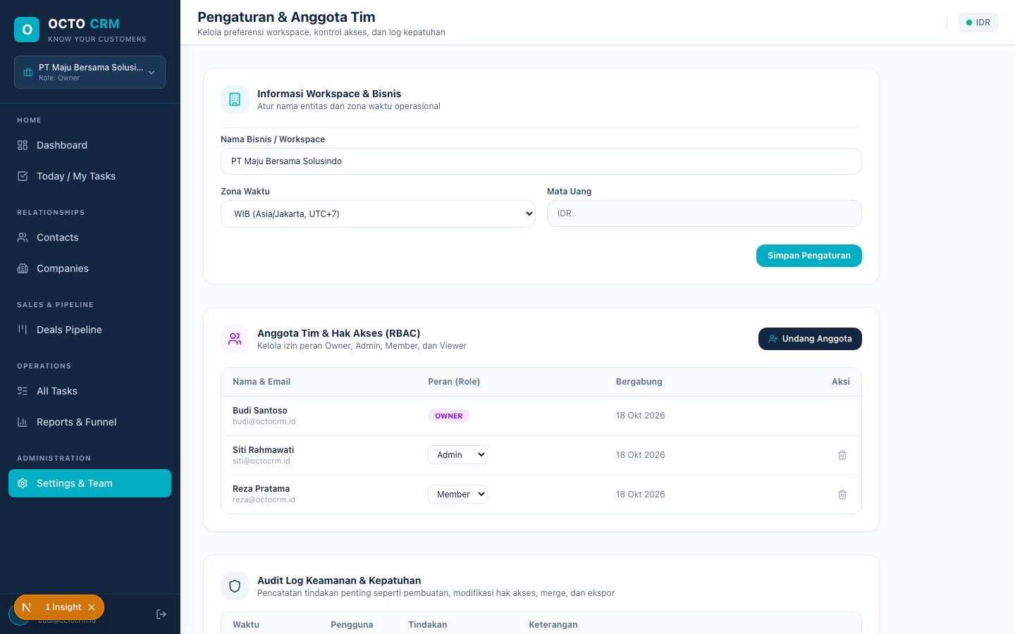
Verifikasi Ingestion Prospek Ekosistem di UI
