GnuCOBOL
TUI TOOLS COLLECTION - DOCUMENTATION

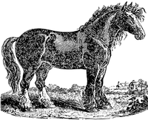

Table of Contents

Table of Contents 1
1. GnuCOBOL TUI (Text User Interface) TOOLS COLLECTION 4
1.1. INTRODUCTION 4
1.2. TABLE OF AVAILABLE TOOLS & UTILITIES 5
2. TUI TOOL 01 - BOX 6
3. TUI TOOL 02 - BOXMEX 9
4. TUI TOOL 03 - YESNO 13
5. TUI TOOL 05 - YESNOCANCEL 15
6. TUI TOOL 09 - BUTTONS 17
7. TUI TOOL 13 - CHECKBOX 20
8. TUI TOOL 15 - OFFON 23
9. TUI TOOL 18 - RADIOBUTTON 26
10. TUI TOOL 21 - MENU 32
11. TUI TOOL 26 - LIST VIEW 37
12. TUI TOOL 51 - CALENDAR (ONE YEAR ON SCREEN) 42
13. TUI TOOL 52 - COLORPICKER 46
14. TUI TOOL 53 - CALENDAR (THREE MONTHS ON SCREEN) 48
15. TUI TOOL 54 - FILE PICKER 50
16. TUI TOOL 55 - DIRECTORY PICKER 51
17. TUI TOOL 56 - DATE PICKER (ONE MONTH ON SCREEN) 54
18. TUI TOOL 58 - BIG CLOCK SCREEN SAVER 56
19. TUI TOOL 61 - POCKET CALCULATOR 58
20. TUI TOOL 64 - CALCULATOR 60
21. TUI TOOL 71 - CRUD: CREATE, READ, UPDATE, DELETE 62
22. TUI TOOL 74 - HELP SYSTEM 68
23. TUI TOOL 76 - QUICK TABLE MANAGEMENT 70
24. AUTOMATIC COPY GENERATORS 77
24.1. FOR REPORTS LAYOUT 77
24.2. FOR SCREEN LAYOUT 84
25. OTHERS 89
25.1. BANNER 90
25.2. FADE RAIN EFFECT 91
25.3. COLOR CODES 94
25.4. FOR FUN 95
26. OTHER GnuCOBOL SCREEN SAMPLES 96
27. GNU Free Documentation License 97

CHANGE LOG
Version 1 of 2021.02.02
First release of TUI TOOLS Documentation
Version 2 of 2021.03.08
Changed Grace Image
GnuCOBOL codes chapter has been deleted
License Information was added
Other small fixes
Version 3 of 2021.03.19
Mouse mgmt added to Datepicker and other tools

This manual documents GnuCOBOL TUI-TOOLS.
Document Copyright (c) 2025 Eugenio Di Lorenzo, FSF (Free Software Foundation).
Permission is granted to copy, distribute and/or modify this document under the
terms of the GNU Free Documentation License [FDL], Version 1.3 or any later
version published by the Free Software Foundation; with Invariant Section “Introduction”,
no Front-Cover Texts, and no Back-Cover Texts. A copy of the license is
included in the section entitled "GNU Free Documentation License".

- GnuCOBOL TUI (Text User Interface) TOOLS COLLECTION

  - INTRODUCTION

In this document you will find the documentation of:
- GnuCOBOL TUI TOOLS (GC01xxxxxx to GC98xxxxxx)
- GnuCOBOL Utilities (GC99xxxxxx)

Although the textual interfaces TUI are often been replaced by graphical interfaces GUI, a good compiler have to allow to develop complete applications in an easy way even with textual user interfaces.

GnuCOBOL have to generate applications with objects that allow a classical and friendly user interface like other programming languages on windows and unix platform.
Here you will find a collection of GnuCOBOL programs useful to this purpose.
The TUI Collection includes programs to manage classical TUI objects like: dropdown menus, Buttons, YES-NO buttons, on-screen messages, boxes, checkboxes, radiobuttons, listview, calculator, date picker, color picker, file picker, directory tree picker and so on.
All programs have been developed exclusively using GnuCOBOL
(pure COBOL with some direct calls to "C" funtions from PDCURSES library but without "C wrappers").

They are GnuCOBOL programs you can "CALL" from your source to manage TUI objects like menus, boxes, buttons, checkboxes, radiobuttons, datepicker ... and so on ...

You can choose objects attributes: position on screen, size, colors, borders, shadows, titles, 3D effect ...
Source files are well commented. Detailed documentation of parameters is inside the copybooks.

Each TUI TOOL have one or more corresponding demo programs to show how to use the TOOL.

The GnuCOBOL sources have been compiled with GnuCOBOL 3.1.

The implementation of the various Tools to add mouse management is currently underway.
Mouse management was already added to almost all TUI TOOLS.

All GnuCOBOL source code are at following link:

https://sourceforge.net/p/gnucobol/contrib/HEAD/tree/trunk/tools/TUI-TOOLS/

 Eugenio Di Lorenzo

  - TABLE OF AVAILABLE TOOLS & UTILITIES

 | TOOL TYPE | DESCRIPTION
01 | BOX | Display boxes on screen,
02 | BOX & MESSAGE | Display Messages in a BOX with text and an OK button,
03 | YESNO | Display a Box with two big buttons YES and NO
05 | YESNOCANCEL | Display a Box with 3 big buttons YES, NO and CANCEL
09 | BUTTONS | Display buttons on screen,
13 | CHECKBOX | Display a group of checkbox items (switches) on screen,
15 | OFF & ON | Display OFF or ON items (switches) on screen,
18 | RADIOBUTTON | Display a group of Radiobutton items (options) on screen,
21 | MENU | Display bar menu and/or dropdown menu on screen
26 | LISTVIEW | Display a window with an item list on screen.
51 | CALENDAR (ONE YEAR) | Display a one year calendar on screen. Pickup a Date.
52 | COLOR PICKER | Display a colorpair map on screen (back/foreground colors)
53 | CALENDAR (3 MONTHS) | Display a calendar on screen, three months on each row
54 | FILE PICKER | Display a window with a File list on screen.
55 | DIRECTORY PICKER | Display a window with a Directory tree list on screen.
56 | DATE PICKER (1 MONTH) | Display a one month calendar (regular or small size). Pickup a Date.
58 | SCREEN SAVER | Display a screen saver with a moving big clock.
61 | POCKET CALCULATOR | Display a simple pocket calculator on screen.
64 | CALCULATOR | Display a more complete calculator on screen.
71 | CRUDE (or CRUD) | A complete "CRUDE" (Create, Read, Update, DElete) application.
74 | HELP SYSTEM | A "HELP" system to be used for GnuCOBOL applications
76 | QUICK TABLE MANAGEMENT | A complete application to manage "TABLE" records from Indexed File
99 | REPORTS: COPY GENERATOR | Create COBOL COPY for REPORTS layout
99 | SCREEN: COPY GENERATOR | Create COBOL COPY for SCREEN layout
99 | BANNER | Print a Report Banner with BIG letters

- TUI TOOL 01 - BOX
DISPLAY A BOX ON SCREEN WITH OPTIONS AND SPECIAL EFFECTS
Display a box with management of: position, size, colors, borders, shadows, titles, 3D effect ...
This box object is the basis for the creation of next, more complex objects.

 | TOOL  TYPE | DESCRIPTION | PROGRAM  & COPY NAME
01 | BOX | Display boxes on screen, you can specify back/fore colors, size, position, single/double/custom borders, 3D effect and so on. This TOOL is mainly developed to be used by other following tools. | GC01BOX.COB  GC01BOX.CPY  GC01BOXDEMO.COB

GC01BOXDEMO in action:

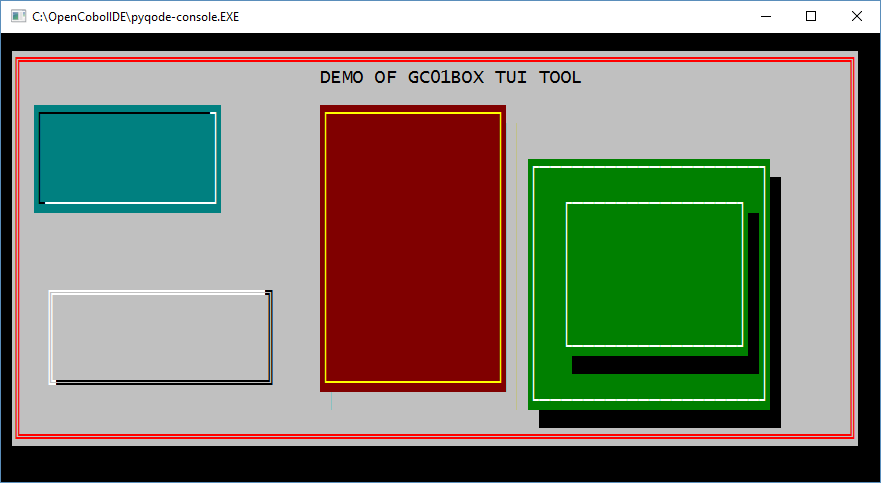

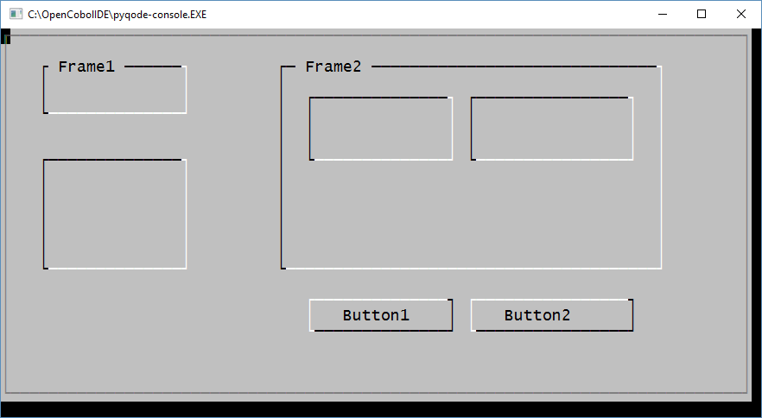

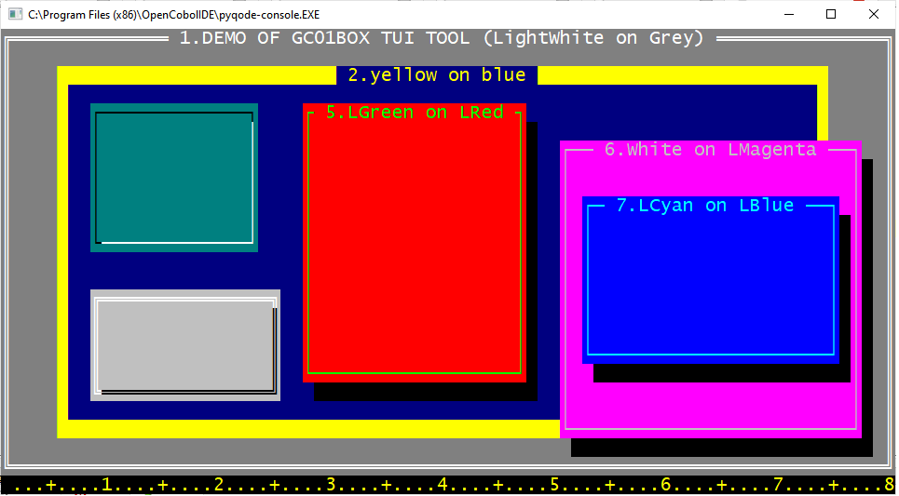

Using of COLOR CODES from 08 to 15 is allowed.
See COLOR CODES Chapter in this document.
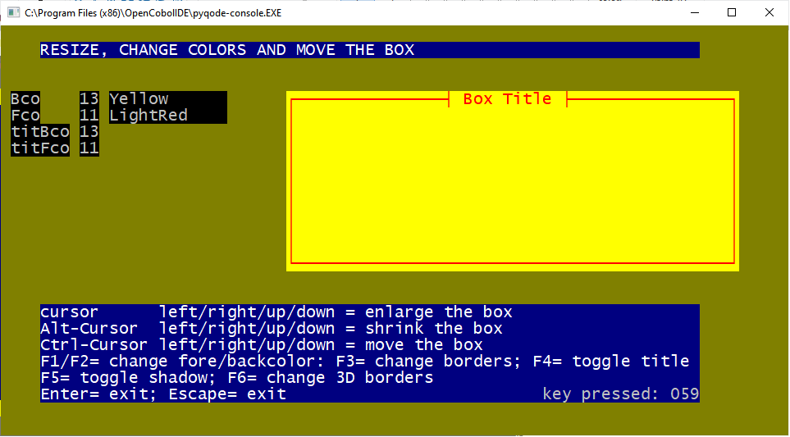

- TUI TOOL 02 - BOXMEX

DISPLAY A MESSAGE IN A BOX ON SCREEN WITH OPTIONS AND EFFECTS
You can set colors, position, text of the message, size of the box ....,
The boxmessage , if requested by caller, can be moved by the user on screen with cursor keys.
The single < OK > button can be omitted.
if requested by the caller the boxmessage returns to caller without waiting a user keypress (this way you can display more than one button combining 2 tools GC02BOXMEX and GC09BUTTONS) see following sample..
 | TOOL  TYPE | DESCRIPTION | PROGRAM  & COPY NAME
02 | BOX & MESSAGE | Display Messages in a BOX with text and an OK button, you can specify back/fore colors, size, position, single / double / custom box borders, 3D effect and so on.  Use Enter or mouse key to exit from message box. | GC02BOXMEX.COB  GC02BOXMEX.CPY  GC02BOXMEXDEMO.COB

GC02BOXMEXDEMO in action:

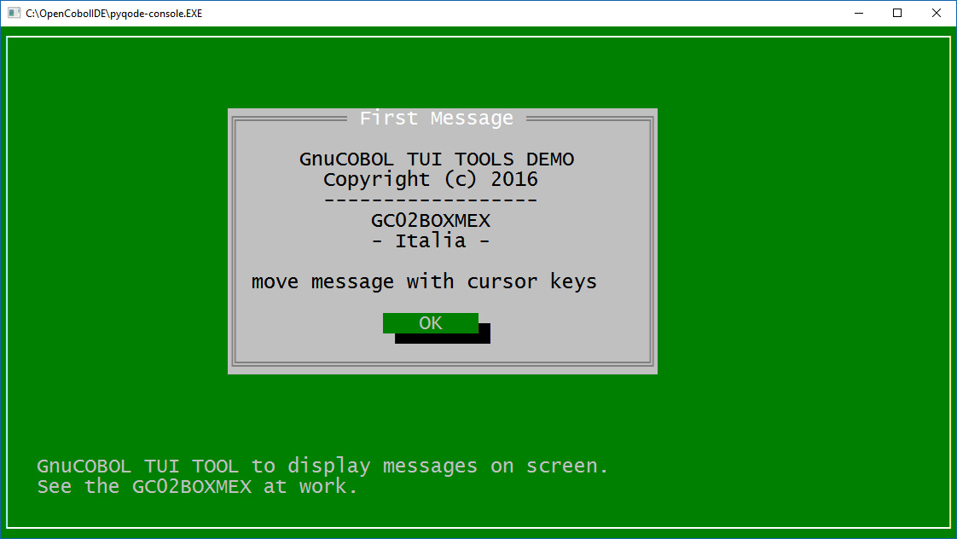

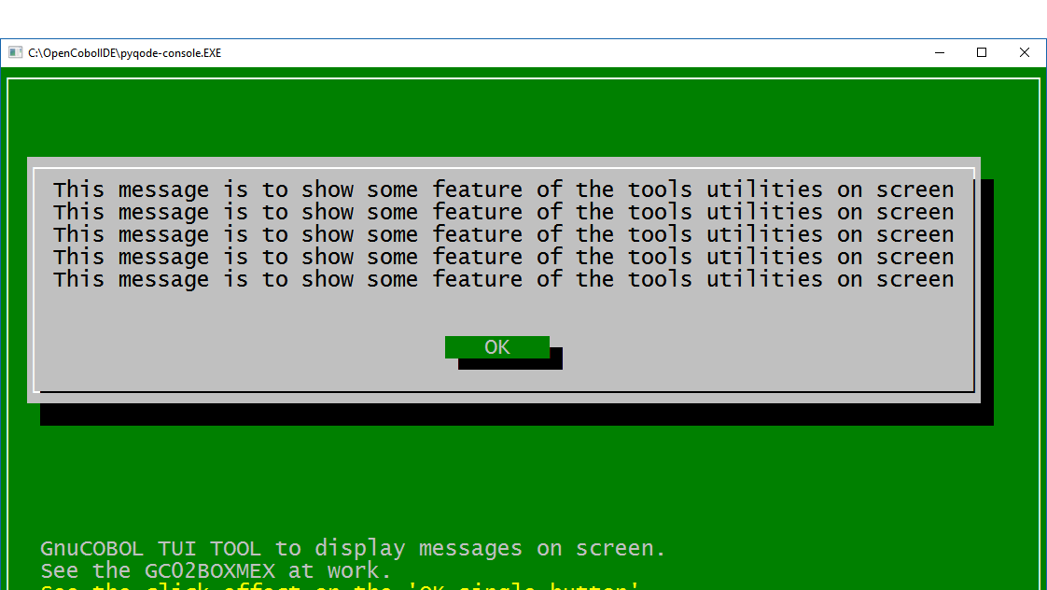

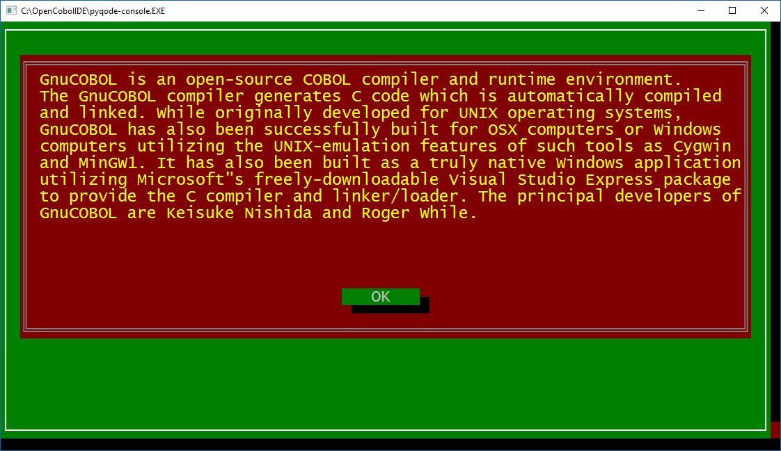

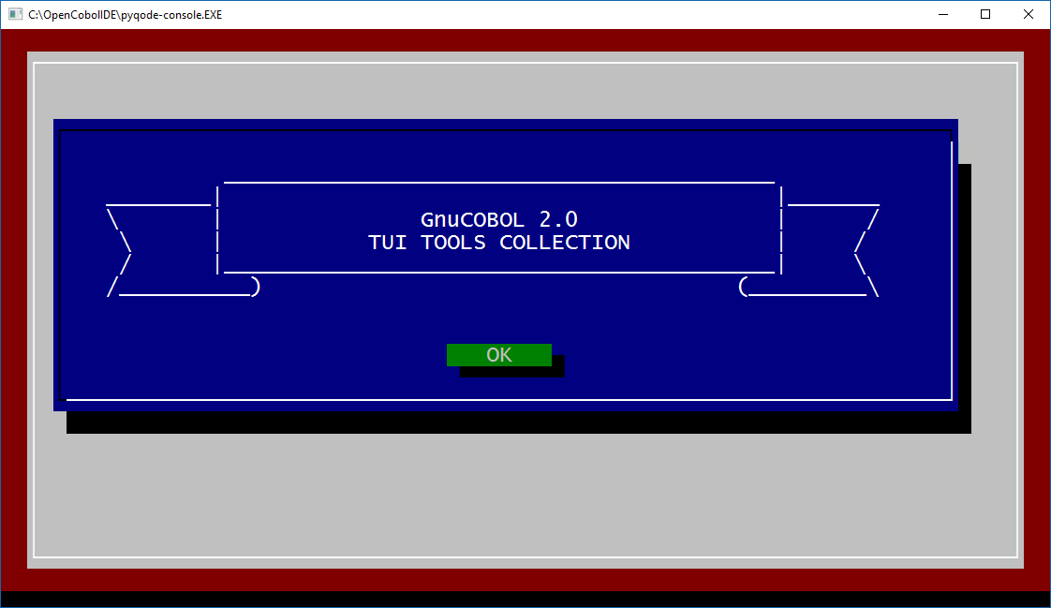

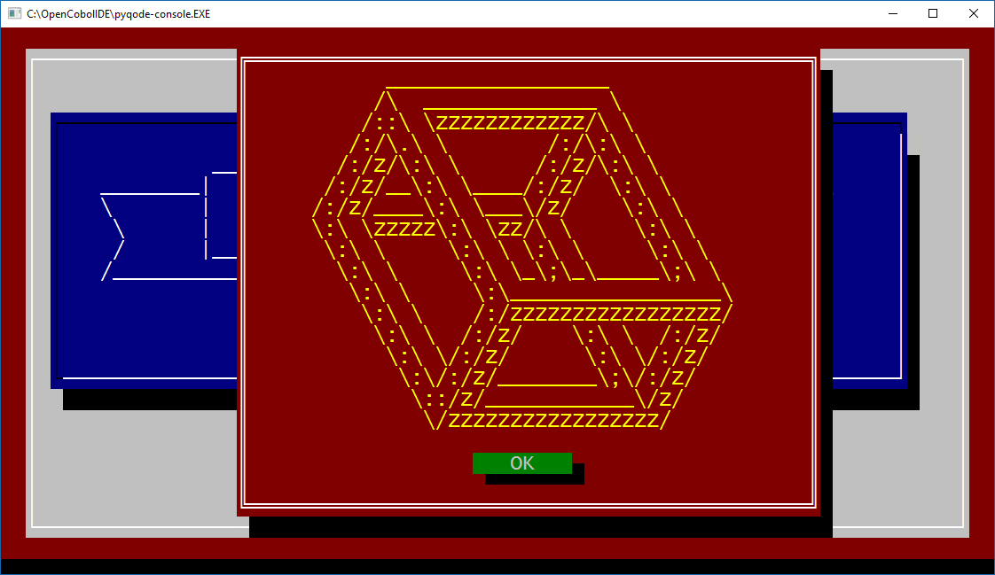

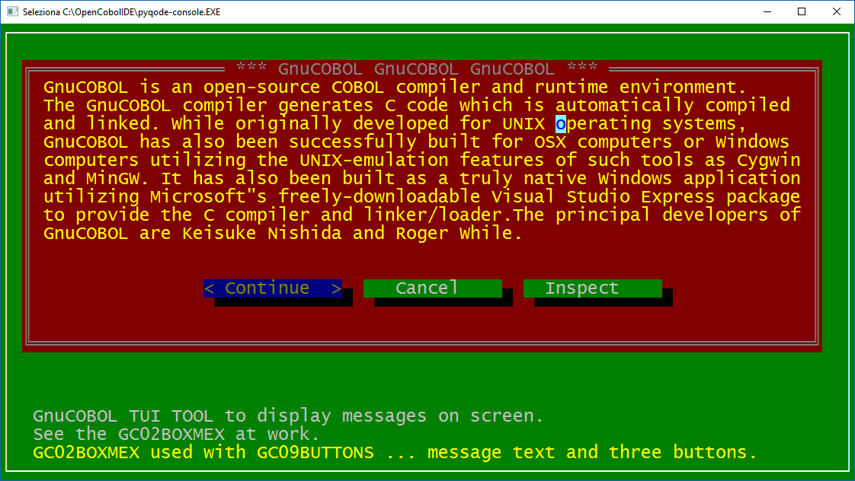

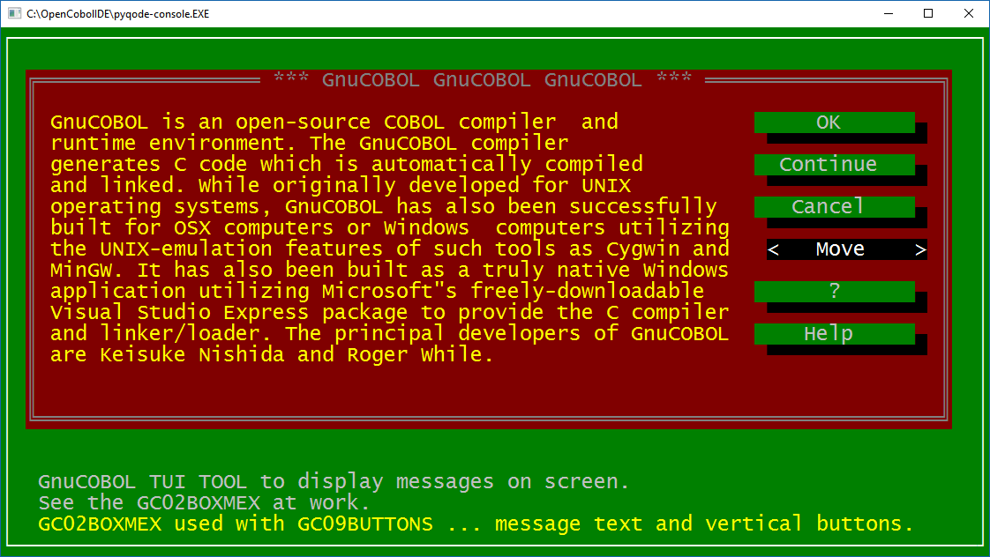

In this page you can see GC02BOXMEX used together with GC09BUTTONS.

- TUI TOOL 03 - YESNO
A program to manage a box with a text and two big buttons: YES and NO.
You can set text, colors, position ...
The ability to select one of the buttons with the mouse has been added.
Detailed parametere documentationin into Cobol sources YESNO.COB, YESNO.CPY and YESNODEMO.COB
The possibility of using colors from 08 to 15 has been added.
ALT-F2 / 3 / 4 / 5 keys have been added to change the colors of the TOOL.

 | TOOL  TYPE | DESCRIPTION | PROGRAM  & COPY NAME
03 | YESNO | Display a Box Message with 3 lines of short text and two big buttons labeled: YES and NO (you can change the labels). Also you can specify back/fore colors, size, position, and so on.  To select a button you can also use mouse key. | GC03YESNO.COB  GC03YESNO.CPY  GC03YESNODEMO.COB

GC02YESNODEMO in action:

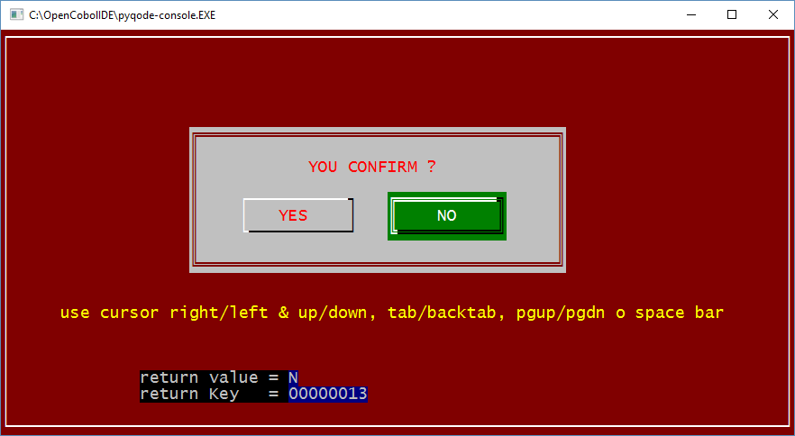

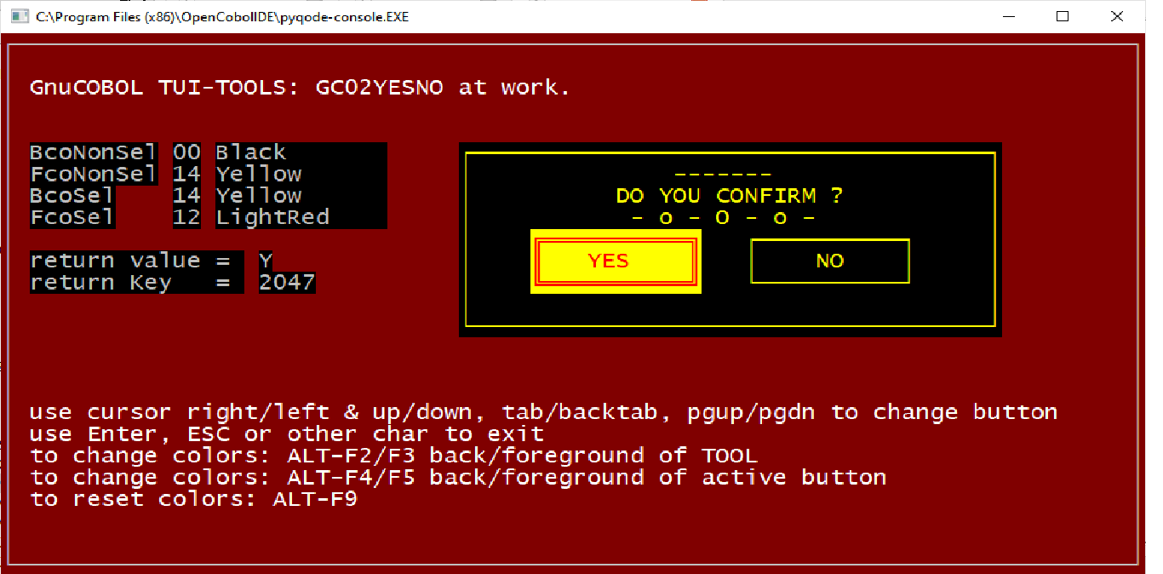

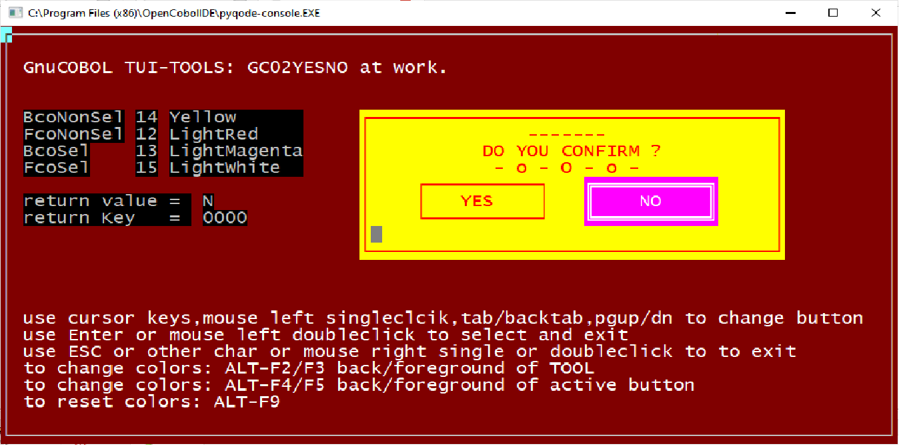

- TUI TOOL 05 - YESNOCANCEL
Similar to YESNO (two big buttons), this tool provides you with three big buttons usually labeled YES, NO and CANCEL. Button labels can be changed for example to Abort, Retry, Ignore.
The button can also be activated and selected with mouse left click.
You can choose text of messages, position, colors ... The colors also include codes from 08 to 15.
 | TOOL  TYPE | DESCRIPTION | PROGRAM  & COPY NAME
05 | YESNOCANCEL | Display a Box Message with 3 lines of a short text and three big buttons labeled: YES, NO and CANCEL (You can change the labels exampe to Abort, Retry, Ignore). You can also specify back/fore colors, size, position, and so on. To select a button you can also use mouse key. | GC05YESNOCANC.COB  GC05YESNOCANC.CPY  GC05YESNOCANCDEMO.COB

GC05YESNOCANCDEMO in action:

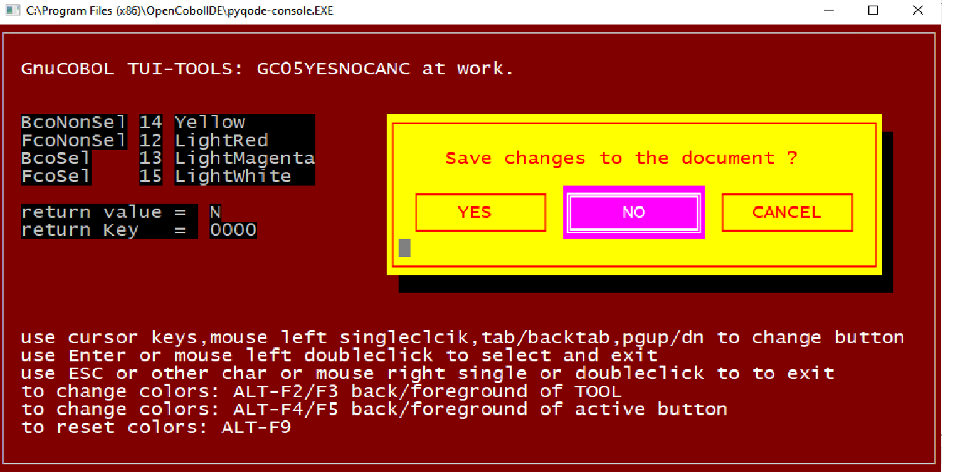

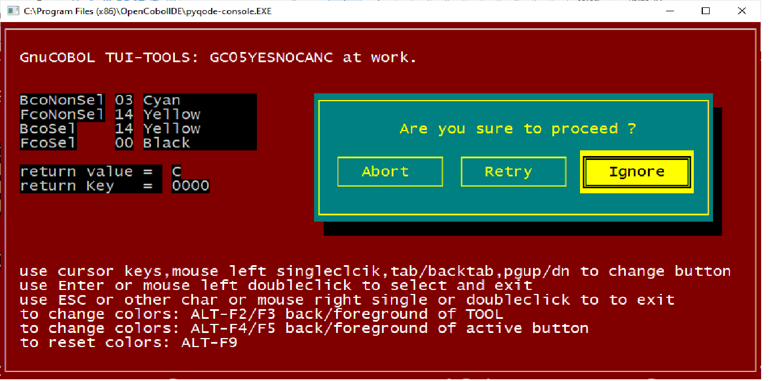

This screen shows using different button labels.

- TUI TOOL 09 - BUTTONS

 | TOOL  TYPE | DESCRIPTION | PROGRAM  & COPY NAME
09 | BUTTONS | Display buttons on screen, you can specify number of  buttons, back/foreground colors, size, position, text of buttons, hotkey and so on. To activate or select a button you can type hotkeys or use mouse key to click on buttons. | GC09BUTTONS.COB  GC09BUTTONS.CPY  GC09BUTTONSDEMO.COB

GC09BUTTONSDEMO in action:

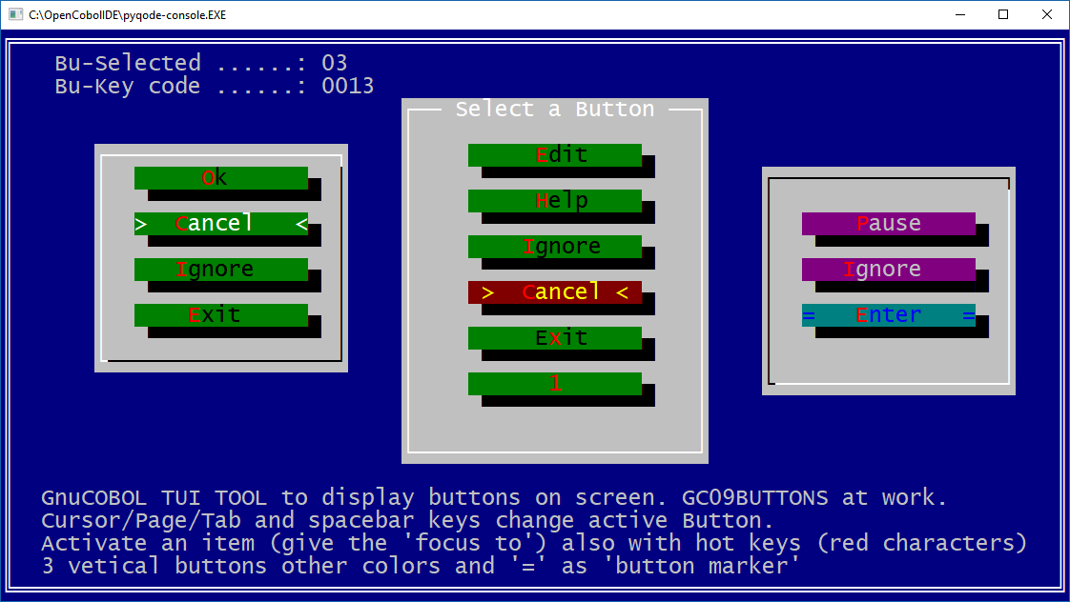

Vertical buttons.

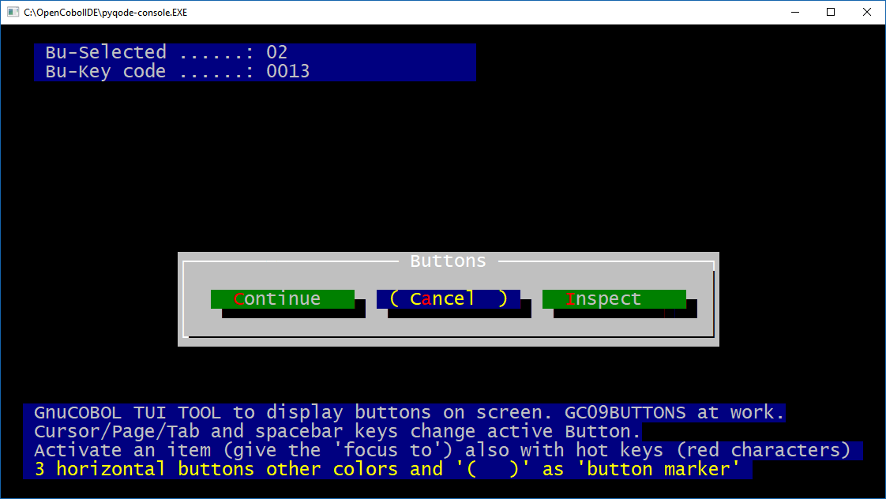

Horizontal buttons with different brackets.

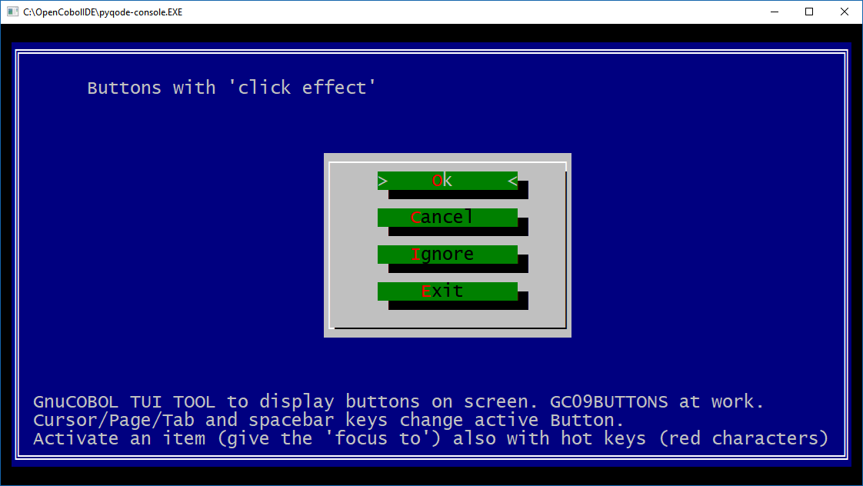
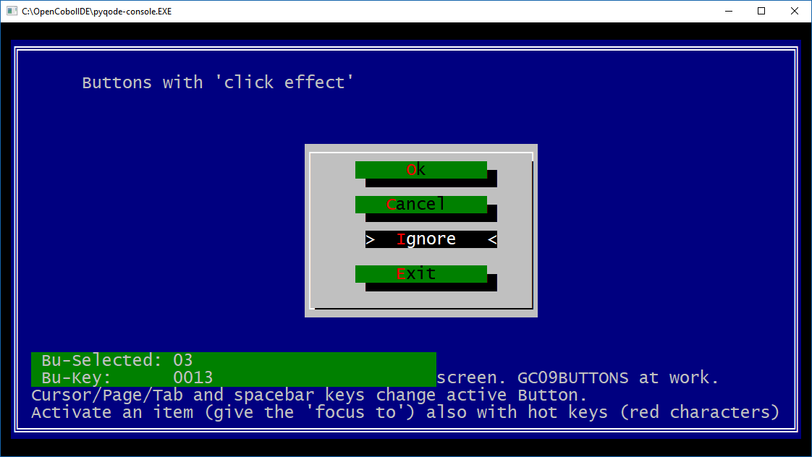

Click effect demo.

- TUI TOOL 13 - CHECKBOX

 | TOOL  TYPE | DESCRIPTION | PROGRAM  & COPY NAME
13 | CHECKBOX | Display a group of checkbox items (switches) on screen, you can specify text of options, number of items, back / foreground colors, size, position, symbol, brackets and so on.You can also type hotkey to position and/or use mouse click to mark/unmark single checkboxes. | GC13CHECKBOX.COB  GC13CHECKBOX.CPY  GC13CHECKBOXDEMO.COB

GC13CHECKBOXDEMO in action:

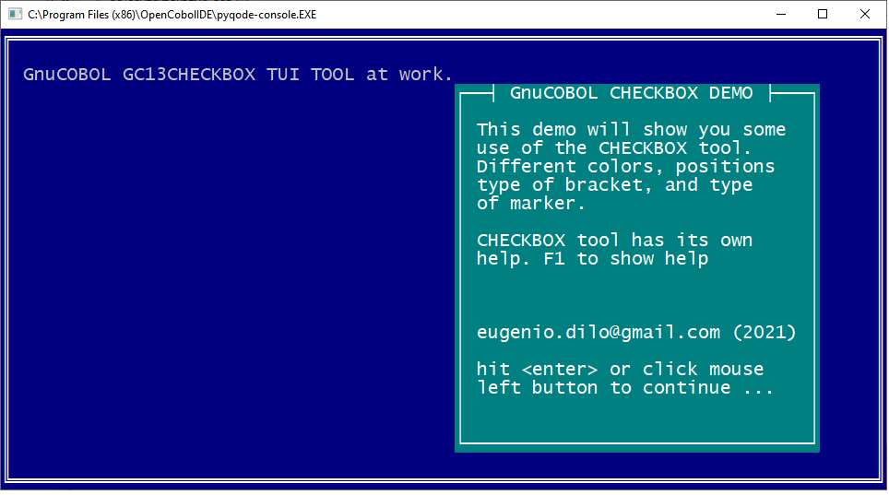

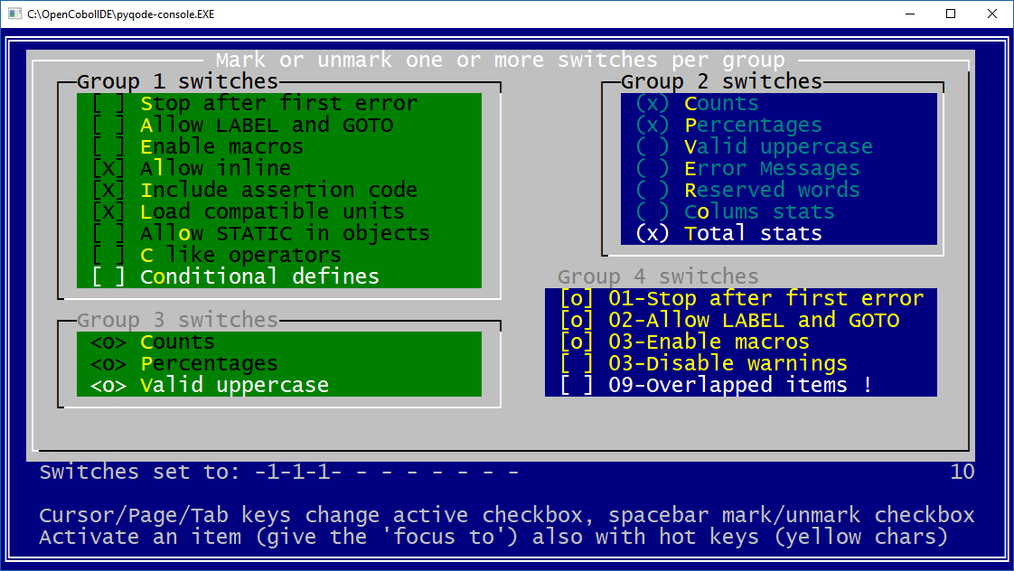

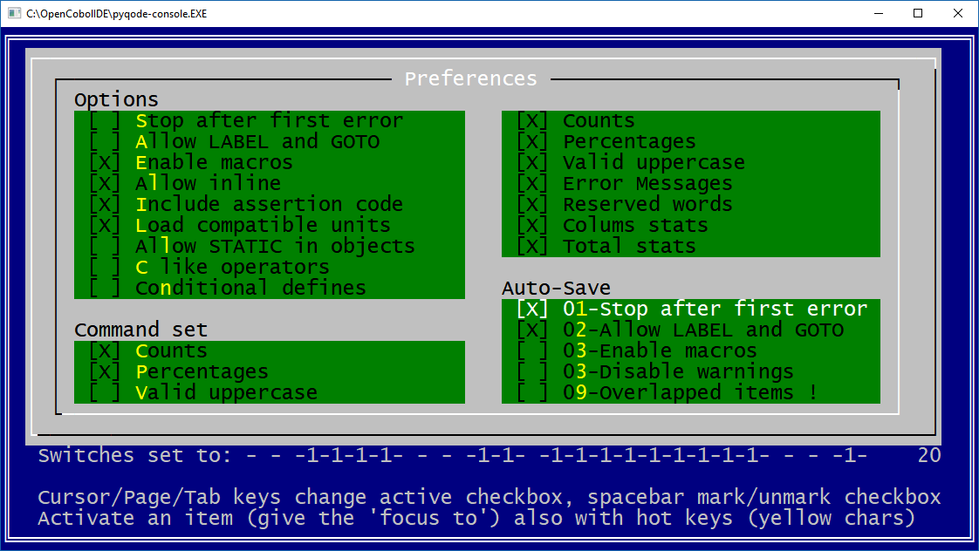

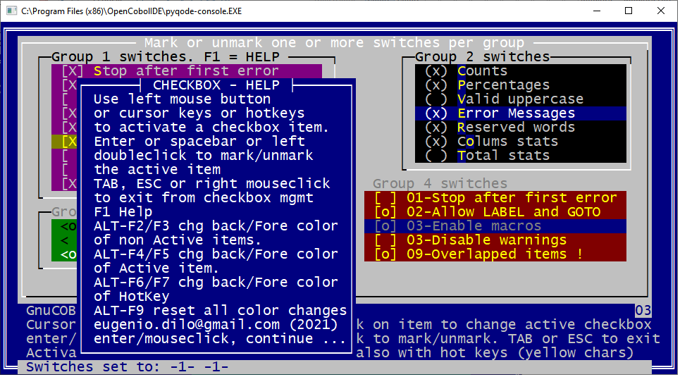

- TUI TOOL 15 - OFFON

Useful for managing the activation (ON) or deactivation (OFF) of a series of values or parameters.
The cobol source is G15OFFON.COB. The parameters are described in the copy GC15OFFON.CPY.
An example / demo of use is in the source GC15OFFONDEMO.COB.
 | TOOL  TYPE | DESCRIPTION | PROGRAM  & COPY NAME
15 | OFF & ON | Display OFF or ON items (switches) on screen, you can  specify labels (OFF & ON or YES & NO and so on...) , number of items, back/fore colors, size, position, symbol, brackets and so on. Hotkey is available, Mouse management in included to put switches ON or OFF. | GC15OFFON.COB  GC15OFFON.CPY  GC15OFFONDEMO.COB

GC15OFFONDEMO in action:

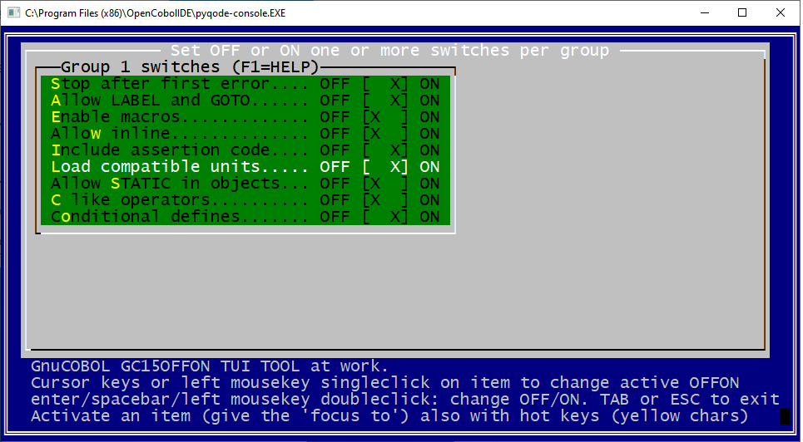

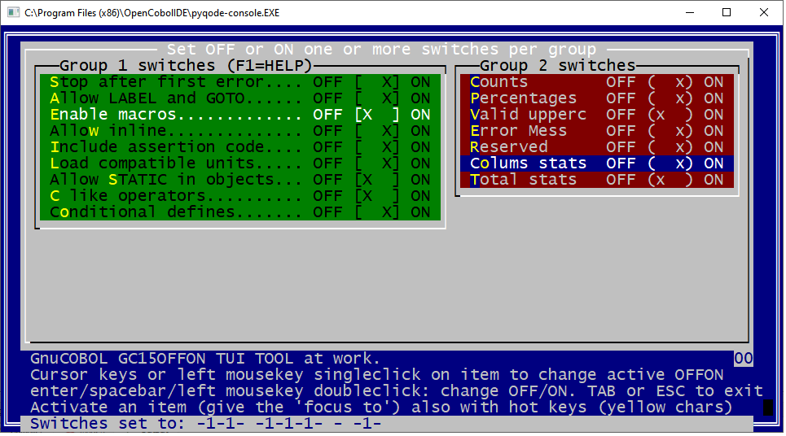

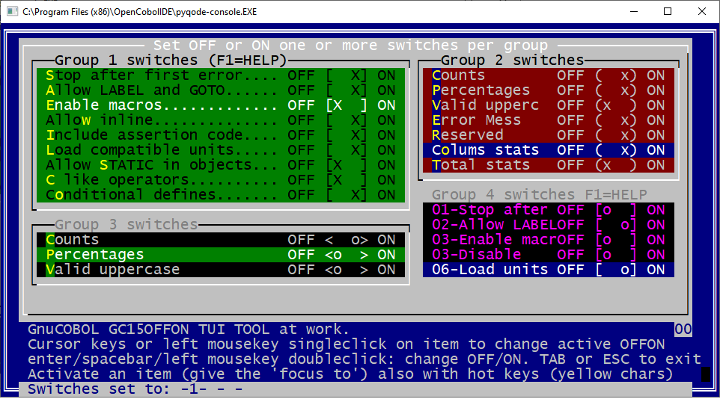

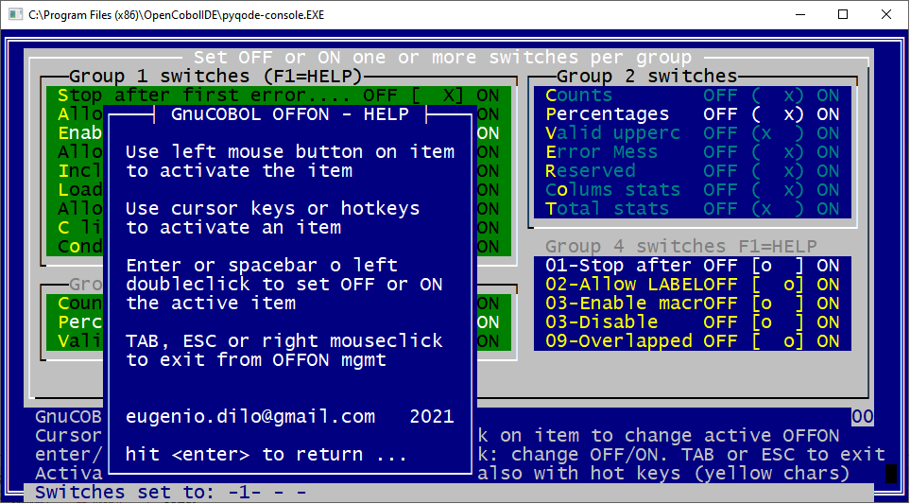

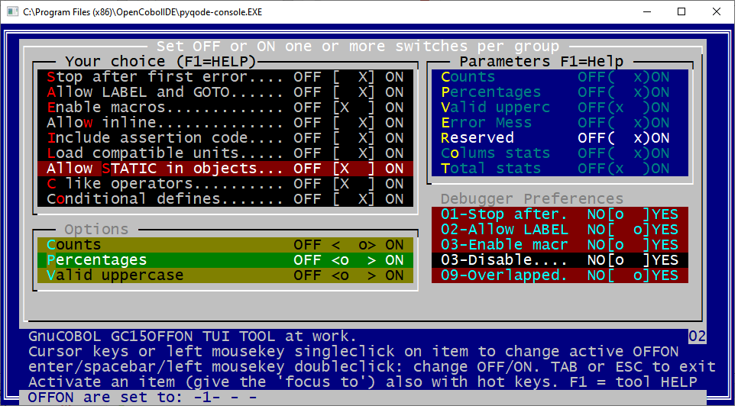

Lat group ha labels with YES & NO instead of OFF & ON.

- TUI TOOL 18 - RADIOBUTTON

A module you can "call" to display a group of RADIOBUTTON items on screen and let the user browse with cursor/page/tab and spacebar keys to select just one of the options in the group.
As usual you can select colors, position, bracket symbols, mark symbol, and so on.
Also to this TUI TOOL has been added the possibility of using the mouse and a HELP function that can be activated with F1.

 | TOOL  TYPE | DESCRIPTION | PROGRAM  & COPY NAME
18 | RADIOBUTTON | Display a group of Radiobutton items (options) on screen, you can specify options text, number of items, back / foreground colors, size, position, symbol of brackets and so on. Hotkey is available.  Mouse management in included to select an option. | GC18RADIOBUTTON.COB  GC18RADIOBUTTON.CPY  GC18RADIOBUTTONDEMO.COB

GC18RADIOBUTTONDEMO in action:

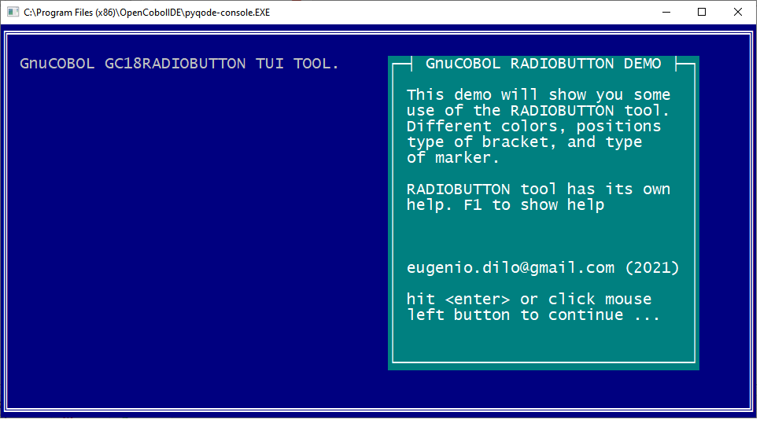

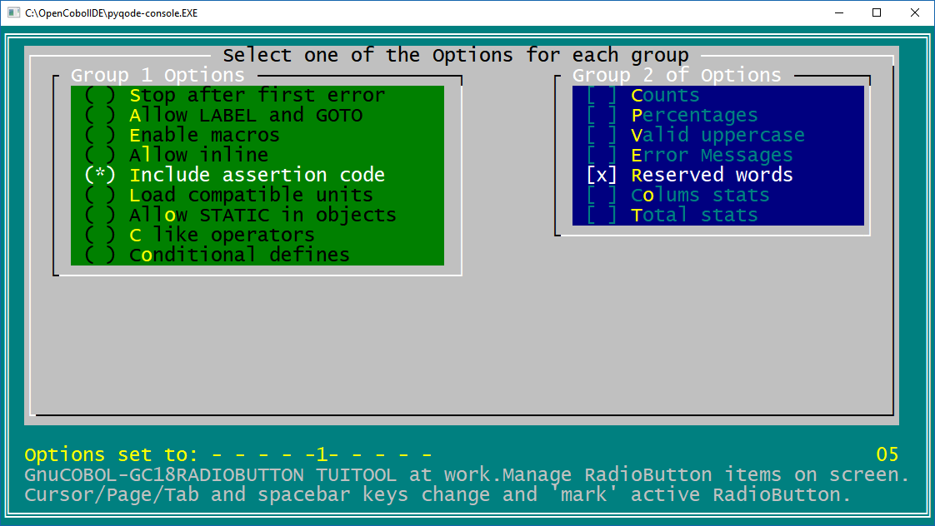

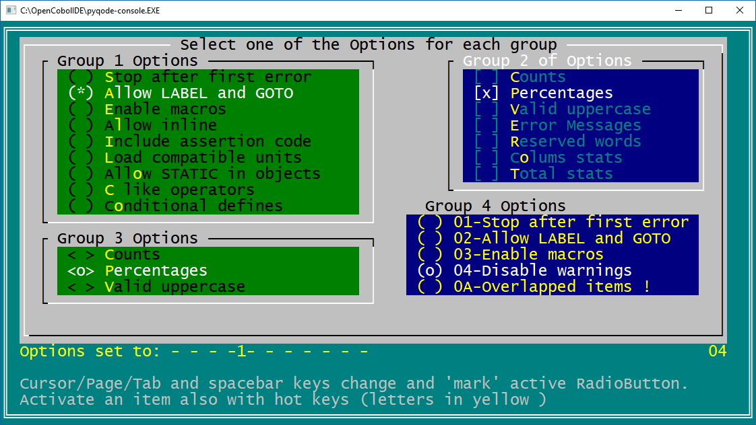

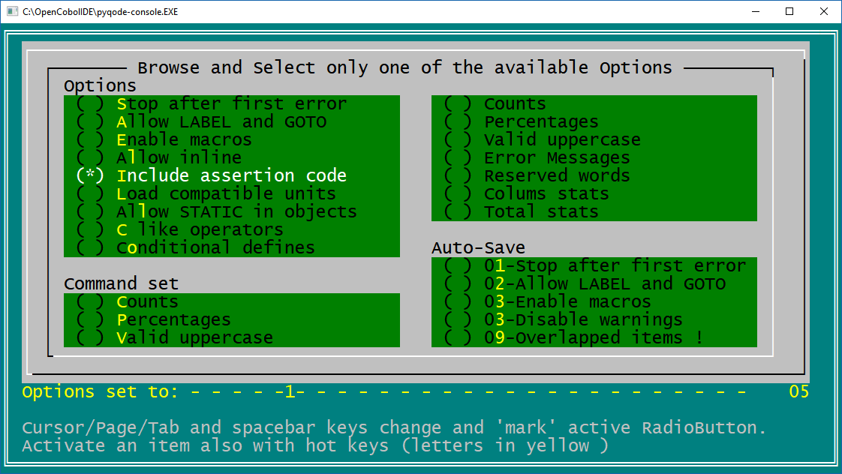

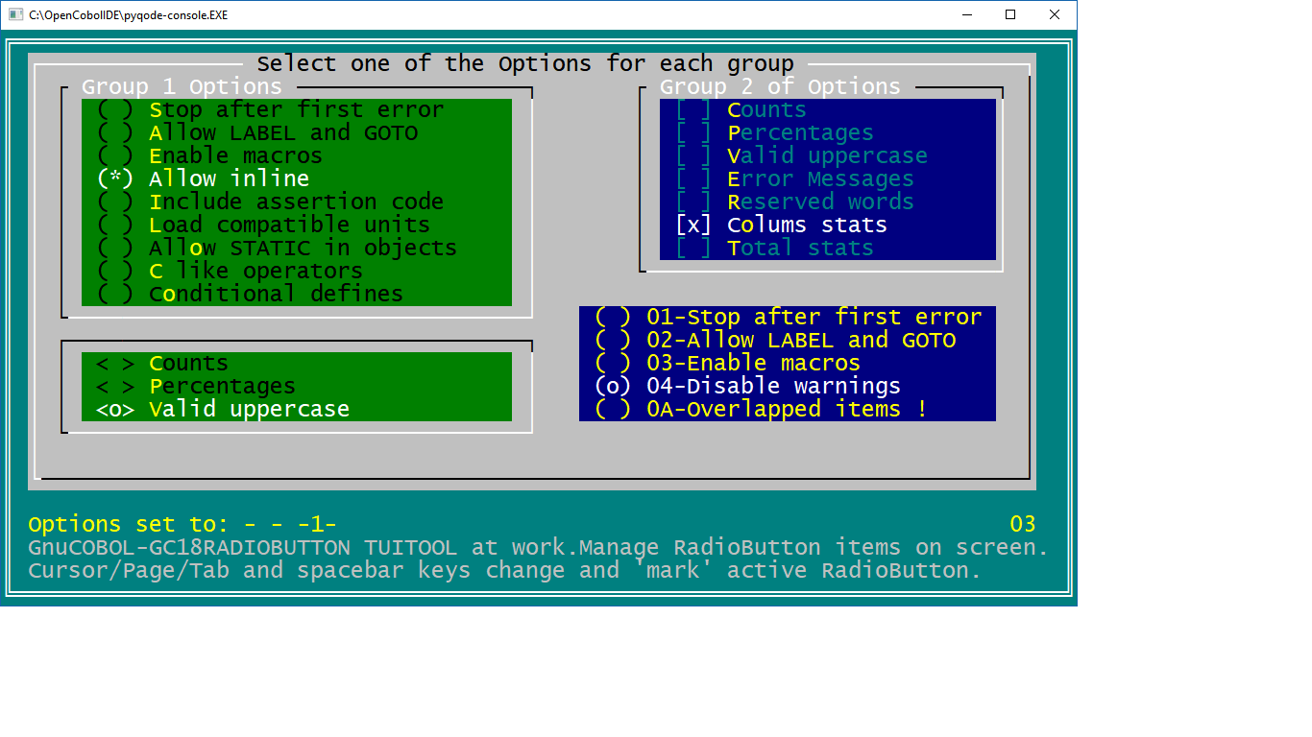

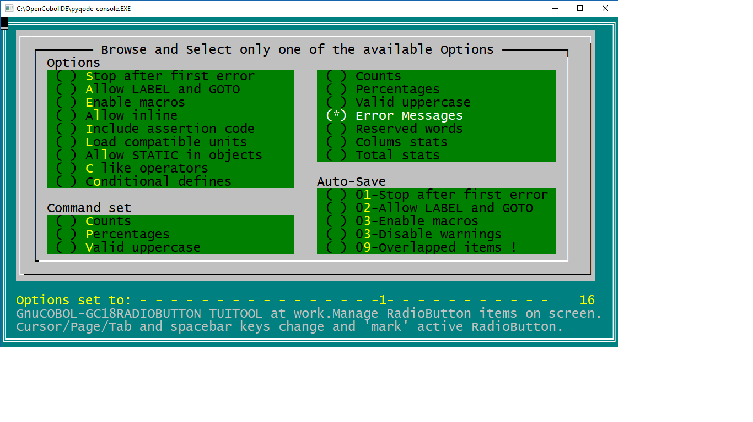

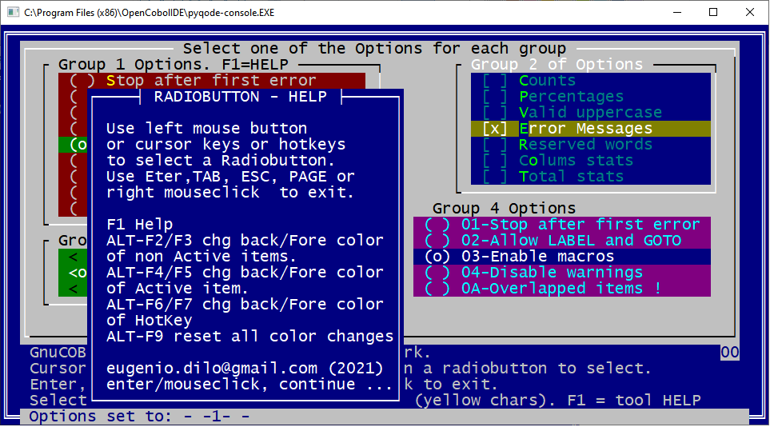

- TUI TOOL 21 - MENU
A program to manage MENU on screen (bar MENU and/or DROP DOWN MENU) and let the user select an item.
You can choose number of menu items, text of items, colors, positions, hotkey ...
Each menu item is a string of characters for example " Master File ".
If , in call parameters, we indicate that the hot key is the character number 2 (the first one in the string is a space) then the user can type an "m" to activate this menu item instead of using cursor keys.
The active item as usual, has to be selected with "enter".
You can also select (make active) a menu item with the click of the left button. And also it is possible to activate a menu item with a double click of the left button on a menu item, instead of typing the enter key.
Click Right mouse button to exit from MENU.

 | TOOL  TYPE | DESCRIPTION | PROGRAM  & COPY NAME
21 | MENU | Display a menu on screen, you can manage bar menu,  dropdown menu, specify text and length of menu items, number of items, back/foreground colors, position, messages associated to menu items, and so on. Hotkeys are available.  Mouse mgmt was added to select menu items. | GC21MENU.COB  GC21MENU.CPY  GC21MENUDEMO1.COB  GC21MENUDEMO2.COB

GC21MENUDEMO1 in action:

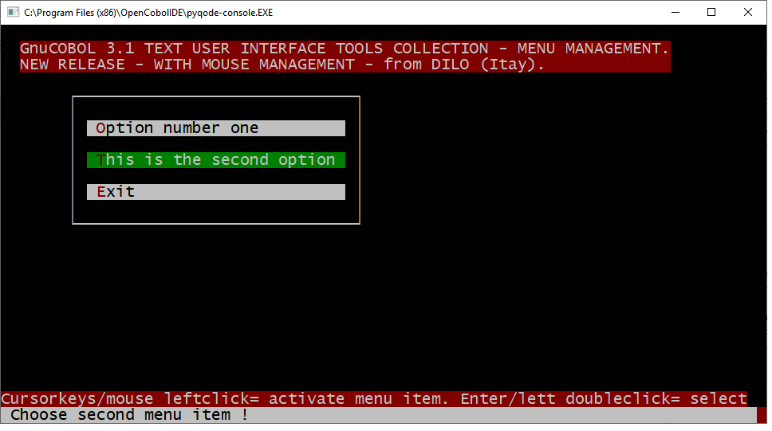

A message can be displayed with each menu item. In these samples the message is on last screen row.

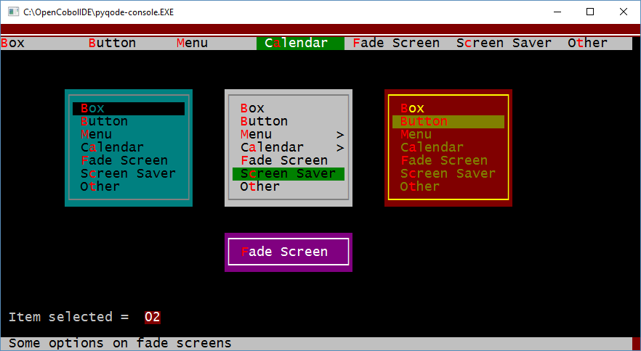

GC21MENUDEMO2 in action: BAR & DROP-DOWN MENU sample:

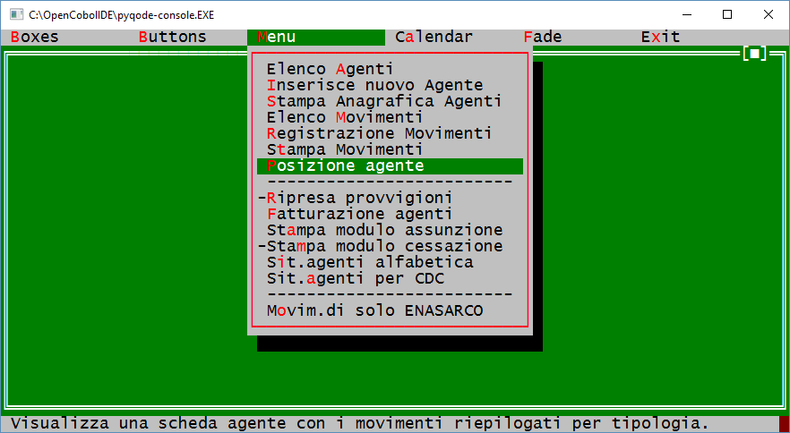

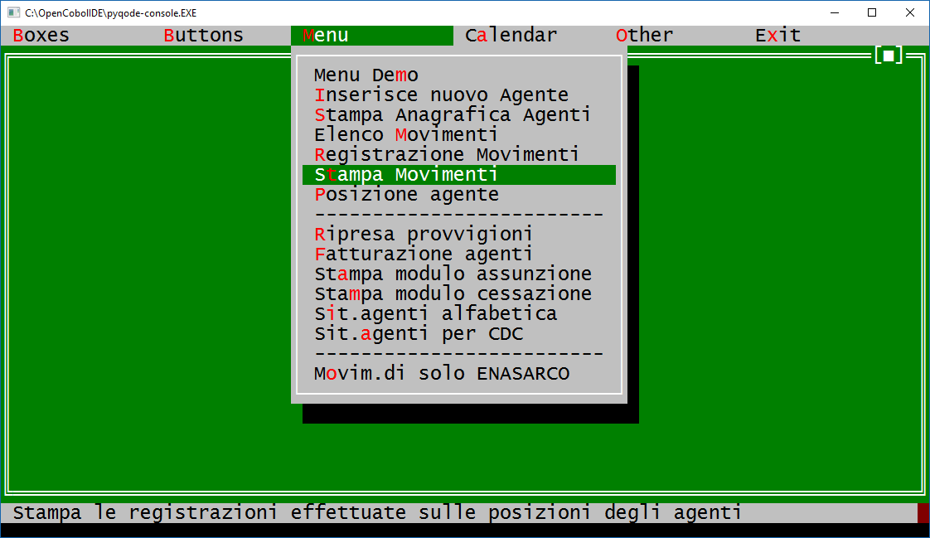

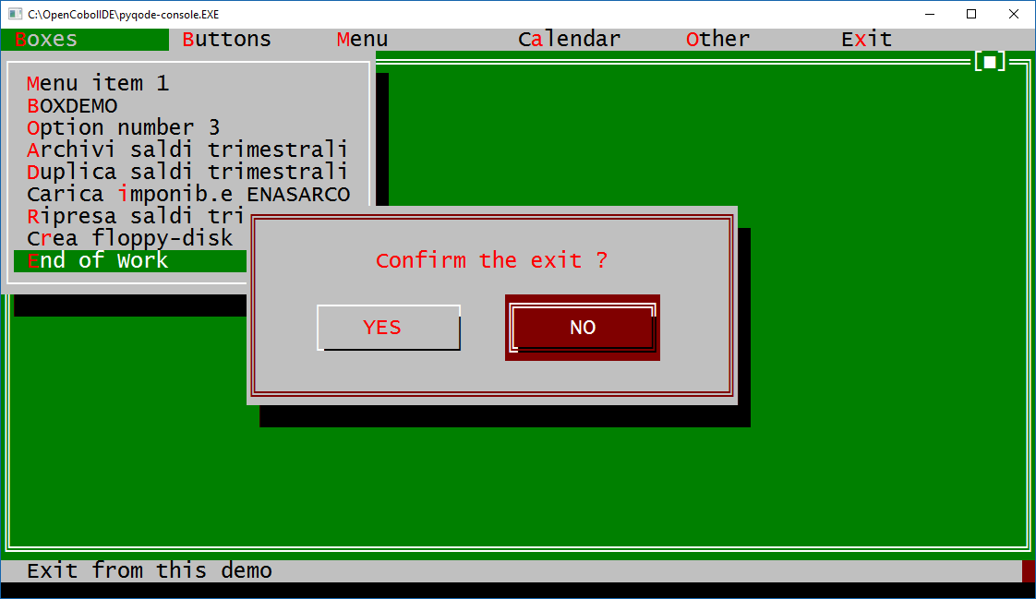

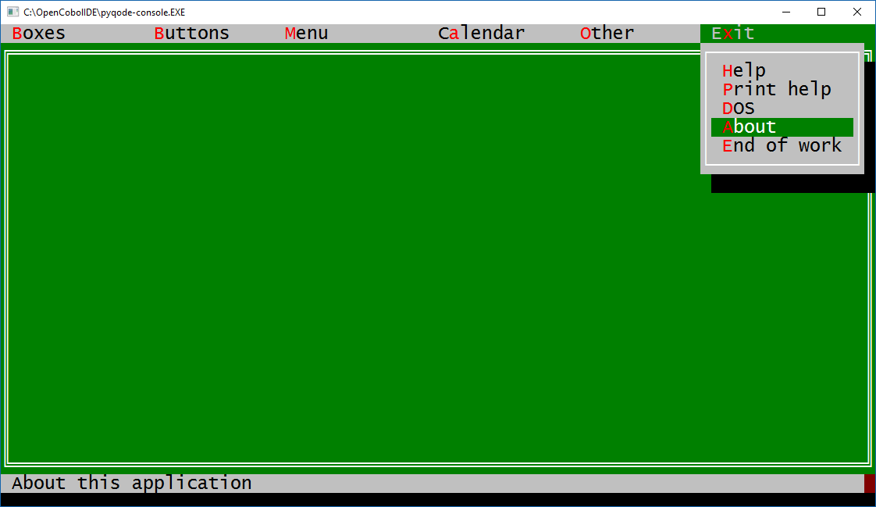

Other samples:

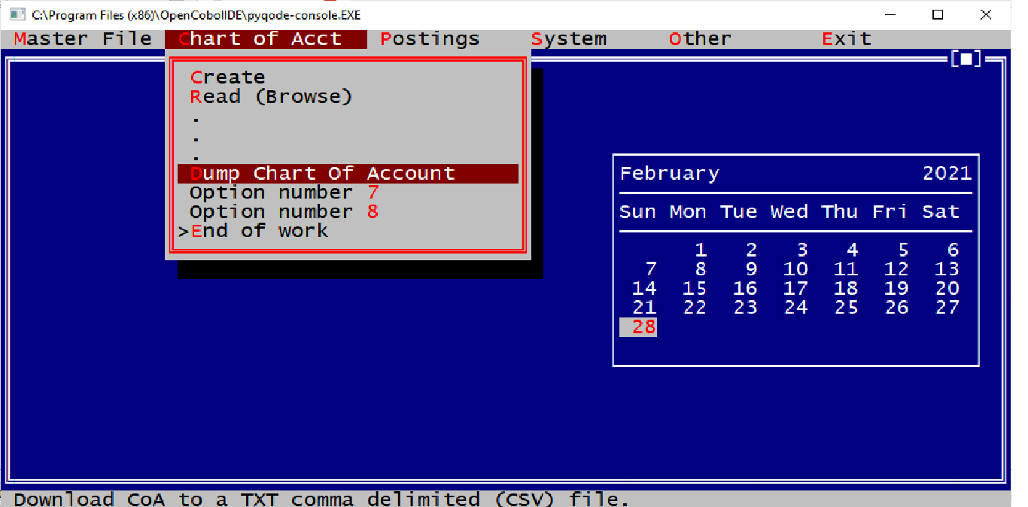

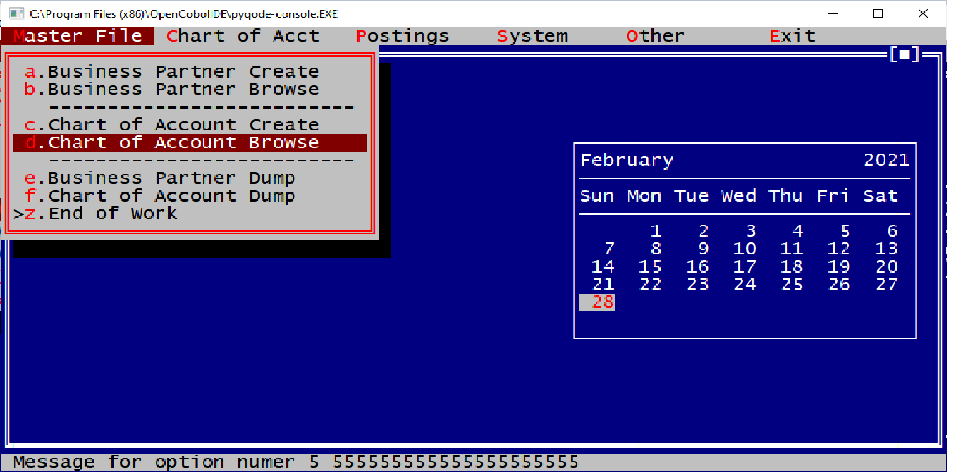

- TUI TOOL 26 - LIST VIEW

Display a list of items (rows) in a window and let the user browse the list (scroll vertical or scroll horizontal) and select one of the items.
Your program have to call this TOOL passing a table (list of items. max 999 item each one of 999 cols max).
Your program can choose: the size of the list (how many rows - max 999 & how many cols - max 999), position and size of the window (how many rows & cols, also full screen), colors, borders, shadow, title, and so on ....
This kind of TOOL is sometimes also called "dropdown list" or "pickup list".
Typical use: when in a program, the user has to type a code in a field, then he can press, for example F4, to get a window with a list of values and select one code from the list.
For example, a field to enter a customer's code, a cost center code, an account code ...
This TOOL use some other TUI TOOLS, so you need those other programs compiled (as .dll modules in a "windows environment").

 | TOOL  TYPE | DESCRIPTION | PROGRAM  & COPY NAME
26 | LISTVIEW | Display a window with an item list on screen. You can set the window size at your needs (also full screen). With cursor keys the user can scroll or browse vertical and horizontal the list and select one of the items with Enter. | GC26LISTVIEW.COB  GC26LISTVIEW.CPY  GC26LISTVIEWDEMO.COB

GC26LISTVIEWDEMO in action:

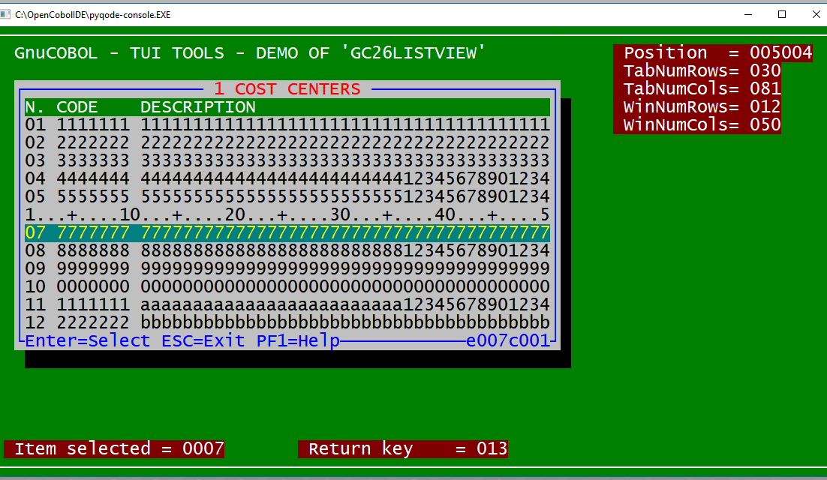

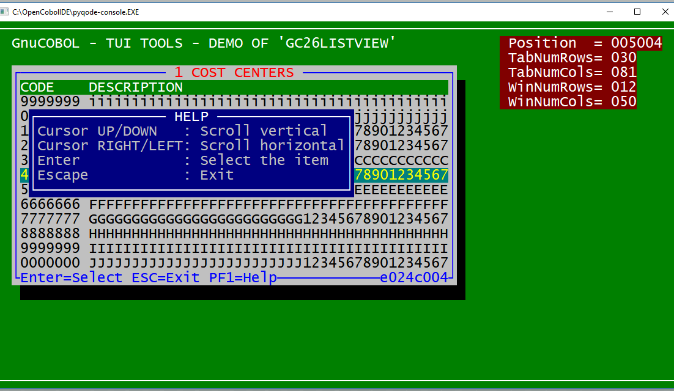

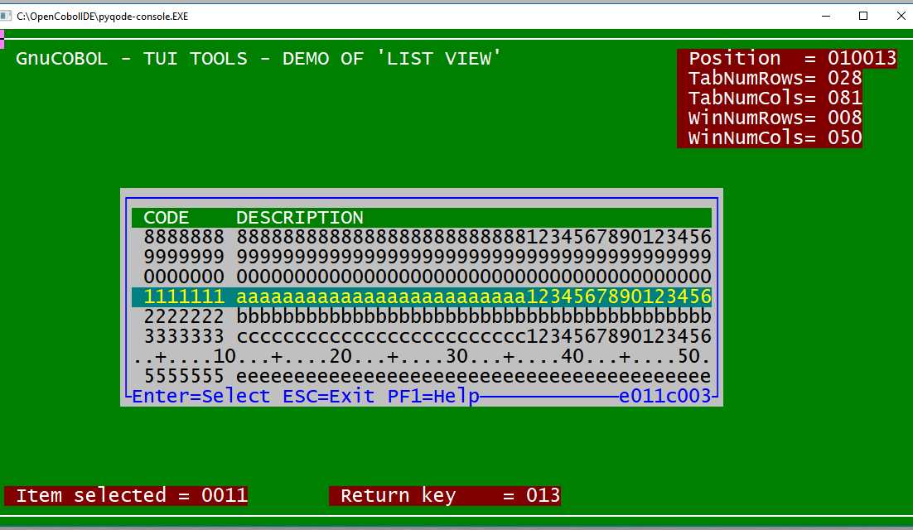

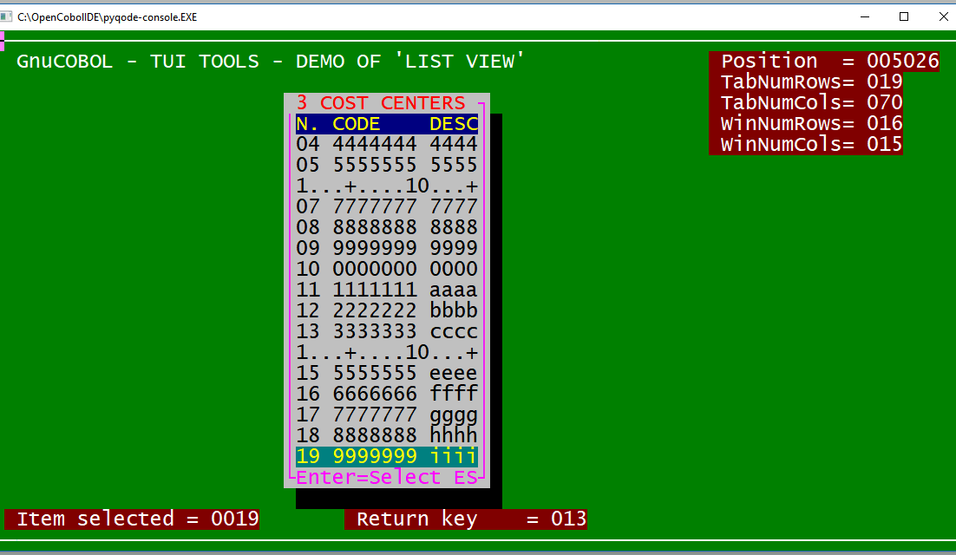

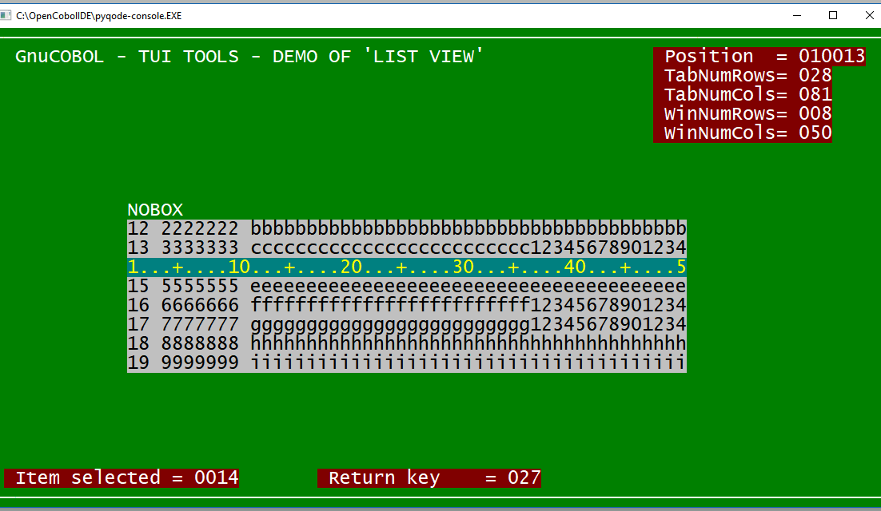

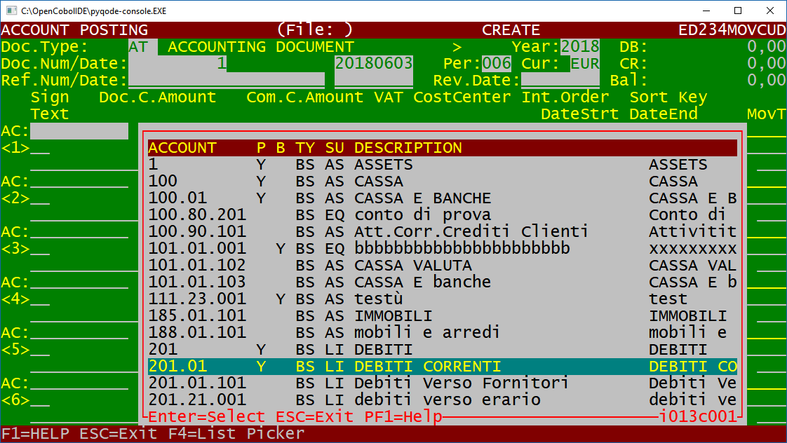

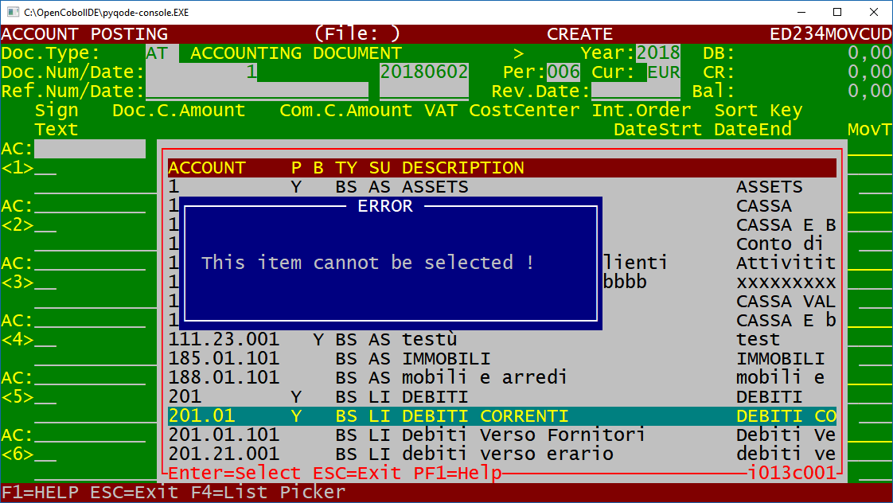

- TUI TOOL 51 - CALENDAR (ONE YEAR ON SCREEN)

Displays a one year calendar on one screen and let the user browse on dates , days, months, years to pick-up a date that is returned to caller program. Warning. the program needs a screen size of at least 50 rows.
Thsi program sets the screen size using following the DOS command: MODE CON: LINES=XXX COLS=XXX
Screen Size of 90 cols x 55 rows

 | TOOL  TYPE | DESCRIPTION | PROGRAM  & COPY NAME
51 | CALENDAR  (ONE YEAR) | Display a one year calendar on screen. User can browse through days, months and years to pick-up a date. | GC51CALYEAR.COB  GC51CALYEAR.CPY  GC51CALYEARDEMO.COB

GC51CALYEARDEMO in action:

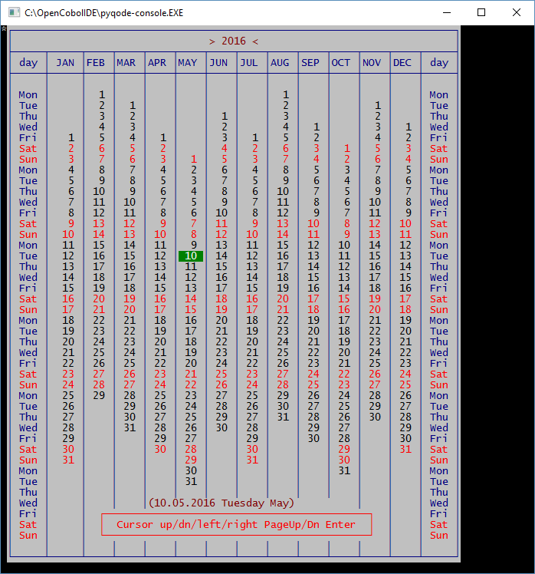

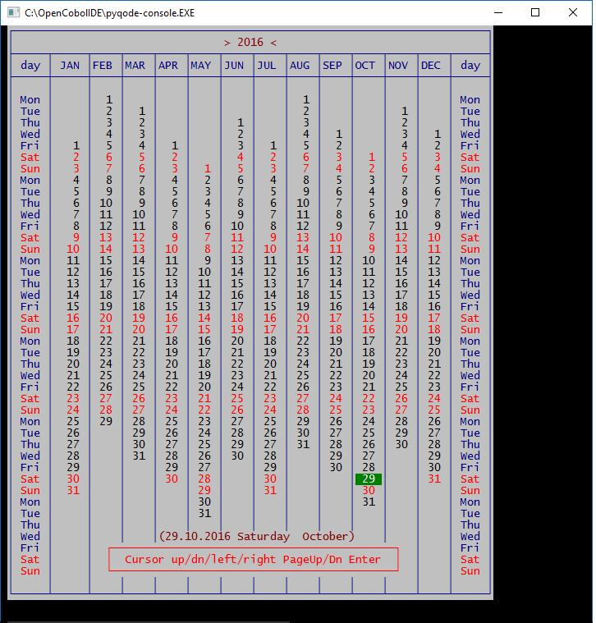

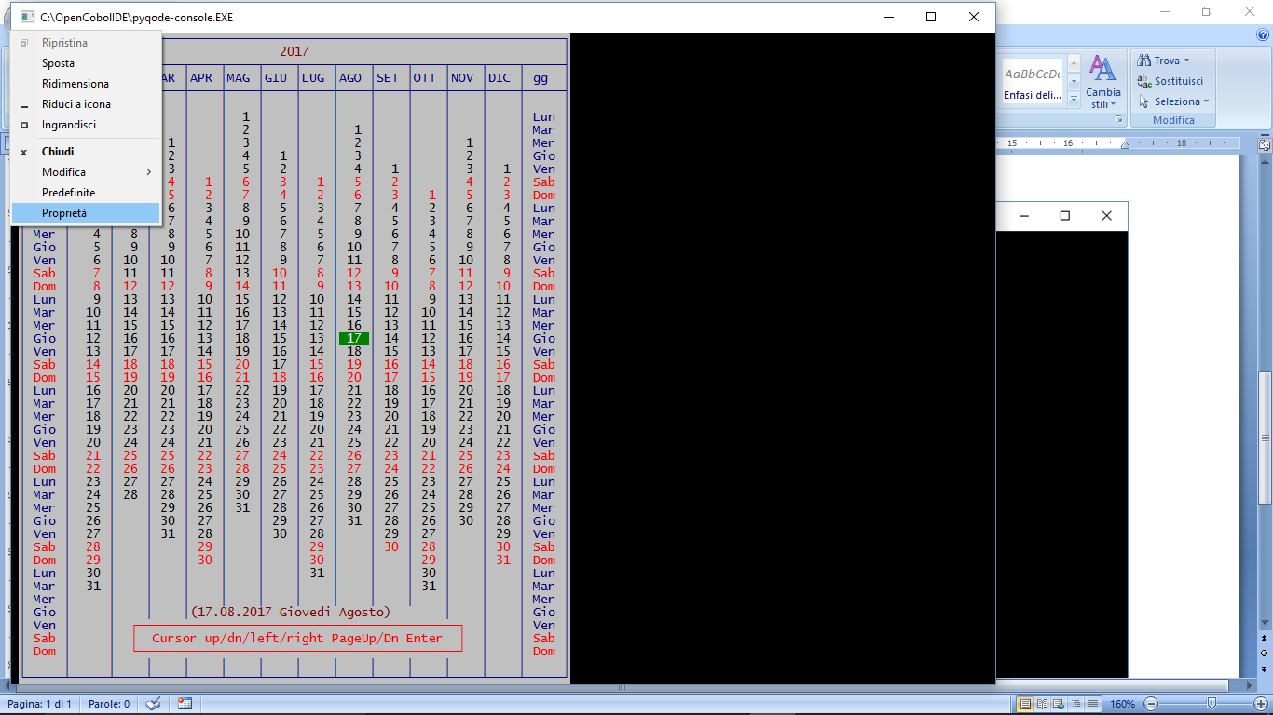

How to manually set more than 25 rows on screen on Windows.

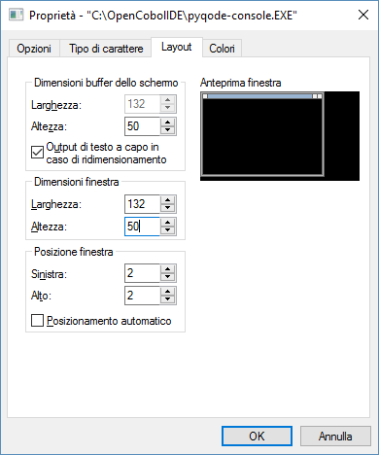

- TUI TOOL 52 - COLORPICKER

Displays a COLOR MAP of 8 Foreground Colors on 8 Background Colors.
A total of 64 different "Color Pairs" .
Let the user browse on the Color Map whit a "big cursor" to choose one of the "Color pairs".
Use F2 and F3 to change Fore / background Color of the frame

The management of F1 = HELP key has been added.
A single click of the left mouse button on a Color Code activates it. In the same way as using the Cursor keys.
Double clicking the left mouse button on a Color Code selects it in the same way as typing Enter.
Using the right mouse button (single or double click) has the same function as ESCAPE: you exit.
 | TOOL  TYPE | DESCRIPTION | PROGRAM  & COPY NAME
52 | COLOR PICKER | Display a colorpair map on screen (back / foreground colors combination) . Let the user to browse on it and pick up a color pair .  You can also use mouse key to select a COLOR pair | GC52COLORPICKER.COB  GC52COLORPICKER.CPY  GC52COLORPICKERDEMO.COB

GC52COLORPICKERDEMO in action:

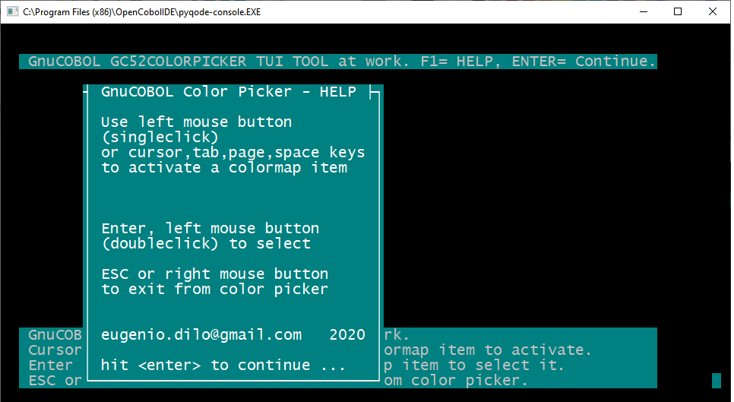

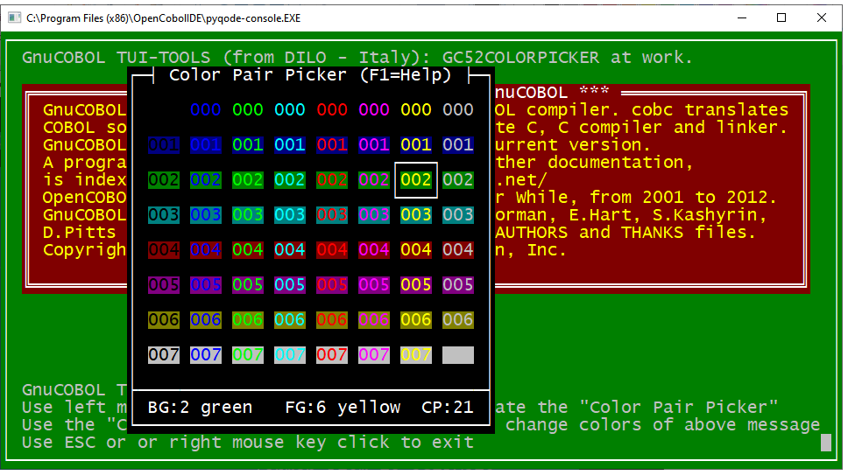

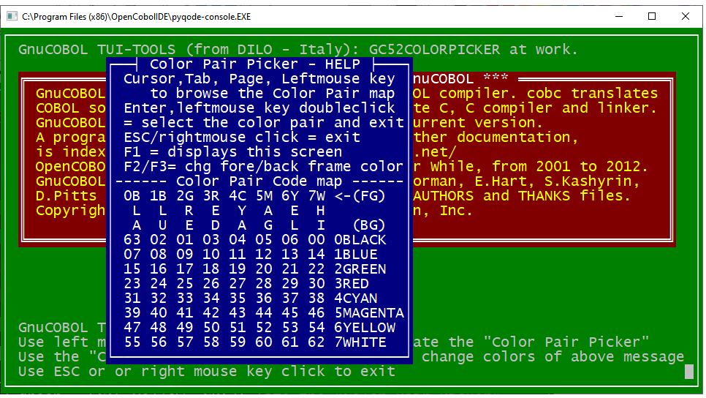

- TUI TOOL 53 - CALENDAR (THREE MONTHS ON SCREEN)

 | TOOL  TYPE | DESCRIPTION | PROGRAM  & COPY NAME
53 | CALENDAR  (THREE MONTHS) | Display a calendar on screen, three months on each row  User can scroll months and years to display month / year calendar. | GC53CALENDAR.COB  GC53CALENDAR.CPY  GC53CALENDARDEMO.COB

GC53CALENDARDEMO in action:

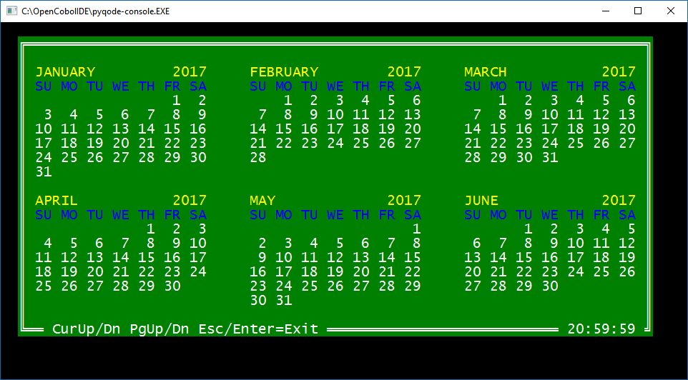

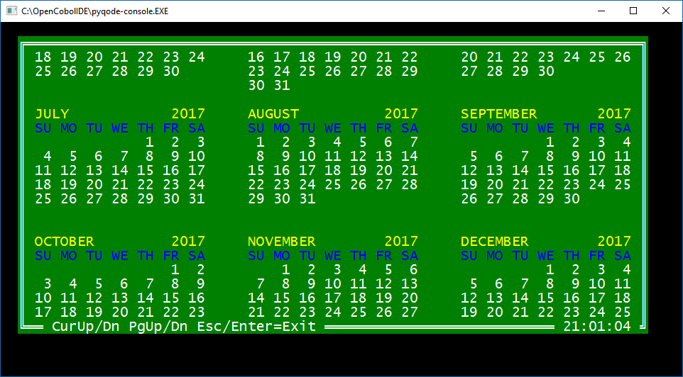

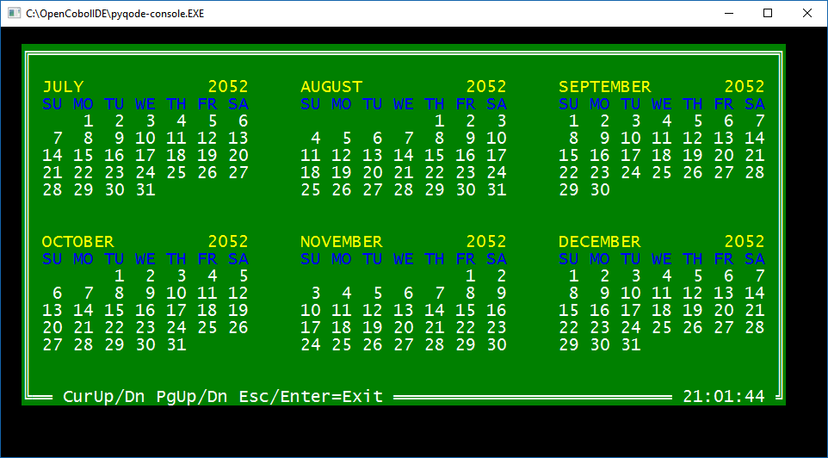

- TUI TOOL 54 - FILE PICKER

GC54FILEPICKER displays a list of files in a directory and allows to the user to select one of the files in that folder. This function uses system commands. For this reason it works just on a WINDOWS environment.
However, the cobol source can easily be adapted to be brought into a UNIX environment or other.
If , in the list on screen, you select a subdirectory, then the function displays the list of files in that subdirectory.
You can also select the line that allows you to go up one level in the directories tree hierarchy.
 | TOOL  TYPE | DESCRIPTION | PROGRAM  & COPY NAME
54 | FILE PICKER | Display a window with a File list on screen.  The user can browse and scroll vertical and horizontal the file list and select one of the items. The user can also select and navigate Up and Down on directories tree. | GC54FILEPICKER.COB  GC54FILEPICKER.CPY  GC54FILEPICKERDEMO.COB

GC54FILEPICKERDEMO in action:

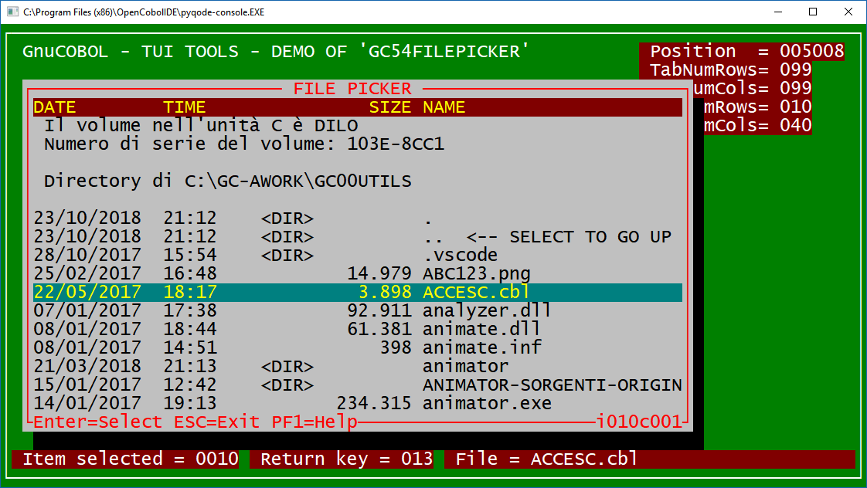

- TUI TOOL 55 - DIRECTORY PICKER
Displays a directory tree and allows you to browse through folders and select a folder.
The start folder of the list is set by the calling program
F4 allows you to go up to the higher level folder.
F5 allows you to switch between the graphic display of the folder structure and the display with non-graphic characters (see screenshot).
F6 allows you to switch between viewing folders only or viewing folders and files in folders (see screenshot).
This tools use system command "TREE" on a windows environment.
I think it will be easy adapt the cobol source to work on a Unix operating system.

 | TOOL  TYPE | DESCRIPTION | PROGRAM  & COPY NAME
55 | DIRECTORY PICKER | Display a window with a Directory tree-list on screen.  The user can browse vertical and horizontal the Directory tree-list and select one of the items.  The user can also select and navigate Up and Down on directories | GC55DIREPICKER.COB  GC55DIREPICKER.CPY  GC55DIREPICKERDEMO.COB

GC55DIREPICKERDEMO in action:

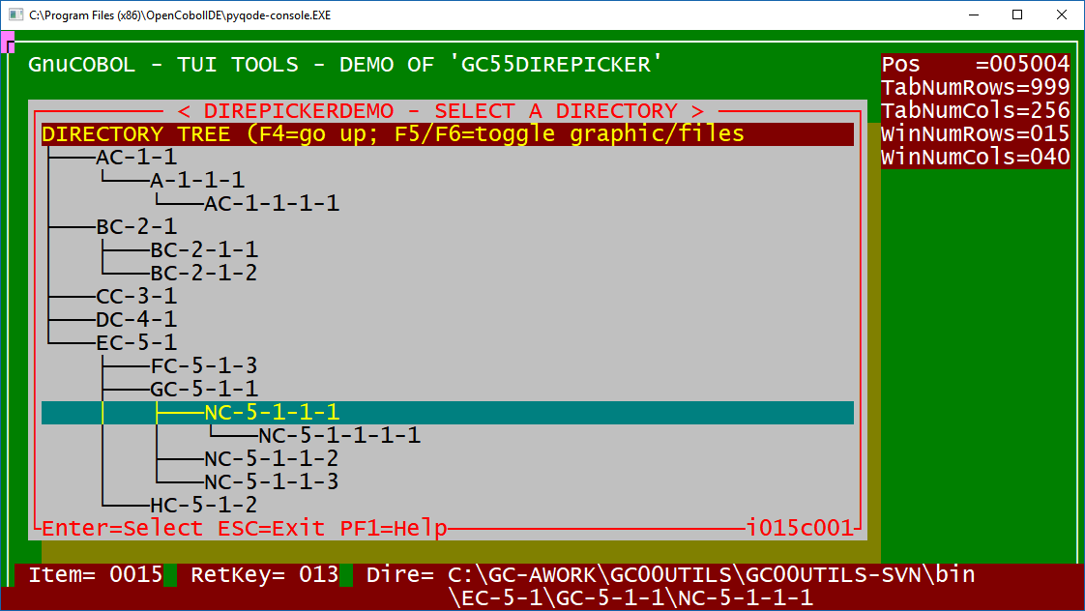

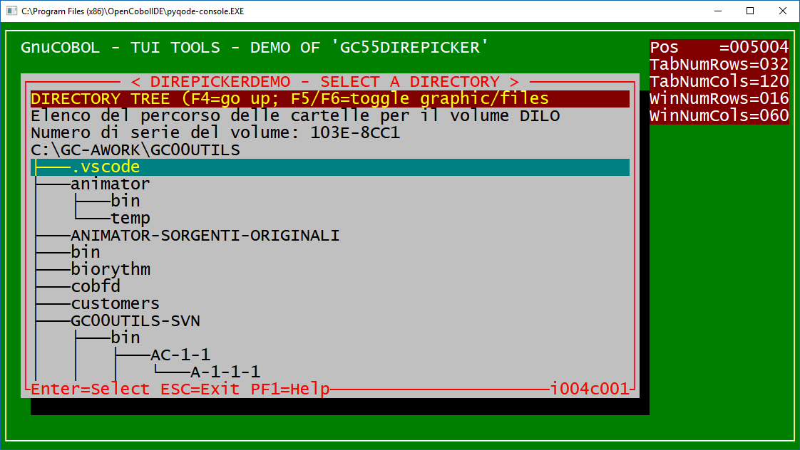

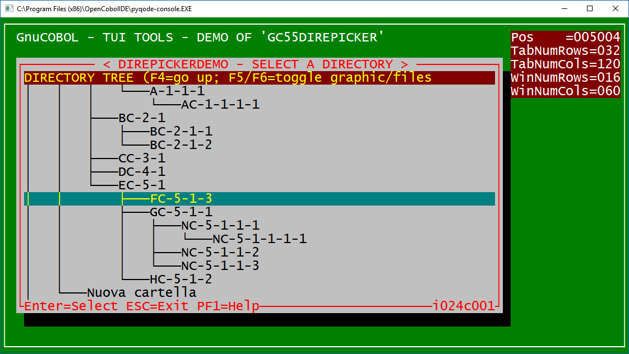

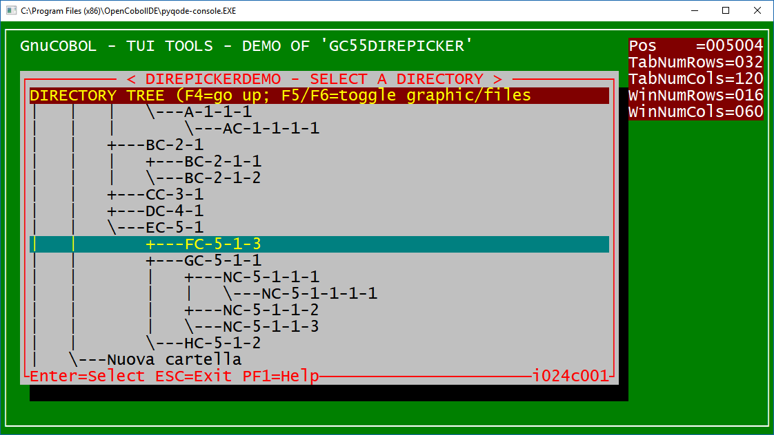

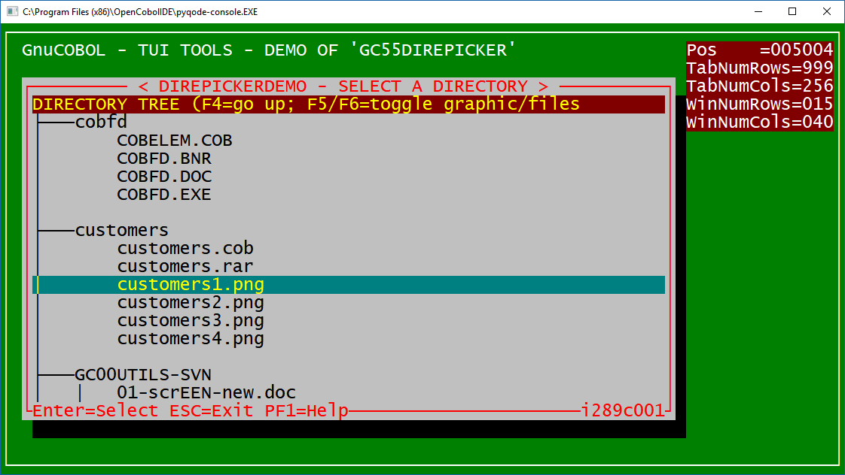

Directories and files.

- TUI TOOL 56 - DATE PICKER (ONE MONTH ON SCREEN)
Display a one month calendar that let the user pick up a date.
You can choose position, size, colors, borders, shadows, titles, 3D effect or not 3D .

Click with left or right mouse button on Month or on Year to browse backward or foreward.
Click on arrows near month or year to have same effect.
Double clicking the left or right mouse button on a Daye selects it in the same way as typing Enter.
F1 = Help.
 | TOOL  TYPE | DESCRIPTION | PROGRAM  & COPY NAME
56 | DATE PICKER  (ONE MONTH) | Display a one month calendar (regular or small size).  You can specify : language of months and days, starting date, back/foreground colors, size, position, single / double / custom borders, 3D effect and so on.  User can browse days, months and years to pick-up a date. Calendar can be displayed on 7 languages.  You can also use mouse keys to browse months and years and click on a day. | GC56DATEPICKER.COB  GC56DATEPICKER.CPY  GC56DATEPICKERDEMO.COB

GC56DATEPICKERDEMO in action:

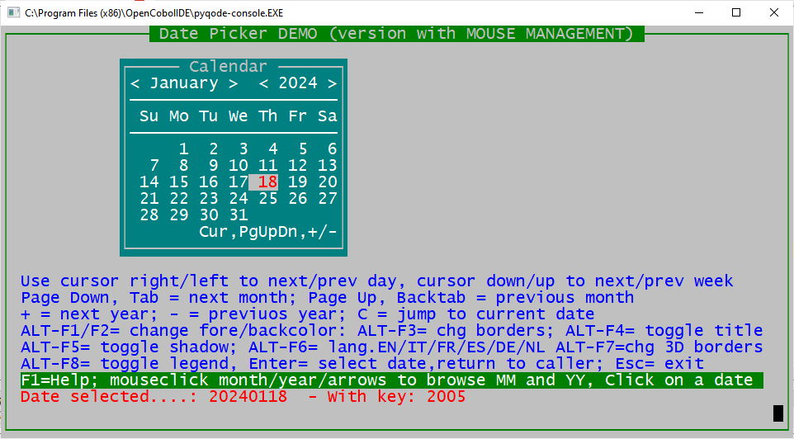

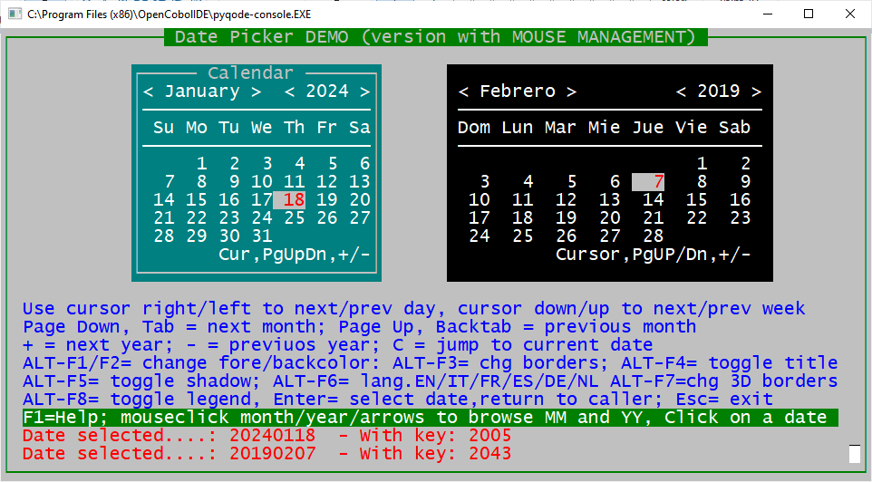

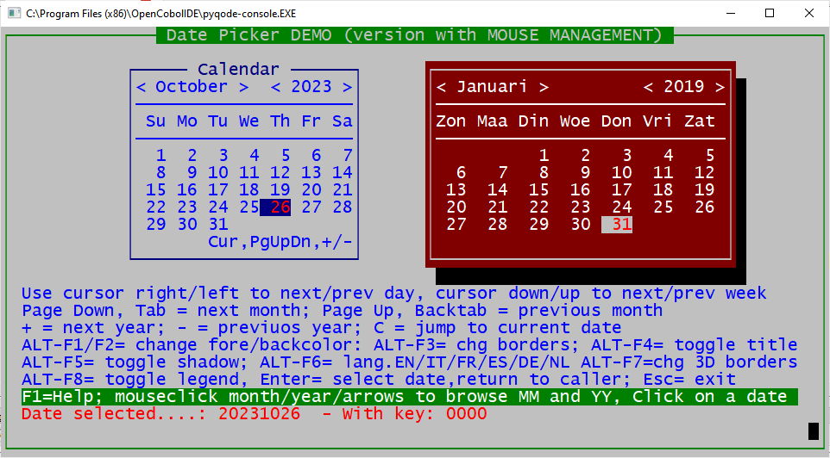

- TUI TOOL 58 - BIG CLOCK SCREEN SAVER

 | TOOL  TYPE | DESCRIPTION | PROGRAM  & COPY NAME
58 | SCREEN SAVER | Display a screen saver with a big clock and a scrolling  string. the big clock will move randomly on screen. you can specify back/foreground colors, size, position, single/double/custom borders, 3D effect and so on.  Exit / ends when user press a key. | GC58SAVERCLOCK.COB  GC58SAVERCLOCK.CPY  GC58SAVERCLOCKDEMO.COB

GC58SAVERCLOCKDEMO in action:

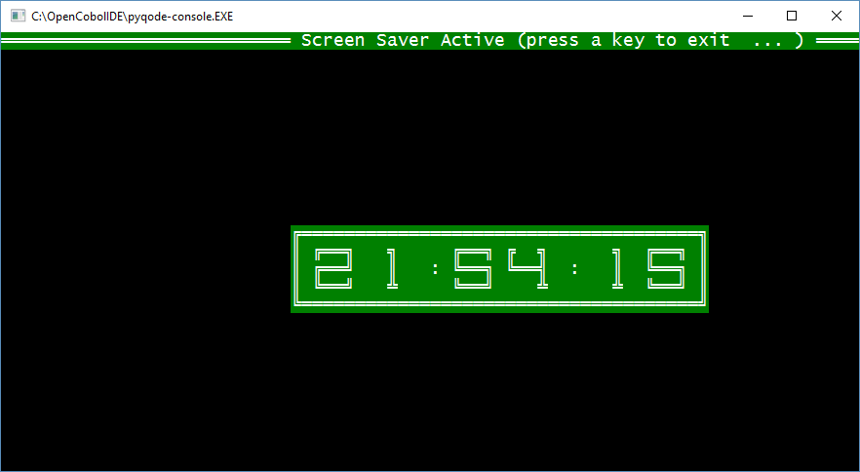

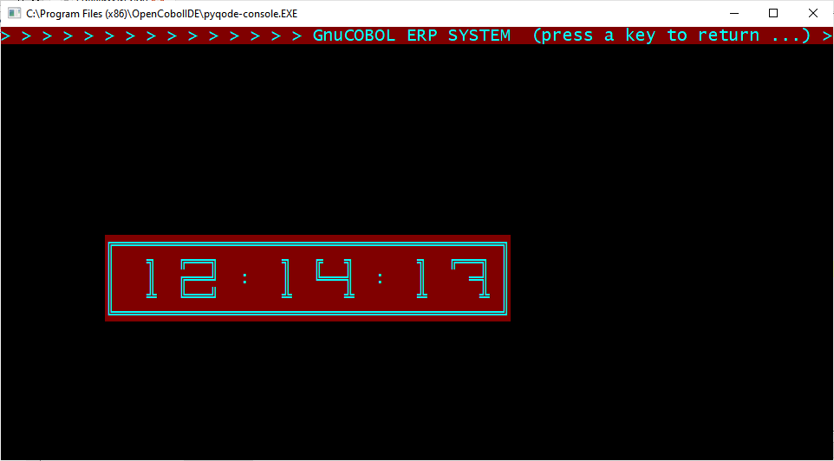

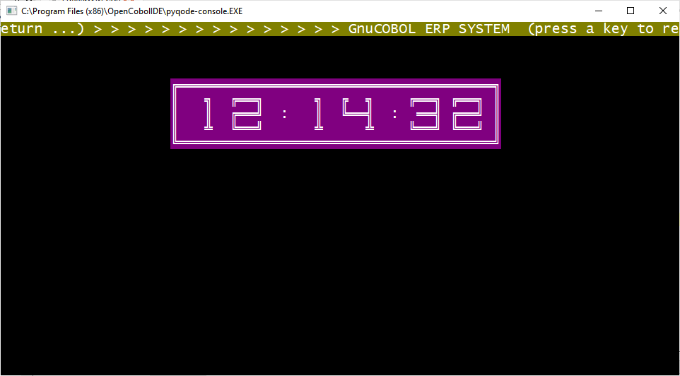

- TUI TOOL 61 - POCKET CALCULATOR

A simple pocket calculator with the four operations and the management of numbers without decimals.
This TOOL is a basic version, fully functional but rather rough. It should be improved in the future with the implementation of the management of decimals and other functions such as: square root sine cosine logarithm etc.
 | TOOL  TYPE | DESCRIPTION | PROGRAM  & COPY NAME
61 | POCKET CALCULATOR | Display a simple pocket calculator on screen.  The user can enter numbers and operators. Returns the result of calculation to the caller . | GC61CALC.COB  GC61CALC.CPY  GC61CALCDEMO:COB

GC61CALCDEMO in action:

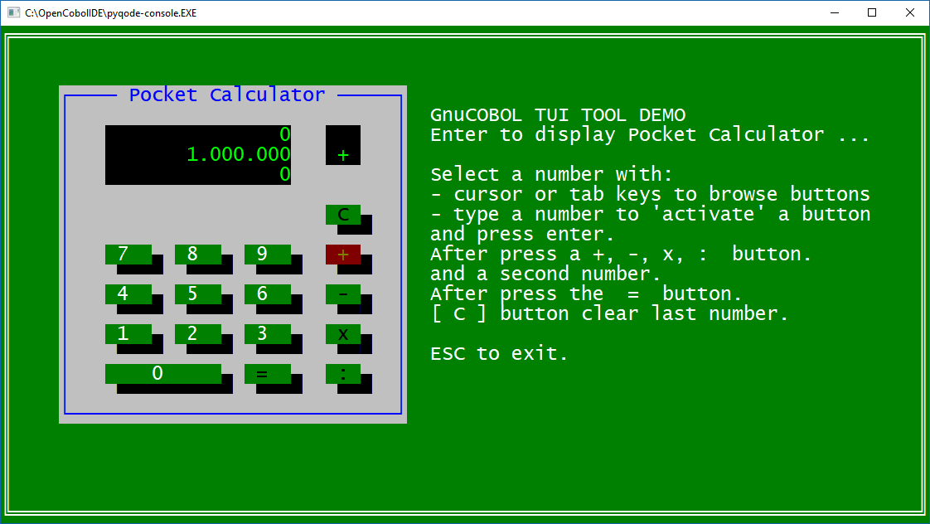

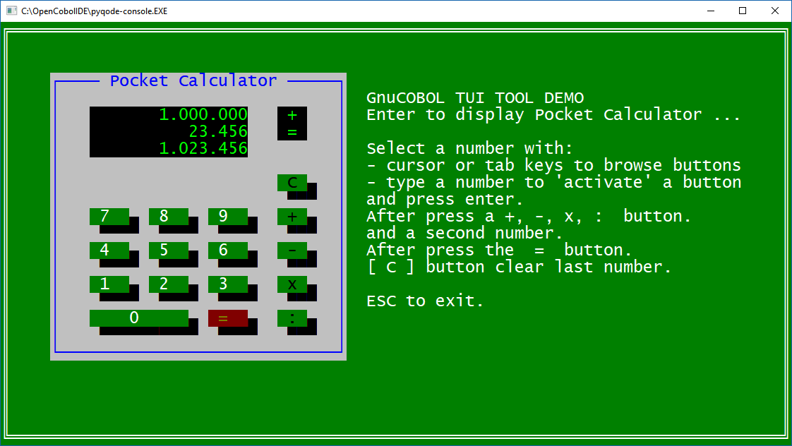

- TUI TOOL 64 - CALCULATOR
A program to manage a CALCULATOR on screen.
Click on Calculator buttons with mouse to select digits and / or operators.
The calculator supports 4 operations and also SQRT, LOG, x^2, 1/x and an internal "memory".
Digits buttons and Operators buttons have a "click" effect on screen
 | TOOL  TYPE | DESCRIPTION | PROGRAM  & COPY NAME
64 | CALCULATOR | Display a more complete calculator on screen.  The user can also select digits and operators using the mouse. Returns the result of calculation to the caller . | GC64CALCULATOR.COB  GC64CALCULATOR.CPY  GC64CALCULATORDEMO.COB

GC64CALCULATORDEMO in action:

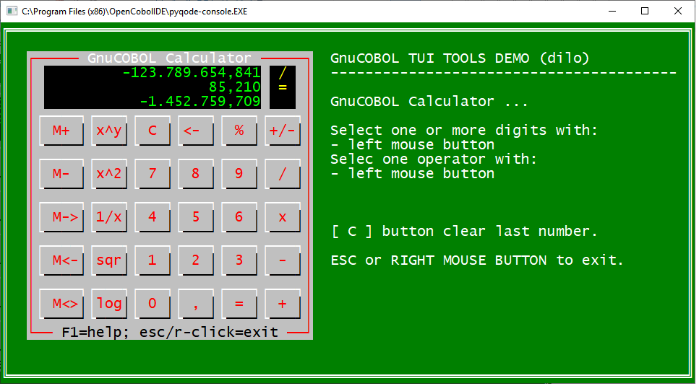

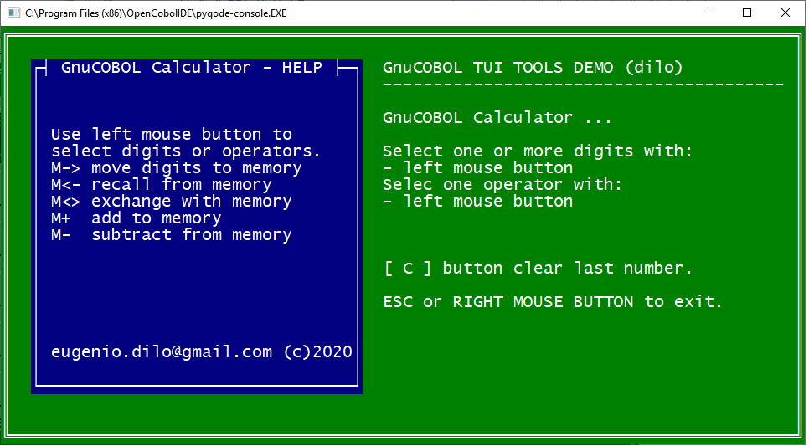

click effect on "5" button:

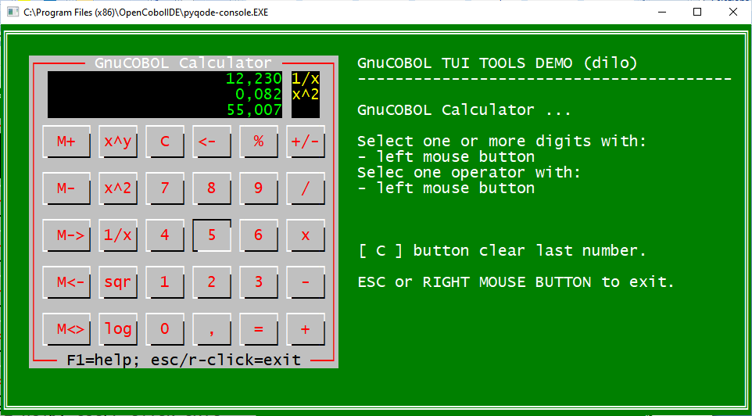

- TUI TOOL 71 - CRUD: CREATE, READ, UPDATE, DELETE
"CRUDE" applications allows you to create, read, update, and delete indexed file records.
These files have a primary key that never allows duplicates and may have alternative keys that may or may not have duplicates. They can be master record type files (customer records, suppliers, accounts, materials ...) or any other type, such as transactional (accounting records, invoices issued, purchase orders, stock movements, and so on). In this example, the CRUDE application manage an INDEXED FILE with a primary key and 3 alternative keys that do not allow duplicate values. The primary key in this application is a simple 9-digit numerator from 1 onwards without any meaning. It is like a GUID. This way, you can have alternative keys that can be modified.

This TUI tool is also a fully functional real working application.
This sample CRUDE tool manages a FILE with master data.
Duplicate these programs, keeping the general logic to manage other customer, supplier, accounts, materials master files or other transactional file files (accounting records, inventory movements, and so on). This way you can create virtually any kind of application.

These files have a similar structure, that is, a primary key with a simple counter and secondary keys according to different needs (codes, descriptions ...).

The application is designed to work and allow in a "multiple companies environment".
In the example we handle more GC71Fxxx.DAT files where "xxx" is a code associated with a certain company code.
This application uses other TUI TOOLS such as MENU, BOX, BOXMEX, DATEPICKER, BUTTONS, YESNO.

The CRUDE application consists of four programs
1. GC71CRUDEMAIN.cob: displays a cover and manages menus.
2. GC71CRUDESEL.cob : allows multi-company and multi-file management.
3. GC71CRUDEBRO.cob : to browse each of the files. it allows to link GC71CRUDE CUD
4. GC71CRUDECUD.cob : performs both creating and editing and deleting records

The application starts with a GC71CRUDEMAIN Menu with only two options: CREATE and READ (Browse).
The Browse program allows selecting a record to be updated or deleted, or creating a new record.
GC71CRUDEMAIN allows the user to select the Browse or Create function.
In both cases, the GC71CRUDESEL program is called, which allows you to select which file (that is, the company code) and then in turn calls GC71CRUDEBRO to have the records list to browse or the GC71CRUDECUD program for creating a new record.
GC71CRUDEBRO lists the records already in the file. Lets you scroll vertically and horizontally within the file and select a record that is managed in edit or delete from the same program GC71CRUDECUD. You can increase or decrease the amount of scrolling columns with + and - keys.
GC71CRUDECUD allows you to create a new record or edit or delete an existing record.
It contains lot of samples on how user input can be managed with various types of fields, mandatory fileds, date fields, numeric fileds, amount fields. How to decode user input. And it shows various types of controls, and how to link a datepicker to select date for date fields.
It contains examples of how to enter amounts with integer and decimal digits and with a negative sign and how to check it.
It also contains the example of link to have help on fields using the TUI GC74HELPVIEW tool.

The general operating schema of the CRUDE application is as follows.

GnuCOBOL C.R.U.DE APPLICATION (CREATE READ UPDATE DELETE)

MENU (browse)
.--- BROWSE Func= R ---. .--> GC71CRUDEBRO ---. <--.
| | | | |
GC71CRUDEMAIN --+ |--> GC71CRUDESEL --| C/U/D |return
| MENU | | | |
'--- CREATE Func= C ---' '--> GC71CRUDECUD <--' ---'
(create/update/delete)

This applications use following .DAT files
GC71FALI.DAT,
and 3 alternative index files:
GC71FALI.DAT.1
GC71FALI.DAT.2
GC71FALI.DAT.3

 | TOOL  TYPE | DESCRIPTION | PROGRAM  & COPY NAME
71 | CRUDE  (or CRUD) | A complete "CRUDE" (Create, Read, Update, DElete) application. It shows you how to create, read(browse), update, delete indexed file records.  It is a real application (it manage a "master data" file) showing also:  - how to accept and check alphanumeric fields on screen,  - how to accept and check numeric fields with sign and decimals,  - how to pick-up a date,  - how to use indexed files with alternate keys,  - how to display context sensitive help information (from GC74HELPxxx TOOL).  Copying and modifying this programs you can develop a lot of other type of applications. | GC71CRUDEMAIN.COB  GC71CRUDESEL.COB  GC71CRUDEBRO.COB  GC71CRUDECUD.COB  GC71CRUDEREC.CPY

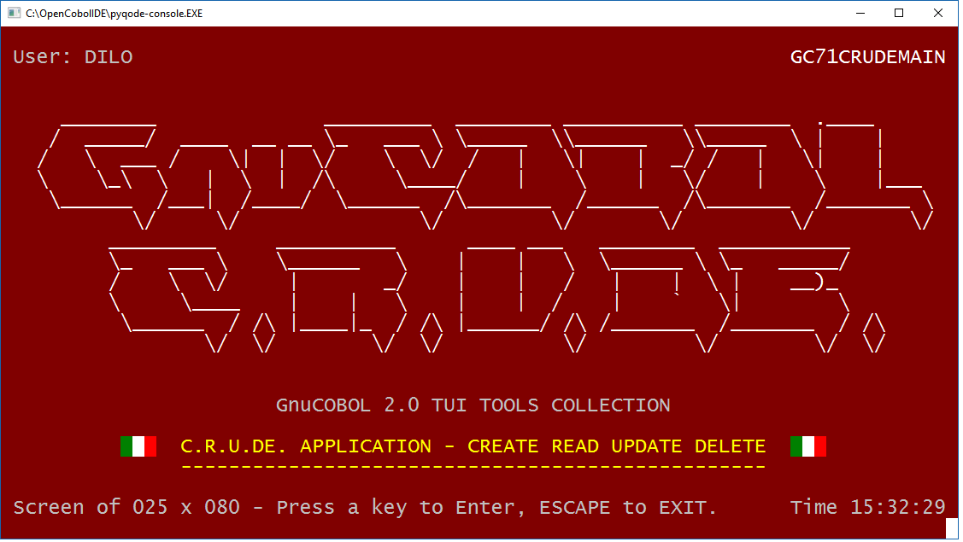

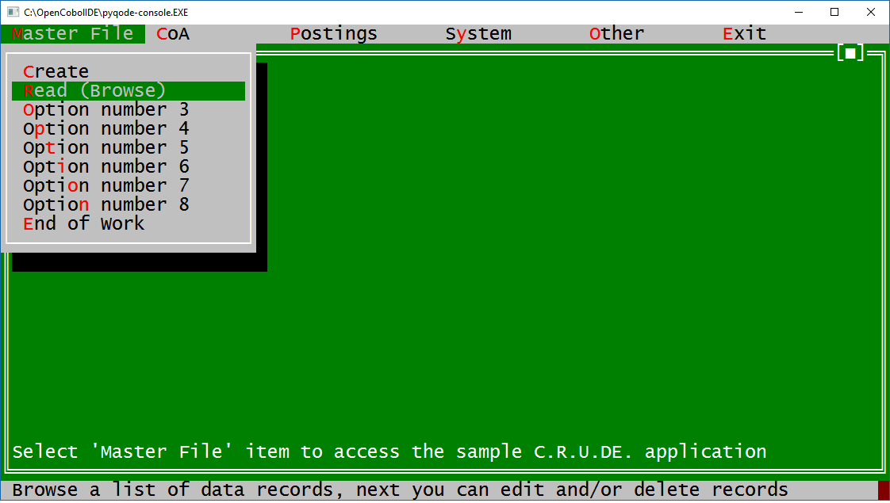

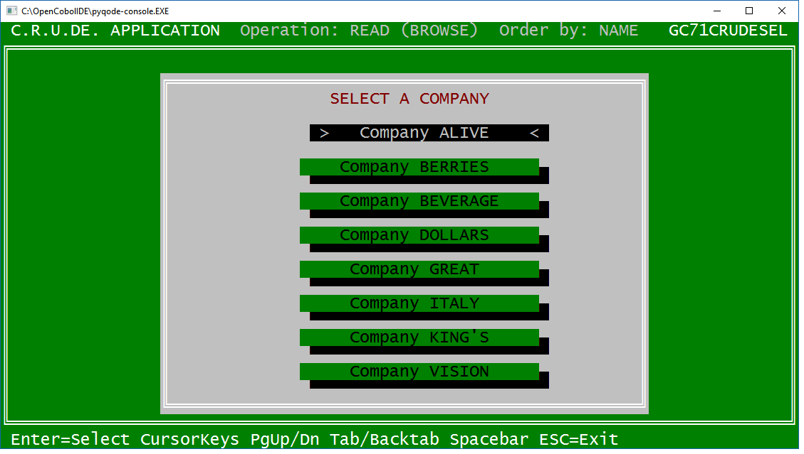

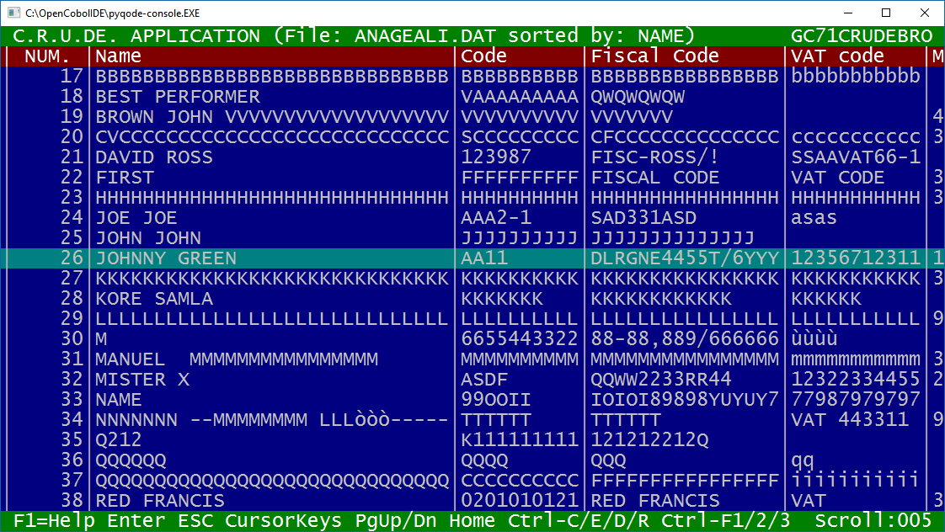

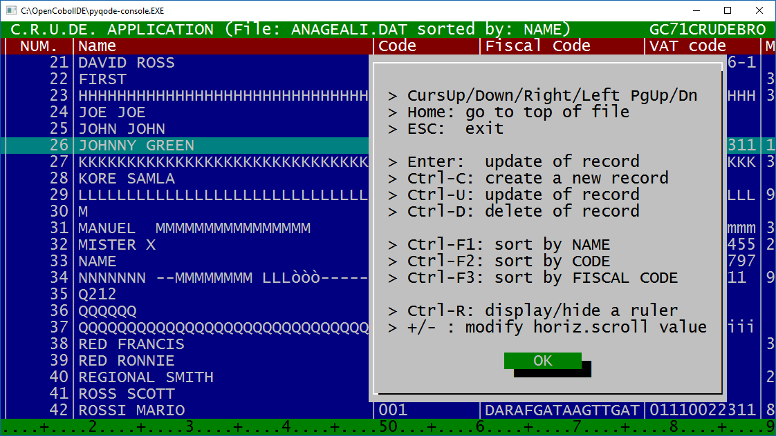

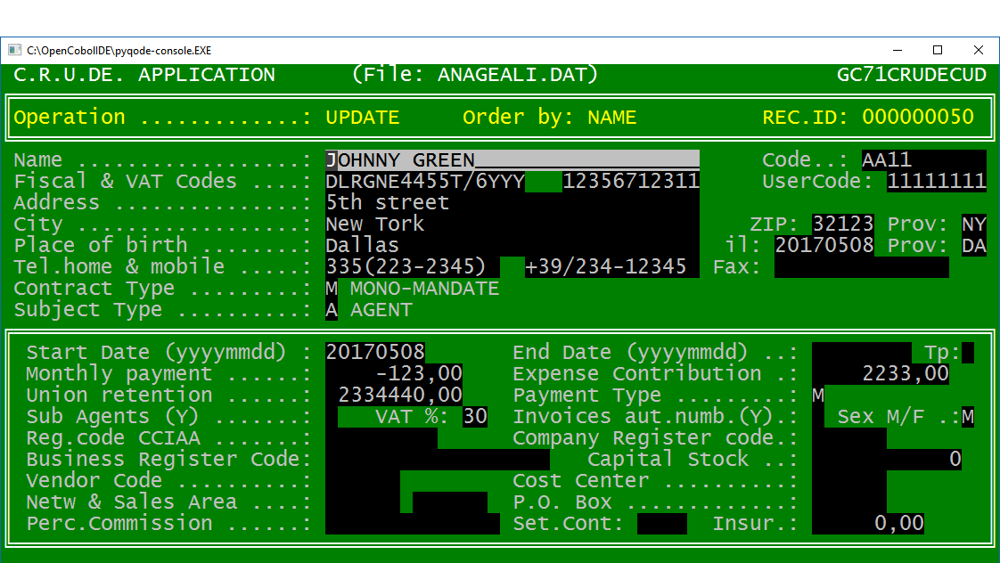

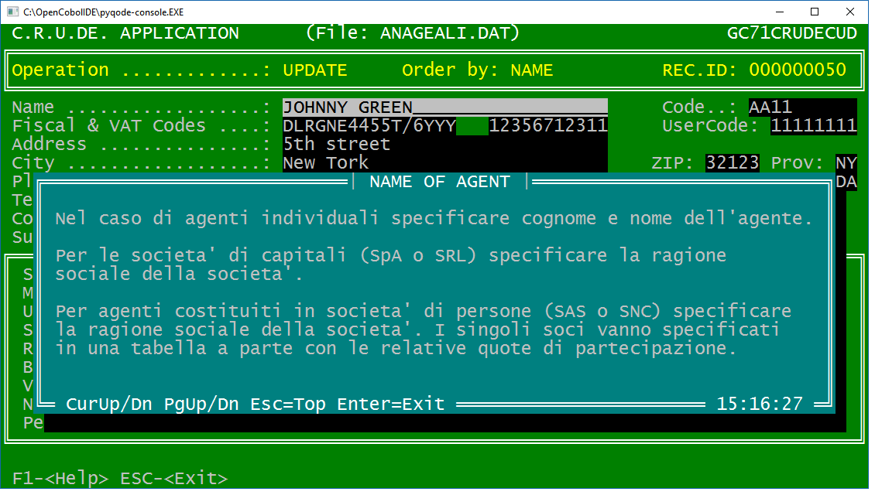

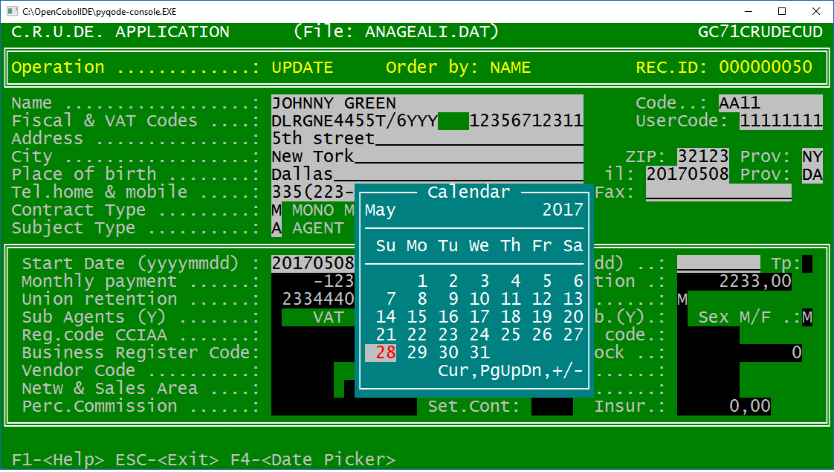

- TUI TOOL 74 - HELP SYSTEM

A new TUI tool to display a scrolling help text window for each accepted field on a TUI screen.
Firts of all you have to edit a source TXT file with HELP informations.
See example GC74HELPFILE.TXT.
This file contains one "HELP TOPIC" for each data field. A HELP TOPIC is made by a HELP KEY, a HELP TITLE and a HELP CONTENT.
Next execute GC74HELPOAD:EXE that read GC74HELPFILE.TXT and create GC74HELPFILE.DAT ad indexed file with help informations.
You can execute GC74HELPLIST:EXE to browse on file GC74HELPFILE.DAT to verify its content.
After that you can develop your application in which you can "call HELPVIEW.dll using Help.Area" to display a window with scrolling help message on screen.
See the TUI TOOLS GC71CRUDECUD.cob to see this tool GC74HELPVIEW at work.
Files:
GC74HELPFILE.TXT = sample text help source file edited by the user
GC74HELPLOAD.COB read a text source file and create the indxed file
GC74HELPFILE.DAT = indexed file created by GC74HELPLOAD.exe
GC74HELPLIST.COB = browse an indexed file, example browse GC74HELPFILE.DAT to verify its content
GC74HELPVIEW.COB = .dll program. call it from your program to display the help window
GC74HELPVIEW.CPY = use this copy to pass parameters to GT74HEPVIEW.dll
In same folder are qa sample GC74HELPFILE.TXT and corresponding file GC74HELPFILE.DAT
First screenshot shows GC71HELPLIST at work
First screenshot shows GC71HELPVIEW at work (called from a sample GC71CRUDECUD.cob program)

 | TOOL  TYPE | DESCRIPTION | PROGRAM  & COPY NAME
74 | HELP SYSTEM | A "HELP" system. You can write text help files and then load it on indexed files.  List the indexed file and access to HELP messages from any application. | GC74HELPLOAD.COB  GC74HELPLIST.COB  GC74HELPVIEW.COB  GC74HELPVIEW.CPY

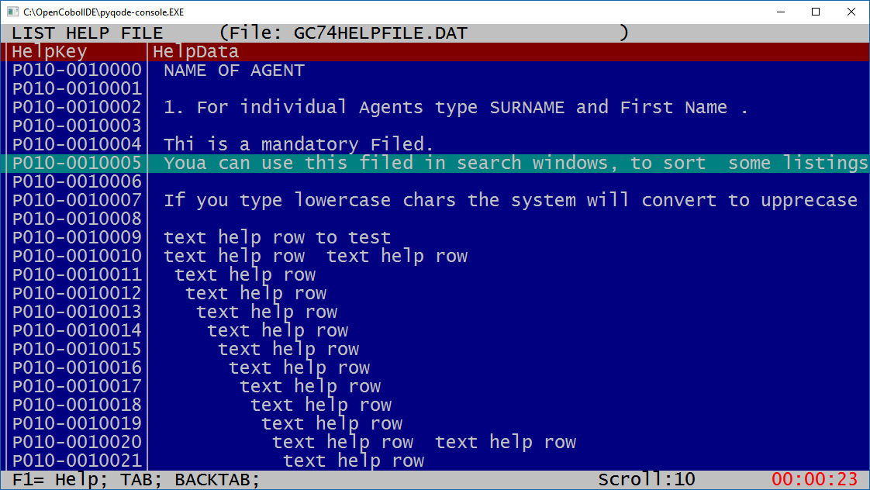

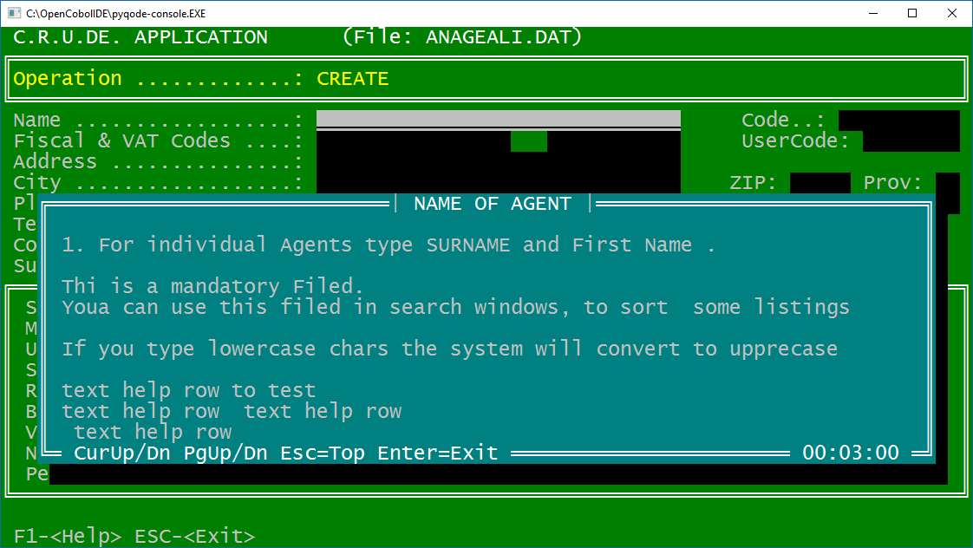

- TUI TOOL 76 - QUICK TABLE MANAGEMENT

Do you need a quick and dirty function and a place to store and manage simple data (system data, customizing data ...) for your application ? Here are ready to use functions for you.

A set of three GnuCOBOL programs to
- manage from 1 to 8 indexed files with following names GC76Fnnn.DAT where "nnn" is from 001 to 008.
- each file containing from 1 up to 20 tables
- each table containing from 1 up to 999 records.
Every file record has a 100 bytes layout. First 7 bytes are the key, following 93 bytes are data (75 bytes of data and 18 of filler), Configure at your needs the Table Headers. Fill at your needs Table Items (records).

Record key layout is 7 bytes as following:
Table headers: H + ttt + bbb where: H= Header), ttt from 001 to 020 and bbb = 3 spaces (blank)
Table Items (records) I + ttt + iii where: I= Items, ttt from 001 to 020, iii from 001 to 999 for table records.

Program GC76TABHEADERS
With this program, the user can select one of the 8 files from GC76F001.DAT to GC76F008.DAT to create or update. Creates the file if it does not exist.
Then display a 20 row x 75 cols full screen where you can update the 001 to 020 Table Headers
There is no controls on data entered by the user .
Execute this program first to create from 1 to 8 files.

Program GC76TABITEMS
With this program, the user can select one of the 8 files. from GC76F001.DAT to GC76F008.DAT
Then the user can select one of the 001 to 020 Table Headers in that file.
Then display a full screen of 20 rows x 75 cols where user can insert or update the 001 to 020 first Table Items
Press Page down to insert or update next 021 to 040 following Table Items .
Repeat Page Down to insert or update next 20 items from 041 to 060 and so on.
There is no control on data entered by the user but the function is very quick to use.

Program GC76TABLIST
Select one of the 8 files. from GC76F001.DAT to GC76F001.DAT
Display a scrolling screen with file content. Table headers and following Table Items.

 | TOOL  TYPE | DESCRIPTION | PROGRAM  & COPY NAME
76 | TABLE MANAGEMENT | A "TABLE" system.  You can insert/write, edit, delete, list "TABLE" data. | GC76TABHEADERS.COB  GC76TABITEMS.COB  GC76TABLIST.COB  GC76TABCOPY.CPY
Following schema shows the structure.

File GC76F001.DAT
+------- Table Header 001
+------ Table Item 001
+------ Table Item 002
................
+------ Table Item 999
+------- Table Header 002
+------ Table Item 001
+------ Table Item 002
................
+------ Table Item 999
............................
............................
............................
+------- Table Header 020
+------ Table Item 001
+------ Table Item 002
................
+------ Table Item 999

File GC76F002.DAT
+------- Table Header 001
+------ Table Item 001
+------ Table Item 002
................
+------ Table Item 999
+------- Table Header 002
+------ Table Item 001
+------ Table Item 002
................
+------ Table Item 999
............................
............................
............................
+------- Table Header 020
+------ Table Item 001
+------ Table Item 002
................
+------ Table Item 999
.............
.............
.............

File GC76F008.DAT
+------- Table Header 001
+------ Table Item 001
+------ Table Item 002
................
+------ Table Item 999
+------- Table Header 002
+------ Table Item 001
+------ Table Item 002
................
+------ Table Item 999
............................
............................
............................
+------- Table Header 020
+------ Table Item 001
+------ Table Item 002
................
+------ Table Item 999

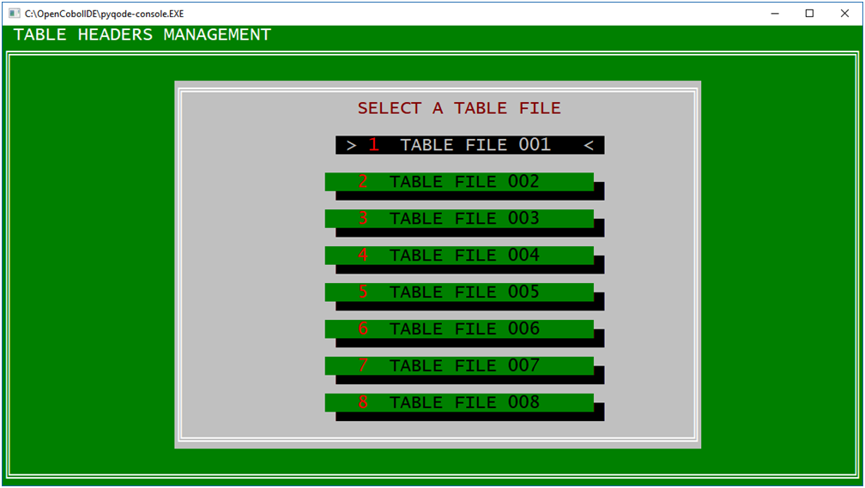

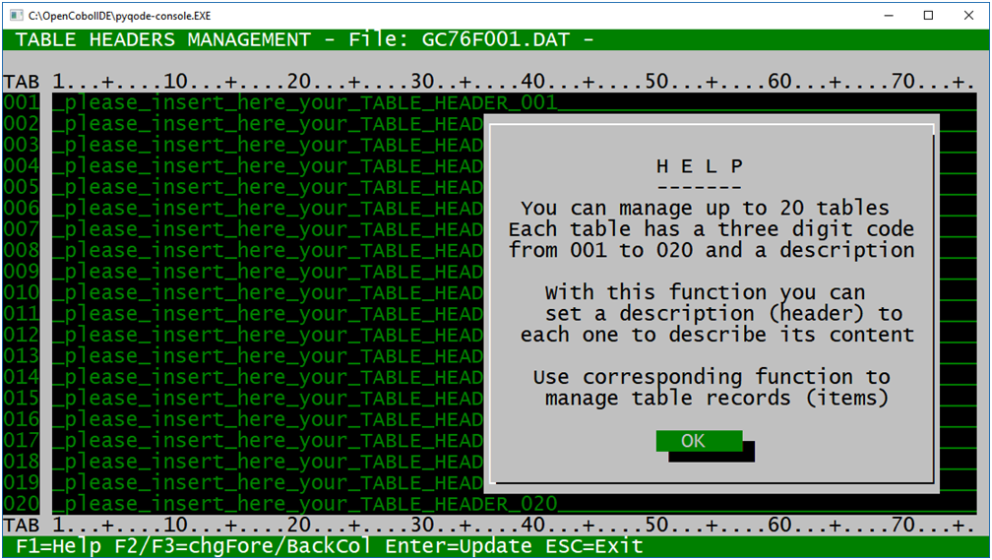

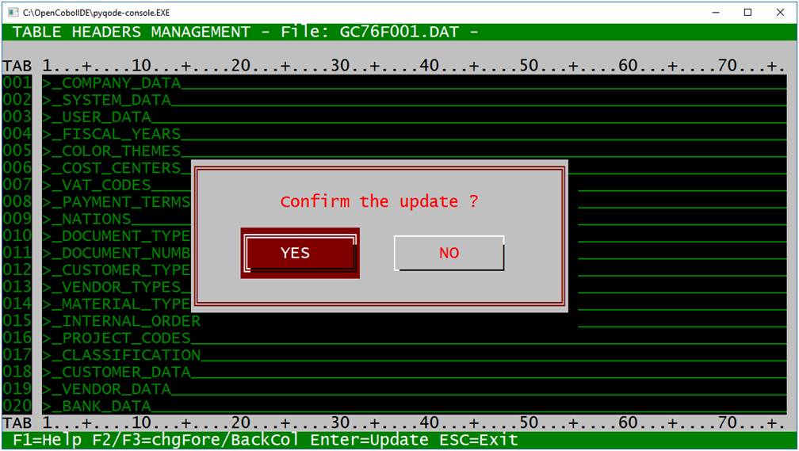

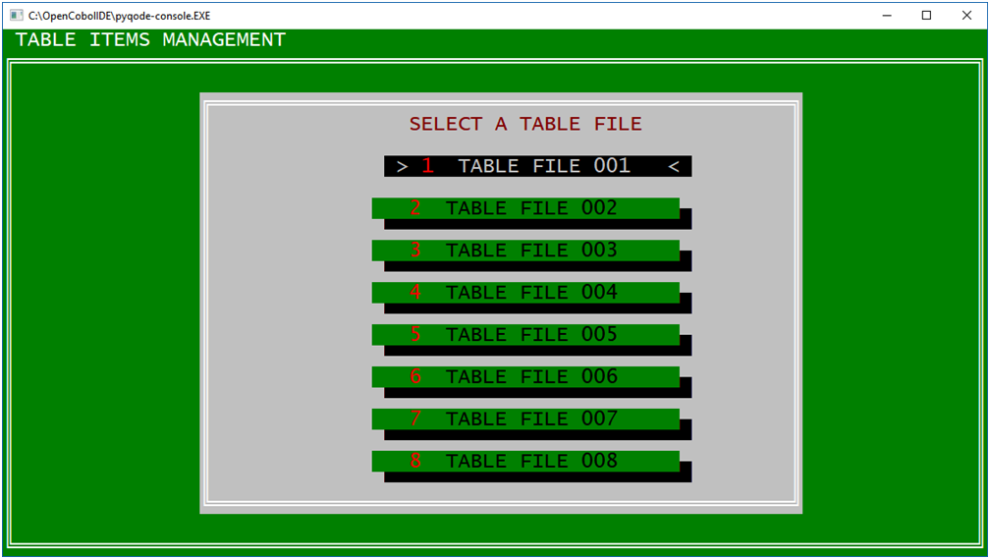

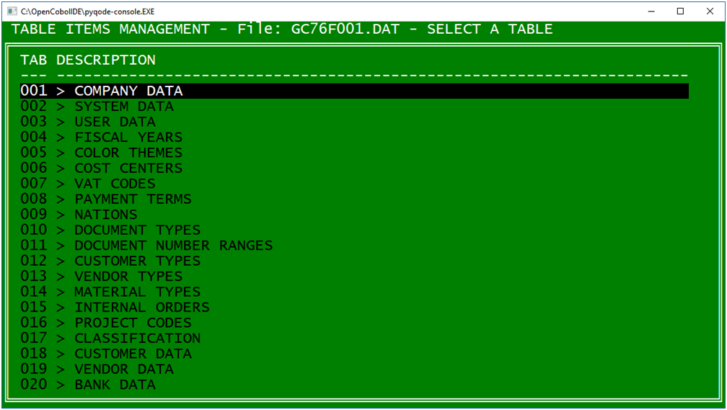

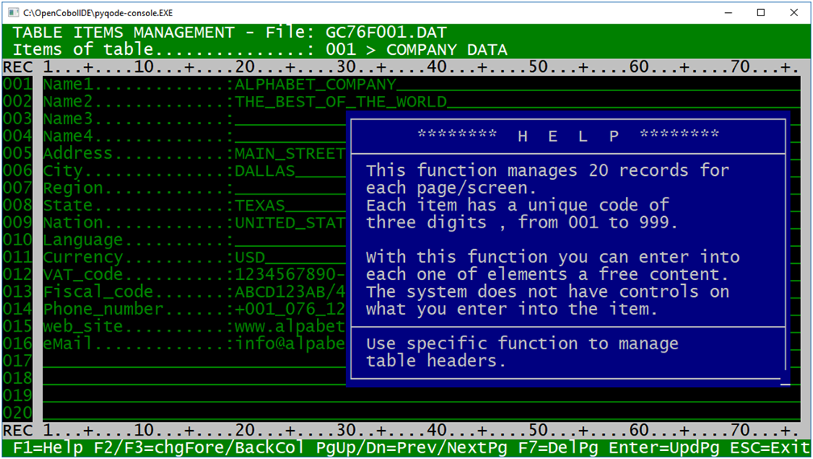

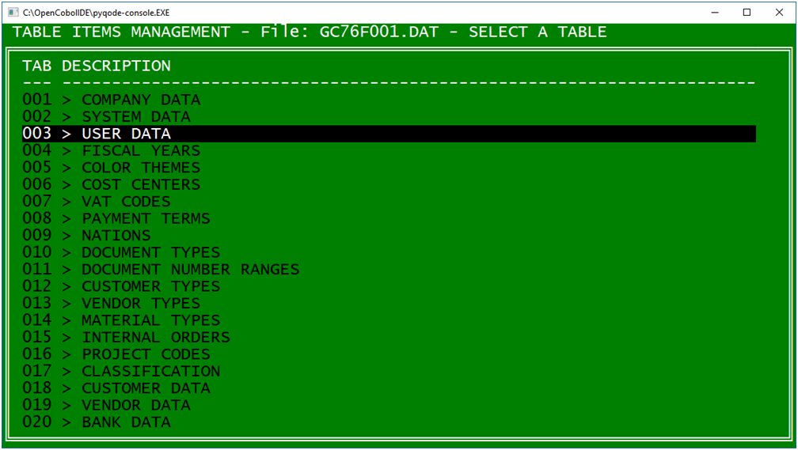

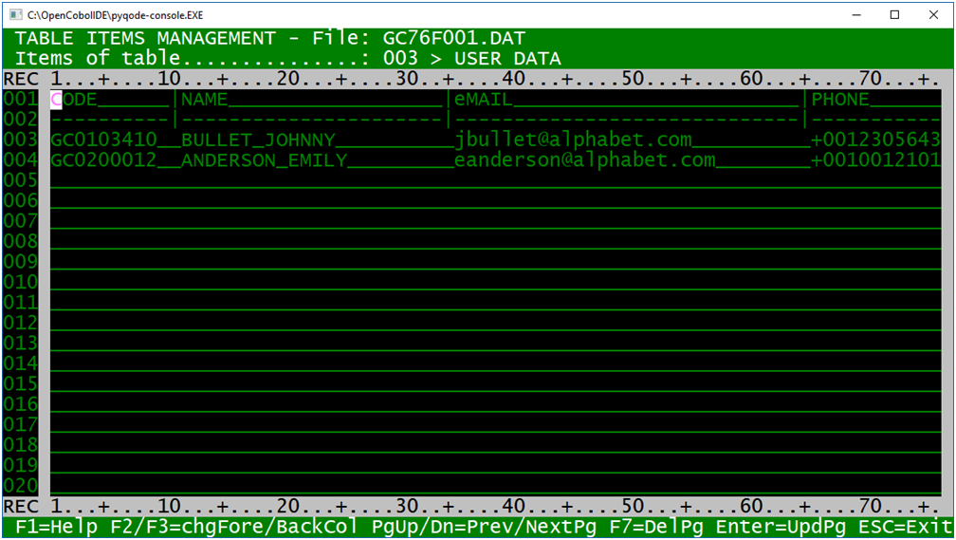

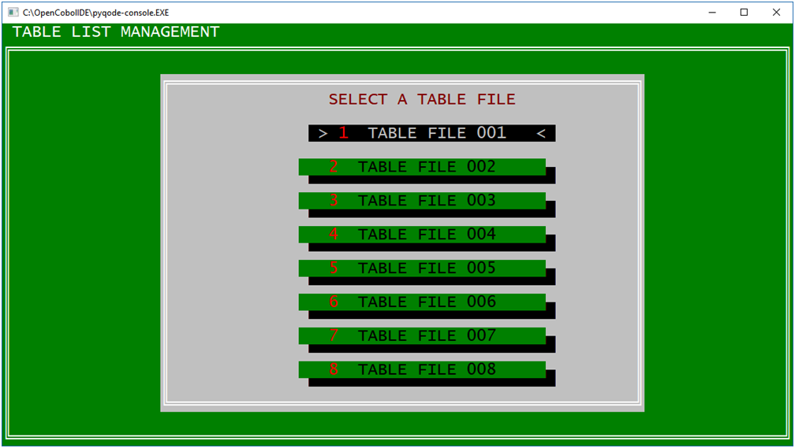

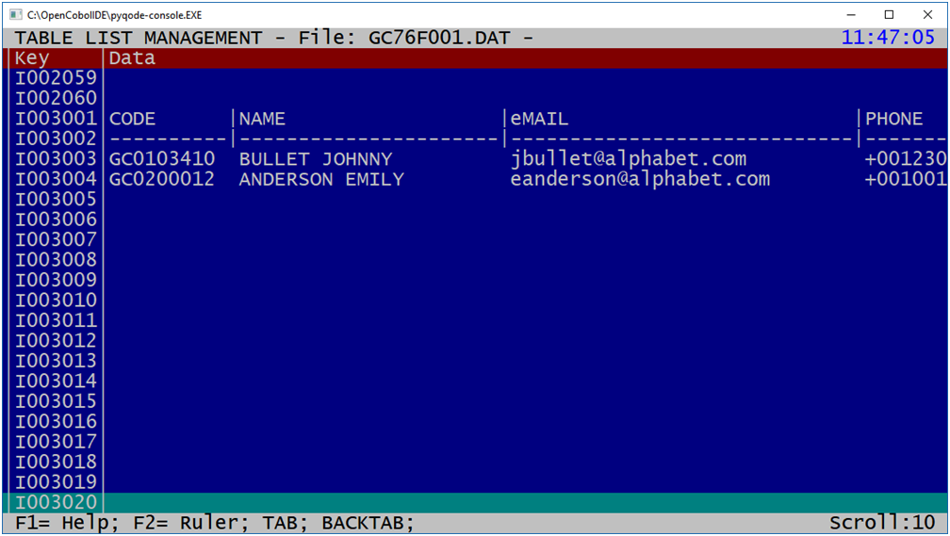

- AUTOMATIC COPY GENERATORS

  - FOR REPORTS LAYOUT

When you develop a COBOL program that produces a report, it is a good idea to prepare first a scheme to represent the data layout of the report itself.
A simple and effective method should be to draw the report layout with a text editor.
For example, a layout like the following one ABC123.TXT with 132 cols for each row.
In this layout you define report constants .
In the same layout the alphanumeric variables are represented by the symbol $ and numeric variables with the # symbol.
At this point to prepare the Copy COBOL corresponding to the report with the representation of the individual lines of the report and the various fields for variables is a long and boring job.

The GC99COPYGEN program eliminates this work, or at least most of it.
It reads the TXT file with the layout, for example the ABC123.TXT file (it is attached to this post), and it generates the corresponding Copy COBOL, for example ABC123.CPY with the individual lines and the individual alphanumeric and numeric fields (see attached sample).A possible refinement to this point can be made manually (for example: change the name of fields, to represent numeric fields in an edited with decimal places, with the minus sign, with "Z" picture and so on).

How to use it:

1 create a text file with the layout of the report. Set all constants and variables. Use the $ symbol when you want a PIC X field and use the # symbol when you want a PIC 9 field. For a better graphical representation of the report you can also insert blank lines or also rows repeated and identical to previous lines.

2. run the program GC99COPYGEN that reads the TXT file with the report layout and creates the corresponding Copy COBOL in a .CPY text file. The program will skip blank lines and will skip rows equals to each other, eg. with the same fields, produces a single line in the copy.

3. the Copy COBOL obtained should be used directly in the COBOL program that will produce the report, or you can change it before, to enhance the Copy COBOL example for a better the editing Picture of individual fields directly in the copy.

GC99COPYGEN at work:

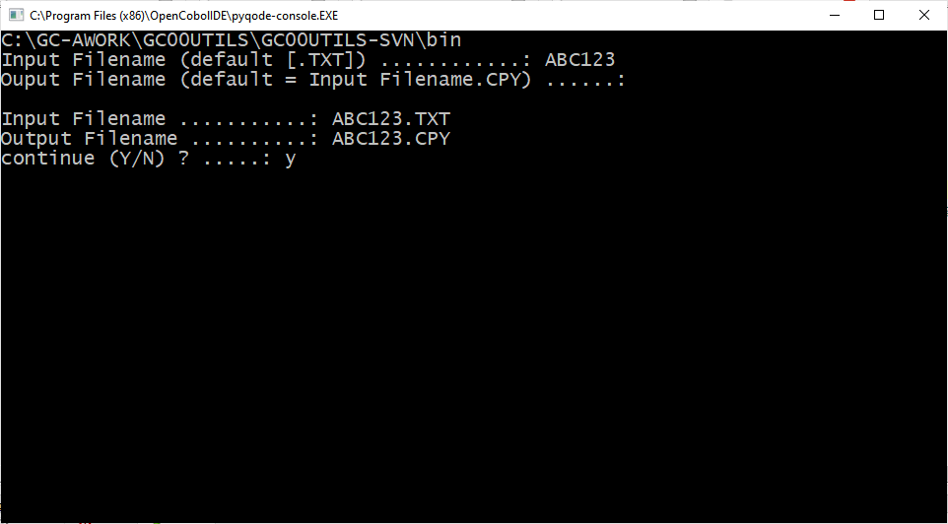

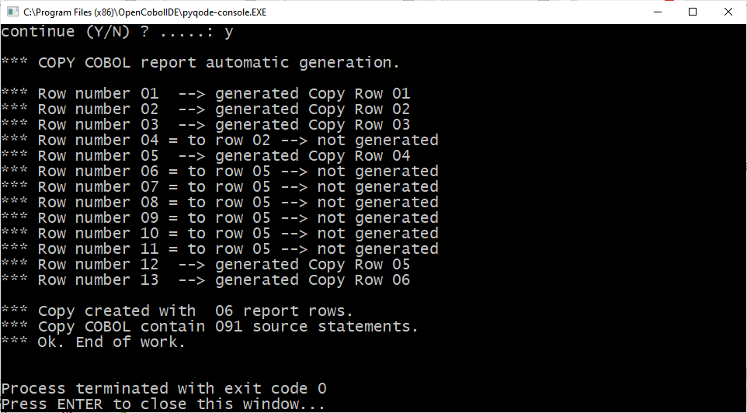

SAMPLE REPORT LAYOUT:

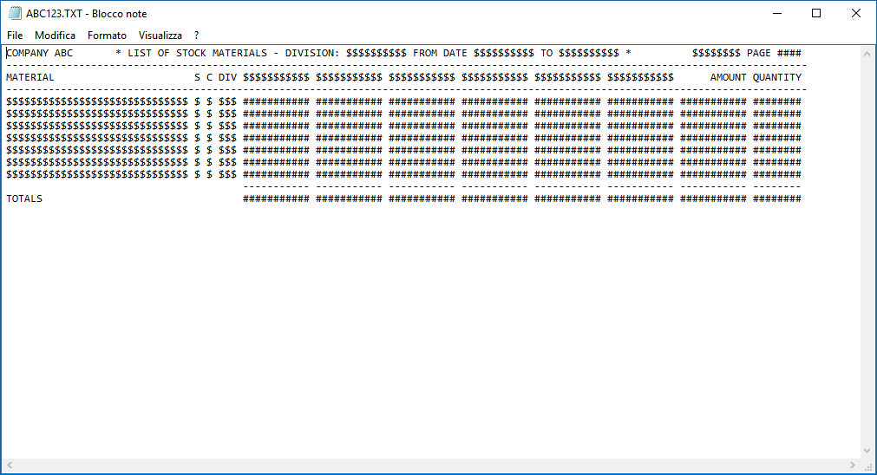

corresponding COPY file generated by the program

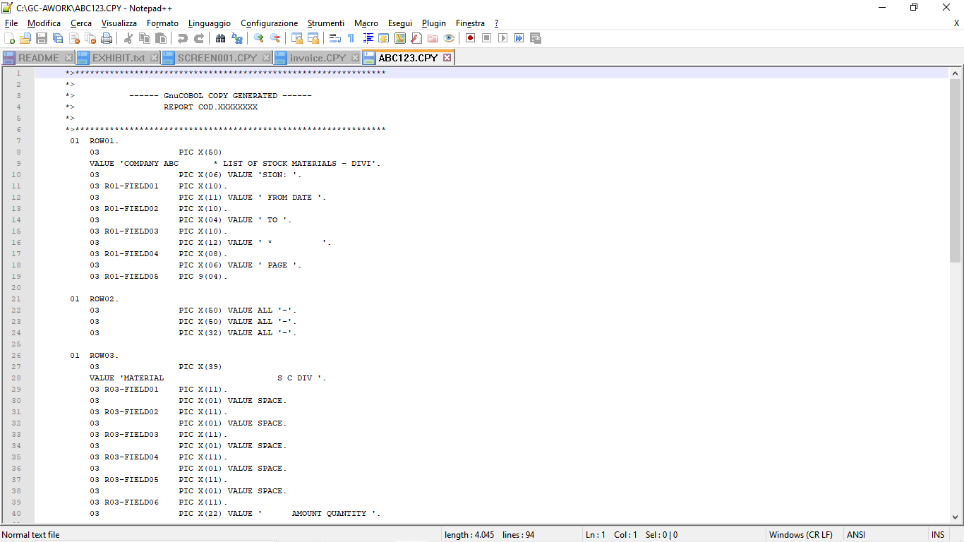

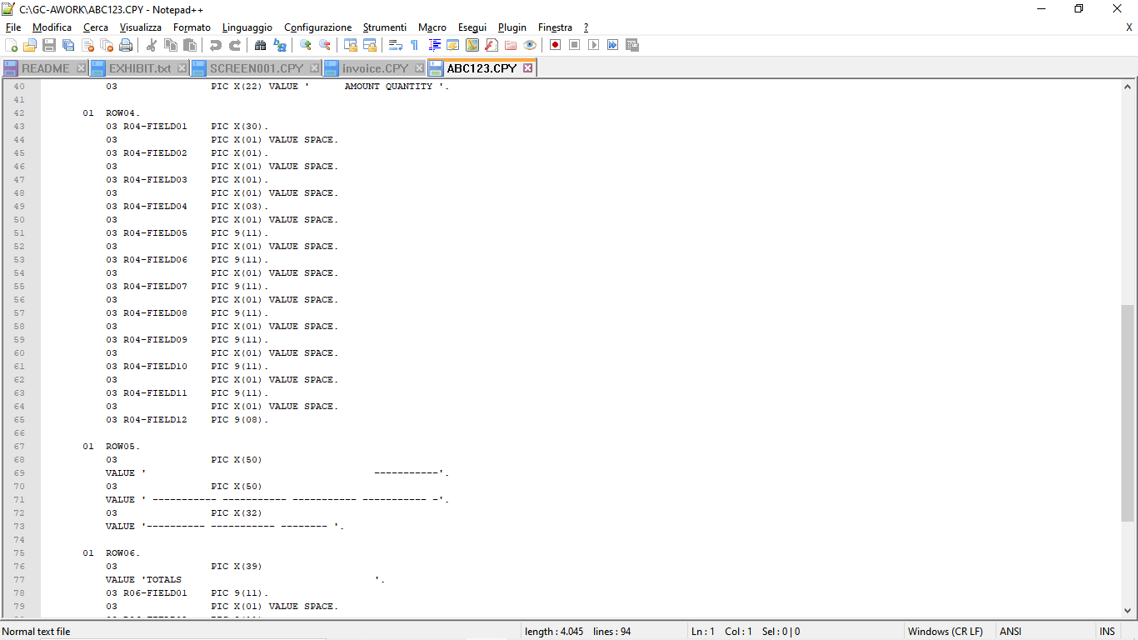

SAMPLE LAYOUT TO PRODUCE AN INVOICE

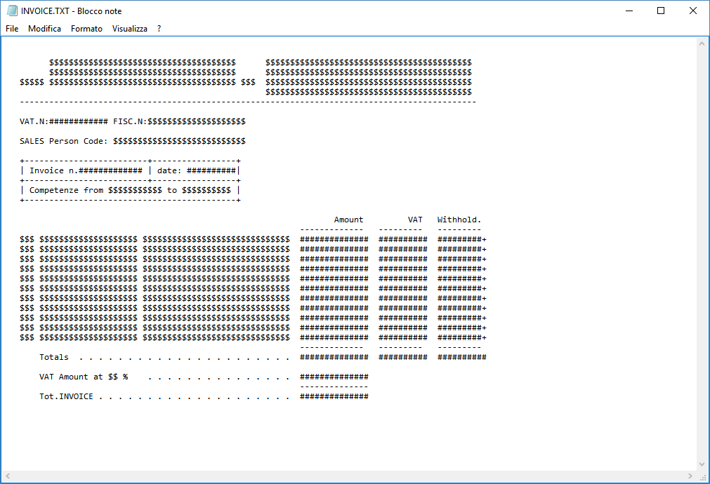

Corresponding COPY file generated by the program:

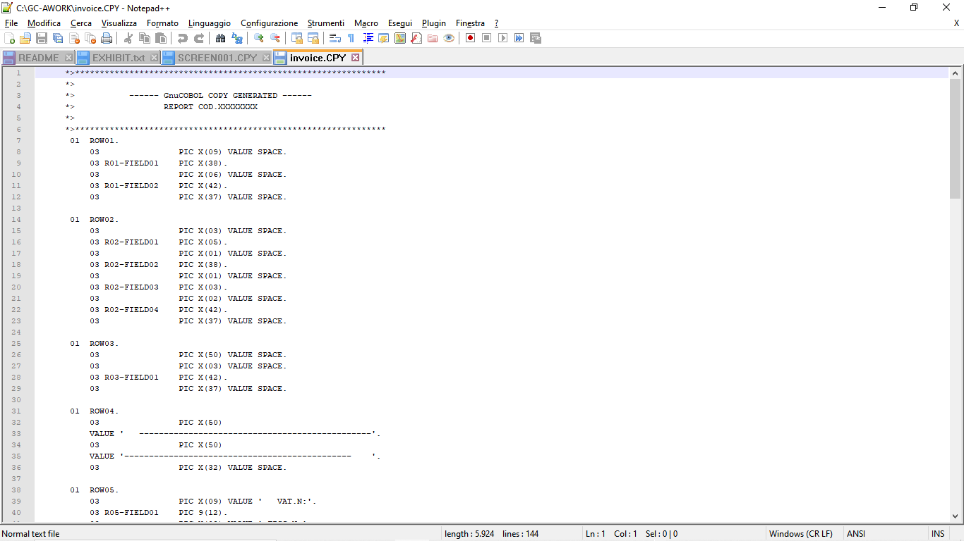

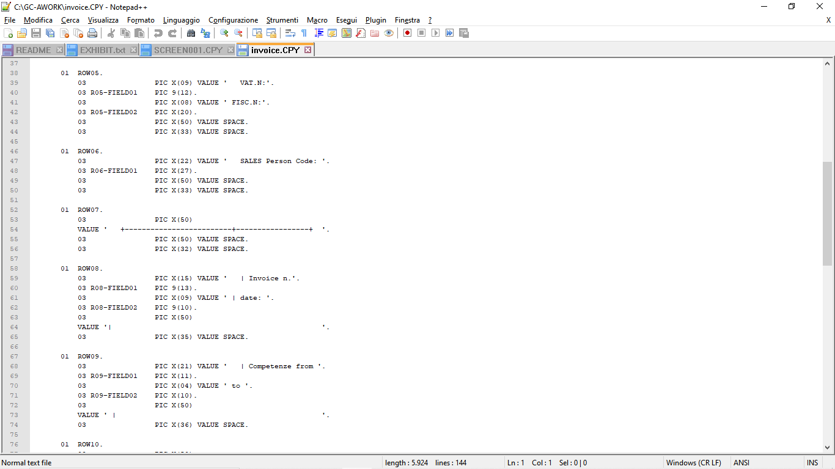

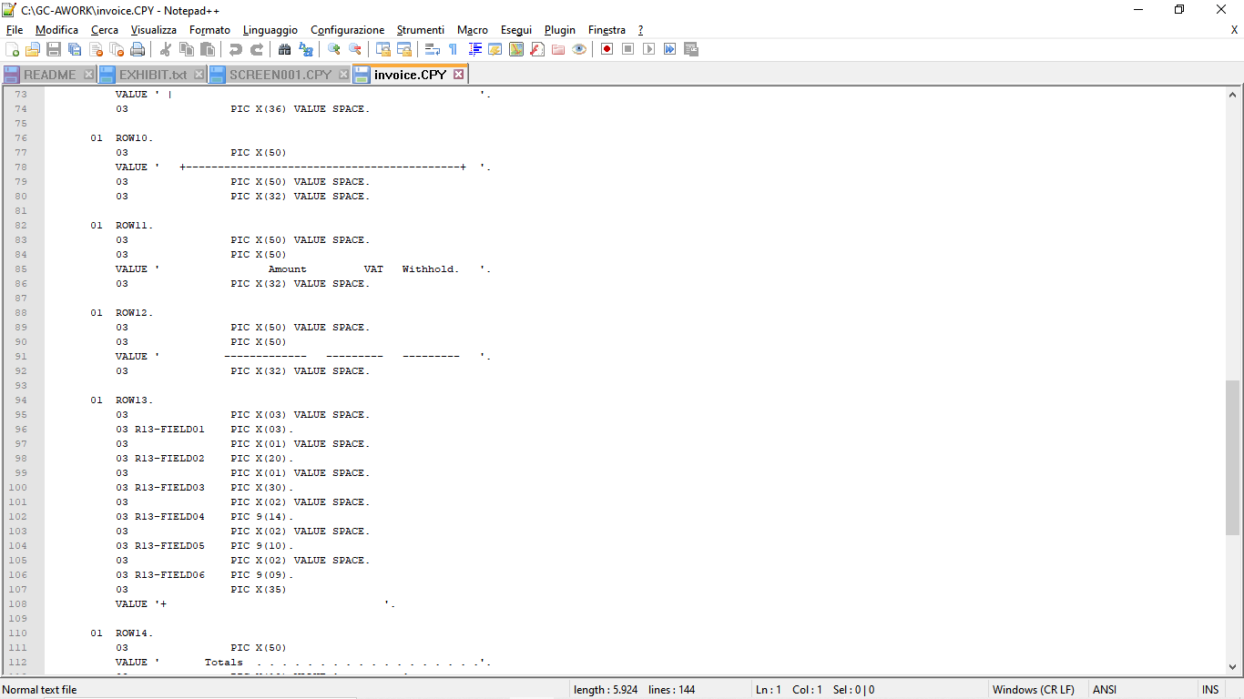

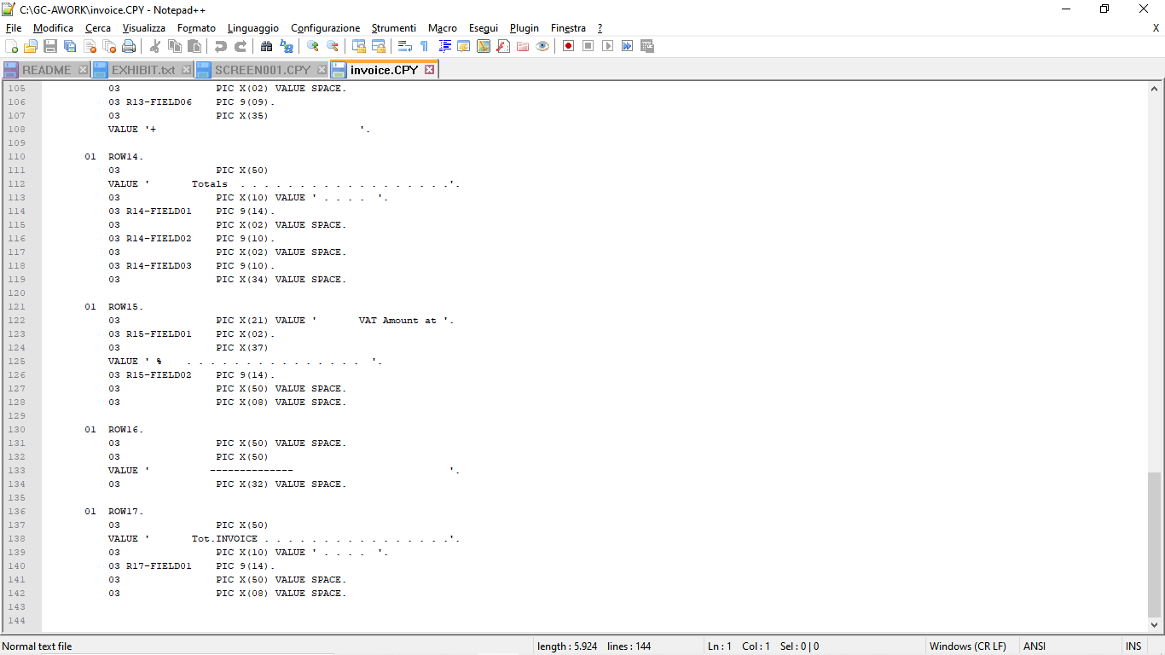

  - FOR SCREEN LAYOUT

When you want to develop applications that have a text-based user interface, you can use the SCREEN SECTION from GnuCOBOL.
This often involves long and tedious work: the definition of the COBOL source code that describes the user interface.
You have to identify the exact position (row and column) of all the fields on the screen, variables and constants, of each data you have to identify the length.This utility avoids all this work.

Draw your user interface in a TXT file of 25 lines and 80 columns or more (max screen size is: 999 rows and 999 colums). Use the symbol $ for the variable fields PIC X and the symbol # for the variable fields PIC 9.
All the rest are constants of the form.

Run the GC99SCREENGEN program that reads the drawing you prepared and generates the COBOL source for you.

GC99SCREENGEN.COB source of the COPY generator,
SCREEN001.TXT input file with video scheme,
SCREEN001.CPY copy generated automatically.
GC99SCREENGENDEMO.COB which uses SCREEN001.CPY and displays the form.

GC99SCREENGEN in action:

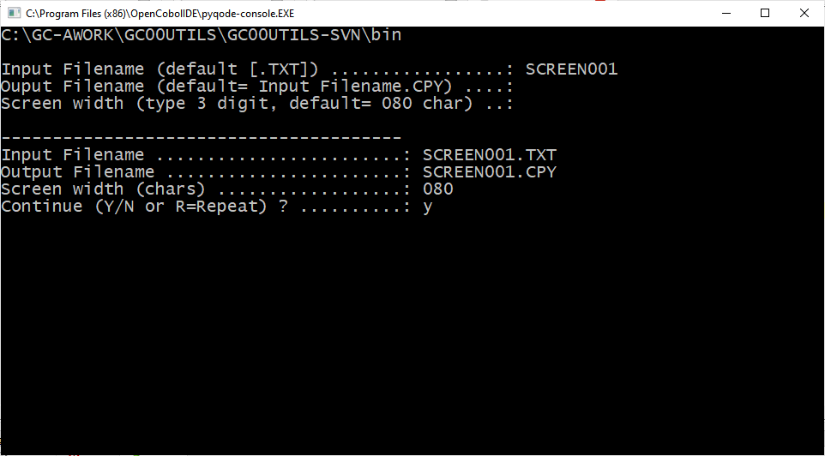

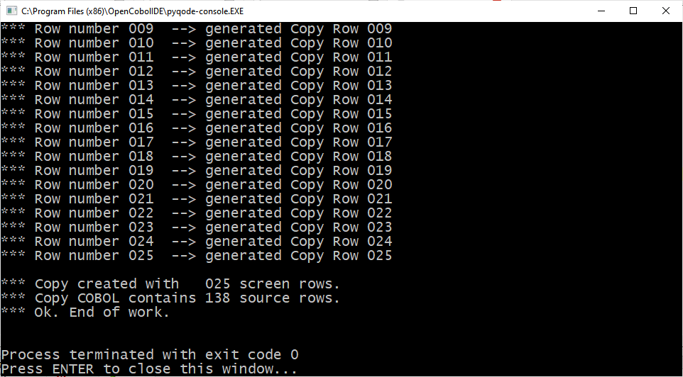

Sample screen layout :

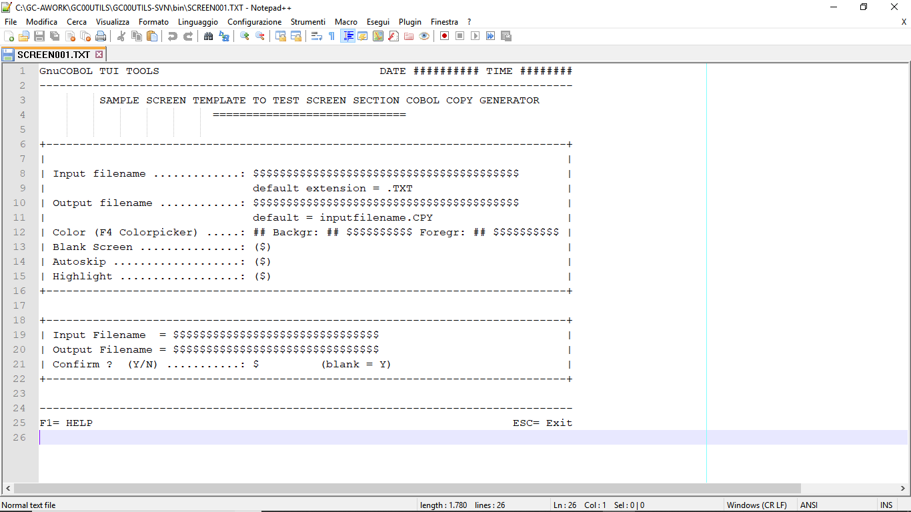

corresponding COPY file generated by the program:

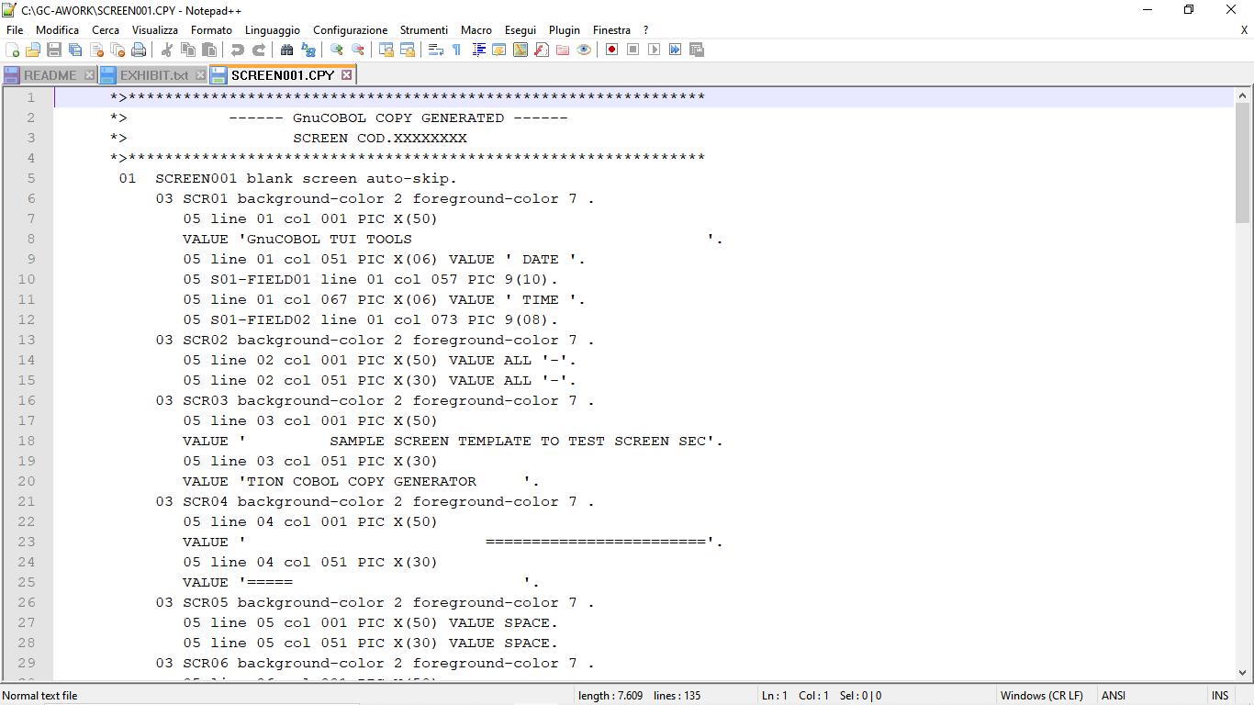
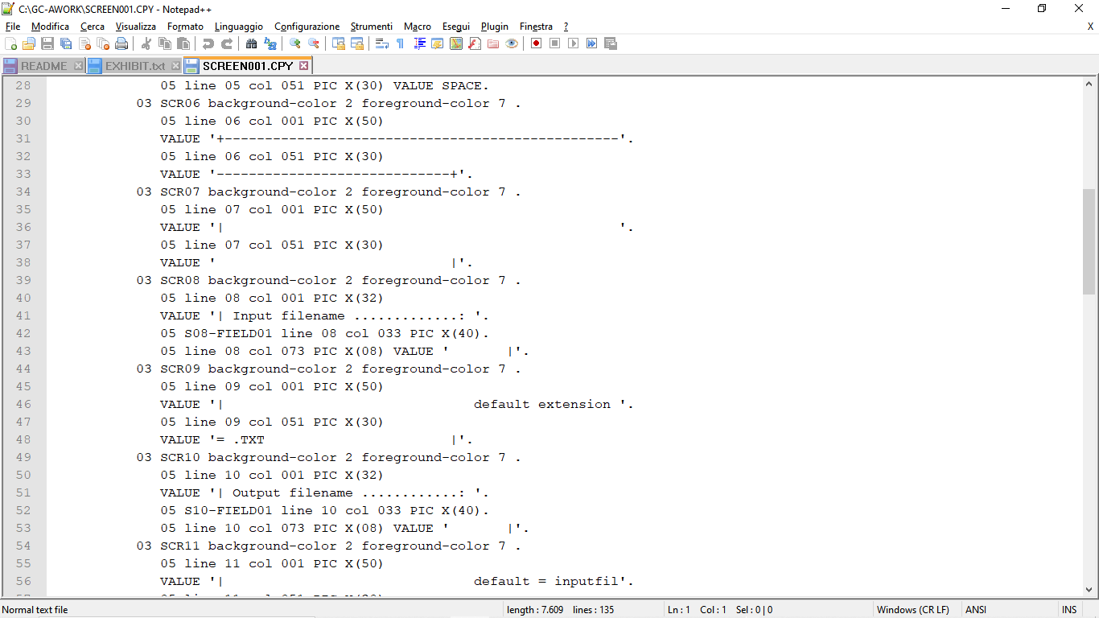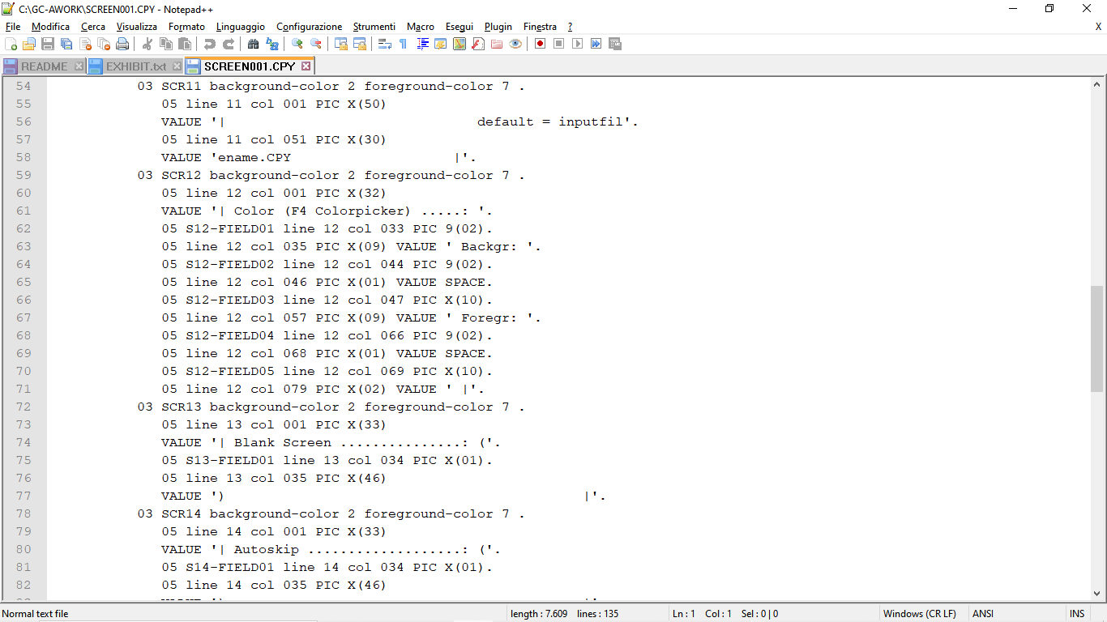
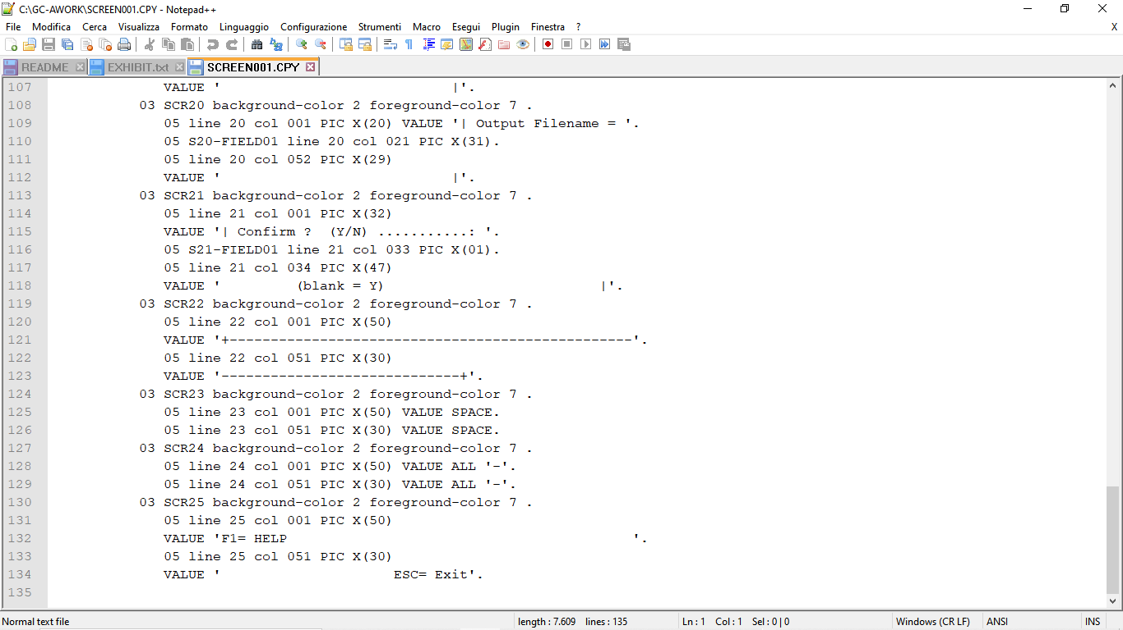

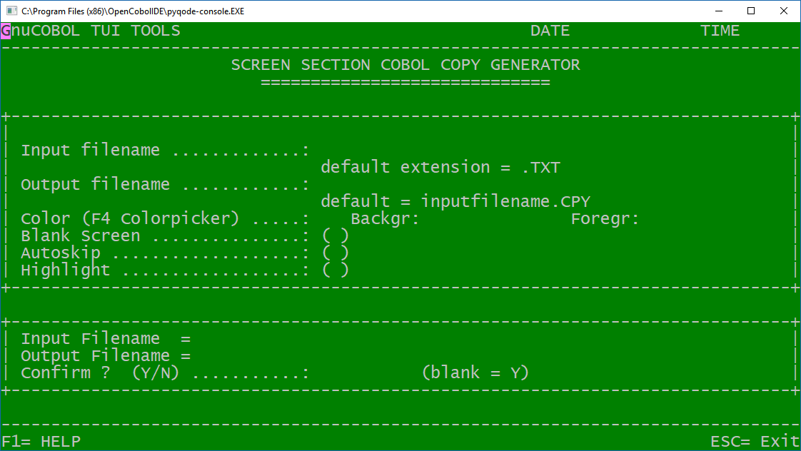

- OTHERS

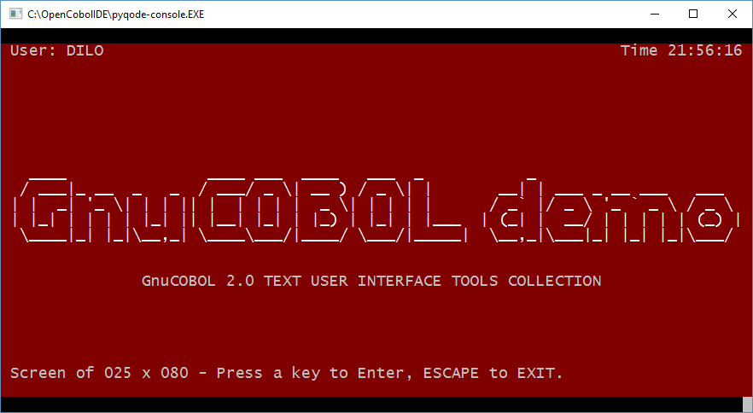

  - BANNER

GC99BANNER.COB - accept a string and print that string in big character.
Useful to print a banner page for your reports.

GC99BANNER in action:

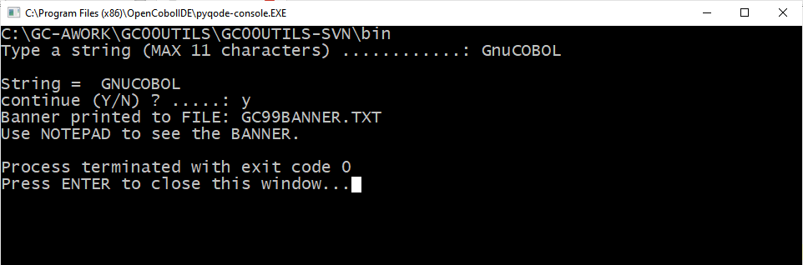

Printed result:

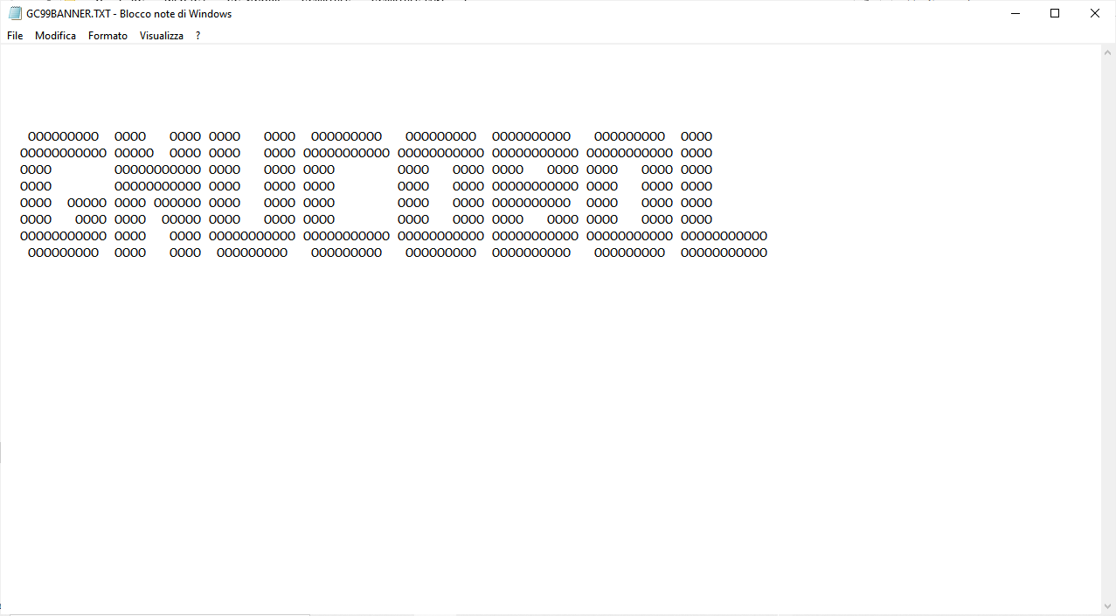

  - FADE RAIN EFFECT
in a TUI application, when switching from one screen to the next, it may be nice to make the previous screen disappear with a "rain" effect.
Make a "CALL" to this program and the screen will disappear with a rain fade effect that you can see in the attached screenshots.

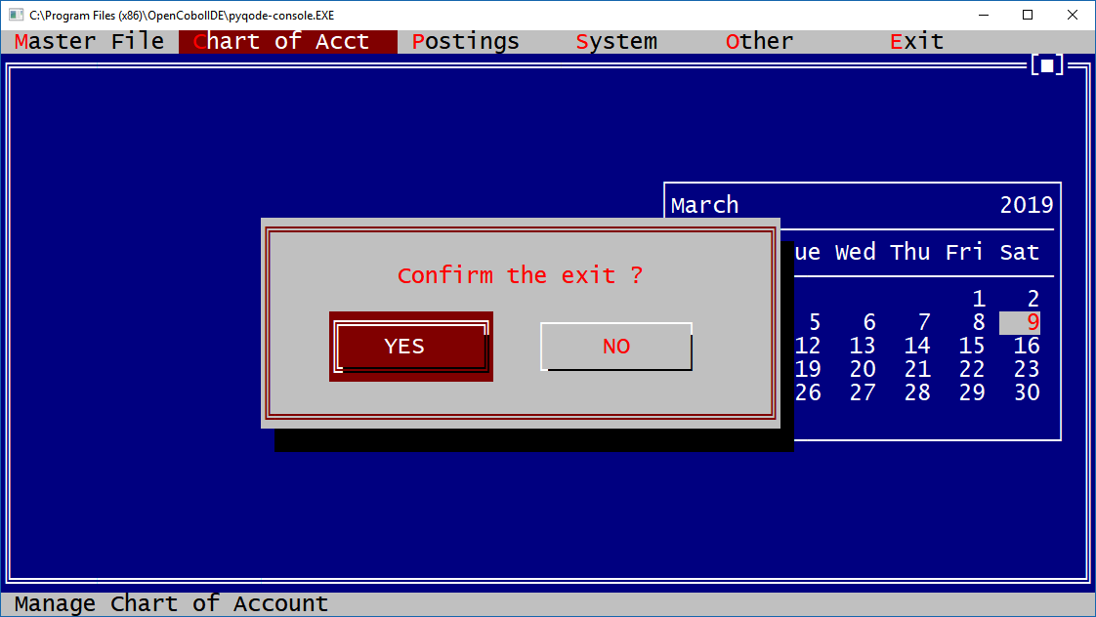

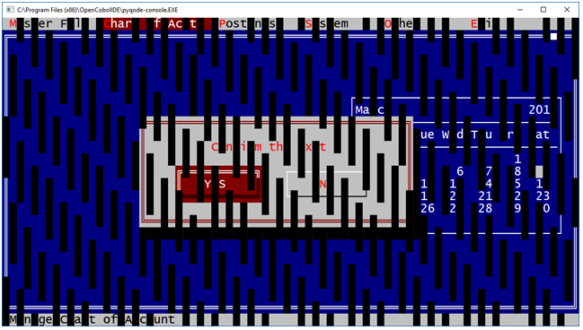

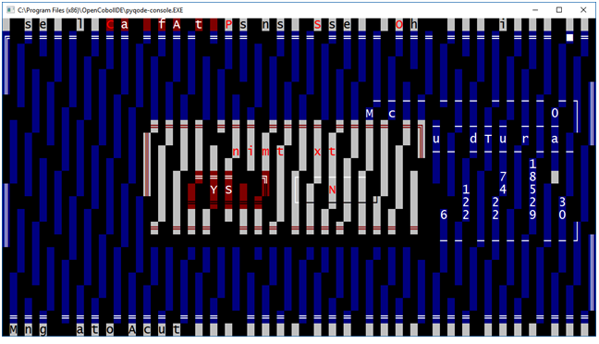

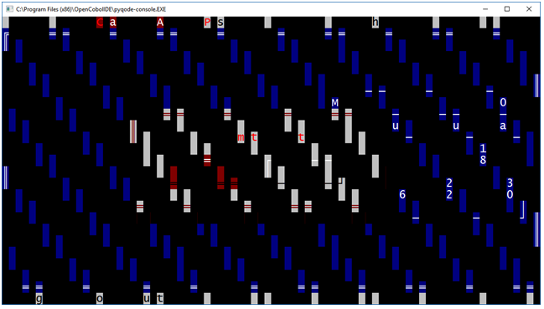

  - COLOR CODES

*> ***********************************************************************************
*> GnuCOBOL TT (TUI TOOLS) COLLECTION
*> Purpose: workarea with GnuCOBOL color codes.
*> Author: Eugenio Di Lorenzo - Italia (DILO) - eugenio.dilo@gmail.com
*> License: (C) 2021 E.Di Lorenzo - LGPL, 3.0 (or greater)
*> ***********************************************************************************
*> WARNING ! PUT THIS COPY FILE AS FIRST LINE IN YOUR WORKING-STORAGE SECTION
*> (because these constants may be used in other "copy" file).
*> ***********************************************************************************
*> FOREGROUND-COLOR values from 8 to 15,
*> For WINDOWS: have same result than values from 0 to 7 and the HIGHLIGHT option.
*> BACKGROUND-COLOR values from 8 to 15,
*> For WINDOWS: have same result than values from 0 to 7 and the BLINK option.

01 Black constant as 00.
01 Blue constant as 01.
01 Green constant as 02.
01 Cyan constant as 03.
01 Rred constant as 04.
01 Magenta constant as 05.
01 Brown constant as 06.
01 DarkGrey constant as 07.

01 LightGrey constant as 08.
01 LightBlue constant as 09.
01 LightGreen constant as 10.
01 LightCyan constant as 11.
01 LightRred constant as 12.
01 Pink constant as 13.
01 Yellow constant as 14.
01 White constant as 15.

  - FOR FUN

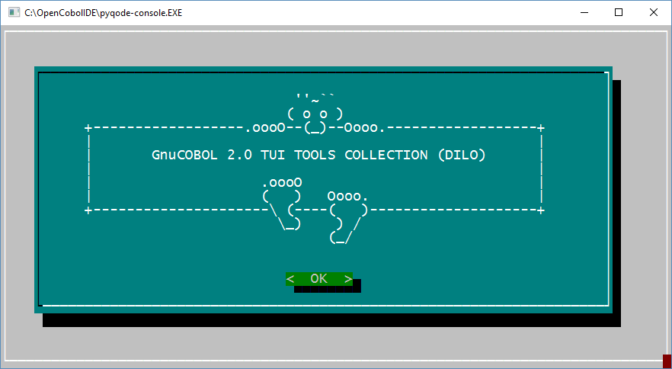

- OTHER GnuCOBOL SCREEN SAMPLES

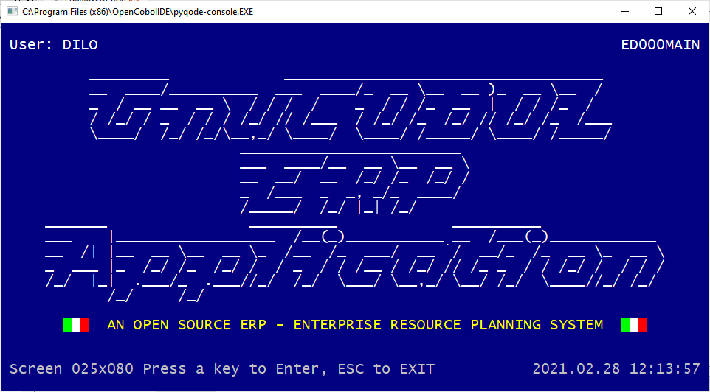

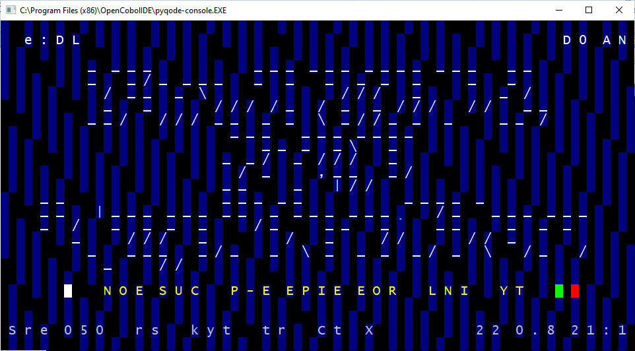

- GNU Free Documentation License

GNU Free Documentation License
Version 1.3, 3 November 2008

Copyright (C) 2000, 2001, 2002, 2007, 2008 Free Software Foundation, Inc.
<https://fsf.org/>
Everyone is permitted to copy and distribute verbatim copies
of this license document, but changing it is not allowed.

0. PREAMBLE

The purpose of this License is to make a manual, textbook, or other
functional and useful document "free" in the sense of freedom: to
assure everyone the effective freedom to copy and redistribute it,
with or without modifying it, either commercially or noncommercially.
Secondarily, this License preserves for the author and publisher a way
to get credit for their work, while not being considered responsible
for modifications made by others.

This License is a kind of "copyleft", which means that derivative
works of the document must themselves be free in the same sense. It
complements the GNU General Public License, which is a copyleft
license designed for free software.

We have designed this License in order to use it for manuals for free
software, because free software needs free documentation: a free
program should come with manuals providing the same freedoms that the
software does. But this License is not limited to software manuals;
it can be used for any textual work, regardless of subject matter or
whether it is published as a printed book. We recommend this License
principally for works whose purpose is instruction or reference.

1. APPLICABILITY AND DEFINITIONS

This License applies to any manual or other work, in any medium, that
contains a notice placed by the copyright holder saying it can be
distributed under the terms of this License. Such a notice grants a
world-wide, royalty-free license, unlimited in duration, to use that
work under the conditions stated herein. The "Document", below,
refers to any such manual or work. Any member of the public is a
licensee, and is addressed as "you". You accept the license if you
copy, modify or distribute the work in a way requiring permission
under copyright law.

A "Modified Version" of the Document means any work containing the
Document or a portion of it, either copied verbatim, or with
modifications and/or translated into another language.

A "Secondary Section" is a named appendix or a front-matter section of
the Document that deals exclusively with the relationship of the
publishers or authors of the Document to the Document's overall
subject (or to related matters) and contains nothing that could fall
directly within that overall subject. (Thus, if the Document is in
part a textbook of mathematics, a Secondary Section may not explain
any mathematics.) The relationship could be a matter of historical
connection with the subject or with related matters, or of legal,
commercial, philosophical, ethical or political position regarding
them.

The "Invariant Sections" are certain Secondary Sections whose titles
are designated, as being those of Invariant Sections, in the notice
that says that the Document is released under this License. If a
section does not fit the above definition of Secondary then it is not
allowed to be designated as Invariant. The Document may contain zero
Invariant Sections. If the Document does not identify any Invariant
Sections then there are none.

The "Cover Texts" are certain short passages of text that are listed,
as Front-Cover Texts or Back-Cover Texts, in the notice that says that
the Document is released under this License. A Front-Cover Text may
be at most 5 words, and a Back-Cover Text may be at most 25 words.

A "Transparent" copy of the Document means a machine-readable copy,
represented in a format whose specification is available to the
general public, that is suitable for revising the document
straightforwardly with generic text editors or (for images composed of
pixels) generic paint programs or (for drawings) some widely available
drawing editor, and that is suitable for input to text formatters or
for automatic translation to a variety of formats suitable for input
to text formatters. A copy made in an otherwise Transparent file
format whose markup, or absence of markup, has been arranged to thwart
or discourage subsequent modification by readers is not Transparent.
An image format is not Transparent if used for any substantial amount
of text. A copy that is not "Transparent" is called "Opaque".

Examples of suitable formats for Transparent copies include plain
ASCII without markup, Texinfo input format, LaTeX input format, SGML
or XML using a publicly available DTD, and standard-conforming simple
HTML, PostScript or PDF designed for human modification. Examples of
transparent image formats include PNG, XCF and JPG. Opaque formats
include proprietary formats that can be read and edited only by
proprietary word processors, SGML or XML for which the DTD and/or
processing tools are not generally available, and the
machine-generated HTML, PostScript or PDF produced by some word
processors for output purposes only.

The "Title Page" means, for a printed book, the title page itself,
plus such following pages as are needed to hold, legibly, the material
this License requires to appear in the title page. For works in
formats which do not have any title page as such, "Title Page" means
the text near the most prominent appearance of the work's title,
preceding the beginning of the body of the text.

The "publisher" means any person or entity that distributes copies of
the Document to the public.

A section "Entitled XYZ" means a named subunit of the Document whose
title either is precisely XYZ or contains XYZ in parentheses following
text that translates XYZ in another language. (Here XYZ stands for a
specific section name mentioned below, such as "Acknowledgements",
"Dedications", "Endorsements", or "History".) To "Preserve the Title"
of such a section when you modify the Document means that it remains a
section "Entitled XYZ" according to this definition.

The Document may include Warranty Disclaimers next to the notice which
states that this License applies to the Document. These Warranty
Disclaimers are considered to be included by reference in this
License, but only as regards disclaiming warranties: any other
implication that these Warranty Disclaimers may have is void and has
no effect on the meaning of this License.

2. VERBATIM COPYING

You may copy and distribute the Document in any medium, either
commercially or noncommercially, provided that this License, the
copyright notices, and the license notice saying this License applies
to the Document are reproduced in all copies, and that you add no
other conditions whatsoever to those of this License. You may not use
technical measures to obstruct or control the reading or further
copying of the copies you make or distribute. However, you may accept
compensation in exchange for copies. If you distribute a large enough
number of copies you must also follow the conditions in section 3.

You may also lend copies, under the same conditions stated above, and
you may publicly display copies.

3. COPYING IN QUANTITY

If you publish printed copies (or copies in media that commonly have
printed covers) of the Document, numbering more than 100, and the
Document's license notice requires Cover Texts, you must enclose the
copies in covers that carry, clearly and legibly, all these Cover
Texts: Front-Cover Texts on the front cover, and Back-Cover Texts on
the back cover. Both covers must also clearly and legibly identify
you as the publisher of these copies. The front cover must present
the full title with all words of the title equally prominent and
visible. You may add other material on the covers in addition.
Copying with changes limited to the covers, as long as they preserve
the title of the Document and satisfy these conditions, can be treated
as verbatim copying in other respects.

If the required texts for either cover are too voluminous to fit
legibly, you should put the first ones listed (as many as fit
reasonably) on the actual cover, and continue the rest onto adjacent
pages.

If you publish or distribute Opaque copies of the Document numbering
more than 100, you must either include a machine-readable Transparent
copy along with each Opaque copy, or state in or with each Opaque copy
a computer-network location from which the general network-using
public has access to download using public-standard network protocols
a complete Transparent copy of the Document, free of added material.
If you use the latter option, you must take reasonably prudent steps,
when you begin distribution of Opaque copies in quantity, to ensure
that this Transparent copy will remain thus accessible at the stated
location until at least one year after the last time you distribute an
Opaque copy (directly or through your agents or retailers) of that
edition to the public.

It is requested, but not required, that you contact the authors of the
Document well before redistributing any large number of copies, to
give them a chance to provide you with an updated version of the
Document.

4. MODIFICATIONS

You may copy and distribute a Modified Version of the Document under
the conditions of sections 2 and 3 above, provided that you release
the Modified Version under precisely this License, with the Modified
Version filling the role of the Document, thus licensing distribution
and modification of the Modified Version to whoever possesses a copy
of it. In addition, you must do these things in the Modified Version:

A. Use in the Title Page (and on the covers, if any) a title distinct
from that of the Document, and from those of previous versions
(which should, if there were any, be listed in the History section
of the Document). You may use the same title as a previous version
if the original publisher of that version gives permission.
B. List on the Title Page, as authors, one or more persons or entities
responsible for authorship of the modifications in the Modified
Version, together with at least five of the principal authors of the
Document (all of its principal authors, if it has fewer than five),
unless they release you from this requirement.
C. State on the Title page the name of the publisher of the
Modified Version, as the publisher.
D. Preserve all the copyright notices of the Document.
E. Add an appropriate copyright notice for your modifications
adjacent to the other copyright notices.
F. Include, immediately after the copyright notices, a license notice
giving the public permission to use the Modified Version under the
terms of this License, in the form shown in the Addendum below.
G. Preserve in that license notice the full lists of Invariant Sections
and required Cover Texts given in the Document's license notice.
H. Include an unaltered copy of this License.
I. Preserve the section Entitled "History", Preserve its Title, and add
to it an item stating at least the title, year, new authors, and
publisher of the Modified Version as given on the Title Page. If
there is no section Entitled "History" in the Document, create one
stating the title, year, authors, and publisher of the Document as
given on its Title Page, then add an item describing the Modified
Version as stated in the previous sentence.
J. Preserve the network location, if any, given in the Document for
public access to a Transparent copy of the Document, and likewise
the network locations given in the Document for previous versions
it was based on. These may be placed in the "History" section.
You may omit a network location for a work that was published at
least four years before the Document itself, or if the original
publisher of the version it refers to gives permission.
K. For any section Entitled "Acknowledgements" or "Dedications",
Preserve the Title of the section, and preserve in the section all
the substance and tone of each of the contributor acknowledgements
and/or dedications given therein.
L. Preserve all the Invariant Sections of the Document,
unaltered in their text and in their titles. Section numbers
or the equivalent are not considered part of the section titles.
M. Delete any section Entitled "Endorsements". Such a section
may not be included in the Modified Version.
N. Do not retitle any existing section to be Entitled "Endorsements"
or to conflict in title with any Invariant Section.
O. Preserve any Warranty Disclaimers.

If the Modified Version includes new front-matter sections or
appendices that qualify as Secondary Sections and contain no material
copied from the Document, you may at your option designate some or all
of these sections as invariant. To do this, add their titles to the
list of Invariant Sections in the Modified Version's license notice.
These titles must be distinct from any other section titles.

You may add a section Entitled "Endorsements", provided it contains
nothing but endorsements of your Modified Version by various
parties--for example, statements of peer review or that the text has
been approved by an organization as the authoritative definition of a
standard.

You may add a passage of up to five words as a Front-Cover Text, and a
passage of up to 25 words as a Back-Cover Text, to the end of the list
of Cover Texts in the Modified Version. Only one passage of
Front-Cover Text and one of Back-Cover Text may be added by (or
through arrangements made by) any one entity. If the Document already
includes a cover text for the same cover, previously added by you or
by arrangement made by the same entity you are acting on behalf of,
you may not add another; but you may replace the old one, on explicit
permission from the previous publisher that added the old one.

The author(s) and publisher(s) of the Document do not by this License
give permission to use their names for publicity for or to assert or
imply endorsement of any Modified Version.

5. COMBINING DOCUMENTS

You may combine the Document with other documents released under this
License, under the terms defined in section 4 above for modified
versions, provided that you include in the combination all of the
Invariant Sections of all of the original documents, unmodified, and
list them all as Invariant Sections of your combined work in its
license notice, and that you preserve all their Warranty Disclaimers.

The combined work need only contain one copy of this License, and
multiple identical Invariant Sections may be replaced with a single
copy. If there are multiple Invariant Sections with the same name but
different contents, make the title of each such section unique by
adding at the end of it, in parentheses, the name of the original
author or publisher of that section if known, or else a unique number.
Make the same adjustment to the section titles in the list of
Invariant Sections in the license notice of the combined work.

In the combination, you must combine any sections Entitled "History"
in the various original documents, forming one section Entitled
"History"; likewise combine any sections Entitled "Acknowledgements",
and any sections Entitled "Dedications". You must delete all sections
Entitled "Endorsements".

6. COLLECTIONS OF DOCUMENTS

You may make a collection consisting of the Document and other
documents released under this License, and replace the individual
copies of this License in the various documents with a single copy
that is included in the collection, provided that you follow the rules
of this License for verbatim copying of each of the documents in all
other respects.

You may extract a single document from such a collection, and
distribute it individually under this License, provided you insert a
copy of this License into the extracted document, and follow this
License in all other respects regarding verbatim copying of that
document.

7. AGGREGATION WITH INDEPENDENT WORKS

A compilation of the Document or its derivatives with other separate
and independent documents or works, in or on a volume of a storage or
distribution medium, is called an "aggregate" if the copyright
resulting from the compilation is not used to limit the legal rights
of the compilation's users beyond what the individual works permit.
When the Document is included in an aggregate, this License does not
apply to the other works in the aggregate which are not themselves
derivative works of the Document.

If the Cover Text requirement of section 3 is applicable to these
copies of the Document, then if the Document is less than one half of
the entire aggregate, the Document's Cover Texts may be placed on
covers that bracket the Document within the aggregate, or the
electronic equivalent of covers if the Document is in electronic form.
Otherwise they must appear on printed covers that bracket the whole
aggregate.

8. TRANSLATION

Translation is considered a kind of modification, so you may
distribute translations of the Document under the terms of section 4.
Replacing Invariant Sections with translations requires special
permission from their copyright holders, but you may include
translations of some or all Invariant Sections in addition to the
original versions of these Invariant Sections. You may include a
translation of this License, and all the license notices in the
Document, and any Warranty Disclaimers, provided that you also include
the original English version of this License and the original versions
of those notices and disclaimers. In case of a disagreement between
the translation and the original version of this License or a notice
or disclaimer, the original version will prevail.

If a section in the Document is Entitled "Acknowledgements",
"Dedications", or "History", the requirement (section 4) to Preserve
its Title (section 1) will typically require changing the actual
title.

9. TERMINATION

You may not copy, modify, sublicense, or distribute the Document
except as expressly provided under this License. Any attempt
otherwise to copy, modify, sublicense, or distribute it is void, and
will automatically terminate your rights under this License.

However, if you cease all violation of this License, then your license
from a particular copyright holder is reinstated (a) provisionally,
unless and until the copyright holder explicitly and finally
terminates your license, and (b) permanently, if the copyright holder
fails to notify you of the violation by some reasonable means prior to
60 days after the cessation.

Moreover, your license from a particular copyright holder is
reinstated permanently if the copyright holder notifies you of the
violation by some reasonable means, this is the first time you have
received notice of violation of this License (for any work) from that
copyright holder, and you cure the violation prior to 30 days after
your receipt of the notice.

Termination of your rights under this section does not terminate the
licenses of parties who have received copies or rights from you under
this License. If your rights have been terminated and not permanently
reinstated, receipt of a copy of some or all of the same material does
not give you any rights to use it.

10. FUTURE REVISIONS OF THIS LICENSE

The Free Software Foundation may publish new, revised versions of the
GNU Free Documentation License from time to time. Such new versions
will be similar in spirit to the present version, but may differ in
detail to address new problems or concerns. See
https://www.gnu.org/licenses/.

Each version of the License is given a distinguishing version number.
If the Document specifies that a particular numbered version of this
License "or any later version" applies to it, you have the option of
following the terms and conditions either of that specified version or
of any later version that has been published (not as a draft) by the
Free Software Foundation. If the Document does not specify a version
number of this License, you may choose any version ever published (not
as a draft) by the Free Software Foundation. If the Document
specifies that a proxy can decide which future versions of this
License can be used, that proxy's public statement of acceptance of a
version permanently authorizes you to choose that version for the
Document.

11. RELICENSING

"Massive Multiauthor Collaboration Site" (or "MMC Site") means any
World Wide Web server that publishes copyrightable works and also
provides prominent facilities for anybody to edit those works. A
public wiki that anybody can edit is an example of such a server. A
"Massive Multiauthor Collaboration" (or "MMC") contained in the site
means any set of copyrightable works thus published on the MMC site.

"CC-BY-SA" means the Creative Commons Attribution-Share Alike 3.0
license published by Creative Commons Corporation, a not-for-profit
corporation with a principal place of business in San Francisco,
California, as well as future copyleft versions of that license
published by that same organization.

"Incorporate" means to publish or republish a Document, in whole or in
part, as part of another Document.

An MMC is "eligible for relicensing" if it is licensed under this
License, and if all works that were first published under this License
somewhere other than this MMC, and subsequently incorporated in whole or
in part into the MMC, (1) had no cover texts or invariant sections, and
(2) were thus incorporated prior to November 1, 2008.

The operator of an MMC Site may republish an MMC contained in the site
under CC-BY-SA on the same site at any time before August 1, 2009,
provided the MMC is eligible for relicensing.

ADDENDUM: How to use this License for your documents

To use this License in a document you have written, include a copy of
the License in the document and put the following copyright and
license notices just after the title page:

Copyright (c) YEAR YOUR NAME.
Permission is granted to copy, distribute and/or modify this document
under the terms of the GNU Free Documentation License, Version 1.3
or any later version published by the Free Software Foundation;
with no Invariant Sections, no Front-Cover Texts, and no Back-Cover Texts.
A copy of the license is included in the section entitled "GNU
Free Documentation License".

If you have Invariant Sections, Front-Cover Texts and Back-Cover Texts,
replace the "with...Texts." line with this:

with the Invariant Sections being LIST THEIR TITLES, with the
Front-Cover Texts being LIST, and with the Back-Cover Texts being LIST.

If you have Invariant Sections without Cover Texts, or some other
combination of the three, merge those two alternatives to suit the
situation.

If your document contains nontrivial examples of program code, we
recommend releasing these examples in parallel under your choice of
free software license, such as the GNU General Public License,
to permit their use in free software.

