BAR MENU
Choose: Number of Items, Text of Items, Position of Items (Horizontal, Vertical, Overlapped), Colors, with/without a Box and a shadow, text message associated to each menu item, ...
Screenshots:

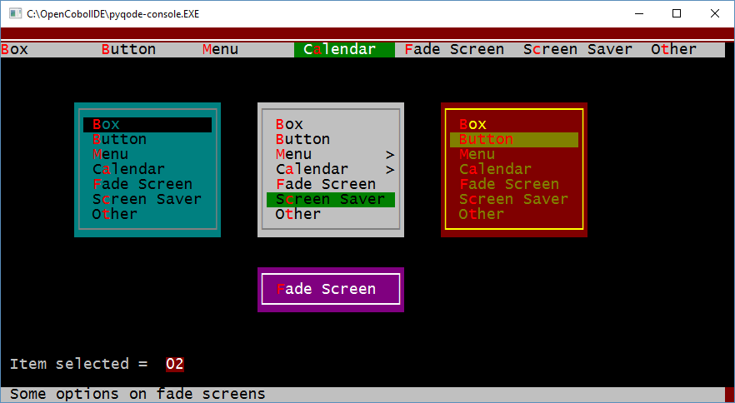

BAR & DROP-DOWN MENU

sample Screenshots: :

