Project “Cu Chulainn” 1.5-Page GDD
Diablo with Habit-Driven Character Development
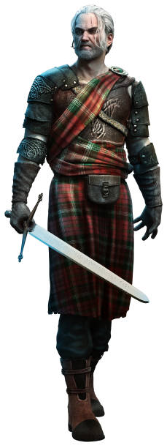
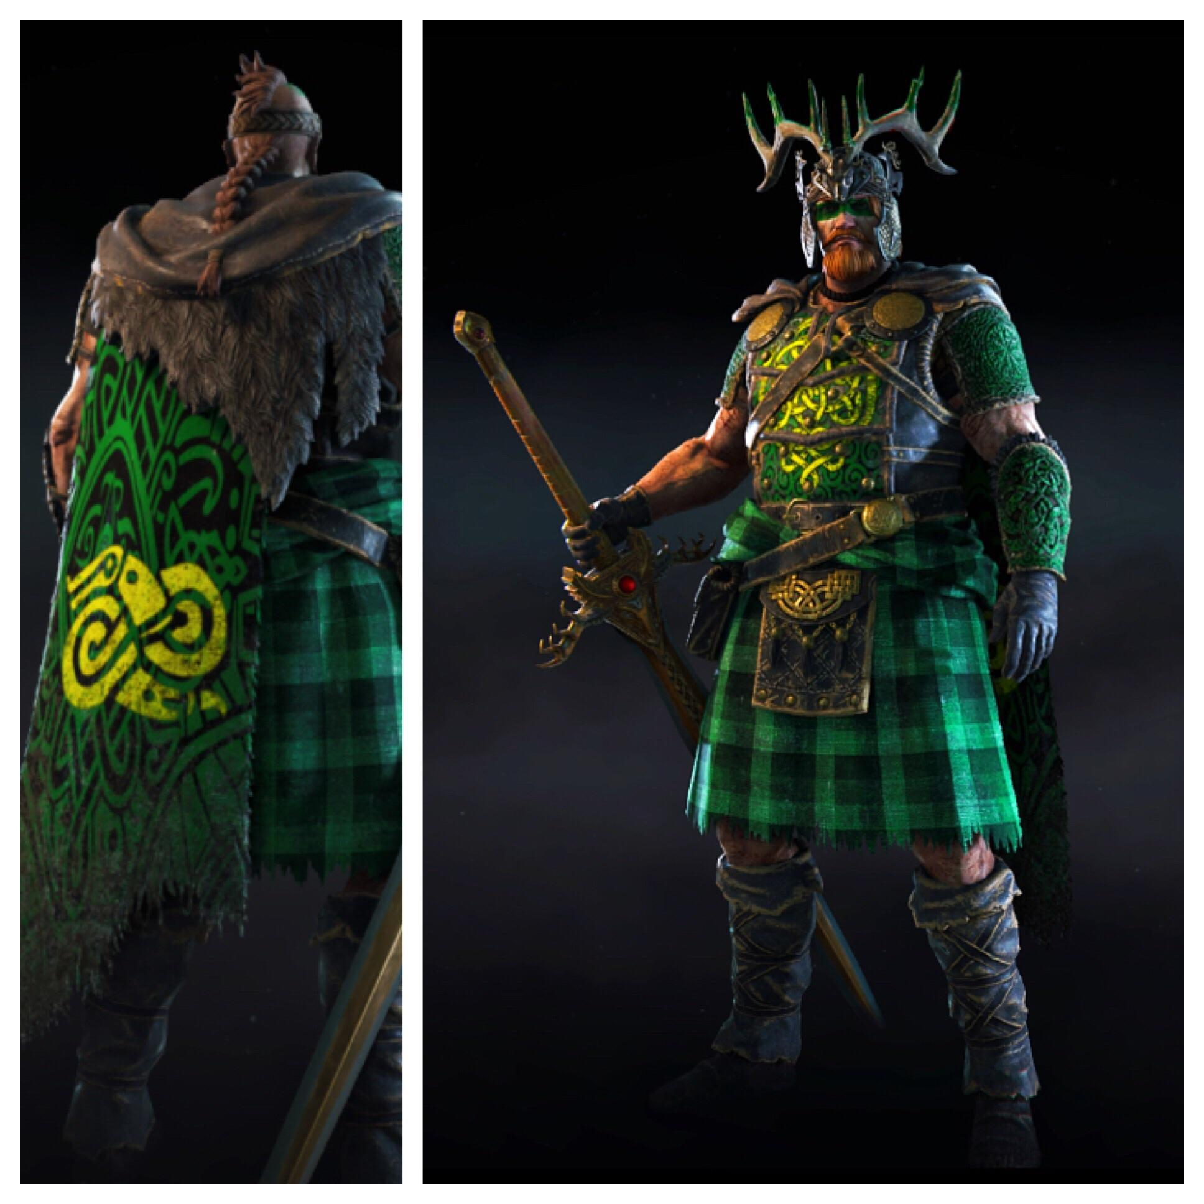

Genre: Single player 3rd Person Action RPG with fixed camera
Target Audience: 13+ (T for Teen) fans of Diablo-like games, Game of Thrones
Controls: Mouse and keyboards
Thematic Setting: Medieval Ireland and Scotland / Fantasy
Tech Stack: Unity 2020.3, Audacity, Blender, Unity Asset Sore
Platform(s): Steam
MVP Game Moment: 2 minutes of simple linear level flow with basic combat against 3 or 4 enemy types.

Game Summary: Project “Cu Chulainn” is a Diablo-style RPG that seeks to reduce or eliminate limits in character development, progression, and relevance and to allow the player to experience these things more naturally, like one would experience them in real life. It is set in a fantasy version of the 8th century British Isles, where kingdoms are locked in complex, multi-polar conflicts for their existence and supremacy. Our hero begins as a young person from somewhere in the isles and must navigate the conflict alone or as a member of one of the kingdoms. The decision to live for freedom, honor, love, wealth, or power is in the hands of the player.

Core Player Experience: freedom / empowerment / relevance
Central Story Theme: dynamic, multi-polar conflicts as cultures come into conflict
Design Pillar: Putting the player in complex situations with multiple possible solutions.
Remarkability: No levels / open-ended, play-style-driven character development

Anticipated Steam Early Access Launch date: December 24, 2022

Feature Development Priorities:
- Real-time combat with complex tactical and strategic situations
- Character development: stats, skills, abilities, etc
- Level building and game progression
- Dynamic, branching dialogue system
- Inventory, loot, usable items

Reference Games:
- Kingdoms of Amalur: Reckoning
- Diablo
- Mount and Blade II: Bannerlord
- Neverwinter
- Kingdom Come: Deliverance

