Cloud Computing
(1)On-demand self-service (2)Broad network access (3)Resource pooling (4)Rapid elasticity (5)Measured service
Cloud Costs
Total Cost of Ownership (TCO):(CAPEX)+(OPEX)
Capital Expenditures (CAPEX): Investments in fixed assets with future benefits. Includes acquisition of fixed/intangible assets, asset repairs, and improvements. Not deductible in the fiscal year paid; must be capitalized.
Operational Expenditures (OPEX)
Ongoing costs for operating a product, business, or system. Includes licensing fees, maintenance, legal fees, utilities, property management.

Cloud Service Model
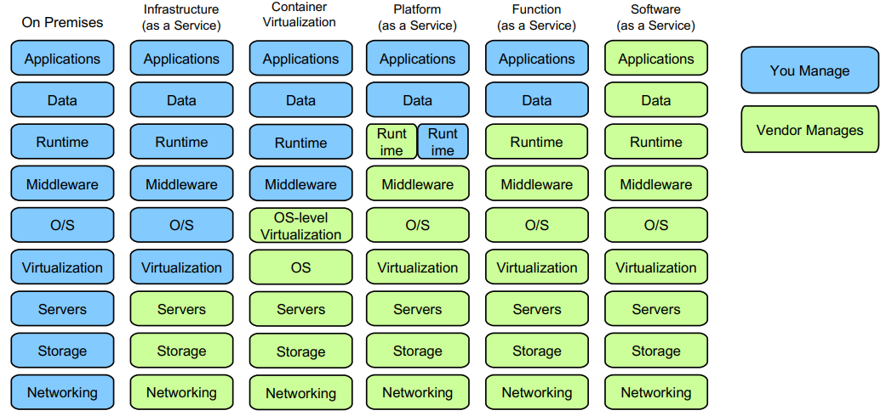
SaaS: Delivers software applications over the internet, on demand and typically on a subscription basis.
PaaS: Provides a platform allowing customers to develop, run, and manage applications without the complexity of building and maintaining the infrastructure.
IaaS: Offers essential computing, storage, and networking resources on demand, over the internet, and on a pay-as-you-go basis.
FaaS: Also known as Server-less Computing, FaaS allows building and running applications and services without managing servers. It involves a high level of abstraction and is event-driven, starting the function when needed and shutting it down afterwards. Breaks down services into individual, independently executable functions.

Cloud Deployment Models
Private Cloud: Dedicated to a single organization.
Community Cloud: Shared by organizations with common concerns.
Public Cloud: Operated for the public or many organizations.
Hybrid Cloud: Combines private, community, and public models.

Architecture Models
Monolithic: Unified application; simple but can be complex to maintain.
Microservices: Divided into independent services; flexible and maintainable.

Cloud Selection Criteria
Prerequisites (Constraints): Data privacy/security, SLA, geographic location.
Application Requirements (Characteristics): Support for services/OS/applications, VM features and performance.
Cost Criteria: Total cost of running an application on a specific cloud.

Storage Systems

Block Storage
Magnetic disk: slower, lifespan limited, cheaper, fragile
SSD: faster, more expensive, shock-resistant, lifespan limited by overwrite

Solid State Drive
Write Amplification Write amplification is an issue that can occur in SSDs. Before it can be written, memory needs to be erased. Memory can only be erased at the page level, not the cell level. Therefore, much more data is re-written than is changed.
Cell Wear out A memory cell can withstand only a finite number of program-erase cycles (100’000). Cell wear out is a term used to describe the degradation of a solid state drive (SSD) over time.
Wear leveling Wear leveling is a process that helps to distribute write operations evenly across the blocks of an SSD. This can help to prolong the life of the SSD by preventing any single block from becoming over-worn.

File System
The file system layer sits on top of the block storage layer and provides: Files, Directories, Metadata(Modification time, access time, permissions, …), Hard and Symbolic links Inside the kernel the Virtual File System (VFS) component is responsible for managing files and directories.
Directories a special kind of file, which contains the file names together with the corresponding Inode numbers. A directory file is a list of variable length records, each one containing the following information: Inode number, Record length, Name length, File type (unknown, regular file, directory, character device, block device, named pipe, socket, symbolic link), File name (aligné sur 4 octets pour des raisons de performance)
Inode contains:
- File metadata (except for the file name): permissions, file size, creation time, access time, modification time.
- Pointers to the data blocks containing the file content (direct pointers, single, double, triple indirection)
Metadata of a file are Type, Permissions, Number of links, Owner, Group, Size, Last modification time, File name.
Disk Initialization 1. Create a partition table 2. Create a file system on each partition 3. Mounting of a file system in the file system tree 4. Show information

File System Link
File is stored in three pieces in unix:
Name is stored in a directory table. The table entry contains also its Inode number. Its Inode contains metadata and pointers to the blocks that store its content. Content is stored in data blocks
Hard Links points directly to the inode of the file or folder they are linked to. We cannot point it over a directory.
Symbolic Links point to the location of the file or folder they are linked to. If a symbolic link points to a target, and sometime later that target is moved, renamed or deleted, the symbolic link is not automatically updated or deleted, but continues to exist and still points to the old target, now a non-existing location or file. Symbolic links pointing to moved or non-existing targets are sometimes called broken, orphaned, dead, or dangling.
Comparison

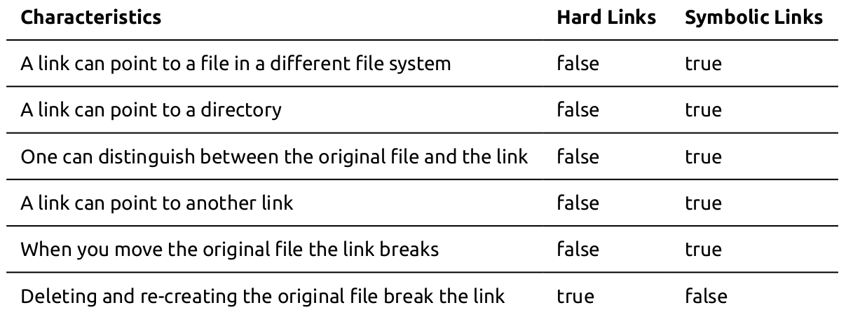
Virtual Storage
Reasons for using virtual storage:
- Create file systems with big capacity by combining several physical disks.
- Dynamically change the size of a virtual disk by adding or removing blocks.
- Generally greater flexibility in the management of disks.
- (When servers access virtual disks remotely via a SAN:) The possibility to share a pool of disks between several servers.
- (In cloud computing:) The possibility to share a pool of disks between several clients.

Snapshot
An interesting functionality of virtual storage is the ability to take a snapshot of a virtual disk. A snapshot behaves like a complete, read-only copy of the disk. The copy process is almost instantaneous.
We start with a virtual disk. On the left we show how the blocks of the virtual disk appear to the file system. On the right we show how the blocks are really stored.
To create a snapshot we create a second virtual disk which is a copy of the first. We only copy the index that contains the pointers. We don’t copy any blocks. (very quick)
After having created the snapshot, writes a treated in a special way. We proceed according to the copy-on-write principle: Before we modify a physical block we make a copy in a new physical block. We make the pointer point to the new block Then we write into the new block. Then we write into the new block. (Blocks that are not modified are shared between the two disks and modifications on the virtual disk have no eﬀect on the second virtual disk.)
Recoverability: Regulary take snapshot to restore system state.
Integrity: Snapshot cannot be modified
Save space: Delete old snapshot, reduce frequency.

Logical Volume Manager
To make file systems more flexible, the designers of the Linux kernel added a layer between the kernel’s file systems and the disks (block devices) called Logical Volume Manager. This layer provides virtual disks, called Logical Volumes, that aggregate several disks and that can grow and shrink in size.
- Flexible capacity: When using logical volumes, file systems can extend across multiple disks, since you can aggregate disks and partitions into a single logical volume.
- Resizeable storage pools: You can extend logical volumes or reduce logical volumes in size with simple software commands, without reformatting and re-partitioning the underlying disk devices.
- Online data relocation: To deploy newer, faster, or more resilient storage subsystems, you can move data while your system is active. Data can be rearranged on disks while the disks are in use. For example, you can empty a hot-swappable disk before removing it.
- Convenient device naming: Logical storage volumes can be managed in user-defined groups, which you can name according to your convenience.
- Disk striping: You can create a logical volume that stripes data across two or more disks. This can dramatically increase throughput.
- Mirroring volumes: Logical volumes provide a convenient way to configure a mirror for your data.
- Volume Snapshots: Using logical volumes, you can take device snapshots for consistent backups or to test the effect of changes without affecting the real data.
Composition Physical Volumes, Volume Groups, Logical Volumes

Type Of Storage
Direct-Attached Storage (DAS): block storage, requires a server with an OS to have FS for storing files. Big effort required to set up servers, disks and network on premises. Big effort to scale, as it requires purchasing physical hardware
Storage-Area Network (SAN) A typical use case for a Storage Area Network is an enterprise that has data-intensive applications (e.g., databases). A SAN volume can also be used by a file server to provide Network-Attached Storage (NAS) to client computers.
Network-Attached Storage (NAS) A NAS device is a file server that provides file storage services to client computers over a network. NAS devices are often used to provide file storage for small offices and home offices.
Cloudb block storage A virtual disk is called an Elastic Block Store (EBS) volume in AWS. Elasticity: modify without unmounting or stopping the EC2 instance (increase ok but cannot decrease) Snapshots: incremental -> store only difference to previous snapshot Encryption: encrypted volume at no additional cost, Random Access, low overhead.
Comparison

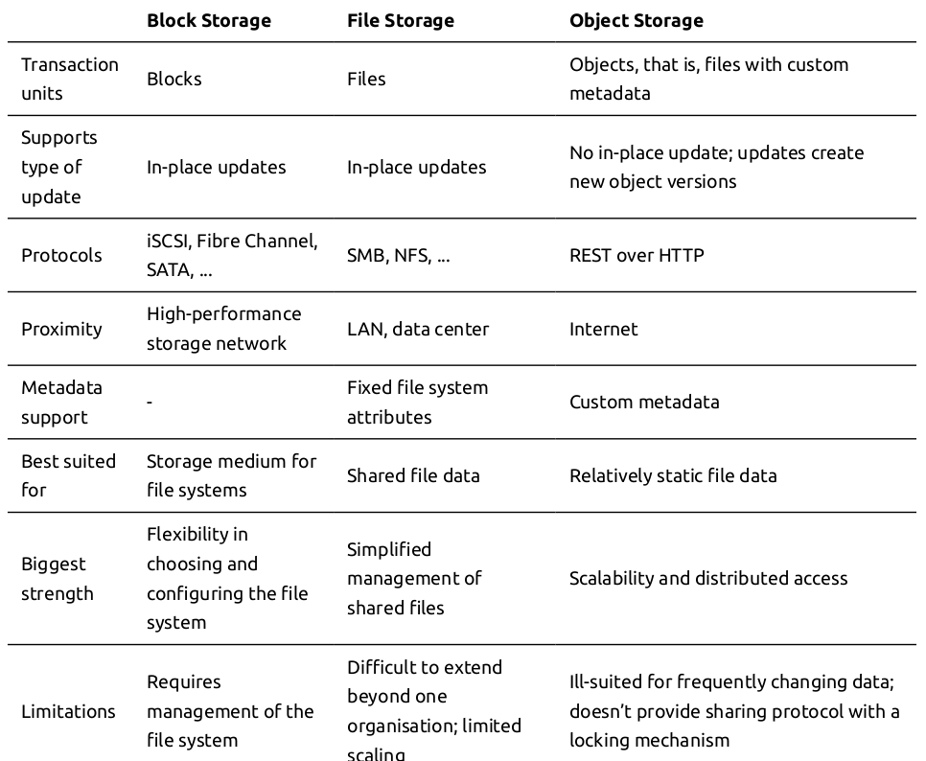
S3
Use cases Storing application assets, Static web hosting, Backup and disaster recovery, Staging are for big data and ml
Access https://s3.region.amazonaws.com/bucketname/key or https://bucketname.s3-region.amazonaws.com/
Price 23$/tb month, different tiers, (You pay for the amount of data that is stored, for each request to the data, for the amount of data that is transferred), additional options (versioning or encryption) paid.
Advantage No servers to set up. The service is inherently scalable (appears to the user as having infinite capacity), no manual intervention necessary to scale.

Identity and Access Management (IAM)
Identity A user, group, or role that you create in AWS. An identity can be associated with one or more permissions. Once authenticated, the request is called principal.
IAM User A person or app that can authenticate with AWS account
IAM Group A collection of IAM users that are granted identical authorization
Permission policy The document that defines which resources can be accessed and the level of access to each resource.
IAM Role Useful mechanism to grant a set of permissions to AWS services that make requests on behalf of the user.
SID Stands for Statement Identifier. A human-readable label for a statement.
Authorization Logically, it can be represented by a matrix that records for each combination of user (identity) and resource the actions that the user is authorized to perform on the resource (permissions flags, Access control list, permission policies)
IAM policies An IAM policy is a document that defines permissions. It can be identity-based or Resource based policies
Identity:
{
"Version": "2012-10-17",
"Statement": {
"Effect": "Allow",
"Action": ["s3:GetObject", "s3:GetBucketLocation", "s3:ListBucket"],
"Resource": [
"arn:aws:s3:::awsexamplebucket1/*",
"arn:aws:s3:::awsexamplebucket1"
]
}
}
Resource:
{
"Version": "2012-10-17",
"Statement": {
"Effect": "Allow",
"Principal": {
"AWS": "arn:aws:iam::123456789012:user/Dave"
},
"Action": ["s3:GetObject", "s3:GetBucketLocation", "s3:ListBucket"],
"Resource": [
"arn:aws:s3:::awsexamplebucket1/*",
"arn:aws:s3:::awsexamplebucket1"
]
}
}
Explicit deny ensures that the user cannot use any other aws actions other than what we allowed
{
"Effect": "Deny",
"Action": ["DynamoDB:*", "s3:*"],
"NotResource": ["arn:aws:s3:::bucket-name", "arn:aws:s3:::bucket-name/*"]
}

Serverless data processing
Definition Serverless is the concept of building and running applications that do not require server management.
FaaS In this model, a “function” is a piece of code that is deployed to the cloud and runs inside a hosting environment that completely abstracts the servers that run the code.
Baas Back-end cloud services, such as databases and storage, provide APIs that enable client applications to connect directly to these services. The services auto-scale and operate transparently.
Benefits zero server operations, no compute cost when idle,
Usecase Realtime file processing, IoT backend, Web application, Asynchronous, concurrent, easy to parallelize into independent units of work, Infrequent or has sporadic demand, with large, unpredictable variance in scaling requirements, Stateless, ephemeral, without a major need for instantaneous cold start time.
(+): Cheap, serverless 0 ops, CI/CD automation
(-): Debug, cold start, unpredictable cost, stateless
Pricing (By resources consumed, by number of invocation, network traffic)
Hello World
import os
import logging
import jsonpickle
import boto3
logger = logging.getLogger()
logger.setLevel(logging.INFO)
client = boto3.client('lambda')
client.get_account_settings()
def lambda_handler(event, context):
logger.info('## ENVIRONMENT VARIABLES\r' + jsonpickle.encode(dict(**os.environ)))
logger.info('## EVENT\r' + jsonpickle.encode(event))
logger.info('## CONTEXT\r' + jsonpickle.encode(context))
// useful work would go here
response = client.get_account_settings() // just for demo
return response['AccountUsage']

Parameters
When a function is deployed you can specified: Memory, CPU, Timeout(The amount of time that the platform allows a function to run before stopping it), Concurrency(The maximum number of requests that a function is serving at any given time), Environment variables

Pricing
You can bill it by resources consumed or by number of invocations, network traffic

Function execution environment lifecycle
(1)Init: The platform creates or unfreezes an execution environment with the configured resources, downloads the code for the function, initializes the runtime and then runs the function’s initialization code.(2)Invoke: The platform invokes the function handler.(3)Shutdown: the platform terminates the runtime and then removes the environment. The function must be designed to be stateless
Invocation types It can be Synchronous, Asynchronous, Message Stream, Job(master worker)
Cold Start the phenomenon that a function that hasn’t been invoked recently will incur some additional latency the next time it runs.

Object lambdas
Usecase: Converting format, Augmenting data, Compressing, Resizing, Watermarking, etc…
Use an accesspoint(endpoint) data not modified

Container Technologies

Container Technologies

Edge-Cloud Technology

Edge-Cloud Technology
(1)Processing data near the network edge, closer to IoT devices. (2)Relieves the cloud, limits traffic, makes decisions near IoT devices, enhances security.
(3)Challenges: Balancing data retention at the edge vs. central cloud processing. (4)Edge-Cloud Concept: Combines acting, deciding, and learning processes.

Network Resource Virtualization

Network Resource Virtualization
Dfadsf

Security For Cloud

Security for Cloud
Dfadsf

Continuous Delivery and Deployment

Continuous Delivery and Deployment
Dfadsf

NoSQL

Cloud Native Application
Characteristics: On-demand resources, Elasticity, Multi-user, Metered services, Broadband network access

Twelve factor App
1.Codebase: A twelve-factor app maintains a single codebase for each app, tracked in a version control system like Git. Different deployments may exist, but they all derive from this common codebase, ensuring consistency and integrity across different instances of the application. 2.Dependencies: Dependencies in a twelve-factor app are explicitly declared and isolated. This approach ensures that all required libraries are present as specified, avoiding any reliance on implicit system-wide packages. The explicit declaration enhances predictability and consistency across development and production environments. 3.Config: Configuration data in a twelve-factor app is separated from the code and stored in the environment. This strategy uses environment variables for managing configuration settings, allowing easy changes between deployments without code alteration, thus maintaining a clear separation between code and configuration. 4.Backing Services: All backing services, such as databases and caching systems, are treated as attached resources in a twelve-factor app. There’s no distinction between local and third-party services, allowing flexibility and consistency in how these services are connected and utilized. 5.Build-Release-Run: The twelve-factor app strictly separates the build, release, and run stages. The build stage creates an executable bundle from the code; the release stage combines this build with the current config; and the run stage executes the app in the environment. This separation enhances clarity and control over each stage of app deployment. 6.Processes: A twelve-factor app is executed as one or more stateless processes. These processes are disposable, facilitating robustness and scalability. They share nothing and any persistent data is stored in a stateful backing service, not in the process itself. 7.Port Binding: In a twelve-factor app, services are exported via port binding, making the app self-contained and independent of external webserver environments. This approach ensures that the app is fully responsible for handling web requests and other services it provides. 8.Concurrency: The twelve-factor app advocates scaling out through a process model. Processes are the first-class citizens here, enabling the app to handle diverse workloads efficiently and to scale horizontally across multiple processes and machines. 9.Disposability: Processes in a twelve-factor app are disposable, meaning they can be started or stopped at a moment’s notice. This disposability maximizes robustness by enabling quick scaling, rapid deployment of changes, and a stable production environment. 10.Dev/Prod Parity: The twelve-factor app methodology aims to keep development, staging, and production environments as similar as possible. This minimizes gaps in time, personnel, and tools between these environments, thereby enabling continuous deployment and reducing inconsistencies. 11.Logs: In a twelve-factor app, logs are treated as event streams. The app never concerns itself with routing or storage of output streams, which are managed by the execution environment. This approach allows for more efficient and flexible log management. 12.Admin Processes: Administrative or management tasks in a twelve-factor app are run as one-off processes. These tasks occur in an environment identical to the regular long-running processes of the app, ensuring consistency and reducing errors during administrative operations.

