Comparative of University Expenditure Trends by Field: Science, Engineering, and Non-S&E from 2010-2022

Based on the NSF expenditure data, the analysis for various institutions highlights trends in how different universities allocate their expenditures across Science, Engineering, non-S&E (non-science and engineering), and other classifications over the years.

# Top 10 Institutions with the Highest Growth in Expenditures (Rank 98 to 134)

Old Dominion University (ODU) has seen a mix of growth and stabilization in its research and development (R&D) expenditures across Science, Engineering, and non-S&E fields from 2010 to 2022. ODU peaked in R&D expenditure around 2012 but has since plateaued, particularly in Science and Non-S&E fields. If ODU aims to climb into the top 100, it must emulate the consistent growth patterns exhibited by institutions currently ranked between 98 and 134. So what made the other universities grow, and ODU reduce its research expenditures?

Among universities ranked between 98 and 134, these institutions—by analyzing the top 10—have demonstrated the most significant growth in their expenditures, particularly in fields like Science, Engineering, and non-S&E (non-science and engineering). It is essential to mention that the University of Louisiana, Lafayette (Rank 132) does not have NSF data; however, it had the second-highest expenditure growth.

|  |  |  |
| --- | --- | --- |
| **Position** | **University** | **Growth** |
| 109 | Wichita State U. | 408% |
| 132 | U. Louisiana, Lafayette | 196% |
| 115 | Northeastern U. | 190% |
| 117 | George Mason U. | 173% |
| 125 | Georgia State U. | 167% |
| 101 | Florida International U. | 155% |
| 102 | U. Notre Dame | 154% |
| 98 | Temple U. | 142% |
| 128 | U. Dayton | 127% |
| 124 | Rice U. | 121% |

## Wichita State U. (Rank 109)

Over the past decade, Wichita State U. has seen a substantial rise in its investment, particularly in engineering fields, where expenditures grew dramatically. By 2022, the university’s total spending exceeded $260 million, highlighting a strong emphasis on research and development.

* Total Expenditure: Total expenditures substantially increased from 2010 to 2022, peaking in 2022 at over $260 million.
* Science & Engineering: Initially, expenditures on Science remained relatively low but showed significant growth in 2021 and 2022. Engineering also experienced a dramatic increase, contributing heavily to total expenditure growth, especially after 2014.
* Non-S&E Fields: Although less than Science and Engineering, Non-S&E expenditures steadily grew from 2014 onwards.

## Northeastern U. (Rank 115)

Northeastern U. is a crucial player in the growth of research expenditures, especially in Science. By 2022, the university’s total expenditures reached over $230 million, with significant investments in science-related fields contributing to its rapid development.

* Total Expenditure: Northeastern consistently grew across all fields, reaching around $230 million by 2022.
* Science & Engineering: The university’s expenditures are dominated by science-related fields, particularly from 2013 onwards. Engineering expenditures were also high, contributing to a solid foundation in S&E.
* Non-S&E: This field’s expenditure remained relatively stable and minor compared to Science and Engineering.

## George Mason U. (Rank 117)

George Mason U. has experienced consistent and robust growth, especially in Science. Its total expenditures peaked at $230 million in 2022, marking its continuous.

* Total Expenditure: Like the others, George Mason experienced a steady increase in total expenditure, with a peak in 2022 of around $230 million.
* Science & Engineering: The university invested heavily in Science-related fields. Though a smaller portion of their budget, engineering showed consistent support, especially after 2013.
* Non-S&E: This category had moderate growth, contributing about $27 million by 2022.

## Georgia State U. (Rank 125)

Georgia State U. has prioritized its growth in science research, seeing substantial increases in funding for scientific fields. With total expenditures reaching over $215 million in 2022, Georgia State continues to advance its research capabilities.

* Total Expenditure: Georgia State had notable growth, especially in the science category, with an overall expenditure of over $215 million in 2022.
* Science: A significant driver of their expenditure, showing steady growth, particularly in the last few years.
* Engineering: No significant expenditure on engineering was reported.
* Non-S&E: This category showed some peaks, contributing moderately to the budget.

## Florida International U. (Rank 101)

FIU has grown significantly across all fields, with Science leading the way. In 2022, FIU’s expenditures surpassed $280 million, making it one of the most vital institutions in terms of financial growth and research investments in this group.

* Total Expenditure: FIU’s total expenditure in 2022 exceeded $280 million, a large portion coming from Science fields.
* Science & Engineering: Science was the most substantial expenditure category, consistently growing over time, while Engineering expenditure was more minor but grew steadily.
* Non-S&E: Although smaller, Non-S&E still saw consistent growth.

## U. Notre Dame (Rank 102)

Notre Dame has consistently expanded its financial support for research, with Science and Engineering being its most vital areas. By 2022, the university’s expenditures exceeded $280 million, emphasizing its role as a leader in research investment.

* Total Expenditure: Notre Dame’s expenditures grew steadily, reaching over $280 million in 2022.
* Science & Engineering: Science dominated the expenditures, with notable growth throughout the years, especially after 2010. Engineering expenditures also increased, though less dramatically.
* Non-S&E: This category had moderate growth, contributing around $38 million by 2022.

## Temple U. (Rank 98)

Temple U. has maintained strong growth in Science-related fields. By 2022, its expenditures reached over $300 million, demonstrating its commitment to advancing research and maintaining a significant presence in higher education.

* Total Expenditure: Temple’s total expenditure reached about $300 million by 2022.
* Science: A significant contributor to their budget, consistent growth in this field.
* Engineering: There was a moderate but stable investment in Engineering.
* Non-S&E: This category remained relatively small but did experience a slight increase over time.

## U. Dayton (Rank 128)

Dayton has seen impressive growth, particularly in Engineering, constituting a significant portion of its budget. By 2022, its total expenditures exceeded $211 million, driven by its strong focus on research and innovation.

* Total Expenditure: Dayton’s expenditures grew steadily, emphasizing engineering, which contributed to most of the budget in the latter years.
* Science & Engineering: Engineering was a primary focus, with expenditures nearly doubling from 2010 to 2022.
* Non-S&E: This category saw minimal expenditures, but a slight increase was observed in recent years.

## Rice U. (Rank 124)

Rice U. stands out with steady growth across Science and Engineering. With expenditures surpassing $216 million in 2022, Rice remains a leader in research investment, particularly in fields that fuel technological advancement and innovation.

* Total Expenditure: Rice steadily grew by over $216 million by 2022.
* Science & Engineering: Science and Engineering together dominated the expenditures, with steady growth in both categories. Engineering, in particular, has shown a notable increase in recent years.
* Non-S&E: Rice maintained minimal expenditure in Non-S&E fields but still increased slightly over time.

## Conclusion

These institutions have demonstrated remarkable financial growth, significantly increasing their expenditures to advance research in Science, Engineering, and non-S&E fields, ensuring their continued impact and leadership in higher education.

* Science Fields: For most universities, Science-related expenditures form the bulk of their budgets, reflecting the importance of research and development in these areas.
* Engineering: While not all institutions allocate the same level of resources to Engineering, those that do, such as Wichita State and Rice University, see this as a substantial portion of their expenditures.
* Non-S&E: The non-science and engineering categories remain small compared to Science and Engineering but show steady growth across institutions.

## What does ODU need at least to reach the Top 100?

To improve its position and enter the top 100 rankings, Old Dominion University (ODU) must adopt a strategic focus on key growth areas. First and foremost, ODU must prioritize expanding its research funding in both Science and Engineering. These areas have been critical to the success of many top 100 institutions, where significant investments have driven growth and development.

Additionally, ODU should explore emerging research fields, such as health sciences, biomedical engineering, and environmental sciences. These disciplines are becoming increasingly important for universities aiming to improve their research output, and targeted investments in these areas could enhance ODU’s standing.

Furthermore, consistent year-over-year growth is essential. Many of the institutions ODU competes with have demonstrated steady, incremental increases in their research budgets over time. For ODU to avoid stagnation, it must ensure continuous funding growth across the next decade.

In conclusion, for ODU to successfully climb into the top 100, it must significantly boost its research and development expenditures, particularly in Science and Engineering. Strategic investments in emerging fields and a commitment to sustained growth will position ODU to compete with higher-ranked institutions. This approach should serve as the foundation for ODU’s roadmap to increasing its standing in the university research expenditure rankings.

# Top 10 universities with highest growth and expenditures between $200K and ODU’s ($65K)

ODU in relation to the 59 universities ranked above it. How does ODU climb 60 positions in the ranking?

ODU With respect to 59 universities above. Blue dotted line: ODU

For the 59 universities ranked above ODU, we analyzed the top 10 that experienced the highest growth between 2010 and 2022. These universities are listed below from highest to lowest growth.

|  |  |  |
| --- | --- | --- |
| **Position** | **University** | **Growth** |
| 188 | Baylor U. | 504% |
| 145 | U. Alabama, Tuscaloosa | 300% |
| 170 | Texas State U. | 260% |
| 174 | U. North Texas, Denton | 197% |
| 151 | U. Texas, San Antonio | 162% |
| 152 | U. Wyoming | 153% |
| 178 | Cleveland State U. | 137% |
| 187 | Northern Arizona U | 132% |
| 143 | U. Alabama, Huntsville | 124% |
| 172 | Colorado School of Mines | 119% |

Let’s look at ODU’s trend with respect to the top 10 universities ranked above with the highest growth:

        

It is important to note that until 2015, ODU was positioned above the universities analyzed, but in 2022, ODU’s ranking dropped significantly. So what made the other universities grow, and ODU reduce its research expenditures?

Let’s look at what universities are investing in over and above ODU.

Baseline: ODU

Top 10 Universities ranked above ODU with the highest growth

Baylor University is an interesting case. It was ranked below ODU until 2021, but in 2022 it rose in the rankings and is now three positions above ODU. Unlike ODU, which has reduced its research expenditures over time rather than increasing them, Baylor University is investing significantly in science. Specifically, Baylor allocates a large portion of its funds to Biological and Biomedical Sciences and Chemistry. In contrast, ODU shows a relatively constant trend over time. While ODU also invests in Biological and Biomedical Sciences, Baylor is boosting its investment. Additionally, ODU invests more in Physics than in Chemistry.

In the case of Baylor, its growth in research has been driven by the quest to achieve R1 status, a goal reached in 2021. A magazine extracted from the Baylor U. website states the following:

“*Guided by Illuminate, Baylor’s strategic plan, and accelerated through funding from the philanthropic campaign Give Light, Baylor has strategically invested in faculty, students and research infrastructure to advance to R1 recognition. Initiatives like the Foster Academic Challenge provided funding for 14 endowed faculty positions among more than 50 funded faculty positions through Give Light, enabling Baylor to attract and retain top-tier Christian researchers. Baylor has further enhanced infrastructure through resources that support faculty grant application and fulfillment in the Office of the Vice Provost for Research, a Postdoctoral Hiring Program and focused opportunities for undergraduate and graduate students to engage in scientific research.”*

*The magazine also state:*

*“Further, the University is moving into Illuminate Forward — the next five years of Baylor’s strategic plan. Continued funding will grow the faculty and provide additional opportunities for students to engage in research. Among the goals of Illuminate Forward is the hiring of 100 net new faculty members, who now will be recruited to an R1 Christian research university.”*

Baylor has adjusted and followed its strategic plan over time and even implemented fundraising strategies[1].

Others universities:

Overall, the universities ranked above ODU are investing heavily in science and engineering, while ODU appears to be maintaining static investment levels. Upon reviewing the subcategories related to science and engineering, the top 10 universities above ODU with the highest growth are primarily investing in Biological and Biomedical Sciences, Computer Science, Geosciences, Atmospheric Sciences, Ocean Sciences, Electrical, Electronic, and Communications Engineering, and Metallurgical and Materials Engineering.

In contrast, ODU focuses its investment primarily on Health Sciences and Industrial and Manufacturing Engineering. This suggests that ODU’s strategic plan may not be aligned with the research trends that other universities are pursuing.

# Top 10 universities with highest growth and expenditures below ODU’s ($65K)

For the universities ranked below ODU, we analyzed the top 10 that experienced the highest growth between 2010 and 2022. These universities are listed below from highest to lowest growth.

|  |  |  |
| --- | --- | --- |
| **Position** | **University** | **Growth** |
| **307** | Long Island U. | 1965% |
| **296** | California State U., East Bay | 1351% |
| **244** | Montclair State U. | 1328% |
| **370** | U. Washington, Bothell | 1201% |
| **279** | Kennesaw State U.* | 1071% |
| **249** | Rowan U. | 903% |
| **236** | Georgia Southern U.* | 882% |
| **402** | Abilene Christian U. | 853% |
| **239** | Chapman U. | 793% |
| **562** | New York City C. of Technology | 746% |

*Due to insufficient data, we were unable to create charts for Kennesaw State University and Georgia Southern University. These institutions do not have enough data points to generate meaningful visual representations.

An analysis of university expenditures by field reveals a notable trend: While most universities have significantly increased their overall spending, this growth is primarily concentrated in a single major research area—either Science, Engineering, or non-Science and Engineering (non-S&E) fields. This pattern suggests that these institutions are focusing their resources heavily on one particular discipline, while other areas receive comparatively less attention and funding. Such an approach indicates a strategic specialization but also raises questions about the balance of investment across different academic fields.

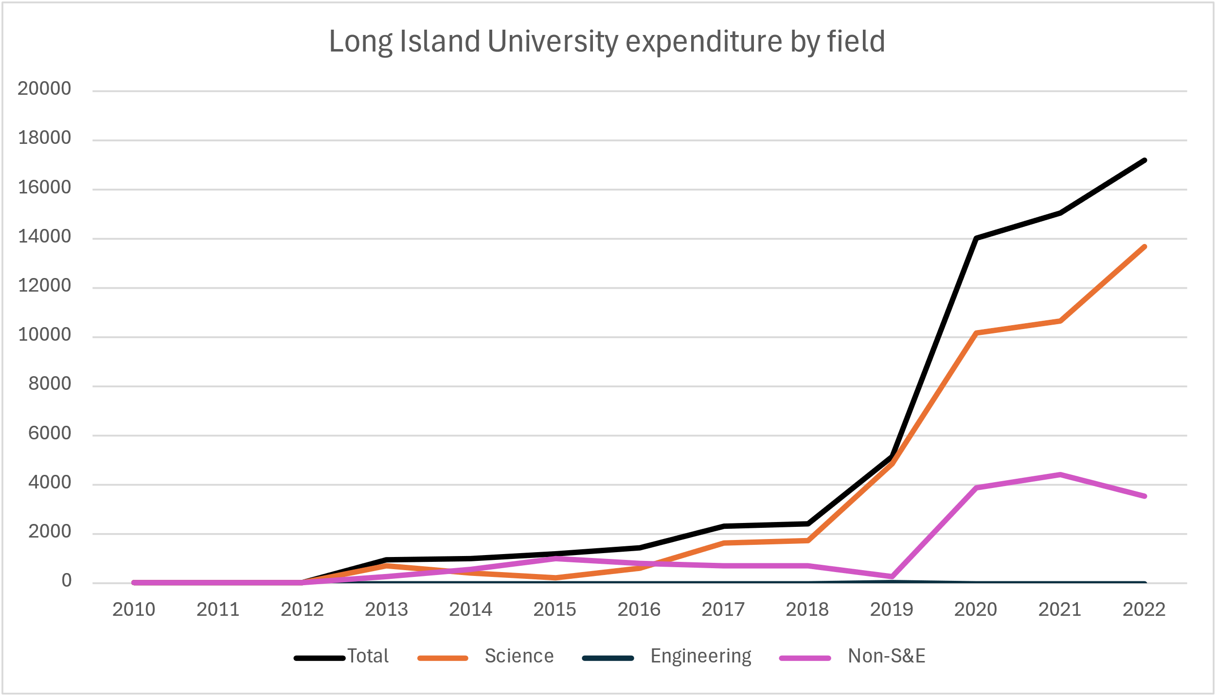 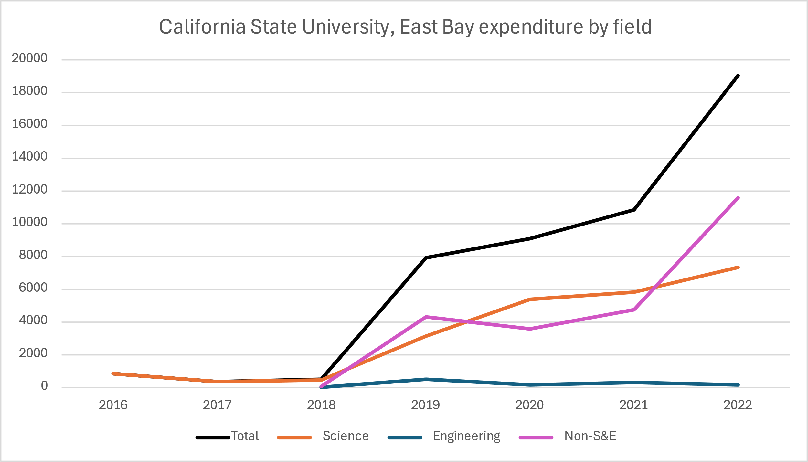

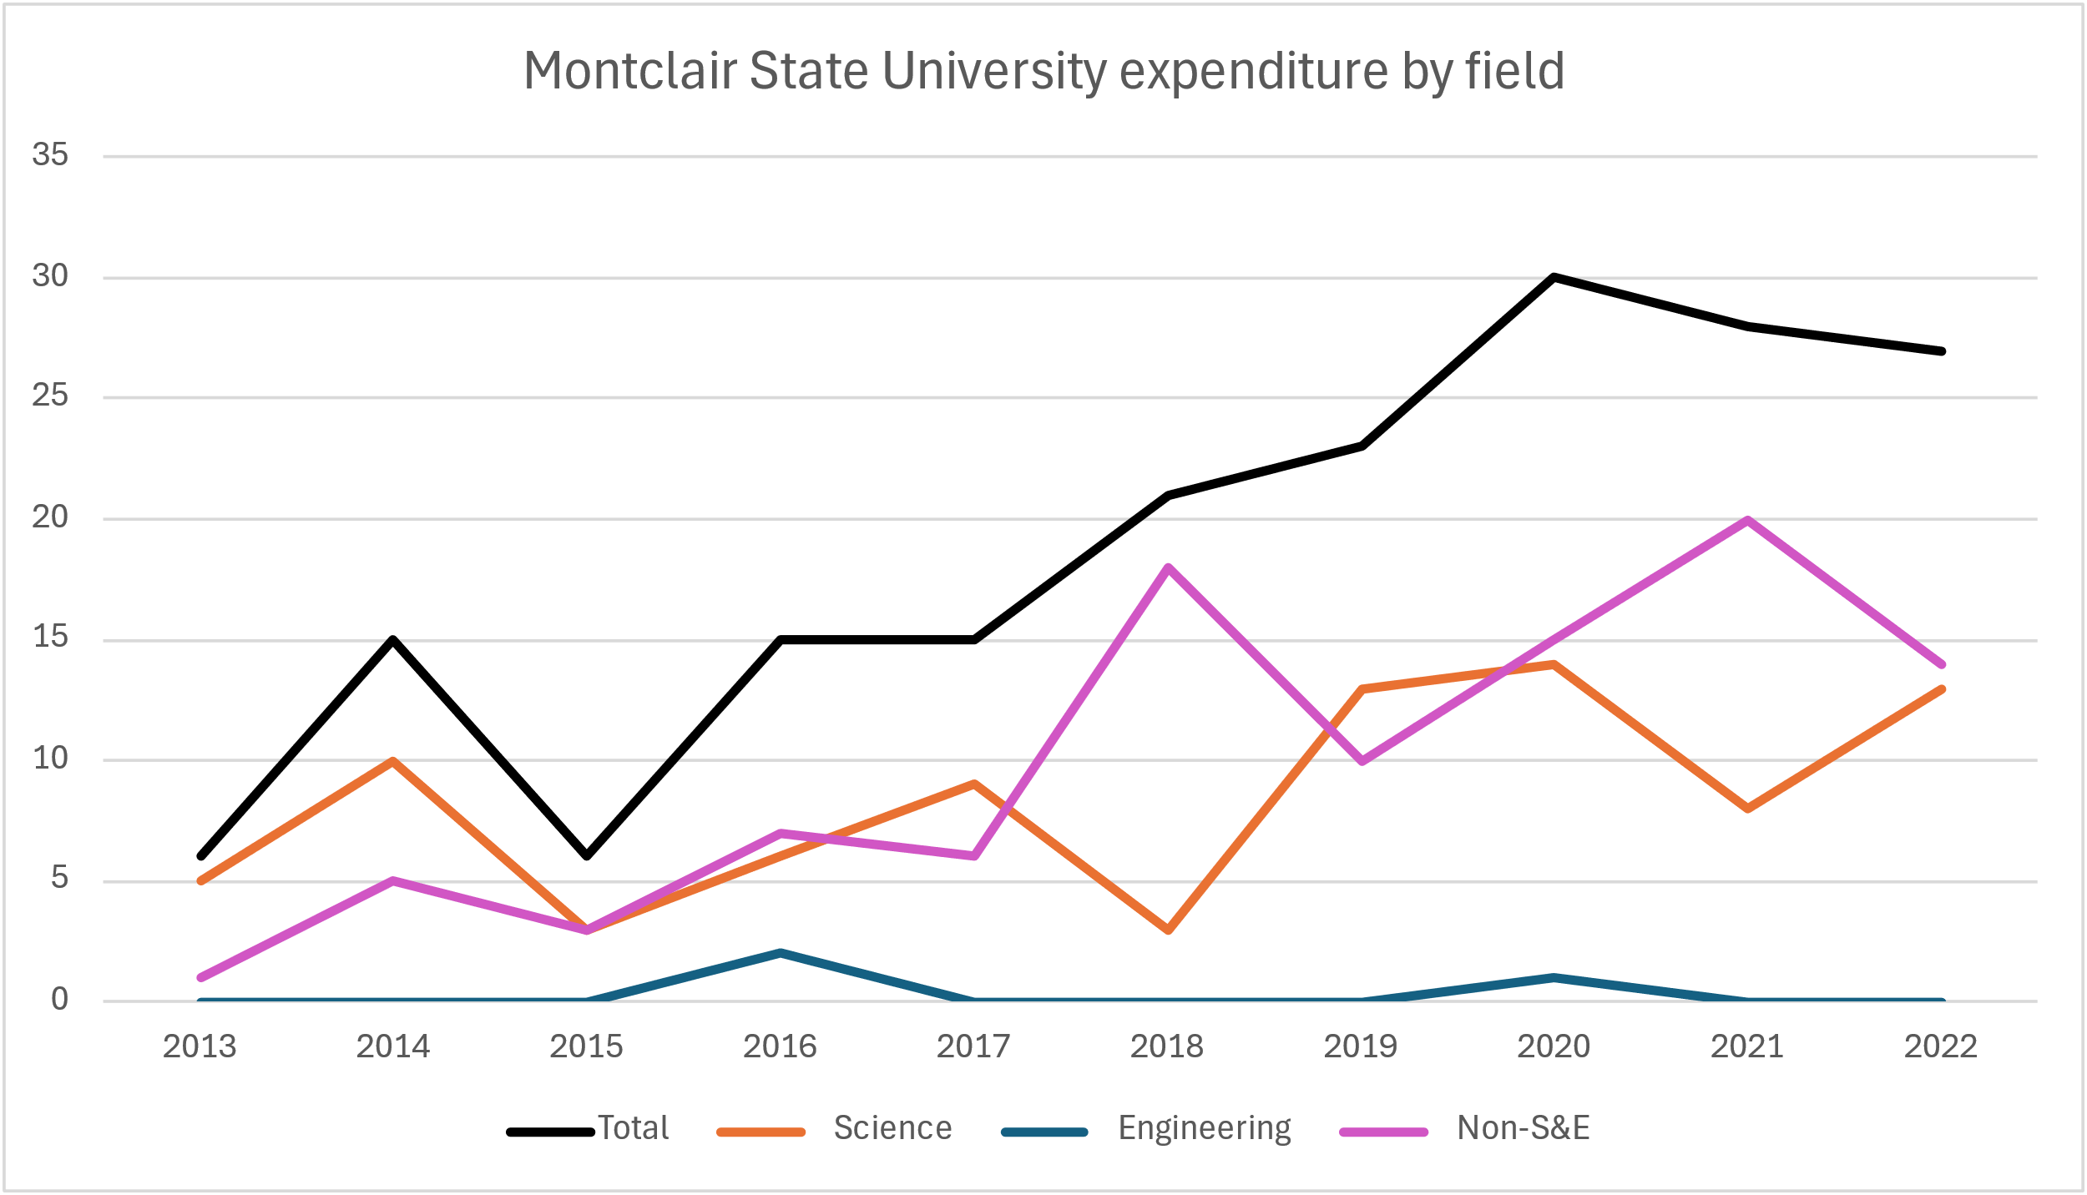 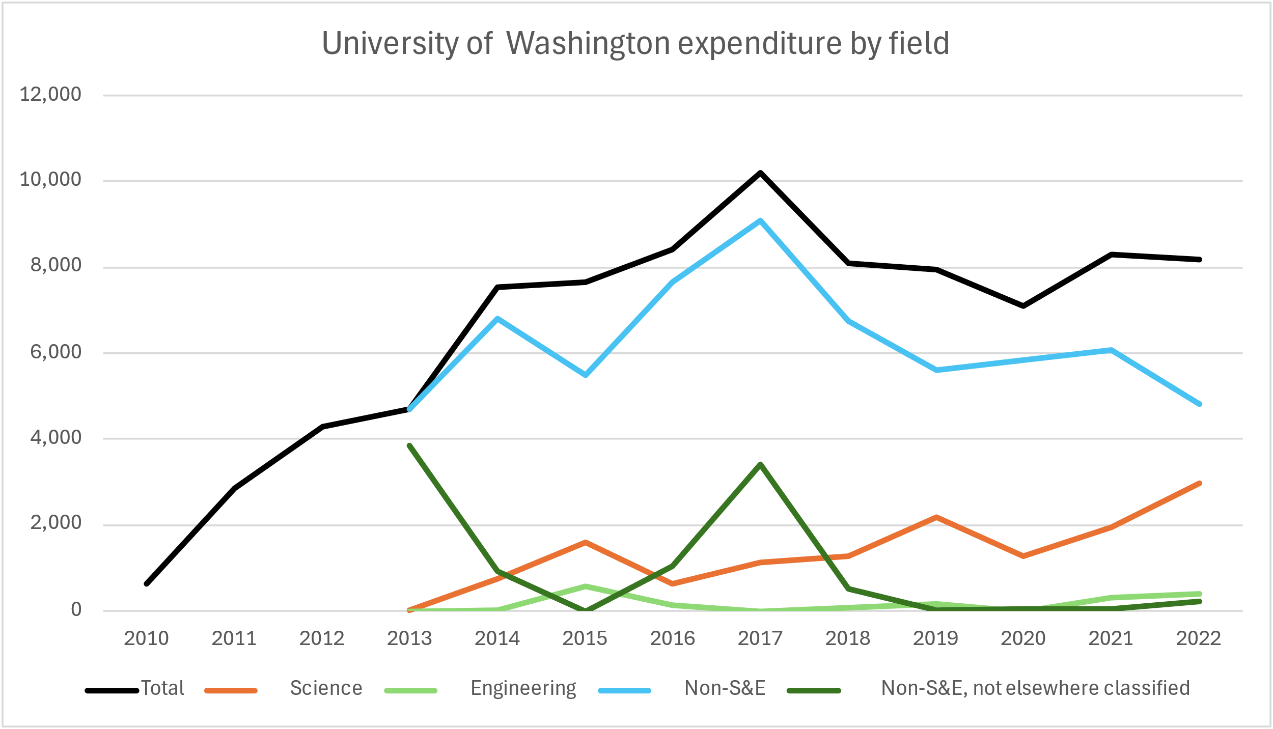 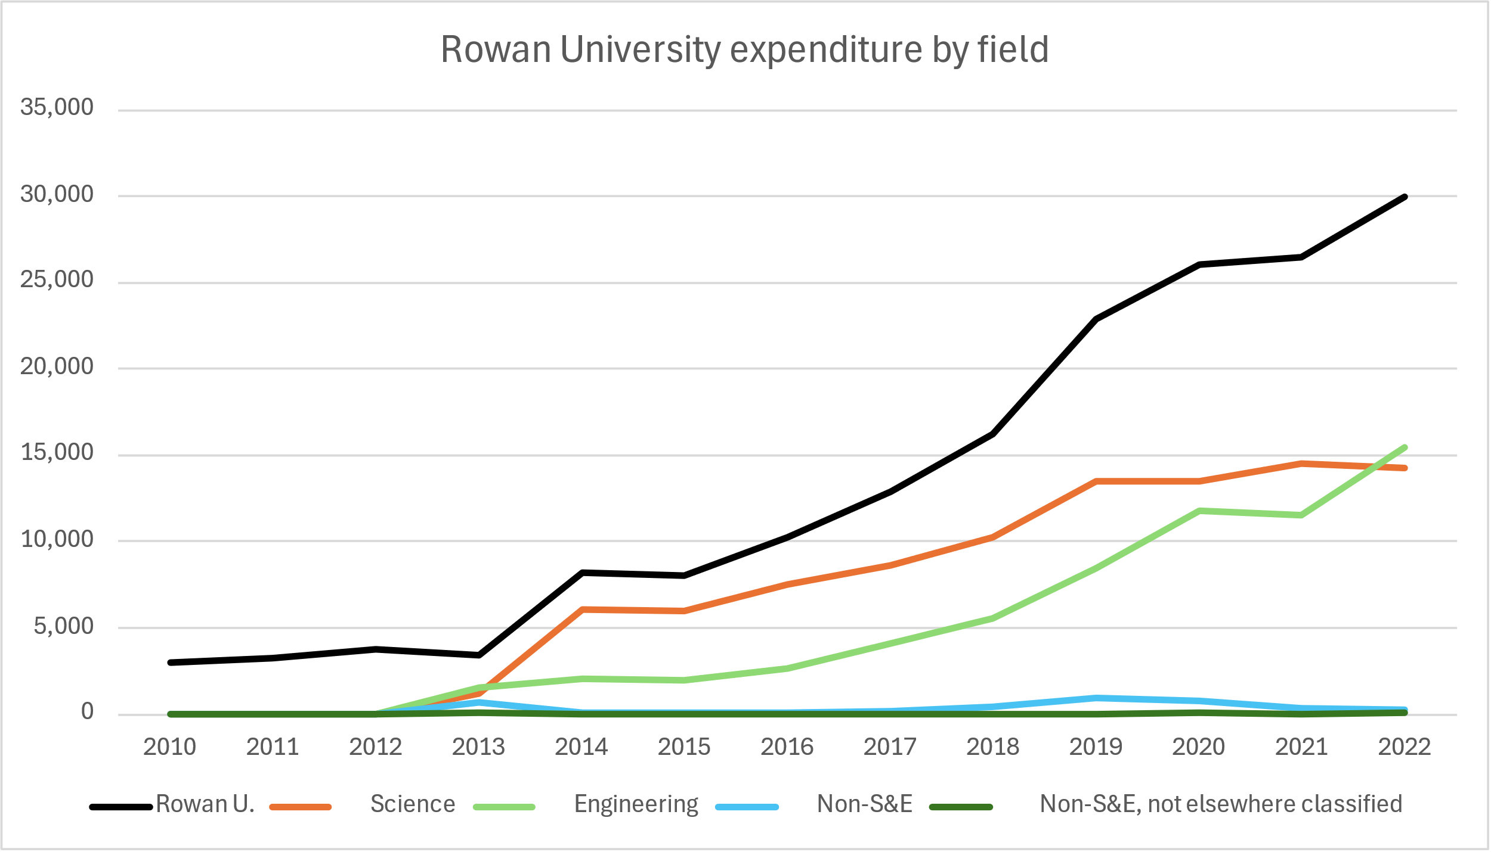 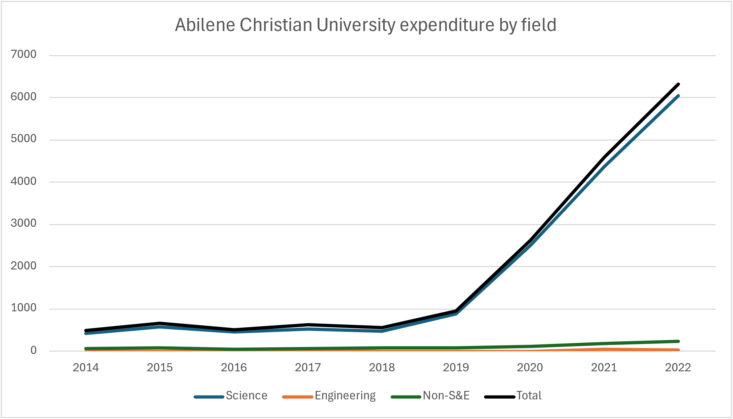

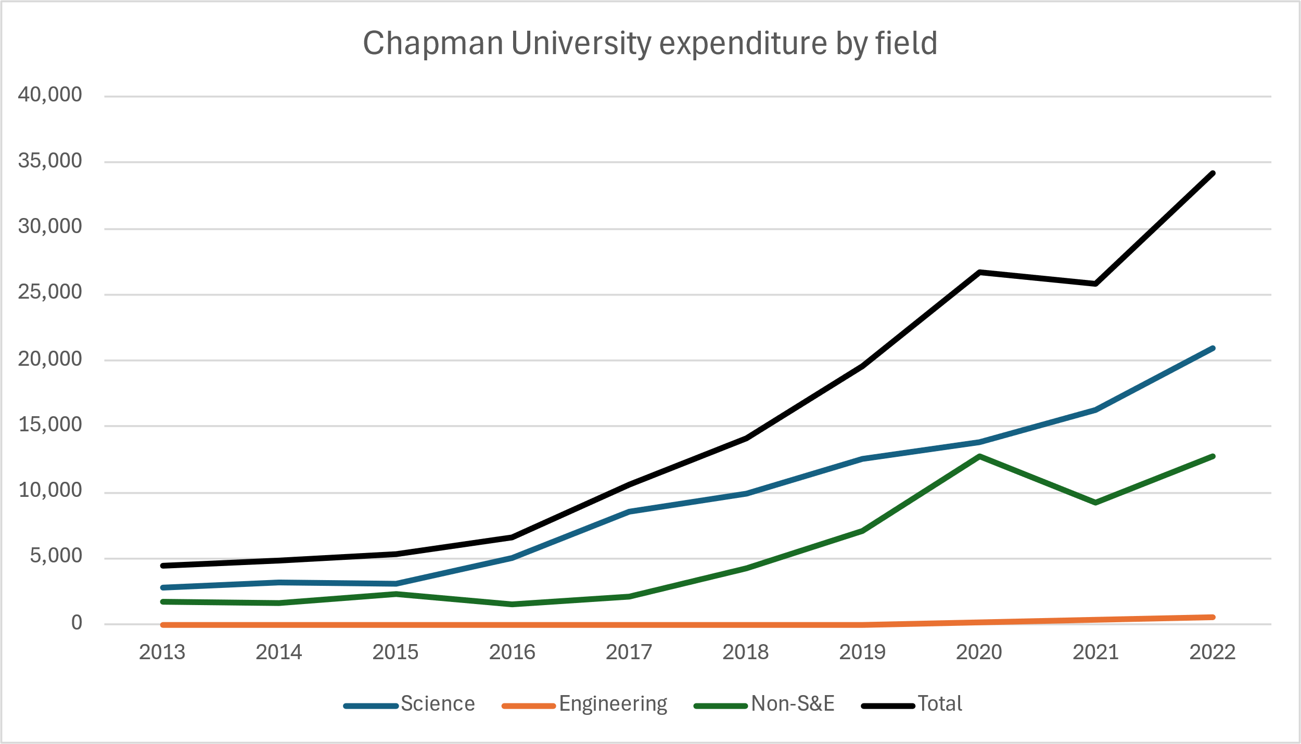 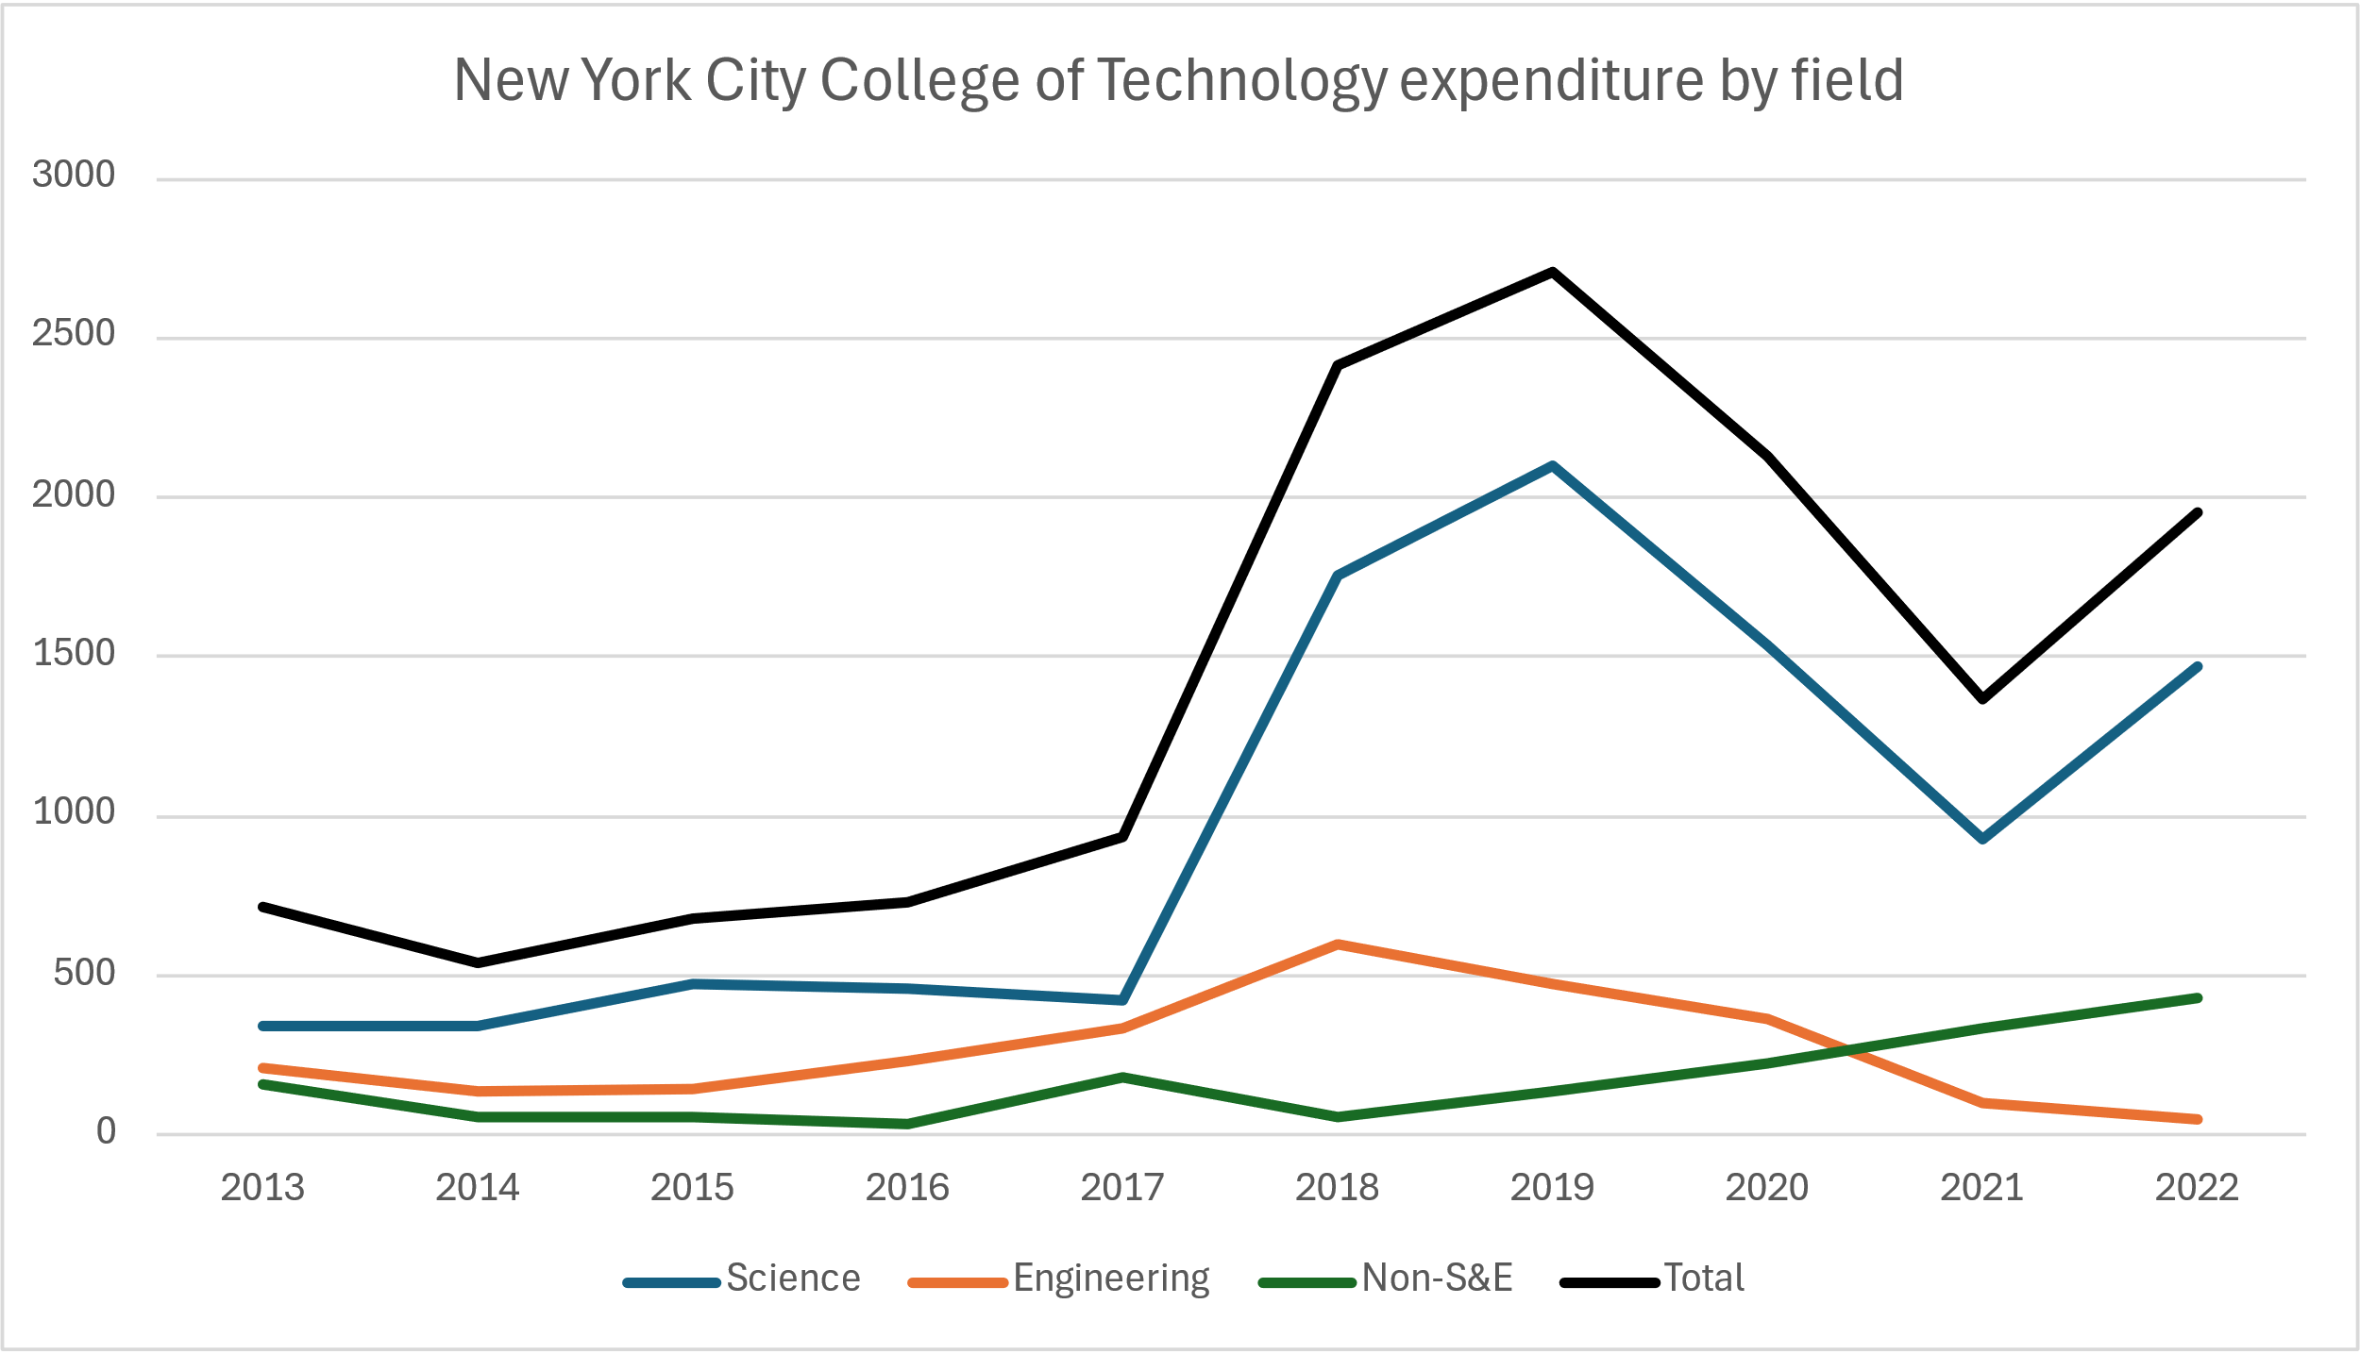

1. <https://news.web.baylor.edu/news/story/2024/baylor-raises-15-billion-concluding-history-making-give-light-campaign>