Neon Juan: There Can Only Be Juan
Game Design Document
(April 2014)

Creative Director
Stephen Dailey

Expected Completion
August 2014

Authors
Stephen Dailey
Shane Harrison
Lookmai Rattana
Mitchell Halman
Matt Hines

Copyright © 2014

Video Game Design and Development Club
Old Dominion University

Table of Contents

Introduction 3
Story 4
Characters 5
Juan: 5
Narrator: 5
Phil the TACO Truck Driver: 5
Bosses 5
Enemies 5
Level/environment design 7
Gameplay 9
Art and Style 10
Sound and Music 11
User Interface, Game Controls 12
Inspirations and References 13
Megaman X 13
Timesplitters 2 – NeoTokyo story level 13
Teenage Mutant Ninja Turtles 13

Introduction

This document is called a Game Design Document (GDD). GDDs are used in industry as a way for members of the development team to keep production organized. Additionally, the GDD is used as a type of contract between the development team and the producer. Artists, Designers, and Programmers will create this document and reference it during production. This hypothetically means any member of the club can edit this document. To keep organized however, this responsibility will be that only of the team leads. The document can contain paragraphs, images, or even flow charts.
Neon Juan is a project of the Video Game Design and Development Club. All aspects of this game will be created by the members of the club.

Story

Neon Juan: There Can Only Be Juan, is a story about the character of Juan. Juan has been framed by the “cyberpunk-style” government as the “most Juan-ted man in Mexico.” The government is named The Association of Corrupt Overlords (T.A.C.O).

Characters

Juan:
The main character. The player plays as Juan. Juan discovers the secret ingredient in T.A.C.O.'s products and fights to end T.A.C.O's evil scheme of mind control.

Narrator:
The narrator for the game. The narrator is characterized in the 3rd person omniscient.

Phil the TACO Truck Driver:
Phil is Juan's Step-brother and is part of the Gobierno or T.A.C.O. He is the man on the inside. Drops pickups. “Have Juan on the house.”

Bosses
- Chip and Potle
- T.A.C.O Executive
- Flying Sombrero
- Veleton
- Walking Taco
- Luchudora the destroya (Dora + Muscleman)
- Hot Tamale

Enemies
- Ninjas
- Beta Max
- TACO Worker
- Chupuracabra
- Generic Luchadors
- Juan Bots
- Mini Skeletons
- Futuristic Meriatchi Band
- Mutant Cacti
- Piñatas

Level/environment design

The game takes place at night on the rooftops of a large city. This city follows the portrayal of the future given by 1980's media. Bright, colorful, neon lights will surround the city, as well as advertisements. Although the setting is futuristic and modeled after representation of a cyber-Tokyo in various futuristic games, the nationality of the location is Mexican.
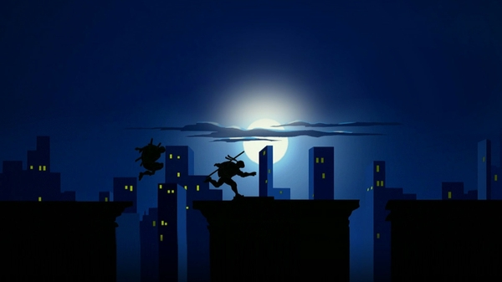
Figure 1: Teenage Mutant Ninja Turtles Rooftops

The game will be played on a single level. There will be one platform that is the rooftop of a building. The building will have almost nothing on it. Perhaps water towers, or heating units. The player will only have access to this one rooftop, however many other buildings can be seen in the background and surrounding area.
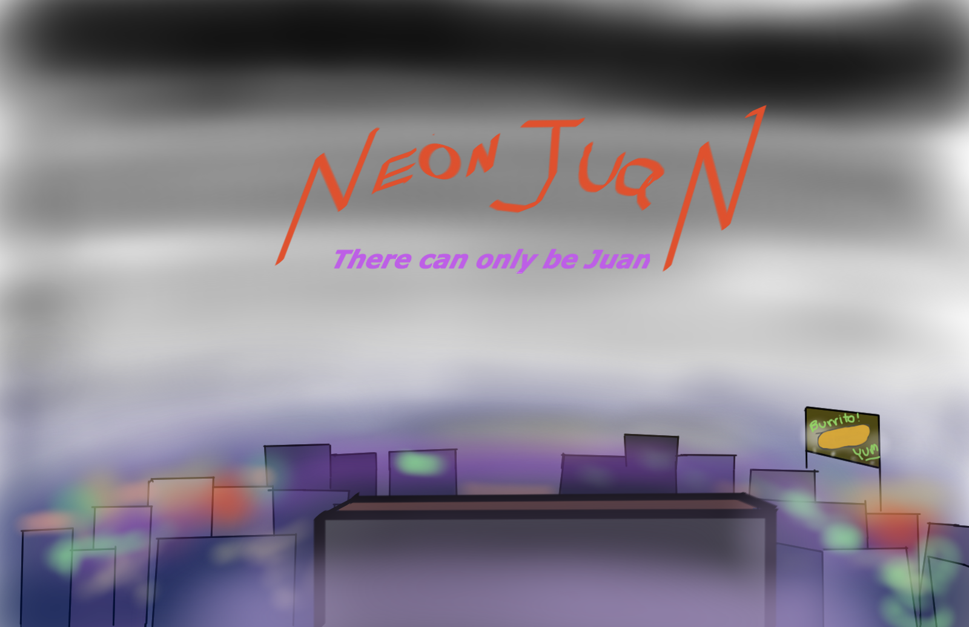
Figure 2: Initial level concept

Gameplay

Neon Juan will be a fast-paced beat'em up.
Juan's movements will be quick, and slick, similar to the gameplay of Megaman X once the player acquires the dash boots. During left and right movements, the player will hover in mid air like X and travel at a high rate. Juan will be able to jump three body lengths high and will be pulled back down to the ground very quickly. The jump should feel as if the player launches themselves into the air.
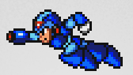
Figure 3: Dash example
Combat should flow and have synergy with the quick character movements. The player will use futuristic variations of weapons one might find in Mexico. The player will pull Laser guns and Laser swords seemingly out of nowhere. Punches and kicks will be powered up with neon glows.
Enemies will come from off camera and try to defeat Juan. This can happen in two different ways. The first is by depleting Juan's life energy by inflicting damage through combat. The second is by knocking Juan off the top of the building.
Power ups: Players receive power ups from Phil dropping down different edible power-ups. Also with each new skin the player receives comes new power-ups and attacks.
Health: With each hit, Juan's Mug Shot will increase in receiving injuries until a Game Over

Art and Style

The art is going to be one of the most important elements of Neon Juan. In order to capture the feel of the game setting as discussed in Section 4, lighting effects will need to be employed. The game will be in 2D, with parallax backgrounds.
Sound and Music
There will be an audible narrator who speaks in mainly Spanish. Otherwise, the narrator is making puns in English. Spanish voice will be accompanied by Japanese subtitles.
The background music for the game will be techno driven with a Mexican flare.
User Interface, Game Controls
The player will have a joystick and several buttons to execute combat maneuvers.

Inspirations and References

Megaman X https://www.youtube.com/watch?v=AISfltM4HRc
Timesplitters 2 – NeoTokyo story level https://www.youtube.com/watch?v=KVz5IqzeyMs

Teenage Mutant Ninja Turtles

