Pedro Gregorio

3/6/17

A7

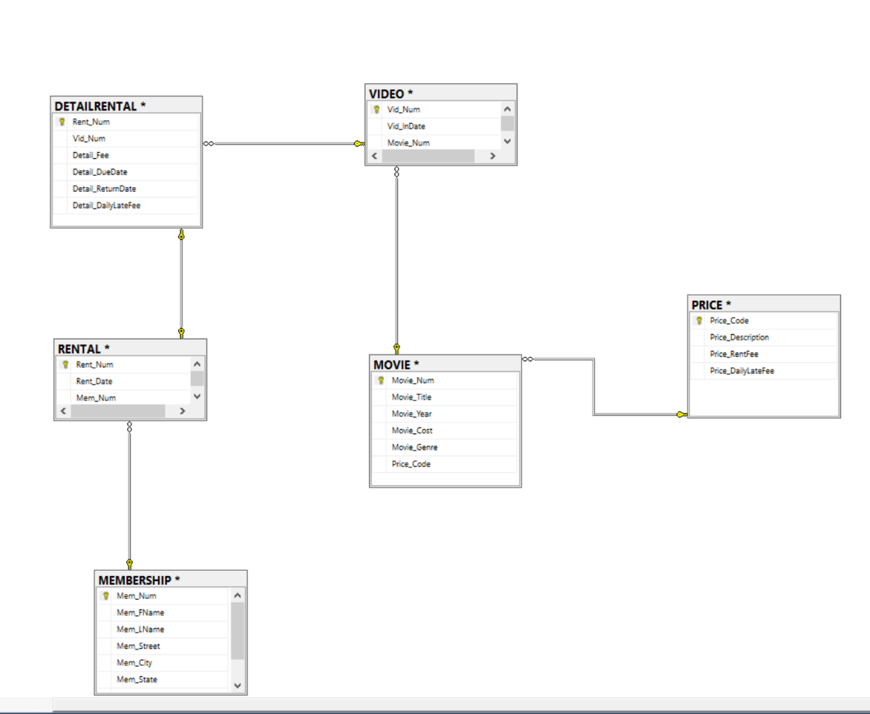

--103

SELECT MOVIE_TITLE, MOVIE_YEAR, MOVIE_GENRE

FROM MOVIE

--104

SELECT MOVIE_YEAR, MOVIE_TITLE, Movie_Cost

FROM MOVIE

ORDER BY Movie_Year DESC

--105

SELECT MOVIE_TITLE, MOVIE_YEAR, MOVIE_GENRE

FROM MOVIE

ORDER BY MOVIE_GENRE ASC, MOVIE_YEAR DESC

--106

SELECT MOVIE_NUM, MOVIE_TITLE, PRICE_CODE

FROM MOVIE

WHERE MOVIE_TITLE LIKE 'R%'

--107

SELECT MOVIE_TITLE, MOVIE_YEAR, MOVIE_COST

FROM MOVIE

WHERE Movie_Title LIKE '%hope%'

--108

SELECT MOVIE_TITLE, MOVIE_YEAR, MOVIE_GENRE

FROM MOVIE

WHERE MOVIE_GENRE = 'ACTION'

--109

SELECT MOVIE_NUM, MOVIE_TITLE, MOVIE_COST

FROM MOVIE

WHERE MOVIE_COST >= 40

--110

SELECT MOVIE_NUM, MOVIE_TITLE, MOVIE_COST, MOVIE_GENRE

FROM MOVIE

WHERE (MOVIE_GENRE = 'ACTION' OR Movie_Genre = 'COMEDY') AND MOVIE_COST <= 50

ORDER BY MOVIE_GENRE ASC

--111

SELECT Mem_Num, Mem_Num, Mem_Street, Mem_State, Mem_Balance

FROM MEMBERSHIP

WHERE MEM_STATE = 'TN' AND Mem_Balance < 5 AND MEM_STREET LIKE '%Avenue'

--112

SELECT MOVIE_GENRE, Count(Movie_Genre) as [Number of Movies]

FROM MOVIE

GROUP BY MOVIE_GENRE

--113

SELECT AVG(MOVIE_COST) AS [Average Movie Cost]

FROM MOVIE

--114

SELECT MOVIE_GENRE, AVG(MOVIE_COST) AS [Average Movie Cost]

FROM MOVIE

GROUP BY MOVIE_GENRE

--115

SELECT MOVIE_TITLE, MOVIE_GENRE, PRICE_DESCRIPTION, PRICE_RENTFEE

FROM MOVIE M, PRICE P

WHERE P.PRICE_CODE = M.PRICE_CODE

--116

SELECT MOVIE_GENRE, AVG(PRICE_RENTFEE) AS [Average Rental Fee]

FROM MOVIE M, PRICE P

WHERE P.PRICE_CODE = M.PRICE_CODE

GROUP BY MOVIE_GENRE

--117-------------------------------------------------------------------------------

SELECT MOVIE_TITLE, (MOVIE_COST / PRICE_RENTFEE) AS [Breakeven Rentals]

FROM MOVIE M, PRICE P

WHERE P.PRICE_CODE = M.PRICE_CODE

--118

SELECT MOVIE_TITLE, MOVIE_YEAR

FROM MOVIE

WHERE PRICE_CODE IS NOT NULL

--119

SELECT MOVIE_TITLE, MOVIE_GENRE, MOVIE_COST

FROM MOVIE

WHERE Movie_Cost BETWEEN 44.99 AND 49.99

--120

SELECT MOVIE_TITLE, PRICE_DESCRIPTION, PRICE_RENTFEE, MOVIE_GENRE

FROM MOVIE M, PRICE P

WHERE M.Price_Code = P.Price_Code AND Movie_Genre IN ('FAMILY', 'COMEDY', 'DRAMA')

--121

SELECT MEM_NUM, MEM_FNAME, MEM_LNAME, MEM_BALANCE

FROM MEMBERSHIP

WHERE MEM_NUM in (SELECT MEM_NUM FROM RENTAL)

--122

SELECT Min(MEM_BALANCE) AS [Mainimum Balance], Max(MEM_BALANCE) AS [Maximum Balance], AVG(MEM_BALANCE) AS [Average Balance]

FROM MEMBERSHIP

WHERE MEM_NUM IN (SELECT MEM_NUM FROM RENTAL)

--123

SELECT R.RENT_NUM, R.RENT_DATE, V.VID_NUM, M.MOVIE_TITLE, L.DETAIL_DUEDATE, L.DETAIL_RETURNDATE

FROM RENTAL R INNER JOIN DETAILRENTAL L ON R.RENT_NUM = L.RENT_NUM

INNER JOIN VIDEO V ON V.Vid_Num = L.VID_NUM

INNER JOIN MOVIE M ON V.Movie_Num = M.Movie_Num

WHERE L.DETAIL_RETURNDATE > L.DETAIL_DUEDATE

ORDER BY RENT_NUM, MOVIE_TITLE

--124

SELECT R.RENT_NUM, R.RENT_DATE, M.MOVIE_TITLE, L.DETAIL_FEE

FROM RENTAL R INNER JOIN DETAILRENTAL L ON R.Rent_Num = L.RENT_NUM

INNER JOIN VIDEO V ON V.Vid_Num = L.VID_NUM

INNER JOIN MOVIE M ON M.Movie_Num = V.Movie_Num

WHERE L.DETAIL_DUEDATE >= L.DETAIL_RETURNDATE

--125

SELECT MOVIE_NUM, MOVIE_GENRE, (SELECT AVG(MOVIE_COST)

FROM MOVIE

WHERE M.Movie_GENRE = Movie_GENRE) AS [AVERAGE COST], MOVIE_COST,

(SELECT (Movie_Cost - (SELECT AVG(MOVIE_COST)

FROM MOVIE

WHERE M.Movie_GENRE = Movie_GENRE)) /

(SELECT AVG(MOVIE_COST)

FROM MOVIE

WHERE M.Movie_GENRE = Movie_GENRE)) * 100 AS [PERCENT DIFFERENCE]

FROM MOVIE M

GROUP BY Movie_Cost, Movie_Genre, Movie_Num