# A10

# Pedro Gregorio

## Part 0

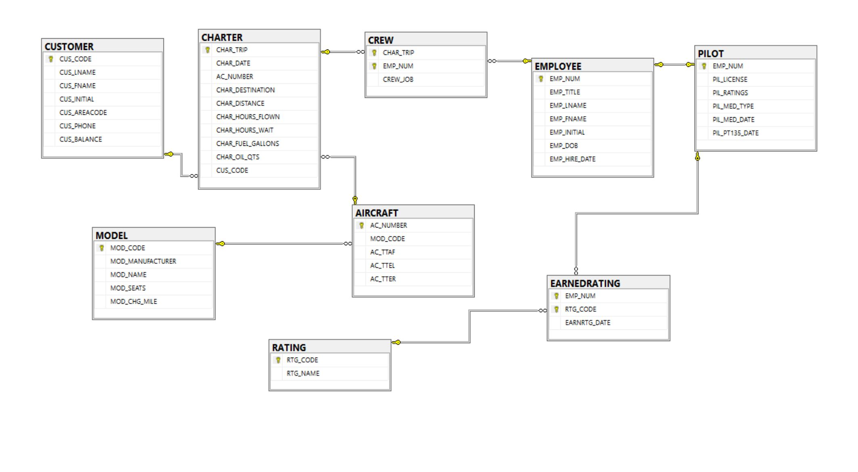

## Part 1

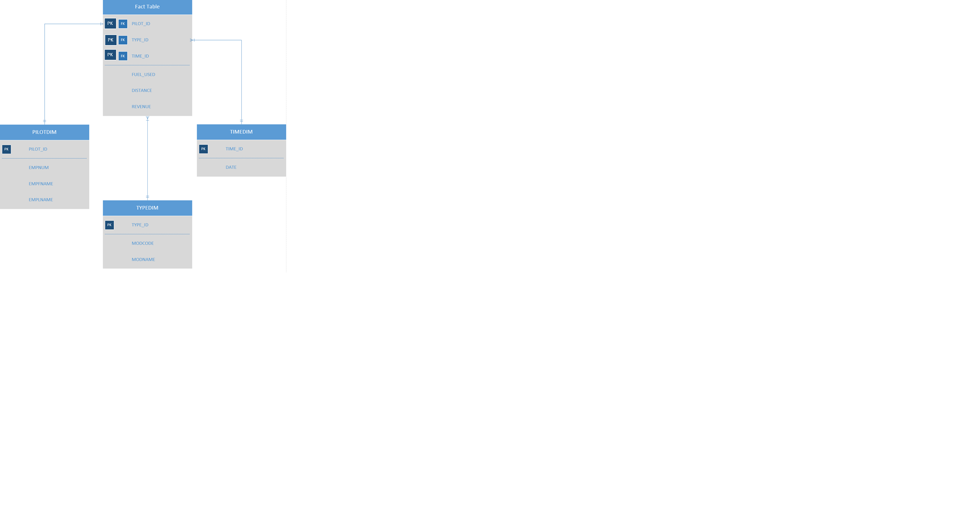

## Part 2

--MAKING THE WAREHOUSE (DIMENSION TABLES AND FACTTABLE)

CREATE TABLE FACTTABLE (

PILOT_ID INT,

TYPE_ID INT,

TIME_ID INT,

FUEL_USED float(8),

DISTANCE float(8),

REVENUE FLOAT(8)

);

CREATE TABLE TIMEDIM (

TIME_ID INT IDENTITY(1,1),

CHAR_DATE DATE,

);

CREATE TABLE PILOTDIM (

PILOT_ID INT IDENTITY(1,1),

EMP_NUM INT,

EMP_LNAME varchar(15),

EMP_FNAME varchar(15)

);

CREATE TABLE TYPEDIM (

TYPE_ID INT IDENTITY(1,1),

MOD_CODE varchar(10),

MOD_NAME VARCHAR(20)

);

-- ADD CONSTRAINTS TO THE DIMENSIONS AND FACT TABLE

ALTER TABLE TIMEDIM

ADD CONSTRAINT PK_TIMEDIM PRIMARY KEY (TIME_ID);

ALTER TABLE PILOTDIM

ADD CONSTRAINT PK_PILOTDIM PRIMARY KEY (PILOT_ID);

ALTER TABLE TYPEDIM

ADD CONSTRAINT PK_TYPEDIM PRIMARY KEY (TYPE_ID);

ALTER TABLE FACTTABLE

ADD CONSTRAINT FK_FACT_PILOTDIM FOREIGN KEY (PILOT_ID) REFERENCES PILOTDIM(PILOT_ID);

ALTER TABLE FACTTABLE

ADD CONSTRAINT FK_FACT_TYPEDIM FOREIGN KEY (TYPE_ID) REFERENCES TYPEDIM(TYPE_ID);

ALTER TABLE FACTTABLE

ADD CONSTRAINT FK_FACT_TIMEDIM FOREIGN KEY (TIME_ID) REFERENCES TIMEDIM(TIME_ID);

-- CREATE STAGING TABLE

CREATE TABLE STAGING (

PILOT_ID INT,

EMP_NUM INT,

TYPE_ID INT,

EMP_LNAME varchar(10),

EMP_FNAME varchar(10),

MOD_CODE varchar(10),

MOD_NAME varchar(25),

TIME_ID INT,

CHAR_DATE DATE,

FUEL_USED FLOAT(8),

DISTANCE FLOAT(8),

REVENUE FLOAT(8)

);

## Part 3

CREATE PROC A10

AS

BEGIN

-- DROP THE FOREIGN KEYS TO TRUNCATE

ALTER TABLE FACTTABLE DROP CONSTRAINT FK_FACT_PILOTDIM

ALTER TABLE FACTTABLE DROP CONSTRAINT FK_FACT_TYPEDIM

ALTER TABLE FACTTABLE DROP CONSTRAINT FK_FACT_TIMEDIM

-- TRUNCATE

TRUNCATE TABLE FACTTABLE

TRUNCATE TABLE PILOTDIM

TRUNCATE TABLE TYPEDIM

TRUNCATE TABLE TIMEDIM

TRUNCATE TABLE STAGING

-- BRING BACK THE FOREIGN KEYS

ALTER TABLE FACTTABLE

ADD CONSTRAINT FK_FACT_PILOTDIM FOREIGN KEY (PILOT_ID) REFERENCES PILOTDIM(PILOT_ID);

ALTER TABLE FACTTABLE

ADD CONSTRAINT FK_FACT_TYPEDIM FOREIGN KEY (TYPE_ID) REFERENCES TYPEDIM(TYPE_ID);

ALTER TABLE FACTTABLE

ADD CONSTRAINT FK_FACT_TIMEDIM FOREIGN KEY (TIME_ID) REFERENCES TIMEDIM(TIME_ID);

-- POPULATE THE DIM TABLES

INSERT INTO PILOTDIM (EMP_NUM, EMP_LNAME, EMP_FNAME)

SELECT P.EMP_NUM, EMP_LNAME, EMP_FNAME

FROM PILOT P INNER JOIN EMPLOYEE E ON P.EMP_NUM = E.EMP_NUM

INSERT INTO TIMEDIM (CHAR_DATE)

SELECT CHAR_DATE

FROM CHARTER

INSERT INTO TYPEDIM (MOD_CODE, MOD_NAME)

SELECT MOD_CODE, MOD_NAME

FROM MODEL

-- POPULATE STAGING TABLE

INSERT INTO STAGING (EMP_NUM, EMP_LNAME, EMP_FNAME , MOD_CODE, MOD_NAME, CHAR_DATE, FUEL_USED, DISTANCE, REVENUE)

SELECT P.EMP_NUM, E.EMP_LNAME, E.EMP_FNAME, M.MOD_CODE, M.MOD_NAME ,C.CHAR_DATE, C.CHAR_FUEL_GALLONS, C.CHAR_DISTANCE, SUM(C.CHAR_FUEL_GALLONS * M.MOD_CHG_MILE) AS REVENUE

FROM PILOT P INNER JOIN EMPLOYEE E ON P.EMP_NUM = E.EMP_NUM

INNER JOIN CREW CR ON CR.EMP_NUM = E.EMP_NUM

INNER JOIN CHARTER C ON C.CHAR_TRIP = CR.CHAR_TRIP

INNER JOIN AIRCRAFT A ON A.AC_NUMBER = C.AC_NUMBER

INNER JOIN MODEL M ON M.MOD_CODE = A.MOD_CODE

GROUP BY P.EMP_NUM, E.EMP_LNAME, E.EMP_FNAME, M.MOD_CODE, M.MOD_NAME ,C.CHAR_DATE, C.CHAR_FUEL_GALLONS, C.CHAR_DISTANCE

-- UPDATE ALL DW KEYS INTO THE STAGING TABLE

UPDATE STAGING

SET PILOT_ID = P.PILOT_ID

FROM STAGING S INNER JOIN PILOTDIM P ON S.EMP_NUM = P.EMP_NUM

UPDATE STAGING

SET TYPE_ID = T.TYPE_ID

FROM STAGING S INNER JOIN TYPEDIM T ON S.MOD_CODE = T.MOD_CODE

UPDATE STAGING

SET TIME_ID = T.TIME_ID

FROM STAGING S INNER JOIN TIMEDIM T ON S.CHAR_DATE = T.CHAR_DATE

-- POPULATE THE FACTTABLE USING THE STAGING TABLE

INSERT INTO FACTTABLE (PILOT_ID, TYPE_ID, TIME_ID, FUEL_USED, DISTANCE, REVENUE)

SELECT PILOT_ID, TYPE_ID, TIME_ID, FUEL_USED, DISTANCE, REVENUE

FROM STAGING

END

## PART 4

--List the names of pilots who have flown the most miles.

SELECT P.EMP_LNAME, P.EMP_FNAME, F.DISTANCE

FROM PILOTDIM P INNER JOIN FACTTABLE F ON P.PILOT_ID = F.PILOT_ID

WHERE F.DISTANCE = (SELECT MAX(DISTANCE)

FROM FACTTABLE)

--List the revenue by model and month in ascending order.

SELECT T.MOD_CODE, T.MOD_NAME,MONTH(TD.CHAR_DATE) AS MONTH, SUM(REVENUE) AS REVENUE

FROM FACTTABLE F INNER JOIN TYPEDIM T ON F.TYPE_ID = T.TYPE_ID

INNER JOIN TIMEDIM TD ON F.TIME_ID = TD.TIME_ID

GROUP BY MOD_CODE, MOD_NAME, MONTH(TD.CHAR_DATE)

ORDER BY SUM(REVENUE) ASC