AIM Modelling for NAVIGATE

## Presentation of the Aviation Integrated Model (AIM)

The Aviation Integrated Model (AIM) is a global aviation systems model which simulates interactions between passengers, airlines, airports and other system actors into the future, with the goal of providing insight into how policy levers and other projected system changes will affect aviation’s externalities and economic impacts. The model was originally developed in 2006-2009 with UK research council funding (e.g. Reynolds et al., 2007; Dray et al. 2014)[1], and was updated as part of the ACCLAIM project (2015-2018) between University College London, Imperial College and Southampton University (e.g. Dray et al., 2019)[2], with additional input from MIT regarding electric aircraft (e.g. Schäfer et al., 2018)[3]. The model is open-source, with code, documentation and a simplified version of model databases which omit confidential data available from the UCL Air Transportation Systems Group website[4]. AIM has been used for aviation policy and technology assessment in a wide range of contexts, including for the UK Department for Transport[5], EC DG CLIMA[6], and the International Energy Agency[7].

AIM uses a modular, integrated approach to simulate the global aviation system and its response to policy. The basic model structure is shown in Figure 1. AIM consists of seven interconnected modules. The Demand and Fare Module projects true origin-ultimate destination demand between a set of cities representing approximately 95% of global scheduled RPK[8], using a gravity-type model based on origin and destination population and income, average journey generalized cost, and other factors, as detailed in Dray et al. (2014). Within each city-city passenger flow, airport choice and routing choice (including hub airport for multi-segment journeys) are handled using a multinomial logit model. Itinerary choice is modelled as a function of journey time, cost, number flight segments, available flight frequency and characteristics of the origin and destination airports. This model is described further in Dray & Doyme (2019)[9]. Fares per individual itinerary are simulated using a fare model (Wang et al., 2017)[10] based on airline costs by type per segment, demand, route-level competition, low-cost carrier presence and other factors. These models are estimated primarily on detailed disaggregate global passenger routing and fare data from Sabre (2017)[11].

1. AIM model structure

AIM model structure.

The Airline and Airport Activity Module, given segment-level demand, assesses which aircraft will be used to fly these routes and at what frequency, using a multinomial logit model estimated from historical scheduling data (Sabre, 2017) and dividing the fleet into nine size categories. Given these aircraft movements per airport, a queuing model then estimates what the resulting airport-level delays would be (Evans, 2008)[12]. Given the lack of long-term airport capacity forecasts, in most cases this delay model is used to estimate the amount of (city-level) capacity that would be required to keep delays at current levels.

The aircraft movement module assesses the corresponding airborne routes and the consequent location of emissions. In particular, routing inefficiencies which increase ground track distance flown beyond great circle distance, and fuel use above optimal for the given flight distance, are modelled using distance-based regional inefficiency factors based on an analysis of radar track data, as discussed in Reynolds (2008)[13].

Given typical aircraft utilization, the aircraft technology and cost module assesses the size, composition, age and technology use of the aircraft fleet, and the resulting costs for airlines and emissions implications. First, aircraft movements by size class including routing inefficiency from the Aircraft Movement Module are input to a performance model (estimated from outputs of the PIANO-X[14] model with reference aircraft types and missions for CO2 and NOx, the FOX methodology (Stettler et al. 2013)[15] for PM2.5, and Wood et al. (2008)[16] for NO2). Second, the costs of operating this fleet for the given schedule are estimated based on historical cost data by category and aircraft type (Al Zayat et al, 2017[17]). Third, emissions and costs are adjusted to account for the current age distribution and technology utilization of the fleet, including typical retirement and freighter conversion behavior (e.g. Dray, 2013)[18]. Finally, any shortfall in aircraft required to perform the given schedule is assumed made up by new purchases, and the uptake of technology and emissions mitigation measures by both new aircraft and existing ones is assessed on a net present value basis, as described in Dray et al. (2018)[19], and the impact of this on costs and emissions is assessed.

These four modules are run iteratively until a stable solution is reached. Data is then output which can be used in the impacts modules, shown on the right of Figure 1. The global climate module is a rapid, reduced-form climate model which calculates the resulting climate metrics (e.g. CO2e in terms of global temperature potential (GTP) and global warming potential (GWP) at different time horizons; see Krammer et al., 2013[20]). The air quality and noise module are similarly rapid, reduced-form models which provide metrics by airport for the noise and local/regional air quality impacts of the projected aviation system. In the case of air quality, dispersion modelling for primary pollutants uses a version of the RDC code (e.g. Yim et al., 2015)[21]. The type of noise modelling carried out depends on whether data on standard flight routes per airport is available, but for all airports noise modelling based on total noise energy is carried out (Torija et al. 2016, 2017)[22]. The regional economics module looks in more detail at the economic impacts, including benefits such as increased employment as well as costing of noise and air quality impacts.

The output data from the first four AIM modules can also be used more generally as input to external impacts models: for example, the model includes the option to produce detailed emissions inventories which can be input into climate models. Further information on the individual sub-models, on model validation, and on typical model inputs and outputs can be found in the papers cited above and in the model documentatation.

## Use of AIM in NAVIGATE

A single AIM model run to 2100 can take several hours. As such, it is not possible to integrate AIM directly into multi-sector integrated assessment models. Instead, a metamodeling approach is taken here. We consider the most important factors affecting future aviation demand and emissions to be:

* Socioeconomic scenario (e.g. population, GDP, and potentially changes in attitudes to flying),
* Oil price,
* Carbon price, and
* Technology characteristics.

For each of these factors, we define a range of model inputs and carry out a grid of model runs using those inputs. These are discussed individually below.

### 2.1 Socioeconomic scenario

For socioeconomic scenarios, we use the widely-used IPCC SSP scenario set[23] rather than defining specific income and population scenarios to interpolate against ourselves. This allows more consistency with other modelling, which typically uses these scenarios. The SSP scenarios differ both in population and income and in the implied storyline about how much global effort is applied towards emissions reductions. For these model runs, we use population and income projections, but do not consider other components of scenario storyline; it is assumed that, where relevant, these will affect aviation sector outcomes via (user-specified) choices about carbon and oil prices, technology availability, and alternative fuels. For example, SSP1 involves relatively robust income growth under the assumption that nations work together to combat climate change. This income growth in turn, when used as an AIM input, drives robust demand growth and leads to SSP1 being scenario with typically a high demand for aviation fuel. Although there is the possibility (highlighted by the sector’s frequent omission from country-level targets and international agreements) that this fuel use remains dominated by fossil Jet A and aviation emissions continue to rise against a backdrop of falling emissions elsewhere, it is more likely that there would be significant use of alternative aviation fuels. The modelling of alternative fuels is discussed in ‘Using the AIM metamodel’, below.

For the AIM metamodel, we have currently included four user-selectable options for socioeconomic scenario:

* SSP1 (high economic growth, low population growth, implied robust global effort towards emissions reduction);
* SSP2 (‘business as usual’ type trends);
* SSP3 (Low economic growth and additional decoupling of demand growth from GDP growth[24]); and
* SSP4 (Relatively low economic growth with inequality between different world regions).

We omit the final SSP5 scenario (very high, fossil fuel-intensive economic growth) as, particularly in light of the Covid19 pandemic, the aviation demand projections resulting from SSP5 are above most literature projections, but this can be included in future if needed. Note that none of the model runs used include Covid19. AIM runs including Covid19 indicate that there may be some long-term impacts on aviation CO2 arising particularly from long-term offsets in economic growth; these could potentially be simulated by adjusting demand downwards or using a lower income growth socioeconomic scenario.

## 2.2 Oil and carbon prices

For oil and carbon prices, we carry out a grid of model runs at each combination of socioeconomic and technology scenario. Following an examination of historical oil prices and oil price projections, yearly average oil prices between $30/bbl (year 2015 US dollars) and $190/bbl are considered. For each grid model run, the oil price is assumed to remain constant at this value after a brief period of adjustment from base year values. Because TIAM generates its own estimates of aviation fuel price, for consistency we provide a routine which estimates the link between kerosene and oil price so that the grid of model runs can also be interpolated between using kerosene prices estimates. Similarly, because TIAM uses year 2005 dollars internally, we convert inputs to account for this.

For carbon prices, values of between $0/tCO2 (year 2015 US dollars) and $1000/tCO2 are considered. Carbon prices are assumed applied to all aviation CO2 in the metamodel input runs. It is notable that most policies which apply a carbon price to aviation at present (e.g. the EU ETS and ICAO’s CORSIA) do so only on CO2 above a baseline threshold and/or for a limited range of countries or type of flights. In this case the effective carbon price is much lower, but can be found straightforwardly using the metamodel by calculating the amount of emissions above the baseline and reducing the carbon price supplied to the metamodel per country and/or type of flight accordingly.

## 2.3 Technology characteristics

Modelling aviation emissions to 2100 requires an estimation of how aircraft technologies will develop to 2100. This is extremely uncertain and, in order to generate the AIM metamodel, we make several simplifying assumptions here.

First, it is possible that there may be a radical shift in aviation technology over the next 80 years. In particular, there is the possibility of a shift to electric or hydrogen-powered aviation. Following a review of available literature, we assess that both of these shifts, though possible, are not the most likely route for large-scale aviation decarbonization. For all-electric aircraft, range limitations mean that initial potential is limited to small aircraft and short-haul routes only, strongly limiting the amount of aviation fossil fuel that can be substituted even by 2070[25]. Further expanding electric aircraft range would require new battery chemistries that are not currently in use. While hydrogen-powered aviation has attracted renewed interest recently, most notably from Airbus[26], a hydrogen-fueled aviation system would require substantial infrastructure provision, widespread fleet replacement, and significant cost barriers. As such, it is more likely that changes in aircraft fuel source will come via the adoption of drop-in alternative fuels, either biofuels or Power-To-Liquids (PTL); in a future hydrogen economy, we assume that green hydrogen would be used in drop-in PTL fuel production rather than being directly burnt in adapted aircraft engines. These fuels can be used in existing aircraft which, given the 30+ year lifetime of a typical aircraft, is a significant advantage. Future scenarios for aviation decarbonization which include significant use of drop-in fuel include those developed by the IEA[27]. Other scenarios, including the UK CCC’s recent Net Zero report[28], anticipate increased use of drop-in alternative aviation fuel but also significant remaining use of aviation fossil fuel which is offset via reductions in other sectors. We therefore assume that the most likely technology shift away from fossil fuels in aviation is likely to come via drop-in fuels, and do not model hydrogen or electric aircraft in detail.

Second, we need to evaluate how other aircraft technologies and operational strategies are likely to change to 2100. Because AIM estimates whether airlines will adopt new technologies based on the associated costs, this includes estimates of the costs associated with each technology. Typically, new generations of aircraft models become available every 15-20 years, with a fuel economy benefit of around 20% over their predecessors. Additional changes in operations (e.g., shifts to higher load factor and longer-haul flights) and increasing system efficiency have led to average yearly improvements in fuel use per revenue passenger-km (RPK) flown of over 2% since 1980. Typical aircraft in the most recent generation of aircraft models include the Airbus A320neo and Boeing 737MAX. If historical behavior is maintained, the next generation of new aircraft models is expected sometime in the 2030-35 time period, with a subsequent generation around 2040-50. A comprehensive evaluation of the technologies on these aircraft and their associated costs was carried out by ATA & Ellondee (2018)[29] for the UK DfT and CCC. Table 1 shows their assessment of likelihood, entry into service date, and fuel use benefits for some key airframe and engine technology options. In general, the report considers Ultra-high bypass ratio engines, increased wing aspect ratio, and increased use of composite materials most likely developments for the next generation of aircraft. For the subsequent generation, there is the possibility of hybrid electric aircraft designs as well as further refinements of the previously-mentioned airframe and engine technologies. Improvements in operations are most likely to come via electrification of taxiing and air traffic management improvements, as shown in Tables 2 and 3. Each of these technologies has some level of uncertainty both in the amount that it is utilized on future aircraft, and in the amount that it can reduce fuel use for a given aircraft that it is utilized on.

Table 1. Airframe and engine technology potential on the next two generations of aircraft, from ATA & Ellondee (2018).

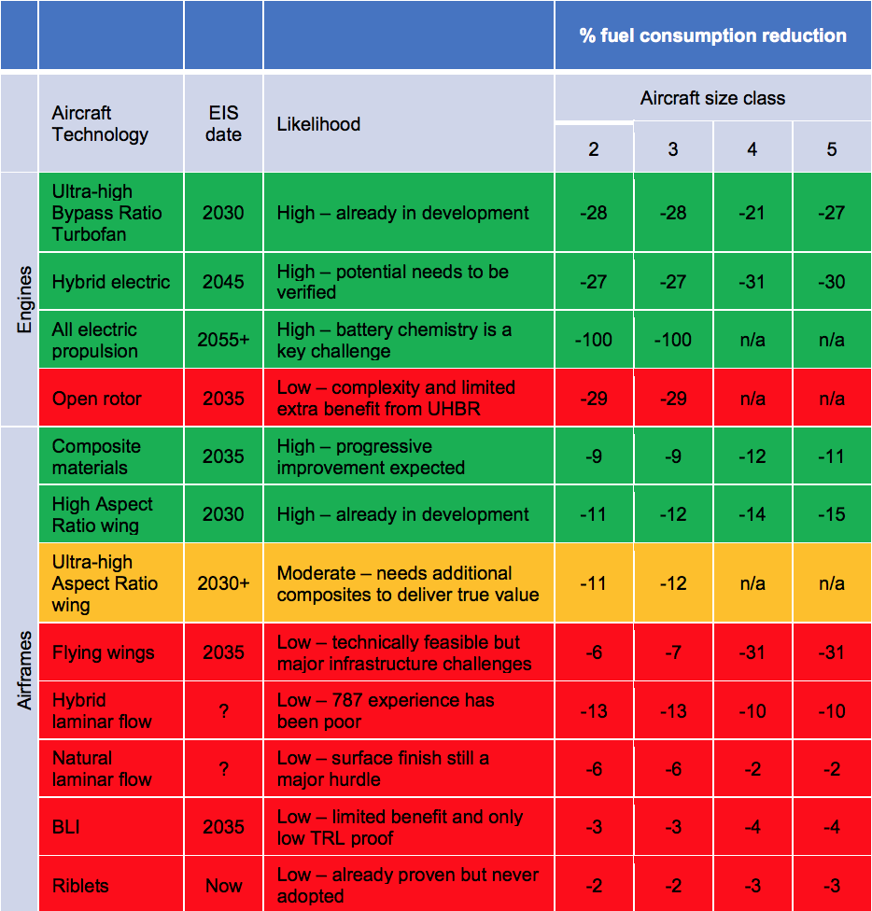

Figure 1 shows how these technology potentials combine for the 2045-2050 generation of aircraft, in comparison to present-day aircraft (e.g. the Airbus A320ceo or Boeing 777). For these technology characteristics, we include three different technology scenarios (1, 2 and 3) based on the given uncertainty range across technology availability and potential. Technology scenario 2 represents the ‘most likely’ judgement of how technology potential and costs will develop. Technology scenario 1 represents the case where technologies are available on the early end of the time range expected, with benefits on the high end of those anticipated, and costs on the low end, i.e. am ‘optimistic’ technology case. Conversely, technology scenario 3 represents a ‘pessimistic’ case in which tcehnologies are later than anticipated, have higher costs and lower benefits. All technology potentials are adapted to the AIM set of size classes and reference aircraft, which differ from those used in ATA and Ellondee (2018).

Table 2. Operational measure potential for current and future aurcraft, from ATA & Ellondee (2018).

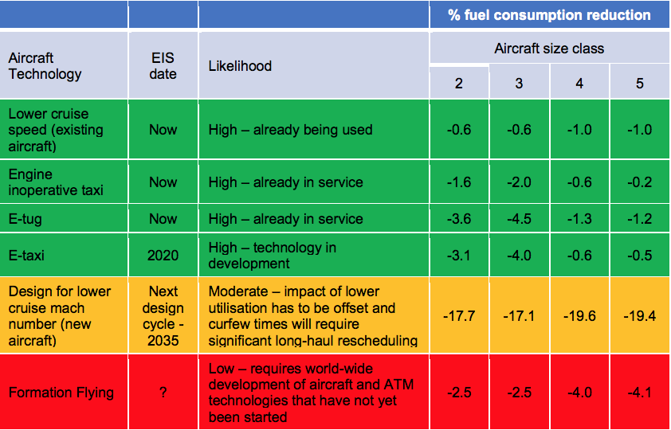

Table 3. Potential for reductions in fuel use via improved air traffic control, from ATA and Ellondee (2018).

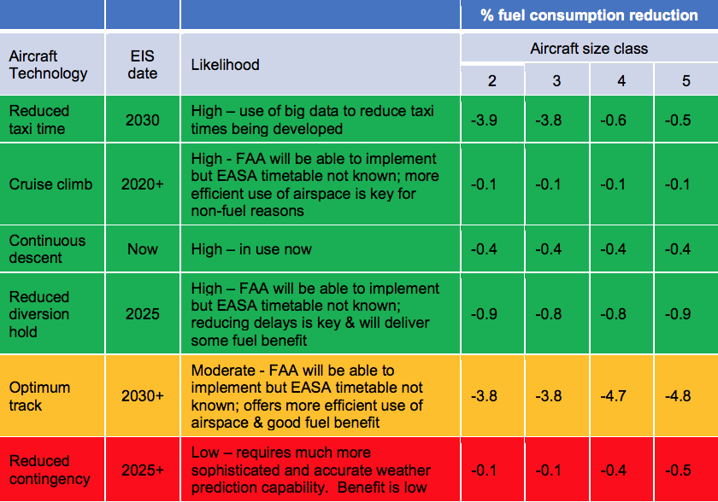

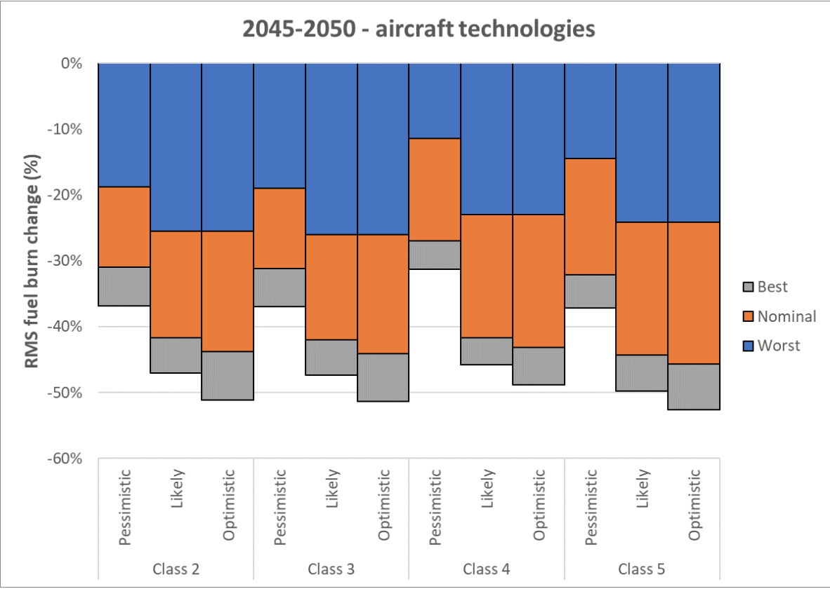

Figure 1. Fuel burn change of the 2045-2050 aircraft generation in comparison to typical current aircraft, from ATA & Ellondee (2018). The aircraft classes shown are those used by the DfT and range from small single aisle aircraft (Class 2) to Very Large Aircraft (Class 5).

After 2050, several further generations of aircraft are likely before 2100. For these aircraft, it is less feasible to examine the specific technologies that are likely to influence their design. Instead, we assess their capabilities by looking at long-term trends in fuel use and costs, and comparison with industry goals. Relevant system goals include:

* ACARE (Flightpath 2050)[30]: 75% reduction in CO2 per RPK, 90% reduction in NOx and 65% reduction in perceived noise by 2050, compared to typical new aircraft.
* ICAO’s carbon standard; as noted by ICCT (2017)[31], the main current purpose of this standard is to prevent backsliding in technology development. However, it is feasible that it could be strengthened in future.
* IATA[32] long-term targets: net 50% reduction in aviation CO2 by 2050 compared to 2005, with aspirational 2%/year improvement in fuel efficiency.

Based on estimated technology potential between the past generation of aircraft and those available in 2050, we assume a range of percent/year improvements in new aircraft fuel economy between 0.5% and 1.3% depending on aircraft size and technology scenario. These are separate from benefits achievable via the adoption of operational measures, for which the benefits and costs are assumed the same as for the previous generation of aircraft. These trends are used to estimate the characteristics of aircraft generations to 2100 by technology scenario.



Figure 2. Fleet by socioeconomic scenario and technology assumptions over time showing different aircraft generations, for a single grid point on the oil/carbon price grid.

Figure 2 shows global fleet by aircraft generation over time for a single point on the oil/carbon price grid and different assumptions about socioeconomic and technology scenario. ‘Neo’ refers to the most recent generation of aircraft as represented by the Airbus A320neo. ‘NextGen 1’ and ‘NextGen 2’ are the two subsequent generations where technology characteristics are modelled in detail. ‘FF1’ – ‘FF3’ are post-2050 aircraft generations whose characteristics are modelled using yearly improvement trends. Note that nonzero numbers of current-technology aircraft beyond 2050 are typically small turboprop aircraft purchases in cases where it is cost-effective to substitute turboprops for small regional jets; although there are relatively many of these aircraft, they account for only a small percentage of global RPK and do not have a significant impact on global emissions.



Figure 3. CO2 per RPK trends by aircraft size to 2100 resulting from aircraft technology assumptions, for the SSP2 socioeconomic scenario and mid-range oil and carbon prices.

Figure 3 shows how typical fleet-level CO2 per RPK flown varies over time to 2100 with these scenarios, for the SSP2 socioeconomic scenario, mid-range oil and carbon prices, and no alternative fuel. Background shaded areas show the amount of variation that would be expected for 1%, 2% and 3%/year average reductions in CO2/RPK; different lines show different aircraft size classes (VLA/LTA = Very Large Aircraft/Large Twin Aisle; MTA = Medium Twin Aisle; STA = Small Twin Aisle; LSA = Large Single Aisle; MSA = Medium Single Aisle; SSA = Small Single Aisle; LRJ = Large Regional Jet; SRJ = Small Regional Jet). Note that Small Twin Aisle aircraft have a higher trend than other aircraft types mainly because the AIM reference aircraft in that size category is already very fuel-efficient. Initial rates of improvement are higher across all size classes because improvements in load factor and air traffic management are assumed to come into operation over this time period.

These trends in fuel use per RPK are somewhat dependent on other model input variables. For example, high demand growth rates such as in the SSP1 model runs typically translate into a fleet that is more fuel efficient (on average) because on average the fleet is younger; low demand growth rates are associated with older, smaller and less fuel-efficient fleets. High oil and carbon prices are associated with more adoption of technologies that reduce fuel use and emissions.

## **The AIM NAVIGATE metamodel**

For use in the NAVIGATE project, we use the outputs of the AIM run grid to generate an interpolation-based metamodel. The metamodel is tailored to take inputs that are compatible with those used internally in TIAM. It takes as input the socioeconomic scenario (e.g. ‘SSP2’), technology scenario (e.g. ‘t2’), year (e.g. 2100), regional kerosene price (e.g. $/kg in year 2005 USD), carbon price (e.g. $/kgCO2 in year 2005 USD) and TIAM region (e.g. ‘AFR’……). For each modelled country in the given region and aviation scope (international/domestic) the metamodel interpolates within grids of aviation output metrics from the AIM grid runs to produce rapid outputs. For compatibility with other model base years that it may be used with, the AIM metamodel can be run from 2005. This uses a mixture of AIM inputs from two different base years (2005 and 2015) and, for the time period to 2017, the metamodel assumes inputs are consistent with actual historical trends (i.e., we do not simulate a grid of different values for years before 2017 and so the model cannot be used for historical counterfactual simulation). The interpolation model takes up to a minute to read in model data (anticipated to be done once at the start of each run), but can produce interpolated model outputs to 2100 in a few seconds. This is in comparison to a full AIM run to 2100, which can take several hours.

The region specification can be varied straightforwardly by adjusting the associated country-region lookup file in the aviation data directory. The model also be run in two modes: ‘basic’ returns only international and domestic aviation fuel use by region, whereas ‘full’ returns a much wider selection of variables including number of flights by type, passengers, passenger-km, freight-tonne-km, NOx and aircraft-km, each divided into international and domestic. It is anticipated that the metamodel will be used as part of various feedback loops in which the response of aviation fuel demand to changes in other variables may need to be queried multiple times. An example slice of the grid data which is interpolated over is given in Figure 4.



Figure 4. Year-2050 global aviation fuel use grid over the full range of oil and carbon prices used, for the SSP2 socioeconomic scenario with central technology assumptions.

Figure 5 shows a comparison of global metrics for full AIM runs and metamodel runs with the same inputs to 2100 for the four main socioeconomic scenarios modelled. For testing, these use a version of the model in which oil price is used as the interpolation variable, as in the main version of AIM, so that outputs can be directly compared. Note, in this case the test runs shown all assume 2%/year increase in oil price and 3%/year increase in carbon price from a $20/tCO2 year 2020 value (in the original AIM model as well as in the NAVIGATE parametric module). Global metrics are obtained by running the model across all world regions and summing totals; note that in turn the underlying interpolation is done on a country level with regional data produced by aggregating country totals.



Figure 5. Comparison of AIM runs (‘AIM’) and the AIM NAVIGATE metamodel (‘NAV’) for a range of aviation metrics to 2100 and test oil and carbon price trends.

The fit is not exact because interpolating in this way misses time lag effects such as the effect on the current fleet of past fuel prices, and fuel price hedging (included in the original AIM model). These effects will be more pronounced in scenarios with rapid and large variations in fuel price. However, accounting for time lag effects such as this would significantly increase parametric model complexity and run time, and the difference between the full model and metamodel runs remains tiny compared to the uncertainty level due to variations in demand or technology.

* 1. Using the AIM NAVIGATE metamodel

Currently, the model is supplied as two Python code files and a set of associated data tables. These routines also contain extensive comments on how they function and on the definition of different variables. Each model run requires two separate components. First, the data tables are read in. Second, each time the main IAM using the aviation metamodel requires aviation metrics, the interpolation model is run.

***Model_Aviation_NAVIGATE.py*** is a routine which runs the aviation model in standalone mode, for a given set of parameters (socioeconomic scenario, technology scenario, fuel price, carbon price).  *Model_Aviation_NAVIGATE.py* reads in the data file appropriate for the specified socioeconomic and technology scenarios, simulates global-level aviation metrics between 2005 and 2100 for the given fuel and carbon price given by the IAM, and writes these metrics to a CSV file. Within this routine the user chooses the SSP (1 to 4) and technology level (1 to 3) chosen for the study as well as the number of outputs from the metamodel: only fuel consumption (0) or the full set of results (1 = consumption, RPK, NOx…). The number of output has an impact on the speed of the metamodel.

***Functions_Aviation_NAVIGATE.py*** contains the functions necessary to run the model. There are two separate components: initial data read-in (as this is slow, the intention is that this is done once at the start of a model run and then the data tables are stored in memory and passed to the aviation model each time it is run) and the metamodel itself.

The functions ***Read_Grid***, ***Read_Price*** and ***Read_Country_Lookup*** are intended to be run at the start of a model run to read in the grid data, the fuel and carbon prices and the regional representation of the IAM. *Read_Grid* reads in interpolation data for a given filename (associated with a given socioeconomic and technology scenario) and run mode (i.e., basic or full). *Read_Price* read the fuel and carbon price for each regions. *Read_Country_Lookup* reads a lookup file of country to region. The grid/price/region files are in the directory *aviation_grid_data*. Within this directory, the file *Prices_KerCO2.csv* contains the fuel and carbon prices resulting from the IAM results.

The function ***Interpolate_Outcomes*** should be run during a model run to get aviation fuel use and potentially other parameters for a given region and year. It takes as input the model year, the world region code to be modelled (e.g. “AFR”), the regional kerosene price **in year 2005 US dollars per kg** (can be oil based or blends of oil-based/bio/synthetic), the carbon price for that region (assumed to apply to all aviation direct CO2, see below for how to use this to model different policies) **in year 2005 US dollars per kg CO2**, and the matrices base_grid and country_lookup which are functions of the given socioeconomic and technology scenario and are read in at the start of each model run by the read-in routines above.

Before 2017, Interpolate_Outcomes returns the same values regardless of what fuel and carbon price are input to it. These values are based on the aviation model output for historical GDP, population, fuel and carbon price inputs (2005-2014 are derived from a base year 2005 run). After 2017, Interpolate_Outcomes interpolates output based on a grid of the aviation model runs (extrapolating for values outside that range).

If Interpolate_Outcomes is run in simple mode, it outputs a two-element array per world region containing domestic and international fuel use (in Mt). In full mode, it will output a 16-element array containing: domestic fuel (in Mt); international fuel (in Mt); domestic Revenue-Passenger-Kilometres or RPK; international RPK (in Passenger.km); domestic hold freight (Revenue-Tonne-Kilometres or RTK); international hold freight; domestic freight in freighters (RTK); international freight in freighters (RTK) (in Ton.km); domestic passenger flights; international passenger flights; domestic freighter flights; international freighter flights (in number of flights); domestic NOx; international NOx (in kt(NO2)); domestic aircraft-km; international aircraft-km (in Aircraft.km).

* 1. ﻿Simulating alternative fuels and carbon pricing using the metamodel

The AIM metamodel does not directly simulate fuel composition or associated CO2 emissions, but assumes that this will be done by the IAM calling the metamodel, and the carbon and fuel prices used to call the metamodel adjusted accordingly. This allows emissions factors by fuel to be set centrally within the main IAM. Similarly, it assumes carbon prices are applied to all aviation CO2 (within a given context) but these values can be adjusted to simulate policies, like CORSIA, that use a baseline to assess which emissions will be subject to a carbon price and which will not. Some examples of how this could be done are given below.

*Biofuel or Synthetic-fuel adoption:* Biofuels and/or Synthetic-fuel are likely to either be adopted because the combined cost of fuel + carbon is lower than that of operating using fossil Jet A, because a fuel blending mandate is applied, or because individual airlines have made the decision that the public relations benefit of reducing emissions is greater than the cost of using alternative fuels. In each case, adoption of alternative fuel will change effective model fuel and carbon prices. It is assumed that the initial calculation of relative alternative and conventional fuel costs is done outside the metamodel, using the IAM’s assessment of Jet fuel prices for a given oil price, biomass price or synthetic fuel production price. Jet price and carbon price should be passed to the metamodel taking into consideration the level of fuel blend. A jet and carbon “blended” prices are calculated from the results of the IAM weighted by the ratio of each type of fuel in the blend.

*Efficiencies and technical changes:* Note that the metamodel includes in its option three different levels of efficiency improvements applied to the aviation sector. This implies that efficiencies from new plane, new technologies or operational measures are out of the scope of the IAM and taken care in the metamodel results (these effects are taken into consideration in the metamodel when calculating fuel consumption, RPK ….).

*Carbon price policy with baseline*: For the region in which the carbon price is applied, the metamodel output fuel use can be used to calculate direct CO2. This can be compared to the associated baseline. For example, CORSIA applies to international aviation CO2 and the baseline is specified as international aviation CO2 (between participating countries) in 2019. The fraction of international aviation CO2 which is above the year-2019 baseline can be used to adjust the model carbon price downwards to get the effective carbon price applying to all international flights.

1. Reynolds, T., Barrett, S., Dray, L., Evans, A., Köhler, M., Vera-Morales, M., Schäfer, A., Wadud, Z., Britter, R., Hallam, H., Hunsley, R., 2007. Modelling Environmental and Economic Impacts of Aviation: Introducing the Aviation Integrated Modelling Tool. In: Proceedings of the 7th AIAA Aviation Technology, Integration and Operations Conference, Belfast, 18–20 September 2007, AIAA-2007-7751; Dray, L., Evans, A., Reynolds, T., Schäfer, A., Vera-Morales, M. and Bosbach, W., 2014. Airline fleet replacement funded by a carbon tax: an integrated assessment. Transport Policy, 34, 75-84.
2. Dray L., Krammer P., Doyme K., Wang B., Al Zayat K, O’Sullivan A., Schäfer A., 2019. [“AIM2015: Validation and initial results from an open-source aviation systems model”](https://doi.org/10.1016/j.tranpol.2019.04.013), *Transport Policy,*79, 93-102.
3. Schäfer A., Barrett, S., Doyme, K., Dray, L., Gnadt, A., Self, R., O’Sullivan, A., Synodinos, A., & Torija, A., 2018. Technological, economic and environmental prospects of all-electric aircraft. Nature Energy, 4, 160-166.
4. <http://www.atslab.org>; note that the website code and databases are slightly simplified from the full version used at UCL to remove confidential data.
5. ATA and Clarity, 2018. The Carbon Leakage and Competitiveness Impacts of Carbon Abatement Policy in Aviation. https://assets.publishing.service.gov.uk/government/uploads/system/uploads/attachment_data/file/763260/carbon-leakage-report.pdf.
6. AIM was used in 2020 to assess potential future interactions between the EU ETS and CORSIA; this report has not yet been made public as the policy decision process is still ongoing.
7. IEA, 2020. Energy Technology Perspectives. https://www.iea.org/reports/energy-technology-perspectives-2020.
8. The remaining 5% of RPK is estimated using a dummy airport to represent ‘all other destinations’ per database airport. Non-scheduled flights and freight are also modelled. Because less information is available on routing for these flights, they are dealt with using a segment-based scaling approach.
9. Dray, L. and Doyme, K., 2019. [“Carbon Leakage in Aviation Policy”](https://www.tandfonline.com/doi/full/10.1080/14693062.2019.1668745), *Climate Policy,*19 (10), 1284-1296.
10. Wang, B., O’Sullivan, A., Dray, L., Al Zayat, K. and Schäfer, A., 2017. Modelling the Pass-Through of Airline Operating Costs on Average Fares in the Global Aviation Market. 21st ATRS conference, Antwerp, 5-8 July 2017.
11. Sabre, 2017. Market Intelligence passenger demand, routing and aircraft schedule databases. <https://www.sabreairlinesolutions.com>.
12. Evans, A., 2008. “Rapid Modelling of Airport Delay”. 12th Air Transport Research Society (ATRS) World Conference, Athens, Greece, July 6-10.
13. Reynolds, T. G., 2009. Development of flight inefficiency metrics for environmental performance assessment of ATM. 8th USA/Europe Air Traffic Management Research and Development Seminar, Napa, CA, June 29 - July 2.
14. Lissys, 2017. The PIANO X Aircraft Performance Model. [www.piano.aero](http://www.piano.aero).
15. Stettler, M. E. J., Boies, A. M., Petzold, A. and Barrett, S. R. H., 2013. Global civil aviation black carbon emissions. Environmental Science and Technology, 47, 10397-10404.
16. Wood, E.C., Herndon, S. C., Timko, M. T., Yelvington, P. E. and Miake-Lye, R.C., 2008. Speciation and chemical evolution of nitrogen oxides in aircraft exhaust near airports. Environmental Science and Technology, 2008, 42(6), 1884-1891.
17. Al Zayat, K., Dray, L., Schäfer A., 2017. A Comparative Analysis of Operating Cost between Future Jet-Engine Aircraft and Battery Electric Aircraft. 21st ATRS Conference, Antwerp, 5-8 July 2017.
18. Dray, L., 2013. An analysis of the impact of aircraft lifecycles on aviation emissions mitigation policies. Journal of Air Transport Management, 28, 62-69.
19. Dray, L., Schäfer, A. & Al Zayat, K., 2018. The global potential for CO2 emissions reduction from jet engine passenger aircraft. *Transportation research Record*, 2672(23), 40-51.
20. Krammer, P., Dray, L. and Köhler, M., 2013. Climate-neutrality versus carbon-neutrality for aviation biofuel policy. Transportation Research Part D, 23, 64-72.
21. Yim, S. H. L., Lee, G. L., Lee, I. H., Allroggen, F., Ashok, A., Caiazzo, F., Eastham, S. D., Malina, R. and Barrett, S. R. H., 2015. Global, regional and local health impacts of civil aviation emissions. Environmental Research Letters, 10(3), 034001
22. Torija, A. J., Self, R. H. and Flindell, I. H., 2016. On the CO2 and noise emissions forecast in future aviation scenarios in the UK. Proceedings of inter.noise 2016, Hamburg; Torija, A. J. , Self, R. H. and Flindell, I. H., 2016. Evolution of noise metrics in future aviation scenarios in the UK. 23rd International Congress on Sound and Vibration, Athens, 10-14 July 2016; Torija, A.J., Self, R. H. and Flindell, I. H., 2017. A model for the rapid assessment of the impact of aviation noise near airports. Journal of the Acoustical Society of America 141(2), 981-995.
23. O’Neill, B. C., Kriegler, E., Riahi, K., Ebi, K., Hallegatte, S., Carter T. R. et al. A new scenario framework for climate change research. Climatic Change, Vol. 122(3), 2013, 387-400
24. The amount of decoupling in this scenario is derived from that used for the UK DfT aviation projections.
25. Schäfer A., Barrett, S., Doyme, K., Dray, L., Gnadt, A., Self, R., O’Sullivan, A., Synodinos, A., & Torija, A., 2018. Technological, economic and environmental prospects of all-electric aircraft. Nature Energy, 4, 160-166.
26. E.g. Clean Skies, 2020. Hydrogen-Powered Aviation. https://www.cleansky.eu/sites/default/files/inline-files/20200507_Hydrogen-Powered-Aviation-report.pdf.
27. IEA, 2020. Energy Technology Perspectives. https://www.iea.org/reports/energy-technology-perspectives-2020.
28. CCC, 2019. Net Zero – the UK’s contribution to stopping global warming. https://www.theccc.org.uk/publication/net-zero-the-uks-contribution-to-stopping-global-warming/.
29. ATA and Ellondee, 2018. Understanding the potential and costs for reducing UK aviation emissions. https://assets.publishing.service.gov.uk/government/uploads/system/uploads/attachment_data/file/785685/ata-potential-and-costs-reducting-emissions.pdf.
30. EC, 2011. Flightpath 2050: Europe’s vision for aviation. https://ec.europa.eu/transport/sites/transport/files/modes/air/doc/flightpath2050.pdf
31. ICCT, 2017. ICAO’s Carbon Standard for New Aircraft. https://theicct.org/sites/default/files/publications/ICCT-ICAO_policy-update_revised_jan2017.pdf
32. ICAO, 2019. Industry views on the basket of measures and a long-term goal. https://www.iata.org/contentassets/e45e5219cc8c4277a0e80562590793da/views-basket-measures-longterm-goal.pdf