ABSTRACT

Interkingdom signaling via small molecules represents a diverse and underexplored field that has important implications for understanding how bacteria communicate with higher organisms. In the study of animal-microbiome interactions, the common bacterial tryptophan metabolite indole has been identified as a neuroactive compound involved in microbe-nervous system signaling. However, it is unclear how most microbial metabolites, including indole, are trafficked to and sensed by the nervous system. In the bacterivorous nematode *C. elegans,* bacterially produced indole is incorporated into carboxylesterase-diversified modular glucosides (MOGLs) produced in the lysosome-related organelles (LRO) of the intestine.1,7 We find that disruption of indole MOGL (iglu) biosynthesis via elimination of bacterial indole production or prevention of LRO formation results in behavioral defects of locomotory escape responses. Additionally, expression of the carboxylesterase CEST-1.2, which is responsible for the 2’ acylation of iglus, in both the gut and a single olfactory neuron is necessary for producing sustained escape reversals. We propose a model by which iglus are assembled in the intestine and trafficked to the nervous system where they are hydrolyzed to release free indole. This locally hydrolyzed indole may signal via the neuronally expressed transient receptor potential ankyrin 1 (TRPA-1) channel to extend escape responses. This system suggests that glycosylation of bacterial metabolites may represent a general mechanism by which microbiota regulate the nervous systems of their animal hosts.

INTRODUCTION

The mechanisms of interkingdom molecular communication between bacteria and host nervous systems are largely undescribed. The bacterivorous nematode *Caenorhabditis elegans* is a powerful model species for understanding a wide array of biological processes, including chemically driven nervous system-microbiome interactions. Recent explorations into the *C. elegans* metabolome, which consists of the profile of chemicals metabolized by the animal, have resulted in the discovery of a new class of modular glucoside compounds (MOGLs) containing various neuroactive, bacterial diet-dependent moieties (*Fig. 1)*.1 In *C. elegans,* these MOGLs are known to be retained in the body of the worm,1suggesting that they may play a role in intra-organismal signaling.Glucosides are glucose molecules covalently modified with various functional groups, some of which are known to exhibit a range of biological functions. In plant systems, glucosylation of toxic or reactive compounds is a common way to sequester such compounds until their release via hydrolysis for organismal defense.2 Glycosides, the general group of compounds including glucosides, have also been identified in animals such as echinoderms,3 arthropods,4 and even mammals.5 However, the role of glucosides in animals, and in particular those with potentially neuroactive moieties, is largely undescribed.

In *C. elegans,* MOGL assembly occurs in the lysosome-related organelles (LROs) of the intestine.1 Intestinal LROs, or gut granules, are endosomal components distinct from conventional degradative lysosomes that are dependent on the Rab-32 family GTPase GLO-1.6 MOGL biosynthesis is hypothesized to rely on UDP-dependent glycosyltransferases (UGTs) and acylation by a conserved family of carboxylesterases (CESTs) in the LROs.1 One such enzyme of the latter class, CEST-1.2, is responsible for the 2-*O*-acylation of diverse glucose scaffolds with a variety of neuroactive chemicals, resulting in more than 150 different MOGLs containing tyramine (tyglu), indole (iglu), or anthranilic acid (angl).7 Many of these moieties are derived from or are directly produced by, the microbiota in the *C. elegans* natural environment.8

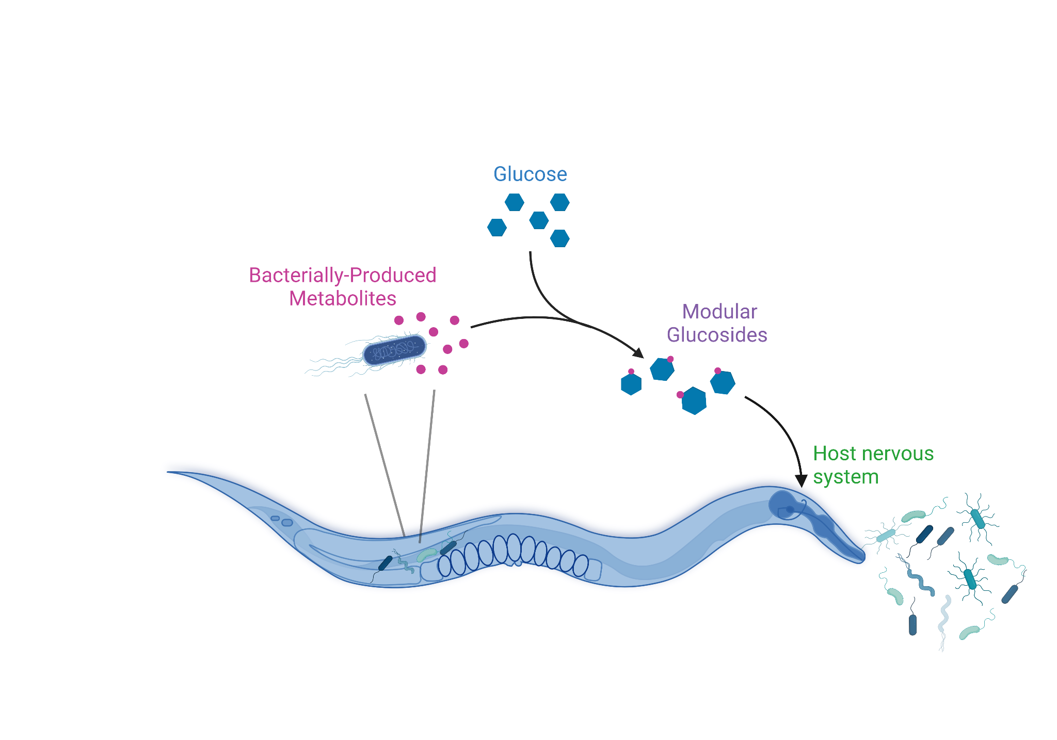

*Figure 1.* Cartoon of bacterial metabolite-dependent modular glucoside (MOGL) biosynthesis.

Of these three classes of MOGLs, iglus are the only class entirely dependent on microbial metabolism. Indole is abundantly produced by a number of gram-negative and gram-positive bacteria by hydrolytic β-elimination of L-tryptophan to indole, ammonium, and pyruvate by a tryptophanase enzyme (*tnaA*).9 Animals, including *C. elegans,* cannot synthesize indole.9 Production by microbial residents of the mammalian gastrointestinal tract result in free indole at a concentration of 250–1100 μM.10 *E. coli,* including the laboratory nematode food strain OP50, are abundant indole producers.9 The role of indole and indole derivatives on host physiology has mainly been attributed to the activation of the aryl hydrocarbon receptor (AhR) which has a multitude of impacts including intestinal epithelial integrity, inflammation, and antioxidant activity.10 However, recent work in mice has shown that indole can directly activate nociceptive neurons through the transient receptor potential ankyrin 1 (TRPA-1) channel.11 Indole is also a common olfactory cue and is known to induce odor-driven behavioral responses in nematodes, drosophila, mosquitoes, and mammals.12 Indole glucosides are therefore an exciting candidate for chemical communication between bacteria and the host nervous system.

Here we show that the glycosylated neuromodulator indole glucosides enable appropriate microbial context-dependent sensory modulation and adaptation. These findings increase our understanding of the basic biological phenomenon of neurotransmitter glycosylation, and how this process impacts sensory-driven behaviors. The molecular features of this system, including the biosynthetic building blocks and enzyme families involved, are widely conserved among animals including humans.13 Therefore, we expect generalizable insights into the mechanisms by which microbiome-produced metabolites influence the nervous systems of animals.

METHODS

***Strains:***

*C. elegans*

All worms were maintained on Nematode Growth Media (NGM) at 20 °C. To generate *cest-1.2* rescue lines *cest-1.2p::cest-1.2::SL2::mCherry* (pMOD215), and *ges-1p::cest-1.2::SL2::mCherry* (pMOD213) plasmids were injected at 10 ng/μl, with the *unc-122p::gfp* co-injection marker at 30 ng/μl. The *ugt-64(moa002)* knockout strain contains a 1.2 kb deletion, including the putative catalytic domain. The allele *moa002* was generated using CRISPR-Cas9 with guide RNAs in exons number four (5’UAAUGGUCCCCAACUUCCUU 3’) and seven (5’CUUGUUCUAGGCUATAUUAU 3’) of *ugt-64*. Strain *cest-1.2 (syb3928)* was described previously.7 N2, *glo-1(zu391),* and  *trpa-1(ok999)* were obtained from the Caenorhabditis Genetics Center (CGC).

*E. Coli*

For all experiments, bacterial strains were streaked from glycerol stocks onto antibiotic-containing LB agar if applicable. All NGM culture plates were seeded with 100uL of overnight cultures derived from a single colony grown in LB medium at 37 °C. The *E. coli* B strain OP50-1 (*strA*) was obtained from the CGC. The K12 parent strain BW25113 and the tryptophanase lacking JW3686-7 (*ΔtnaA739::kan)* were sourced from the Keio Collection through the Yale *E. coli* genetic stock center (CGSC). The OP50 *tnaA* knockout MOYb116 was generated using P1 virus (CGSC #12133) transduction14 of the *ΔtnaA739::kan* cassette from JW3686-7 into OP50-1 from CGC. Transduction was confirmed by selection with kanamycin (50 µg/mL) followed by PCR and Sanger sequencing of the *tnaA* locus. Elimination of indole production was confirmed colorimetrically using Kovács indole reagent (MilliporeSigma).

***Behavior:***

All behavioral analyses were performed on young adult hermaphrodite animals whose age was synchronized by transferring L4 animals to a seeded NGM plate approximately 18 hrs before the experiment. Each assay was done in a temperature and humidity-controlled room at 20℃; different genotypes and conditions were scored in parallel with the researcher blinded. Behavior NGM plates were pre-dried overnight and allowed to acclimatize to 20 ℃ before beginning the assay. To transfer worms between bacterial strains aseptically, gravid adults were bleached using a 1:1:1 solution of commercial NaClO, 1 M NaOH, and H2O to obtain sterile eggs.

*Video Tracking*

All videos were recorded at 40x magnification using a Leica S9D stereoscope with a Chameleon 3 CM3-U3-13Y3M camera attachment. Videos were analyzed using the open-source Tierpsy Tracker software.15 Individual worm tracks were manually isolated and the worm skeleton information including position and velocity was exported using the Open Worm Analysis Toolbox.15

*Anterior Touch*

The anterior touch response assay was performed as previously described.16 Five minutes after transferring worms to an unseeded NGM plate, forward-moving animals were touched gently in the anterior region of the body (near the pharynx) with the eyelash to initiate the escape response. Scoring consisted of counting the number of backward sinusoidal body bends following the touch stimulus until the animal initiated an omega turn. Animals were censored if they initiated a reversal then halted or moved forward without an omega turn, were unresponsive to touch, or if they had been visibly injured during transfers.

***Molecular Biology:***

Total RNA was extracted from a population of N2 worms using QIAzol lysis reagent (QIAGEN sciences) for cDNA synthesis. *cest-1.2* cDNA was cloned from this RNA using One-Step RT PCR kit (Thermo Fisher Scientific). The 2,454 bp *cest-1.2* promoter and 2,100 bp *ges-1* promoter sequences were cloned from genomic DNA. Plasmids pMOD215 and pMOD213 were assembled using Gibson homology cloning.

***Transcriptomics:***

Total RNA was extracted in triplicate from populations of N2 and *cest-1.2* worms using QIAzol lysis reagent (QIAGEN sciences). mRNA was isolated using poly A selection and sequenced with Illumina by the Yale Center for Genome Analysis (YCGA). Transcript data were analyzed using Kallisto v.0.48.17

***Metabolomics:***

HPLC–MS analyses were performed on starved and fed worms as described 7 and reanalyzed to show the relationship between the anomeric carbon attachment of MOGLs and feeding state.

***Microscopy:***

All fluorescence and differential interference contrast microscopy was performed using worms anesthetized with 10 mM tetramisole (Sigma Aldrich). Worms were imaged on 5% agarose pads using a Leica DMi8 THUNDER imager with a 20x air objective and a 63x oil immersion objective. Imaging of amphid sensory neurons filled with the lipophilic dye DiO (Biotium) was conducted after soaking a population of worms in a dye solution (1:200 ratio of 2 mg/mL DiO in DMSO diluted with M9) for one hour followed by a one hour recovery on an OP50 seeded plate. Images were false colored using ImageJ.

***Statistical Analyses:***

All statistical analyses were performed in R ([https://www.R-project.org/](https://www.r-project.org/)) and RStudio ([http://www.rstudio.com](http://www.rstudio.com/)). Error bars represent the standard error of the mean and P-values were calculated using Wilcoxon’s signed rank tests.

RESULTS

*Starvation results in retention of indole and tyramine linked glucosides*

Previous work has shown that specific classes of modular glucosides are altered in response to starvation. Given our interest in potential neuroactive headgroups linked to these MOGLs, we analyzed the levels of 63 MOGLs containing tyramine, indole, octopamine, benzoic acid or anthranilic acid using HPLC-MS metabolomics data in worms subjected to 24hrs of starvation relative to well-fed worms (*Fig 1a*). Both indole (iglu) and tyramine (tyglu) groups were overrepresented in at the anomeric carbon (1º) position among MOGLs in starved worms (*Fig 1a*). In contrast, anthranilic-acid-linked MOGLs (angl) were decreased by starvation (*Fig 1a*). Interestingly, these starvation-enriched iglus included predominantly 2*-O-*acylated and 6-*O*-acylated glucosides compared to mono-acylated and non-acylated iglus (Fig 1a). These results indicate that specific subclasses of MOGLs, including iglus, are enriched as a function of feeding state.

*Loss of microbially derived indole results in aberrant locomotory responses.*

To determine whether indole glucosides alter *C. elegans* behaviors, we first raised worms on bacteria unable to produce indole. *E. coli* is the sole source of free indole in standard *C. elegans* culture (refs), and production of indole in *E. coli* depends on Tryptophanase, encoded by tnaA, which catalyzes the conversion of L-tryptophan to free indole, pyruvate and ammonia. As locomotion is strongly dependent on diet (refs), we introduced a *tnaA* deletion into the OP50 strain using P1 phage transduction. Wild-type animals raised on OP50 *tnaA* were morphologically indistinguishable from control worms (data not shown).

We analyzed locomotion of worms grown on wild type as well as OP50 *tnaA* and found that [Insert locomotory phenotype] (Fig S1a). To ascertain whether these locomotory effects impact sensory-driven behaviors, we examined stimulus evoked behavioral reversals following an aversive anterior touch (Fig 1b-c). Animals removed from food exhibit longer reversals after anterior touch (Fig S1b). Analysis of kinematic parameters following anterior touch showed that animals raised on OP50 *tnaA* exhibited shorter duration of reversals compared to controls (Fig 1b), but these animals covered a similar distance to controls, indicating that reversals are more rapid in animals raised without microbial indole. In contrast, the average speed of forward locomotion of these animals were indistinguishable from controls, suggesting that indole may specifically alter locomotion during locomotory escape responses. Analysis of body curvature showed that animals raised on *tnaA* showed shallower body bends, which may underlie the increased reversal speed. Consistent with this hypothesis, animals fed OP50 *tnaA* exhibited fewer body bends following a well-established anterior touch assay (Fig 1d). These results suggest that microbial indole alters locomotory escape responses.

*Indole glucosides regulate locomotory escape responses*

To determine whether indole glucosides alter escape responses, we genetically disrupted the putative iglu biosynthetic pathway. Modular glucosides are thought to be synthesized in the intestine, likely in the lumen of lysosomal-related organelles (Fig 2a, He + Wrobel). Biogenesis of lysosomal-related organelles requires the activity of the Rab32-related GTPase, encoded by *glo-1* in *C. elegans* (Morris - PMID*30419011*)*.* In *glo-1* mutants the majority of MOGLs are lost, including nearly all iglus (He + Wrobel). *glo-1* mutants exhibited a quantitatively similar phenotype to wild type animals raised on OP50 *tnaA* (*Fig.* 2b). ~~Assembly of iglus from bacterially produced indole is hypothesized to rely on a UDP-glycosyltransferase (UGT) followed by acylation via CESTs in the LROs of the intestine (~~*~~Fig. 3a~~*~~).~~~~1,4~~ ~~Using bulk RNA-seq, we identified a candidate UGT that is nearly 2-fold upregulated in~~ *~~cest-1.2~~* ~~mutants relative to wild type animals (~~*~~Fig. 3b~~*~~).~~ ~~Loss of function mutations in this glycosyltransferase,~~ *~~ugt-64,~~* ~~resulted in a similarly reduced body bend phenotype as~~ *~~cest-1.2~~* ~~(~~*~~Fig. 3c~~*~~).~~ Lysosomal related organelles are important for the biogenesis of other compounds such as certain pheromones (He, refs). To determine whether defects in MOGL synthesis underlie these behavioral phenotypes, we examined the role of enzymes specifically implicated in MOGL production. Simple glucosides, including iglus, are further diversified via acylation by a family of carboxylesterase (CEST) enzymes in lysosomal related organelles, resulting in a large number of structurally distinct MOGLs (Fig 2a). In particular, nearly all 2*-O-*acylated iglus are lost in *cest-1.2* mutant worms (Wrobel). Similar to *glo-1* mutants, *cest-1.2* mutants exhibited fewer body bends per reversal.

*MOGL acylation by CEST-1.2 modulates locomotory escape responses.*

Several key features of *C. elegans* locomotion and sensation are altered as a function of feeding state.(REFS)18,19 To identify possible neuronal effects of bacteria-influenced MOGLs we observed locomotory escape responses of *cest-1.2* mutant worms. Video tracking of animals following anterior touch-induced locomotory reversals indicated subtle differences in reversal behaviors (*Fig. 2b*). While both *cest-1.2* and wild-type (N2) showed relatively consistent speed in both the reverse and forward locomotion, *cest-1.2* worms consistently exhibited shorter reversal duration. Other locomotory parameters appeared largely unaffected in *cest-1.2* mutants (Fig S1a). This phenotype was confirmed using a well-established manual anterior touch assay (*Fig. 2a*).16 While on food there was no significant difference between *cest-1.2* and N2 animals, *cest-1.2* worms off food exhibited shorter reversals as compared to the wild type (*Fig. 2d*). This effect is partially rescued via an extrachromosomal array expressing the wild-type *cest-1.2* sequence driven by the *cest-1.2* endogenous promoter (*Fig. 2e*). We conclude thatactivity of CEST-1.2, MOGL acylation, is necessary to modulate locomotory escape responses.

*Figure 2.* a) Video stills depicting the *C. elegans* anterior touch followed by locomotory escape response behavior. b) Relative MOGL abundance by indicated head group class in fed worms vs 24 hrs off food. c) Video tracking of worms of the indicated genotype. Each track represents a single animal performing a reversal in response to anterior touch. [n=26] d) Number of body bends per reversal following anterior touch for animals of the indicated genotype (N2 or cest-1.2 (syb3928)) on food or removed from food for the indicated duration [n= at least 5 independent assays with an average of 20 animals each]. e) Number of body bends per reversal following anterior touch after 5 min off food among worms of the indicated genotypes [n= at least 1 independent assays with an average of 20 animals each].

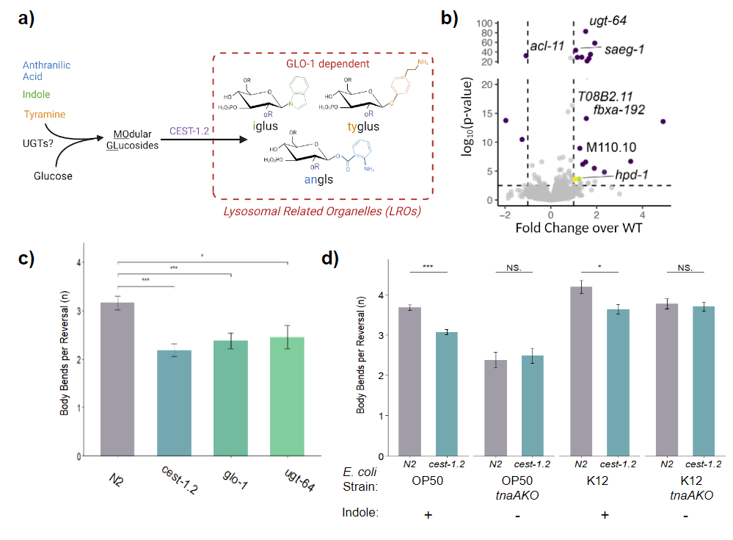

*Figure 3.* a) Schematic outlining CEST-1.2 dependent biosynthesis of 2’ acylated modular glucosides. b) Volcano plot representing the fold change in gene expression between wild type and cest-1.2 (syb3928) animals. The UDP-glycosyltransferase *ugt-64* is significantly upregulated in cest-1.2 mutants. c) Number of body bends per reversal for N2, cest-1.2 (syb3928), *glo-1(zu391),* and *ugt-64(moa002)* animals [n= at least 3 independent assays with an average of 20 animals each with the exception of *ugt-64* which represents a single assay] d) Number of body bends per reversal for N2 and cest-1.2 (syb3928) reared on indole or non-indole-producing *E. coli* [n= at least 2 independent assays with an average of 20 animals each]*.*

*CEST-1.2 activity is necessary in both the gut and a sensory neuron for behavioral modulation.*

To determine the function of CEST-1.2 in indole glucoside-modulated behavior we first examined the expression pattern of *cest-1.2* with a fluorescent transcriptional reporter. Using this reporter, we observed that mCherry under the control of the *cest-1.2* promoter is expressed in the intestine and a single amphid neuron (*Fig. 4a*). The identity of this neuron was subsequently determined to be AWC based on cell body position and cilia morphology (*Fig. 4a*). While expression of *cest-1.2* cDNA in the gut alone did not rescue the reversal behavior of *cest-1.2* mutants, expression of *cest-1.2* in both the gut and AWC was sufficient to increase the number of body bends in the anterior touch response phenotype (*Fig. 4b*). This indicates that *cest-1.2* is not only necessary for iglu diversification in the gut but also plays an additional role in the nervous system to extend reversals.

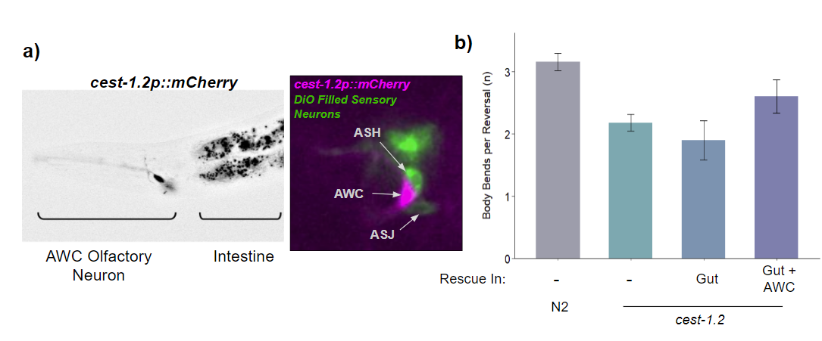

*Figure 4.* a) Expression pattern of *cest-1.2* visualized with mCherry. Second panel shows cell body positions of green (DiO filled amphid sensory neurons) and magenta (*cest-1.2p::mCherry)* confirming expression in a single AWC neuron. Anterior of animal is to the left [n = 25]. b) Number of body bends per reversal for N2, cest-1.2 (syb3928), gut rescue (*ges-1p::cest-1.2::SL2::mCherry ),* and endogenous rescue (*cest-1.2p::cest-1.2::SL2::mCherry* [n= at least 1 independent assays with an average of 20 animals each]*.*

*Iglus or free indole in the nervous system may signal via TRPA-1.*

We hypothesize that a putative receptor for iglus or free indole hydrolyzed from iglus in the nervous system may be expressed in neurons involved in reversal behavior. In mammalian systems, the TRPA1 cation channel is known to have remarkable ligand promiscuity as well as transducing thermal and mechanosensory inputs (*Fig. 5a*).20 One such ligand is indole which, in high concentrations, has been shown to activate the TRPA1 channel in mice dorsal root ganglion neurons.7 In *C. elegans*, the gene encoding the orthologue of mammalian TRPA1, *trpa-1,* is expressed in neurons involved in touch response behavior.21,22 We observed that a loss of function mutation in *trpa-1* results in behavioral defects in the locomotory escape response that are quantitatively similar to animals unable to produce iglus (*Fig. 5b*). These data are consistent with *trpa-1* acting as a neuronal receptor in the indole/iglu pathway.

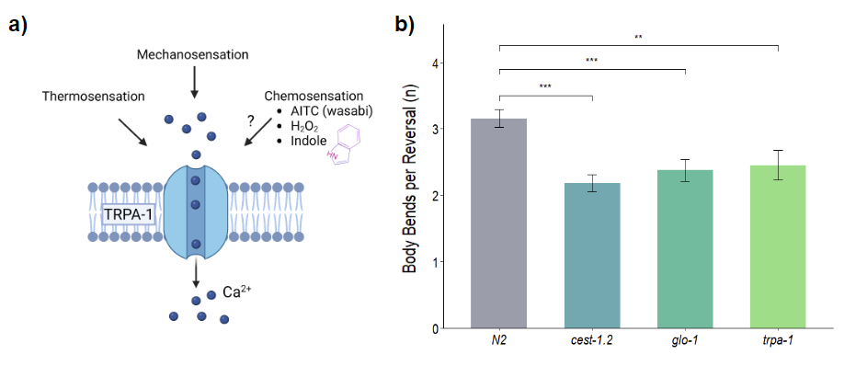

*Figure 5.* a) Cartoon representing the known role of the TRPA-1 channel across animal systems. Information adapted from Lindsay & Timperley 2020 and Chung et al. 2022. b) Number of body bends per reversal for N2, cest-1.2 (syb3928), *glo-1(zu391),* and *trpa-1(ok999)* animals [n= at least 3 independent assays with an average of 20 animals each].

*CEST-1.2 acylated iglus acts as an off-food signal in conjunction with olfactory responses.*

AWC has been previously implicated in chemosensory responses to volatile indole via G protein-coupled receptors (GPCRs).12 Because *cest-1.2* is specifically expressed in AWC, we sought to explore the possible connection between internal iglu sensation and external sensation of volatile indole. We found that behavioral assays on plates containing free indole reduced the wild-type escape response to *cest-1.2-*like levels. *cest-1.2* mutation had no further effects on this behavior under the odorant conditions (*Fig. 6*). We hypothesized that this effect was due to either a dominant effect on indole on the touch response circuit via an indole receptor such as TRPA-1, or alternatively, due to stimulation of the AWC neurons by the odorant. We observed a similar reduction of reversal responses of wild-type worms exposed to the unrelated odorant isoamyl alcohol, a chemical known to be detected by AWC (*Fig. 6*).23 We conclude that activity in the AWC neuron is likely an important regulator of iglu-dependent behavioral responses.

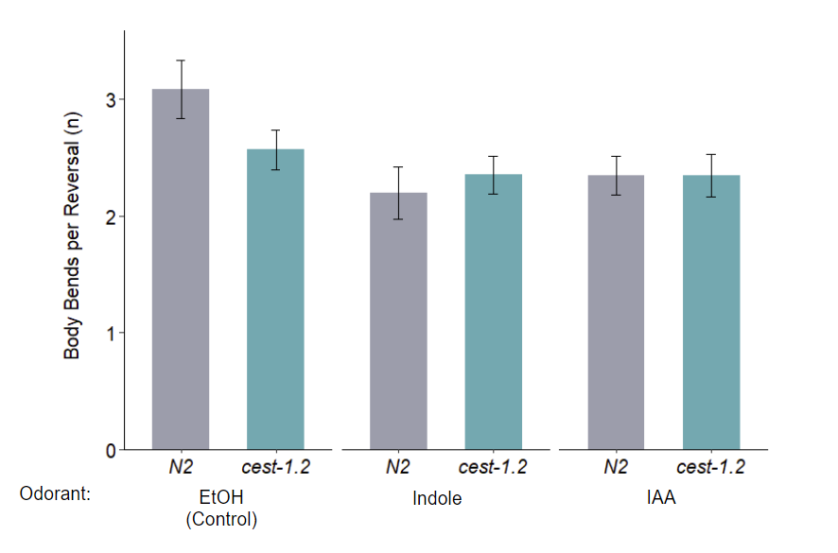

*Figure 6.* Number of body bends per reversal for N2 and cest-1.2 (syb3928) tested on behavior plates containing 0.5 mM indole, 0.92mM (1:1000 ratio) isoamyl alcohol, (IAA) or an equivalent amount of ethanol solvent [n= at least 1 independent assay with an average of 20 animals each].

DISCUSSION

Our work suggests a novel role for *CEST-1.2* acylated indole glucosides in driving a microbial metabolite-dependent behavior. We propose that bacterial indole is taken up by intestinal cells and assembled into modular indole glucosides by UGT-64 and CEST-1.2 in the LROs, thereby creating and storing a bacterial signal as soluble small molecules. These iglus may then be trafficked to the nervous system where AWC-expressed CEST-1.2 acts to reverse the acylation of iglus. We speculate that these iglus could be subsequently susceptible to hydrolysis spontaneously or via an unidentified hydrolase. Free indole released by AWC may then act on local TRPA-1 receptors on surrounding neurons. Adjacent neurons like ASH have been shown to modulate reversals and locomotory behaviors24, therefore suggesting a mechanism by which iglus can modulate the anterior touch response behavior.

Regulation of CEST-1.2 activity in AWC by external olfactory cues presents another factor in the molecular control of behavior. We observed suppression of locomotory escape responses by an AWC inhibiting food odor such as indole or isoamyl alcohol. These results suggest that calcium activity in this olfactory neuron might act as a coincidence sensor—only allowing extended reversals when the animal is not exposed to bacterial odors and when stored indole glucosides are available. We speculate that a mechanism by which this may occur is through increased surface localization of CEST-1.2 following transient activation of AWC upon removal from food odors. CEST-1.2 is predicted to be an integral membrane protein7 that may increasingly localize to the cell surface by conventional calcium-driven membrane fusion. This could therefore impact the flux of iglu hydrolysis resulting in free indole acting on neuronal receptors.A summary of this model is presented in *Fig. 7*.

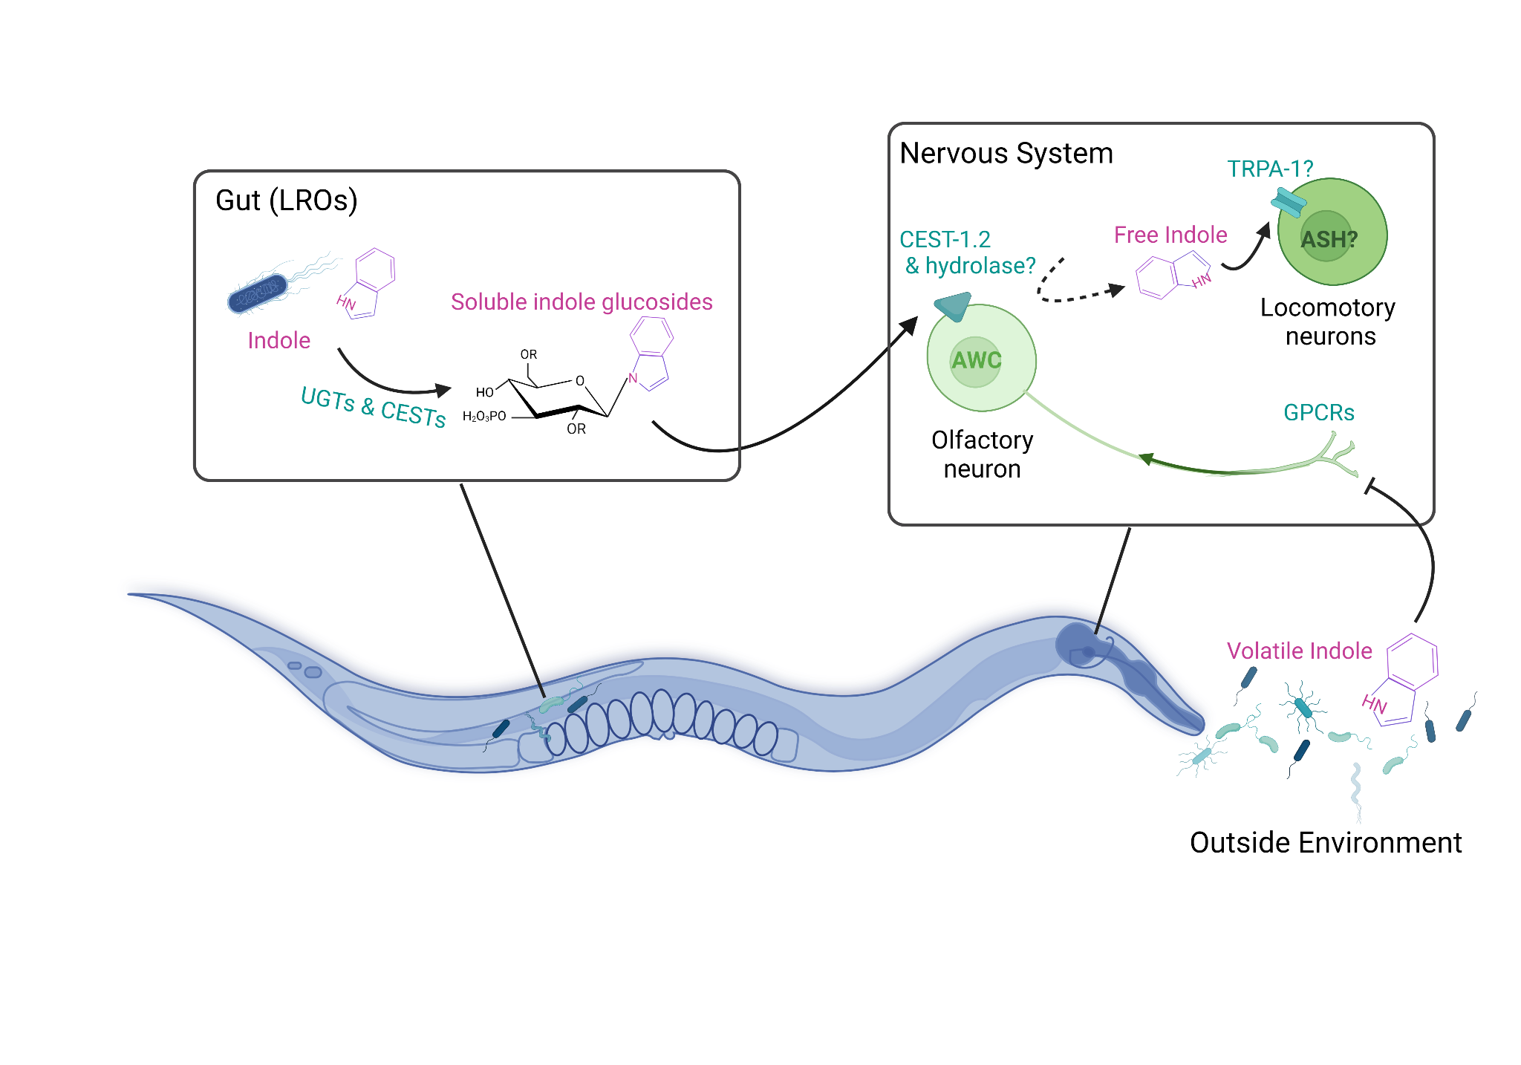

*Figure 7.* Cartoon of working model for the role of bacterial indole-derived glucosides in modulating *C. elegans* locomotory behavior.

Future work will determine the cell biological phenomena underlying the odorant- and CEST-1.2-dependent behavioral effects, including the substrate specificity of TRPA-1 as well as the subcellular localization of CEST-1.2. Our work suggests that glycosylation of bacterial metabolites may be a general mechanism by which microbiota regulate the nervous systems, and ultimately behaviors, of their animal hosts.

ACKNOWLEDGEMENTS

Thank you to everyone who provided support and feedback in the preparation of this thesis including: The members of the O’Donnell Lab, particularly Madhumanti Dasgupta for her feedback and contribution to the RNA-seq experiment. Our collaborators at Cornell University’s Frank Schroeder Lab (Chester Wrobel and Jinfang Yu) for their metabolomics work. Funding by the Yale College Dean’s Office, and the Science, Technology, and Research Scholars (STARS) II Program. Figures created with BioRender.com.

REFERENCES

1. Le, H. H., Wrobel, C. J. J., Cohen, S. M., Yu, J., Park, H., Helf, M. J., ... Schroeder, F. C. (2020). Modular metabolite assembly in caenorhabditis elegans depends on carboxylesterases and formation of lysosome-related organelles. *eLife, 9*, e61886.
2. Heldt, H., & Piechulla, B. (2021). Chapter 16 - special metabolites fulfill specific biological and ecological functions in plants. In H. Heldt, & B. Piechulla (Eds.), Plant biochemistry (fifth edition) (pp. 373-389) Academic Press.
3. Mondol MAM, Shin HJ, Rahman MA, Islam MT. Sea Cucumber Glycosides: Chemical Structures, Producing Species and Important Biological Properties. Mar Drugs. 2017 Oct 17;15(10):317. doi: 10.3390/md15100317. PMID: 29039760; PMCID: PMC5666425.
4. Lechtenberg, M. (2021). Cyanogenic Glycosides and Biogenetically Related Compounds in Higher Plants and Animals. In eLS , John Wiley & Sons, Ltd (Ed.). <https://doi.org/10.1002/9780470015902.a0029316>
5. Shimamura M. Structure, metabolism and biological functions of steryl glycosides in mammals. Biochem J. 2020 Nov 13;477(21):4243-4261. doi: 10.1042/BCJ20200532. PMID: 33186452; PMCID: PMC7666875.
6. Morris C, Foster OK, Handa S, Peloza K, Voss L, Somhegyi H, Jian Y, Vo MV, Harp M, Rambo FM, Yang C, Hermann GJ. Function and regulation of the Caenorhabditis elegans Rab32 family member GLO-1 in lysosome-related organelle biogenesis. PLoS Genet. 2018 Nov 12;14(11):e1007772. doi: 10.1371/journal.pgen.1007772. PMID: 30419011; PMCID: PMC6268011.
7. Wrobel CJJ, Yu J, Rodrigues PR, Ludewig AH, Curtis BJ, Cohen SM, Fox BW, O'Donnell MP, Sternberg PW, Schroeder FC. Combinatorial Assembly of Modular Glucosides via Carboxylesterases Regulates *C. elegans* Starvation Survival. J Am Chem Soc. 2021 Sep 15;143(36):14676-14683. doi: 10.1021/jacs.1c05908. Epub 2021 Aug 30. PMID: 34460264; PMCID: PMC8594405.
8. Oliphant, K., Allen-Vercoe, E. Macronutrient metabolism by the human gut microbiome: major fermentation by-products and their impact on host health. *Microbiome* 7, 91 (2019). https://doi.org/10.1186/s40168-019-0704-8
9. Jin-Hyung Lee, Thomas K. Wood, Jintae Lee, Roles of Indole as an Interspecies and Interkingdom Signaling Molecule, Trends in Microbiology, Volume 23, Issue 11, 2015, Pages 707-718, ISSN 0966-842X
10. Miguel A. Pappolla, George Perry, Xiang Fang, Michael Zagorski, Kumar Sambamurti, Burkhard Poeggeler, Indoles as essential mediators in the gut-brain axis. Their role in Alzheimer's disease, Neurobiology of Disease, Volume 156, 2021, 105403, ISSN 0969-9961,
11. Chung S, Kim H, Kim D, Lee JM, Lee CJ, Oh SB. Common bacterial metabolite indole directly activates nociceptive neuron through transient receptor potential ankyrin 1 channel. Pain. 2022 Aug 1;163(8):1530-1541.
12. Zhu, M., Chen, Y., Zhao, N. *et al.* Multiple olfactory pathways contribute to the lure process of *Caenorhabditis elegans* by pathogenic bacteria. *Sci. China Life Sci.* 64, 1346–1354 (2021).
13. Wang D, Zou L, Jin Q, Hou J, Ge G, Yang L. Human carboxylesterases: a comprehensive review. Acta Pharmaceutica Sinica B. 2018 Sep;8(5):699–712.
14. Thomason, L. C., Costantino, N. and Court, D. L. 2007. E. coli Genome Manipulation by P1 Transduction. Current Protocols in Molecular Biology.
15. Javer A, Currie M, Lee CW, Hokanson J, Li K, Martineau CN, Yemini E, Grundy LJ, Li C, Ch'ng Q, Schafer WR, Nollen EAA, Kerr R, Brown AEX. An open-source platform for analyzing and sharing worm-behavior data. Nat Methods. 2018 Sep;15(9):645-646. doi: 10.1038/s41592-018-0112-1. PMID: 30171234; PMCID: PMC6284784.
16. Chalfie M, Sulston JE, White JG, Southgate E, Thomson JN, Brenner S. The neural circuit for touch sensitivity in Caenorhabditis elegans. J Neurosci. 1985 Apr;5(4):956-64. doi: 10.1523/JNEUROSCI.05-04-00956.1985. PMID: 3981252; PMCID: PMC6565008.
17. Bray NL, Pimentel H, Melsted P, Pachter L. Near-optimal probabilistic RNA-seq quantification. Nat Biotechnol. 2016 May;34(5):525-7. doi: 10.1038/nbt.3519. Epub 2016 Apr 4. Erratum in: Nat Biotechnol. 2016 Aug 9;34(8):888. PMID: 27043002.
18. Ben Arous J, Laffont S, Chatenay D. Molecular and sensory basis of a food related two-state behavior in C. elegans. PLoS One. 2009 Oct 23;4(10):e7584. doi: 10.1371/journal.pone.0007584. PMID: 19851507; PMCID: PMC2762077.
19. Takeishi A, Yeon J, Harris N, Yang W, Sengupta P. Feeding state functionally reconfigures a sensory circuit to drive thermosensory behavioral plasticity. Elife. 2020 Oct 19;9:e61167. doi: 10.7554/eLife.61167. PMID: 33074105; PMCID: PMC7644224
20. Lindsay C, Timperley C. TRPA1 and issues relating to animal model selection for extrapolating toxicity data to humans. *Human & Experimental Toxicology*. 2020;39(1):14-36.
21. Hammarlund M, Hobert O, Miller DM 3rd, Sestan N. The CeNGEN Project: The Complete Gene Expression Map of an Entire Nervous System. Neuron. 2018 Aug 8;99(3):430-433. doi: 10.1016/j.neuron.2018.07.042. PMID: 30092212; PMCID: PMC6576255.
22. Kindt KS, Viswanath V, Macpherson L, Quast K, Hu H, Patapoutian A, Schafer WR. Caenorhabditis elegans TRPA-1 functions in mechanosensation. Nat Neurosci. 2007 May;10(5):568-77. doi: 10.1038/nn1886. Epub 2007 Apr 22. PMID: 17450139.
23. Bargmann CI, Hartwieg E, Horvitz HR. Odorant-selective genes and neurons mediate olfaction in C. elegans. Cell. 1993 Aug 13;74(3):515-27. doi: 10.1016/0092-8674(93)80053-h. PMID: 8348618.
24. Hart AC, Kass J, Shapiro JE, Kaplan JM. Distinct signaling pathways mediate touch and osmosensory responses in a polymodal sensory neuron. J Neurosci. 1999 Mar 15;19(6):1952-8. doi: 10.1523/JNEUROSCI.19-06-01952.1999. PMID: 10066248; PMCID: PMC6782580.