CS492 Final Project
  - 16-bit RSA Encrypted Chatroom
Course Title: Computer Security
Student: O’Donovan Murphy II
Instructor: Dr. Mahdieh Zabihimayvan
Date: 4/29/26

Contents
Introduction to the Cybersecurity Problem 4
Problem Statement 4
Motivation and Scope 4
Description of Implementation 4
General Methodology 4
Server/Client Handling 5
Encryption/Decryption 6
Test Results 6
Client to Server Connection 6
Additional Client Joins the Server 7
Encryption, Transmission, Reception, Decryption, and Broadcast 7
Lessons Learned & Current Limitations 8
The Impact of Key Width 8
Why I Chose RSA and Did Not Use It to Share an AES Key 8
Confidentiality Limitations 8
Authenticity Limitations 9
Socket Challenges 9
References 9
Source Code 9
GITHUB Information 9
Security Related Code Snips 10
Public and Private Key Handling 10
Client-Server Handshake 11
Encryption 13
Decryption 14
Message Broadcasting and Per Client Encryption 14

Introduction to the Cybersecurity Problem

Problem Statement
There must be a way to transmit data privately and securely between sender and receiver across the internet. Furthermore, this technique must be scalable. That is, being able to support additional users as needed. This means a solution must allow for an asymmetric key to be shared that allows for the encryption of data prior to transmission.

Motivation and Scope
RSA solves this problem by allowing a public key to be shared that is such that only a corresponding private key can decrypt the resulting ciphertext. This application demos a simple RSA implementation using a locally hosted multi-user chatroom.

Description of Implementation
The code is comprised of four Python scripts:
- Server.py: Contains server related code
- Client.py: Contains client related code
- Key.py: Contains server key information
- Common.py: Contains common “defines” and helper functions used across the codebase
The general methodology section covers the structure of the codebase and the general flow of the software. There is a detailed section for the server and client scripts and one for the support scripts. Lastly, there is a section on the RSA implementation and a section on lessons learned/limitations of the current design.

General Methodology
The server script runs and loads its own public and private keys into memory. A thread is started which invokes a connection handler daemon. This daemon waits for incoming connection requests from clients. When a connection request is received, a handshake process is started which is as follows:
- Client sends SYN
- Server sends ACK
- Server sends its public key
- Client sends its public key
If this process happens successfully, the newly connected client is added to the servers list of active client instances. A plain-text, framed accordingly, welcome message is transmitted to the client. When a client transmits a message, it is sent to the server and broadcasted to other connected clients.

Server/Client Handling

Naming
Each client is given a name which appears in the chat when they transmit a message. The naming structure is: “User” suffixed with the ephemeral port they’ve connected with.

Messaging
After joining the chatroom, the server sends a plain-text message to the user. Confirming they have joined successfully.
When another user sends a message, it is encrypted using the servers public key and transmitted. The server sees and displays all data, both plain-text and ciphertext.

Broadcasting
Messages, client to server, are encrypted using the server’s public key. The server tracks the sender of the original message and broadcasts the data to other connected clients but first encrypts it with each individual client’s public key. Data is received by clients and decrypted using their unique private key.

Handshaking
When a connection request is received, a handshake process is started which is as follows:
- Client sends SYN
- Server sends ACK
- Server sends its public key
- Client sends its public key

Encryption/Decryption

Server Side
The server private and public key is fixed. P and Q primes are static, and the remaining terms are derived when the server script performs initialization. This information is held in key.py.
Decryption of received data is performed using the python pow() function in conjunction with a custom function. 2-bytes of ciphertext are stored in a buffer. Then pow such that the buffer is the base raised to d mod n. d and n being the server’s private key. This returns 2-bytes of plain-text. This iterates until all ciphertext is decrypted and returned for further processing.
Encryption happens once for each connected client, using their respective public key. This occurs when the server broadcasts messages to other connected clients. The encryption process uses e and n from the client, again in conjunction with the python pow function.

Client Side
The client side private and public keys are dynamic. That is, the user is prompted to enter P and Q primes, and the remaining terms are calculated during initialization. Values 181-251 are recommended to keep n under 2^16 and to avoid a client having the same key values as the server. Data transmitted to the server is encrypted using the server’s public key. Data received, ciphertext messages, are decrypted using the client’s private key.
Encryption and decryption follow the same techniques as described above.

Test Results

Client to Server Connection
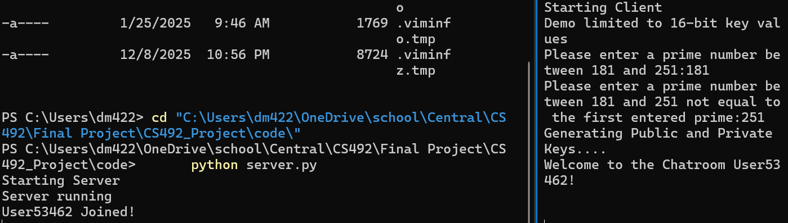
Figure 1 - User53462 Joins Server and Public Keys are Exchanged

Additional Client Joins the Server
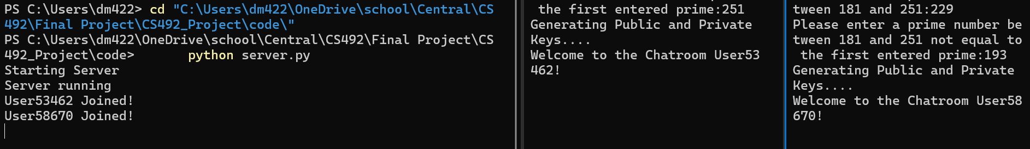
Figure 2 - User58670 Joins Server and Public Keys are Exchanged

Encryption, Transmission, Reception, Decryption, and Broadcast
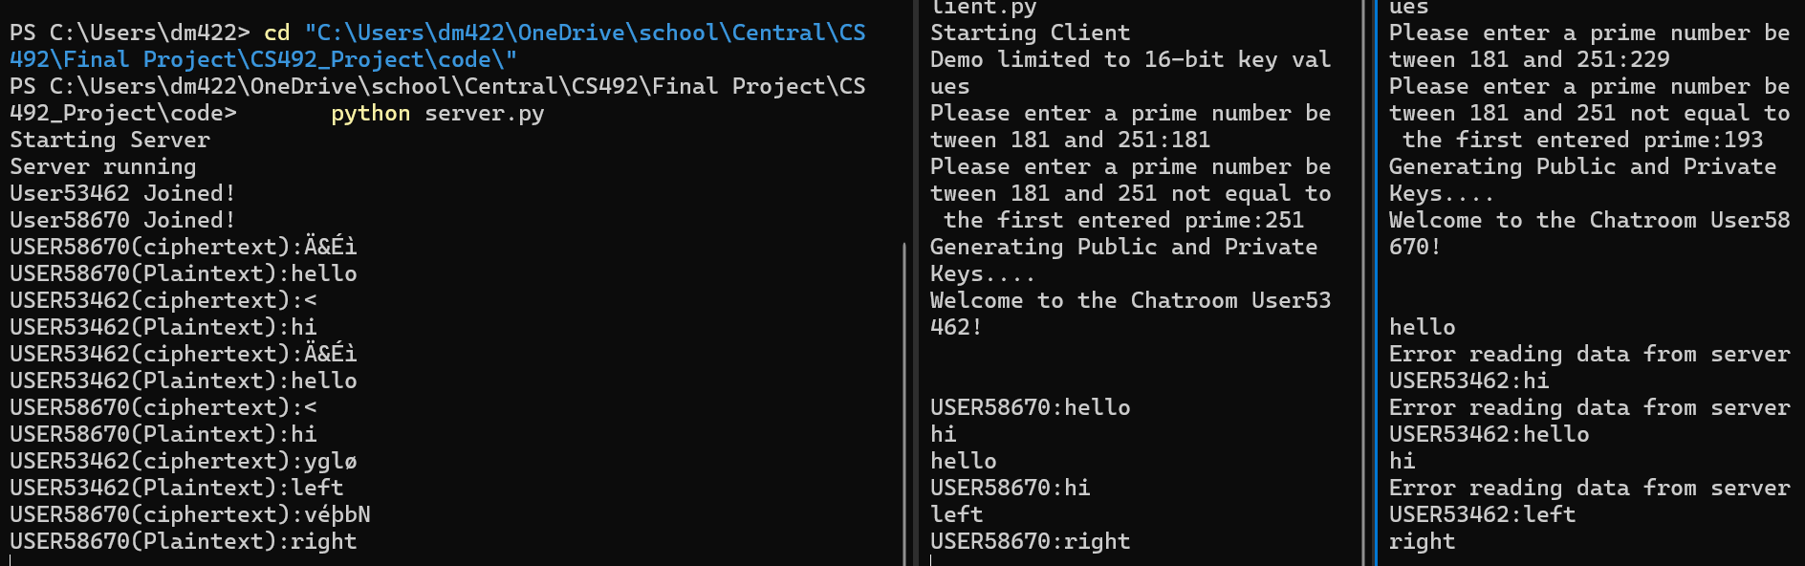
Note: There is an intermittent bug that sometimes causes the second client that joins to erroneously print “error reading data from server” prior to printing the actual received data.
What this data proves:
- Encryption, Transmission, Reception: By monitoring the server terminal, we can see that data sent by a user is received as ciphertext. We can also note that the same data sent by multiple users results in the same ciphertext. This proves the server’s public key was shared during the handshaking process.
- Decryption: By monitoring the server and corresponding client terminals, we can see the ciphertext is decrypted into plaintext.
- Broadcast: By monitoring the client terminals, we can see that the broadcast implementation is functional.

Lessons Learned & Current Limitations

The Impact of Key Width
One thing that I, fortunately, realized early on is that the number of bits used for your key dictates the size, mathematically speaking, of plaintext you can actively work with at one time.
Assume n is some value such that the product, n, of P * Q primes is less than or equal to 255.
Assume we have two bytes of plaintext data and they are summed together. Creating M.
We know that:
C = M^e mod(n)
M = C^d mod(n)
In order for RSA to function, we must ensure that each M^e mod(n) yields a distinct result. That is, the pigeonhole principle must be considered. By selecting an M smaller than n we ensure that for all M, M^e mod(n) will yield a distinct result.

Why I Chose RSA and Did Not Use It to Share an AES Key
For this project, I wanted to implement as much of this “by hand” as what was practical to deepen my understanding. Spinning up an AES implementation manually on top of socket handling would have proven to be too much of a burden to the schedule. Ultimately, I chose shared RSA keys as it was a good middle ground between a relevant application that did not rely heavily on APIs and external libraries.

Confidentiality Limitations
A 16-bit key is trivially easy to defeat by an outside source if they choose to do so. So, while in the literal sense data transmitted through this program is confidential, that is, transferred as ciphertext, it isn’t secure in a practical real-world sense.
For the purposes of this assignment however, I feel it meets the mark of employing an encryption method discussed in class in a real-world application.

Authenticity Limitations
While the server script tracks and IDs users, the clients do not append or prefix their messages with any sort of signature. Therefore, the server relies purely on the open socket connection, and the port being used, to identify which user sent what message.
There are some inherent limitations with this, one being that if someone wrote a malicious script to force the use of a specific port, they could impersonate another user. Also, username assignments are not fixed in any way. That is, every time a user connects, they are given a new username, again making it difficult to track messages to a specific user.

Socket Challenges
Timing, especially with handshaking, was a challenge. Socket data is sent as a stream, and my background is mostly in embedded programming so dealing with data that couldn’t be dealt with “byte by byte” was difficult at first.
I added framing to help distinguish one packet from another and aid parsing. This exposed an unexpected limitation of the implementation. I accounted only for bytes 0x20 – 0x7F to be entered by the user. Working under this assumption, SOH & EOT were obvious choices for start and end bytes respectively. What I did not account for, however, is that when the client encrypts the data with the server’s public key there is a chance albeit “small” that the ciphertext result may contain an erroneous SOH or EOT byte.
While I couldn’t create this scenario, if it occurred it would likely result in unexpected behavior or an exception being thrown.

References
- https://docs.python.org/3/library/socket.html#
- Many, many Python and RSA related Google Searches.

Source Code

GITHUB Information
URL: https://github.com/ODonovanMurphyII/CS492_Project
Branch: donsMain

Security Related Code Snips

Public and Private Key Handling
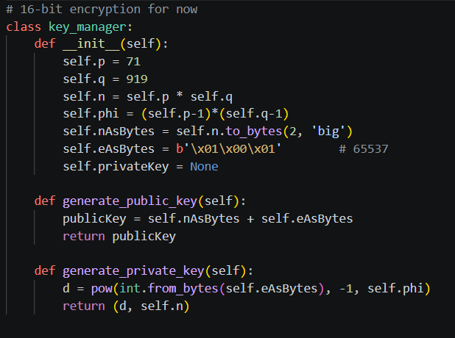
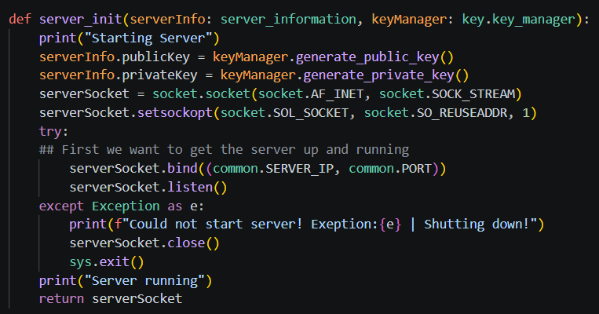
Server-side key generation

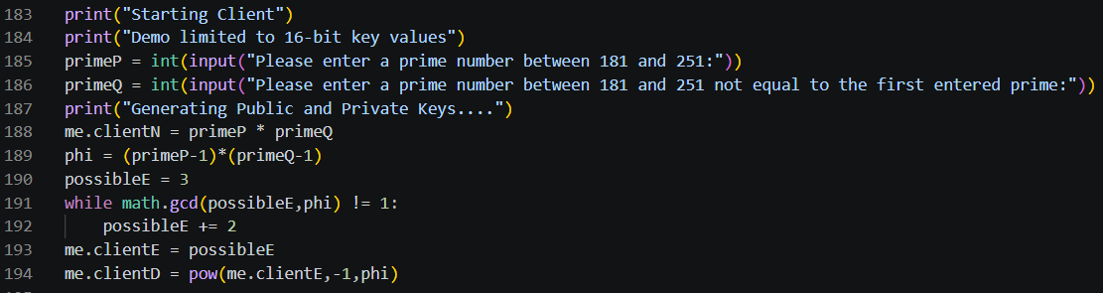
Figure 3 - Client-Side Key Generation

Client-Server Handshake
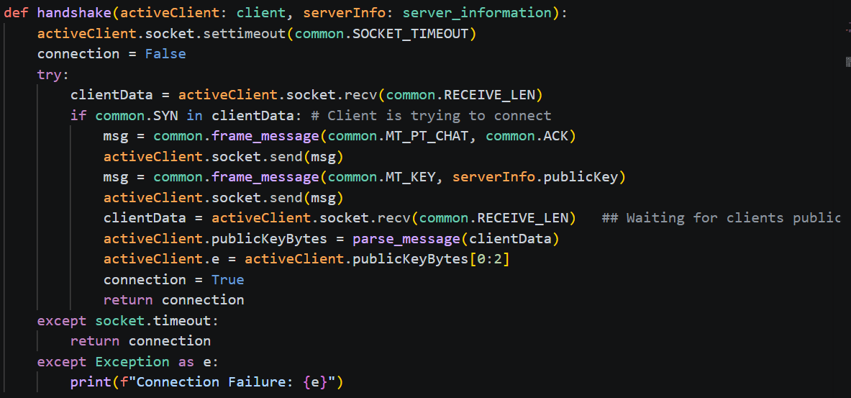
Figure 4 - Server-side handshake
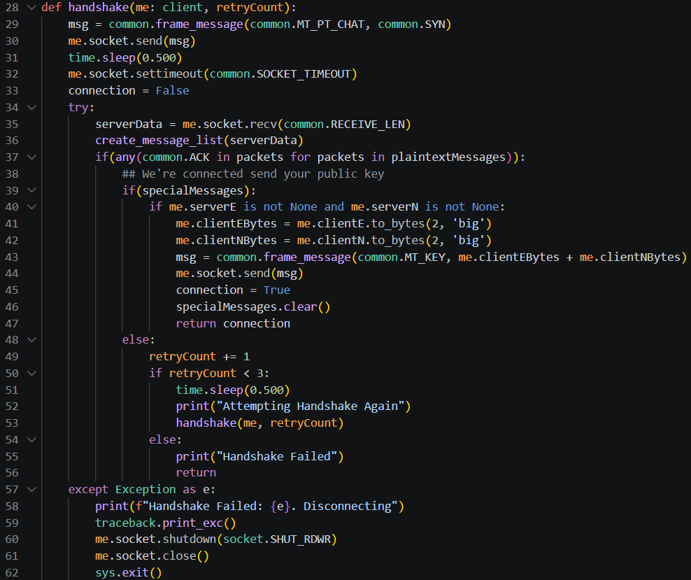
Figure 5 - Client-Side Handshake

Encryption
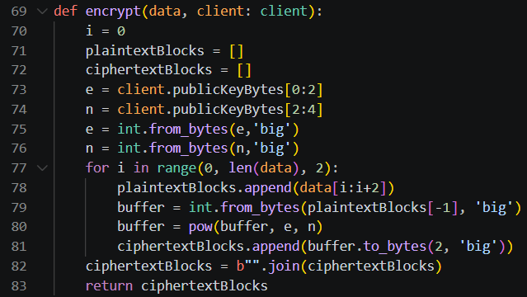
Figure 6 - Server-side Encryption
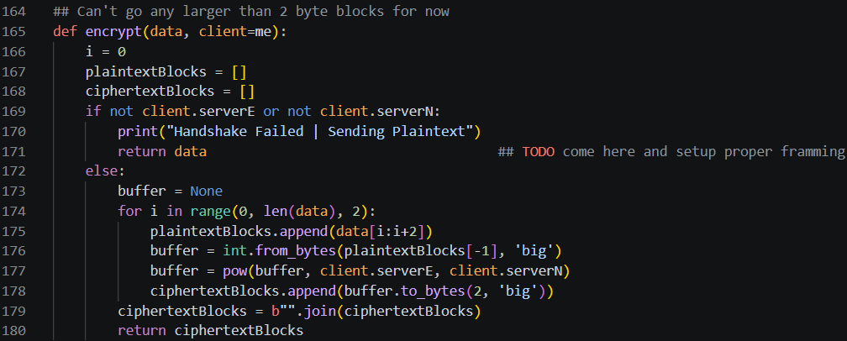
Figure 7 - Client-side Encryption

Decryption
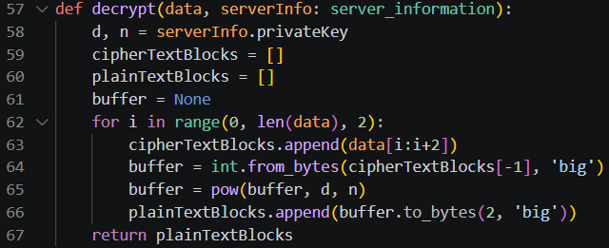
Figure 8 - Server-side Decryption
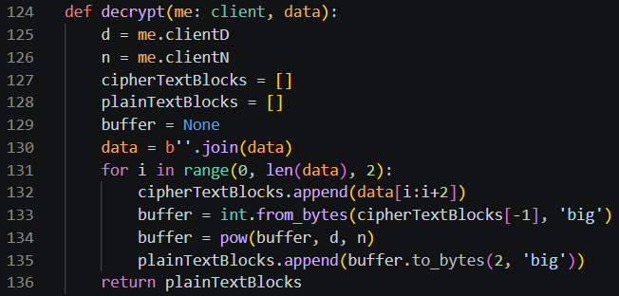
Figure 9 - Client-side Decryption

Message Broadcasting and Per Client Encryption
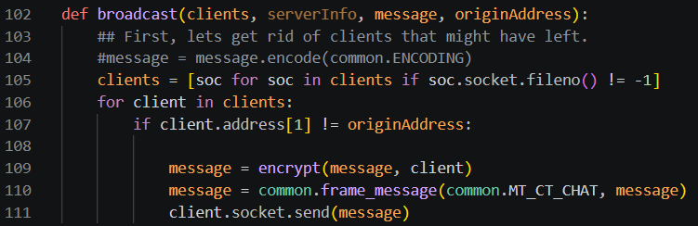
Figure 10

