CS492
Project Survey
O’Donovan Murphy II

Introduction

Overview
The main goal is to design a simple encrypted messaging service, a chat room, that users can log into and communicate securely. Goals include the option for a user to communicate insecurely within the same chat room. Enabling this option will configure the client such that messages are transmitted as plaintext and will request the server not decrypt any incoming messages.
This feature is added to demonstrate the effect encryption has on messages.
Project Significance/Relevance
- Public key handling
- Encryption
- Secure data transfer
- Private key handling
- Asymmetric encryption algorithm use

Background and Literature Review

Existing Research
Research primarily covers the different methods of key exchange in asymmetric encryption algorithms. Common implementations include:
- RSA
- ECC
- DH
While other methods will be reviewed for the sake of learning the material, RSA will be the likely choice for this effort.

Gaps
While it isn’t an inherent gap of RSA the chatroom poses a specific challenge. Large keys may slow the chatroom down considerably. A smaller key alleviates this but creates a less secure environment. For the sake of demonstration purposes, this seems like a fair trade off.

3. Methodology
The project will use a simple client/server configuration. A client will run a Python script on their machine which connects to the remote server running any accompanying server-side script. The server will work in broadcast mode, meaning all users will see every message.
A common asymmetric encryption technique will be used in the development of this software.
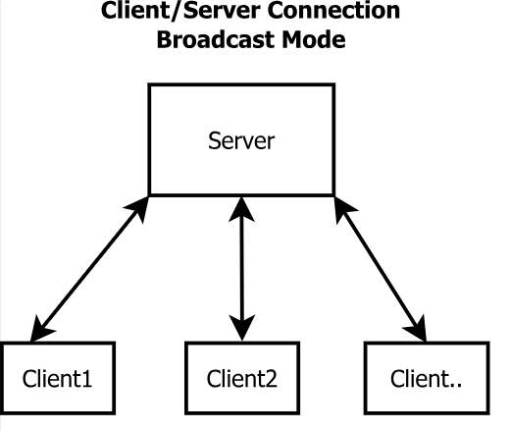
Figure 1 - Client and Server Relationship

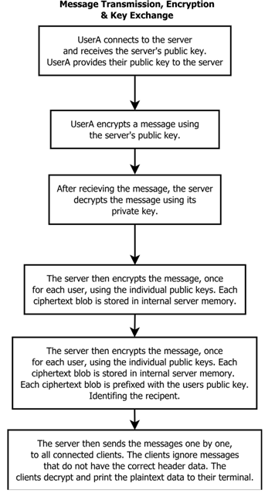
Figure 2 - Message and Key Handling

4. Expected Outcomes
Goals:
- Create a chatroom where multiple users can communicate securely
- Create a chatroom where users can choose to send their messages as plaintext
- Create a chatroom where all transmitted data is logged securely
Stretch Goals:
- User authentication for login
- Develop a way for the server to only open the chatroom port if a user requests access. This way, the port isn’t open when the chatroom isn’t being used.

5. Timeline
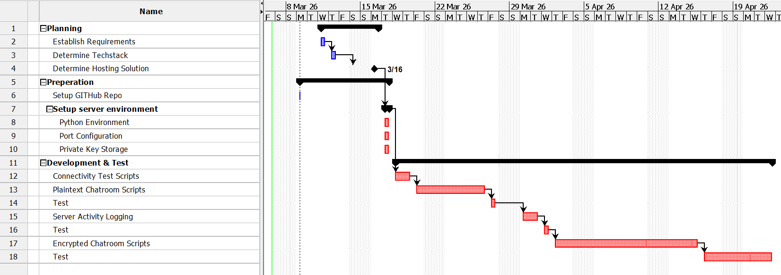
Figure 3 - Project Schedule

6. Resources
- Free or low-cost hosting solution.
- PCs with a Python development environment.

7. Ethical Considerations
- All user data will be logged.
  - Users will be notified that all transmitted data is logged.
  - Logging data will allow for illicit use to be reviewed by a system administrator if needed.
  - Notifying the user of this provides transparency about the limitations of privacy when using the system.
- The system will not remain active when not in use by students for the purpose of development, test, and demonstration.
  - This prevents the long-term use of the system for illicit or illegal behavior.
- Access to the system will be shared in a limited fashion.
  - By controlling the use of the system, the risk of its use for illicit or illegal behavior is reduced.

8. Conclusion
This project will serve as an opportunity to learn asymmetric encryption by using a known algorithm. The intent is to focus on building something that is simple, but foundationally secure and robust from a security standpoint. Also, the package will be developed in a way that is scalable.

9. References
“Asymmetric Algorithms — Cryptography 2.8.Dev1 Documentation.” Cryptography.io, 2013, cryptography.io/en/latest/hazmat/primitives/asymmetric/.
GeeksforGeeks. “What Is an Asymmetric Encryption?” GeeksforGeeks, 5 Mar. 2023, www.geeksforgeeks.org/computer-networks/what-is-asymmetric-encryption/.
GeeksforGeeks. “RSA Algorithm in Cryptography.” GeeksforGeeks, 22 Apr. 2017, www.geeksforgeeks.org/computer-networks/rsa-algorithm-cryptography/.
‌

