# Introduction

My project is to produce a website and program to allow business owners to manage new job enquiries and keep track of active jobs and create invoices, using all of the data held in a database. I am creating this program for myself as I am hoping to start a local computer repair business in which this type of program would be very useful for receiving enquires and managing any work to be done.

# 3.1.1 Problem Identification

This project should improve flow of work for businesses by improving speed and convenience of enquiring and job managing.

* Enquiring about a problem with a computer from a local business could be inconvenient if the customer has to go to the business physically, if this is implemented into a website it can be done with little effort. This can be done by hosting the website and a database on a computer and using php to allow the website to input data into the database.
* The management of jobs and enquiries can be done with a pen and paper easily but as the business grows, space and organisation of these files may become harder and a struggle to maintain, therefor I feel a program interfacing with a database would be much easier to use as everything can be easily located, modified and transferred between tables with minimal effort.
* Invoices can be a time consuming process to create, this time could be saved if a template is made in the program for it to autofill information about the customer and produce a simple invoice with details of work carried out and standardised pricing for these services and a total.

# 3.1.2 Stakeholders

The stakeholder for my project is myself, as I am hoping to start a computer repair business and thought this would be a great tool for such a business. The requirements of my project are features that will allow customers to easily submit an enquiry to the business and for the business employees to easily review the enquiries and contact the customer about the enquiry. Then to be able to easily manage the job and keep track of progress. And to also quickly make invoices and archive the completed jobs details.

My project will accommodate a solution for all these needs. Customer enquiries should be much more convenient and easier through a form on a website, then the business employees would be able to open the program and look at the enquiries and respond to the customer with ease about their enquiry as their contact details will be attached to the enquiry. Then they will be able to manage jobs taken on and keep track of progress through the programs GUI and once finished to generate a basic invoice in MS Word and archive the data of the job with the click of a button.

# 3.1.3 Research The Problem

During my research I found a product with a similar function to my program, the software is called WorkflowMAX, the program lets you keep track of jobs, they are displayed in a table similarly to how I would present mine. It allocates a Job number to each job, holds the details of the client, a name for the job, and the progress of the job (*Figure 1*). This is similar to how I will lay out my database table. The difference between this program and my project, is that I am including a website to retrieve enquiries from customers which will also be processed through my program.

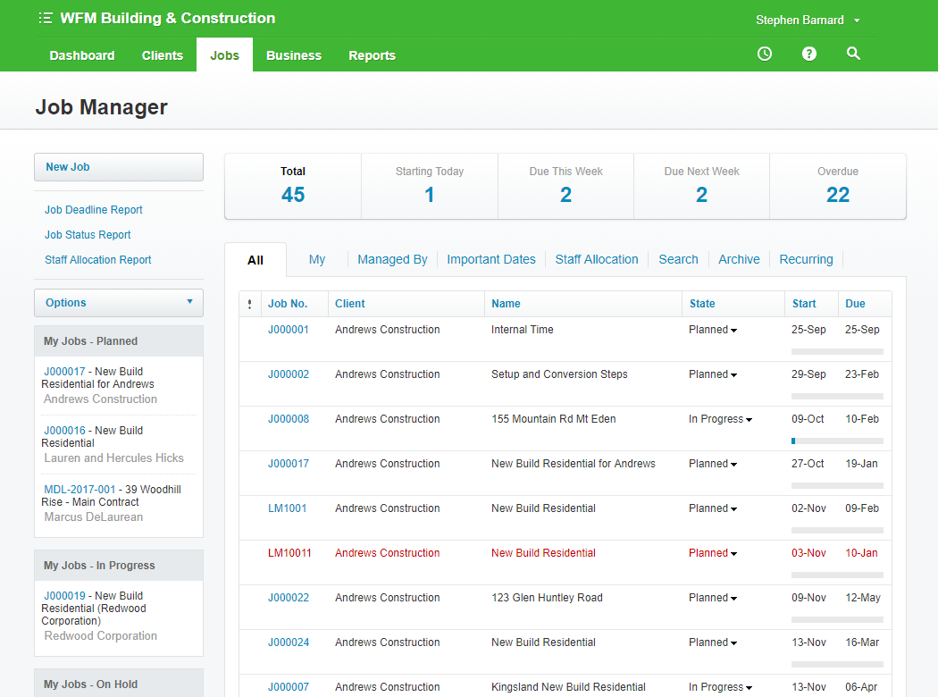

Figure - WorkflowMAX Job Management Software

This program includes almost everything that it could, from custom headings to creating quotes. However, my solution will not be as detailed and as modular as this may be too complex for the time limit and would be unnecessary for my needs. I will not include features such as a customisable GUI or customisable invoice formats, these features would take too long to implement and would not benefit the needs of the project. But I would expect to be able to implement the core features such as receiving enquiries and viewing the enquiries and jobs and generating a simple invoice for completed jobs. One feature I would like to add if I had more time would be a log in for the website for customers to track the progress of their job, this could be done with PHP but would be hard to make secure and keep customers data safe.

# 3.1.4 Specify The Proposed Solution