ᴄoᴄonut
Project: CCN on Arduino Uno / ATmega328P, 16 MHz
Serial connection: 9600 baud, 8 data bits, no parity, 1 stop bit (8N1)
Status: first version, source history 1995–2027

Origins and acknowledgements
ᴄoᴄonut is derived from work by the Dutch software expert Hans Jonkers. His design provided the technical foundation for the Philips team in Nuremberg and Vienna. Paul Schenk ported it to the PAOLINA environment, where ᴄoᴄonut was used in Philips video recorders. He succeeded in making this small operating system both very fast and exceptionally compact, and therefore often referred to it jokingly as “Peanut”.
The attribution to Hans Jonkers is based on the project team's recollection. The surviving PAOLINA source headers document Paul Schenk's subsequent authorship and porting work.

Paul Schenk
Profile: The surviving PAOLINA file headers identify Paul Schenk as the first author of the BPCI, EVTI, MBXI, QUEI and TIMI core modules, with creation dates ranging from 20 November to 1 December 1995. According to the project team's recollection, he ported and integrated the original Dutch design for PAOLINA, laying the foundation for its use in Philips video recorders. His name also appears on interface descriptions added later.
Later career: A Philips Research Laboratories study lists Paul Schenk as a software architect at the Vienna site. In 2006 he was named with Hendrikus G. van Horck as an inventor on a Philips patent for seamless playback across devices in UPnP AV networks. He is now Chief Operating Officer of XroadMedia in Vienna. The company's profile credits him with more than 25 years of experience in R&D, innovation and project management and states that he is responsible for customer care, quality of service and the company's infrastructure.
Public sources checked on 1 November 2026: XroadMedia, About Us – https://www.xroadmedia.com/about-us/; Philips patent ATE458346T1 – https://patents.google.com/patent/ATE458346T1/en; Philips Research study on software architecture – https://www.cs.vu.nl/~x/sar/sar.pdf. The first-author attribution is additionally supported by the surviving PAOLINA source files from 1995–1997.
Paul Schenk is also named as an inventor on several other patents.

What makes this project particularly interesting
The software runs on an ordinary ATmega328P, best known as the microcontroller used by the Arduino Uno, yet it uses none of the Arduino framework. The controller's data sheet is sufficient as the technical reference needed to understand the work. There is no millis(), Serial.print(), attachTimer(), delay(), or any other facility that might stand in the way of using this software as a professional tool.
It is a pleasure to study this software in all its elegance and modesty—and perhaps to reuse it under the terms of the General Public License.

Overview and startup
After power-up, main() configures the LED pin and the serial interface. It then initializes the historical modules in dependency order: BPCI, QUEI, MBXI, EVTI and TIMI. ccn_init() subsequently initializes the active ccn_* kernel, resets its management data and configures Timer1 as an 8 ms time base.
main() then creates four tasks: the output task, the serial input task, the LED task and the periodic counter task. The output task has priority 2; the other three tasks have priority 1. One event, one mailbox and four timers follow: serial polling (periodic, 8 ms), LED (periodic, 1 s), one-shot timer (3 s) and the initially stopped periodic counter timer (1 s). The scheduler starts only after configuration has completed successfully.
After successful initialization, the firmware prints exactly this startup block and then waits for commands:
- - - - - - - - - - - - - - - - - - - -
ᴄoᴄonut started
e=Event, m=Mailbox, w=WakeUp, t=3-s-Timer, p=1-s-Timer.

a) Scheduler
ccn_start() enables interrupts and then enters the system's central infinite loop. In each cycle, the scheduler first collects the hardware ticks accumulated since the previous cycle and updates all software timers. It then selects a ready task and calls its function. Tasks run cooperatively until their functions return voluntarily; a task must therefore neither block indefinitely nor retain control.
Selection favours the task with the highest numerical priority. Among tasks of equal priority, each search resumes after the task selected last (round-robin). The ready flag is taken atomically. Repeated wake-ups while a task is already ready do not create additional task instances. If no task is ready, the loop continues checking for new ticks and wake-up requests.

b) Wake-up task system
ccn_task_wake(task) sets the specified task's ready flag. The call neither creates a new task instance nor executes the task immediately: the scheduler calls it during the next suitable cycle. If the task is already ready, only one pending execution remains.
The serial command w additionally records the wake-up reason and wakes the output task directly. It then reports “Task direkt aufgeweckt” (“Task woken directly”). Timer and event wake-ups also use the ready flag internally; the task subsequently checks the relevant reason.

c) Event system
An event is a single pending signal for exactly one connected task. ccn_event_send(event) sets the pending flag and wakes the receiver. The task reads the signal with ccn_event_receive(event); reading clears the flag.
Events are coalesced: if the same event is sent repeatedly before the receiver collects it, it remains one pending event and does not count the number of sends. The demo command e triggers this event.

d) Mailbox system
A mailbox contains a FIFO queue of messages and is connected to one receiving task. The current demo mailbox can hold four messages. ccn_mailbox_send() appends a message and wakes the receiver. If the mailbox is full, the call returns false and the message is rejected.
ccn_mailbox_receive() retrieves the oldest message. In the demo it contains the whole seconds elapsed since startup. The output uses a 32-bit value so the timestamp is not limited to one byte. The output task drains multiple stored messages in sequence.

e) Timer system
Timer1 runs in CTC mode with a prescaler of 64. At 16 MHz it counts at 250 kHz; compare value 1999 generates an interrupt every 8 ms. The interrupt service routine remains short: it updates the serial elapsed-time counter and increments the number of pending kernel ticks. Only the scheduler loop collects these ticks and updates the software timers.
Timer delays are specified in 8 ms ticks. The demo timer for t is a one-shot timer with 3000 / 8 = 375 ticks. On expiry, the kernel sets the expiry flag and wakes the connected output task. The task consumes the flag with ccn_timer_expired() and prints the three-second message. Entering t again while the timer is running restarts it with its full delay.
The LED, serial input task and p-controlled counter task use periodic timers. Their notifications are flags, not counters: if a task is not run for an extended period, several periodic expiries may coalesce into one pending notification.
The p command toggles the periodic one-second timer. Starting it resets the counter to 0. Each subsequent expiry wakes the counter task, which increments and prints the value. Another p stops the timer, clears any pending expiry flag and reports the final counter value.

f) UML sequence diagrams

EVTI: Sending and receiving an event
The following sequence diagram shows the historical EVTI_* interface: the caller sends an event that has previously been created and connected. EVTI sets its pending flag and wakes the receiver through BPCI. The task later reads the event with EVTI_Receive(); this operation clears the pending flag. Note: the current serial demo uses the newer ccn_event_* API instead. The EVTI module is still initialized but is not used for the demo event.
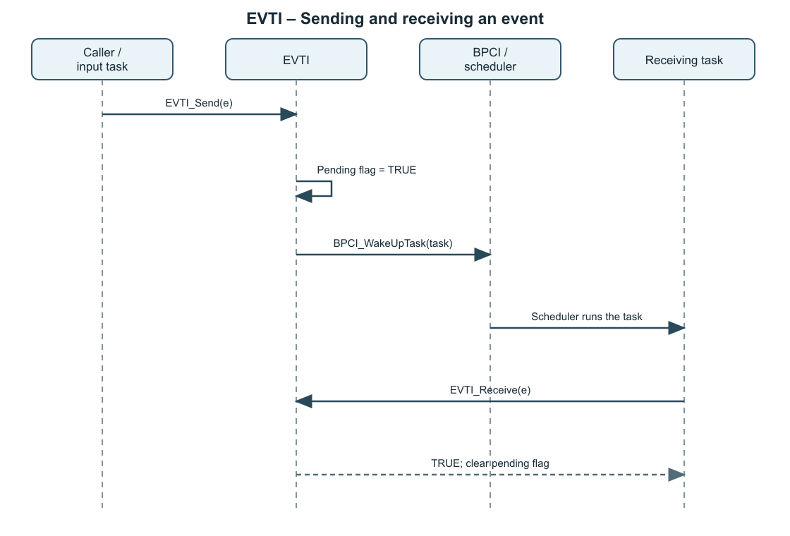 UML sequence: EVTI_Send() wakes the connected task; EVTI_Receive() consumes the pending flag.

Periodic TIMI timer
The second sequence diagram shows a periodic timer of the historical TIMI_* interface. The application creates it in TIMI_PERIODIC mode, connects it to a task and starts it. The timer ISR collects ticks; the BPCI scheduler calls TIMI_TaskFunction() to process them. On expiry, TIMI queues the periodic timer again and wakes the task. The task consumes the timer event with TIMI_Event(). Note: the current demo uses the newer ccn_timer_* API described in the previous section instead.
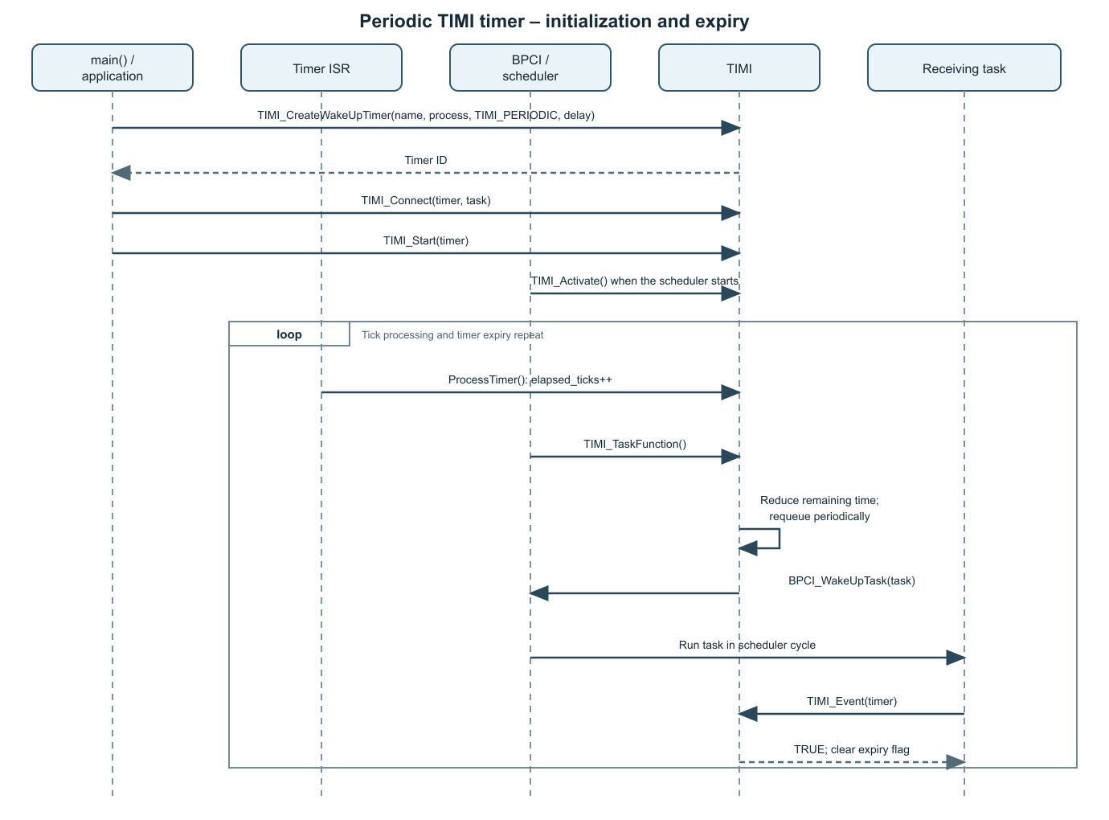 UML sequence: create, connect and start a TIMI_PERIODIC timer; check expiry with TIMI_Event().

g) Serial commands
Key | Action | Firmware response
e | Send event; receiver becomes ready. | “Event empfangen.” (“Event received.”)
m | Send whole seconds since startup as a mailbox message. | Timestamp in seconds.
w | Wake the output task directly. | “Task direkt aufgeweckt.” (“Task woken directly.”)
t | Start or restart the one-shot three-second timer. | On expiry: “3-Sekunden-Timer abgelaufen.” (“Three-second timer expired.”)
p | Start or stop the periodic one-second counter. | Start message, counter value every second and final value when stopped.
Upper-case E, M, W, T and P are accepted as well. Newline and carriage return are ignored; unknown characters are discarded. UART reception uses a 32-byte ring buffer, of which at most 31 characters can be occupied at once.

h) Port status and project structure
The former PC test version (PCV), CNF_ASSERTING and the CCN_NO_MAIN switch have been removed completely. The project has exactly one program entry point in src/main.c and is built with AVR-GCC without the Arduino framework. Shared historical types, compiler compatibility definitions, critical-section macros and bit operations are consolidated in include/types.h.
The historical BPCI, QUEI, MBXI, EVTI and TIMI modules remain available and initialized as a traceable original structure. The current demonstration uses the newer ccn_* API for tasks, events, mailboxes and timers. Interface headers document every function consistently with PURPOSE, IN, OUT and—only for persistent state changes—POST. The verified Uno build occupies 4,846 bytes of flash and 869 bytes of RAM.

Appendix A – printf and serial output
printf is provided by avr-libc and declared in <stdio.h>. The SIOI module does not implement formatting itself: SIOI_Init() configures UART0 for 9600 baud and connects stdout to an avr-libc FILE output function. This callback waits until UART0 can transmit the next character and writes it to the UART data register.
Examples from the program (the strings match the German firmware output):
printf("Event empfangen.\n");
printf("Mailbox-Nachricht: %lu Sekunden seit Start.\n",
(unsigned long)timestamp);
%lu matches the 32-bit seconds value passed as unsigned long on the AVR. The module converts \n to CR/LF for the terminal. Because output is synchronous, tasks should print only short messages.

Appendix B – Receive and query functions
Function | Result and side effect | Use in the demo
SIOI_ReadChar() | Returns a character value (0–255), or -1 if the RX ring buffer is empty. A returned character is removed from the buffer. | The serial task reads all available characters and interprets commands.
ccn_event_receive(event) | Returns true if an event was pending and then clears its pending flag; otherwise false. | The output task consumes event e.
ccn_mailbox_receive(mailbox, &message) | On success, writes the oldest FIFO message to message and removes it from the mailbox; otherwise returns false. | The output task drains the mailbox completely.
ccn_timer_expired(timer) | Returns true if the timer has expired since the previous query and consumes this expiry flag. | The output task detects the three-second timer; the LED and counter tasks consume their periodic expiries.
ccn_mailbox_count(mailbox) | Returns the current number of stored messages; an invalid ID yields 0. | Can be used to inspect mailbox occupancy.
Important: the serial receive interrupt collects bytes in a ring buffer. Commands are processed later by the cooperative task; the interrupt service routine executes neither printf nor scheduler logic.
Central project files: src/main.c; coconut/ccn.c, timer_avr.c and sioi.c; the historical modules bpci.c, quei.c, mbxi.c, evti.c and timi.c; include/ccn.h, types.h and the *_if.h headers. Editable UML sources are stored in docs/uml/evti-sequence-en.svg and docs/uml/periodic-timer-sequence-en.svg.

