New Docking, Molecular Dynamics and QSAR Models to Predict Disruption of Human and Rat Transthyretin Function by Per- and Polyfluoroalkyl Substances (PFAS)
Nuno M. S. Almeida^{a,b*}, Heather M. Bolstadª, Scott Coffinª, Sana Majidª, Angela K. Wilson^{b}, Anatoly A. Soshilov^{a*}

ªNew Toxicology Evaluations Section (NTES), Office of Environmental Health Hazard Assessment, California Environmental Protection Agency
1001 I St, Sacramento, CA, 95814, USA
^{b}Department of Chemistry, Michigan State University, East Lansing, MI, 48864, USA

* Corresponding authors (nuno.almeida@oehha.ca.gov; anatoly.soshilov@oehha.ca.gov)
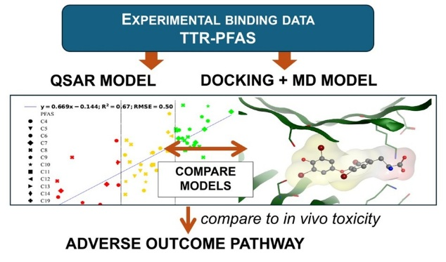
For TOC Only
Abstract
Per- and polyfluoroalkyl substances (PFAS) are environmentally persistent chemicals that require improved understanding of the toxicity mechanisms and the development of predictive models for risk assessment. One observed effect of PFAS exposure is a decrease in thyroxine (T₄) levels in vivo resulting from the direct displacement of T₄ from a carrier protein transthyretin (TTR) in a proposed adverse outcome pathway (AOP). In this study, the mechanism of thyroxine (T₄) displacement from human and rat TTRs was investigated using structural approaches (i.e., docking and molecular dynamics) and quantitative structure-activity relationship (QSAR) models. A QSAR model was developed using the largest available binding dataset and a two-tier approach that allowed inclusion of all data. Docking models that utilized a pharmacophore approach showed near perfect overlap with independently sourced crystal structures for PFOA and PFOS. Molecular dynamics simulations demonstrated similar PFAS binding modes in rat and human TTR enabling interspecies toxicity comparisons. All models predicted moderate to strong binding of the novel PFAS ammonium 4,8-dioxa-3H-perfluorononanoate (ADONA) and hexafluoropropylene oxide dimer acid (GenX) to TTR, consistent with the limited toxicity and binding data for these chemicals. Predicted PFAS binding energies for rat TTR correlated well with the in vivo PFAS associated decreases in T₄ levels supporting the AOP. The development of reliable predictive toxicity models for PFAS requires extensive validation, maximal use of available experimental data, and careful consideration of toxicokinetic differences in inter-chemical comparisons.

Introduction
Per- and polyfluoroalkyl substances are hazardous persistent environmental pollutants, with documented adverse effects in humans and animals. Despite growing concerns, PFAS continue to be widely used in industrial processes, firefighting foams, and in common household products.^{1, 2} The resistance of PFAS to environmental degradation stems from their fluorine saturation and the strength of carbon-fluorine bonds. Due to their widespread use and biological persistence, PFAS pose a significant health risk; they are reported to be present in more than 99% of the U.S. population.³⁻⁸
Health risk assessments have been conducted for certain PFAS and mixtures with sufficient toxicological data.⁹⁻¹¹ However, many PFAS of potential concern have not been evaluated due to limited in vivo data necessary for the establishment of health-protective standards. Additionally, new PFAS are regularly introduced as alternatives, often without comprehensive toxicity profiles.¹² This underscores the need for predictive approaches to assess PFAS toxicity.¹³⁻¹⁶
In mammals, exposure to PFAS has been associated with a wide variety of adverse outcomes such as cancer, hepatotoxicity, immunotoxicity, developmental toxicity, and thyroid toxicity, among the most reported.^{17, 18} While epidemiological PFAS studies generally support many of the observations in animal models, it is difficult to isolate the effects of individual PFAS in multi-chemical environmental exposures.^{19, 20} Therefore, animal models have had an important role in health risk assessment, serving as both a foundation for understanding human effects and as aid in the development and validation of predictive tools for PFAS toxicity. However, the ever-expanding list of PFAS of concern, limited available animal data and the overall proposed shift away from animal research toward alternative toxicity models, make the development of predictive in silico models imperative in the PFAS health risk assessment.
Thyroid toxicity caused by PFAS is an important example of this framework. Decreases in triiodothyronine (T₃) and thyroxine (T₄) in rat studies have been identified as the most sensitive adverse effects for certain short-chain PFAS - perfluorobutanesulfonic acid (PFBS), perfluorobutanoic acid (PFBA), perfluorohexanoic acid (PFHxA), and perfluorohexanesulfonic acid (PFHxS), and these findings have informed human health-protective concentrations in recent health assessments.²¹⁻³⁵ For longer chain PFAS, such as perfluorooctanoic acid (PFOA), perfluorooctanesulfonic acid (PFOS), perfluorononanoic acid (PFNA) and perfluorodecanoic acid (PFDA) hepatic or immune effects appear to be more sensitive indicators of toxicity than thyroid effects, suggesting endpoint-specific trends within this chemical group.^{2, 9, 10, 17, 24, 25, 27-36} Epidemiological data for PFAS typically does not show consistent changes in thyroid hormone levels, although decreases in T₃/T₄ have been reported in occupational settings.³⁷⁻⁴⁰ The differences between available animal and human data could be due to species (e.g., toxicokinetic) differences and different levels of exposure in the animal (higher) and human epidemiological (lower) studies.
In vivo T₃ and T₄ decreases have been proposed to result from increased degradation following the PFAS-dependent displacement from the T₃/T₄ transport protein, transthyretin (TTR). This mechanism has been proposed as an AOP for the neurodevelopmental toxicity of xenobiotics (AOP 152 at aopwiki.org).⁴¹
In vitro ability of PFAS to displace T₄ or related probes has been intensively investigated with human TTR.⁴²⁻⁴⁸; however, no in vitro studies are available with rat TTR. Most recently, Degitz et al. examined 136 PFAS with a panel of nine in vitro assays targeting various thyroid toxicity mechanisms and found that binding to human TTR was the most common (i.e., had highest number of active compounds) and most sensitive in vitro endpoint among those analyzed.⁴⁴ In this and related studies, the ability of PFAS to displace T₄ from TTR is quantified using half maximal effective concentration (EC₅₀), or half maximal inhibitory concentration (IC₅₀), in a ligand-binding assay employing a radioactive or fluorescent high-affinity ligand probe (distinct from the endogenous T₄). Of note, Degitz et al. reported three PFAS - PFHxS, PFHpS, and (Perfluorobutyryl)-2-thenoylmethane with higher affinity for TTR than that of T₄. PFAS binding to hTTR was also investigated with mutagenesis, demonstrating the critical role of Lys15.⁴³
In silico investigations into the mechanism of T₄ displacement by PFAS primarily involved docking models and quantitative structure-activity relationship (QSAR) models. Docking studies based on crystal structures of PFAS with TTR have been reported.^{49, 50} Furthermore, such docking models have been used to conduct in silico mutagenesis of TTR and to investigate species and PFAS differences in TTR-PFAS binding.^{49, 51-53} For example, Zhang et al. conducted virtual mutagenesis of hTTR to investigate how a small set of thyroid-disrupting chemicals including PFOA interacted differently with seabream TTR and hTTR.⁴⁹ In this study, Ser117 was identified as potentially important for binding polar chemicals (but not PFOA); however, no experimental validation of this prediction was provided.⁴⁹ In another recent study, binding energies predicted from molecular dynamics simulations of TTR-PFAS were used to develop a QSAR model for 430 PFAS.⁵⁴ Dharpure et al. analyzed species-specific PFAS binding to TTR and found that many key binding residues (including Lys15) are conserved among species.⁵² This study also suggested that long-chain PFAS ( ≥ 6 carbons) tend to bind TTR more efficiently than short-chain PFAS (< 6 carbons).
Several QSAR models for hTTR-PFAS interactions have been developed based on experimental direct binding data.^{42, 48, 54-58} Notably, almost all published QSAR models for direct PFAS binding are based on the same TTR-PFAS binding dataset from Weiss et al.^{42, 54} A key limitation of this dataset is its small size (N=24 PFAS), which limits the predictive power of the QSAR models. As mentioned above, more comprehensive and structurally diverse datasets have recently become available^{44, 46} potentially enabling more comprehensive QSAR models. Thus, Evangelista et al. (2025) utilized the TTR-PFAS binding dataset from Degitz et al., which is the largest dataset available to date, to build a multi-linear regression QSAR model.⁴⁴
While PFAS-T₄ displacement from hTTR has been extensively studied in vitro and in silico^{42-44, 57}, no animal PFAS-T₄/TTR in vitro displacement data have been reported to date. This represents an important knowledge gap, especially since the more conclusive in vivo data on PFAS-induced thyroid toxicity are from animal (rat) studies. Buglewicz et al. used structural comparisons and molecular dynamics simulations of PFOA to understand species differences in binding to TTR. ⁵⁹ The authors found that the PFOA-TTR binding interactions are generally conserved in vertebrate groups.
Herein, the PFAS-mediated displacement of T₄ from TTR is investigated as a molecular mechanism and as a basis for AOP for PFAS-induced T₄ reduction in rats. First, molecular docking based on hTTR-T₄ structure and QSAR models were developed for hTTR and validated using available binding data and additionally, with the comparison between our modelled hTTR-PFOA and hTTR-PFOS structures and their corresponding reported crystal structures. These validated hTTR-PFAS models were then used to predict binding affinities for two novel PFAS that were not analyzed in the hTTR binding data set (ADONA and GenX). To consider interspecies differences in this mechanism, a rat TTR (rTTR) docking model was developed, and molecular dynamics simulations were used to compare PFAS binding energies between hTTR and rTTR models. Finally, to investigate the role of PFAS/T₄ displacement as a key molecular interaction underpinning in vivo T₄ reduction in male rats (AOP), MD - predicted rTTR-PFAS binding energies were compared to toxicokinetically standardized in vivo points of departure (PODs) for PFAS-dependent T₄ decreases. A summary of the study design is shown in Fig. 1. This graphic includes different experimental data sources used, models that were developed and validated using experimental data, and predictions generated from these models.
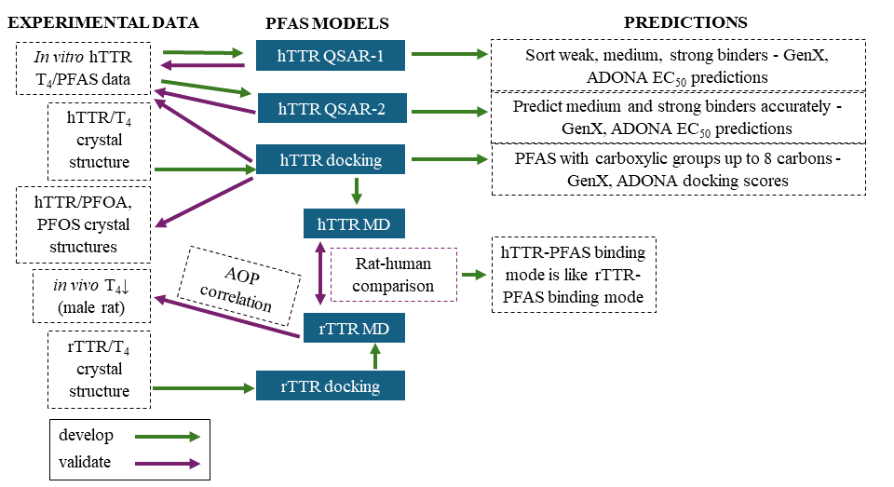

Figure 1. Project outline. Abbreviations: h, human; r, rat; TTR, transthyretin; T₄, thyroxine; AOP, adverse outcome pathway; EC₅₀, effective concentration at half maximum activity; MD, molecular dynamics.

Methodology
hTTR and rTTR QSAR models
Five in vitro dose response studies reporting T₄ displacement from TTR were identified using PubMed searches.^{42-44, 57} Binding data from these are summarized in Fig. 2 (only a representative selection of PFAS from the Degitz et al. (2024)⁴⁴ is included due to the large size of this dataset). To develop relative binding values (-log${EC}_{50}/{EC}_{50}^{PFOA}$) for this graph, EC₅₀ values from corresponding sources were converted to μM. The red vertical line corresponds to a binding affinity similar to that of PFOA. The Degitz et al. dataset (Table S1) was chosen for model development since it had the largest number of active PFAS (n=80).
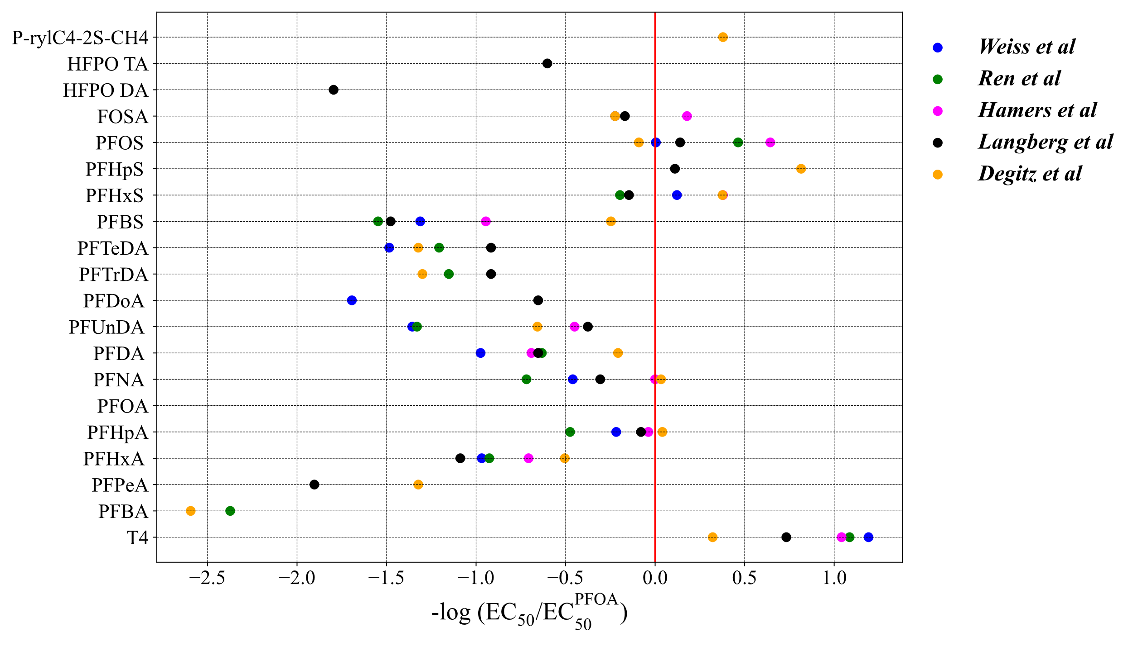
Figure 2. In vitro TTR displacement data. EC₅₀ values for each PFAS were transformed into normalized binding activities and plotted on x-axis. Data are from Weiss et al. (2009)⁴², Ren et al. (2016)⁴³, Hamers et al. (2020)⁴⁷, Landberg et al. (2024)⁴⁶ and Degitz et al. (2024)⁴⁴. Only select representative data points from Degitz et al. are included, full data set can be found in the Supplementary Information.
Several quantitative structure activity relationship (QSAR) models were constructed based on the dataset from Degitz et al. using linear regression in Molecular Operating Environment (MOE 2022), (equations for the models are provided in the SI).⁶⁰ Two QSAR models demonstrating the best fit with different applications (as described below) were chosen for further evaluation. Molecular and physicochemical descriptors (2D and 3D) were generated using MOE 2022. For QSAR Model 1, the selected descriptors included: number of carbons (n_C), number of atoms (a_count), number of single bonds (b_single), Topological Polar Surface Area (TPSA), Balaban J Index (BalabanJ), number of oxygens (a_no), Lipinski violation rules (lip_violation), GCUT descriptors using atomic contribution to logP (GCUT_SLOP_3), and first kappa alpha modified shape index (KierA1). For QSAR Model 2, a 3D descriptor - van de Waals energy (E_vdw) was included, while the KierA1 descriptor was excluded.

For QSAR Model 1, a training set of 62 PFAS structures were selected from the Degitz et al. dataset, representing a broad range of physicochemical structures and biological activities (Table S2). The pEC₅₀ value for this model ranged from 1.17 to -2.62. The dataset included weak (pEC₅₀ < -0.9), medium (-0.9 ≤ pEC₅₀ ≤ 0.12), and strong (0.12 > pEC₅₀) binders. Model validation was performed using ten PFAS including weak, medium and strong binders (Table S2). QSAR Model 2 included 32 PFAS with pEC₅₀ values ranging from 1.17 to 0.16 in the training set (Table S3) and eight PFAS classified as medium or strong binders to validate this model (Table S3).
The domain of applicability (DoA) for the QSAR models was analyzed using principal component analysis (PCA) in MOE 2022.⁶⁰ Sixty two PCA components were generated for QSAR Model 1 and 32 for Model 2. PCA values for the validation set, along with GenX and ADONA were calculated and plotted alongside the PCA1 and PCA2 values from the model training sets. ADONA and GenX were found to be withing the DoA for both QSAR models. Accordingly, predicted pEC₅₀ values for these compounds were generated in both QSAR models.
hTTR and rTTR docking models
Docking simulations were performed with MOE 2022.⁶⁰ Crystal structures of human and rat TTR were obtained from the RSCB Protein Data Bank (PDB IDs: 1ICT and 1IE4, respectively).^{61, 62} In vivo, TTR has a homotetrameric structure with T₄ binding sites seemingly located in the interface or interfaces between monomers. The hTTR crystal structure (1ICT) is composed of a tetrameric form of TTR co-crystalized with T₄, therefore enabling a full structural analysis of the potential binding sites.³⁶ The rTTR structure (1IE4) includes T₄ bound in two distinct binding pockets (Fig S1A). ³⁷ For both species, binding pocket 1 was selected for model development (Fig. 2 A, C); the rationale for this selection is detailed in the Molecular dynamics simulations section below. Prior to docking, protein structures were protonated at pH=7, 300K, and 1 atm, utilizing the protonate3D approach in MOE 2022.^{60, 63}
Regarding docking to the hTTR, 73 PFAS were selected from the Degitz et al. dataset⁴⁴ (certain PFAS with their redundant salts were not included). For the rTTR, a targeted subset of 11 PFAS was docked to allow comparison with the hTTR binding data and corresponding in vivo toxicity data. In both structures, the binding site was selected using MOE’s “site finder” and encompassed residues within 5 Å range of the co-crystalized T₄ ligand.
The selected ligand binding pocket 1 for human and rat TTRs are shown in Figs. 3A and 3C, respectively, highlighting key protein residue interactions. One such residue, Lys15 has previously been identified by Ren et al. as critical for ligand binding.⁴³ In this study, Lys15 mutations led to significantly weaker binding affinities for all studied PFAS and T₄. Pharmacophore models for the T₄ interaction with human and rat TTRs were developed premised on the importance of Lys15 and considering the structural features of 1ICT and 1IE4 (Figs. 3B, D). These pharmacophore models were then integrated into the docking protocols.
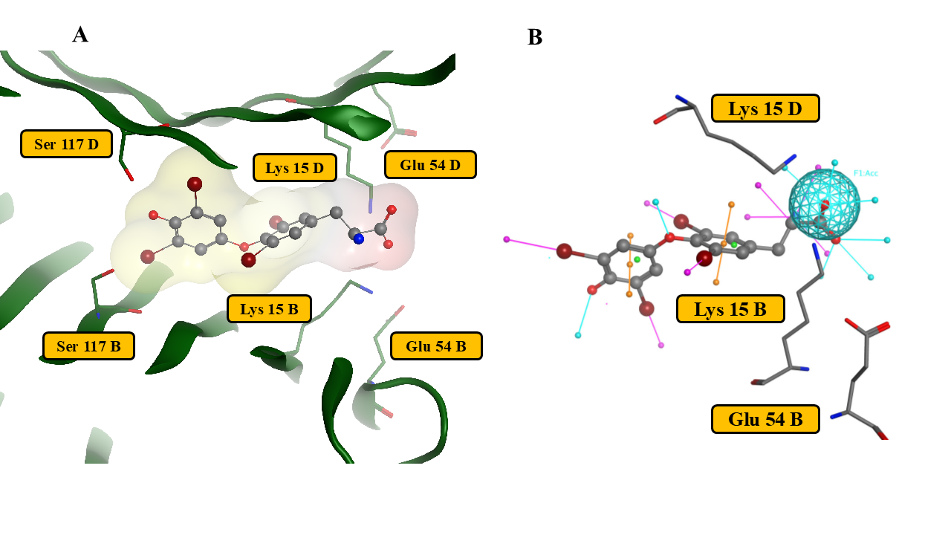
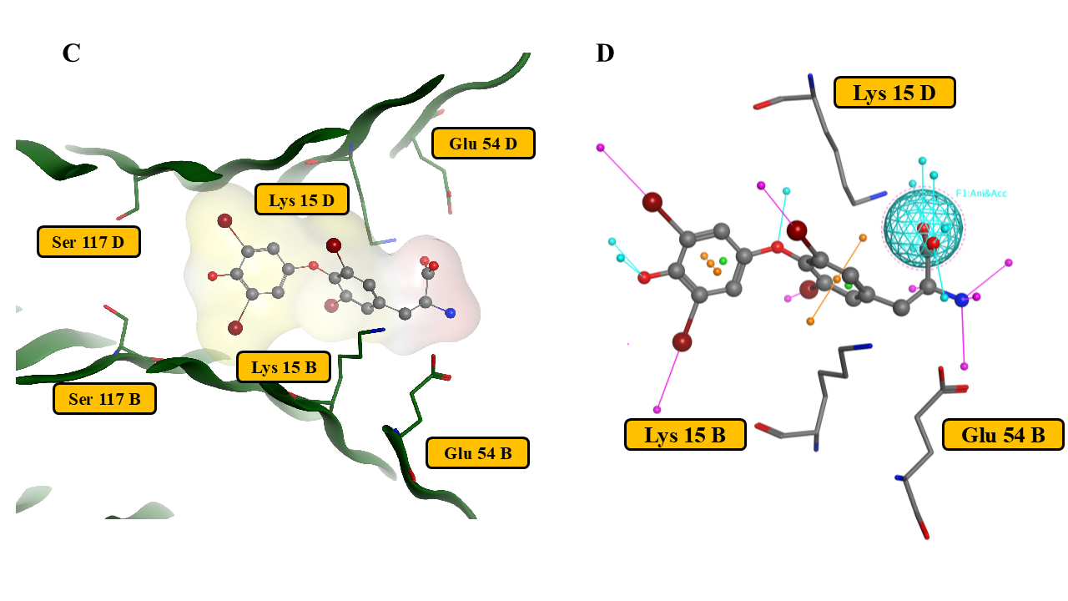
Figure 3. Binding pockets of the crystal structures of human (3A) and rat (3C) with T₄. T₄-binding fragments of hTTR (3A) and rTTR (3C) are shown for the binding pocket 1. The T₄ surface is indicated and marked yellow for lipophilic areas, and red for hydrophilic areas. The pharmacophore models utilized for hTTR and rTTR docking models are shown (3B and 3D respectively).

Molecular dynamic simulations
Molecular dynamics simulations were performed for selected PFAS using the relevant docking poses in human and rat TTR models, with Amber22.⁶⁴ Simulations were run for eleven PFAS and T_{4,} each for 100 nanoseconds (ns), with a 2 femtosecond (fs) timestep. To evaluate the stability and strength of T₄ binding to TTR, the simulations were done in triplicate in both human and rat models. These simulations assessed T₄ positional dynamics and potential interactions within the binding pocket (further details of the simulations are provided in SI).
As previously noted, the rat crystal structure (1IE4) contains two distinct binding pockets, each with distinct residue interactions. To investigate possible differences in binding behavior, both pockets were initially simulated. However, no noticeable differences in binding affinity were observed between the two, so only binding pocket 1 for rat was used for subsequent PFAS-TTR simulations in the rat model. For human TTR, binding pocket 1 was also selected, as T₄ binding poses were found to be consistent across both sites.
Binding energies were calculated using the molecular mechanics Poisson−Boltzmann surface area (MM-PBSA) method.⁶⁵ The full simulation trajectory was analyzed, with 51 frames sampled per 10 ns time-step. Each frame was analyzed individually, and the binding energy results were averaged. CPPTRAJ was used for the residue decomposition step analysis.⁶⁶
In vivo toxicity data analysis
PFAS rat toxicology literature was reviewed to identify studies reporting thyroid hormone measurements. Our analysis focused on 28-day oral gavage studies conducted by the National Toxicology Program (NTP), which encompassed a wide range of PFAS chain lengths and used standardized methodologies thereby reducing inter-study variability and facilitating direct comparison of results.^{24, 25} The NTP evaluated the following perfluoroalkylcarboxylic acids (PFCAs): PFHxA, PFOA, PFNA, and PFDA, along with the following perfluoroalkylsulfonic acids (PFSAs): PFBS, PFHxS, and PFOS. In addition, a separate 28-day oral gavage study in rats conducted with PFBA was identified.²¹ Thyroid toxicity endpoints from selected studies were reviewed, and datasets on free and total T₄ decreases were chosen for inclusion in this analysis. These endpoints were prioritized due to their widespread reporting across the selected PFAS studies and the mechanistic considerations of the model (TTR specifically binds T₄). Applied doses in these datasets were converted to serum concentrations (see below) and dose response data were modeled in ToxicR (version 24.10.1.4)⁶⁷ to derive benchmark dose (BMD) values using the default suite of continuous models and the Bayesian model average option. In this analysis, BMR of one standard deviation was used. Consistent with the regulatory practice, the resulting BMDL values would be used as the points of departure (PODs) for subsequent risk assessment. A single-compartment, first-order toxicokinetic model (with or without an absorption phase), or a physiologically based pharmacokinetic (PBPK) model, was used to model serum concentrations at 1-hr time-point increments, with model choice based on parameter data availability. Sex-specific rat toxicokinetic parameters (including elimination half-life, volume of distribution, and absorption rate constant) for each PFAS were obtained from the literature (Table S4). Serum maximum concentration (C_{max}) and time-weighted average concentrations (TWA) were estimated using each toxicology study’s modelled time-series data. Additional details about the models are included in the supplemental information (Toxicokinetic modelling).
Bayesian regression
To investigate the relationship between rat TTR binding energy and BMD metrics, a Bayesian regression model was implemented using the BMRS package (2.22)⁶⁸ in R (4.4.1), with separate analyses for dose metrics. The model incorporated measurement errors in both the predictor (rTTR binding energy; kcal mol⁻¹) and the response variable (in vivo BMDL PODs; µM), with priors informed by frequentist regression results. Specifically, the slope and intercept priors were defined as normal distributions, centered on the frequentist estimates with standard deviations equal to their respective standard errors. A weakly informative Cauchy prior was applied to the residual standard deviation. Posterior samples were drawn using Markov Chain Monte Carlo methods, and posterior predictive checks were performed to evaluate model fit. Model performance metrics, including root mean squared error (RMSE), Bayesian R-squared, Widely Applicable Information Criterion (WAIC), and Leave-One-Out Cross-Validation (LOO), were calculated to assess predictive accuracy and model quality.
Results and Discussion
Three predictive approaches were used to assess PFAS binding to hTTR: QSAR, docking, and molecular dynamics simulations. For PFAS binding to rTTR, docking and molecular dynamics simulations were used. The PFAS-hTTR QSAR model was developed in two tiers: Tier 1 predicted binding across all PFAS, while Tier 2 provided refined predictions for medium and strong binders.
QSAR models for TTR
For the hTTR-PFAS model, the pEC₅₀ values from the Degitz et al. dataset provided an appropriate benchmark for QSAR predictions. The developed QSAR models allow for predictions of PFAS-hTTR binding. Model 1 facilitates the understanding of the binding region of any PFAS, while Model 2 predicts strong and medium binders with a smaller root mean square error (RMSE). These models provide a wide range of structural features for use in the structure activity relationships of different PFAS (see Figures 4 and 5), including carboxylic and sulphonic acids, alcohols, aliphatic and non-aliphatic structures. GenX and ADONA were also evaluated using both QSAR models and their pEC₅₀ were calculated (Fig. 6 shows QSAR predictions for GenX and ADONA along with calculated docking scores). A comparison summary of prior QSAR modeling based on the Weiss et al. data from 2009 ^{42, 55-58} was performed (Table S5). The most recent PFAS-TTR QSAR model (Zhao et al. ⁵⁴) used the Degitz et al. dataset similar to this study, incorporated both 2D and 3D descriptors and was also included in the comparison of QSAR models (Table S5).
The two QSAR models reported here were the best fitting and possess unique features. For the first QSAR model, the R² and RMSE are 0.67 and 0.50, respectively (Fig. 4A). The validation set for this model in Figure 4C shows that it worked equally well for strong, medium, and weak binders. The comparatively better performing QSAR Model 2, which was developed for strong and medium binders, had a smaller RMSE (0.19) and an R² of 0.78 (Fig. 4B). As expected, this model provided good predictions for strong and medium binders (Fig. 4D). The cross-validation plots for QSAR Models 1 and 2 are included in the SI (Figures S2 and S3). Based on the model characteristics, QSAR Model 1 offers broad applicability across diverse PFAS structures while QSAR Model 2 can produce accurate predictions for strong and medium binders, with a smaller RMSE. The QSAR models were also used to predict EC₅₀ values for T₄/TTR displacement for ADONA and GenX. QSAR Model 1 predicted ADONA and GenX as medium binders, with pEC₅₀ values of -0.180 and -0.462, respectively. Similarly, QSAR Model 2 predicts ADONA and GenX as medium binders, with pEC₅₀ values of 0.114 and -0.301, respectively. In both models, ADONA is a stronger binder than GenX (Fig. 6). The top descriptors for each model are presented in Table S6 in SI.

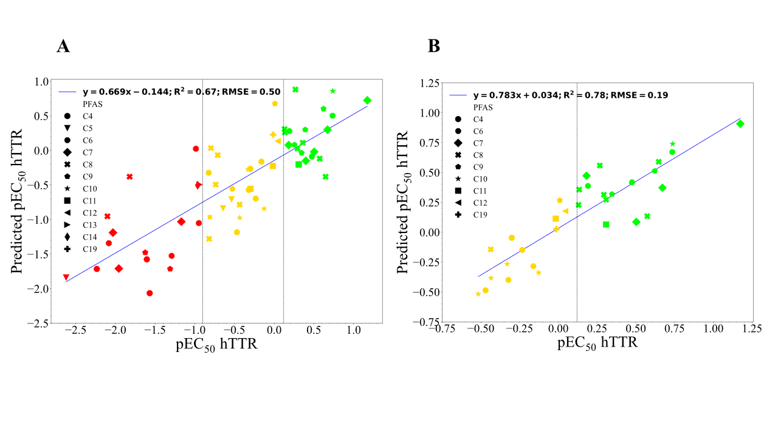
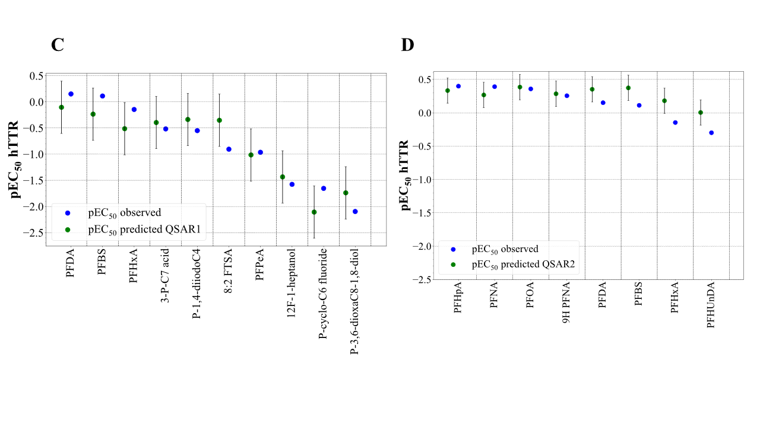
Figure 4. PFAS-hTTR QSAR models. (A) QSAR Model 1 derivation (training set); (B) QSAR model 2 derivation (training set); (C) QSAR model 1 validation (test set); (D) QSAR Model 2 validation (test set). (A, B) Green, yellow, and red correspond to strong, medium, and weak binders respectively.

DoA was defined for the QSAR models by Principal Component Analysis (PCA) (Figs. 5A and 5B). DoA for QSAR Model 1 is more extensive than the DoA for QSAR Model 2 (greater range on either PCA axis), reflecting the inclusion of lower affinity PFAS that are more structurally diverse. Smaller DoA for model 2, which is optimized for stronger binders likely indicates more specific structural parameters that favor binding. For both models, validation sets and tested chemicals GenX and ADONA are located well within the DoA (Fig. 5A, B).
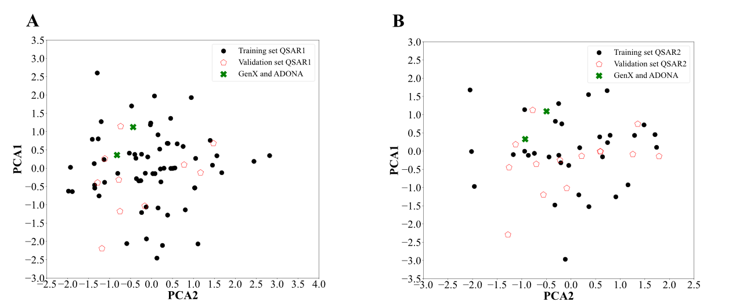
Figure 5. Principal component (PCA) analysis for QSAR Model 1 (A) and QSAR Model 2 (B).

Comparison with previous QSAR studies
The mechanism of TTR/T₄ displacement by PFAS has been investigated in several previously published QSAR models, which include classification and regression models (as summarized in Table S5). Weiss et al⁴² reported a TTR/PFAS experimental dataset but concluded that it was not sufficient for an effective regression QSAR (R² 0.61). In contrast, Kovarich et al.⁵⁵, Papa et al.⁵⁶, and Kar et al.⁵⁷ leveraged the same Weiss et al. dataset for better performing QSAR models (R² values for regression models 0.87-0.89). One notable difference between these studies and Weiss et al. was the inclusion of two-dimensional and three-dimensional descriptors.
In 2024, the Tox24 challenge took place focusing on the prediction of in vitro binding of multiple chemicals to TTR.^{69, 70} Seventy-eight teams used Tox21^{71, 72} and Degitz et al⁴⁴ datasets to create QSAR models for TTR binding, which were validated by blind testing with a separate set of 300 chemicals. The top two competitors chose machine learning algorithms for their best models/predictions: the winning team (Makarov et al.⁷³) used Transformer Convolutional Neural Networks (CNN)⁷⁴, and the second placed team (Cirino et al.⁷⁵) used Convolutional Neural Fingerprints (CNF2)⁷⁶, CNN⁷⁴ and Graph Neural Networks (GNN)⁷⁷. Makarov et al. chose an ensemble of four methodologies for their best performing model and included descriptors based on chemical mixtures, while Cirino et al. optimized their model by using tautomers, to help validate active compounds.^{70, 73, 75, 78} Both models used the Online CHEmical database and Modeling environment (OCHEM) to and submit their models.⁷⁹ Only the Makarov et al. model is included in Table S5, as the representative study of the Tox24 challenge.
Similar to the Tox24 challenge, Evangelista et al. expanded the training set to more than 200 heterogenous chemicals that included 14 PFAS (from Weiss et al.).⁴² Additional alternative approaches have been used. Zhao et al. constructed a TTR QSAR model based on developed docking scores (we experimented with a similarly constructed model in this study, see discussion below).⁵⁴ Sosnowska et al. utilized activity values from an in vitro reporter bioassay that would indirectly measure ligand binding to TTR as a basis for several QSAR models.⁴⁸ This study also investigated combining multiple regression models in a model suite to optimize prediction.
Despite differences in datasets and modeling approaches, there is some level of similarity in descriptors across QSAR models (Table S5) and models developed here. Some of common top descriptors, e.g. in Weiss et al.⁴², Makarov et al.⁷³, Zhang et al.⁵¹ and Zhao et al.⁵⁴ overlap with our choices, for example the topological surface area, molecular size and van-der-Waals interactions, potentially indicating important factors for effective binding. Surprisingly, despite using similar or significantly overlapping training sets and molecular descriptors derived from the same limited platforms (DRAGON, MOE or PaDEL), there is no overlap in top descriptors among models. Additional discussion of the important issue of the relevance of top QSAR descriptors to the TTR binding mechanism is included below.
One recurring challenge in developing effective QSAR models for TTR-PFAS binding is the presence of apparent outliers that could be due to the inherent non-uniformity of structurally diverse PFAS datasets. For instance, Weiss et al., excluded PFBS from the test set to improve the accuracy of the developed model. Similarly, Evangelista et al. excluded multiple PFAS outliers from the two PFAS-containing QSAR models.⁵⁸ Exclusion of outliers to improve model performance, however, may not be an optimal strategy as it would decrease the overall applicability domain of the model. In the present study, the same effect was observed, exacerbated by many structurally diverse PFAS in the dataset. Rather than developing a model for the best-performing PFAS subset (and excluding the worse performing PFAS as outliers), we chose a tiered model strategy: a more encompassing if less efficient model that can separate PFAS into low, medium and high binding categories, and the second highly efficient model that predicts binding affinity for medium and high binders. Evangelista et al. also ranked TTR disruptors as strong, moderate and weak binders, but that classification was based on relative potencies.⁵⁸ Both QSAR models predicted medium-high TTR binding potential for ADONA and GenX.
TTR docking models
PFAS-TTR docking models were developed using human structures and rat TTR co-crystalized with T₄.^{61, 62} Each structure has four T₄ subunits. hTTR has two equivalent binding sites, while rTTR has two non-identical binding sites. Fig. 3 demonstrates binding site 1 for human and rat TTRs (Figs. 3A and 3C, respectively) and Fig. S1 shows a complete description of both pockets. The docking scores for the hTTR-PFAS binding are provided in Table S7. A key stabilizing residue common to each structure is Lys15, which is consistent with a previous mutagenesis study, which found this residue to be essential for T₄ and PFAS binding in hTTR.⁴³ However, for rTTR (Fig. 3B) additional binding differences were observed: besides interacting with Lys15, T₄ formed a hydrogen bond with Glu54 via its NH₃⁺ group. This interaction results in the twist of T₄ NH₃⁺ group in the pocket compared to the human crystal structure, as detailed in Fig. S1. The geometries of the TTR/T₄ complexes and mutagenesis data for hTTR/T₄ binding (Lys15) were used to generate human and rat pharmacophores models for TTR ligand-binding sites (Fig. 3B and 3D). For hTTR, the pharmacophore model was used to generate docking poses for seventy-two PFAS, for which binding data are available from experiment.
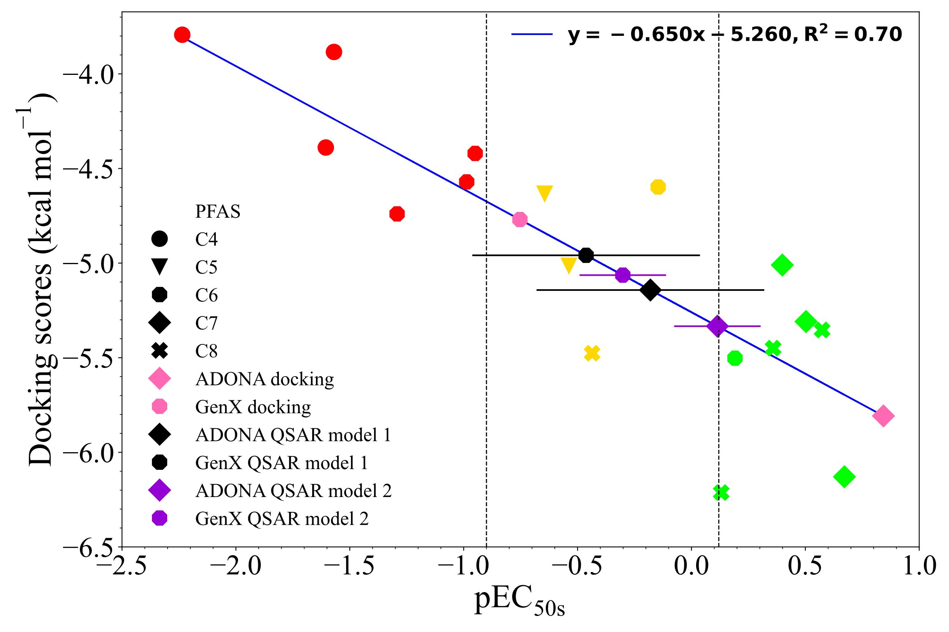
When the docking scores were compared to experimental binding data, the correlation was poor (Figs. S4 and S5). The correlation was slightly improved when only the docking scores below 6 kcal mol⁻¹ were included (Fig. S5). Specifically, PFSAs were generally overestimated (along with additional smaller PFAS) with predicted lower binding scores (more negative) despite having low binding affinities, resulting in the placement into an incorrect binding range. However, PFCAs containing four to eight carbons (17 compounds) showed a strong correlation between docking scores and pEC₅₀ values (R²=0.70, Fig. 6). This specificity suggests that the hTTR docking model is more reliable for PFCAs (N=4-8), highlighting the importance of ligand similarity for accurate predictions. In this model, ADONA and GenX resulted in docking scores of -5.808 and -4.770, respectively. Therefore, GenX falls in the medium binding range (-0.9 ≤ pEC₅₀ ≤ 0.12), while ADONA is classified as a strong binder (pEC₅₀ < -0.9).

Figure 6. Correlation plot between docking scores and experimental pEC₅₀ values for PFAS containing carboxylic groups (4 to 8 carbons). Green, yellow, and red correspond to strong, medium, and weak binders respectively. ADONA and GenX predictions are provided with docking (pink), and two different QSAR models (QSAR Model 1, black; QSAR Model 2, purple).

While previous studies have developed PFAS-hTTR docking models, they have not been formally (externally) validated.^{43, 50, 53, 54, 57} In contrast, the hTTR docking model generated here was based on mutagenesis evidence and moreover, it was successfully validated with two independently sourced human TTR-PFOA and TTR-PFOS crystal structures, which demonstrated nearly perfect overlap with the modeled hTTR-PFOA⁴⁹ and hTTR-PFOS⁵⁰ structures, providing strong support for the model’s accuracy.
Comparison of QSAR and docking approaches
In ligand-receptor experimental systems with available binding data (such as PFAS-hTTR), QSAR and docking models serve complimentary roles. QSAR models use structural and physicochemical descriptors to enable formal predictive analysis including the domain of applicability considerations. Docking models maximize the use of structural data (both for the receptor interface and the ligand) and serve as the foundation for molecular dynamics simulations by generating initial ligand-binding poses. In contrast, the domain of applicability of the docking model cannot be easily defined. To expand the structural applicability of the docking, molecular dynamics can be used to help refine binding poses and allow for more accurate calculation of binding energies. Moreover, the easy-to-interpret mechanistical insights derived from the docking and molecular dynamics models provide an interesting contrast to the important issue of the mechanistic interpretation of QSAR models, as described in Table 1 and detailed below.
The most recent update of the OECD QSAR assessment framework (2023)⁸⁰ lists plausibility of mechanistic interpretation of a QSAR model as one of the five essential principles to facilitate the consideration of a (Q)SAR model for regulatory purposes. For the equation-based models (such as those developed in this study), the mechanistic interpretation can be based on physicochemical interpretation of each descriptor and its association with the mechanism of action. ⁸⁰ Table 1 lists and explains three important mechanistic considerations of the PFAS/TTR binding mechanism (as we named them): “charge advantage”, “length limitation”, and “hydrophobicity disadvantage”. These considerations are supported by external evidence (mutational analysis for Lys 15), and by the human docking and molecular dynamics models. As demonstrated in Table 1, the interpretation that can be inferred between these mechanistic considerations and the top descriptors in the QSAR models developed in this study and the representative Makarov et al. PFAS/TTR QSAR model (winner of the Tox24 challenge) is somewhat limited. For example, the presence of oxygens (QSAR models in this study) or carboxyl groups (Makarov model) would only weakly point to the observed “charge advantage” (Table 1). From the regulatory perspective, the interpretability of the QSAR models included in Table 1 is more meaningful in the context of the corresponding docking and MD models.

QSAR models based on docking scores have been previously reported.^{54, 81-83} The limitations of this approach were demonstrated by a similar model experiment conducted in this study. The QSAR model for hTTR-PFAS was developed based on docking scores but only successfully converged when the training set was limited to carboxylates (Fig. 6). A similar attempted model with all PFAS resulted in a low R² (0.12) when predicted values were compared to observed (Fig. S4). We interpreted this result as an inability of this carboxylate (i.e., T₄)-based docking model to effectively capture distinct binding characteristics of non-carboxylate PFAS molecules compared to carboxylates. Thus, future improvements to QSAR models may include docking scores (as part of descriptor sets) but also explore multiple binding modes in developing chemical specific binding score predictions.
ADONA and GenX, two PFAS that are not included in the Degitz et al. TTR in vitro binding dataset, have been predicted to bind TTR in all in silico models developed in this study (Fig. 6). Interestingly, weak binding of GenX was reported in the study by Langberg et al.⁴⁶ Moreover, pregnant female rats exposed to GenX during gestation demonstrated reduced serum total T₄ levels⁸⁴, which is consistent with the proposed PFAS-mediated TTR/T₄ displacement mechanism. No in vivo data for thyroid hormone effects are available for ADONA.

Comparison of human and rat TTR-PFAS binding using molecular dynamics
Molecular dynamics simulations were performed for both human and rat TTR models, enabling direct structural interactions and calculating free binding energies between two species. The last frame for each of the PFOA and PFOS simulations in the human model was aligned with its respective crystal structures (Fig. 7), showing nearly perfect overlap and similar residue interactions, thereby validating the approach and the resulting docking models.
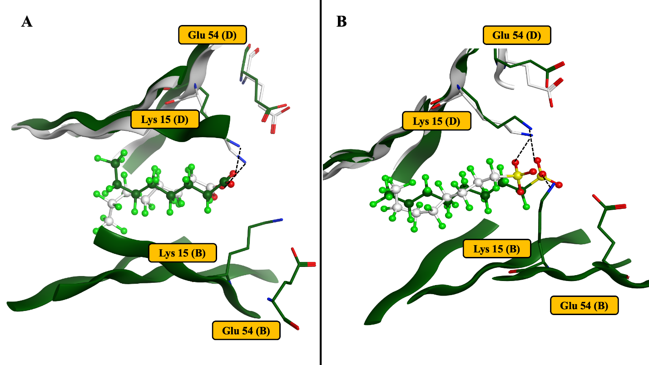
Figure 7. Representative modeled PFOA (A) and PFOS (B) binding poses (dark green) overlapped with TTR/PFOA and TTR/PFOS crystal structures (grey).^{49, 50} Modeled binding poses demonstrate excellent agreement with published structures.

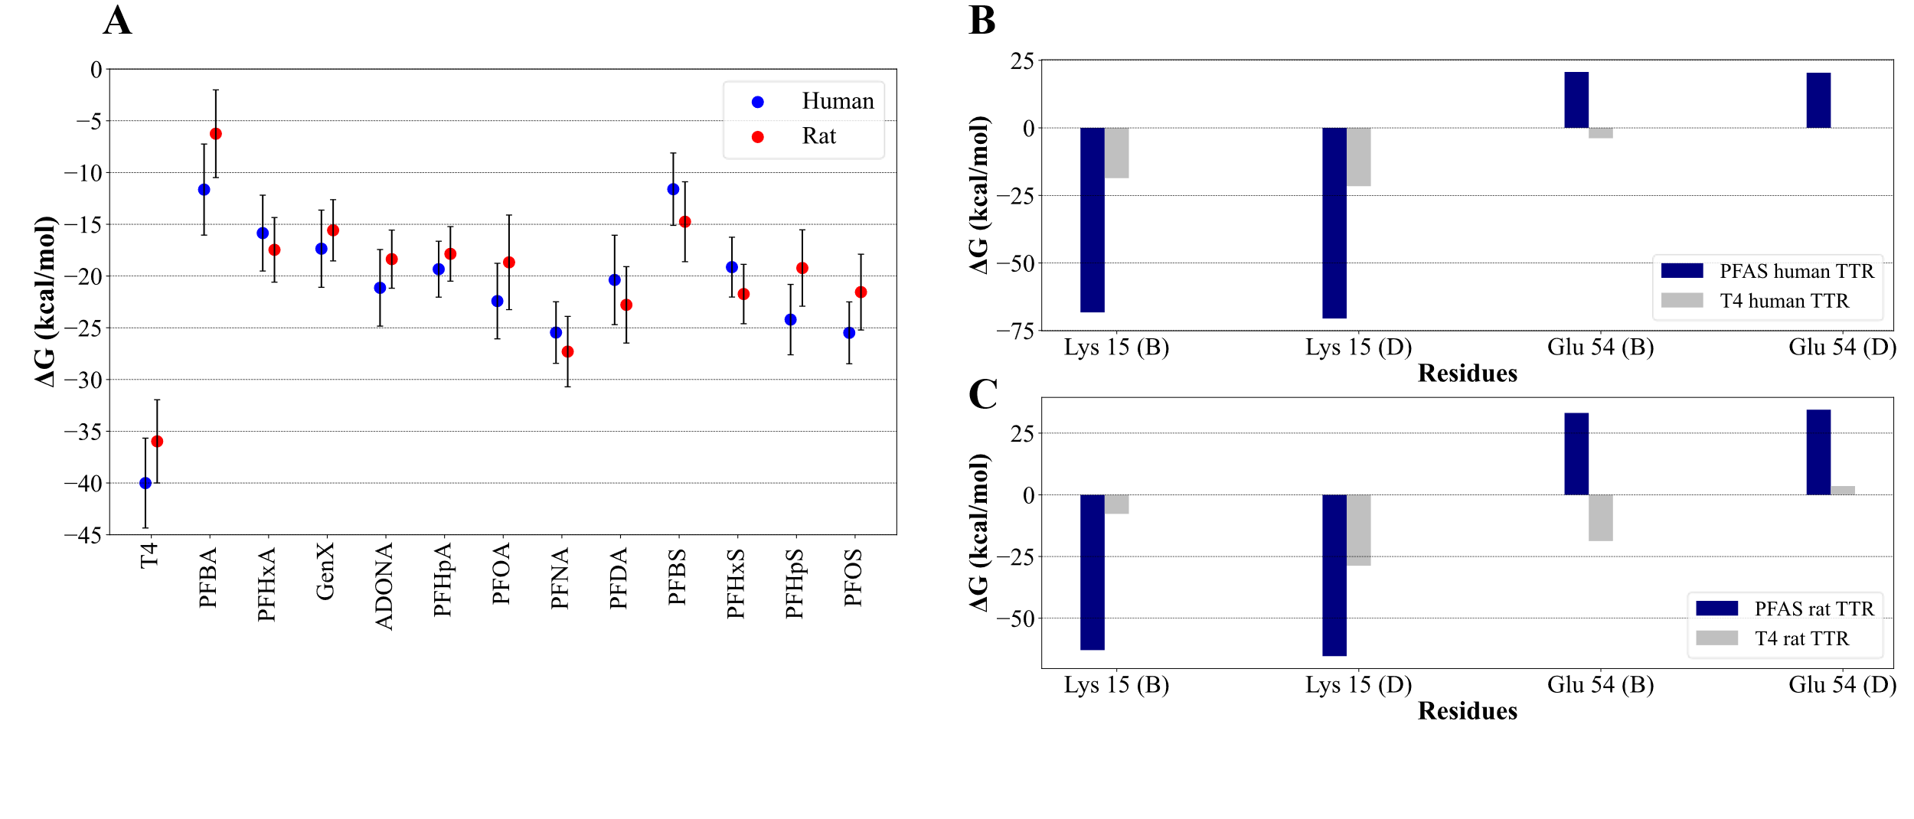
Human and rat models were simulated for 100 ns, and binding energies for each analyzed PFAS were estimated using MM-PBSA and compared between species (Fig. 8A). The MD simulations showed consistent and stable results, with converging RSMDs, both for the protein and the ligand (Figs. S6-S35). Protein RMSDs stabilized/plateaued around 2 Å within the first 5 ns for all simulated PFAS and T₄. The averaged binding energy for T₄ was -40.01 ± 4.34 kcal mol⁻¹ in the human model, -35.97±4.02 kcal mol⁻¹ for the rat binding pocket 1 and -36.14±3.97 kcal mol⁻¹ for the rat binding pocket 2 (Table S8). In the human model, short-chain PFAS (PFBA, PFBS) were relatively less stable in the pocket than longer-chain PFAS. For example, during hTTR MD simulation PFBA repeatedly broke the hydrogen bond with Lys15 resulting in a higher RMSD (Fig. S9). PFBS was also comparatively less stable, showing some movement within the pocket (Fig. S17). For rat, PFBA and PFBS were comparatively more stable within the pocket (Figs. S24 and S30, respectively). However, despite fewer stable poses with hTTR compared to rTTR, short chain PFAS (PFBS, PFBA) demonstrated comparable binding energies to these two proteins (Fig. 8A). The long-chain PFAS (PFHxA, PFHxS, PFHpA, PFHpS, PFOA, PFOS, PFNA, PFDA, ADONA and GenX) maintained stable poses within the pocket for both human and rat TTR models (Figs. S10-S16, S18-S20, S25-S29, S31-S35), consistent with their stronger binding affinities.
Figure 8. PFAS binding to hTTR and rTTR demonstrates similar binding energies and comparable contributions from individual amino acids. (A) Free binding energies calculated for human and rat models with MM-PBSA. Values are averages of three independent runs and bars are standard deviations (B, C) Comparison of residue decompositions for hTTR (B) and rTTR (C) between all PFAS bound averaged MD simulations and T₄ bound MD simulation. Letters B and D in parentheses after each amino acid refer to the two TTR subunits in the dimer.
A direct comparison of free binding energies across species (Fig. 8A) showed striking similarity between the human and rat models despite differences in their initial docking poses (Figs. 3A and 3C). This demonstrates cross-species similarity of TTR-PFAS binding, which is important for species extrapolation of toxicological outcomes. To further investigate this similarity, residue decomposition analysis was conducted for PFAS and T₄ simulations (Fig. 8B). Interestingly, in either hTTR or rTTR, T₄ binds very differently compared to PFAS. However, the PFAS interactions with individual residues were quite similar between the human and the rat models. A notable species difference was observed for T₄, which forms a strong hydrogen bond with Glu54 (subunit B) in rTTR but not in hTTR. For PFAS, the deprotonated acid group of Glu54 (subunit B) appears to repel PFAS more strongly for rTTR than for hTTR with the resulting higher positive contribution for rTTR (Fig. 8B). This could be due to this residue being located closer to the bound ligand in rTTR.
Comparison of predicted binding energies to in vivo toxicity
The difference between the calculated free binding energies (Fig. 8A) of PFAS and that of T₄ represents the free energy change of the PFAS-T₄ displacement and can be directly compared to the in vivo potency data for PFAS-induced reductions in serum T₄ levels in the male rat as evidence in support of the proposed AOP.⁴¹ This analysis would inform the applicability of the developed models to predict toxicity in vivo, specifically in the AOP context.
Better in vivo comparisons among PFAS are based on internal exposures (such as averaged serum concentration) to account for dramatic toxicokinetic differences among species and PFAS. ⁸⁵ Thus, toxicokinetic adjustments were applied to studied PFAS (PFBA, PFBS, PFHxA, PFHxS, PFOA, PFOS, PFNA and PFDA) as described in the Supporting information, and serum concentrations were expressed with two metrics: C_{max}, indicating maximum achieved plasma concentration during treatment, and TWA,time-weighted average serum concentration. Use of different internal metrics can further inform toxicity comparisons.
Available toxicity data for PFAS were reviewed.^{2, 9, 10, 17, 24, 25, 27-36} Most studies that analyzed thyroid effects reported some changes in thyroid hormone levels. Plasma and free T₄ levels were selected as primary endpoints, as these effects have been reported for most PFAS of interest in this study, and they are linked to the proposed PFAS-T₄ direct displacement mechanism. Male rats were chosen for this analysis since in female rats, thyroglobulin (and not TTR) has been previously found to be primarily responsible for serum T₄ stabilization.⁸⁶ Toxicity analysis included PFBA, PFBS, PFHxA, PFHxS, PFOA, PFOS, PFNA and PFDA. Applied doses were converted into effective serum concentrations (C_{max} and TWA), and the resulting dose-response data were analyzed by BMD analysis as described in Methods. The resulting benchmark dose values (BMDs) are considered appropriate metrics for potency comparisons among compounds. The correlation of BMDs with PFAS/TTR binding energies was analyzed with Bayesian linear regression. Variances (standard deviations) for the two arguments were included in this analysis. Variances for BMDs were derived from the 95th percentile upper and lower (BMDL, BMDU) from the ToxicR’s MCMC model average outputs. Variances for the binding energies were adopted from the selected MD simulations. Fit and validation metrics (including root mean squared error, RMSE; Bayesian R-squared; Widely Applicable Information Criterion, WAIC; and Leave-One-Out Cross-Validation, LOO CV) were calculated.
Predicted binding energy of PFAS to rTTR (averaged over a 90 ns MD simulation) correlated well with both C_{max} and TWA BMDs for the studied PFAS (Fig. 9A and 9B respectively). The strongest correlation was for C_{max} and free T₄ levels (Fig. 9A), which had a plausible biological slope (-2.3; 95% CI: -4 to -0.83) with an intercept of 4.06 (95% CI: 2.18 to 6.05) good R² (0.47 ±0.12) and low RMSE (1 uM). The performance with TWA was nearly equivalent, with a slope of -2.1 (95% CI: -3.6, -0.78) and an intercept of 3.67 (95% CI: 1.96 to 5.41), an R² values of 0.46 ±0.13, and an RMSE of 1 (Fig. 9B). The most important observation in these experiments is the statistically significant positive slope under conservative uncertainty assumptions. The simplified analysis of linear trend only using mean values is presented in Fig. S34. In this analysis, R² for linear trend was 0.649 for C_{max} vs binding energy, and 0.625 for TWA vs binding energy. In either approach (Fig. 9, Fig. S34), there were no clear differences in the goodness of fit between using C_{max} or TWA as metrics; thus, no conclusion can be made regarding the most appropriate metric.
Correlations developed for total T₄ with both metrics (C_{max} and TWA) were generally similar to the correlations for free T₄ despite fewer available data points for this endpoint among PFAS (data not shown). These findings support the PFAS-T₄ displacement mechanism as a rate-controlling step in the proposed AOP. Two additional considerations arise. Firstly, the mechanism appears to operate within PFAS as a group, since datapoints from multiple PFAS contribute to the observed correlation. Secondly, the displacement step could be rate-limiting (i.e., proportionally affecting the apical effects – observable outcomes) and therefore, may represent the Molecular Initiating Event (MIE) of this AOP.

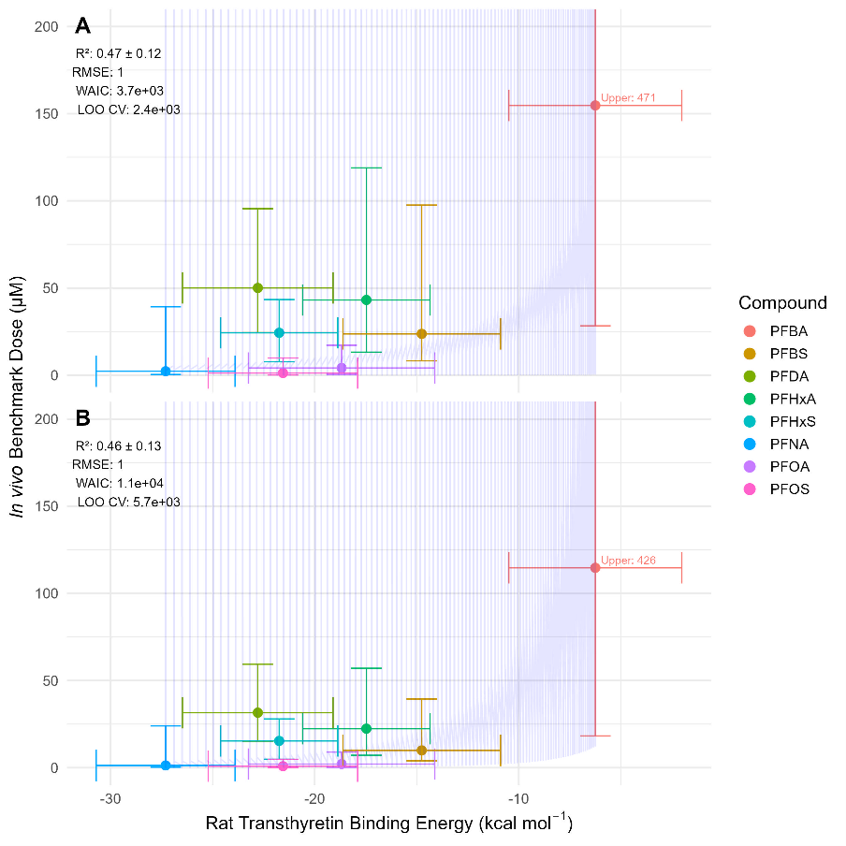
Figure 9 - PFAS/rTTR free binding energies correlate with in vivo points of departure (PODs) for serum free T₄ decreases in male rats. Free binding energies were calculated with molecular dynamic simulations. For toxicity studies, applied doses were converted to (A) maximum plasma concentrations (B) time averaged plasma concentrations and using PFAS-specific toxicokinetic models and converted to molar equivalents for comparison. Root mean squared error (RMSE), Bayesian R-squared, Widely Applicable Information Criterion (WAIC), and Leave-One-Out Cross-Validation (LOO CV).
Importantly, alternative mechanisms of thyroid toxicity have also been proposed for PFAS including inhibition of the Na⁺/I⁻ symporter and binding to the thyroid receptor.^{87, 88} Thus, the discussion of the underlying mechanisms of thyroid toxicity of PFAS is ongoing. While the AOP observations and evidence proposed here is for an animal model (male rat), they can also inform thyroid toxicity considerations of PFAS in humans, particularly since several available health evaluations for some PFAS (PFBS, PFHxA, PFHxS) from U.S. EPA and California’s Office of Environmental Health Hazard Assessment (OEHHA) are based on animal thyroid toxicity studies as the most sensitive endpoint. ^{2, 9, 10, 17, 24, 25, 27-36}
PFAS effects on thyroid hormone levels (T₃, T₄, TSH) have been extensively investigated in epidemiological studies.^{2, 9, 10, 28-33, 35} Some meta-analyses found mixed effects on T₃ and T₄ in the general population although one recent study found an overall TSH increase in pregnant females.^{89, 90} Most animal studies are conducted at higher PFAS doses compared to observed human exposures, which could be one reason for the difference with human data. Thus, in vitro binding data for PFOA and PFOS (as an example) indicates effective displacement at approximately 0.5 µM, which is about an order of magnitude higher than the higher end of reported plasma concentrations (approximately 10 ng mL⁻¹ or 0.025 µM) in most epidemiological studies.³⁴ Interestingly, in one occupational study Olsen et al. reported upper limit PFOA exposure at higher levels (maximum, 92 ng mL⁻¹) and found PFOA-dependent decreases in free T₄ when adjusted for PFOS (Olsen et al.).⁹¹ Thus, PFAS serum levels in general population studies appear to be generally below the TTR/PFAS displacement levels, although most analyses have not considered mixture effects, human variability, or sensitive subpopulations.
Final Remarks
Here, we developed TTR models (summarized in Table 2) to investigate the complexities of the proposed mechanism by which PFAS displace T₄ from TTR, and how this displacement correlates with in vivo reductions in plasma T₄ in male rat. Three fundamental aims were addressed: (1) evaluating species differences between human and rat TTR-PFAS interactions (using docking and MD models); (2) predicting binding potential using QSAR models; and (3) assessing how in silico predictions of rTTR-PFAS binding energies correlate with in vivo points of departure for PFAS-dependent T₄ decreases. This study demonstrated how docking/MD models and QSAR models can be complimentary in analyzing and predicting structural interaction of a ligand with its protein target.
Table 1. Comparison of T₄/PFAS binding site properties (as supported by Docking/MD conclusions) with applicable top descriptors in QSAR models (mechanistic relevance of QSAR models)
T₄/PFAS binding site properties | Supporting evidence from Docking/Molecular dynamics model | TTR-PFAS QSAR-1  TTR-PFAS QSAR-2 (this study) | Makarov et al. (2025)ª catBoost/AlogPS/  OEstate model
Primary stabilization through ionic bonds to Lys 15  “charge advantage” | Success of the pharmacophore model  Binding stabilization with Lys 15 (Fig. 8B) | Number of oxygens (a_nO, #5) | Polar surface area (PSA #4)  Carboxyl group (Se1C3O1a, #2)
Optimum molecule length for linear PFAS mimics T₄ molecular length^{b} (16 Å)  “length limitation” | Highest affinity is predicted for PFNA (15.6 Å – molecular length^{b}), lower affinity for short and long chained | Number of atoms (a_nc, a_count, #1, #3)  Molecule linearity (balabanJ, #8) | Molecular weight (MW, #8)
Spatially shifted PFAS binding site due to hydrophobic properties  “hydrophobicity disadvantage” | PFAS bind distinctly than T₄ and away from Ser 117 and Glu 54; minor/no stabilization from hydrophobic interactions | Lipophilicity (GCUT_SLOGP_3, #5)  van-der-Waals interactions (E_vdw, #4 in QSAR-2 only) | Lipophilicity (ALogPS_logP #1, ALogPS_logS #3)
ªWinner of the Tox24 Challenge
^{b} Maximum distance between any pair of atoms within the molecule

Table 2. TTR model comparisons
TTR model | Rationale | Main results/predictions | Interpretation/limitations
Human QSAR models | Maximize use of in vitro hTTR binding data | Predictive model with defined DoA  Prediction: ADONA, GenX | In tandem, models can be used to predict PFAS binding to hTTR
Human docking | Based on crystal structure  Use mutation data (Lys15) to design the TTR-PFAS pharmacophore and to improve docking approach | Basis for human MD model  Prediction: ADONA, GenX | Predicted hTTR-PFOA and hTTR-PFOS structures matched well with independently reported crystal structures  As prediction model: only 4-8 carbons PFCAs
Rat docking | Based on crystal structure | Basis for rat MD model | Limitation: no in vitro rTTR-PFAS data for validation
Human MD | Investigate interspecies (rat-human) differences in PFAS binding to TTR | Binding modes for human and rat TTR-PFAS appear similar | Limitation: time- and resource-consuming approach
Rat MD |  | Binding modes for human and rat TTR-PFAS appear similar | Limitation: time- and resource-consuming approach
Comparison with  free T₄↓  (in vivo) | Investigate TTR-PFAS displacement as a possible mechanism for free T₄↓ in male rats | Good correlation (R²=0.47±0.12; 0.46±0.13) was observed between in silico calculated rTTR-PFAS free binding energies and in vivo PODs for free plasma T₄ decrease in male rats | Developed in silico evidence is consistent with the AOP.  Limitation: empirically observed correlation

Supporting information
Tables:
Table S1 – All PFAS with available in vitro data from the Degitz et al dataset.; Table S2 – PFAS molecules used in QSAR model 1, along with experimental pEC₅₀ values from Degitz et al., predicted, and cross validated pEC₅₀ values; Table S3 – PFAS molecules used in QSAR model 2, along with experimental pEC₅₀ values from Degitz et al., predicted, and cross validated pEC₅₀ values; Table S4 – Toxicokinetic models and parameters used to estimate serum concentrations. Table S5 – QSAR comparison: Models that predict TTR/PFAS binding potencies; Table S6 – Top descriptors for QSAR models 1 and 2 (listed in other order of descending importance); Table S7 – PFAS used for docking models and corresponding pEC₅₀ values and docking scores; Table S8 – Averaged binding energies (100ns) for human and rat MC models.
Figures:
Figure S1 – Crystal structures for human and rat TTR; Figure S2 – QSAR model 1 cross validation data; Figure S3 – QSAR model 2 cross validation data; Figure S4 – All Docking scores versus pEC50s; Figure S5 - Docking scores (below 6 kcal mol⁻¹) versus pEC₅₀; Figure S6 – S33 – Human and rat RMSD plots (100ns).

Data Availability Statement
All human and rat TTR-PFAS poses, and molecular dynamics calculation files are made available upon request in Zenodo (DOI: 10.5281/zenodo.17059159).
Funding sources
This research project did not receive any specific financial grant from funding agencies in the public, commercial, or not-for-profit sectors.
Acknowledgments
This work was supported in part through computational resources and services provided by the Institute for Cyber-Enabled Research (ICER) at Michigan State University. We would like to thank Dr. Kimberly Gettmann (OEHHA) and Dr. Kannan Krishnan (OEHHA) for the thoughtful review of the manuscript.

References
(1) Gaines, L. G. T. Historical and current usage of per- and polyfluoroalkyl substances (PFAS): A literature review. American Journal of Industrial Medicine 2023, 66 (5), 353-378.
(2) United States Environmental Protection Agency. Final PFAS National Primary Drinking Water Regulation. 2024.
(3) Manzano-Salgado, C. B.; Casas, M.; Lopez-Espinosa, M.-J.; Ballester, F.; Basterrechea, M.; Grimalt, J. O.; Jiménez, A.-M.; Kraus, T.; Schettgen, T.; Sunyer, J. Transfer of perfluoroalkyl substances from mother to fetus in a Spanish birth cohort. Environmental research 2015, 142, 471-478.
(4) Fei, C.; McLaughlin, J. K.; Tarone, R. E.; Olsen, J. Perfluorinated chemicals and fetal growth: a study within the Danish National Birth Cohort. Environmental health perspectives 2007, 115 (11), 1677-1682.
(5) Cariou, R.; Veyrand, B.; Yamada, A.; Berrebi, A.; Zalko, D.; Durand, S.; Pollono, C.; Marchand, P.; Leblanc, J.-C.; Antignac, J.-P. Perfluoroalkyl acid (PFAA) levels and profiles in breast milk, maternal and cord serum of French women and their newborns. Environment international 2015, 84, 71-81.
(6) Apelberg, B. J.; Goldman, L. R.; Calafat, A. M.; Herbstman, J. B.; Kuklenyik, Z.; Heidler, J.; Needham, L. L.; Halden, R. U.; Witter, F. R. Determinants of fetal exposure to polyfluoroalkyl compounds in Baltimore, Maryland. Environmental science & technology 2007, 41 (11), 3891-3897.
(7) Fábelová, L.; Beneito, A.; Casas, M.; Colles, A.; Dalsager, L.; Den Hond, E.; Dereumeaux, C.; Ferguson, K.; Gilles, L.; Govarts, E.; et al. PFAS levels and exposure determinants in sensitive population groups. Chemosphere 2023, 313, 137530.
(8) Ode, A.; Rylander, L.; Lindh, C. H.; Källén, K.; Jönsson, B. A. G.; Gustafsson, P.; Olofsson, P.; Ivarsson, S. A.; Rignell-Hydbom, A. Determinants of maternal and fetal exposure and temporal trends of perfluorinated compounds. Environmental Science and Pollution Research 2013, 20 (11), 7970-7978.
(9) United States Environmental Protection Agency. FINAL Human Health Toxicity Assessment for Perfluorooctanoic Acid (PFOA) and Related Salts. U.S. Environmental Protection Agency Office of Water (4304T) Health and Ecological Criteria Division Washington, DC 20460: 2024; p 556.
(10) United States Environmental Protection Agency. FINAL Human Health Toxicity Assessment for Perfluorooctane Sulfonic Acid (PFOS) and Related Salts. U.S. Environmental Protection Agency Office of Water (4304T) Health and Ecological Criteria Division Washington, DC 20460: 2024; p 514.
(11) Commission Recommendation (EU) 2022/1431 of 24 August 2022 on the monitoring of perfluoroalkyl substances in food. In 32022H1431, EFSA, Ed.; Official Journal of the European Union 2022.
(12) Joerss, H.; Menger, F. The complex ‘PFAS world’ - How recent discoveries and novel screening tools reinforce existing concerns. Current Opinion in Green and Sustainable Chemistry 2023, 40, 100775.
(13) Ateia, M.; Scheringer, M. From “forever chemicals” to fluorine-free alternatives. Science 2024, 385 (6706), 256-258.
(14) Corsini, E.; Iulini, M.; Galbiati, V.; Maddalon, A.; Pappalardo, F.; Russo, G.; Hoogenboom, R. L. A. P.; Beekmann, K.; Janssen, A. W. F.; Louisse, J.; et al. EFSA Project on the use of NAMs to explore the immunotoxicity of PFAS. EFSA Supporting Publications 2024, 21 (8), 8926E.
(15) Carstens, K. E.; Freudenrich, T.; Wallace, K.; Choo, S.; Carpenter, A.; Smeltz, M.; Clifton, M. S.; Henderson, W. M.; Richard, A. M.; Patlewicz, G.; et al. Evaluation of Per- and Polyfluoroalkyl Substances (PFAS) In Vitro Toxicity Testing for Developmental Neurotoxicity. Chemical Research in Toxicology 2023, 36 (3), 402-419.
(16) Patlewicz, G.; Judson, R. S.; Williams, A. J.; Butler, T.; Barone, S.; Carstens, K. E.; Cowden, J.; Dawson, J. L.; Degitz, S. J.; Fay, K.; et al. Development of chemical categories for per- and polyfluoroalkyl substances (PFAS) and the proof-of-concept approach to the identification of potential candidates for tiered toxicological testing and human health assessment. Computational Toxicology 2024, 31, 100327.
(17) United States Department of Health and Human Services. Toxicological Profile for Perfluoroalkyls. Agency for Toxic Substances and Disease Registry: 2021.
(18) Zeng, Z.; Song, B.; Xiao, R.; Zeng, G.; Gong, J.; Chen, M.; Xu, P.; Zhang, P.; Shen, M.; Yi, H. Assessing the human health risks of perfluorooctane sulfonate by in vivo and in vitro studies. Environ Int 2019, 126, 598-610.
(19) Zheng, J.; Liu, S.; Yang, J.; Zheng, S.; Sun, B. Per- and polyfluoroalkyl substances (PFAS) and cancer: Detection methodologies, epidemiological insights, potential carcinogenic mechanisms, and future perspectives. Science of The Total Environment 2024, 953, 176158.
(20) Ríos-Bonilla, K. M.; Aga, D. S.; Lee, J.; König, M.; Qin, W.; Cristobal, J. R.; Atilla-Gokcumen, G. E.; Escher, B. I. Neurotoxic Effects of Mixtures of Perfluoroalkyl Substances (PFAS) at Environmental and Human Blood Concentrations. Environmental Science & Technology 2024, 58 (38), 16774-16784.
(21) Butenhoff, J. L.; Bjork, J. A.; Chang, S. C.; Ehresman, D. J.; Parker, G. A.; Das, K.; Lau, C.; Lieder, P. H.; van Otterdijk, F. M.; Wallace, K. B. Toxicological evaluation of ammonium perfluorobutyrate in rats: twenty-eight-day and ninety-day oral gavage studies. Reprod Toxicol 2012, 33 (4), 513-530.
(22) Ramhøj, L.; Hass, U.; Boberg, J.; Scholze, M.; Christiansen, S.; Nielsen, F.; Axelstad, M. Perfluorohexane Sulfonate (PFHxS) and a Mixture of Endocrine Disrupters Reduce Thyroxine Levels and Cause Antiandrogenic Effects in Rats. Toxicol Sci 2018, 163 (2), 579-591.
(23) Coperchini, F.; Croce, L.; Ricci, G.; Magri, F.; Rotondi, M.; Imbriani, M.; Chiovato, L. Thyroid Disrupting Effects of Old and New Generation PFAS. Front Endocrinol (Lausanne) 2020, 11, 612320.
(24) NTP Technical Report on the Toxicity Studies of Perfluoroalkyl Carboxylates (Perfluorohexanoic Acid, Perfluorooctanoic Acid, Perfluorononanoic Acid, and Perfluorodecanoic Acid) Administered by Gavage to Sprague Dawley (Hsd: Sprague Dawley SD) Rats (Revised). Program, N. T., Ed.; 2022.
(25) Toxicity studies of perfluoroalkyl sulfonates administered by gavage to Sprague Dawley (Hsd: Sprague Dawley SD) rats. In Toxicity Report Series 96, Program, N. T., Ed.; 2019.
(26) Coperchini, F.; Croce, L.; Denegri, M.; Pignatti, P.; Agozzino, M.; Netti, G. S.; Imbriani, M.; Rotondi, M.; Chiovato, L. Adverse effects of in vitro GenX exposure on rat thyroid cell viability, DNA integrity and thyroid-related genes expression. Environ Pollut 2020, 264, 114778.
(27) United States Environmental Protection Agency. Human Health Toxicity Assessment for GenX Chemicals. 2021.
(28) United States Environmental Protection Agency. IRIS Toxicological Review of Perfluorobutanoic Acid (PFBA, CASRN 375-22-4) and Related Salts. Integrated Risk Information System Center for Public Health and Environmental Assessment Office of Research and Development U.S. Environmental Protection Agency Washington, DC: 2022.
(29) United States Environmental Protection Agency. IRIS Toxicological Review of Perfluorohexanoic Acid [PFHxA, CASRN 307-24-4] and Related Salts. Integrated Risk Information System Center for Public Health and Environmental Assessment Office of Research and Development U.S. Environmental Protection Agency Washington, DC: 2023.
(30) United States Environmental Protection Agency. IRIS Toxicological Review of Perfluorodecanoic Acid (PFDA) and Related Salts CASRN 335-76-2. Integrated Risk Information System Center for Public Health and Environmental Assessment Office of Research and Development U.S. Environmental Protection Agency Washington, DC: 2024.
(31) United States Environmental Protection Agency. IRIS Toxicological Review of Perfluorohexanesulfonic Acid (PFHxS, CASRN 335-46-4) and Related Salts. Integrated Risk Information System Center for Public Health and Environmental Assessment Office of Research and Development U.S. Environmental Protection Agency Washington, DC: 2025.
(32) OEHHA. Notification Level Recommendation for Perfluorobutane Sulfonic Acid (PFBS) in Drinking Water. Office of Environmental Health Hazard Assessment, California Environmental Protection Agency: 2021.
(33) OEHHA. Notification Level Recommendation for Perfluorohexane Sulfonic Acid (PFHxS) in Drinking Water. Office of Environmental Health Hazard Assessment, California Environmental Protection Agency: 2022.
(34) OEHHA. Public Health Goals for Perfluorooctanoic Acid and Perfluorooctane Sulfonic Acid in Drinking Water. Office of Environmental Health Hazard Assessment, California Environmental Protection Agency: 2024.
(35) OEHHA. Notification Level Recommendation for Perfluorohexanoic Acid (PFHxA) in Drinking Water. Office of Environmental Health Hazard Assessment, California Environmental Protection Agency: 2024.
(36) United States Environmental Protection Agency. Maximum Contaminant Level Goals (MCLGs) for Three Individual Per- and Polyfluoroalkyl Substances (PFAS) and a Mixture of Four PFAS. U.S. Environmental Protection Agency Office of Water (4304T) Office of Science and Technology Health and Ecological Criteria Division Washington, DC 20460: 2024; pp EPA-815-R-824-004
(37) Miller, M. D.; Crofton, K. M.; Rice, D. C.; Zoeller, R. T. Thyroid-disrupting chemicals: interpreting upstream biomarkers of adverse outcomes. Environ Health Perspect 2009, 117 (7), 1033-1041.
(38) Olsen, G. W.; Burris, J. M.; Burlew, M. M.; Mandel, J. H. Epidemiologic Assessment of Worker Serum Perfluorooctanesulfonate (PFOS) and Perfluorooctanoate (PFOA) Concentrations and Medical Surveillance Examinations. Journal of Occupational and Environmental Medicine 2003, 45 (3).
(39) Tan, K.; Zhang, Q.; Wang, Y.; Wang, C.; Hu, C.; Wang, L.; Liu, H.; Tian, Z. Associations between per- and polyfluoroalkyl substances exposure and thyroid hormone levels in the elderly. Science of The Total Environment 2024, 920, 170761.
(40) Noyes, T. S.; Abington, L. M.; van ‘t Erve, T. J.; Wang, L.; McDonald, J. M.; Wasilevich, E. A.; Gray, J. S.; Karrer, T. A.; Smith, K.; Bailey, J. M. Per and polyfluoroalkyl substances affect thyroid hormones for people with a history of exposure from drinking water. Scientific Reports 2025, 15 (1), 12502.
(41) Janus, E. R.; Sullivan, K.; Paul-Friedman, K.; Gilbert, M.; Crofton, K. M.; Zalm, A. v. d. Interference with thyroid serum binding protein transthyretin and subsequent adverse human neurodevelopmental toxicity. 2023.
(42) Weiss, J. M.; Andersson, P. L.; Lamoree, M. H.; Leonards, P. E.; van Leeuwen, S. P.; Hamers, T. Competitive binding of poly- and perfluorinated compounds to the thyroid hormone transport protein transthyretin. Toxicol Sci 2009, 109 (2), 206-216.
(43) Ren, X.-M.; Qin, W.-P.; Cao, L.-Y.; Zhang, J.; Yang, Y.; Wan, B.; Guo, L.-H. Binding interactions of perfluoroalkyl substances with thyroid hormone transport proteins and potential toxicological implications. Toxicology 2016, 366-367, 32-42.
(44) Degitz, S. J.; Olker, J. H.; Denny, J. S.; Degoey, P. P.; Hartig, P. C.; Cardon, M. C.; Eytcheson, S. A.; Haselman, J. T.; Mayasich, S. A.; Hornung, M. W. In vitro screening of per- and polyfluorinated substances (PFAS) for interference with seven thyroid hormone system targets across nine assays. Toxicol In Vitro 2024, 95, 105762.
(45) Eytcheson, S. A.; Zosel, A. D.; Olker, J. H.; Hornung, M. W.; Degitz, S. J. Screening the ToxCast Chemical Libraries for Binding to Transthyretin. Chem Res Toxicol 2024.
(46) Langberg, H. A.; Choyke, S.; Hale, S. E.; Koekkoek, J.; Cenijn, P. H.; Lamoree, M. H.; Rundberget, T.; Jartun, M.; Breedveld, G. D.; Jenssen, B. M.; et al. Effect‐Directed Analysis Based on Transthyretin Binding Activity of Per‐ and Polyfluoroalkyl Substances in a Contaminated Sediment Extract. Environmental Toxicology and Chemistry 2024, 43 (2), 245-258.
(47) Hamers, T.; Kortenkamp, A.; Scholze, M.; Molenaar, D.; Cenijn, P. H.; Weiss, J. M. Transthyretin-Binding Activity of Complex Mixtures Representing the Composition of Thyroid-Hormone Disrupting Contaminants in House Dust and Human Serum. Journal Environmental Health Perspectives 2020, 128 (1).
(48) Sosnowska, A.; Mudlaff, M.; Mombelli, E.; Behnisch, P.; Zdybel, S.; Besselink, H.; Kuckelkorn, J.; Bulawska, N.; Kepka, K.; Kowalska, D.; et al. Identification of new PFAS for severe interference with thyroid hormone transport: A combined in vitro/silico approach. Journal of Hazardous Materials 2025, 491.
(49) Zhang, J.; Grundström, C.; Brännström, K.; Iakovleva, I.; Lindberg, M.; Olofsson, A.; Andersson, P. L.; Sauer-Eriksson, A. E. Interspecies Variation between Fish and Human Transthyretins in Their Binding of Thyroid-Disrupting Chemicals. Environmental Science & Technology 2018, 52 (20), 11865-11874.
(50) Zhang, J.; Begum, A.; Brännström, K.; Grundström, C.; Iakovleva, I.; Olofsson, A.; Sauer-Eriksson, A. E.; Andersson, P. L. Structure-Based Virtual Screening Protocol for in Silico Identification of Potential Thyroid Disrupting Chemicals Targeting Transthyretin. Environmental Science & Technology 2016, 50 (21), 11984-11993.
(51) Zhang, J.; Kamstra, J. H.; Ghorbanzadeh, M.; Weiss, J. M.; Hamers, T.; Andersson, P. L. In Silico Approach To Identify Potential Thyroid Hormone Disruptors among Currently Known Dust Contaminants and Their Metabolites. Environmental Science & Technology 2015, 49 (16), 10099-10107.
(52) Dharpure, R.; Pramanik, S.; Pradhan, A. In silico analysis decodes transthyretin (TTR) binding and thyroid disrupting effects of per- and polyfluoroalkyl substances (PFAS). Arch Toxicol 2023, 97 (3), 755-768.
(53) Tiburtini, G. A.; Bertarini, L.; Bersani, M.; Dragani, T. A.; Rolando, B.; Binello, A.; Barge, A.; Spyrakis, F. In silico prediction of the interaction of legacy and novel per- and poly-fluoroalkyl substances (PFAS) with selected human transporters and of their possible accumulation in the human body. Archives of Toxicology 2024, 98 (9), 3035-3047.
(54) Zhao, L.; Zhang, Z.; Su, H.; Zhang, W.; Sun, J.; Li, Y.; Teng, M. Molecular docking–QSAR–Kronecker-regularized least squares-based multiple machine learning for assessment and prediction of PFAS–protein binding interactions. Journal of Hazardous Materials 2025, 492, 138069.
(55) Kovarich, S.; Papa, E.; Li, J.; Gramatica, P. QSAR classification models for the screening of the endocrine-disrupting activity of perfluorinated compounds. SAR and QSAR in Environmental Research 2012, 23 (3-4), 207-220.
(56) Papa, E.; Kovarich, S.; Gramatica, P. QSAR prediction of the competitive interaction of emerging halogenated pollutants with human transthyretin. SAR and QSAR in Environmental Research 2013, 24 (4), 333-349.
(57) Kar, S.; Sepulveda, M. S.; Roy, K.; Leszczynski, J. Endocrine-disrupting activity of per- and polyfluoroalkyl substances: Exploring combined approaches of ligand and structure based modeling. Chemosphere 2017, 184, 514-523.
(58) Evangelista, M.; Chirico, N.; Papa, E. In silico models for the screening of human transthyretin disruptors. Journal of Hazardous Materials 2024, 480, 136188.
(59) Buglewicz, D. J.; Staub, R.; Chang, D. T.; Evoli, S.; Schumann, P. G.; Cole, A. R.; Olker, J. H.; LaLone, C. A. Using molecular dynamics simulation to enhance conservation analysis for cross species extrapolation of the PFOA-Transthyretin interaction. Environmental Toxicology and Chemistry 2025.
(60) Molecular Operating Environment (MOE) 2022; Chemical Computing Group ULC, 910-1010 Sherbrooke St. W., Montreal, QC H3A: (accessed May 2024).
(61) Wojtczak, A.; Neumann, P.; Cody, V. Structure of a new polymorphic monoclinic form of human transthyretin at 3 A resolution reveals a mixed complex between unliganded and T4-bound tetramers of TTR. Acta Crystallographica Section D 2001, 57 (7), 957-967.
(62) Wojtczak, A.; Cody, V.; Luft, J. R.; Pangborn, W. Structure of rat transthyretin (rTTR) complex with thyroxine at 2.5 A resolution: first non-biased insight into thyroxine binding reveals different hormone orientation in two binding sites. Acta Crystallographica Section D 2001, 57 (8), 1061-1070.
(63) Labute, P. Protonate3D: assignment of ionization states and hydrogen coordinates to macromolecular structures. Proteins 2009, 75 (1), 187-205.
(64) D.A. Case, H. M. A., K. Belfon, I.Y. Ben-Shalom, J.T. Berryman, S.R. Brozell, D.S. Cerutti, T.E.; Cheatham, I., G.A. Cisneros, V.W.D. Cruzeiro, T.A. Darden, R.E. Duke, G. Giambasu, M.K. Gilson, H.; Gohlke, A. W. G., R. Harris, S. Izadi, S.A. Izmailov, K. Kasavajhala, M.C. Kaymak, E. King, A. Kovalenko, T. Kurtzman, T.S. Lee, S. LeGrand, P. Li, C. Lin, J. Liu, T. Luchko, R. Luo, M. Machado, V.; Man, M. M., K.M. Merz, Y. Miao, O. Mikhailovskii, G. Monard, H. Nguyen, K.A. O’Hearn, A.; Onufriev, F. P., S. Pantano, R. Qi, A. Rahnamoun, D.R. Roe, A. Roitberg, C. Sagui, S. Schott-Verdugo,; A. Shajan, J. S., C.L. Simmerling, N.R. Skrynnikov, J. Smith, J. Swails, R.C. Walker, J. Wang, J. Wang,; H. Wei, R. M. W., X. Wu, Y. Xiong, Y. Xue, D.M. York, S. Zhao, and P.A. Kollman. Amber2022. University of California, San Francisco 2022.
(65) Onufriev, A.; Bashford, D.; Case, D. A. Exploring protein native states and large-scale conformational changes with a modified generalized born model. Proteins: Structure, Function, and Bioinformatics 2004, 55 (2), 383-394.
(66) Roe, D. R.; Cheatham, T. E., III. PTRAJ and CPPTRAJ: Software for Processing and Analysis of Molecular Dynamics Trajectory Data. Journal of Chemical Theory and Computation 2013, 9 (7), 3084-3095.
(67) Wheeler, M. W.; Lim, S.; House, J. S.; Shockley, K. R.; John Bailer, A.; Fostel, J.; Yang, L.; Talley, D.; Raghuraman, A.; Gift, J. S.; et al. ToxicR: A computational platform in R for computational toxicology and dose–response analyses. Computational Toxicology 2023, 25, 100259.
(68) Bürkner, P.-C. brms: An R Package for Bayesian Multilevel Models Using Stan. Journal of Statistical Software 2017, 80 (1), 1 - 28.
(69) Tetko, I. V. Tox24 Challenge. Chemical Research in Toxicology 2024, 37 (6), 825-826.
(70) Eytcheson, S. A.; Tetko, I. V. Which Modern AI Methods Provide Accurate Predictions of Toxicological End Points? Analysis of Tox24 Challenge Results. Chemical Research in Toxicology 2025, 38 (9), 1443-1451.
(71) Richard, A. M.; Tao, D.; LeClair, C. A.; Leister, W.; Tretyakov, K. V.; White, E. V.; Lewis, K. C.; Sefler, A.; Shinn, P.; Collins, B. J.; et al. Analytical Quality Evaluation of the Tox21 Compound Library. Chemical Research in Toxicology 2025, 38 (1), 15-41.
(72) Richard, A. M.; Huang, R.; Waidyanatha, S.; Shinn, P.; Collins, B. J.; Thillainadarajah, I.; Grulke, C. M.; Williams, A. J.; Lougee, R. R.; Judson, R. S.; et al. The Tox21 10K Compound Library: Collaborative Chemistry Advancing Toxicology. Chemical Research in Toxicology 2021, 34 (2), 189-216.
(73) Makarov, D. M.; Ksenofontov, A. A. B., Yury A. Consensus Modeling for Predicting Chemical Binding to Transthyretin as the Winning Solution of the Tox24 Challenge. Chemical Research in Toxicology 2025, 38 (3), 392-399.
(74) Karpov, P.; Godin, G.; Tetko, I. V. Transformer-CNN: Swiss knife for QSAR modeling and interpretation. Journal of Cheminformatics 2020, 12 (1), 17.
(75) Cirino, T.; Pinto, L.; Iwan, M.; Dougha, A.; Lučić, B.; Kraljević, A.; Navoyan, Z.; Tevosyan, A.; Yeghiazaryan, H.; Khondkaryan, L.; et al. Consensus Modeling Strategies for Predicting Transthyretin Binding Affinity from Tox24 Challenge Data. Chemical Research in Toxicology 2025, 38 (6), 1061-1071.
(76) Makarov, D. M.; Fadeeva, Y. A.; Shmukler, L. E.; Tetko, I. V. Machine learning models for phase transition and decomposition temperature of ionic liquids. Journal of Molecular Liquids 2022, 366, 120247.
(77) Scarselli, F.; Gori, M.; Tsoi, A. C.; Hagenbuchner, M.; Monfardini, G. The Graph Neural Network Model. IEEE Transactions on Neural Networks 2009, 20 (1), 61-80.
(78) Pan, X.; Gu, Y.; Zhou, W.; Zhang, Y. Enhancing Transthyretin Binding Affinity Prediction with a Consensus Model: Insights from the Tox24 Challenge. Chemical Research in Toxicology 2025, 38 (5), 900-908.
(79) Sushko, I.; Novotarskyi, S.; Körner, R.; Pandey, A. K.; Rupp, M.; Teetz, W.; Brandmaier, S.; Abdelaziz, A.; Prokopenko, V. V.; Tanchuk, V. Y.; et al. Online chemical modeling environment (OCHEM): web platform for data storage, model development and publishing of chemical information. Journal of Computer-Aided Molecular Design 2011, 25 (6), 533-554.
(80) OECD. (Q)SAR Assessment Framework: Guidance for the regulatory assessment of (Quantitative) Structure - Activity Relationship models, predictions, and results based on multiple predictions, OECD Series on Testing and Assessment. Environment, Health and Safety, Environment Directorate, OECD.: 2023.
(81) Vilar, S.; Costanzi, S. Predicting the Biological Activities Through QSAR Analysis and Docking-Based Scoring. In Membrane Protein Structure and Dynamics: Methods and Protocols, Vaidehi, N., Klein-Seetharaman, J. Eds.; Humana Press, 2012; pp 271-284.
(82) Daoui, O.; Elkhattabi, S.; Chtita, S.; Elkhalabi, R.; Zgou, H.; Benjelloun, A. T. QSAR, molecular docking and ADMET properties in silico studies of novel 4,5,6,7-tetrahydrobenzo[D]-thiazol-2-Yl derivatives derived from dimedone as potent anti-tumor agents through inhibition of C-Met receptor tyrosine kinase. Heliyon 2021, 7 (7), e07463.
(83) Vilar, S.; Costanzi, S. Predicting the biological activities through QSAR analysis and docking-based scoring. (1940-6029 (Electronic)).
(84) Conley, J. M.; Lambright, C. S.; Evans, N.; Medlock-Kakaley, E.; Dixon, A.; Hill, D.; McCord, J.; Strynar, M. J.; Ford, J.; Gray, L. E. Cumulative maternal and neonatal effects of combined exposure to a mixture of perfluorooctanoic acid (PFOA) and perfluorooctane sulfonic acid (PFOS) during pregnancy in the Sprague-Dawley rat. Environment International 2022, 170, 107631.
(85) Pizzurro, D. M.; Seeley, M.; Kerper, L. E.; Beck, B. D. Interspecies differences in perfluoroalkyl substances (PFAS) toxicokinetics and application to health-based criteria. Regulatory Toxicology and Pharmacology 2019, 106, 239-250.
(86) Emerson, C. H.; Cohen, J. H., III; Young, R. A.; Alex, S.; Fang, S.-L. Gender-related differences of serum thyroxine-binding proteins in the rat. Acta Endocrinologica 1990, 123 (1), 72-78.
(87) Li, S.; Qin, S.; Zeng, H.; Chou, W.; Oudin, A.; Kanninen, K. M.; Jalava, P.; Dong, G.; Zeng, X. Adverse outcome pathway for the neurotoxicity of per- and polyfluoroalkyl substances: A systematic review. Eco-Environment & Health 2024, 3 (4), 476-493.
(88) Du, X.; Wu, Y.; Tao, G.; Xu, J.; Du, Z.; Wu, M.; Gu, T.; Xiong, J.; Xiao, S.; Wei, X.; et al. Association between PFAS exposure and thyroid health: A systematic review and meta-analysis for adolescents, pregnant women, adults and toxicological evidence. Science of The Total Environment 2024, 953, 175958.
(89) Zhang, B.; Zhao, M.; Cong, X.; Liu, C.; Li, C.; Qiu, Y.; Li, S.; Chen, Y.; Li, X.; Li, P. The Association Between Per- and Polyfluoroalkyl Substances Exposure and Thyroid Hormones in Men and Non-Pregnant Women: A Systematic Review and Meta-Analysis. Toxics 2025, 13 (3), 214.
(90) Boesen, S. A. H.; Long, M.; Wielsøe, M.; Mustieles, V.; Fernandez, M. F.; Bonefeld-Jørgensen, E. C. Exposure to Perflouroalkyl acids and foetal and maternal thyroid status: a review. Environmental Health 2020, 19 (1), 107.
(91) Olsen, G. W.; Zobel, L. R. Assessment of lipid, hepatic, and thyroid parameters with serum perfluorooctanoate (PFOA) concentrations in fluorochemical production workers. International Archives of Occupational and Environmental Health 2007, 81 (2), 231-246.

