Федеральное государственное бюджетное
образовательное учреждение высшего образования
«Новосибирский государственный технический университет»

Кафедра прикладной математики

Лабораторная работа № 2

по дисциплине «Нейросети»

Обучение нейросети на своем датасете
 | Бригада 4 | Костовский владимир
 | Группа ПМ-23 | мандалов бато
 |  | тривайлов виталий
 | Преподаватель | Ступаков илья михайлович
Новосибирск, 2026

Разобрать туториал по классификации изображений. Выбрать себе задачу, собрать свой датасет и использовать его для обучения. Провести исследования влияния гиперпараметров и размера обучающей выборки на качество модели.
Требования:
- Датасет должен быть от 4 до 10 классов, 50-100 изображений на класс. Классы не должны быть различимы только по цвету или размеру.
- Должно быть разбиение на train, test и validation части (каждая не менее 10 изображений на класс).
- Гиперпараметры - learning rate, batch size, способ обучения (Finetuning/Feature Extractor).
- Для всех исследований должны быть приведены графики loss на train и validation, и метрики точности.
Обучение моделей
exp1_default
Epoch | Train |  | Val |  |  | Test Accuracy: | 97.50%
 | Loss | Acc | Loss | Acc |  | Accuracy of kirby: | 100.00%
0 | 1.2299 | 0.4478 | 0.8213 | 0.7288 |  | Accuracy of pink  panther: | 100.00%
1 | 0.5910 | 0.8586 | 0.4094 | 0.9153 |  | Accuracy of pinkie pie: | 100.00%
2 | 0.3955 | 0.8855 | 0.2639 | 0.8983 |  | Accuracy of slowpoke: | 90.00%
3 | 0.3679 | 0.8620 | 0.1739 | 0.9492
4 | 0.2772 | 0.9024 | 0.1632 | 0.9661
5 | 0.2866 | 0.9057 | 0.1506 | 0.9831
6 | 0.1842 | 0.9461 | 0.1300 | 0.9661
7 | 0.1634 | 0.9495 | 0.1310 | 0.9661
8 | 0.1717 | 0.9428 | 0.1239 | 0.9661
9 | 0.1472 | 0.9630 | 0.1238 | 0.9661
TIME: | 1m 4s
Best val Acc: | 0.983051
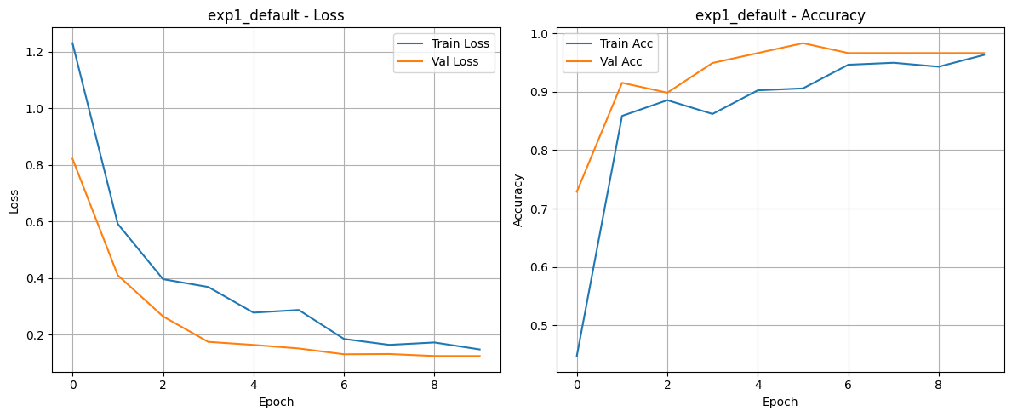
Test Accuracy: 97.50%
Исследование на другой архитектуре ResNet50

arch_resnet50
Epoch | Train |  | Val |  |  | Test Accuracy: | 97.50%
 | Loss | Acc | Loss | Acc |  | Accuracy of kirby: | 100.00%
0 | 1.2509 | 0.4343 | 0.7535 | 0.7627 |  | Accuracy of pink panther: | 100.00%
1 | 0.6299 | 0.7811 | 0.4979 | 0.7966 |  | Accuracy of pinkie pie: | 100.00%
2 | 0.4205 | 0.8687 | 0.2779 | 0.9492 |  | Accuracy of slowpoke: | 90.00%
3 | 0.2786 | 0.9192 | 0.2059 | 0.9492
4 | 0.2551 | 0.9024 | 0.1710 | 0.9492
5 | 0.2151 | 0.9327 | 0.1338 | 0.9661
6 | 0.2225 | 0.9394 | 0.1107 | 0.9831
7 | 0.1707 | 0.9596 | 0.1082 | 0.9831
8 | 0.1295 | 0.9663 | 0.1093 | 0.9831
9 | 0.1354 | 0.9630 | 0.1082 | 0.9831
TIME: | 1m 2s
Best val Acc: | 0.983051
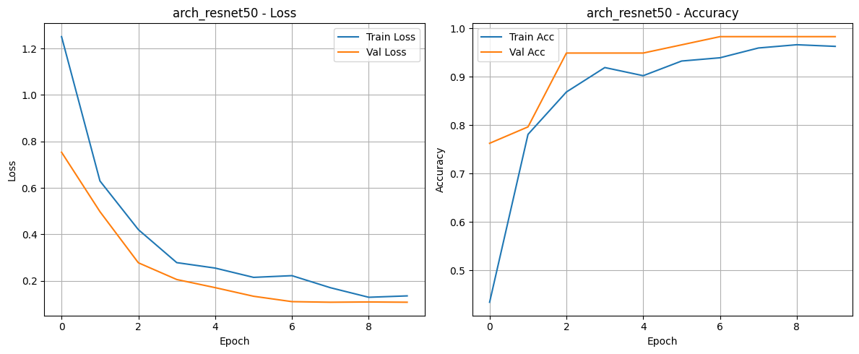

Исследования Learning Rate
сильно большой
exp_lr_high
Epoch | Train |  | Val |  |  | Test Accuracy: | 35.00%
 | Loss | Acc | Loss | Acc |  | Accuracy of kirby: | 90.00%
0 | 16.0041 | 0.2660 | 165672.0434 | 0.2542 |  | Accuracy of pink panther: | 50.00%
1 | 7.3985 | 0.2727 | 1423.1608 | 0.2373 |  | Accuracy of pinkie pie: | 0.00%
2 | 7.7113 | 0.2525 | 15.8875 | 0.2542 |  | Accuracy of slowpoke: | 0.00%
3 | 2.2670 | 0.2525 | 1.6610 | 0.2373
4 | 1.9439 | 0.2862 | 2.5118 | 0.1864
5 | 1.5816 | 0.2795 | 1.4741 | 0.3220
6 | 1.5117 | 0.2525 | 1.3673 | 0.3390
7 | 1.3919 | 0.2929 | 1.3321 | 0.3220
8 | 1.3784 | 0.2828 | 1.3106 | 0.3559
9 | 1.3598 | 0.3266 | 1.3068 | 0.3390
TIME: | 1m 5s
Best val Acc: | 0.355932

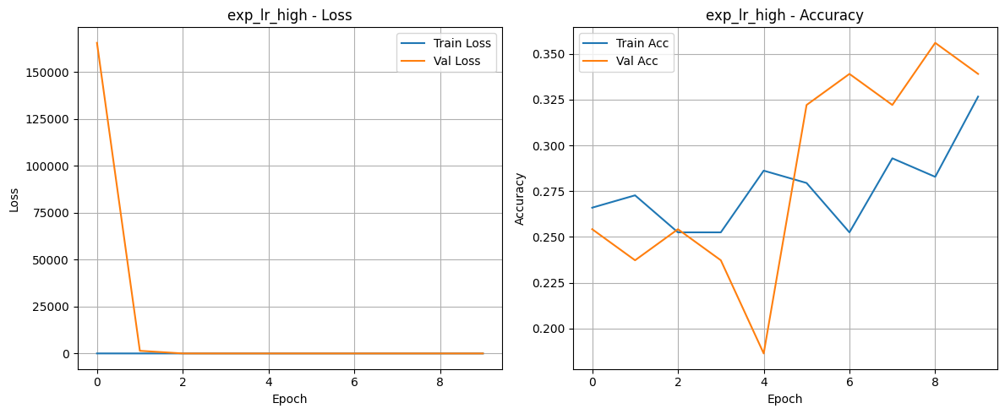

сильно маленький
exp_lr_low
Epoch | Train |  | Val |  |  | Test Accuracy: | 80.00%
 | Loss | Acc | Loss | Acc |  | Accuracy of kirby: | 80.00%
0 | 1.4435 | 0.2323 | 1.5086 | 0.1695 |  | Accuracy of pink panther: | 80.00%
1 | 1.3120 | 0.4007 | 1.3224 | 0.3729 |  | Accuracy of pinkie pie: | 90.00%
2 | 1.1738 | 0.5589 | 1.1821 | 0.5424 |  | Accuracy of slowpoke: | 70.00%
3 | 1.0584 | 0.6296 | 1.0661 | 0.5763
4 | 0.9354 | 0.7239 | 0.9585 | 0.6441
5 | 0.8921 | 0.7205 | 0.8772 | 0.6780
6 | 0.8370 | 0.7710 | 0.8036 | 0.7119
7 | 0.7930 | 0.7879 | 0.8075 | 0.7119
8 | 0.7686 | 0.8081 | 0.8005 | 0.7119
9 | 0.7576 | 0.8350 | 0.7852 | 0.6949
TIME: | 1m 5s
Best val Acc: | 0.711864

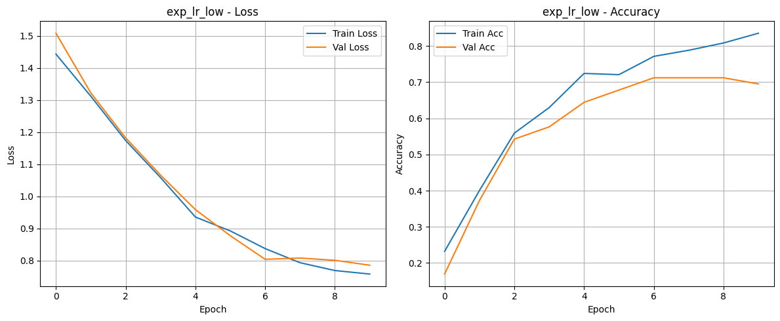

Исследование Batch size
batch size = 32
exp_bs_32
Epoch | Train |  | Val |  |  | Test Accuracy: | 95.00%
 | Loss | Acc | Loss | Acc |  | Accuracy of kirby: | 90.00%
0 | 1.4921 | 0.2694 | 1.2696 | 0.3898 |  | Accuracy of pink panther: | 100.00%
1 | 1.0138 | 0.5960 | 0.7524 | 0.7966 |  | Accuracy of pinkie pie: | 100.00%
2 | 0.6214 | 0.8283 | 0.5550 | 0.7797 |  | Accuracy of slowpoke: | 90.00%
3 | 0.5334 | 0.8316 | 0.3550 | 0.9153
4 | 0.3593 | 0.9125 | 0.3087 | 0.8983
5 | 0.3144 | 0.9158 | 0.2465 | 0.9492
6 | 0.2205 | 0.9630 | 0.2144 | 0.9492
7 | 0.2163 | 0.9461 | 0.2084 | 0.9492
8 | 0.2302 | 0.9495 | 0.2031 | 0.9492
9 | 0.2242 | 0.9428 | 0.2025 | 0.9492
TIME: | 1m 6s
Best val Acc: | 0.949153
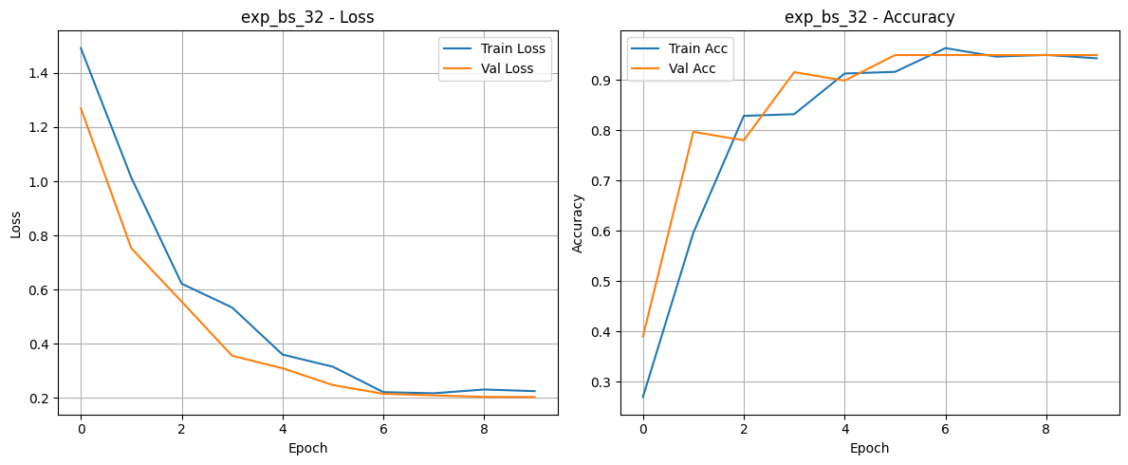

batch size = 64
exp_bs_64
Epoch | Train |  | Val |  |  | Test Accuracy: | 85.00%
 | Loss | Acc | Loss | Acc |  | Accuracy of kirby: | 80.00%
0 | 1.6809 | 0.2222 | 1.4569 | 0.3559 |  | Accuracy of pink panther: | 90.00%
1 | 1.3456 | 0.3232 | 1.2409 | 0.4746 |  | Accuracy of pinkie pie: | 100.00%
2 | 1.0960 | 0.5320 | 0.9407 | 0.6780 |  | Accuracy of slowpoke: | 70.00%
3 | 0.7937 | 0.8249 | 0.7408 | 0.7627
4 | 0.6778 | 0.8215 | 0.5878 | 0.8305
5 | 0.5402 | 0.8889 | 0.5157 | 0.8475
6 | 0.4530 | 0.8956 | 0.4663 | 0.8475
7 | 0.4015 | 0.8956 | 0.4526 | 0.8475
8 | 0.3832 | 0.9024 | 0.4500 | 0.8475
9 | 0.3785 | 0.9125 | 0.4432 | 0.8475
TIME: | 1m 10s
Best val Acc: | 0.847458

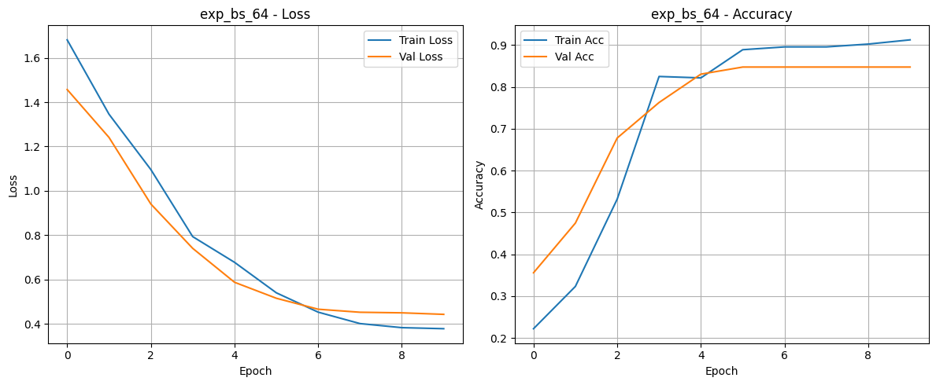

batch size = 128
exp_bs_128
Epoch | Train |  | Val |  |  | Test Accuracy: | 80.00%
 | Loss | Acc | Loss | Acc |  | Accuracy of kirby: | 100.00%
0 | 1.5841 | 0.2391 | 1.5419 | 0.3051 |  | Accuracy of pink panther: | 90.00%
1 | 1.4478 | 0.2525 | 1.4045 | 0.4068 |  | Accuracy of pinkie pie: | 100.00%
2 | 1.3121 | 0.3872 | 1.2326 | 0.4915 |  | Accuracy of slowpoke: | 30.00%
3 | 1.1610 | 0.5758 | 1.0579 | 0.5932
4 | 0.9943 | 0.6801 | 0.9075 | 0.6780
5 | 0.8533 | 0.7407 | 0.7882 | 0.7458
6 | 0.7406 | 0.7845 | 0.6941 | 0.7797
7 | 0.6495 | 0.8350 | 0.6809 | 0.7797
8 | 0.6551 | 0.8384 | 0.6664 | 0.7797
9 | 0.6685 | 0.7946 | 0.6544 | 0.7797
TIME: | 1m 12s
Best val Acc: | 0.779661

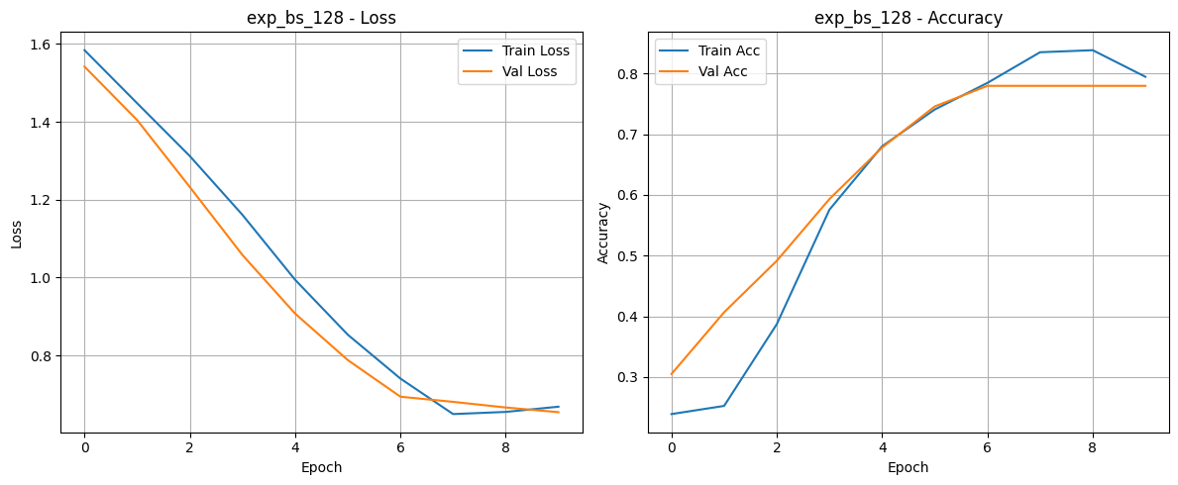

Исследование feature extract
exp_feature_extract
Epoch | Train |  | Val |  |  | Test Accuracy: | 92.50%
 | Loss | Acc | Loss | Acc |  | Accuracy of kirby: | 80.00%
0 | 1.3508 | 0.3569 | 1.0452 | 0.5254 |  | Accuracy of pink panther: | 100.00%
1 | 0.9159 | 0.7003 | 0.6983 | 0.7458 |  | Accuracy of pinkie pie: | 100.00%
2 | 0.6147 | 0.8283 | 0.5311 | 0.8814 |  | Accuracy of slowpoke: | 90.00%
3 | 0.6186 | 0.8114 | 0.4805 | 0.8475
4 | 0.5265 | 0.8451 | 0.5009 | 0.8305
5 | 0.5130 | 0.8249 | 0.3882 | 0.8983
6 | 0.4694 | 0.8418 | 0.3479 | 0.9322
7 | 0.4212 | 0.8889 | 0.3421 | 0.9322
8 | 0.3616 | 0.9226 | 0.3440 | 0.9322
9 | 0.4118 | 0.8822 | 0.3376 | 0.9153
TIME: | 1m 4s
Best val Acc: | 0.932203
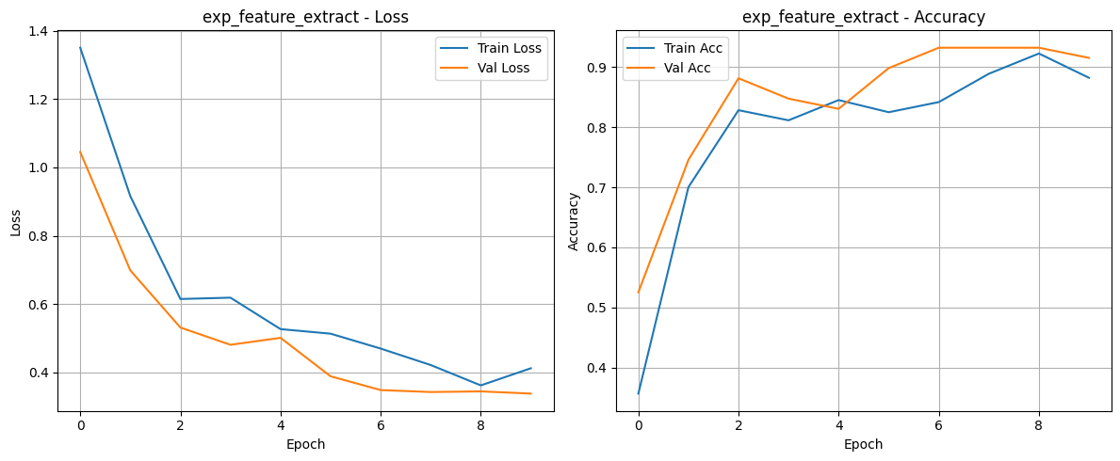
Текст программы
import torch
import torch.nn as nn
import torch.optim as optim
from torch.optim import lr_scheduler
import torch.backends.cudnn as cudnn
import numpy as np
import torchvision
from torchvision import datasets, models, transforms
import matplotlib.pyplot as plt
import time
import os
import copy
import pathlib
from PIL import Image

print(f"CUDA available: {torch.cuda.is_available()}")
if torch.cuda.is_available():
print(f"GPU: {torch.cuda.get_device_name(0)}")

# --- 1. НАСТРОЙКИ ПУТЕЙ И ПАРАМЕТРОВ ---
try:
BASE_DIR = pathlib.Path(__file__).parent
except NameError:
BASE_DIR = pathlib.Path.cwd()

DATA_ROOT = BASE_DIR / "dataset"

# Гиперпараметры для эксперимента
CONFIG = {
'batch_size': 16,
'learning_rate': 0.001,
'momentum': 0.9,
'num_epochs': 10,
'mode': 'feature_extract',
'experiment_name': 'exp1_default'
}

cudnn.benchmark = True
plt.ion()

# --- 2. ПРЕПРОЦЕССИНГ ДАННЫХ ---
data_transforms = {
'train': transforms.Compose([
transforms.RandomResizedCrop(224),
transforms.RandomHorizontalFlip(),
transforms.ToTensor(),
transforms.Normalize([0.485, 0.456, 0.406], [0.229, 0.224, 0.225])
]),
'val': transforms.Compose([
transforms.Resize(256),
transforms.CenterCrop(224),
transforms.ToTensor(),
transforms.Normalize([0.485, 0.456, 0.406], [0.229, 0.224, 0.225])
]),
'test': transforms.Compose([ # Для теста только нормализация
transforms.Resize(256),
transforms.CenterCrop(224),
transforms.ToTensor(),
transforms.Normalize([0.485, 0.456, 0.406], [0.229, 0.224, 0.225])
]),
}

full_dataset = datasets.ImageFolder(DATA_ROOT, data_transforms['train'])

image_datasets = {}
for x in ['train', 'val', 'test']:
dir_path = DATA_ROOT / x
if dir_path.exists():
image_datasets[x] = datasets.ImageFolder(dir_path, data_transforms[x])
else:
print(f"Warning: Directory {dir_path} not found. Using random split logic needed.")

dataloaders = {x: torch.utils.data.DataLoader(image_datasets[x],
batch_size=CONFIG['batch_size'],
shuffle=True, num_workers=2) # num_workers=0 для Windows часто стабильнее
for x in ['train', 'val', 'test']}

dataset_sizes = {x: len(image_datasets[x]) for x in ['train', 'val', 'test']}
class_names = image_datasets['train'].classes
print(f"Classes found: {class_names}")

device = torch.device("cuda:0" if torch.cuda.is_available() else "cpu")
print(f"Using {device} device")

# --- 3. ФУНКЦИИ ВИЗУАЛИЗАЦИИ И ОБУЧЕНИЯ ---
def imshow(inp, title=None, ax=None):
"""Display image for Tensor."""
inp = inp.numpy().transpose((1, 2, 0))
mean = np.array([0.485, 0.456, 0.406])
std = np.array([0.229, 0.224, 0.225])
inp = std * inp + mean
inp = np.clip(inp, 0, 1)
if ax is None:
plt.imshow(inp)
if title: plt.title(title)
plt.pause(0.001)
else:
ax.imshow(inp)
if title: ax.set_title(title)
ax.axis('off')

def train_model(model, criterion, optimizer, scheduler, num_epochs=25, phase_name='train'):
since = time.time()
history = {'train_loss': [], 'train_acc': [], 'val_loss': [], 'val_acc': []}

best_model_wts = copy.deepcopy(model.state_dict())
best_acc = 0.0

for epoch in range(num_epochs):
print(f'Epoch {epoch}/{num_epochs - 1} | {phase_name}')
print('-' * 10)

for phase in ['train', 'val']:
if phase == 'train':
model.train()
else:
model.eval()

running_loss = 0.0
running_corrects = 0

for inputs, labels in dataloaders[phase]:
inputs = inputs.to(device)
labels = labels.to(device)
optimizer.zero_grad()

with torch.set_grad_enabled(phase == 'train'):
outputs = model(inputs)
_, preds = torch.max(outputs, 1)
loss = criterion(outputs, labels)
if phase == 'train':
loss.backward()
optimizer.step()

running_loss += loss.item() * inputs.size(0)
running_corrects += torch.sum(preds == labels.data)

if phase == 'train':
scheduler.step()

epoch_loss = running_loss / dataset_sizes[phase]
epoch_acc = (running_corrects.double() / dataset_sizes[phase]).cpu()

print(f'{phase} Loss: {epoch_loss:.4f} Acc: {epoch_acc:.4f}')

# Сохраняем историю для графиков
if phase == 'train':
history['train_loss'].append(epoch_loss)
history['train_acc'].append(epoch_acc)
else:
history['val_loss'].append(epoch_loss)
history['val_acc'].append(epoch_acc)

if phase == 'val' and epoch_acc > best_acc:
best_acc = epoch_acc
best_model_wts = copy.deepcopy(model.state_dict())

print()

time_elapsed = time.time() - since
print(f'Training complete in {time_elapsed // 60:.0f}m {time_elapsed % 60:.0f}s')
print(f'Best val Acc: {best_acc:4f}')

model.load_state_dict(best_model_wts)
return model, history

def plot_history(history, title="Metrics"):
plt.figure(figsize=(12, 5))

plt.subplot(1, 2, 1)
plt.plot(history['train_loss'], label='Train Loss')
plt.plot(history['val_loss'], label='Val Loss')
plt.title(f'{title} - Loss')
plt.xlabel('Epoch')
plt.ylabel('Loss')
plt.legend()
plt.grid(True)

plt.subplot(1, 2, 2)
plt.plot(history['train_acc'], label='Train Acc')
plt.plot(history['val_acc'], label='Val Acc')
plt.title(f'{title} - Accuracy')
plt.xlabel('Epoch')
plt.ylabel('Accuracy')
plt.legend()
plt.grid(True)

plt.tight_layout()
plt.show()

def evaluate_test(model):
model.eval()
correct = 0
total = 0
class_correct = [0] * len(class_names)
class_total = [0] * len(class_names)

with torch.no_grad():
for inputs, labels in dataloaders['test']:
inputs, labels = inputs.to(device), labels.to(device)
outputs = model(inputs)
_, predicted = torch.max(outputs, 1)
c = (predicted == labels).squeeze()

for i in range(labels.size(0)):
label = labels[i]
class_correct[label] += c[i].item()
class_total[label] += 1

total += labels.size(0)
correct += (predicted == labels).sum().item()

print(f'\nTest Accuracy: {100 * correct / total:.2f}%')
for i in range(len(class_names)):
if class_total[i] > 0:
print(f'Accuracy of {class_names[i]:12s}: {100 * class_correct[i] / class_total[i]:.2f}%')

# --- 4. СОЗДАНИЕ МОДЕЛИ ---
def create_model(mode='finetune', num_classes=4, model_name='resnet18'):
if model_name == 'resnet18':
model = torchvision.models.resnet18(weights='IMAGENET1K_V1')
elif model_name == 'resnet50':
model = torchvision.models.resnet50(weights='IMAGENET1K_V1')

if mode == 'feature_extract':
for param in model.parameters():
param.requires_grad = False

num_ftrs = model.fc.in_features
model.fc = nn.Linear(num_ftrs, num_classes)
return model.to(device)

# --- 5. ЗАПУСК ЭКСПЕРИМЕНТА ---
def create_dataloaders(batch_size):
"""Создаёт новые dataloaders с указанным batch_size"""
dataloaders = {x: torch.utils.data.DataLoader(
image_datasets[x],
batch_size=batch_size,
shuffle=True,
num_workers=2
) for x in ['train', 'val', 'test']}
return dataloaders

def run_experiment(config):
print(f"\n>>> Running experiment: {config['experiment_name']}")

# ПЕРЕСОЗДАЁМ dataloaders с новым batch_size
global dataloaders, dataset_sizes
dataloaders = create_dataloaders(config['batch_size'])
dataset_sizes = {x: len(image_datasets[x]) for x in ['train', 'val', 'test']}

model = create_model(mode=config['mode'], num_classes=len(class_names))
criterion = nn.CrossEntropyLoss()

# Оптимизируем только те параметры, которые требуют градиента
optimizer = optim.SGD(filter(lambda p: p.requires_grad, model.parameters()),
lr=config['learning_rate'], momentum=config['momentum'])
scheduler = lr_scheduler.StepLR(optimizer, step_size=7, gamma=0.1)

model_trained, history = train_model(model, criterion, optimizer, scheduler,
num_epochs=config['num_epochs'],
phase_name=config['experiment_name'])

plot_history(history, title=config['experiment_name'])
evaluate_test(model_trained)

return history

