|  |
| --- |
| Verizon Wireless  MTC Core Analytics  User Guide |
| MTC Core Analytics  June 2016 |

Notices

Legal notice

© 2016, Hewlett Packard Enterprise Development LP.

Confidential computer software. Valid license from HPE required for possession, use or copying. Consistent with FAR 12.211 and 12.212, Commercial Computer Software, Computer Software Documentation, and Technical Data for Commercial Items are licensed to the U.S. Government under vendor's standard commercial license.

The information contained herein is subject to change without notice. The only warranties for HPE products and services are set forth in the express warranty statements accompanying such products and services. Nothing herein should be construed as constituting an additional warranty. HPE shall not be liable for technical or editorial errors or omissions contained herein.

Trademarks

Vertica is a registered trademark of Hewlett-Packard Enterprise. Windows is a registered trademark of Microsoft Corporation. Tableau is a registered trademark of Tableau Software.

|  |  |  |  |  |
| --- | --- | --- | --- | --- |
| Document version history | | | | |
| Version No. | Version date | Revised by | Approved by | Affected section and  description of change |
| 1.0 |  | MTC Core Analytics Development Team |  | Initial document creation. |
|  |  |  |  |  |
|  |  |  |  |  |
|  |  |  |  |  |
|  |  |  |  |  |
|  |  |  |  |  |
|  |  |  |  |  |
|  |  |  |  |  |
|  |  |  |  |  |
|  |  |  |  |  |
|  |  |  |  |  |
|  |  |  |  |  |
|  |  |  |  |  |
|  |  |  |  |  |
| * Action types: Approve, Review, Inform, File, Action Required, Attend Meeting, Other (please specify) | | | | |

Table of contents

1 Introduction 7

1.1 Purpose 7

1.2 Audience 7

1.3 References 7

2 MTC Core Analytics Reports 8

2.1 Interacting with Tableau Reports 8

2.1.1 Common Icons 8

2.1.2 Export Views 8

2.2 Table of Contents 10

2.3 SGSIWF KPI Reports 11

2.3.1 VLR Location Updates Success Rate 12

2.4 SMSC KPI Reports 14

List of figures

**Figure 1** Tableau Toolbar 10

**Figure 2** Export Toolbar 11

**Figure 3** Export PDF Dialog Box 12

**Figure 4** VLR Location Update Success Rate 14

List of tables

**Table 1** Common Icons in Tableau Reports 24

**Table 2** VLR Location Update Success Rate Filter List 29

# Introduction

## Purpose

The purpose of this document is to guide users through the Verizon Wireless MTC Core Analytics reports.

## Audience

This document is developed for all individuals interacting with the Verizon Wireless SPS Management Complex.

## References

Tableau 9.1 Desktop Online Help System: <http://onlinehelp.tableau.com/v9.1/pro/online/windows/en-us/help.htm>

# MTC Core Analytics Reports

The Verizon Wireless MTC Core Analytics is a reporting and monitoring solution created to provide insight into the operation of the SPS platform.

This section addresses the visualization of SPS application metrics or KPIs, using Tableau as the presentation layer for a Vertica database data warehouse that collects and aggregates SPS transaction data.

## Interacting with Tableau Reports

Viewing, interacting, and exporting data is possible through the use of various icons present in almost every report.

### Common Icons

|  |  |  |
| --- | --- | --- |
| Icon | Icon Name | Description |
|  | Export | Export the view as an Image, Data, Crosstab or PDF; refer to the Export Views section on page 26 for more details. |
|  | Revert All | Revert the view to its original state. |
|  | Pause Automatic Updates | Pause updates from the data source when making changes to the view to avoid an update after every change. |
|  | Resume Automatic Updates | Resume updates from the data source. |
|  | Refresh Data | Manually update the view to retrieve the latest data from the data source. |
|  | Share | Share the link to a published view or workbook via email or embedded into another webpage, wiki, or web application. |
|  | Download | Download a published workbook from the Tableau Server. |
|  | Drill Down | Expands a field to reveal additional information. |
|  | Drill Up | Collapses a field to hide additional information. |
|  | View Data | Displays the underlying data for the selected mark. |

1. Common Icons in Tableau Reports

### Export Views

Published views can be exported as images, data, crosstab, or PDFs:

1. Click the Export button on the toolbar located at the bottom center of a view.



1. Tableau Toolbar
2. Select either Image, Data, Crosstab, or PDF.

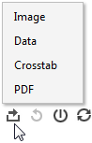

1. Export Toolbar

Export as Image

The Image option allows you to export the view as an image.

Export as Data

The Data option allows you to export the view as a text file.

Export as Crosstab

The Crosstab option allows you to export the view into a new Excel workbook.

Export as PDF

The PDF option allows you to export the view or workbook as a PDF.

After selecting the PDF option, the Export PDF Dialog Box appears and allows you to select the page orientation, paper size, scaling, content, and the sheets available for export.

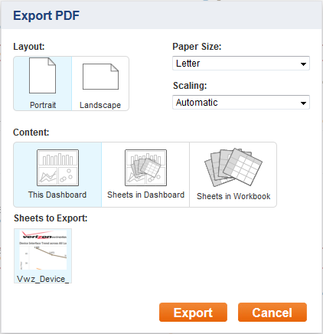

1. Export PDF Dialog Box

## Table of Contents

*[TBD]*

## SGSIWF KPI Reports

The following reports are part of the SGSIWF system:

* **System Performance Reports**
  + VLR Location Update
  + SGsAP Paging Success Rate
  + Network SMS Success Rate
  + M3UA MSU Success Rate
  + SMS Restore Success Rate
  + SCTP Packet Deviation
* **Call Model Related Reports**
  + MO SMS per Subscriber
  + Location per Subscriber
  + VLR per Subscriber
  + SGs per Subscriber
* **Capacity KPI Report**
* **Trending KPI Report**

### VLR Location Updates Success Rate

VLR Location Update Success Rate Report displays the

VLR Location Update Success Rate

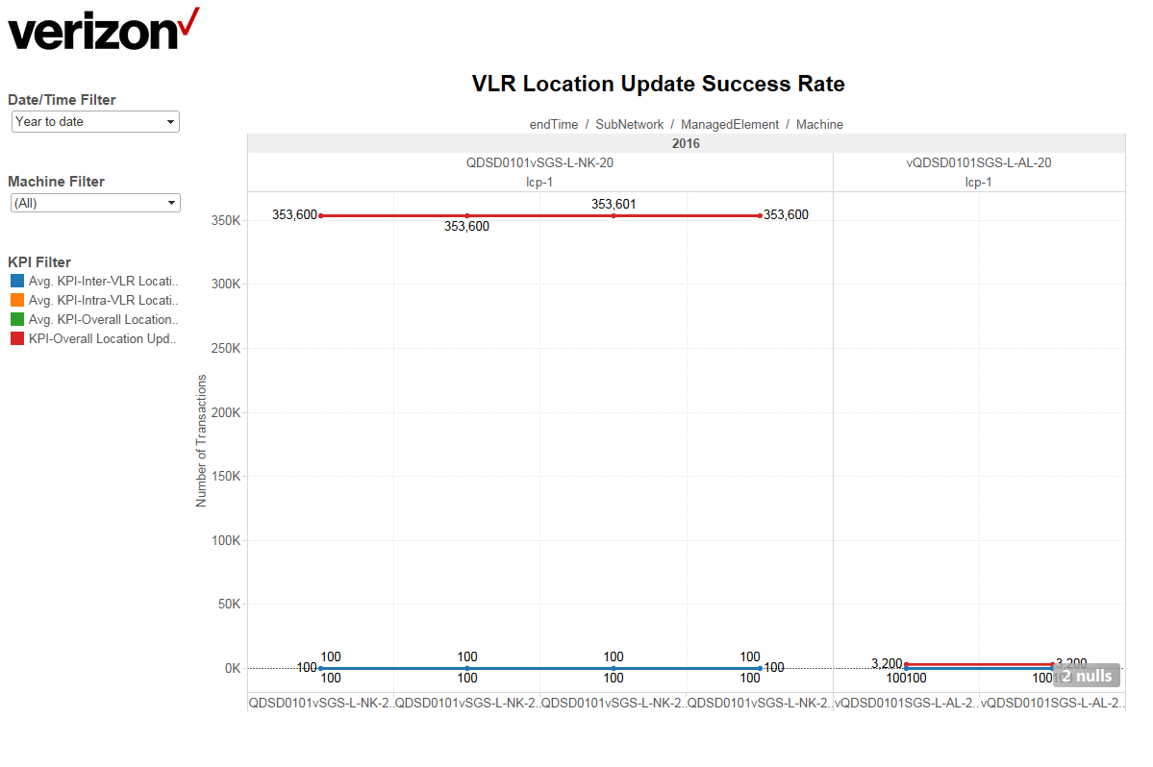

1. VLR Location Update Success Rate

*[This section will be used to document the steps in which to use the report]*

The following filters and parameters can be used in the report:

| Filter/Parameter | Filter/Parameter Name | Description |
| --- | --- | --- |
|  | Date/Time Filter | Allows the user to filter by various date/time units that will affect the worksheet displayed on the dashboard. User can filter by year, quarter, month, week, day, hour and minute. |
|  | Machine Filter | Allows the user to filter by all or by specified machine systems. |
|  | KPI Filter | Allows the user to filter by a specific or several KPIs. |

1. VLR Location Update Success Rate Filter List

VLR Location Update Success Graph

The graph of the report measures the.

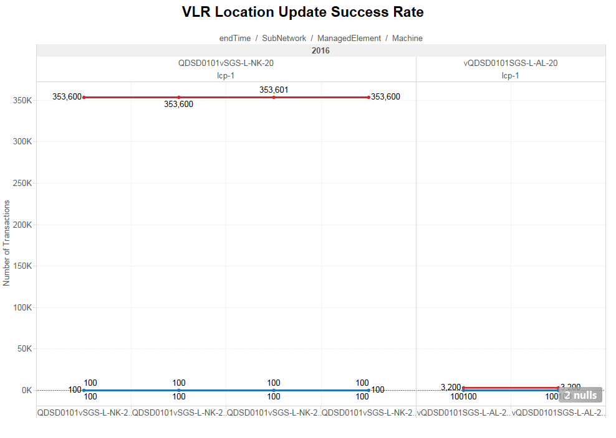

## SMSC KPI Reports

The following reports are part of the SMSC system:

*[TBD]*