1.

Input: [12, 34, 33, 25, 777, 945, 221, 448, 99999999999999]

Output:

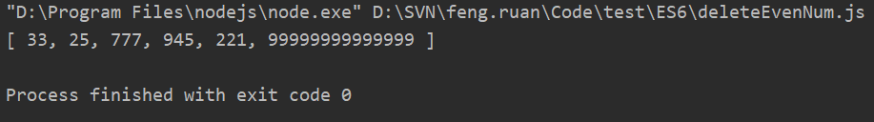

2.

Input: [12, 34, 44, 78, 770, 942, 220, 4480]

Output:

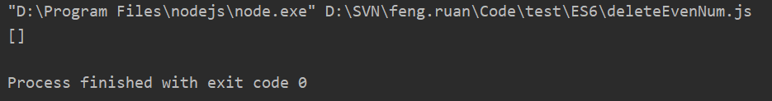

3.

Input: [11, 31, 33, 25, 777, 945, 221, 999]

Output:

