數位電子學 第三章 習題

3.2 If the input in Fig. 3.63 is expressed as *VX* = *V0* sin*ωt*, plot the current through the circuit as a function of time.

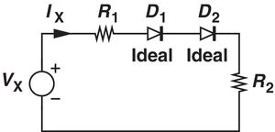

Fig. 3.63

3.4 For the circuit shown in Fig. 3.65, plot *IX* as a function of *VX* for two different cases :

*VB* =+1V, and *VB* =−1V.

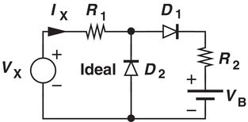

Fig. 3.65

3.7 For the circuit shown in Fig. 3.67, plot *IX* as a function of *VX* Assume *VB* > 0.

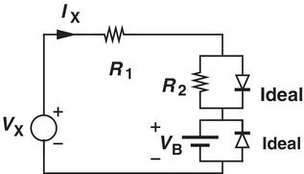

Fig. 3.67

3.9 P Plot input/output characteristics for the Fig. 3.69 using an ideal model for the diode. Assume *VX* = *V0* sin*ωt*, and *VB* = 3 V.

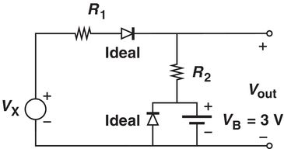

Fig. 3.69

3.12 Plot the input/output characteristics of the circuit shown in Fig. 3.71 using a constant model for the diode. (Assume *VB* =2 V, *VD,ON* = 800 mV ).

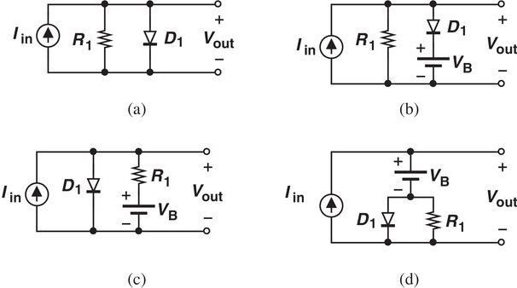

Fig. 3.71

3.14 In the circuit of Fig. 3.71, plot the current flowing through **R1**as a function of *Vin* Assume a constant voltage diode model (Assume *VD,ON* = 800 mV ).

3.16 Plot the *Vout* as a function of *VX* in the circuit of Fig. 3.72. Assume *Vx* = *V0* sin*ωt*, and a constant voltage diode model.

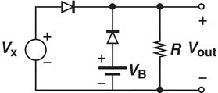

Fig. 3.72

3.23 Plot the input/output characteristics of the circuit illustrated in Fig. 3.76 assuming a constant voltage model and *VB* =2 V.

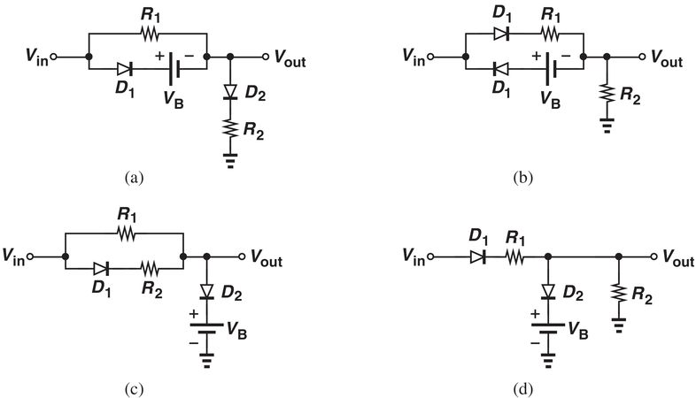

Fig. 3.73

3.26 Beginning with *VD,on* ≅ 800 mV for each diode, determine the change in *Vout* if *Vin* changes from +2.4 V to +2.5 V for the circuits shown in Fig. 3.78.

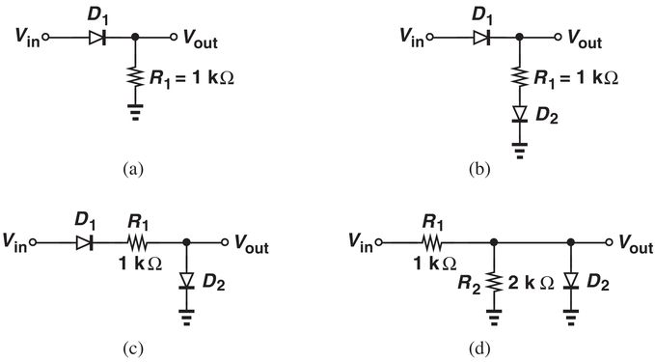

Fig. 3.78

3.32 While constructing a full-wave rectifier, a student mistakenly has swapped the terminals of *D3* as depicted in Fig. 3.82. Explain what happens.

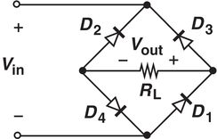

Fig. 3.82

3.36 Suppose in Fig. 3.43, the diodes carry a current of 5 mA and the load, a current of 20 mA. If the load current increases to 21 mA, what is the change in the total voltage across the three diodes? Assume *R1* is much greater than 3*rd*.

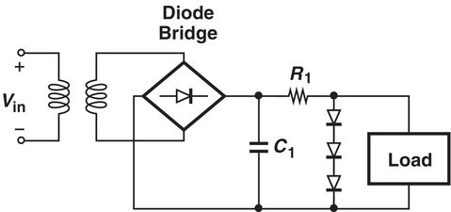

Fig. 3.43