數位電子學 第八章 習題

8.3 A noninverting amplifier employs an op amp with a finite output impedance, *Rout*,. Representing the op amp as depicted in Fig. 8.43, compute the closed-loop gain and output impedance. What happens if *A0* → ∞ ?

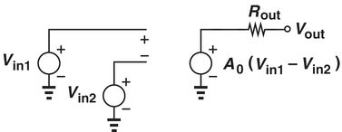

Fig. 8.43

8.9 The circuit of a noninverting op amp is designed to have nominal gain of 5.00, but *R1* and *R2* suffer from mismatch of 5%, i.e., *R1* = (1+0.05) *R2*. What will be the actual voltage gain? (Refer to fig below, and if open loop gain A0 = 1000 )

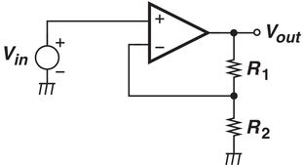

Fig. 8.47

8.12 The op amp used in an inverting amplifier exhibits a finite input impedance, *Rin*. Modeling the op amp as shown in Fig. 5.43, determine the closed-loop gain and input impedance.

8.14 Assuming A0 = ∞, compute the closed loop gain of the inverting amplifier shown in Fig. 8.51. Verify that the result reduces to expected values if *R1* → 0 or *R3* → 0.

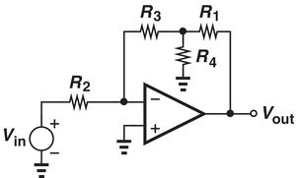

Fig. 8.51

8.24 For Fig. 8.56, if *V1* = 0.8 V, *V2* = 1.1 V, and *V3* = 0.5 V, *R1* = *R2* = *R3* = 5 kΩ and *RF* = 10 kΩ, *A0* = ∞, find *Vout* . The notation at the positive terminal of operational amplifier is the symbol for ground or 0 V.

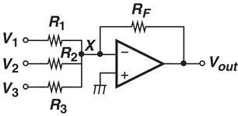

Fig. 8.56

8.43 What will be the effect of an inverting op amp shown in Fig. 8.66 (b) if the effect of input offset is considered.

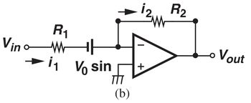

Fig. 8.66 (b)