數位電子學 第六章 習題

μnCox =200 μA/V2 , μpCox =100 μA/V2 , NMOS *VTH* =0.4 V, PMOS *VTH* =−0.4 V,

6.6 A NMOS device operating in the saturation region with *W*/*L* = 10, carries a drain current of 5 mA. Calculate the transconductance of the device?

6.11 In the circuit shown in Figure 6.37, what value of *R* is required to get a current of 75 μA with *W* = 5μm, *L* = 0.5μm, and λ = 0.

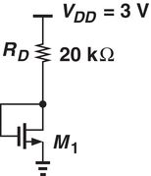

Figure 6.37

6.14 Determine the region of operation of *M1* in each of the circuits shown in Figure 6.38.

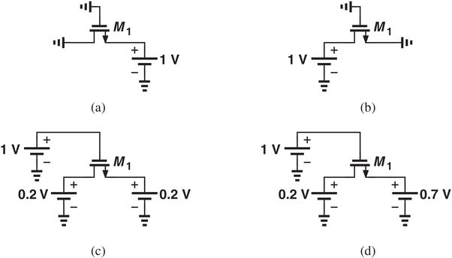

Figure 6.38

6.19 In the Figure 6.43, compute the value of the *W*/*L* required to operate the transistor M1 in saturation region.

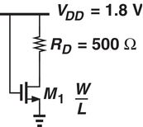

Figure 6.43

6.24 In the circuit of Fig. 6.48 W/L = 10/0.18 and λ = 0. What is the value of current flowing through M1, assuming that the device operating at the edge of saturation?

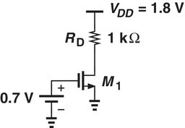

Figure 6.48

6.28 Assuming a constant *VDS* , a graph of *gmro* verse (VGS − VTH) of a NMOS gives a slope of 50 V-1. Find the W/L ratio if λ = 0.1 V-1 and ID = 0.5 mA

6.36 Construct the small signal model of each circuit shown in Fig. 6.56 if all of the transistors operate in saturation and λ ≠ 0.

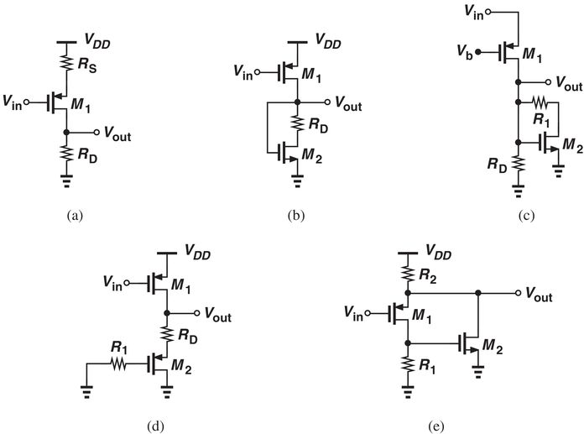

Figure 6.56