數位電子學 第二章習題

2.16 Consider a pn junctions in forward bias. Initially a current of 1 mA flows through it, and the current increases by 10 times hen the forward voltage is increased by 1.5 times. Determine the initial bias applied and reverse saturation current.

2.18 Consider the circuit shown in Figure 2.42, where *IS* = 2 × 10-15 A. Calculate *VD1* , and *IX* for *VX* = 0.5 V, 0.8 V, 1 V, and 1.2 V. Note that *VD1* changes little for *VX* ≥ 0.8 V.

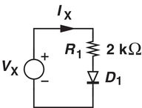

Figure. 2.42

2.19 For what value of *VX* in Figure 2.42, does *R1* sustain a voltage equal to *VX* /2 ?

Assume *IS* = 2 × 10-16 A.

2.21 Figure 2.44 depicts a parallel resistor-diode combination. If *IS* = 3 × 10-16 A, calculate *VD1* for *IX* = 1 mA, 2 mA, and 4 mA.

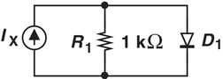

Figure 2.44

2.25 In the circuit of Figure 2.47, employs two identical diodes with *IS* =5×10-16 A. Calculate the voltage across *R1* for *IX* =2 mA

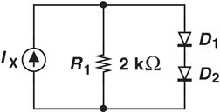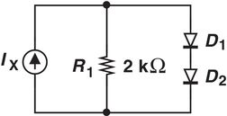

Figure 2.47