Republic of the Philippines

**Bohol Island State University- Main Campus**

**College of Engineering and Architecture**

6300 Tagbilaran City

***Vision:*** *A premier Science and Technology university for the formation of world class and virtuous human resource for sustainable development in Bohol and the Country.*

***Mission:*** *BISU is committed to provide quality higher education in the arts and sciences, as well as in the professional and technological fields; undertake research and development and extension services for the sustainable development of Bohol and the country.*

***Objectives:***

1. To provide a technologically-advanced curriculum to develop competent graduates;
2. To enthuse learners to apply operational researches to further new knowledge and technology and to involve students in research-based extension activities;
3. To perform managerial activities through actual installation and maintenance project;
4. To inculcate the culture of excellence, instil personal values and professional ethics with emphasis on environmental issues on global warming and other climatic conditions

**Project in**

**EE - 4**

**(Microprocessor)**

**“Automatic Room Temperature Control using AC Fan with Arduino”**

Submitted by:

Hasmen Estrada

Remar Acaso

Mel Ryan Curiba

Marius Rommel Angeles

John Nino Celeres

Submitted to:

Engr. Max Angelo Perin

INSTRUCTOR

**TABLE OF CONTENTS**

ABSTRACT------------------------------------ 3

INTRODUCTION ------------------------------- 5

OBJECTIVES---------------------------------- 6

METHODOLOGY--------------------------------- 6

BLOCK DIAGRAM------------------------------- 10

CONCLUSSIONS-------------------------------- 10

RECOMMENDATIONS----------------------------- 10

**ABSTRACT**

In present scenario, availability of electricity is found to reach crucial stage. To protect and safeguard one’s future we need to save the energy. As a slogan suggest “One unit saved is one unit generated”. Since automatic controls play an ever-increasing role in a human way of life. Automatic control is vast technological area whose central aim is to develop control strategies that improve performance when they applied to a system, the distinct characteristic o of automatic control is that it reduces the human operator. One such gadget is the fan. The fans are generally available with speed control depending on the requirement that speed is set. Usually, when the temperature is high the fan is set at high speed and at lower temperatures the fan is operated with lower speed. In this paper, an automatic control solution suggested to control the fan speed. A circuit with LM35 temperature sensor, ATMega382P microcontroller and few of electronic components is designed and implanted to control the fan speed automatically. As an additional feature 16x2-line LCD( Liquid Crystal Display) is used to present or set the values of the temperature and the speed. It is very compact as it is constructed by using few components and can be interfaced for several applications including air-conditioners, water-heaters, snow-melters, ovens, heat-exchangers, mixers, furnaces, incubators, thermal baths and veterinary operating tables. Arduino micro controller is the heart of the circuit as it controls all the functions. The temperature sensor LM35 senses the temperature and converts it into an electrical signal, which is forwarded to the microcontroller.

**INTRODUCTION**

Electric fan is one of the most popular electrical devices due to its cost effectiveness and low power consumption advantages. It is a common circuit and widely used in many applications. It is also one of the most sensible solutions to offer a comfortable and energy efficient. In fact, the fan has been long used and still available in the market.

Nowadays, the demand for accurate temperature control and air freshening control has conquered many of industrial domains such as process heat, automotive, industrial office buildings where the air cooled in order to maintain a comfortable environment for its occupants. One of the most important concerns involved in heat area consist in the desired temperature achievement and consumption optimization.

Fan can be controlled manually by pressing on the switch button, where in this method any change in the temperature will not give any change in the fan which is manually. So, an automatic temperature control system technology is needed to the controlling purpose in the fan speed according to the temperature changes.

**OBJECTIVES**

This project aims to:

* To develop a low cost, user friendly automated temperature controlled fan which reduces power consumption.
* To assist people who are unable to control the speed of fan from their locations.
* To prevent wastage of useful resources in Homes and Industries.
* To manage the temperature of storage areas, thus keeping stored items at temperature that extend their value period.
* To eliminate hazard that result from the accidental neglect of heating and cooling appliance in the homes and industries, even when they are not needed.

**METHODOLOGY**

These are the following steps in making these project:

1. **Preparing all the tools and materials needed.**
   1. Arduino Uno
   2. LM35 Humidity Sensor
   3. 16x2 Liquid Crystal Display
   4. 10k Potentiometer
   5. 5v relay module
   6. Bread Board
   7. Screw Driver
   8. 220 ohms Resistor
   9. 220V AC Ceiling Fan
   10. Jumper Wires
   11. Paint
   12. Used plywood
   13. Nails
   14. Hammer
2. **Wire Connections.**

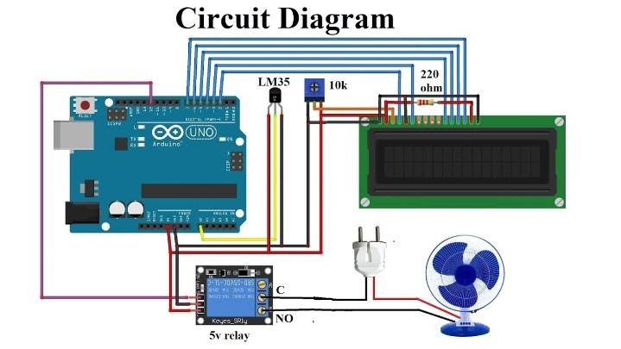

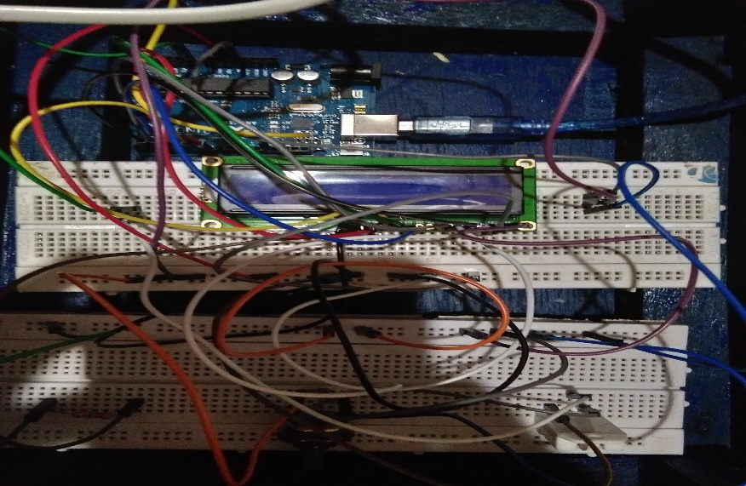

1. **Programming the Arduino.**

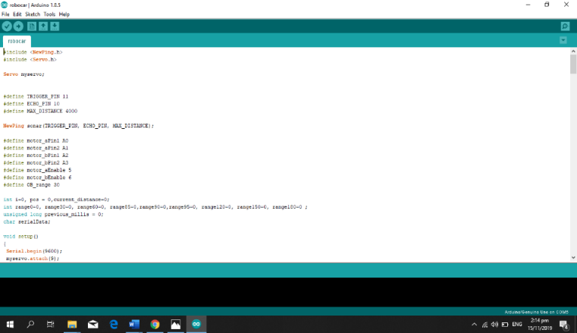

#include $<$ LiquidCrystal.h $>$

LiquidCrystal lcd(2,3,4,5,6,7); // lcd pin (RW, EN, D4, D5, D6, D7)

int FanPin=12; // connect to the relay signal pin to control fan on off

int TempAdcRead;

int SetTemp=35; // Set your threshold temperature

void setup()

{

Serial.begin(9600);

lcd.begin(16,2);

pinMode(FanPin, OUTPUT);

digitalWrite(FanPin,HIGH); // initially FanPin High because Relay module active LOW

}

void loop()

{

TempAdcRead=analogRead(AD);

Floatmilivolts=(TempAdcRead/ 1024.0) * 50000;

Float temp=millivolts/10;

lcd.setCursor(0,0);

lcd.print(“Temp:”);

lcd.print(temp);

lcd.write(0xdf); //for degree sign

lcd.print(“C”);

if (temp $>=$ SetTemp)

{

digitalWrite(FanPin, LOW); //Relay module active lcd.setCursor(0,1);

lcd.print(“Fan:”);

lcd.printer(“ON”;

}

else

{

digitalWrite(FanPin, HIGH);

lcd.setCursor(0,1);

lcdprint(“Fan:”);

lcd.setCursor(0,1);

lcd.print(“Fan:”);

lcd.print(“OFF”);

}

delay(1000);

lcd.clear();

}

1. **Finishing touches.**

Using the used plywood , we made the box to properly place the materials, then painted it with our desired design.

**BLOCK DIAGRAM**

**10k Potentiometer**

**Liquid Crystal Display**

**LM35 Humidity Sensor**

**MICROCONTROLLER**

**(ATmega382P)**

**Power Supply**

**5V RELAY**

**Fan**

**CONCLUSIONS**

The Arduino is an open source device that has been the brain fornumerous projects. The Arduino has everything that is required by the user which includes its inbuilt converter, i/o pins etc. With the use of Arduino, we can control over many other things, like home lightings, air conditioner and many more through or with the use of gadgets . The Arduino can also contribute at large for the SmartHome system. By doing this Project we found out a lot about the Arduino, and how it has made us easier to convert digital signal into physical movements. This paper elaborates the design and construction of fan speed control system to control the room temperature. The temperature sensor was carefully chosen to gauge the room temperature. Besides, the microcontroller had been used to control the fan speed using the PWM, the fan speed in the rpm and the room temperature was successfully programmed using C Language and their values displayed in LCD. As conclusion, the system which designed in this work was perform very well, for any temperature change and can be classified as automatic control.

**RECOMMENDATIONS**

It can be implemented for the advancement in the technology such in home indoor environment and has seen a quick presentation of system empowered computerized innovation. This artificial technology offers new and emerging chances to expand the network of devices inside the home with the end goal of home mechanization. This could significantly save the cost for the electricity bill and perhaps instead of standing and locating the switch to turn it on or off we can allow to make it easier by just wait until it will automatically on or off and our work will not be disturb.