**MBEYA UNIVERSITY OF SCIENCE AND TECHNOLOGY**



**DEPARTMENT:** COMPUTER SCIENCE AND ENGINEERING

**COURSE NAME:** COMPUTER SCIENCE

**MODULE NAME:** SOFTWARE DEVELOPMENT MANAGEMENT

**MODULE CODE:** CS 8212

**INSTRACTOR’S NAME:** NEEMA RAJAB

**TASK:** GROUP ASSIGNMENT

|  |  |  |  |
| --- | --- | --- | --- |
| **NO** | **NAME** | **REG: NO** | **ROLE** |
| **1** | **QUEEN.H. BERNARD** | **21100533350011** | **PROJECT MANAGER** |
| **2** | **BARAKA JUMA** | **21100533350015** | **DEVELOPER** |
| **3** | **GODBLESS KIWOVELE** | **21100533350027** | **DESIGNER** |
| **4** | **ANETH NYAVILWE** | **21100533350005** | **TESTER** |
| **5** | **JACKSON EMMANUEL** | **21100533350031** | **DEVELOPER** |
| **6** | **FAITH FAIKO NKYAMI** | **21100533350030** | **ANALYSTICS** |

**PURPOSE**

The purpose of OLMS is to filling the logbook online, submitting the logbook for student side and supervising, marking of the logbook to the stuff side.

SOFTWARE REQUIREMENT SPECIFICATION(SRS) DOCUMENT

This is a document which describes the whole nature of the project which prepared before start the project which include the purpose of the (OLMS) project, scope of it functional and non-functional requirement of (OLMS) software of our project as well as hardware of project.

Apart from this also it includes information about environmental condition required, safety and security of the project requirements software quality attribute and its cost of OLMS

**PROJECT SCOPE**

The project scope it covers two areas which is in student side and supervisor side

In student side it should

1. Filling industrial practical center information online using OLMS
2. Filling logbook information online using OLMS
3. Submission of report and logbook online using OLMS.

Also, in supervisor side

1. Supervising students using OLMS
2. Marking and grading of submitted students’ logbooks and reports using OLMS.

**OLMS LIMITATION AND ITS STRENGTH.**

* An internet connection is required during submission of weekly report and final report and in supervisor it required also during grading BUT the advantage of this system it require offline whiling a student filling the logbook.

**TOOL AND TECHNOLOGY**

* HTML
* CSS
* DJANGO
* JS
* MYSQL
* DIAGRAM DRAWING TOOLS

DATABASE DRAWING TOOLS

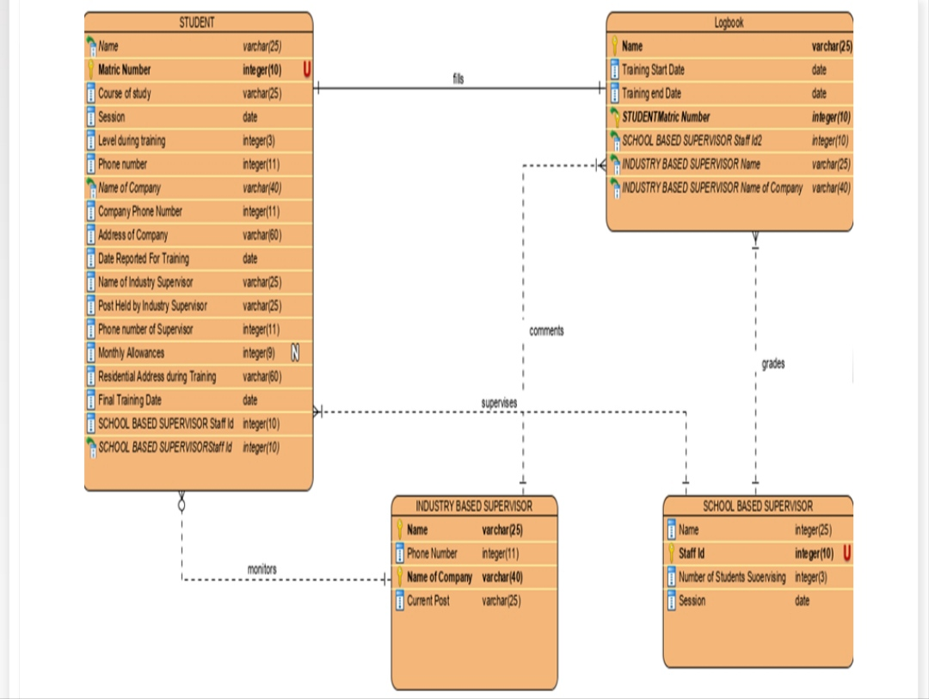

**OLMS SYSTEM ENVIRONMENT REQUIREMENTS.**

The operating environment for the OLMS

* User/server system
* Operating system: MAC OS, Windows.
* database: sql, MYSQL
* platform: HTML/CSS/PHP /JavaScript.

**EXTERNAL INTERFACE OLMS REQUIREMENTS**

**USER INTERFACES**

* Front-end language: HTML, JavaScript, and CSS.
* Back-end: SQL+PHP.

**HARDWARE INTERFACE**

* A Web browser that supports HTML, JavaScript, CSS.
* Windows & Mac OS.
* Computer & Phone with 4RAM+
* Processor – intel core i3+
* Phone processor’s 2GHz+

**SOFTWARE INTERFACES**

The following is the software used for the OLMS

1. Operating System

Windows and MacOS for their best interfaces available and easy to use for all users.

1. Database

To save the user data like students, and supervisor in SQL database.

**OLMS MODEL FOR THE PROJECT**

* The model chosen for the development of the system OLMS is the **Agile model.**

**Why agile model?**

The agile model is the most widely used software development model due to the fact that it is dynamic and flexible project management process. Also, the agile model is important because it helps to ensure that the development teams complete the projects on time and within budget. It also helps to improve communication between the development team and the product owner.

**HOW AGILE MODEL IS EMPLOYED IN THE OLMS.**

The following are the steps involved in the development of OLMS by using the agile model:

1. Concept generation; this is the first step in which we selected the project title. Whereby the concept can be generated through brainstorming or discussing current issues affecting an organization and come up with some ideas. Also determining whether the projects selected are feasible or not and estimating the time and costs to complete the project.
2. Selection of the project team; After the generation of the project, we came up with the selection of the project team giving each member a task involved in the project.
3. Requirements gathering, development, testing, delivery and feedback; here the requirements are gathered according to the need of the project and the stakeholders’ expectations, then developing the system from the requirements gathered and testing whether the system operates efficiently and then delivering it and obtain feedback from the user.

**FUNCTIONAL REQUIREMENTS**

Students side

1. Software must have compatibility intact
2. Software should have groups such as colleges and department in order to bring simplicity
3. Software should have enough paragraph to write their weekly summary.
4. Software must have option to attach and send their final report to their department
5. Software could have offline capability for logbook form and online submission

**Staff side**

1. Software must have ability to mark logbook and reports online.
2. Software must have staff registration and login user interface
3. Software must allow grading in stuff side after marking.

**NON-FUNCTIONAL REQUIREMENTS**

The following are the nonfunctional requirement of OLMS system.

**NON-FUNCTIONAL REQUIREMENTS**

These are set of specifications that describe the system’s operation capabilities and attempt to improve its functionalities.

It deals with the quality attributes of the system, they may include performance, portability, usability, security, maintainability etc. When we come to our system the OLMS, we will contain the following non-functional requirements.

1. Performance; OLMS should be able to respond quickly within a short time under different load conditions. Where the system should be able to process a certain amount of data within a specific time frame.
2. Portability; Our system should be able to run on all types of hardware, operating systems and browsers. This helps to establish how well actions performed via one platform are run on another. Also, the system elements should be accessed and interact from two different environments.
3. Security; The OLMS should be secure, protecting the data and from cyber attackers and any unauthorized. Also, the system has to be able to detect and recover from security breaches.
4. Availability; The system has to be accessible for a user at a given point in time.
5. Usability; This includes requirements related to the ease of use and understandability of the system for the end users.
6. Reliability; This includes requirements needed for the system’s ability to function correctly and consistently under normal and abnormal conditions.
7. Maintainability; This includes requirements related to the ease of maintaining the system including, debugging, and modifying the system.

**CONCLUSION**

The identification of functional and non-functional requirements in the OLMS is very important in the management and development of the software. The following are the advantages of functional and non-functional requirements:

* Improvement in system quality; by specifying the requirements engineers can ensure that the system will have desired characteristics such as performance, security, usability, reliability, maintainability, portability which can improve the overall quality of the system.
* Meeting organization goals; by aligning the requirements with the organization goals, engineers can ensure that the system supports the overall objectives of the organization and meets the expectations of the stakeholders.
* Better system maintenance; Specifying non-functional requirements related to maintainability, we can ensure that the system is easy to maintain, test and debug which can save timeand cost in the long run.

REFERENCES

* SLIDESHARE
* <http://www.slideshare.net/pasinduTennage/sample-software-engineering-feasibility-study-report>