**UNIVERSITY OF ENERGY AND NATURAL RESOURCES**

**SCHOOL OF SCIENCES,**

**DEPARTMENT OF INFORMATION TECHNOLOGY AND DECISION SCIENCES**



**TITLE:**

**PREDICTING STUDENT’S PERFORMANCE USING ARTIFICIAL NEURAL NETWORKS**

**A PROJECT WORK SUBMITTED IN PARTIAL FULFILLMENT OF THE REQUIREMENTS FOR**

**BSC. INFORMATION TECHNOLOGY**

**BY:**

**OPOKU OFORIWAAH PATRICIA**

**(UEB3213922)**

**OSEI ROBERT**

**(****UEB3215620)**

**OFORI ALFRED JOSHUA**

**(UEB3208520)**

**KOTEI NIKOI CHRISTIANA**

**(UEB3203820)**

**AWUDU MUFTAWU BAKARI**

**(UEB3211120)**

### OCTOBER 2024

**DECLARATION**

We, Opoku Oforiwaah Patricia, Osei Robert, Ofori Alfred Joshua, Kotei Nikoi Christiana, and Awudu Muftawu Bakari hereby declare that the study was carried out and written by us and that all sources of information have been acknowledged and that we are wholly responsible for any acts that may infringe on the research ethics policies of the University.



OPOKU OFORIWAAH PATRICIA ……………………. ……………………

(UEb3213922) DATE SIGNATURE

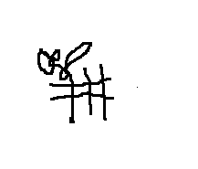



OSEI ROBERT … …………………. ……………………

 (UEB3215620) DATE SIGNATURE



OFORI ALFRED JOSHUA ……………………. ……………………

 (UEB3208520) DATE SIGNATURE



KOTEI NIKOI CHRISTIANA …………………… ………………………

(UEB3203820) DATE SIGNATUERE



AWUDU MUFTAWU BAKARI …………………… ………………………

(UEB3203820) DATE SIGNATUERE

DR. MICHAEL OPOKU ……………………... ……………………

(SUPERVISOR) DATE SIGNATURE

DR. PETER APPIAHENE ……………………. ……………………

(HEAD OF DEPARTMENT) DATE SIGNATURE

**ACKNOWLEDGEMENT**

First of all, we want to show my deepest gratitude, appreciation, and thanks to the Almighty God, who has given us good health and the wisdom I needed to make this excellent work. Our family has been there for us, kept us going, and provided us with all financial support during our studies. Also, we want to thank our supervisor Dr. Michael Opoku at the University of Energy and Natural Resources in Sunyani. Without His help, patience, and helpful criticism, this project would not have been finished.

**ABSTRACT**

This study investigates the development and application of an Artificial Neural Network (ANN) model to predict student academic performance in higher education. By incorporating a diverse set of factors, including demographics, study habits, extracurricular activities, and parental support, the model offers a comprehensive approach to understanding the elements that contribute to academic success. Unlike traditional models that primarily rely on past academic records, this ANN model leverages both academic and non-academic variables to enhance predictive accuracy.

The research highlights the value of early identification of at-risk students, enabling timely interventions and personalized learning strategies. The ANN model demonstrated moderate predictive accuracy, suggesting its potential for practical use in educational settings. Key recommendations for universities include the integration of predictive tools into learning management systems, improving data collection, and ensuring ethical use of student data. The findings underscore the potential of using predictive analytics to support better decision-making, optimize resource allocation, and improve student outcomes in higher education.

**DEDICATION**

This project is dedicated to our families whose unwavering support-both monitor and emotional has been invaluable throughout our studies. Your encouragement has been our anchor in challenging times. Additionally, we extend our heartfelt gratitude to our esteemed lecturers at the department. Your passion for education and commitment to excellence have profoundly inspired us. The encouragement and insightful feedback you provided motivated us to push boundaries and delve into extensive research. Your dedication to fostering a supportive learning environment enabled us to explore new ideas and strive for impactful findings. Thanks, you believing in us and challenging us to reach our full potential

**Table of Contents**

Dedication ............................................................................................................................... 2

Acknowledgements .................................................................................................................. 3

Abstract .....................................................................................................................................4

List of Figures .......................................................................................................................... vi

List of Abbreviations ............................................................................................................... vii

**Chapter 1**: Introduction ............................................ ………………………………………..10

    1.1 Background of the Study ................................................................................................10

    1.2 Problem Statement .............................................. ……………………………………...10

    1.3 Objectives of the Study .................................................................................................. 11

    1.4 Research Questions ....................................................................................................... 12

    1.5 Significance of the Study .............................................................................................. 13

    1.6 Scope and Limitations .......................................... ……………………………………13

    1.7 Project Organization ................................... …………………………………………..14

**Chapter 2**: Literature Review ...................................... ……………………………………..15

    2.1 Introduction .................................................................................................................. .15

    2.2 Overview of Academic Performance Prediction ........................................................... 15

    2.3 Artificial Neural Networks in Education ...................................................................... 16

    2.4 Factors Affecting Student Performance ....................................................................... .17

    2.5 Related Works ...................................................... …………………………………….19

    2.6 Factors Influencing Students Performance ................................................................... 20

**Chapter 3**: Methodology ........................................................................................................ 21

    3.1 Overview ....................................................................................................................... 21

    3.2 Data Collection .............................................................................................................. 21

    3.3 Data Pre-processing ....................................................................................................... 21

    3.4 Model Development ...................................................................................................... 22

    3.5 Model Training and Evaluation ..................................................................................... 23

    3.5.1 Training Processes ...................................................................................................... 23

3.3.4 Performance Validation………………………………………………………………….23

3.4 Proposed Methodology ………………………………………………………….………..23

3.4.1 Neural Development Lifecycle………………………………………………………….23

3.4.2 Strength of Neural Networks Development lifecycle…………………………………...24

3.4.3 Weakness of Neural Networks Development lifecycle………………………………….26

3.5 Tools and Techniques…………………………………………………………………….....29

3.5.1 Ethical Consideration………………………………………………………………….….34

3.6 Requirement Specifications…………………………………………………………….…. 39

3.7 Functional Requirement………………………………………………………………….....39

3.8 Non-Functional Requirement……………………………………………………………….40

3.8.1 System Design…………………………………………………………………………….40

3.8.2 Application Architecture…………………………………………………………………..40

3.8.3 Database Design…………………………………………………………………………..41

3.9 Model Function Processes………………………………………………………………..…45

3.9.1 Summary…………………………………………………………………………………..47

**Chapter 4**: Results and Discussion ……………………………………................................... 48

    4.2 Data Pre-processing and Model Input ............................................................................. 49

    4.3 Model Training and Architecture .................................................................................... 49

4.4 Model Performance ............................................................................................................ 50

4.4.1 Mean Absolute Error. ........................................................................................................51

4.4.2 Model Loss………………………………………………………………………………51

4.5 Model Development and Practical Application……………………………………………52

4.6 Discussion of Findings……………………………………………………………………..53

**Chapter 5**: Conclusion and Recommendations ................. ……………………………………55

    5.1 Summary of Findings ....................................................................................................... 55

    5.2 Limitations and Challenges .........................................…………………………….…….56

    5.3 Recommendation............................................................................................................... 56

    5.4 Summary .......................................................................................................................... 57

References .................................................................................................................................. 58

**LIST OF FIGURES**

1. Figure 1: Application Architecture of Proposed System………………………………..24
2. Figure 2: Entity Relationship Diagram for the Prototype……………………………….44
3. Figure 3: Use Case Model……………………………………………………………….45
4. Figure 4: Flowchart of the model………………………………………………………..46
5. Figure 5: Model Performance Graph……………………………………………………48
6. Figure 6 : User Interface of the Web-Based Application………………………………..54
7. Figure 7 : Proposed Model for the prototype……………………………………………

**LIST OF ABBREVIATIONS**

ANN : Artificial Neural Network

GPA :Grade Point Average

MAE : Mean Absolute Error

WAEC : West African Examinations Council

UML :Unified Modeling Language

CSV : Comma Separated Values

ARFF : Attribute-Relation File Format

E-Learning: Electronic Learning

# CHAPTER ONE

# INTRODUCTION

## 1.1 BACKGROUND OF STUDY

A student's academic success and commitment to their studies are reflected in their performance. On the flip side, improving education quality depends on students’ performance and their education ability. Dropout rates significantly contribute to the decline in educational standards, with a notable concentration occurring at secondary or tertiary levels (Ahmad et al., 2021). The ability to predict the student's academic performance is very important in higher educational institutions, as well for faculty, universities, and educators, as well as for students.

Education institutions at different educational levels are established to provide high-quality education capable of changing people’s levels of awareness, knowledge, and mental capacity. Lecturers and educators are always looking to enhance student achievement and monitor their performance to determine the efficiency of the teaching process (Ling et al., 2014). The new advancement of technology enables educators to use analytics and data mining methodologies to search large datasets for patterns that reflect their students’ behavior and learning. Predicting students’ academic performance has long been an important research topic. Among the issues of the education system, questions concerning admissions into academic institutions remain important. The results of predicting a student’s academic performance can be used by lecturers to specify the most suitable teaching actions for each group of students and provide them with further assistance directed to their specific needs. In addition, the prediction results may help students develop a good understanding of how well or how poorly they would perform and then develop a suitable learning strategy.

In machine learning and cognitive science, Artificial Neural Networks (ANN) are a family of statistical learning models inspired by biological neural networks (the central nervous systems of animals, particularly the brain) and are used to estimate the approximate functions that depend on many inputs and are generally unknown. A multilayer perception neural network can be used to predict students’ performance (Yang & Wang, 2020).

## 1.2 PROBLEM STATEMENT

In higher education, students typically spend their first year completing general coursework before specializing in their chosen field of study. As they progress to their second year, they begin to focus on specific areas of interest, with their choice of major often influenced by their performance in prerequisite courses. Understanding the factors that contribute to academic success is important for both students and educational institutions, as it can guide decision-making and support strategies.

Traditionally, academic performance prediction models have relied heavily on past grades as indicators of future success. However, this study aims to explore a more comprehensive method of predicting student performance by utilizing an Artificial Neural Network (ANN) model. Unlike conventional methods, this study incorporates a diverse set of parameters that extend beyond academic history. This study will focus on key factors such as demographics, study habits, extracurricular activities, weekly study time, and parental support. Using these variables, we seek to uncover the relationships and patterns that may significantly impact academic outcomes. This approach allows for a more diversified understanding of the various elements that contribute to student success.

Leveraging machine learning techniques and a comprehensive set of parameters, this study seeks to provide insights into the factors that drive academic success. The results of this research have the potential to enhance student outcomes, improve resource allocation within educational institutions, and contribute to a more nuanced understanding of the complex dynamics that shape academic achievement in higher education.

## 1.3 OBJECTIVES OF THE STUDY

### 1.3.1 Main Objective

This proposed study aims to develop and evaluate an artificial neural network model that predicts university students' academic performance based on a diverse set of non-academic factors. This model will serve as a tool to support students in making informed decisions about their academic paths and assist university administrators in implementing targeted support strategies.

### 1.3.2 Specific Objectives

The study aims to specifically:

1. To analyze the relationship between various non-academic factors and student academic performance.
2. To design and implement an Artificial Neural Network model capable of accurately predicting student academic performance using these non-academic factors as input variables.
3. To evaluate the effectiveness of the developed model in predicting student performance and explore its potential applications in guiding major selection and identifying students who may benefit from additional academic support.

## 1.4 RESEARCH QUESTIONS

1. How effectively can an artificial neural network (ANN) model predict student academic performance using non-academic factors?
2. What are the most significant non-academic factors influencing student academic performance, as identified by the ANN model?
3. How can the insights derived from the ANN model be applied to guide students in major selection and assist university administrators in implementing targeted support strategies?

**1.5 scope of project**

This project focuses on applying Artificial Neural Networks (ANNs) to predict university students' academic performance. It encompasses a comprehensive approach, beginning with the collection and analysis of extensive student data. This data includes demographic information, study habits, extracurricular activities, weekly study time, and parental support, all of which will be analyzed to identify key factors influencing academic performance. The core of the project involves designing and implementing an ANN model specifically tailored for predicting student performance. This process includes selecting an appropriate network architecture, such as a feedforward neural network, determining the optimal input variables based on the collected data, and implementing training methodologies with a focus on backpropagation and gradient descent for network optimization.

The project will utilize a portion of the collected data to train the ANN model, with another portion reserved for validation to ensure its accuracy and generalizability. Once trained, the model will be applied to predict student performance based on the identified non-academic factors. A critical component of the project is the evaluation and interpretation of the model's effectiveness in predicting student performance, as well as analyzing the relative importance of different factors in influencing academic outcomes. The practical application of these predictive insights will be explored, particularly in guiding major selection and identifying students who may benefit from additional academic support.

Throughout the project, popular frameworks such as TensorFlow will be utilized for implementation. While the primary focus is on predicting academic performance, the project will also address common challenges associated with ANNs, such as overfitting and the need for extensive data. This comprehensive scope aims to provide a holistic understanding of how ANNs can be effectively applied in the educational context to enhance student success.

**1.6 SIGNIFICANCE OF THE PROJECT**

This project, leveraging Artificial Neural Networks to predict students' performance, offers significant contributions to the field of education. By identifying key non-academic factors influencing student performance, educators can develop more personalized instructional strategies, helping students maximize their potential by addressing their unique strengths and challenges. The predictive model plays a crucial role in identifying at-risk students early in their academic journey, allowing for timely intervention and support, potentially improving student outcomes and reducing dropout rates. The insights gained from this project can guide students in making more informed decisions about their academic paths, particularly in choosing majors that align with their strengths and interests. Universities can utilize these predictive insights to allocate resources more effectively, ensuring that support services are directed where they are most needed, leading to more efficient educational operations and improved student support systems. Furthermore, the findings from this project can inform educational policies and strategies, promoting evidence-based decision-making in higher education institutions.

Considering a diverse set of non-academic factors, this study will contribute to an understanding of student success. This approach can lead to more effective strategies for improving overall academic performance. The development of this ANN model represents an innovative approach to student performance prediction, potentially paving the way for more advanced educational technology tools. The insights gained from the ANN model can facilitate continuous improvement in teaching methodologies and support systems, adapting to the evolving needs of students.

**1.7 Project Organization**

This project is organized into five distinct chapters, each addressing aspects of the study.

Chapter One: Introduction - This chapter provides the foundation of the study, including the background, problem statement, research objectives, scope, and significance of the project.

Chapter Two: Literature Review - This section offers a critical analysis of existing research related to student performance prediction and the application of artificial neural networks in education.

Chapter Three: Methodology - This chapter details the research design and methods employed in the study. It describes the data collection process, preprocessing techniques, and the development of the artificial neural network model.

Chapter Four: Results and Discussion - This section presents the findings of the study, including the performance of the artificial neural network model in predicting student outcomes. It provides a detailed analysis and interpretation of the results, discussing how various factors contribute to student performance and the implications of these findings.

Chapter Five: Conclusion and Recommendations - The final chapter summarizes the key findings of the research, drawing conclusions based on the analysis. It discusses the implications of the results for educational practice and policy, and provides recommendations for future research and practical applications of the model in educational settings.

# CHAPTER TWO

# LITERATURE REVIEW

## 2.1 OVERVIEW OF PAST PREDICTING OF STUDENTS’ PERFORMANCE USING ARTIFICIAL NEURAL NETWORK

This chapter will discuss previous research that has been done relating to the use of artificial neural networks for predicting students’ performance. It also focuses on the diverse interests and concerns of earlier academics in the area of study in local and global contexts. Artificial neural networks (ANNs) have been increasingly used in educational data mining to predict student performance. This literature review aims to summarize the current state of research.

## 2.2 STUDENT PERFORMANCE

The literature is replete with various works bordering on university admission, student performance, and related problems. In 1954 the University of New Zealand Council for Educational Research investigated the relationship between academic standards of the students' entrance and their first year of university work. The study found that the median correlation found among the many sets of variables representing general school performance was indicated by a tau coefficient of 0.36 for the first-year students undertaking their studies on a full-time basis (Maidment,1968).

In 1975, Bakare summarized the factors and variables affecting students’ performance into the intellective and non-intellective factors, emphasizing that intellectual abilities were the best measure (Bakare,1975).

Studies such as Tregelia (1996) and Dynan (1977) looked at move general aspects of success while (Anderson et al., 1994) studied the effect of factors such as gender, student age, and high school scores in mathematics, English, and economics, on the level of university attainment. According to their study students who received better scores in high also performed better in university. Another aspect discovered was that men had better grades than women and chose to drop out of school less often. Adedeji (2001) sought to find a correlation between students’ matriculation exam (UME) scores and their academic performance in Nigerian universities, using the Faculty of Technology, University of Ibadan, Nigeria test case. He investigated the relationship between students’ UME scores first, second, and final grade points (GP) with the use of a simple correlation and regression analysis. He concluded in his research that there exists a positive relationship between student admission scores and undergraduate performance.

## 2.3 ARTIFICIAL NEURAL NETWORKS

One of the earliest studies in this area was conducted by Sinha & Kumar (2005), who used ANNs to predict student performance based on variables such as attendance, assignment scores, and exam results. Their model achieved an accuracy of 80%, demonstrating the potential of ANNs in predicting student performance.

Since then, numerous studies have employed ANNs to predict student performance in various educational settings. Ramasamy &Srinivasan (2017) used ANNs to predict student performance in an e-learning environment, achieving an accuracy of 85%. Ghosh & et al. (2019) developed an ANN model that predicted student performance based on demographic and academic variables, achieving an accuracy of 90%.

Artificial neural networks (ANNs) have been increasingly used in educational data mining to predict student performance. forecasting students’ success and coming out with a result that shows which method is more appropriate. Ahmed and Elaraby (2014) in their study developed what is known as rules for classification in predicting the success rate of a sampled population. The study investigated previous students’ information that was admitted in other programs interval between 2005 and 2010, and the results of the study predicted students’ last grade to increase their success rate and decrease their rate of failure of students in the selected program. In addition, Romero and Ventura (2020) conducted research to investigate the relationship between student success and some variables of interest. The results of the study revealed that students' learning techniques on campus, students' reading styles, students’ environment, and student’s family relationships contribute significantly to the student’s success in the study area. Banik and Kumar (2019) carried out a study on variables that contribute to undergraduate students’ achievement at Arba Minch University. The outcome of the study shows that there is statistical significance between sex variation, type of examination, and reading time. The results of the findings also revealed that these variables determine the student’s CGPA. This means that these variables of interest contribute significantly to the academic success of the students. The study further shows statistical relationships among variables such as students’ former academic background, studying hours, social life on campus, and social media attitude with the student’s success rate. This means that these factors have a significant impact on determining students’ academic performance.

Ofori et al. (2020) conducted a literature-based review. The study focused on the application of ML techniques to forecast students’ success to come out with an improved success rate. The study compares different types of ML algorithms to test for prediction accuracy. The results of the study came out with different results based on the model outcome. The main objective of the study is to design a model that will predict students’ performance using different types of ML algorithms. The final results of the study show that the graduate booting algorithm has the highest level of prediction with 93.8% accuracy.

Zacharis (2016) carried out a study to predict the success of the students in a particle course; he sampled students’ information kept in a Moodle server to predict students’ performance in a course using four different learning activities stored in the server. The study trained an MLP neural network which he used to predict student performance in a blended learning course environment. The results of the model predicted the performance of students with a correct classification rate of 98.3%. This shows that the MPPNN has a significant impact on predicting student performance.

## 2.4 HISTORICAL OVERVIEW

The application of ANNs in predicting student performance can be traced back to the late 1990s and early 2000s, as educational institutions started leveraging technology to manage and analyze student data. Over the years, the sophistication of ANN models and the availability of large educational datasets have significantly improved. 1990s -2000s, initial studies focused on basic neural network architectures for small-scale datasets. Early research often struggled with limited computational power and data availability. Since the 2010s, the proliferation of big data and advancements in computational power led to more sophisticated models. Researchers began using deeper neural networks and more comprehensive datasets, including demographic information, academic records, and behavioral data from learning management systems.

In the 2020s the focus has shifted towards optimizing ANN architectures, integrating various data sources, and addressing ethical concerns such as bias and privacy.

## 2.5 RELATED WORKS

lykourentzou et al. (2009), this study used feedforward neural networks to predict student dropout rates based on learning management system data. It highlighted the potential of ANNs in early intervention strategies. Yu et al. (2010) this research demonstrated the effectiveness of ANNs in predicting academic success using a combination of demographic and performance data. Zacharias carried out a study to predict the success of the student in a particle course; he sampled students’ information kept in a Moodle server to predict students’ performance in a course using four different learning activities stored in the server. The study trained an MLP neural network which he used to predict student performance in a blended learning course environment. The results of the model predicted the performance of students with a correct classification rate of 98.3%.

Mid-era studies, kotsiantis et al. (2013), compared various machine learning techniques including ANNs, for predicting student grades. Their finding suggested that ANNs outperformed traditional statistical methods. Barrack and Al – Razgan. (2016) this study focused on using deep learning techniques to predict student performance, emphasizing the importance of feature selection and data preprocessing. Recent advances, Hussain et al. (2018); their work utilized a deep neural network model to predict student performance in online courses. The study highlighted the importance of incorporating behavioral data from LMS interactions.

Shahiri et al. (2019) This research provided a comprehensive review of EDM techniques, with a focus on ANN applications. They discussed the challenges and opportunities in using ANNs for predicting student performance.

Zhang et al. (2021): They proposed a hybrid model combining ANNs with other machine learning techniques to enhance prediction accuracy. Their study underscored the potential of ensemble methods in educational data mining.

## 2.6 FACTORS INFLUENCING STUDENT PERFORMANCE

Demographic Factors; studies like those by Al-Barrak and Al-Razgan (2016) have shown that age and gender can influence academic performance. Gender differences in learning styles and performance have been noted, with some studies indicating that female students often outperform males in certain subjects

Socio-economic status; research by Sirin (2005) demonstrates a strong correlation between SES and academic achievement. Students from higher SES backgrounds tend to have resources, parental support, and conducive learning environments.

Prior academic achievement is one of the most consistent predictors of future performance. Studies by Lykourentzou et al. (2009) and Marquez-vera et al.(2013) have utilized past grades and GPA as crucial input features in ANN models.

**CHAPTER THREE**

**METHODOLOGIES AND REQUIREMENT ANALYSIS**

**3.0 OVERVIEW**

In this chapter, we will discuss the requirements analysis and design and the data-gathering technologies utilized in the system’s design. The data has been systematically analyzed and requirement-gathering techniques have been identified and planned. Information systems have been developed to implement them, as well as a framework for the new system.

To predict students’ performance, a predictive model based on a machine learning technique will be employed. The predictive model utilizes the Artificial Neural Network (ANN) technique that will be developed to predict students' actual performance. It will comprise data collection, data pre-processing, network/model development, and performance validation.



**Figure 1**. Block diagram of the students’ performance prediction

3.1 **DATA COLLECTION**

Data of first-year and second-year semester results of students (100) from the Information Technology department will be obtained for this study. The input variable factors will be transformed into a format that is suitable for neural network analysis. To develop the prediction model, the collected data will be divided into two parts. The first part is the training and learning process which is to create a nominal model with regards to the loaded data. The second part is the efficiency evaluation of the developed model.

Demographic Information will be obtained such as AGE, GENDER, SOCIOECONOMIC STATUS, AND other relevant personal details.

Behavioral data and psychometric data, study habits, library usage, time spent on online learning, surveys on motivation, stress levels, and learning styles.

**3.2 PRE-PROCESSING OF COLLECTED DATA**

**3.2.1 DATA CLEANING**

Handling missing values; input missing data or exclude incomplete records. Identify and handle outliers that could skew the model

**3.2.2 DATA TRANSFORMATION**

Normalization /standardization; scale numerical features to a common range. Encoding categorical variables by using techniques like one-hot encoding for categorical features. Identify and retain the most relevant features for prediction. Create new features from the existing data to enhance model performance.

**3.3 MODEL DEVELOPMENT PROCESS**

**3.3.1 CHOOSING THE ANN ARCHITECTURE**

Input layer; the number of neurons corresponds to the number of features.

Design the number and size of hidden layers based on the complexity of the data. Common practices include starting with a simple architecture and increasing complexity as needed.

Output layer; typically one neuron for regression tasks (predicting continuous scores) or multiple neurons with a softmax activation function for classification tasks (predicting categories).

**3.3.2 MODEL TRAINING**

Training set; usually 70-80% of the data used for training the model. A validation set is used to tune hyperparameters and prevent overfitting. The test set is used to evaluate the final model performance.

**3.3.3 TRAINING PROCESS**

Forward propagation will be used to calculate the output of the ANN for each input. Measure the error between predicted and actual values using the mean squared error for regression.

**3.3.4 PERFORMANCE VALIDATION**

Mean squared error MSE is a widely used metric for evaluating the performance of regression models, including those involving artificial neural networks. MSE measures the average of the squares of the errors that is the average squared difference between the predicted and actual values.

**3.4 PROPOSED METHODOLOGY**

**3.4.1 NEURAL NETWORK DEVELOPMENT LIFECYCLE (NNDC)**

Developing artificial neural networks (ANNs) involves a structured process to ensure the resulting model is accurate, efficient, and meets the desired objectives. Here's a typical software development lifecycle (SDLC) tailored for developing ANN;

**1. Requirements Analysis**

2. **Data Collection and Preparation**

3. **Model Design and Architecture**

4. **Model Training**

**5. Model Evaluation**

6. **Model Optimization**

**7. Deployment**

**8. Monitoring and Maintenance**

**9. Feedback and Iteration**

The Neural Network Development Lifecycle (NNDC) has several strengths and weaknesses. Understanding these can help you navigate the complexities of developing neural networks effectively.

**3.4.2 STRENGTHS OF NEURAL NETWORK DEVELOPMENT LIFECYCLE**

1. Structured Approach
   * Clear Phases: Provides a systematic framework for tackling neural network development, ensuring that each critical aspect of the project is addressed.
   * Focus Areas: Helps in organizing efforts from data preparation to deployment, making it easier to manage complex projects.
2. Iterative Improvement
   * Continuous Refinement: Allows for iterative development and fine-tuning, leading to progressively better models.
   * Feedback Integration: Facilitates incorporating feedback and performance metrics into the development process, improving model accuracy and robustness.
3. Flexibility
   * Adaptability: Can adapt to changes in data, requirements, or technology, making it suitable for dynamic environments.
   * Experimentation: Encourages experimentation with different architectures and hyperparameters, which can lead to innovative solutions.
4. Performance Monitoring
   * Evaluation: Includes phases for evaluating model performance on test data, ensuring that the model generalizes well to unseen data.
   * Optimization: Focuses on model optimization and fine-tuning, which can enhance performance and efficiency.
5. Documentation and Maintenance
   * Transparency: Promotes thorough documentation and maintenance practices, which are crucial for understanding and updating the model over time.
   * Sustainability: Helps in creating models that can be maintained and improved continuously.

**3.4.3 WEAKNESSES OF NEURAL NETWORK DEVELOPMENT LIFECYCLE**

1. Complexity and Time-Consuming
   * Resource Intensive: Neural network development can be computationally expensive and time-consuming, requiring significant resources for training and experimentation.
   * Overhead: The lifecycle phases can introduce overhead, especially if iterative improvements are not managed efficiently.
2. Data Dependency
   * Data Quality: Relies heavily on the quality and quantity of data. Poor data can lead to suboptimal models, making data preparation a critical and sometimes challenging phase.
   * Data Management: Handling large datasets and ensuring their correct preprocessing can be complex and error-prone.
3. Overfitting Risks
   * Generalization: There's a risk of overfitting to training data, which can lead to poor performance on new, unseen data. Ensuring good generalization requires careful monitoring and validation.
   * Model Complexity: More complex models might offer better performance but can also lead to issues with interpretability and increased risk of overfitting.
4. Hyperparameter Tuning Challenges
   * Trial and Error: Finding the right hyperparameters often involves extensive experimentation and can be difficult to automate effectively.
   * Time and Effort: Hyperparameter tuning can be time-consuming and may require significant computational resources.
5. Integration and Deployment Issues
   * Deployment Complexity: Integrating neural networks into existing systems or applications can be challenging, especially if the deployment environment differs significantly from the development environment.
   * Scalability: Ensuring that the model performs well at scale can introduce additional challenges in deployment and maintenance.

In this section, the implementation of the selected Neural Network Development Lifecycle (NNDC) will be discussed. The phases of the technique are as follows:

During the requirements analysis phase, various interviews were conducted with the Department of Information Technology and Decisions Sciences at the University of Energy and Natural Resources, the project’s user. By meeting and collaborating closely with them, we were able to obtain information.

Understand the problem you're solving and the goals for the ANN. This could be classification, regression, generation, etc. Identify the types and sources of data needed. Consider data quality, quantity, and relevance Establish evaluation criteria (e.g., accuracy, precision, recall, F1 score)

In the Data Collection and Preparation phase we Gather raw data from various sources, such as databases, APIs, or sensors. Handle missing values, outliers, and inconsistencies. Normalize or standardize the data as needed. Convert data into a format suitable for training, such as encoding categorical variables or scaling numerical features.

In the model Design and Architecture, we Choose the type of neural network (e.g., feedforward, convolutional, recurrent) based on the problem domain. Decide on the number and types of layers (e.g., dense, convolutional, LSTM) and their configurations (e.g., number of neurons, activation functions). Determine key hyperparameters (e.g., learning rate, batch size, number of epochs) and their initial values.

In Model Training Start with initial weights, either randomly or using pre-trained weights if available. Feed the training data into the model and adjust weights using optimization algorithms (e.g., SGD, Adam). Track metrics suchas loss and accuracy on the training and validation sets to avoid overfitting orunderfitting**.**

performance against benchmarks and requirements. Conduct error analysis to understand shortcomings Model Evaluation; Evaluate the model on the test set using predefined metrics. Perform cross-validation if applicable to ensure robustness and generalizability. Compare the models**.**

Model Optimization Adjust hyperparameters based on performance metrics and retrain the model if necessary. Optimize the model by reducing complexity, such as removing redundant neurons or layers. Apply techniques like dropout or weight decay to improve generalization.

In Deployment Convert the model into a deployable format (e.g., TensorFlow Saved Model, ONNX). Integrate the model with the application or system where it will be used. Validate the model in the production environment to ensure it performs as expected.

In Monitoring and Maintenance Continuously track the model's performance in the real-world setting and make adjustments as needed. Retrain the model with new data or refine it based on changing requirements or performance issues. Maintain documentation of the development process, model changes, and performance metrics for future reference**.**

In Feedback and Iteration Gather feedback from stakeholders and end-users about the model’s performance and usefulness. Refine the model based on feedback and new data, and repeat the relevant phases of the SDLC as necessary.

**3.5 TOOLS AND TECHNIQUES**

The project’s features were created using Python is a dominant language in the field of artificial intelligence and machine learning due to its rich ecosystem of libraries and frameworks. Here’s a comprehensive list of tools and techniques using Python for each phase of the Neural Network Development Lifecycle (NNDC).

**Requirements Analysis**

* **Tools:**
  + **Jupyter Notebooks:** For documenting and analyzing project requirements interactively.
  + **Pandas Profiling:** For initial data analysis and reporting.
* **Techniques:**
  + **Exploratory Data Analysis (EDA):** Use Python libraries to understand the data’s characteristics and requirements.

**2. Data Collection and Preparation**

* **Tools:**
  + **Pandas:** For data manipulation and analysis.
  + **NumPy:** For numerical operations and array handling.
  + **Beautiful Soup, Scrapy:** For web scraping to collect data.
  + **TensorFlow Data API, PyTorch DataLoader:** For building data pipelines.
  + **OpenCV:** For image data processing.
* **Techniques:**
  + **Data Cleaning:** Handle missing values, outliers, and inconsistencies using functions from Pandas and NumPy.
  + **Feature Engineering:** Create and select features using libraries like Pandas and Scikit-learn.
  + **Normalization and Standardization:** Scale features using Scikit-learn’s preprocessing functions.

**3. Model Design and Architecture**

* **Tools:**
  + **TensorFlow/Keras:** For designing and building neural network models.
  + **PyTorch:** For dynamic and flexible model creation.
  + **ONNX:** For interoperability between different machine learning frameworks.
* **Techniques:**
  + **Model Selection:** Utilize pre-built models and layers from TensorFlow/Keras or PyTorch.
  + **Hyperparameter Tuning:** Use libraries like Scikit-learn's GridSearchCV or RandomizedSearchCV for hyperparameter optimization.

**4. Model Training**

* **Tools:**
  + **TensorBoard:** For visualizing training progress and metrics.
  + **Weights & Biases:** For experiment tracking and visualization.
  + **MLflow:** For managing machine learning experiments.
  + **Keras Tuner:** For hyperparameter tuning in Keras.
* **Techniques:**
  + **Gradient Descent Variants:** Utilize optimizers like Adam, RMSprop, or SGD from TensorFlow/Keras or PyTorch.
  + **Early Stopping:** Implement early stopping callbacks to prevent overfitting.

**5. Model Evaluation**

* **Tools:**
  + **Scikit-learn:** For evaluation metrics and tools (e.g., accuracy, precision, recall, F1 score).
  + **Yellowbrick:** For visualizing model performance and diagnostics.
  + **TensorFlow Model Analysis:** For in-depth evaluation of TensorFlow models.
* **Techniques:**
  + **Cross-Validation:** Use Scikit-learn's cross-validation functions to assess model performance.
  + **Confusion Matrix:** Evaluate classification performance using confusion matrices from Scikit-learn.

**6. Model Optimization**

* **Tools:**
  + **Optuna:** For hyperparameter optimization with efficient search algorithms.
  + **Hyperopt:** For distributed hyperparameter optimization.
  + **TensorRT, ONNX Runtime:** For model optimization and accelerated inference.
* **Techniques:**
  + **Regularization:** Apply techniques such as dropout or L2 regularization using TensorFlow/Keras or PyTorch.
  + **Quantization:** Convert models to lower precision to reduce size and improve speed.

**7. Deployment**

* **Tools:**
  + **Flask, FastAPI:** For serving models through web APIs.
  + **Docker:** For containerizing models and applications.
  + **TensorFlow Serving:** For serving TensorFlow models in production.
  + **TorchServe:** For serving PyTorch models.
* **Techniques:**
  + **Model Serialization:** Save models using formats like .h5 for Keras, or TorchScript for PyTorch.
  + **CI/CD Pipelines:** Automate model deployment with tools like GitHub Actions or Jenkins.

**8. Monitoring and Maintenance**

* **Tools:**
  + **Prometheus, Grafana:** For monitoring system and model performance metrics.
  + **ELK Stack (Elasticsearch, Logstash, Kibana):** For logging and visualizing performance data.
* **Techniques:**
  + **Performance Tracking:** Continuously monitor model performance metrics and system

**3.5 ETHICAL CONSIDERATION**

Ethical considerations are crucial when developing and deploying artificial neural networks (ANNs) and other machine learning models. Here’s a comprehensive overview of key ethical issues and best practices to address them throughout the Neural Network Development Lifecycle (NNDC):

**1. Data Privacy and Security**

* **Issue:** Ensuring the privacy and security of sensitive data used in training models.
* **Best Practices:**
  + **Data Anonymization:** Remove or obfuscate personally identifiable information (PII) from datasets.
  + **Secure Data Storage:** Use encryption and secure access controls for data storage.
  + **Compliance:** Follow data protection regulations (e.g., GDPR, CCPA) and industry standards.

**2. Bias and Fairness**

* **Issue:** Avoiding and mitigating biases that may lead to unfair or discriminatory outcomes.
* **Best Practices:**
  + **Bias Detection:** Use techniques and tools to detect and measure bias in training data and model predictions.
  + **Diverse Data Collection:** Ensure datasets are representative of diverse demographics to minimize bias.
  + **Fairness Metrics:** Implement fairness metrics and evaluate model performance across different groups.

**3. Transparency and Explainability**

* **Issue:** Making models understandable and transparent to stakeholders.
* **Best Practices:**
  + **Model Interpretability:** Use methods like LIME or SHAP to explain model predictions and feature importance.
  + **Documentation:** Maintain thorough documentation of model design, training processes, and decision-making criteria.
  + **Open Communication:** Provide clear explanations of how models work and their limitations to end-users.

**4. Accountability**

* **Issue:** Ensuring responsible use of models and holding stakeholders accountable for their deployment.
* **Best Practices:**
  + **Ethical Guidelines:** Develop and adhere to ethical guidelines for model development and usage.
  + **Impact Assessment:** Conduct impact assessments to evaluate the potential societal effects of the model.
  + **Clear Ownership:**
  + Define roles and responsibilities for model development, deployment, and monitoring.
  + 5. Informed Consent
  + Issue: Ensuring that individuals whose data is used are informed and consent to its use.
  + Best Practices:
  + Consent Processes: Implement clear consent processes for data collection, especially for sensitive information.
  + Transparency: Inform data subjects about how their data will be used and any potential risks.
  + **6. Model Safety and Robustness**
  + Issue: Ensuring that models are robust and do not produce harmful or unintended consequences.
  + Best Practices**:**
  + Adversarial Testing: Test models against adversarial examples to identify vulnerabilities.
  + Robustness Checks: Evaluate models under various conditions to ensure stability and reliability.
  + Safety Mechanisms: Implement safeguards to prevent misuse and mitigate potential harms.
  + 7. **Environmental Impact**
  + Issue: Considering the environmental impact of training and deploying large models.
  + Best Practices:
  + Energy Efficiency: Optimize models and training processes to reduce computational and energy consumption.
  + Sustainable Practices: Utilize energy-efficient hardware and support green computing initiatives.
  + **8. Long-Term Implications**
  + Issue: Addressing potential long-term societal impacts of deploying AI systems.
  + Best Practices:
  + Future-Proofing: Consider the long-term implications of AI systems on employment, social dynamics, and human behavior.
  + Ethical Review: Regularly review and update ethical practices and policies to adapt to evolving societal norms.
  + 9. **Access and Equity**
  + Issue: Ensuring equitable access to the benefits of AI technologies and preventing exacerbation of inequalities.
  + Best Practices:
  + Inclusive Development: Involve diverse stakeholders in the development process toaddress various needs and perspectives.
  + Accessibility: Design systems that are accessible and usable by people with different abilities and from various backgrounds**.**

**3.6 REQUIREMENTS SPECIFICATIONS**

This section will provide a comprehensive description of the systems and their functional and non-functional requirements. It will include all the required features necessary to secure the system’s completion

**3.7 FUNCTIONAL REQUIREMENTS**

1. The input field should contain data comprising previous scores of students over the years in various

subjects before the examinations (i.e. average for years 1 and 2), their final result after the examination (WAEC result in this case for the training dataset), and values for the factors affecting students performance for each student which will be scaled for the model to utilize.

2. The data should be split into two sets; train dataset and test dataset.

3. The train data set consists of the following;

i. Subject

ii. Grades (year 1,2)

iii. Factors/ contextual data (Student, School, Teacher, Parent e.t.c)

iv. Final result (Outcome)

4. The test dataset consists of the same as above except for the finalresult which will be predicted.

5. The model should be able to validate the compatibility of the two data sets to prevent runtime

error.

6. The system must be able to automatically predict the outcome of a fresh data set.

**3.8 NON-FUNCTIONAL REQUIREMENTS**

1. The system must have an easy-to-understand and use user interface.

2. The system must allow easy navigation.

3. The system must display information in an orderly and understandable manner.

4. The system must be able to handle the recovery of data in case of loss.

5. The system must allow room for new features to be added.

6. The system must be maintainable.

**3.8.1 SYSTEM DESIGN**

This section provides a full overview of the system, its functionality, and its implementation. It contains the application architecture, database model, user, and interface diagrams, as well as UML diagrams.

**3.8.1 APPLICATION ARCHITECTURE**

The application architecture is depicted in the diagram below the diagram below illustrates the application, views, and database. It also displays the possible interactions inside the system

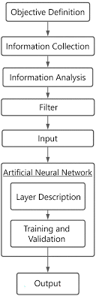

Figure 2 APPLICATION ARCHITECTURE OF PROPOSED SYSTEM

## Database Design

The data collected was collated in Microsoft Excel and saved in a Comma Separated Variable (.csv) format which is a format acceptable by WEKA. It can also be converted into Attribute Related File Format (.arff). Figure 5 below is the entity relationship diagram for the prototype following the requirements stated in the input design stage.

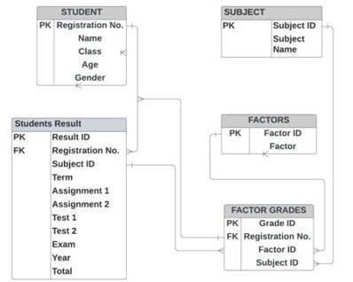

**Figure 3 : DATABASE DESIGN**

## Use Case Model

The figure shows the use case model showing how the user interacts with the system.

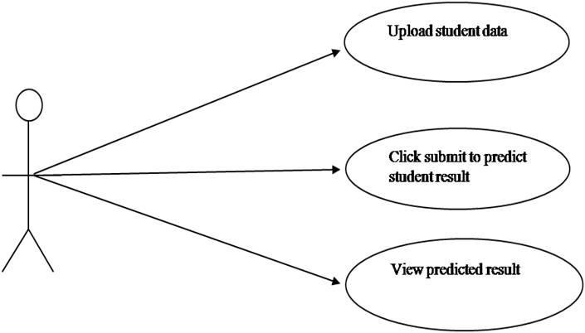

**FLOWCHART**

This is a diagram that represents an algorithm, workflow, or process of the system. The flow of data is, that the user uploads students' data already arranged in a format acceptable by the Neural network, clicks the predict button, and then the system predicts the performance using the trained model. Figure 7 below shows the flow of the system.

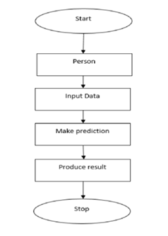

**Flowchart of the model**

**MODEL FUNCTIONS AND PROCESSES**

The major function of the model can be derived from the structure of the artificial neuron as depicted in Figure 2.2 in section 2. The predicted outcome can be defined by the formula

𝑃 = ∑ 𝑓𝑛*,* where

*P* = Predicted outcome

*Σ =* summation

𝑓𝑛 =activation function = (inputs * weights + bias)

input = (academic performance data variables and Contextual factors variables). Figure 8 illustrates the proposed model for the prototype.

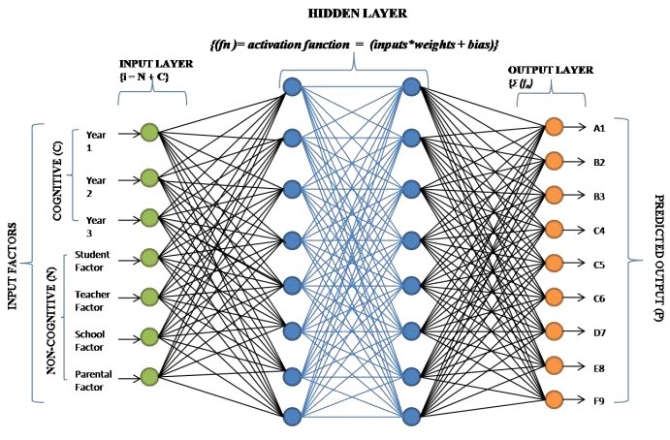

**SUMMARY**

In this chapter, the functional and non-functional requirements of the system were discussed, along with the development approach. As demonstrated by the discussion of the benefits and drawbacks of the methodology. The tools and techniques utilized in the construction of the system were also described.

This chapter concludes with a variety of UML (Unified Modelling Language Language)-created graphical representations of the system, its users, and their interaction

# CHAPTER FOUR

# RESULTS AND DISCUSSION

**4.1 INTRODUCTION**

This chapter presents an analysis of the artificial neural network (ANN) model developed to predict student academic performance, as measured by Grade Point Average (GPA). The study leverages a diverse set of predictors, encompassing both academic and non-academic factors, to create a holistic prediction model. The following sections detail the data analysis process, model development and training, performance evaluation, and a critical discussion of the findings. Additionally, this chapter explores the practical implementation of the model through a web-based interface, demonstrating its potential for real-world application in educational settings.

**4.2 DATA PRE-PROCESSING AND MODEL INPUT**

The dataset used for this study comprised 2,392 students, encompassing a wide range of variables including demographic details, study habits, parental involvement, and extracurricular activities. Before feeding the data into the neural network, several pre-processing steps were undertaken to ensure optimal model performance. The input form for the predictive model includes various fields that correspond to the pre-processed data. Key variables include age, study time weekly, absences, gender, ethnicity, parental education, tutoring, parental support, extracurricular activities, sports participation, music participation, and volunteering. These variables were carefully selected to capture a comprehensive picture of factors potentially influencing student performance. The pre-processing of these variables involved normalization of numeric inputs and one-hot encoding of categorical variables to ensure compatibility with the neural network architecture.

**4.3 MODEL ARCHITECTURE AND TRAINING**

The artificial neural network model was designed as a sequential model with multiple dense layers. The architecture consisted of an input layer corresponding to the number of pre-processed features, two hidden layers with 64 and 32 neurons respectively, using ReLU activation, dropout layers with a 30% dropout rate after each hidden layer to prevent overfitting, and an output layer with a single neuron using linear activation for GPA prediction. This carefully structured design aimed to balance the model's ability to capture complex relationships with its generalizability to new data.

The model was compiled using the Adam optimizer with a learning rate of 0.001 and mean squared error as the loss function. These choices were made to ensure efficient learning and accurate prediction of the continuous GPA values. The training process involved 100 epochs with a batch size optimized for the available computational resources, allowing the model to learn from the data iteratively while managing memory constraints.

**4.4 MODEL PERFORMANCE**

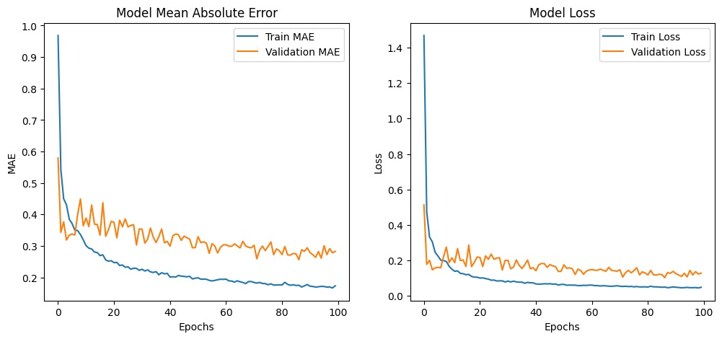

Figure 4.1 Model Performance

Figure 4.1 illustrates the model's performance over the training epochs. The left graph shows the Mean Absolute Error (MAE) for both the training and validation sets, while the right graph displays the model loss. These visualizations provide crucial insights into the learning process and the model's ability to generalize.

### 4.4.1 Mean Absolute Error (MAE)

The MAE graph demonstrates the model's learning progress over time. The training MAE, represented by the blue line, shows a steady decrease from approximately 0.9 to 0.18, indicating consistent improvement in the model's predictions on the training data. This downward trend suggests that the model was effectively learning patterns from the input features to predict GPA accurately.

The validation MAE, depicted by the orange line, initially fluctuates but stabilizes around 0.28, suggesting good generalization to unseen data. This stabilization is a positive indicator that the model is not overfitting to the training data and can maintain its predictive power on new, unseen student profiles.

The final Test MAE of 0.2825 indicates that, on average, the model's GPA predictions deviate by approximately 0.28 points from the actual GPA values. This level of accuracy is promising for a complex predictive task involving numerous variables and demonstrates the model's potential utility in real-world educational settings.

### 4.4.2 Model Loss

The loss graph provides insight into the model's optimization process throughout the training. The training loss, shown by the blue line, demonstrates a rapid initial decrease followed by a gradual decline, reaching a low value of approximately 0.05 by the end of training. This pattern is typical of well-behaved learning processes, indicating that the model quickly grasped the main patterns in the data and then fine-tuned its predictions.

The validation loss, represented by the orange line, shows more fluctuation but generally decreases, stabilizing around 0.15. The convergence of training and validation loss, without significant overfitting, suggests that the model has learned meaningful patterns from the data while maintaining good generalization capabilities. This balance between fitting the training data and generalizing to new data is crucial for the model's practical applicability.

## 4.5 MODEL DEPLOYMENT AND PRACTICAL APPLICATION

A significant aspect of this research is the translation of the developed ANN model into a practical, user-friendly tool for educational stakeholders. To this end, the model was deployed as a web-based application using TensorFlow and associated frameworks. Figure 4.2 presents the user

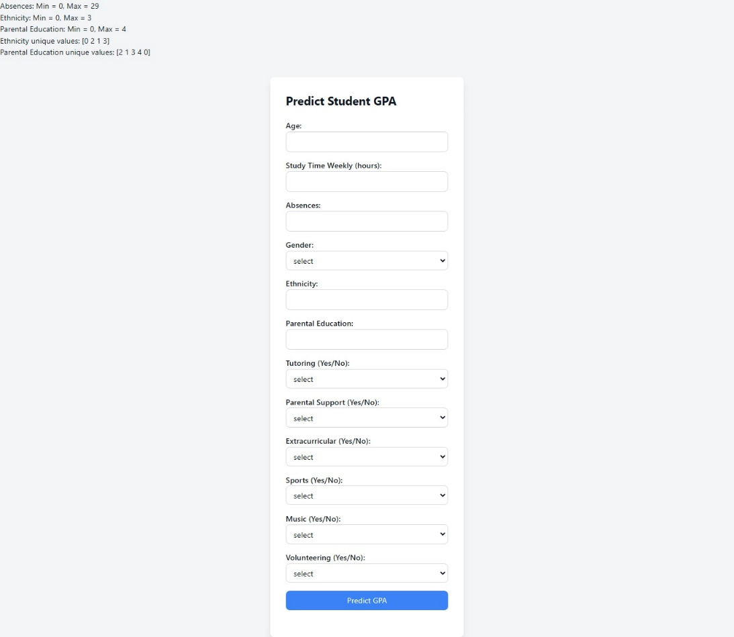

Figure 4.2 Model Deployment

interface of this deployment. The web form allows users to input various student characteristics, including both academic and non-academic factors. This interface not only demonstrates the practical applicability of the model but also provides valuable insights into the range and nature of the input variables considered. For instance, the form reveals that 'Absences' can range from 0 to 29, while 'Ethnicity' and 'Parental Education' are categorical variables with specific value ranges.

This deployment represents a significant step towards making predictive analytics accessible to educators, administrators, and potentially students themselves. By providing a user-friendly interface for inputting student data and receiving GPA predictions, the tool offers a tangible means of utilizing machine learning in educational decision-making processes.

## 4.6 DISCUSSION OF FINDINGS

The results of this study offer several important insights into the prediction of student academic performance and the application of artificial neural networks in educational contexts:

* Multifaceted Nature of Academic Performance: The diverse set of input variables utilized in the model presents the multifaceted nature of academic achievement. The inclusion of non-academic factors such as extracurricular activities and parental support alongside traditional academic indicators reflects a holistic approach to understanding student performance. This aligns with contemporary educational theories that emphasize the importance of considering the whole student experience.
* Model Learning and Generalization: The training process revealed the model's capacity to learn effectively from the training data, as evidenced by the steadily decreasing training MAE and loss. However, the discrepancy between training and validation performance, particularly in later epochs, highlights the challenge of developing models that generalize well to unseen data. This phenomenon underscores the need for careful consideration of model complexity and the potential benefits of regularization techniques or early stopping mechanisms.
* Predictive Accuracy and Practical Implications: With a test MAE of approximately 0.28, the model demonstrates moderate predictive capability. While this level of accuracy could be valuable for identifying students, who might benefit from additional support or intervention, it may not be sufficiently precise for high-stakes decision-making. The practical implications of this accuracy level should be carefully considered in any potential applications of the model.
* Feature Importance and Educational Insights: The inclusion of a wide range of predictors in the model offers the potential for valuable insights into the relative importance of different factors in influencing academic performance. Further analysis of feature importance could provide educators and policymakers with data-driven insights to inform interventions and support strategies.
* Deployment and Accessibility: The implementation of the model as a web-based tool represents a significant step towards making predictive analytics accessible to educational practitioners. This deployment demonstrates the potential for integrating machine learning models into everyday educational practices, potentially facilitating more data-informed decision-making at various levels of educational institutions.

**CHAPTER FIVE**

**SUMMARY RECOMMENDATION AND CONCLUSION**

**5.0 INTRODUCTION**

The steps that have been discussed throughout the project to reach the finished system will be covered in this last chapter. This project has been effective in putting into practice every feature that was covered in the requirements chapter and in being careful to avoid making the same faults as the systems covered in the literature study.

The project successfully developed an Artificial Neural Networks (ANNs) to predict students’ academic performance based on non-academic factors such as demographics, extracurricular activities, and parental support, in addition to academic data. The model offer valuable insights into how various elements affect student outcomes ad provides a more holistic approach to student performance prediction compared to traditional methods that rely solely on academic history.

.

**5.1 LIMITATIONS AND CHALLENGES**

The model’s accuracy is heavily dependent on the quality and quantity of the input data. Missing data or poorly collected information can lead to suboptimal results. Although precautions were taken to prevent overfitting like dropout layers, there’s still risk that the model may not generalize well to unseen data, especially if the data set is too small or lack diversity. While ANNs are powerful, they are often considered black-box making it difficult for educators to interpret how certain inputs lead to specific predications.

**5.2 FUTURE IMPROVEMENTS**

The fact that there is so much possibility for development in this project is a huge plus.

As a result, just because this project is over doesn't imply the system can't still be improved.

Integration with real-time data; incorporating real-time data from learning management systems and other digital platforms could improve the model’s accuracy and relevance. This would allow the model to reflect ongoing changes in student behavior.

Combining ANNs with other machine learning techniques such decision trees or random forest in an ensemble model could enhance predictive accuracy by leveraging the strengths of multiple algorithms. Future models could incorporate additional relevant factors, such as social media usage, health metrics, or detailed course interaction, to capture more nuances in student performance.

**5.3 RECOMMENDATIONS**

Implementing predictive analytics through artificial neural networks (ANNs) can revolutionize student performance monitoring and support systems within the university. As educational institutions increasingly rely on data-driven strategies to enhance learning outcomes, it becomes essential for universities to adopt innovative tools that provide deeper insights into student needs. The following recommendations are designed to guide the university in leveraging the ANN model effectively to predict student performance, optimize resource allocation, and personalize learning experiences.

* The university should adopt the Artificial Neural Networks model to predict student performance based on both academic and non-academic factors. This predictive tool can help identify students who are at risk of poor performance early on, enabling timely academic support and intervention programs.
* The university should regularly evaluate the performance of the ANN model and refine it based on feedback and new data this ongoing improvement will ensure the model remains relevant and beneficial to the institution’s changing needs

**5.4 SUMMARY**

The project documentation is finished with this part. The study looked into and talked about the value of the Artificial Neural Networks (ANN) model in predicting student academic performance by incorporating both academic and non-academic factors. By analyzing variables such as demographics, study habits, and extracurricular activities, the ANN model provided a more comprehensive approach to understanding student success. The model demonstrated moderate accuracy in identifying students who may require additional support or guidance.

**REFERENCE**

Ahmad, N., Hassan, N., Jaafar, H., & Enzai, N.I.M. (2021). Students ‘Performance Prediction Using Artificial Neural Network. IOP Conference Series: Materials Science And Engineering,1176(1),012020. [Https://Doi.Org/10.1088/1057-899x/1176/1/01/2020](https://doi.org/10.1088/1057-899x/1176/1/01/2020)

Adedeji, O.B. 2001. ”AStudy Of The Relationship Between Student UME Results and Their Undergraduate Performance”. Department Of Industrial And Production Engineering, University Of Ibadan. Unpublished BSc. Project

Anderson, G., Benjamin, D., And Fuss, M. 1994 “The Determinant Of Success In University, Introductory Economics Courses”. Journal Of Economics Education25:99-120**.**

Al-Barrak, M. A., & Al-Razgan, M. S. (2016). Predicting Students Final GPA Using Decision Trees: A Case Study. International Journal Of Information And Education Technology, 6(7), 528-533.

Bakare, C.C. 1975. “Some Psychological Correlates Of Academic Success And Failure”. African Journal Of Educational Research. 2.

Dynan, K. And Rouse, C. 1997. “The Under Utilization Of Women In Economics: A Study of Undergraduate Economics Students”. Journal Of Economics Education. 28:50-68.

Hussain, M., Zhu, W., Zhang, W., & Abidi, S. M. R. (2018). Student Engagement Predictions In An E-Learning System And Their Impact On Student Course Assessment Scores. Computers & Education, 123, 113-127.

Kotsiantis, S. B., Pierrakeas, C. J., & Pintelas, P. E. (2004). Preventing Student Dropout In Distance Learning Using Machine Learning Techniques. Applied Artificial Intelligence, 18(5), 411-426

Lage, M. And Tregelia, M. 1996. “The Impact Of Integrating Scholarship On Women Into Introductory Economics: Evidence From One Institution”. Journal Of Economics Education. 27:26-36

Ling, N., E., Baker, R., & Islam, M.A. (2014). Awareness Of Knowledge Management Among Higher Learning Institutions: A Review. Advances In Environmental Biology, 8(9 SPEC.ISSUE 4), 436-439.

Lykourentzou, I., Giannoukos, I., Mpardis, G., Nikolopoulos, V., & Loumos, V. (2009). Dropout Prediction In E-Learning Courses Through The Combination Of Machine Learning Techniques. Computers & Education, 53(3), 950-965.

Shahiri, A. M., Husain, W., & Rashid, N. A. (2015). A Review On Predicting Student’s Performance Using Data Mining Techniques. Procedia Computer Science, 72, 414-422.

Yang, G. R., & Wang, X. J. (2020). ArtificialNeuralNetworksFor Neuroscientists**:** A Primer Neuron 107(6), 1048-1070. [Https://Doi.Org/10.1016/J.NEURON.2020.09.005](https://doi.org/10.1016/J.NEURON.2020.09.005)**.**

Yu, H., Digangi, S., Jannasch-Pennell, A., & Kaprolet, C. (2010). A Data Mining Approach For Identifying Predictors Of Student Retention From Sophomore To Junior Year. Journal Of Educational Technology & Society, 13(4), 16-27.

Zhang, K., Zhang, X., & Yu, W. (2021). A Hybrid Neural Network Model For Predicting Student Performance. IEEE Access, 9, 57749-57757