Transportation Management System

Submit the following:
(i) Document showing
• (i) Brainstorming infographic diagram (looks like Sun with spokes) - this will help you to identify different entities, stakeholders, etc around the problem,

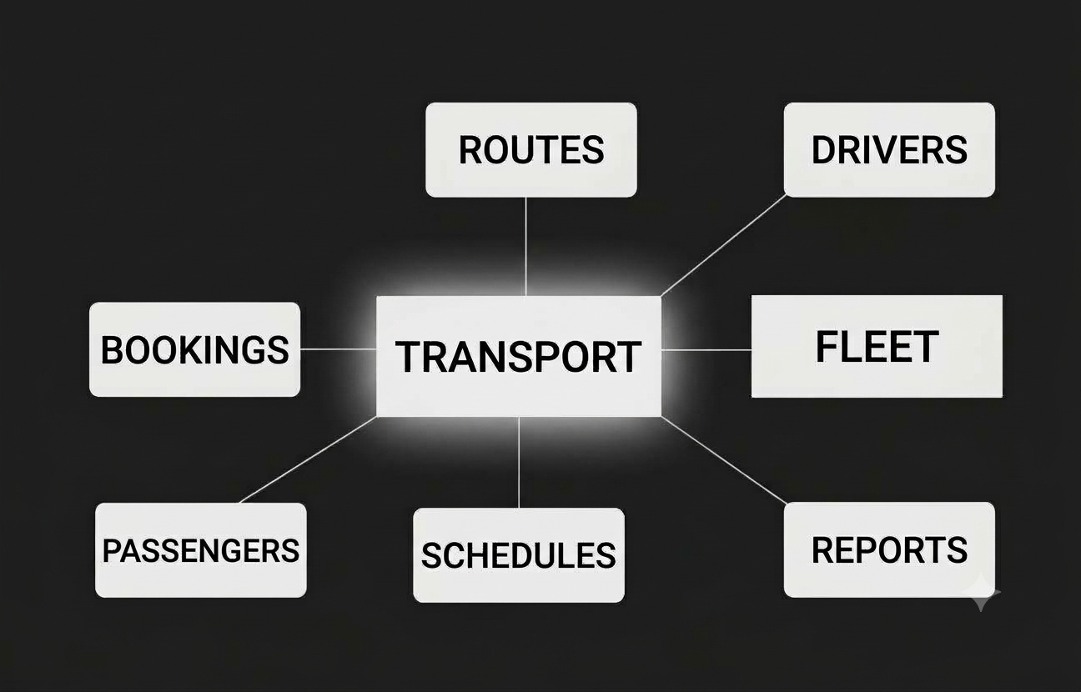

• (ii) Corresponding E-R Diagram - take entities from above diagram and establish relationships between entities

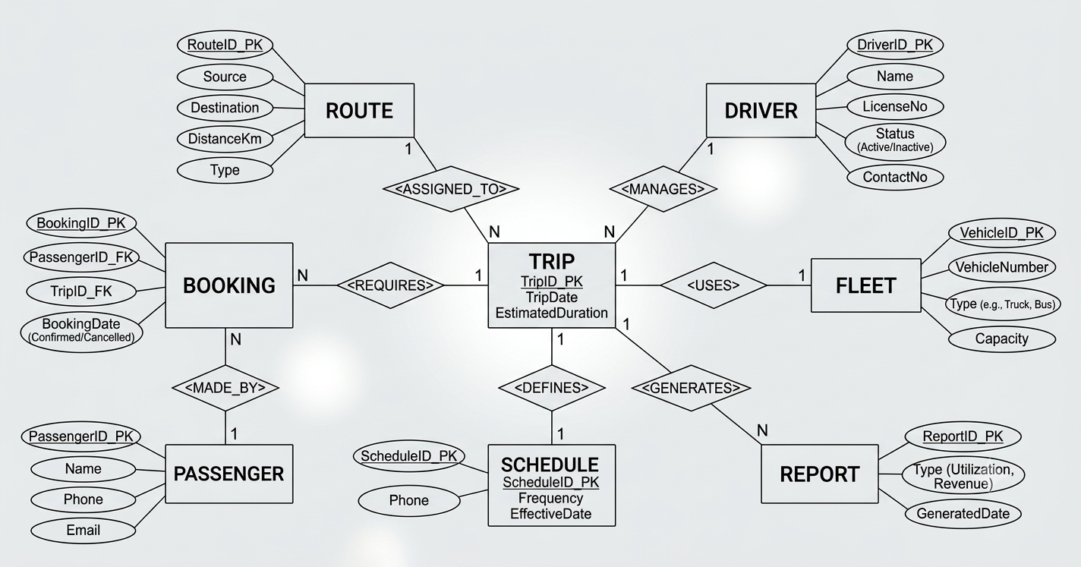
• (iii) Class Diagram corresponding to E-R Diagram
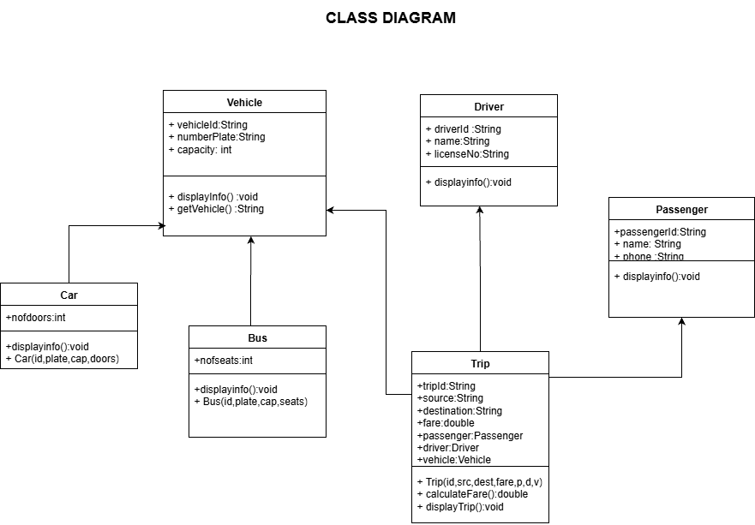

(ii) Push your code to GitHub repository and share the link here
https://github.com/OG-Deepak/OOt/upload/main/Assignment1

(iii) Screenshot of the output
