Installing a Local instance of MongoDB
For this course we can use MongoDB Community Edition. You can find a copy of the installed on Brightspace (or the MongoDB Website).

- Double Click the mongodb-windows-x86_64-5.0.1-signed.msi installed, follow the onscreen prompts
- For our install we’re going to do a Complete install:
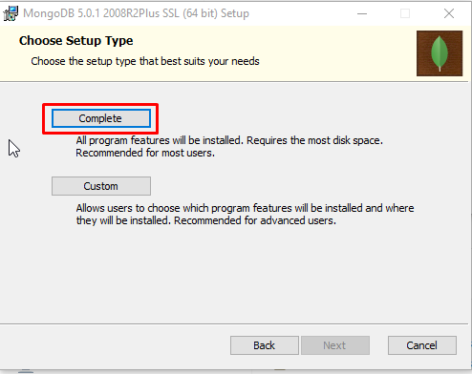
- You can stick with the default Service Configuration. Installing MongoDB as a service means it will boot up in the background without an interface component.
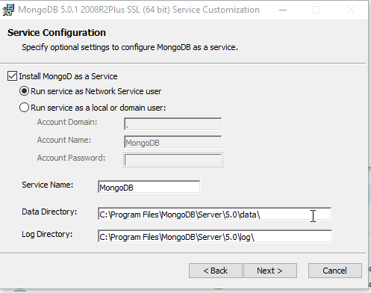

- Installing Compass – You can think of compass as MongoDB’s Management Studio. We’re going to be using it to run queries against our database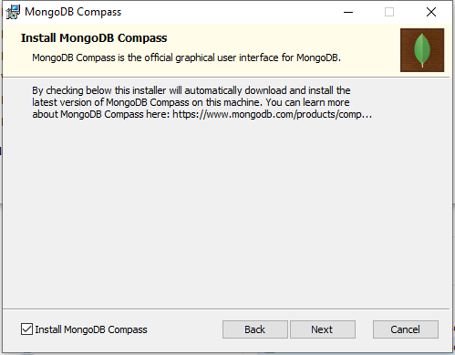

Loading our first Database with our first Collection

Once MongoDBCompass is installed, open it up we should be able to connect with our default server information (localhost: 27017). We can create our first database, this will hold our collection
- Create a database using the add database + :  > 
- Create a new database called Assignments with a Collection called Restaurants:
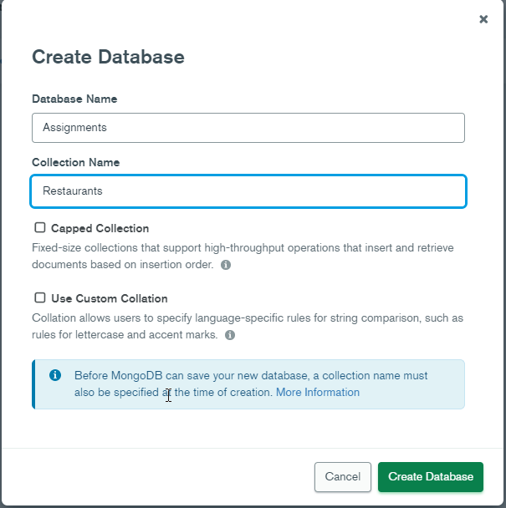
- Once you created your new Collection, lets add some data to it, you can do this by selecting the collection and selecting > Import File. Import the restaurants.json

Enable Authentication

We’re going to turn on authentication, because later we’ll need it for our ETL(extract transform load) tools. To turn on authentication first we’re going to add an administrator user:
- Using MongoDB Compass navigate to the shell (command line) area at the bottom of the tool. We’re going to switch into the admin database using the command: use admin
- Next we’re going to create our new admin user and add them to some security roles. Roles have certain privileges associated with them. In this case we’re going to give this new user full access to our DB. Run the following command, modifying it to fit your needs (Username and Password):
db.createUser(
{
user: "Adnub",
pwd: "myAdminPassword", // or use passwordPrompt()
roles: [ { role: "userAdminAnyDatabase", db: "admin" }, "readWriteAnyDatabase" ]
}
)
- Next we need to shut down our MongoDB server, we can do this by opening command prompt as an administrator (right click> Run As Administrator): 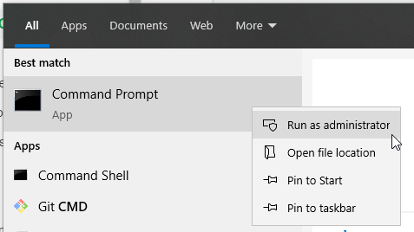
- Using the command net stop MongoDB, this will stop the MongoDB Server. Next we’re going to edit a config file to turn on authentication.
- Locate the mongod.cfg file in your mongo install directory (it should be under /MongoDB/Server/4.4/bin/mongod.cfg) But your root will depend where you installed your mongoDB instance. Open this file with notepad, or other text editor. Add the following line(s):

security:
authorization: enabled

My file looked like this:
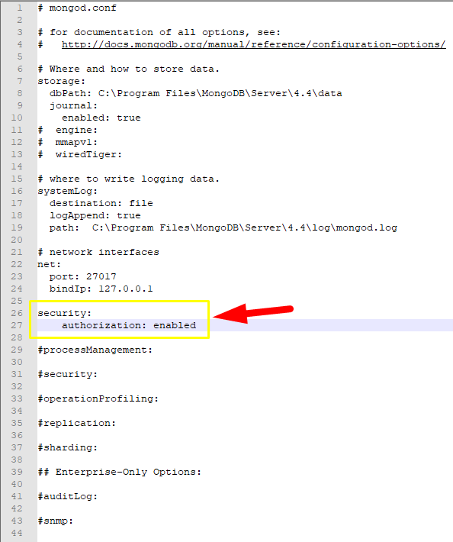
- Finally restart our MongoDB Service but going back to command line and running the following command: net start MongoDB. If you get an error (like “The service is not responding to the control function”). It likely means you have a type-o in your mongod.cfg
- Once your service is restarted you can open Compass, you shouldn’t be able to log into your DB, You’ll have to edit your connection string. This is easiest by selecting : . Change your authentication to SCRAM-SHA-256, and enter your username and password you used above. Your authentication DB should be admin: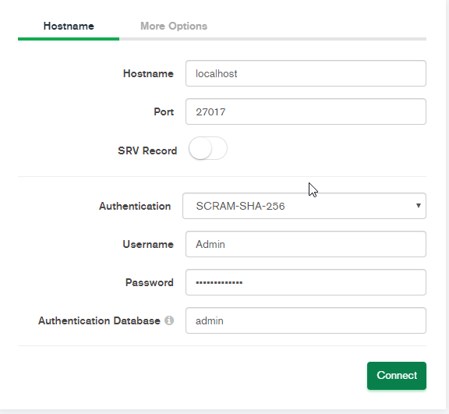

You’re not all setup to use your new database and prepared for future lessons.

