Overview:
In this assignment, you will look at Entity Relationship Diagrams. This assignment will focus on identifying the parts of an ERD. You'll also answer some design questions based on an ERD.

Recommended Readings:

Pro SQL Server 2012 Relational Database Design and Implementation - Chapter 3: The Language of Data Modeling
This is a textbook available through the Saskatchewan Polytechnic library; it goes into detail about data modelling and is worth checking out if you want a deep dive into ERDs
https://learning.oreilly.com/library/view/pro-sql-server/9781430236955/9781430236955_Ch03.xhtml

Visual Paradigm - What is Entity Relationship Diagrams (ERD)?
A great summary resource for ERDs, a solid quick read
https://www.visual-paradigm.com/guide/data-modeling/what-is-entity-relationship-diagram/#erd-data-models-conceptual

Recommended Studies:
It's strongly recommended that you read at least one of the resources above. They will be of great help for the required assignment:

Required Assignment:
Below is an example of a movie rental system:
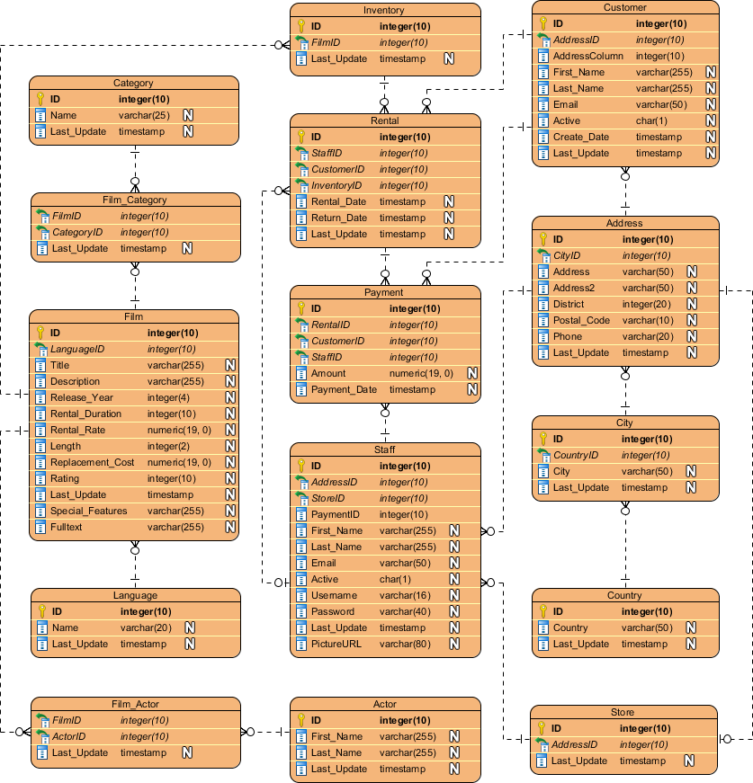
In a Word document, answer the following questions:
- What shape usually represents an Entity?
- The diagram above represents what type of ERD?
- What is a Primary Key?
- What is a Foreign Key?
- In the above example, what is the cardinality between:
  - Film_Actor and Actor?
  - Store and Address?
- List the attributes of the Rental entity
- What is the datatype of the attribute city?
- What is the PK for the Film_Actor entity?
- What are the FK attribute's in the Rental entity?
- If I had a customer ID, what entities would I have to go through to get the first name of their favorite Actor?

