Ogre v2.0
SceneManager Redesign

World Update Design Notes

Version 1.0a
Steve Streeting
5 April 2007

Table of Contents
1 Introduction 3

Introduction
This document describes the design principles under which Ogre v2.0 will observe the world as defined by the using application, and how that world can be updated by the application code.
This document does not cover any detail of the new SceneManager / Locality structures and spatial management systems. These will be covered in detail in another document – where there are interactions with these processes, they are noted at summary level.

Requirements
There are a set of core requirements which Ogre v2.0 must fulfil as regards world update management:
- Ogre's role in the overall system architecture must be strictly that of a 'View' in a Model/View/Controller architecture. World state must only be required to be held by Ogre if it is associated specifically with visual outcomes.
- To fulfil the previous requirement, the user should not be forced to use Ogre's own hierarchical scene graph. Clearly Ogre must hold spatial structures in order to optimise rendering but crucially those mandatory structures must be primarily for that purpose – logical structuring of the scene (such as transform hierarchies) must be decoupled from that.
- The must be accepted strategies for coping with worlds which are updated in threads other than the rendering thread. There should be a number of options depending on application requirements; no threading, simple functional parallelism and complex data parallelism.
- World update processing must take account of the fact that the world can be extremely large. Therefore iterating over the entire scene or even subsets of the entire scene regularly is not appropriate – it must be selective update driven.

These requirements mean a fairly significant change to the way that objects are attached to Ogre's visible world, an how updates are managed.

Design Details

SceneNode and friends
The key change is that MovableObject can no longer be required to be associated with a SceneNode to be visible. Instead, MovableObject will be directly associated with a Locality – a concept not discussed at length in this document but basically it is a region of world space controlled by a single SceneManager, with a local origin. The local origin is used to contain precision errors in large worlds.

So, MovableObject will always be relative to a Locality origin, but it still needs to obtain a transform from somewhere, and that somewhere may not be a SceneNode. Enter the TransformSource class:
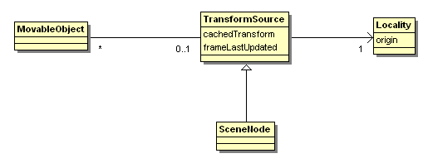
A TransformSource is responsible for providing, on demand from the render thread, details of the transform for one or more MovableObject instances. SceneNode can perform this task, but it is now only one option.
Notice that TransformSource has a 'cachedTransform' attribute which contains a 4x4 matrix. The requirement to store the matrix, rather than to have the option to delegate the production of it dynamically, is deliberate. This is in part to enforce the fact that we assume that TransformSource does not change state until an interesting event happens. The cachedTransform and frameLastUpdated both serve to allow the transform to be re-used multiple times after it is calculated.
Events are very important. As I will discuss later, the assumption is that unless an event is raised, an object is assumed not to have changed transform. This becomes important when updating the derived spatial structures that a SceneManager may use to optimise visibility calculations.
It is also important to note that TransformSource is not necessarily the 'Model' in a Model/View/Controller setup. When using SceneNode, or when providing another implementation which directly reflects the stored state of the scene, even if it's external, then it is an element of the Model. However, as you will see later, when threading is involved, the underlying Model may be updated at a different frequency to the render loop, and thus the TransformSource's job is to provide a View's perspective on the state of the Model via interpolation or extrapolation.

Event-driven updates
In Ogre v1.x, the SceneNode hierarchy is a lazy-updated structure that just before rendering has to be 'baked' – i.e. all derived transforms are updated to reflect any state changes that have been made. This is done by recursing down the scene graph, following only branches marked as dirty until everything is up to date. In addition, custom SceneNode instances aligned with their parent SceneManager trigger updates to any derived spatial structures like octrees and BSP trees as those updates are performed. With the removal of SceneNode as a requirement this can no longer happen.
Instead, Ogre v2.0 will move to an event driven system. When a TransformSource is updated, an event will be queued that the renderer can process just before rendering. This event process will do two things: trigger the TransformSource to update its cachedTransform, and trigger the owning Locality to update its spatial structures (the SceneManager owning it will in fact do that – more detail on this process in a later document). It's important to note that this final transform update will occur at the frame rate – whilst the world update that triggered the update may not. More on this in the threading section.

Single-threaded world updates using SceneNode
Here's a simple world update sequence using the default SceneNode structures:
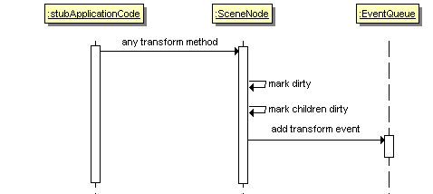
This example represents the way most people's applications will be working currently – i.e. That the application code is executing in the same thread as the renderer, and the world is updated once per frame, probably in the frameStarted callback.
SceneNode largely behaves the way it does now, with 2 small differences:
- The 'dirty' marker only traverses down the node hierarchy, not up. The current system makes parents dirty because the scene graph update is top-down, and thus parents must know some descendent of theirs is dirty for recursion to happen.
- A transform event is raised at the end – but only if the node was not already marked as dirty (in which case there's already an event queued). It's not that clear from the sequence but an event s raised for each child node too.
This event will trigger the necessary derived update later to replace the previous top-down scene graph update. Notice that children are marked as dirty and have events raised for them too – this is to make sure we pick up a need to update should ordering issues in deep hierarchies arise.
It's important to note that whilst event communication is used here, this is still assumed to be a single-threaded scenario. That's because the SceneNode state would require locking if you were to update in parallel to the rendering thread (the event queue will be using a lock-free queue implementation and will be threadsafe). I may provide a compile-time option to add locking to SceneNode should people want to pursue this, but there are actually better ways to deal with threading (discussed later)
When it comes to resolving the transforms just before we look for visible objects:
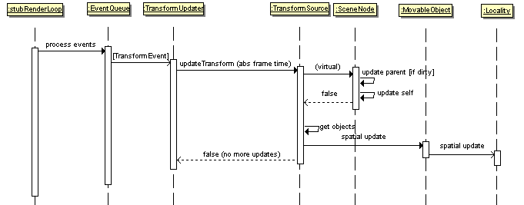
As you can see the two things that happen are the derived transform updates, and the derived spatial updates for the Locality. These operations happen in the main rendering thread. There's some redundant information that the single threaded version doesn't need, such as the absolute frame time passed to updateTransform and the return value from that method which would indicate that the update hasn't finished and that next frame the same event should be processed. The reason for these is covered in the multithreaded section.

This example used SceneNode but if you were writing a single-threaded world application but also wanted to derive transforms from some external Model, you could do that in exactly the same way. You would implement TransformSource differently but the overall sequence above would be the same.

Multi-threaded world updates
The threadsafe event queue model clearly means that you could update the world from a different thread to the render thread, and even across many threads. The question then arises about how often those updates are performed.

High frequency threaded updates
In an single isolated system you may just decide to run the world updates at full speed, but spread the load over a couple of threads. Provided you balance your workload correctly, the delivery of world update information will be high-frequency, probably very similar to the frame rate especially if you perform a sync between them at certain points, but not necessarily directly aligned with it – there may be times when you're only half way through updating the entire world when a new frame is rendered.

In this situation the assumption is that if there is a one or two-frame difference between objects because of this, it won't be noticeable to the human eye. The simplistic way of implementing this would be as follows:
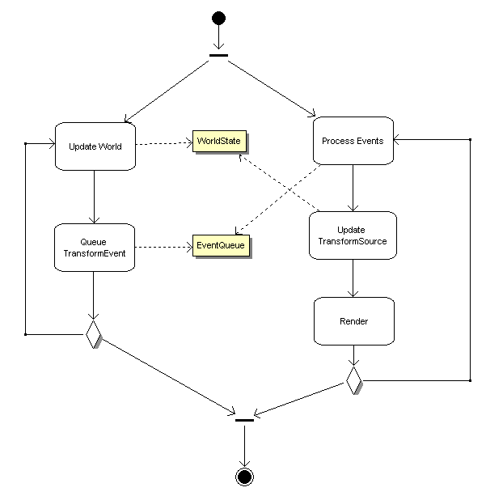
In this case the custom TransformSource just observes the shared world data whenever it needs to render and assumes that any deviance caused by different sets of updates being at different 'world ticks' is small. The big downside though is that it requires a lock on the 'WorldState' data.
A better way would be to include the transform information in the transform event that you raise, rather than having it stored on the TransformSource like SceneNode does it – and this will be an optional bit of data in the event. Thus the processing of the event passes the transform data with it in the render thread whilst the world update thread(s) can carry on calculating and generating new updates entirely separately with only the event queue under contention (which can be implemented with a lock-free strategy). Then, it would look like this:
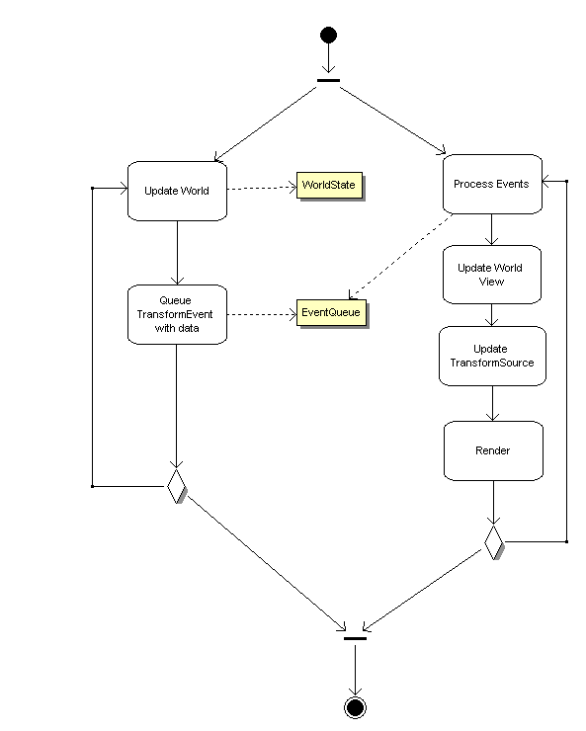
In this situation we're assuming that because world updates are largely matching the frame rate, the information in the transform event is just transferred directly to TransformSource with no interpolation. See the next section for other scenarios.

Alternate frequency threaded updates
Sometimes you either can't predict the frequency of updates (e.g. They're coming over the network), or you want to run the world update at a fixed frequency which is probably lower than the frame rate although in some rare cases may be higher. Either way your update frequency doesn't match the frame rate, probably by quite a reasonable margin.
In this situation, the View has to have a dynamically approximated version of the Model at all points that it needs to render for, to keep the visuals smooth. Depending on precisely why your update frequency is different to the frame rate, you will want to deal with this one of two ways:
- Interpolation. If you're still in local control of your update frequency but are just choosing to run it at a fixed, slower rate, you could use interpolation. To do this, you basically lag by one update and interpolate between one sample and the next each frame. This is only possible when you are very sure the next update is going to come along predictably and regularly.
- Extrapolation. If your updates are unpredictable then this is the only option. As well as sample points, you will almost always want derivative information (e.g. positional and angular velocity) in order to accurately predict motion until the next update arrives, especially when the last update should result in a a sudden cessation of motion – simply deriving trends from previous updates cannot cope with that. This data can be held as custom information against the transform update event, to be used by your TransformSource when needed.

Ogre v2.0 doesn't aim to directly fulfil all your needs here but it will be structured to allow for them. This is why the updateTransform call on TransformSource will take an absolute current time value as well as the event details – this can be used by interpolators / extrapolators to determine the transform in the current frame, allowing for smooth motion even under erratic conditions. It would be relatively simple for example to write an extrapolating TransformSource so long as you raised transform events based on (filtered / validated) network information, or based on regular updates from your AI & physics engines which may be running on different update clocks.

